Moottoriajoneuvo- ja ajoneuvovero 1990-2023

https://statfin.stat.fi:443/PxWeb/sq/8b581436-71ea-431b-a3bf-0ccb2e38eed7

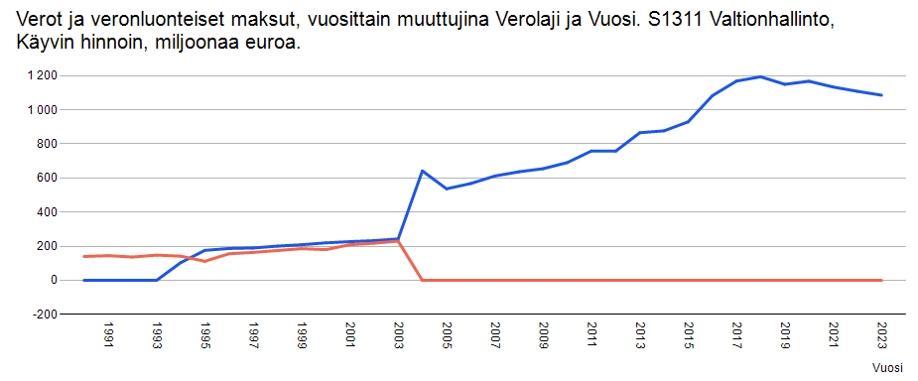

{"columns":[{"code":"Sektori","text":"Sektori","type":"d"},{"code":"Verolaji","text":"Verolaji","type":"d"},{"code":"Vuosi","text":"Vuosi","type":"t"},{"code":"cp","text":"Käyvin hinnoin, miljoonaa euroa","type":"c"}],"comments":[],"data":[{"key":["S1311","521001","1990"],"values":["0"]},{"key":["S1311","521001","1991"],"values":["0"]},{"key":["S1311","521001","1992"],"values":["0"]},{"key":["S1311","521001","1993"],"values":["0"]},{"key":["S1311","521001","1994"],"values":["104"]},{"key":["S1311","521001","1995"],"values":["176"]},{"key":["S1311","521001","1996"],"values":["187"]},{"key":["S1311","521001","1997"],"values":["190"]},{"key":["S1311","521001","1998"],"values":["201"]},{"key":["S1311","521001","1999"],"values":["209"]},{"key":["S1311","521001","2000"],"values":["220"]},{"key":["S1311","521001","2001"],"values":["227"]},{"key":["S1311","521001","2002"],"values":["233"]},{"key":["S1311","521001","2003"],"values":["243"]},{"key":["S1311","521001","2004"],"values":["642"]},{"key":["S1311","521001","2005"],"values":["537"]},{"key":["S1311","521001","2006"],"values":["568"]},{"key":["S1311","521001","2007"],"values":["612"]},{"key":["S1311","521001","2008"],"values":["637"]},{"key":["S1311","521001","2009"],"values":["655"]},{"key":["S1311","521001","2010"],"values":["691"]},{"key":["S1311","521001","2011"],"values":["759"]},{"key":["S1311","521001","2012"],"values":["758"]},{"key":["S1311","521001","2013"],"values":["866"]},{"key":["S1311","521001","2014"],"values":["877"]},{"key":["S1311","521001","2015"],"values":["930"]},{"key":["S1311","521001","2016"],"values":["1083"]},{"key":["S1311","521001","2017"],"values":["1169"]},{"key":["S1311","521001","2018"],"values":["1194"]},{"key":["S1311","521001","2019"],"values":["1150"]},{"key":["S1311","521001","2020"],"values":["1168"]},{"key":["S1311","521001","2021"],"values":["1134"]},{"key":["S1311","521001","2022"],"values":["1109"]},{"key":["S1311","521001","2023"],"values":["1086"]},{"key":["S1311","521002","1990"],"values":["140"]},{"key":["S1311","521002","1991"],"values":["145"]},{"key":["S1311","521002","1992"],"values":["137"]},{"key":["S1311","521002","1993"],"values":["148"]},{"key":["S1311","521002","1994"],"values":["142"]},{"key":["S1311","521002","1995"],"values":["112"]},{"key":["S1311","521002","1996"],"values":["156"]},{"key":["S1311","521002","1997"],"values":["164"]},{"key":["S1311","521002","1998"],"values":["175"]},{"key":["S1311","521002","1999"],"values":["186"]},{"key":["S1311","521002","2000"],"values":["180"]},{"key":["S1311","521002","2001"],"values":["209"]},{"key":["S1311","521002","2002"],"values":["218"]},{"key":["S1311","521002","2003"],"values":["230"]},{"key":["S1311","521002","2004"],"values":["0"]},{"key":["S1311","521002","2005"],"values":["0"]},{"key":["S1311","521002","2006"],"values":["0"]},{"key":["S1311","521002","2007"],"values":["0"]},{"key":["S1311","521002","2008"],"values":["0"]},{"key":["S1311","521002","2009"],"values":["0"]},{"key":["S1311","521002","2010"],"values":["0"]},{"key":["S1311","521002","2011"],"values":["0"]},{"key":["S1311","521002","2012"],"values":["0"]},{"key":["S1311","521002","2013"],"values":["0"]},{"key":["S1311","521002","2014"],"values":["0"]},{"key":["S1311","521002","2015"],"values":["0"]},{"key":["S1311","521002","2016"],"values":["0"]},{"key":["S1311","521002","2017"],"values":["0"]},{"key":["S1311","521002","2018"],"values":["0"]},{"key":["S1311","521002","2019"],"values":["0"]},{"key":["S1311","521002","2020"],"values":["0"]},{"key":["S1311","521002","2021"],"values":["0"]},{"key":["S1311","521002","2022"],"values":["0"]},{"key":["S1311","521002","2023"],"values":["0"]}],"metadata":[{"updated":"2024-09-18T05.00.00Z","label":"Verot ja veronluonteiset maksut, vuosittain muuttujina Sektori, Verolaji, Vuosi ja Tiedot","source":"Tilastokeskus, verot ja veronluonteiset maksut"}]}

