On my honor, Aaron Canda, this assignment is my own work. I, Aaron Canda, will follow the instructor’s rules and processes related to academic integrity as directed in the course syllabus.

1.

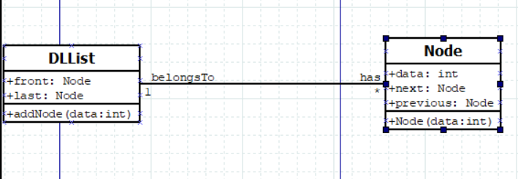

2.

3.

5.

