 REPORT ON
INTERNSHIP 2024-25
Carried out on

Faculty Cabin Navigation Website
Submitted to

NMAM INSTITUTE OF TECHNOLOGY, NITTE
(Off-Campus Centre, Nitte Deemed to be University, Nitte - 574 110, Karnataka, India)

In partial fulfillment of the requirements for the award of the

Degree of Bachelor of Technology in
Computer Science and Engineering
By

ADITHYA D
USN: NNM24CS015

Under the guidance of

Dr. SARIKA HEGDE
Professor, Department of Computer Science and Engineering

CERTIFICATE

This is to certify that the “Internship report” submitted by Mr. ADITHYA D bearing USN: NNM24CS015 of First year B.Tech., a Bonafide student of NMAM Institute of Technology, Nitte, has undergone internship on building a “Faculty Cabin Navigation Website” during the year 2024-25 fulfilling the partial requirements for the award of degree of Bachelor of Technology in Computer Science and Engineering at NMAM Institute of Technology, Nitte.

Name and Signature of Mentor Signature of H.O.D (Computer Science)

ACKNOWLEDGEMENT

The internship opportunity of “Faculty Cabin Navigation Website” was a great chance for learning and developing personal and professional editorial skill.
We dedicate this page to acknowledging and thanking those responsible for shaping the project. Without their guidance and help, the experience during the internship would not have been so smooth and efficient.
We are incredibly thankful to our principal, Dr. Niranjan N. Chiplunkar, for their support and encouragement.
We owe our profound gratitude to Dr. Jyothi Shetty, the head of the department of Computer Science and Engineering. Their kind consent and guidance helped us to complete this work successfully.
We sincerely thank Dr. Sarika Hegde, our professor and mentor, from the Department of Computer Science and Engineering for her guidance and valuable suggestions which helped us to complete the project.
We also thank our friends and family members for their continuous support.

I would also like to thank NMAM Institute of Technology for providing me the opportunity to choose a subject of interest for our internship project and equipping us with the necessary resources to complete it successfully.

INDEX
Acknowledgement………………………………………………………………………3
Abstract…………………………………………………………………………………..5
- Introduction
  - Details of internship undergone…………………………………………..…..6
  - Objectives ………………………………………………………………7
  - Scope & Importance…………………………………………………………………………...8
  - Technology used………………………………………………………………………9
- Result………………………………………………………………………………...10
- Conclusion…………………………………………………………………………….12
- Reference…………………………………………………………………………….13

Abstract

This internship project focused on developing a Faculty Cabin Navigation Website, a web-based application designed to streamline faculty member management and enhance user interaction for academic libraries, using HTML, CSS and JavaScript. A cabin navigation system, important to educational institutions, relies on efficient organization, intuitive interfaces and accessible features to support faculty and students.

The primary objective was to build a front-end platform replicating core cabin navigation functionalities, such as faculty member browsing, search functionality with a responsive and user-centric design. Key tasks included creating a homepage, faculty member catalog and search interface, while ensuring cross-browser compatibility and mobile-first design principles.

The project strengthened proficiency in front-end development, emphasized clean code practices and provided insights into UI/UX design for academic applications. Challenges included implementing dynamic search functionality and ensuring responsiveness across devices, which were addressed through iterative design and JavaScript enhancements. The internship highlighted the importance of accessibility, usability, and ethical web development.

While limited to front-end features, the project lays a foundation for future backend integration (e.g., Node.js, Firebase) and advanced features like real-time faculty member availability. This internship made us more prepared for web development jobs and showed us how important it is to create academic systems that are easy and useful for students and teachers.

1.Introduction

Details of the internship undergone
Our internship project focused on developing a Faculty Cabin Navigation Website. This web-based application aims to replicate and simplify the main functions of academic cabin navigation and management. The goal was to improve accessibility, increase user engagement, and offer a clear interface for browsing and managing faculty-related information. The system includes a responsive faculty catalog, a search function with filtering options, and account management modules. These features help students, staff, and other users easily find faculty members, access details, and interact with resources in an organized digital space. We prioritized smooth navigation and compatibility across different platforms to ensure a consistent experience on desktops, tablets, and mobile devices. The project was built using HTML, CSS, and JavaScript, combining structure, styling, and interactivity to create a user-friendly and visually appealing platform. In the end, the project offers more than just a prototype. It provides a functional and engaging navigation experience while highlighting our skills in front-end development and practical problem-solving within an academic setting.

Moreover, the project showed how widely technology can be used and improved at a smaller scale. This not only improves technical knowledge but also builds confidence in tackling larger and more advanced projects in the future.

1.2 Objectives

- Provide a seamless cabin navigation experience through intuitive navigation and faculty member discovery.
- Enhance user interaction with features like faculty member details and their cabin locations.
- Offer categorized faculty member listings with detailed descriptions.
- Optimize search and filter options to help users quickly find desired faculty data.
- Ensure responsive design for accessibility across devices and screen sizes.
- Empower developers to understand cabin navigation system structures through practical implementation.
- Maintain a user-friendly interface while continuously improving design and functionality.

1.3 Scope & Importance

The Faculty Cabin Navigation Website was designed as a dynamic web platform that replicates the core features of an academic cabin navigation management system. With a user-focused approach, it offers essential functionalities, enhances resource accessibility, and supports user interaction—delivering a seamless and engaging cabin navigation experience.

Faculty Member Browsing Experience: The website features a well-structured homepage and faculty member catalog, allowing users to explore a wide range of titles with detailed listings. Faculty Member pages include descriptions, authors, genres, and availability status, ensuring informed decision-making.

User Interaction: A simple and intuitive interface enables users to access features such as faculty member details and personalized cabin navigation, making the process smooth and user-friendly.

Search Functionality: The current implementation includes a dynamic search bar powered by JavaScript, allowing users to search faculty data by title. Future enhancements could integrate backend technologies like Node.js or Firebase for real-time data retrieval and advanced filtering by availability or publication year.
Responsive Design: The website is optimized for various screen sizes and devices, ensuring a consistent and accessible experience whether viewed on a desktop, tablet, or mobile phone.

1.4 Technology Used

- HTML: HTML (Hypertext Markup Language) is the standard markup language for creating web pages and web applications. It provides the structure and content of a web-page, defining elements like headings, paragraphs, images, links, and more.

- CSS: CSS (Cascading Style Sheets) is a style sheet language used for describing the presentation of a document written in HTML. It allows developers to control the layout, design, and appearance of web pages, including aspects like colors, fonts, spacing, and responsive behavior.

2.RESULT

The Faculty Cabin Navigation Website successfully delivers a functional and user-friendly web application that simulates the core operations of an academic cabin navigation. Below are examples of the website's key pages, showcasing the implemented features and design:

Landing Page: The homepage welcomes users with a clean layout, featuring faculty department categories and a quick guide to campus buildings. The responsive design ensures accessibility across devices, with a focus on easy user accessibility.

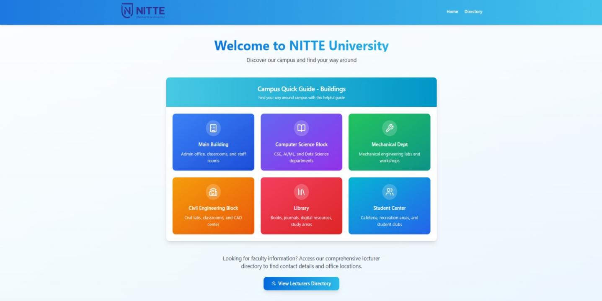

[Fig 1. Landing Page]

Faculty Member Directory Page: This page displays a grid of faculty data with details in dropdown format. JavaScript-powered search and filter options allow users to dynamically browse the catalog, enhancing usability.

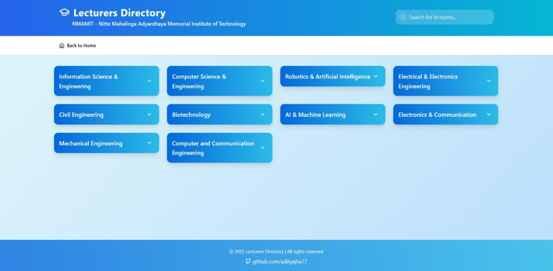

[Fig 2. Faculty Member Directory Page]

The results demonstrate proficiency in front-end development, with a focus on clean code, responsive design, and user-centric features. The project aligns with industry standards for web accessibility and usability, laying a strong foundation for future enhancements

3.CONCLUSION

In conclusion, the Faculty Cabin Navigation Website serves as a robust platform for simulating real-world academic cabin navigation operations while reinforcing essential web development concepts. By offering an intuitive interface, functional features like faculty member browsing and search, and a realistic user journey, the website enhances both user engagement and developer learning. The use of HTML, CSS, and JavaScript enabled the creation of a responsive and interactive application, with a focus on accessibility and usability. The project reflects a strong foundation in front-end development, addressing challenges like dynamic search implementation and cross-device compatibility through iterative design. As an evolving platform, the system is well-positioned for future enhancements, such as backend integration for real-time data management or advanced features like user login and automated notifications for faculty member availability. This internship experience has significantly improved readiness for web development roles and underscored the importance of user-focused design in academic applications.

4.REFERENCE

geeksforgeeks (HTML): https://www.geeksforgeeks.org/html-tutorial/

geeksforgeeks (CSS): https://www.geeksforgeeks.org/css-tutorial/

w3schools: https://www.w3schools.com/Html/

