“WIRELESS REMOTE DOOR LOCK”

by

Arshad Feeroz

Diljit PR

Faraz Alam

Neha Firdaush Raun

Final Year Project submitted in fullfillment of the requirements for the degree of Bachelor in Computer Science and Engineering

The Computer Science and Engineering Department,

Guru Nanak Institute Of Technology

(affld. West Bengal University of Technology)

Year : 2015

Index

Process Documentation

(Project Design Documents)

1.Abstract....................................................................................................2.Introduction.............................................................................................

3.Description of Algorithms........................................................................

4.System Design.........................................................................................

5.Implementation........................................................................................

6.Experimental Results and Values.............................................................

Abstract

Technology is advancing rapidly at a faster pace and so is the Internet. These days every house has a internet connectivity. Things have changed from the old traditional way to the ultra modern way of doing things. Everthing has become mobile since then,whether its about bank payments or household bills. Innovations are taking a new turn in the world of Internet. With the new trend of technology called “The Internet of Things”, each and unique object can be manipulated just via an internet connectivity. The Internet of Things(IoT) is the network of things embedded with electronics, software, sensors and internet connectivity to enable it to achieve greater value and service.

This could bring a plethora of oppurtunities and can make things easier in the fast moving world. From medicare to education, this technology has huge benefits. Our idea stands upon the concept called IOT(Internet of things) whereby door locks or any kind of locks can be controlled remotely from anywhere around the world just via a mobile application but without replacing the old fashioned way of manipulating door locks. Security has become a primary concern in everyone's day-today life. Therefore we have decided to pay priority towards the security using latest encryption protocols. We have worked on the idea of locking and unlocking the door remotely using a smartphone or a computer. The basic idea behind this locking & unlocking is the use of a wifi network and accessing it with a web app. The smartlock is simple, secure and easy to handle without the need of keys. This provides you the control of your lock from anywhere in the world. In a nutshell it replaces your keys with your smartphone. It authenticates and validates the user and open the door automatically. It also keeps the record of check-in and check-out of the user.

Introduction

Aim : The aim of the project is to develop an embedded based software solution for a door lock which can be controlled wirelessly and remotely via a mobile and web application.

The intended audience of this project are the general consumers. Anyone can use this application to lock/unlock their locks using the given software application and the hardware.

Scope : The scope of this project is resolve the issues in tradional way of door locking using the new trend called Internet of Things.

Broad Description :

We often face a lot of issues in the tradional way of door locking.Whether its about the hassle of distributing physical keys or the worry about intruders.We even fail to afford high end secuirty lock systems due to their high market prices.At times,when we are away from home,our friends or relatives can't get into our house until we arrive which is really a big pain for our friends or relatives.We have come up with a better yet affordable lock system solution which works on the concept called Internet of Things.

Our hardware cum software based lock system can be integrated into any existing system and can be controlled both traditionally as well as the new fashioned way using a web application or a mobile application.Imagine you are miles away from home and you dont want your friend to wait for you, you could open our software app and give him access to your door lock from anywhere around the world.

**Algorithm**

Start app

validate user:

if user == “admin”

redirect to admin panel

print choice “1.Lock/Unlock”;

print choice “2.Send Invites”;

print choice “3.View Logs”;

print choice “4.Logout”;

if (isValid(admin.choice)) then

if admin.choice == “Lock/Unlock” then

start critical block:

call the remote hardware api with the required parameters

if the api call is success then

log the datetime,uesrname,lock status into the database

else

try again

end critical block;

if admin.choice == “Send Invites” then

accept invitee contactnumber,name,accessStartTime,accessEndTime as input

hash a secure key for the invitee

send invitee the key,username and url via a sms notification

if admin.choice == “View Logs” then

show the log for all guests accesed your lock

if admin.choice == “Logout”

logout of the system

redirect to login

if user == “guest” then

redirect to guest panel

print choice “1.Lock/Unlock”

print choice “2.Logout”

if guest.choice == 'Lock/Unlock” then

start critical block:

call the remote hardware api with the required parameters

if the api call is success then

log the datetime,uesrname,lock status into the database

else

try again

end critical block

if guest.choice == “Logout”

logout of the system

redirect to login

end app

**DB SCHEMA**

**'**

**First Design:**

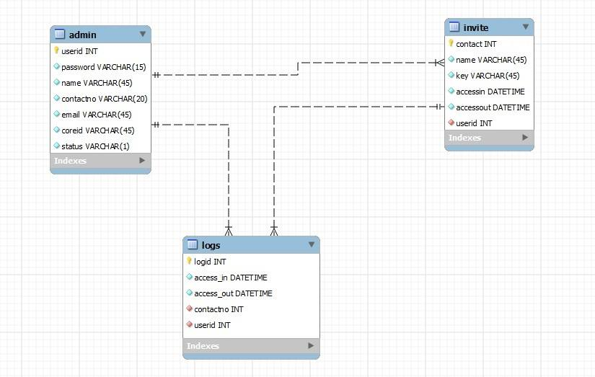

**System Architecture**

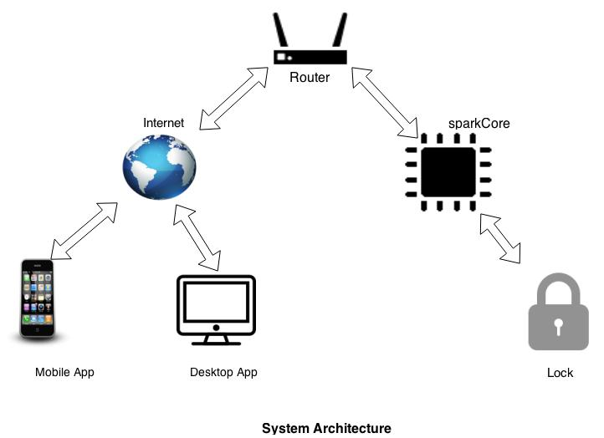

**Process Flow Diagram**

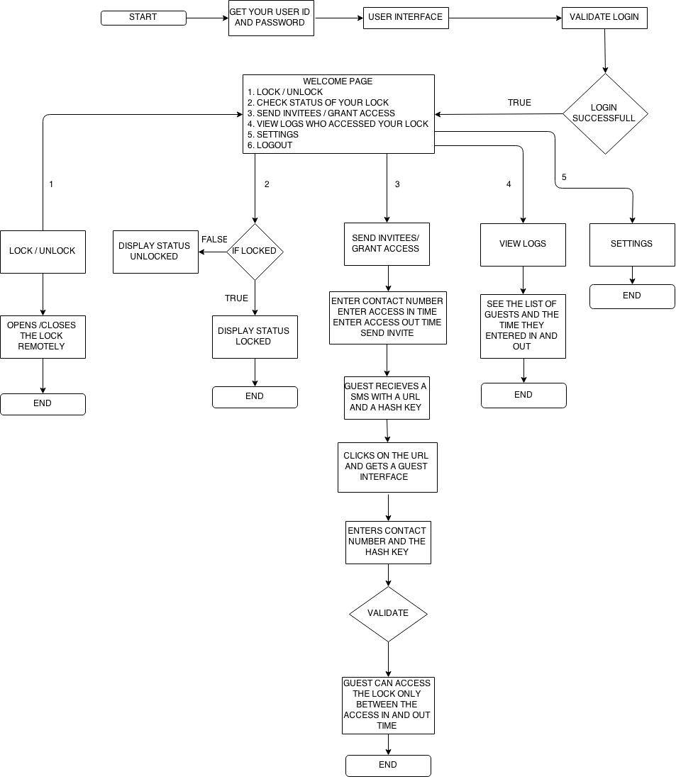

**Expiremental Results and Values:**

App Loading Time (Home Page) : 120 ms