fprintf('\n normalize the data can let the handwriting become more suitable for the image ')

fprintf('\n also, the normalization can let all the handwriting in a similiar size')

fprintf('\n which is good for the trainning and classification ')

fprintf('\n therefore, the normailization is necessary')

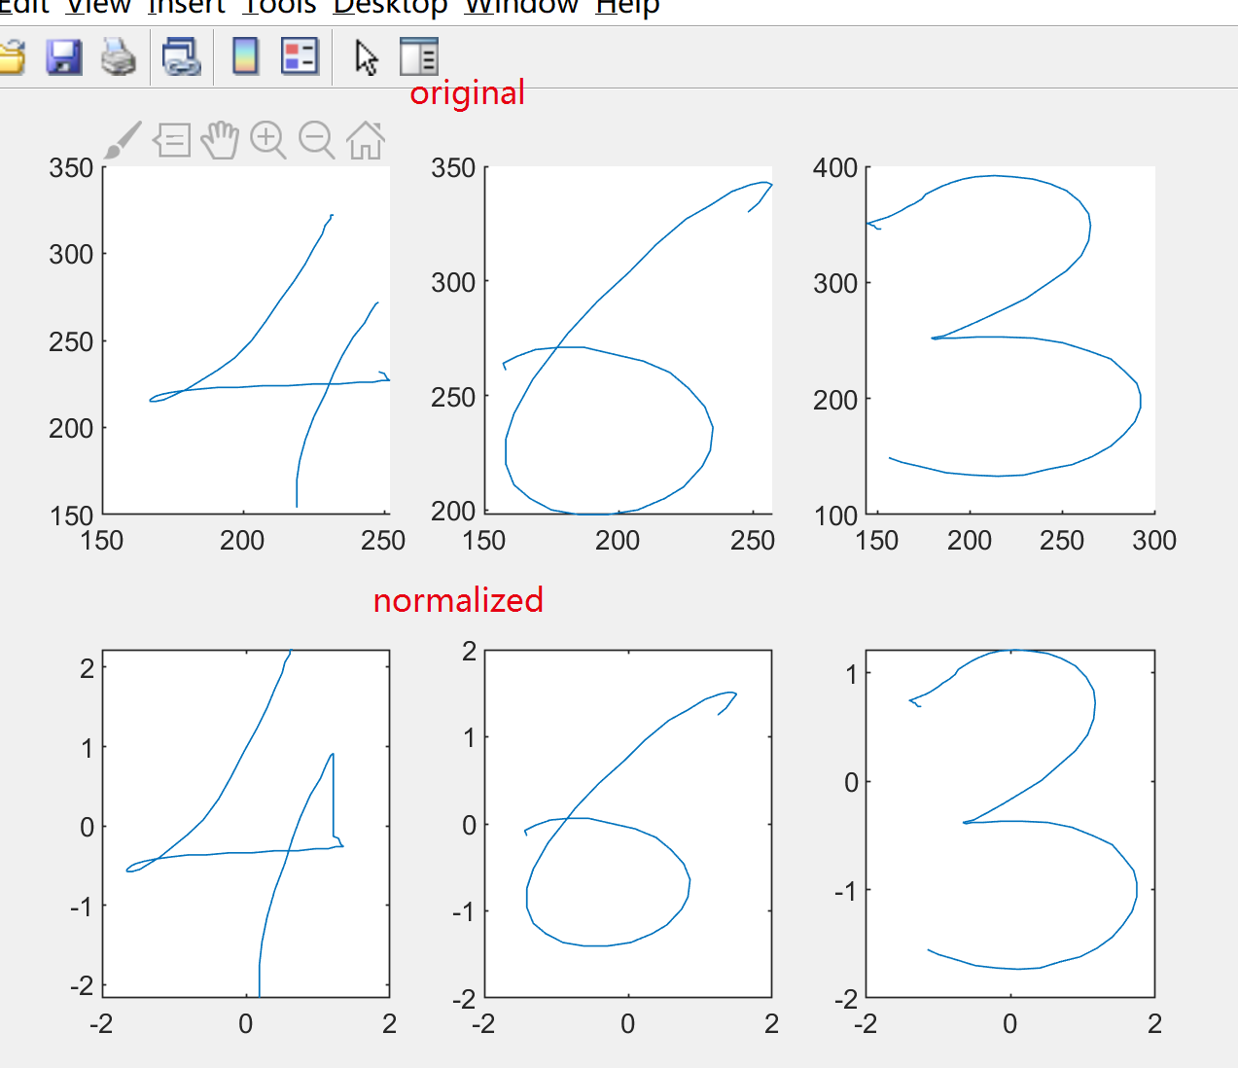

fprintf('\n the best accuracy i got is 88.16 percent')

fprintf('\n the parameter for it is, 8 states, tol = 1e-4, iter = 200 ')

fprintf('\n the accuracy will increase as the state increases, but the calculation will then become longer ')

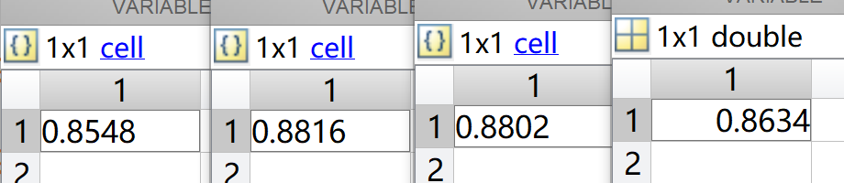

|  |  |  |  |  |
| --- | --- | --- | --- | --- |
| Try set | Tol | iter | states | accuracy |
| 1 | 1e-4 | 200 | 5 | 85.48% |
| **2** | **1e-4** | **200** | **8** | **88.16%** |
| 3 | 1e-4 | 100 | 5 | 88.02% |
| 4 | 1e-5 | 200 | 5 | 86.34% |