[1] Installing python

Run the **Install_python-3.11.3-amd64.exe** file in this folder

This screen will appear:

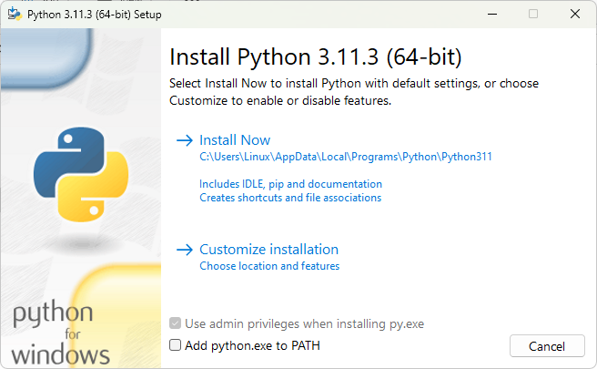

Check “Add python.exe to PATH”:

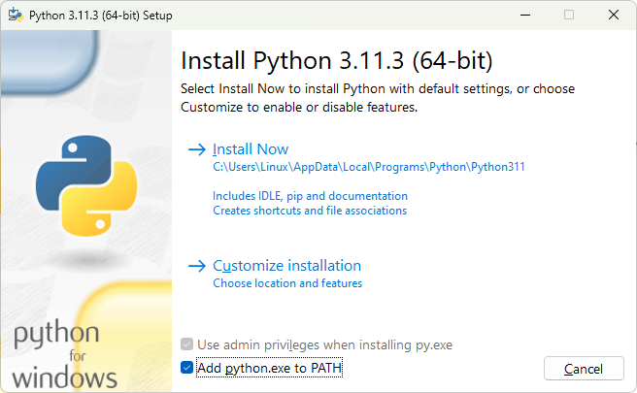

Press on “🡪Install Now”

You will see a screen like this:

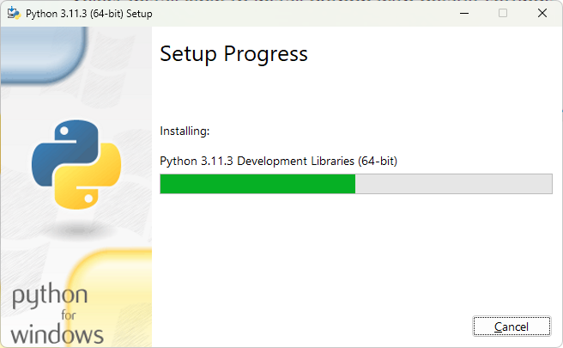

After the installation has finished, click on Close

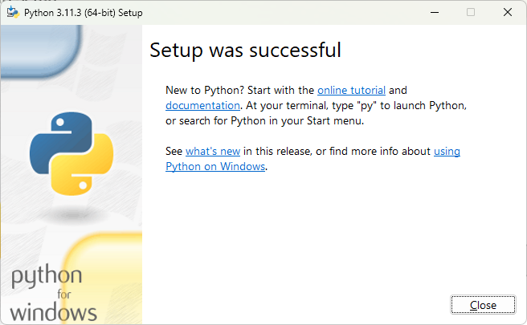

Restart your computer.

Now, go to the start windows logo and right click it, you’ll see this screen:

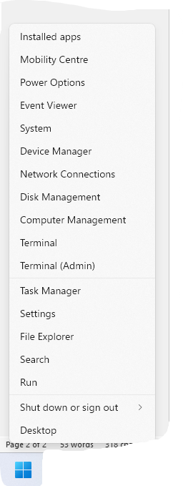

Click on “Terminal (Admin)” or “Command Prompt(Admin)”

You will see this:

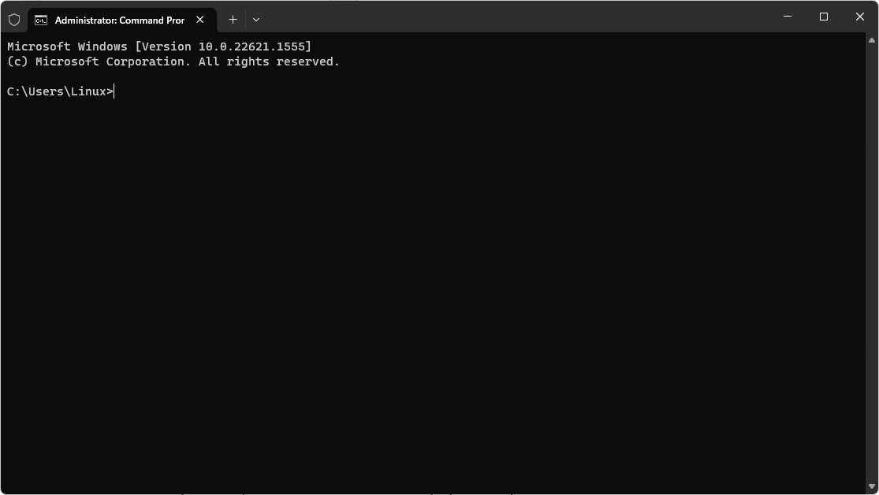

Now, type **pip install wheel numpy pandas matplotlib vpython pyautogui** and press enter

You should see a screen like this:

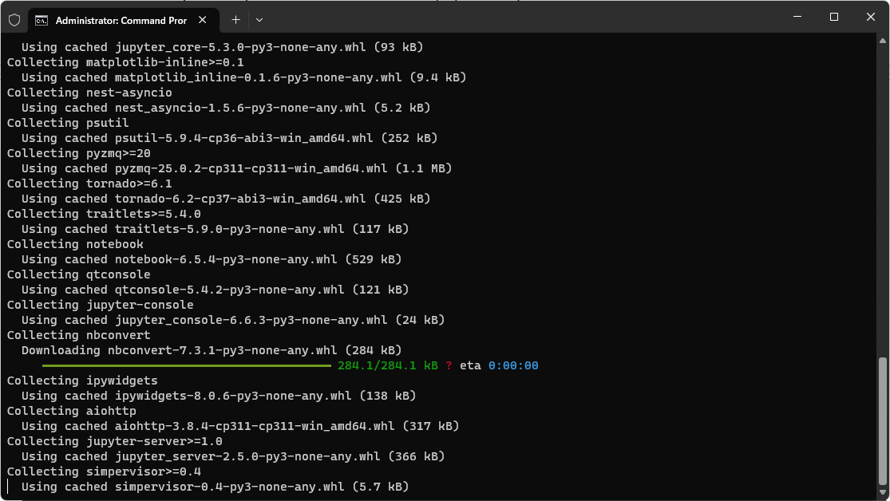

When it has finished, type **exit** and press enter. The window will close.

Now everything is ready for the script to be run.

Now go to this folder and double-click 

A terminal window will appear, and a window asking to open the POSCAR file will appear:

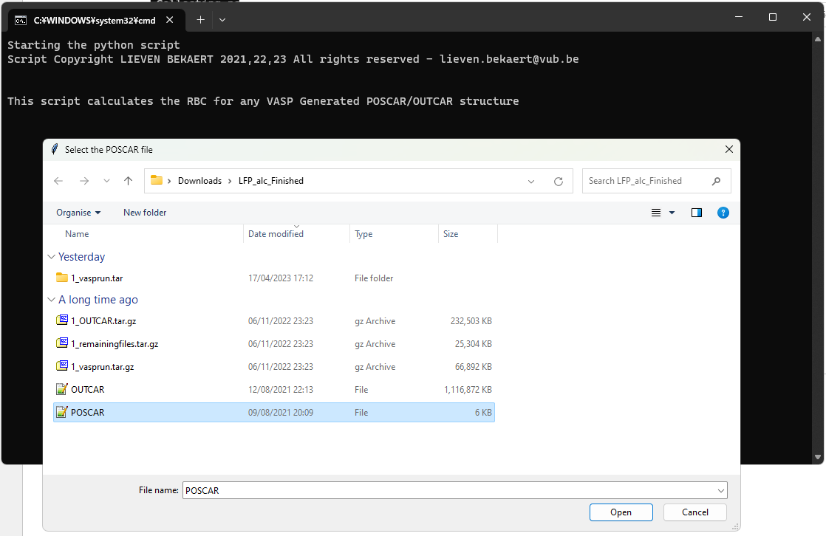

Select the POSCAR file and click on Open.

Another window will appear, select the OUTCAR file and click on Open

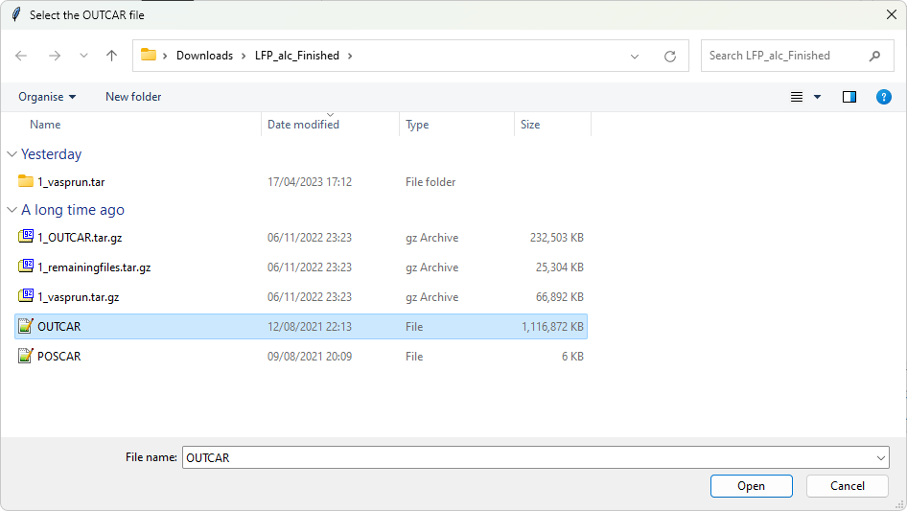

We will now select only the functional group (molecule) – Not the LFP surface.

A window will appear asking you in which direction to plot the POSCAR file. First select XY (if XY doesn’t show a good view in the next window, you can restart the programme and choose YZ or XZ)

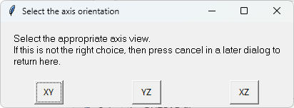

This window will appear:

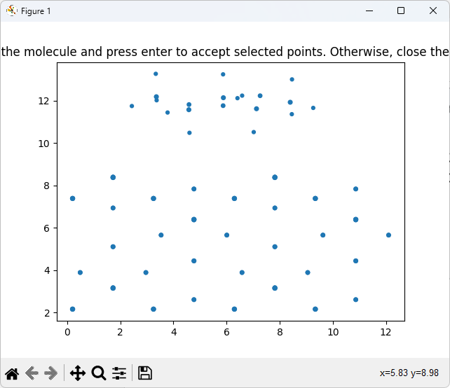

The molecule can be seen above the electrode. Use your mouse to draw a circle around the molecule (slowly)

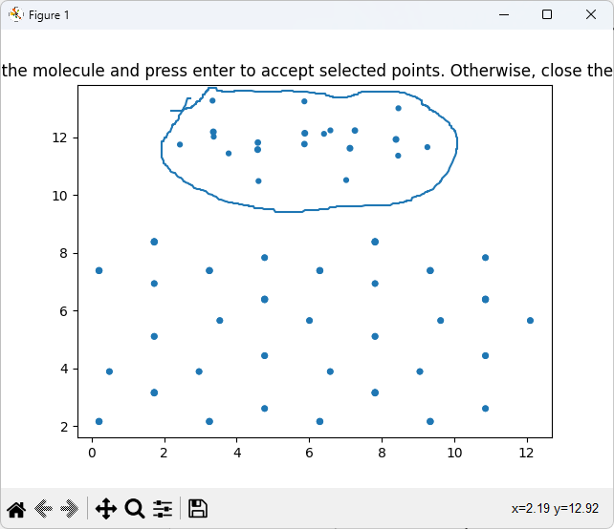

The colour of the surrounded dots will change a bit (the selection will remain dark blue, whereas the other points go lighter)

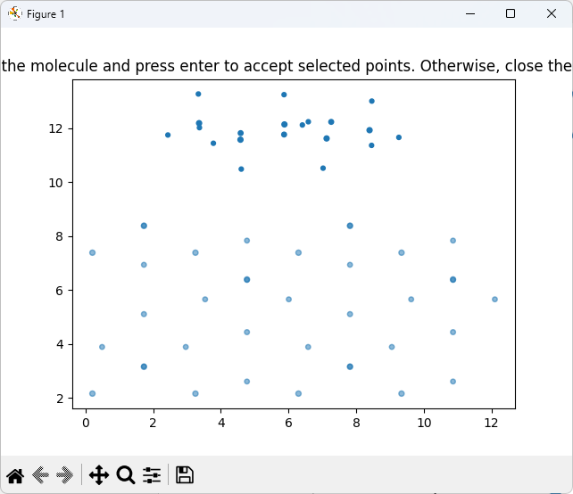

If you did not manage to select all the molecule atoms, you can draw again.

If you have successfully selected the molecule, click **Enter**

The window title will change:

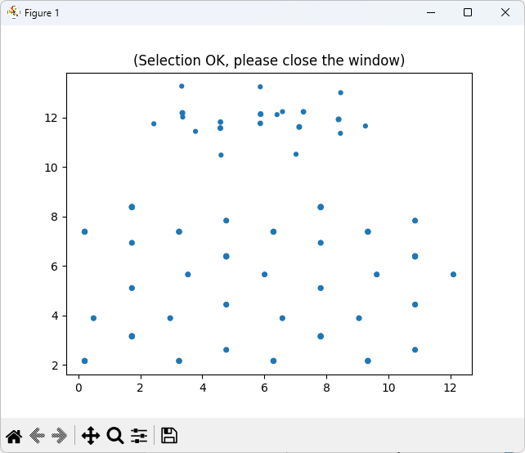

Now you can close the window by clicking on the red close button.

The following window appears:

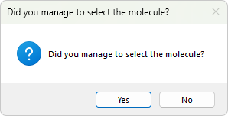

Click on **Yes**.

Now the following window will appear, showing the molecule which you selected and also the bonds between the atoms that it anticipated:

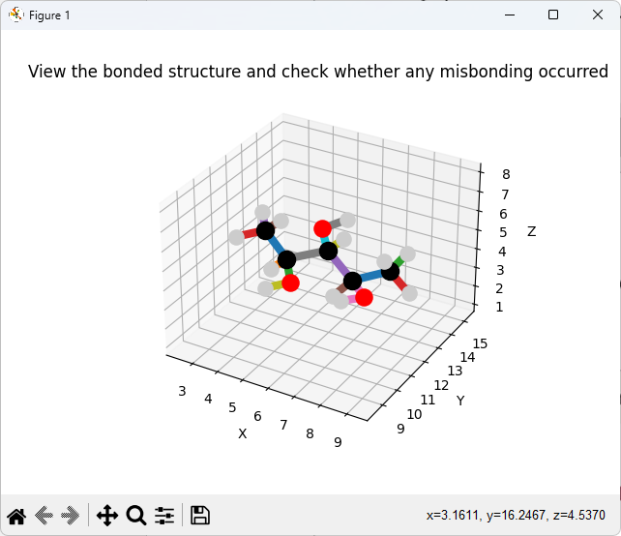

You can left-click on the molecule, keep it pressed in, and move the mouse to see if all atoms are correctly bonded.

! If there is a mistake, or if atoms belonging to the electrode are also included, then close the terminal window:

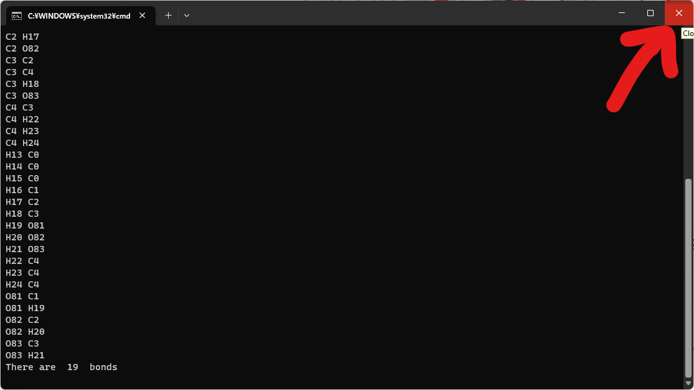

Otherwise, if there is no mistake, then close the Figure window

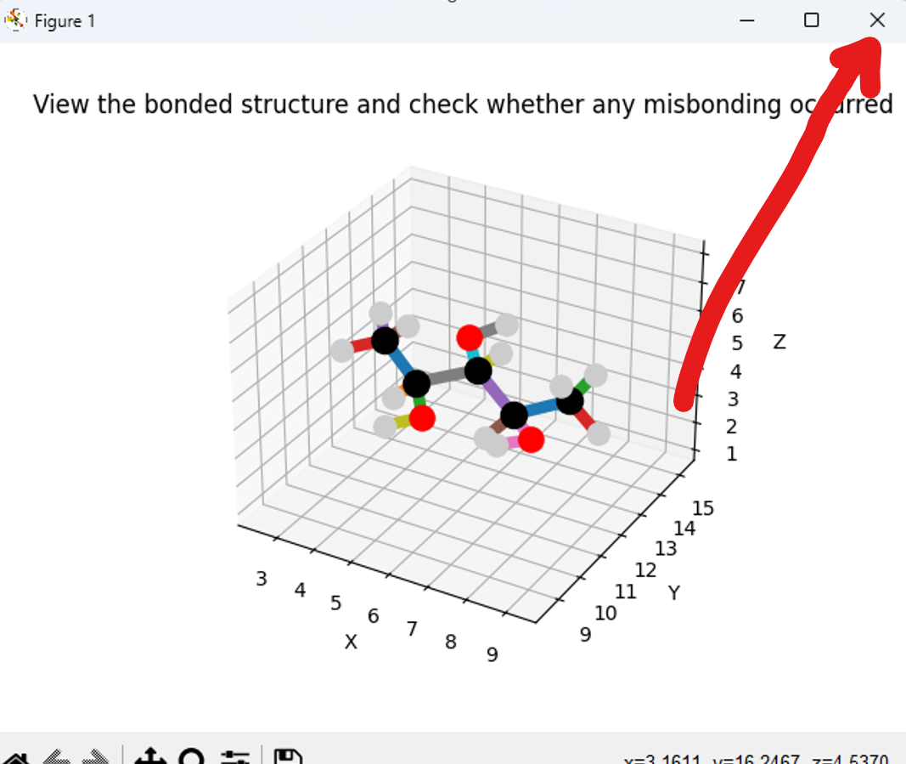

The programme will now read the OUTCAR file and calculate the bond lengths over time.



When it is finished, you will see this:

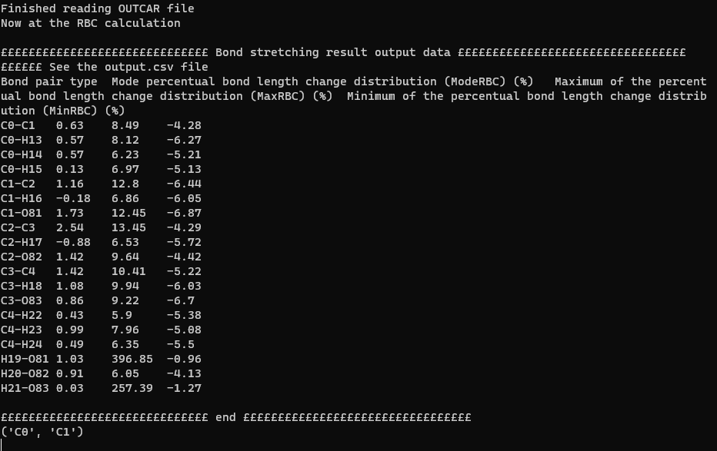

If you see “££££££££ end ££££££££” then it means that the calculation has successfully finished.

Go to the folder which contains the runme.bat file, you will find a csv file called output.csv.  Open it:

Here you will see the bond, ModeRBC, MaxRBC, and MinRBC.

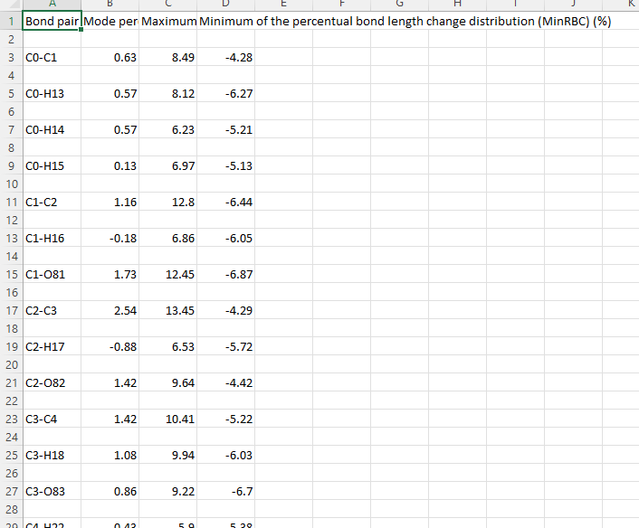

Try plotting MinRBC vs MaxRBC:

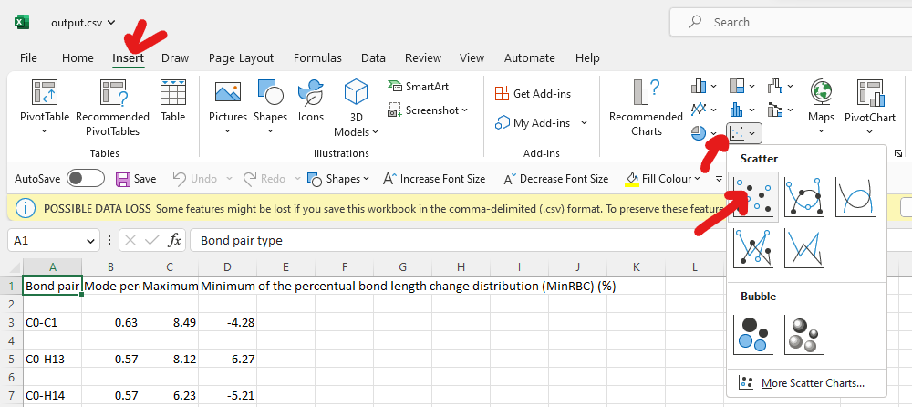

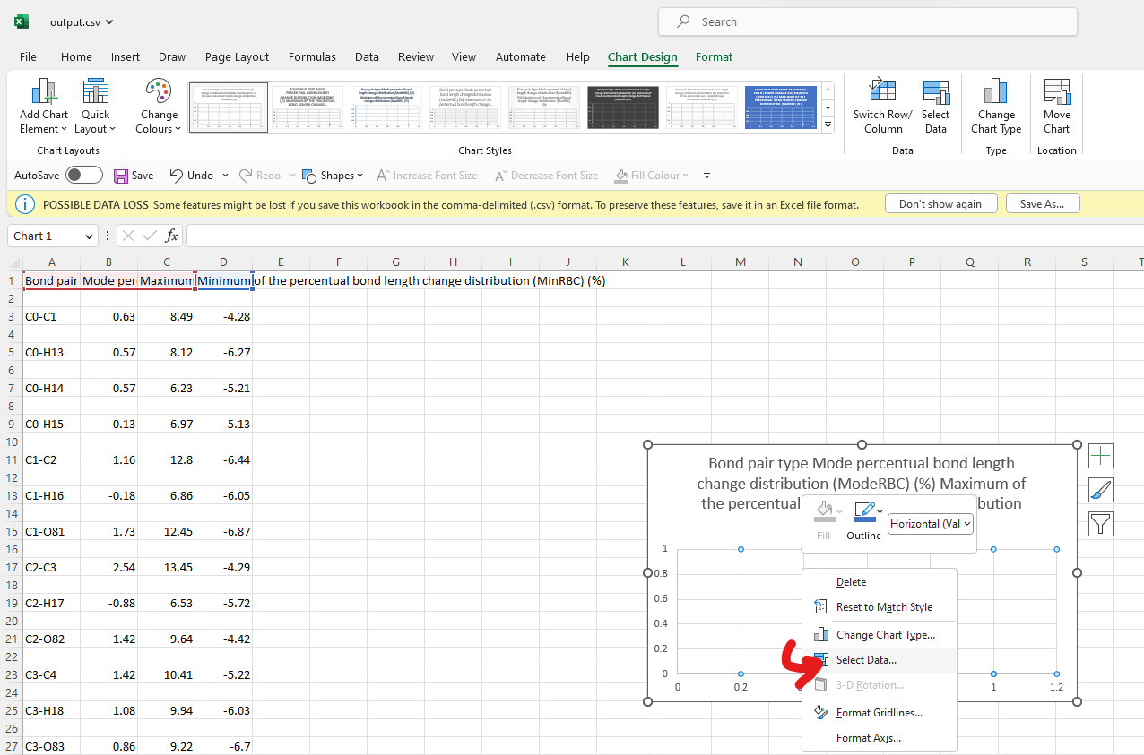

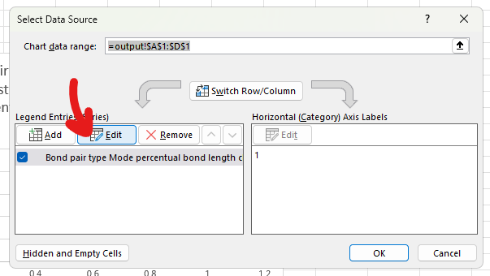

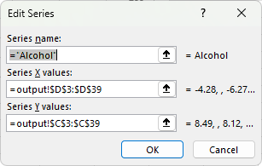

Set x-axis=MinRBC

Set y-axis=MaxRBC

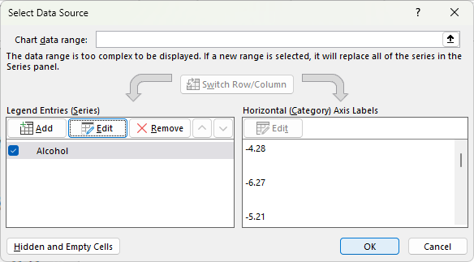

Press on Ok

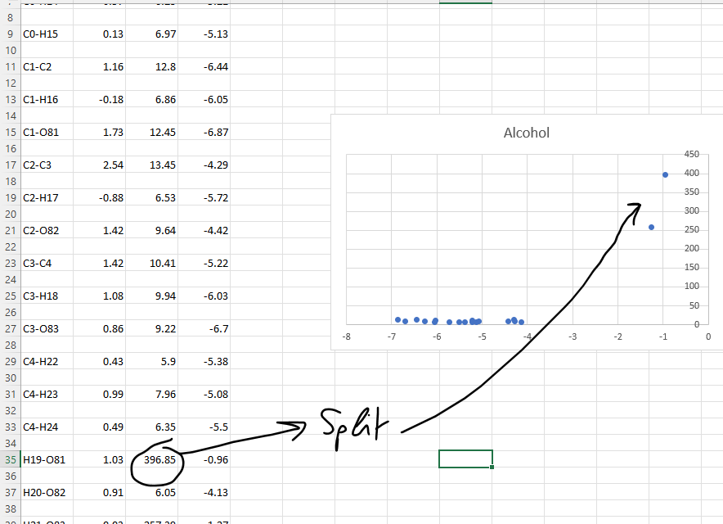

In this simulation, one of the O-H groups reacted, so that is why there is a high MaxRBC.

To look at the interactions of the unreacted bonds, change the axis limits:

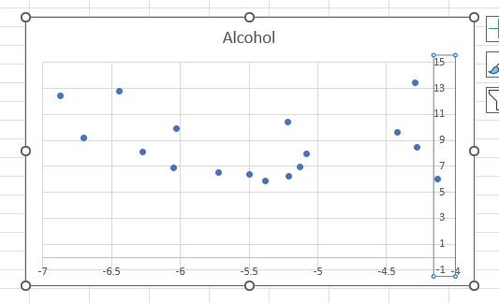

And you have the RBC graph, which you can use to compare between different molecules.

After the output.csv file is created, automatically a new window will pop up:

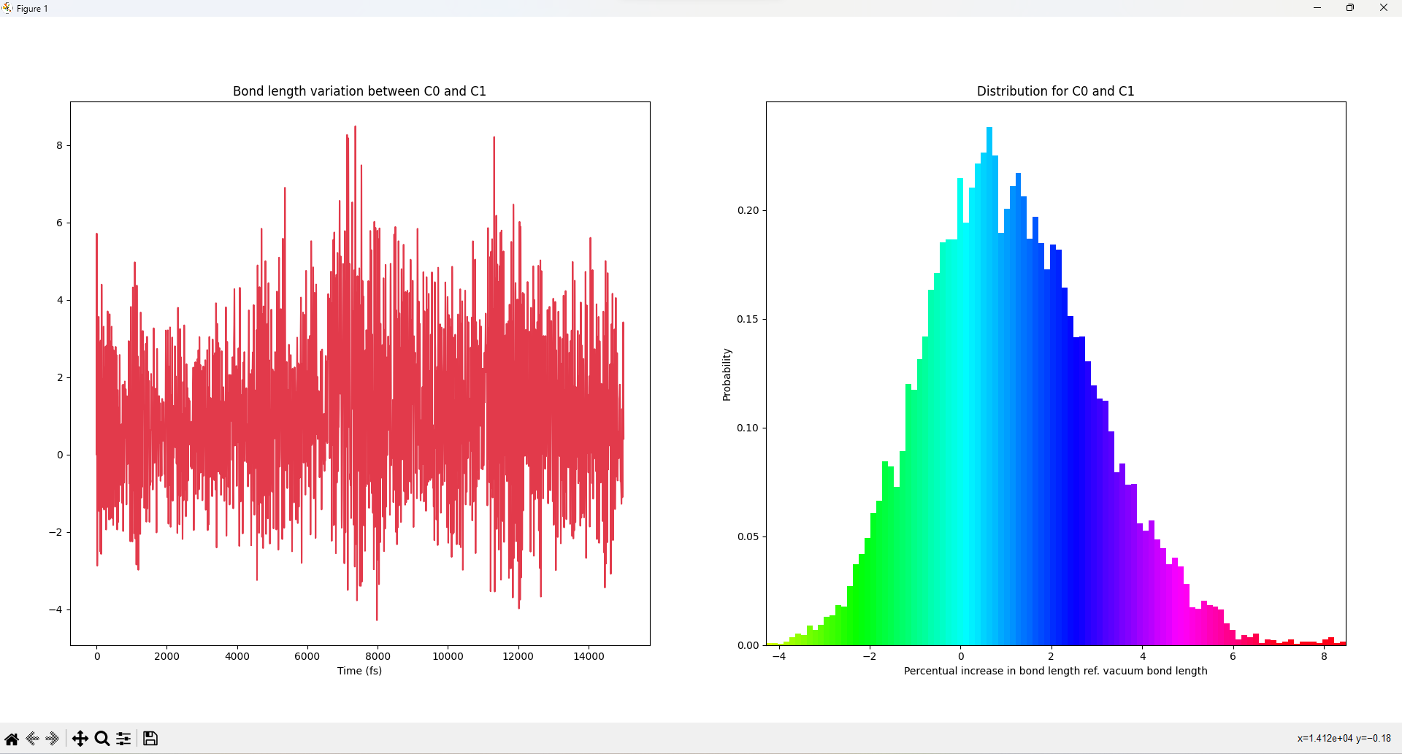

It shows the bond length change on the left, and the corresponding RBC distribution on the right from which the statistics are calculated. This is out of information.

Finished 😊