1
https://www.pexels.com/photo/leafless-trees-on-the-field-11546830/
Maximilian Ruther
Haines Junction, YT, Canada
Leafless Trees on the Field
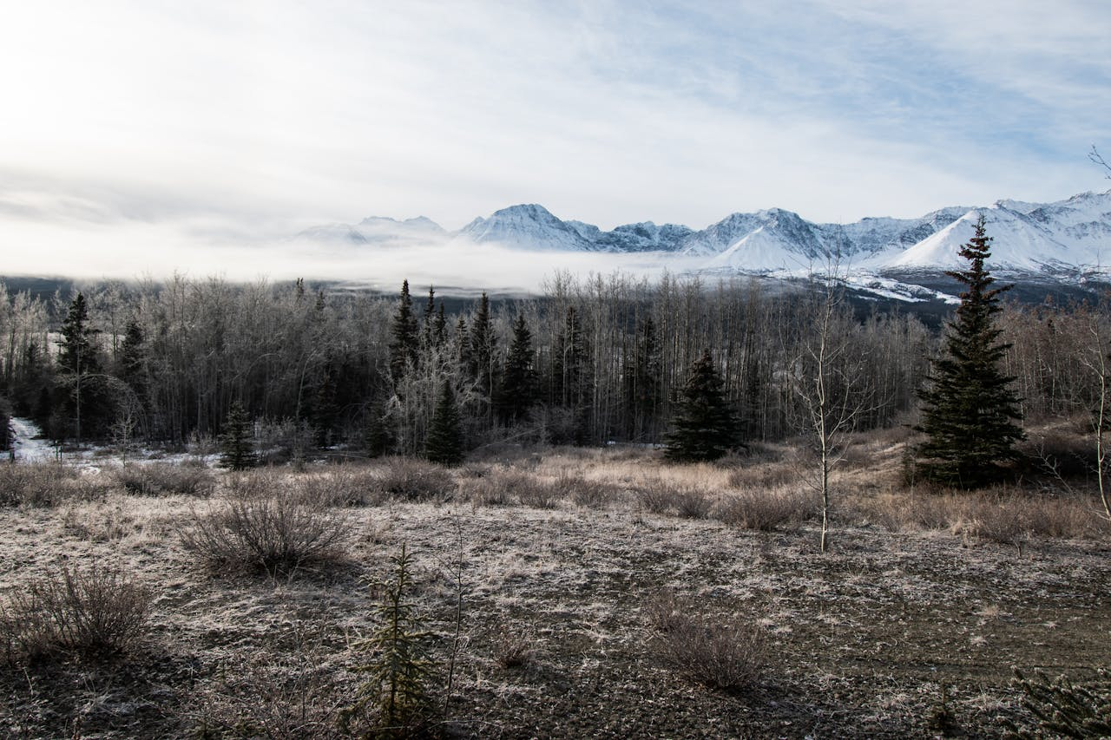

2
https://www.pexels.com/photo/hiker-is-sitting-on-rock-and-looking-at-mountains-18870116/
Ali Kazal
Field, BC, Canada
Hiker is Sitting on Rock and Looking at Mountains
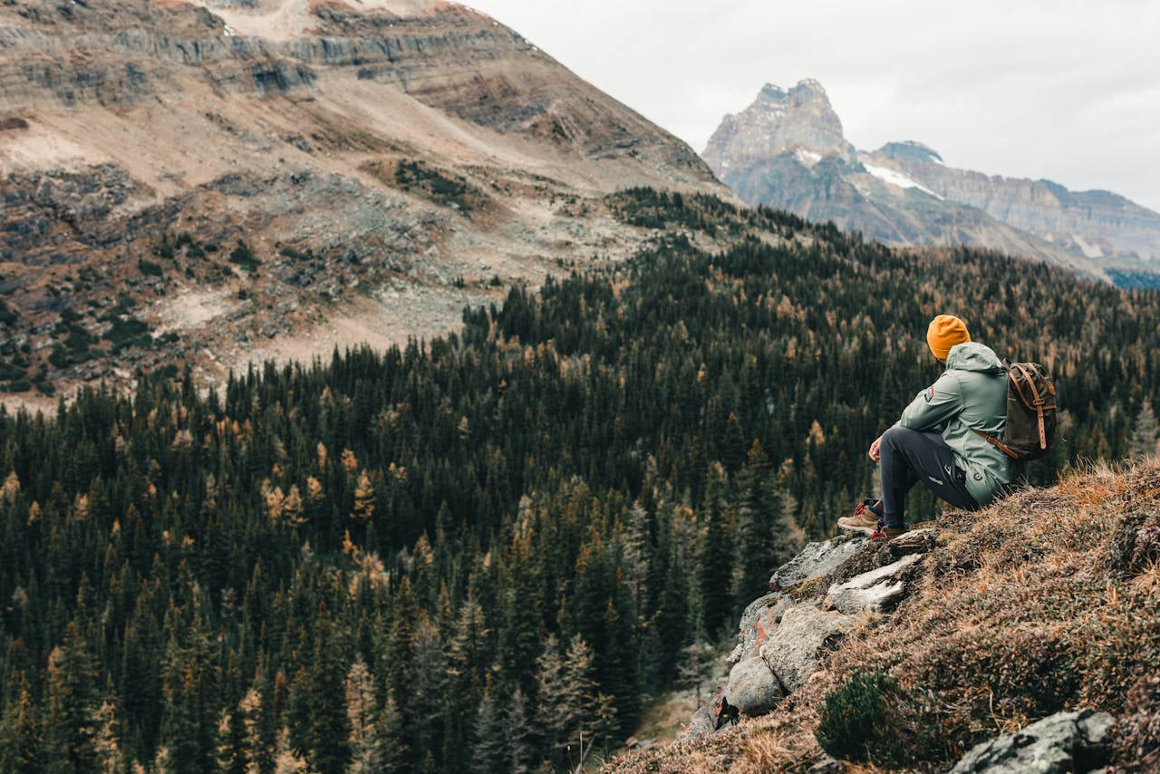

3
https://www.pexels.com/photo/body-of-water-near-mountain-11546831/
Maximilian Ruther
YT, Canada
Body of Water Near Mountain
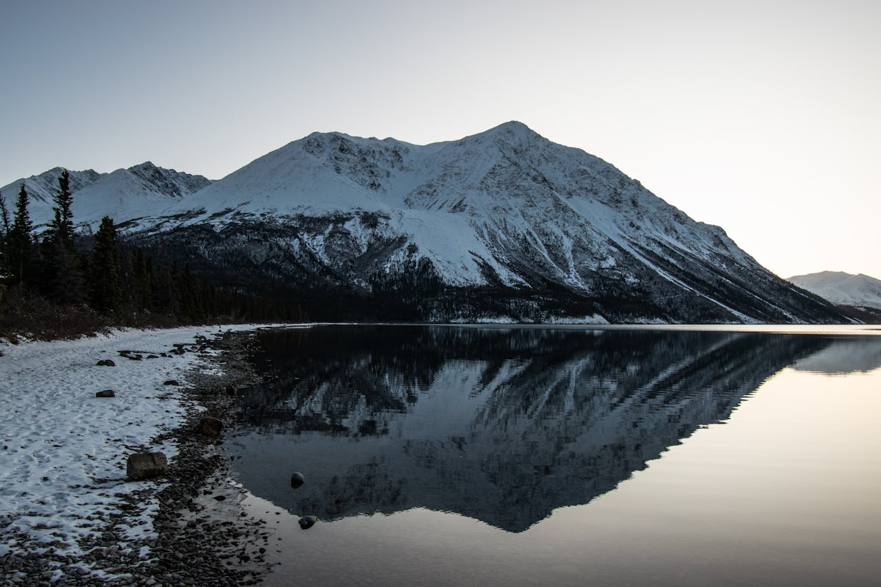

4
https://www.pexels.com/photo/snow-covered-mountains-during-dusk-11589282/
Maximilian Ruther
North Vancouver, BC, Canada
Snow Covered Mountains during Dusk
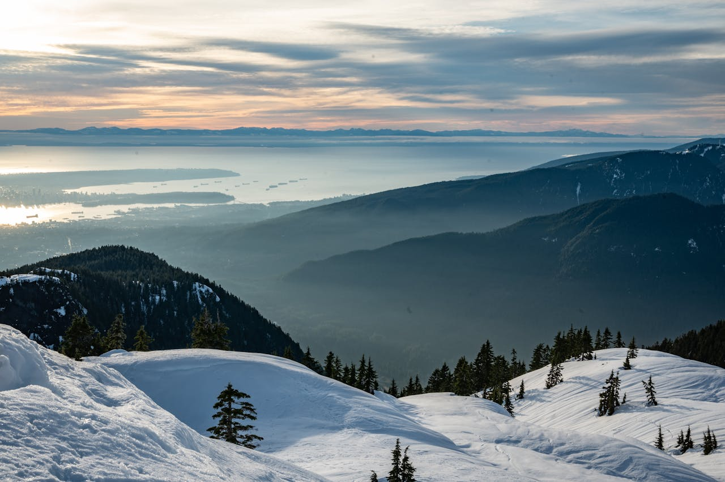

5
https://www.pexels.com/photo/drone-photography-of-valley-under-cloudy-sky-11589849/
Maximilian Ruther
Unknown
Drone Photography of Valley under Cloudy Sky
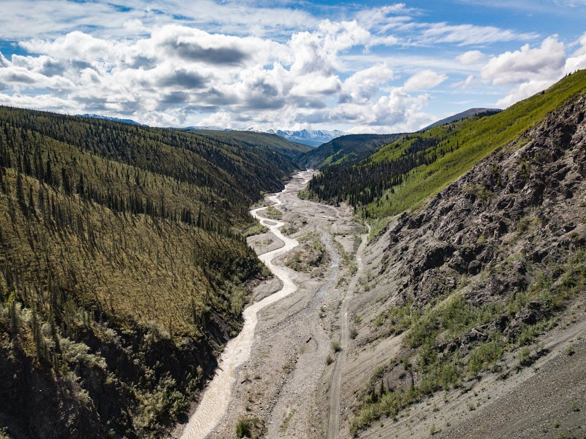

6
https://www.pexels.com/photo/snow-covered-mountains-near-a-lake-11589899/
Maximilian Ruther
YT, Canada
Snow Covered Mountains Near a Lake
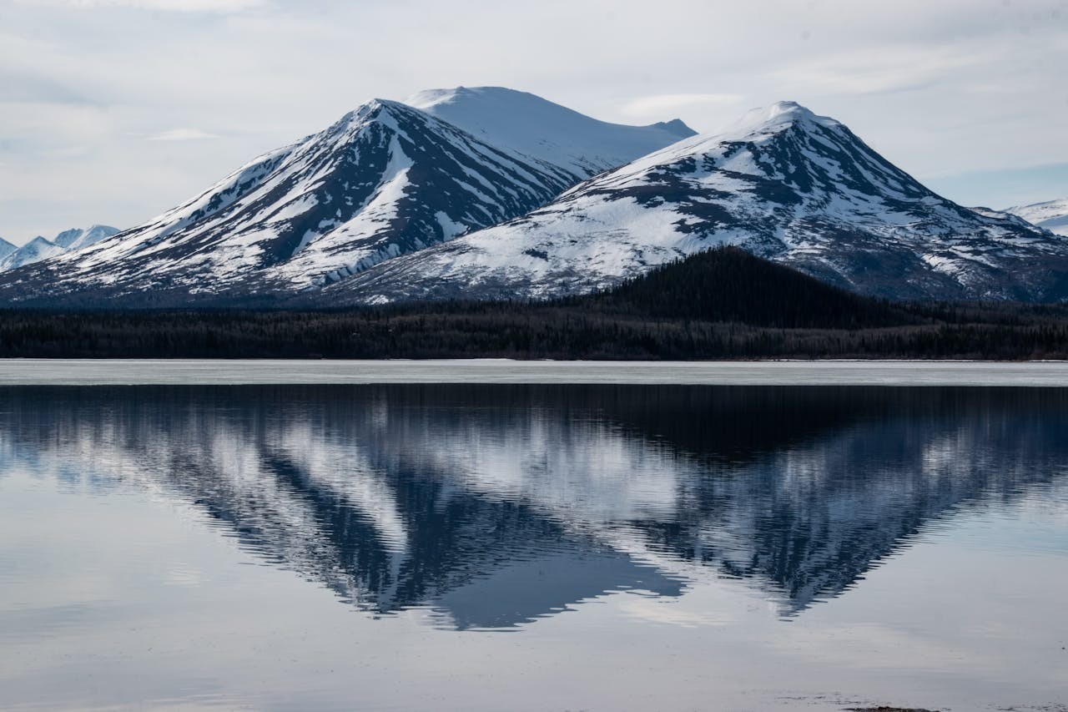

7
https://www.pexels.com/photo/low-angle-shot-of-snow-covered-mountains-near-calm-lake-12694900/
JP
Field, BC, Canada
Low-Angle Shot of Snow-Covered Mountains near Calm Lake
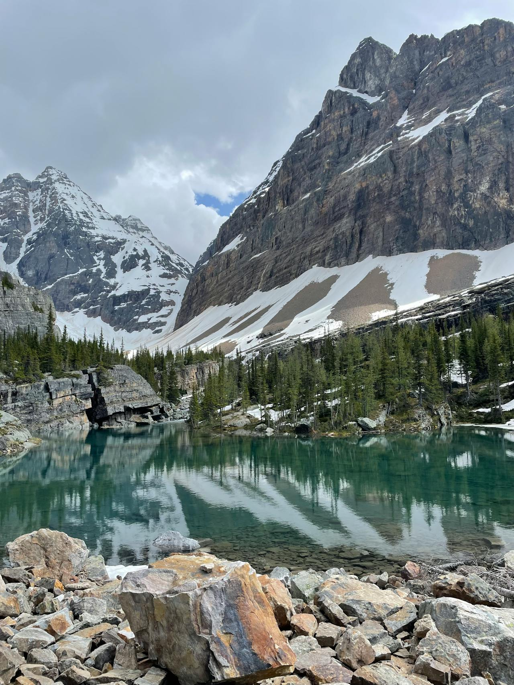
8
https://www.pexels.com/photo/an-aerial-photography-of-a-lake-near-the-mountains-13084256/
JP
Unknown
An Aerial Photography of a Lake Near the Mountains
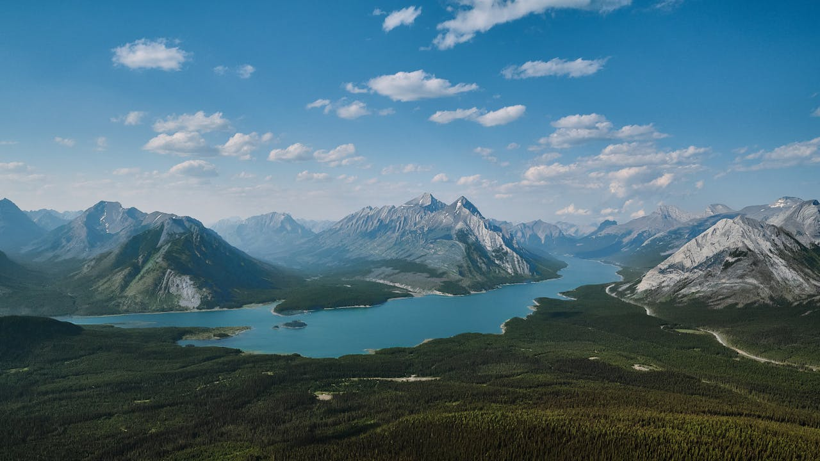

9
https://www.pexels.com/photo/aerial-view-of-snow-covered-mountains-12973191/
JP
Unknown
Aerial View of Snow Covered Mountains
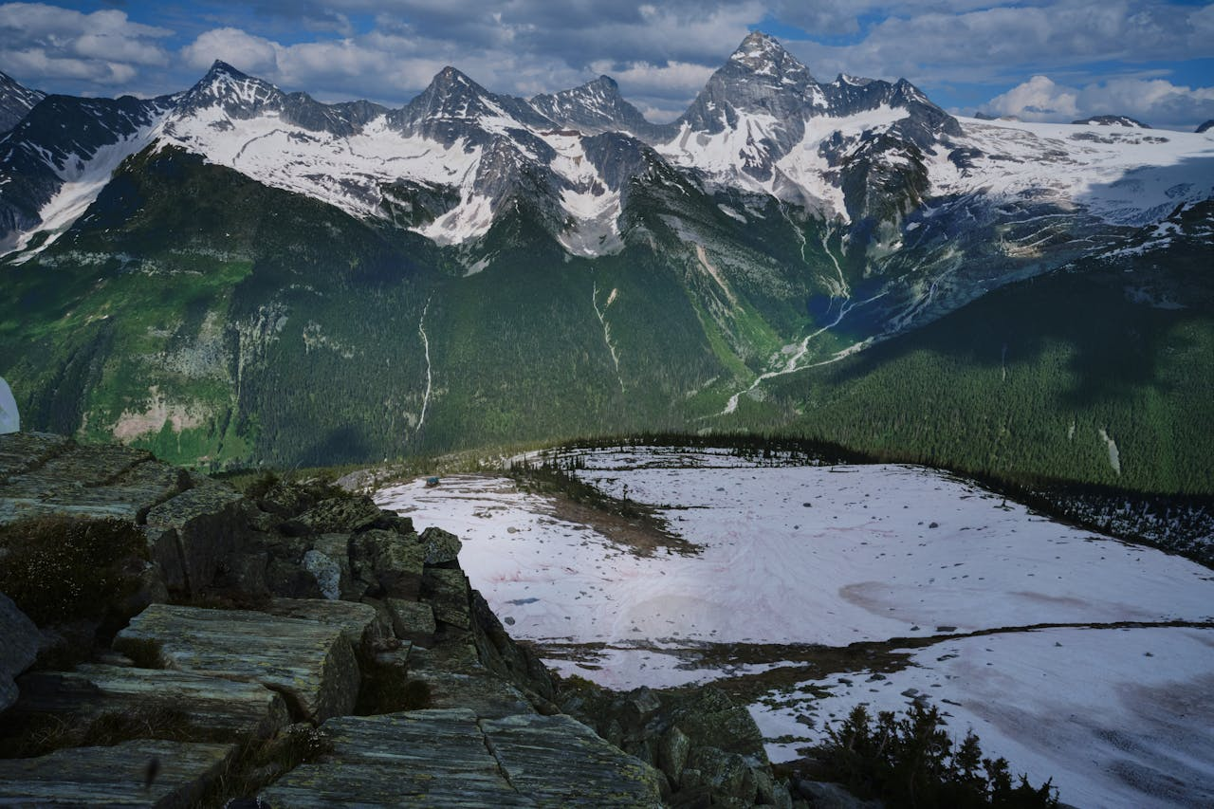

10
https://www.pexels.com/photo/lake-surrounded-by-rock-formations-12699494/
JP
Field, BC, Canada
Lake surrounded by Rock Formations
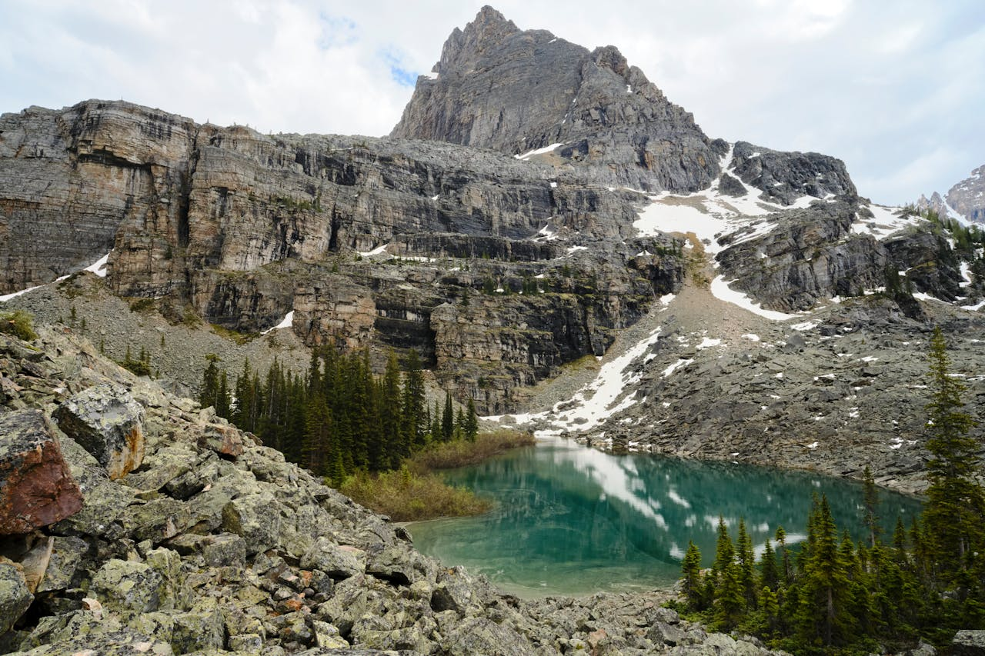

11
https://www.pexels.com/photo/the-milky-way-galaxy-in-the-night-sky-13252134/
JP
Unknown
The Milky Way Galaxy in the Night Sky
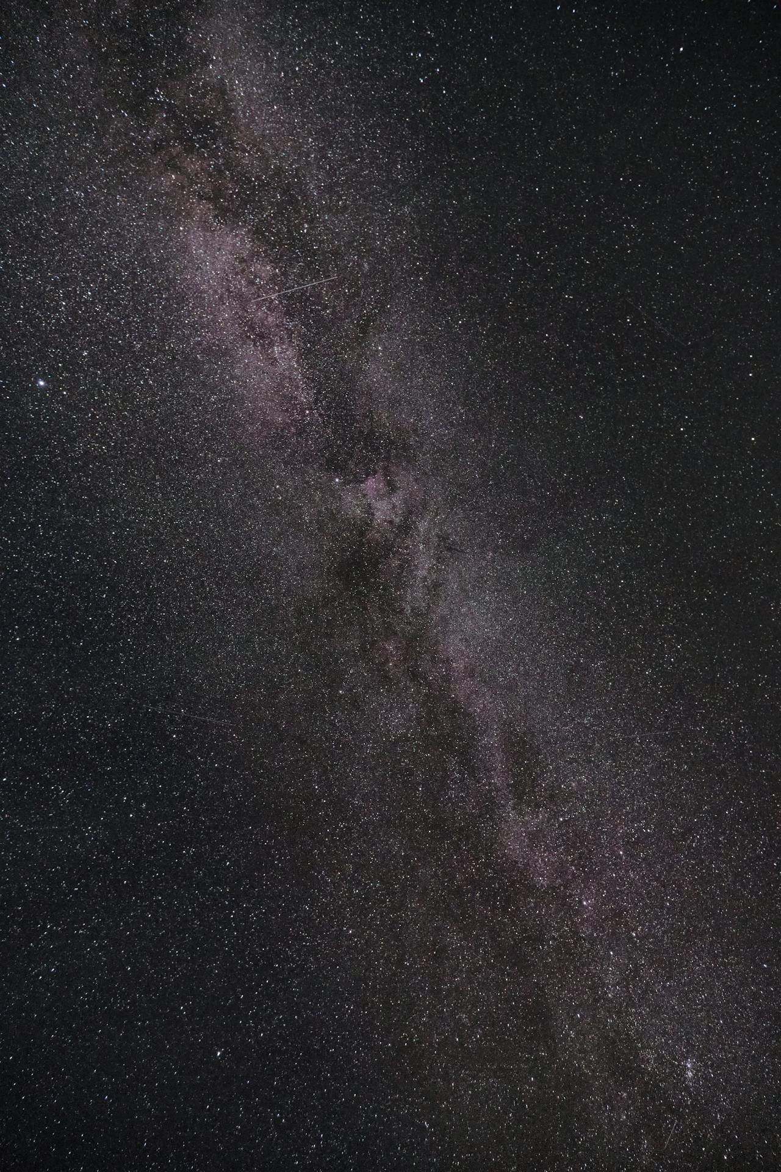
12
https://www.pexels.com/photo/silhouette-of-trees-under-the-starry-night-14457005/
JP
Unknown
Silhouette of Trees Under the Starry Night
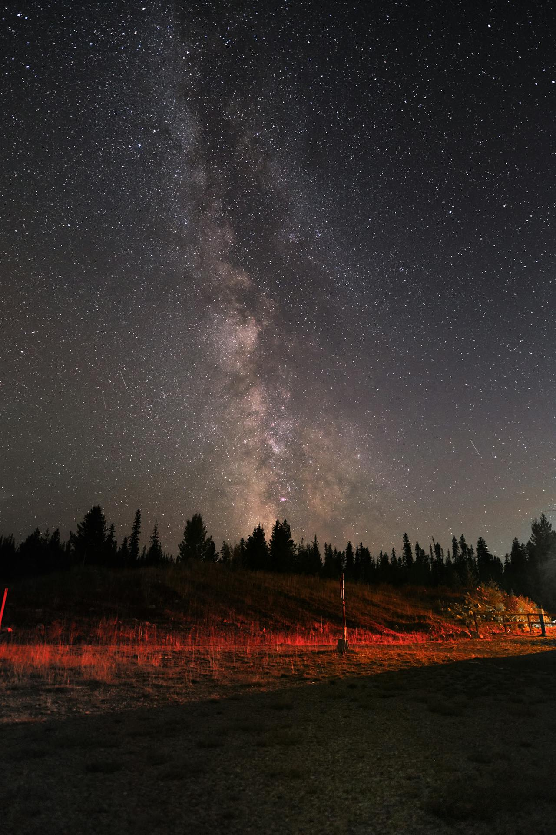
13
https://www.pexels.com/photo/a-lake-in-the-middle-of-mountains-11425176/
Arnab Chaudhuri
Haines Junction, YT, Canada
A Lake in the Middle of Mountains
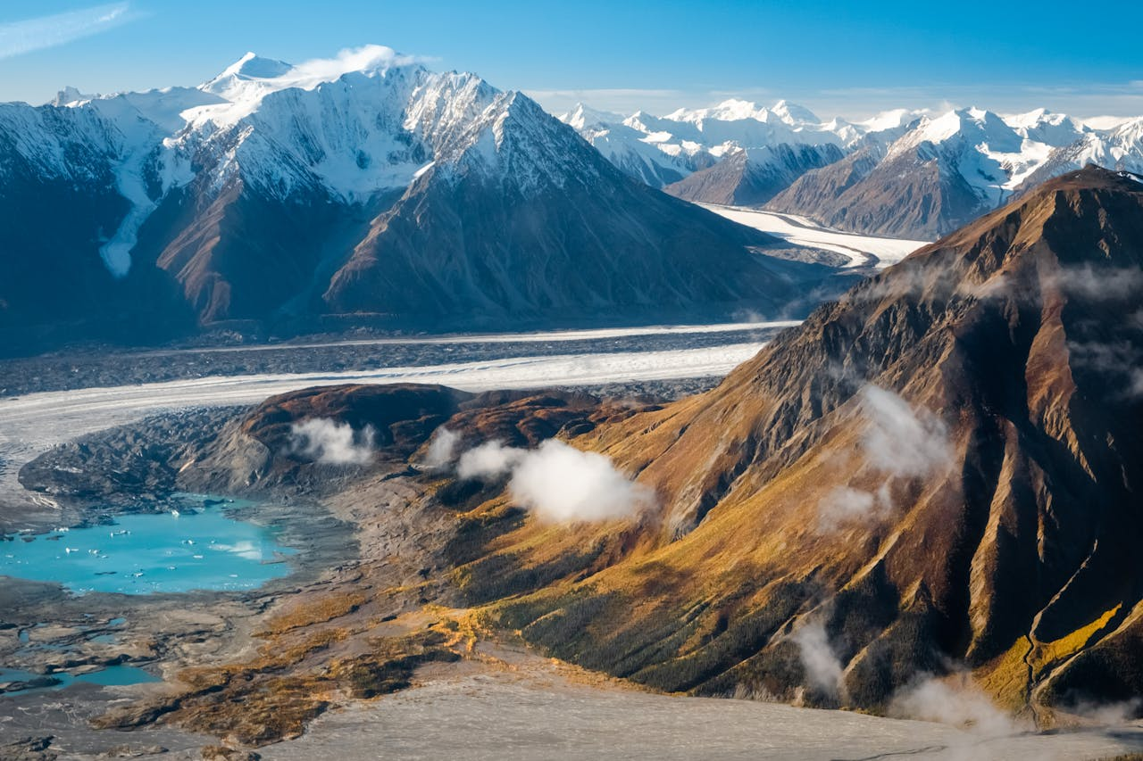

14
https://www.pexels.com/photo/a-brown-mountain-covered-with-snow-under-blue-skies-11425174/
Arnab Chaudhuri
Haines Junction, YT, Canada
A Brown Mountain Covered with Snow Under Blue Skies
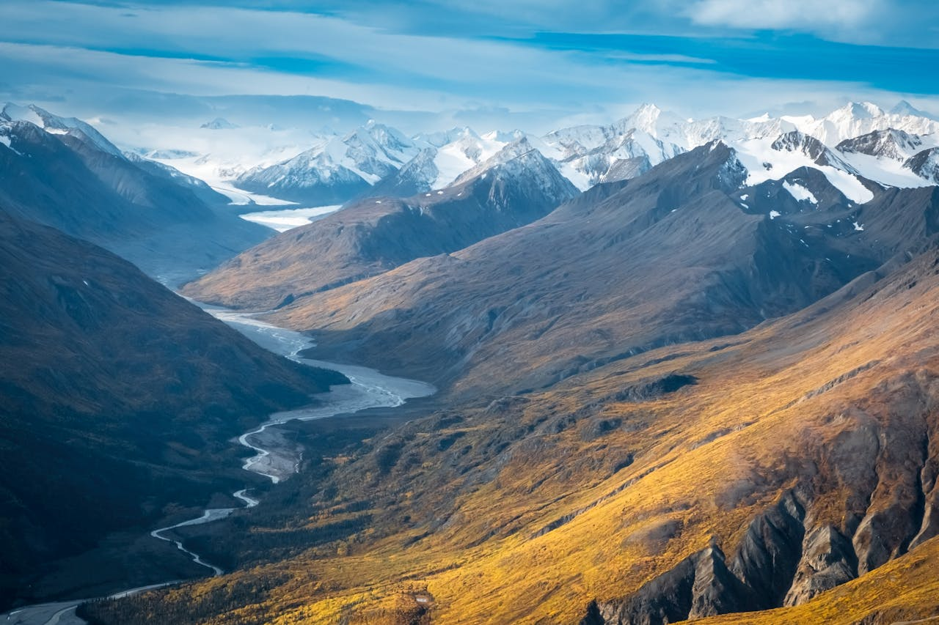

15
https://www.pexels.com/photo/time-lapse-photo-of-northern-lights-1933316/
stein egil liland
Lofoten, Norway
Time Lapse Photo of Northern Lights
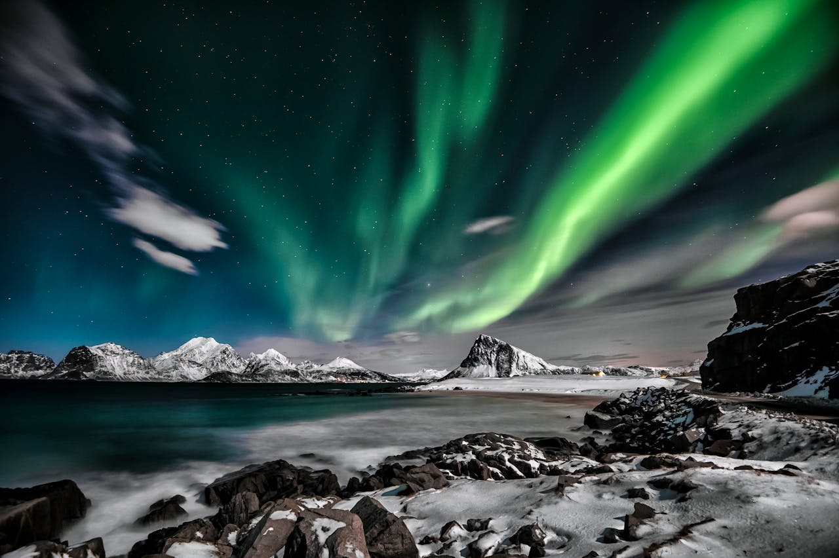

16
https://www.pexels.com/photo/green-aurora-lights-over-snow-covered-mountain-during-night-time-10903696/
stein egil liland
Nordland, Norway
Green Aurora Lights over Snow Covered Mountain during Night Time
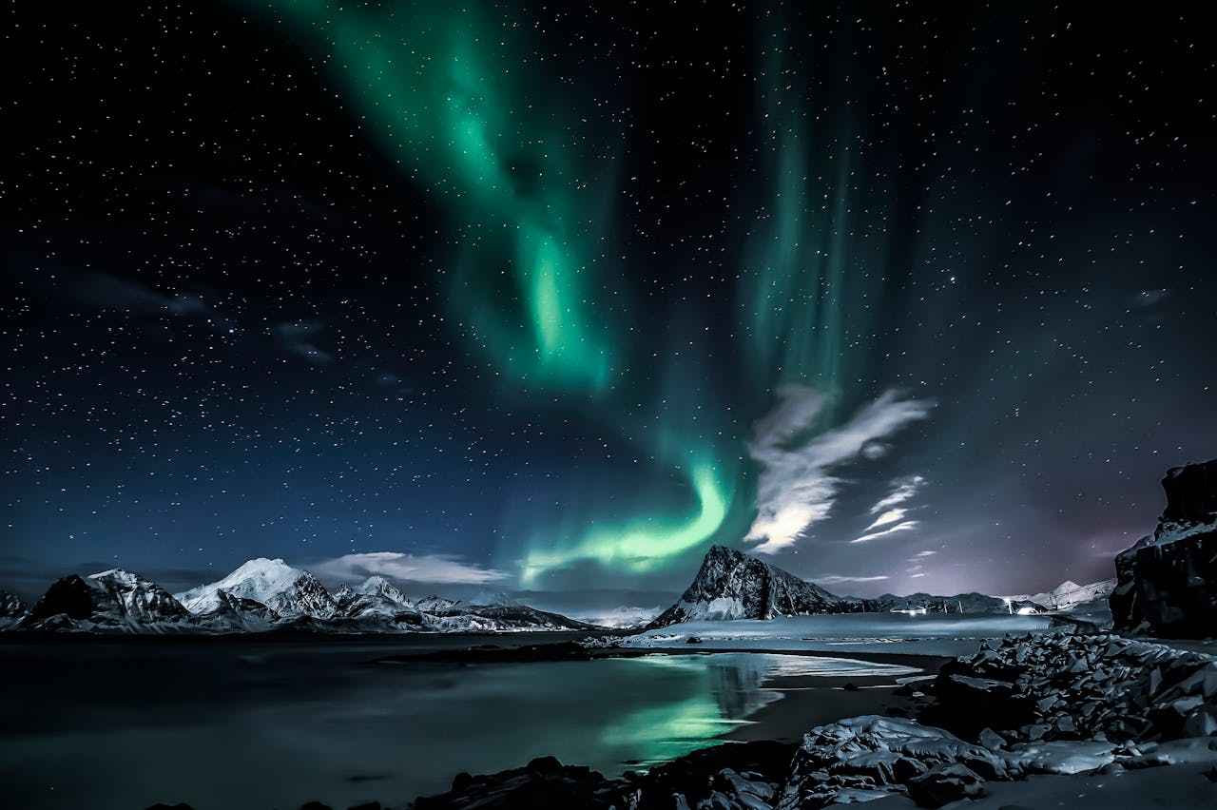

17
https://www.pexels.com/photo/night-view-of-pensi-la-mountain-in-zanskar-valley-in-ladakh-region-17725688/
Vikash Singh
Zanskar, India
night view of Pensi La mountain in zanskar valley in Ladakh region
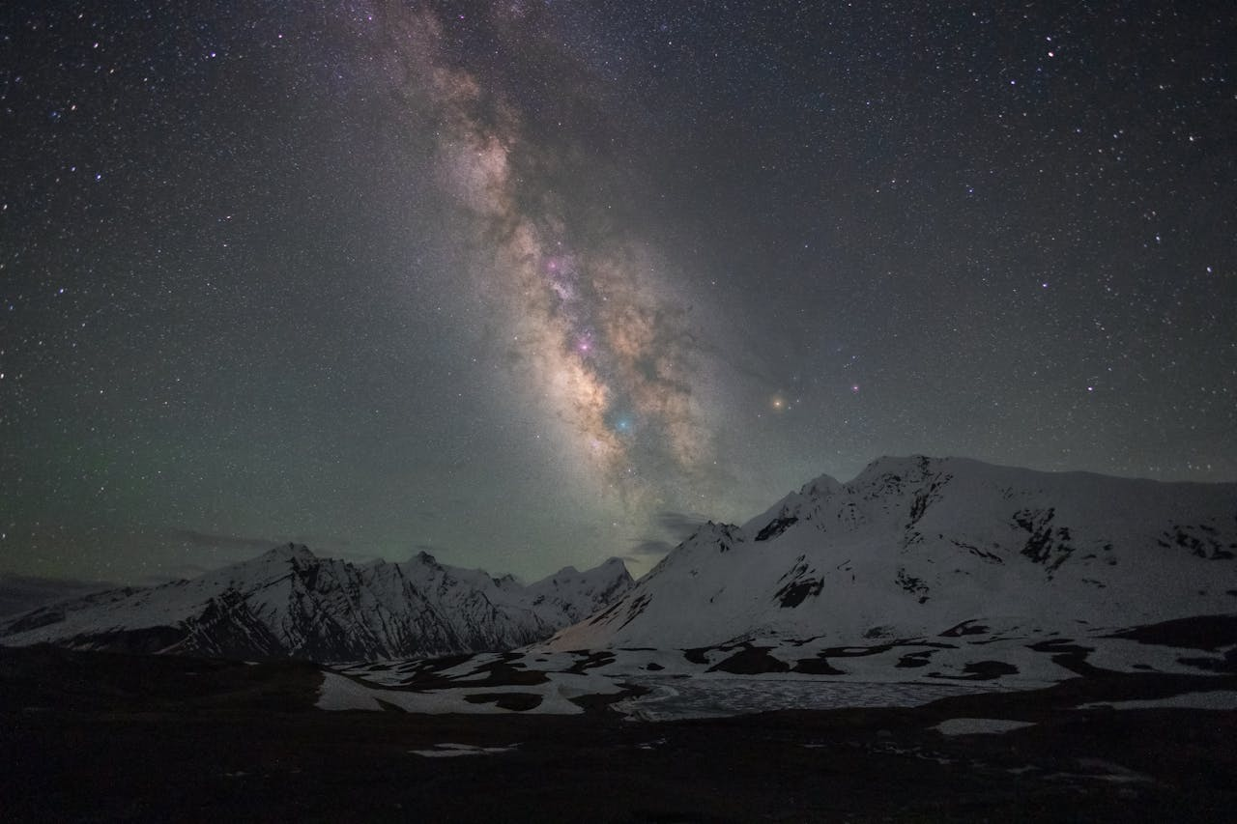

18
https://www.pexels.com/photo/the-milky-way-over-the-campfire-in-death-valley-17863399/
Vikash Singh
Himachal Pradesh, India
The milky way over the campfire in death valley
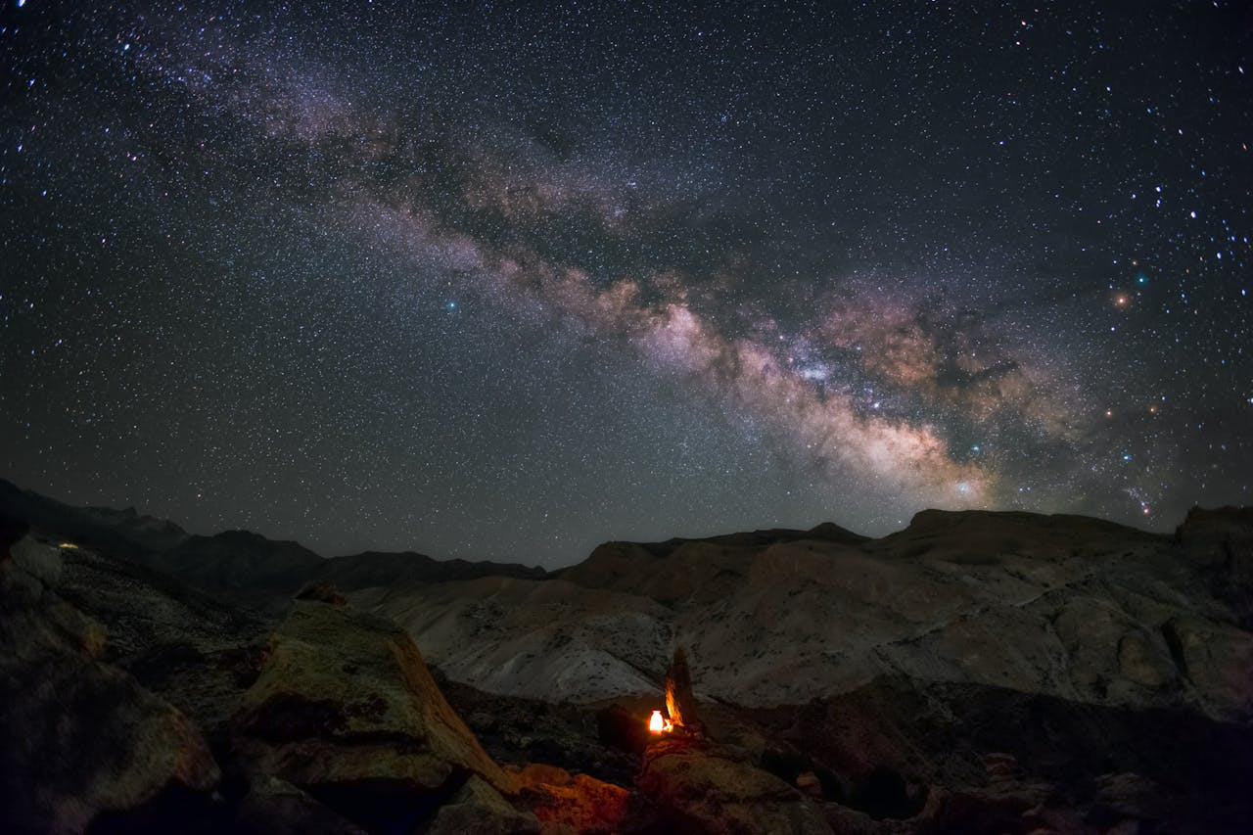

19
https://www.pexels.com/photo/body-of-water-surround-by-mountains-210271/
Pixabay
Canada
Body of Water Surround by Mountains
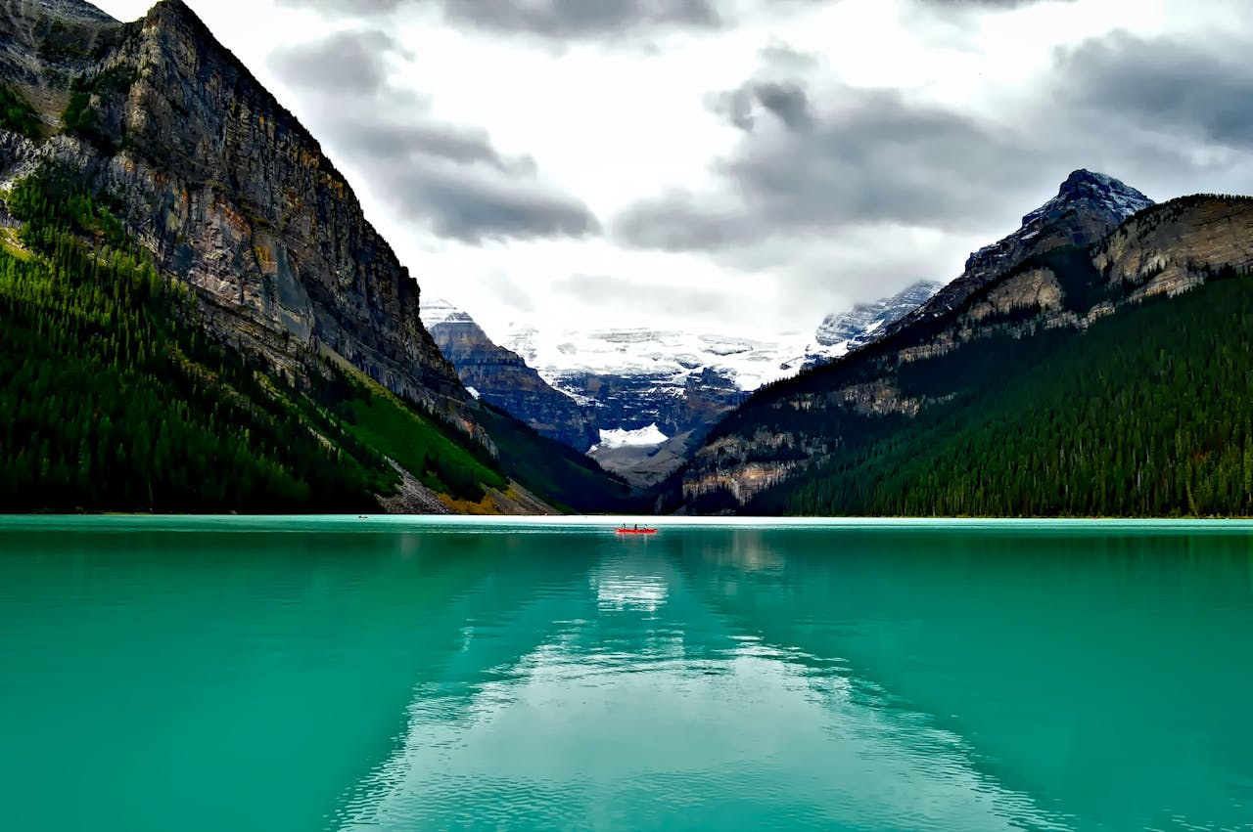

20
https://www.pexels.com/photo/woman-sitting-on-canoe-on-river-near-trees-2827849/
Vincent M.A. Janssen
Banff, AB, Canada
Woman Sitting On Canoe On River Near Trees
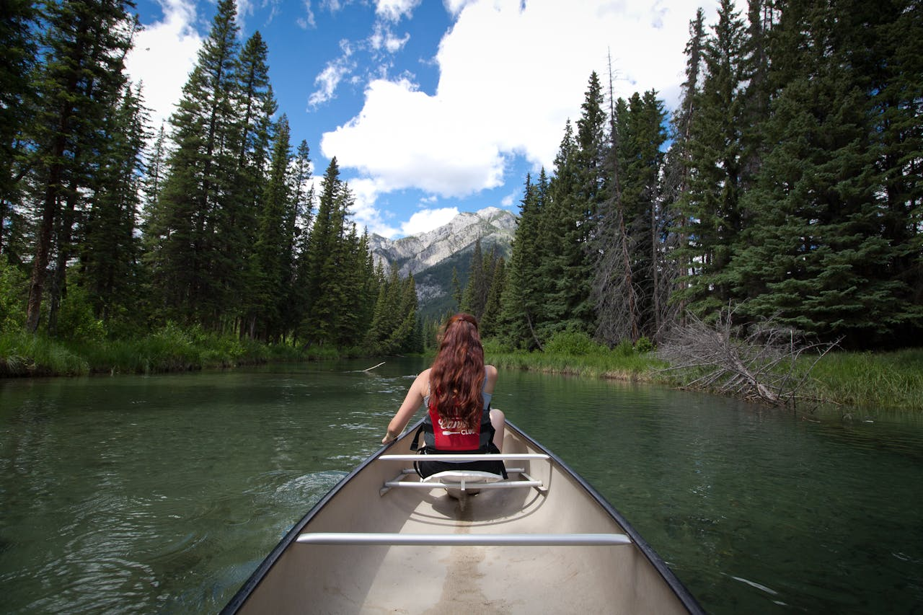

21
https://www.pexels.com/photo/wooden-boat-on-lake-in-mountains-15953852/
Jaime Reimer
Unknown
Wooden Boat on Lake in Mountains
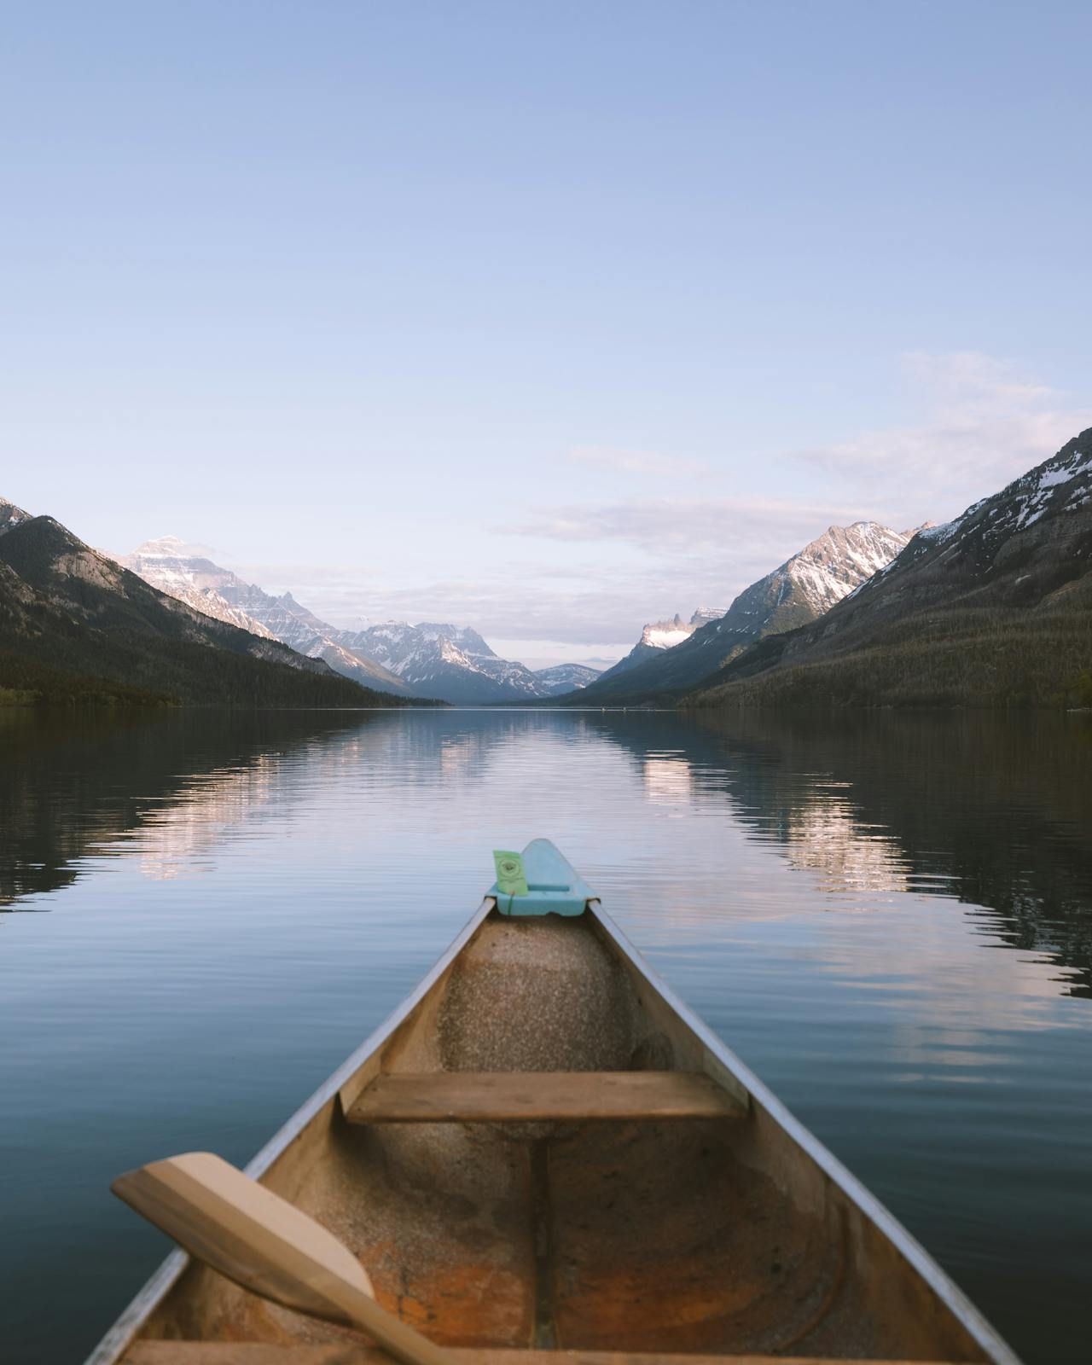

22
https://www.pexels.com/photo/person-riding-on-gray-kayak-2749500/
Jaime Reimer
AB, Canada
Person Riding on Gray Kayak
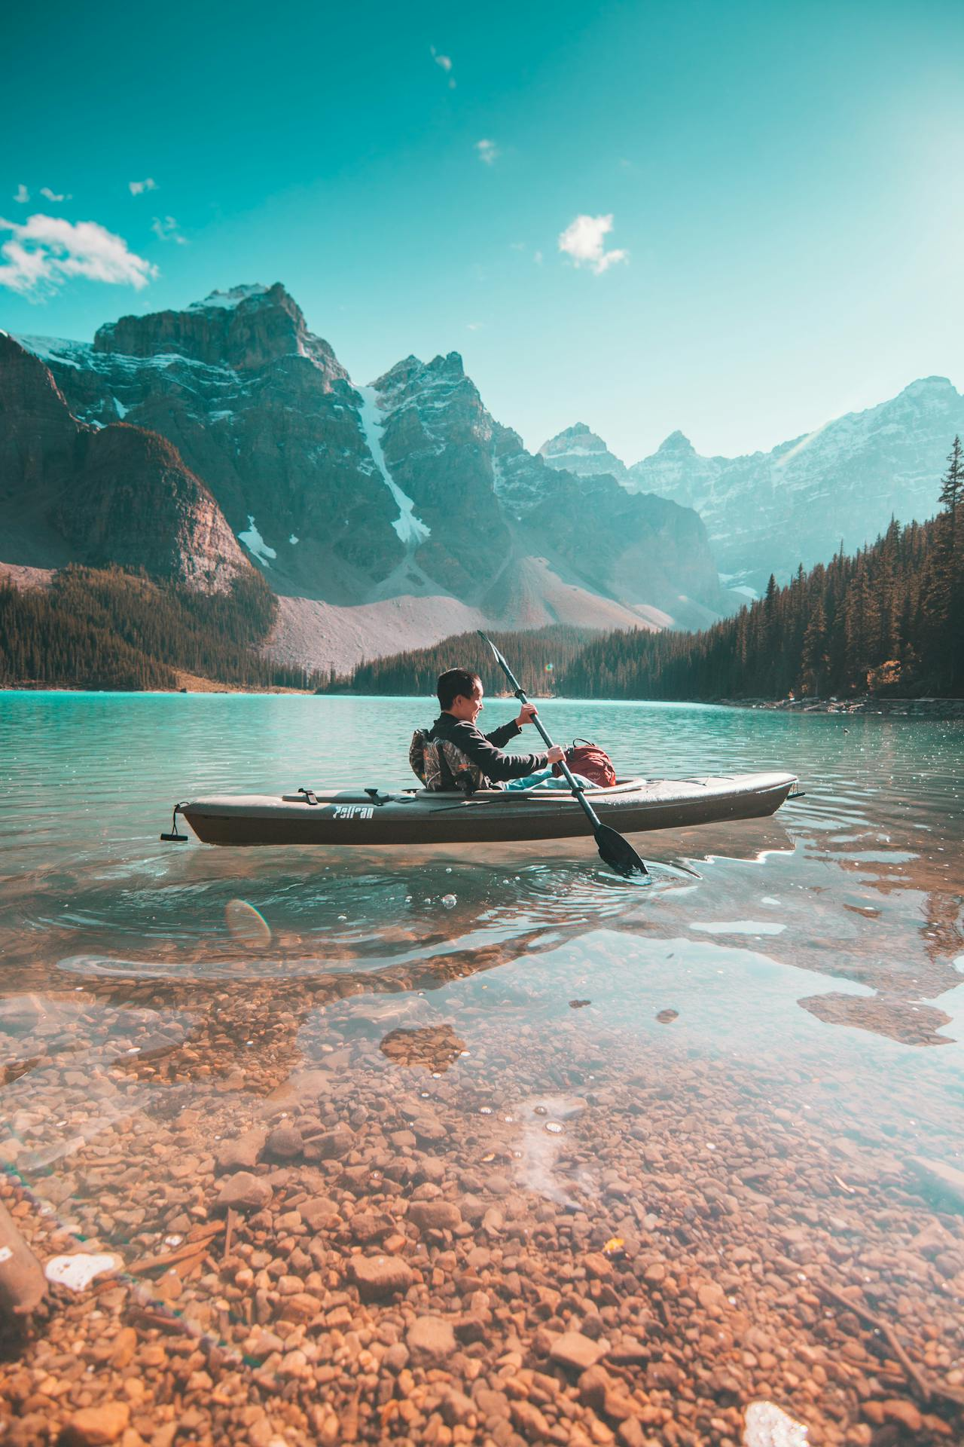
23
https://www.pexels.com/photo/red-boat-in-the-lake-near-mountain-1598072/
James Wheeler
Lake Louise, AB, Canada
Red Boat In The Lake Near Mountain
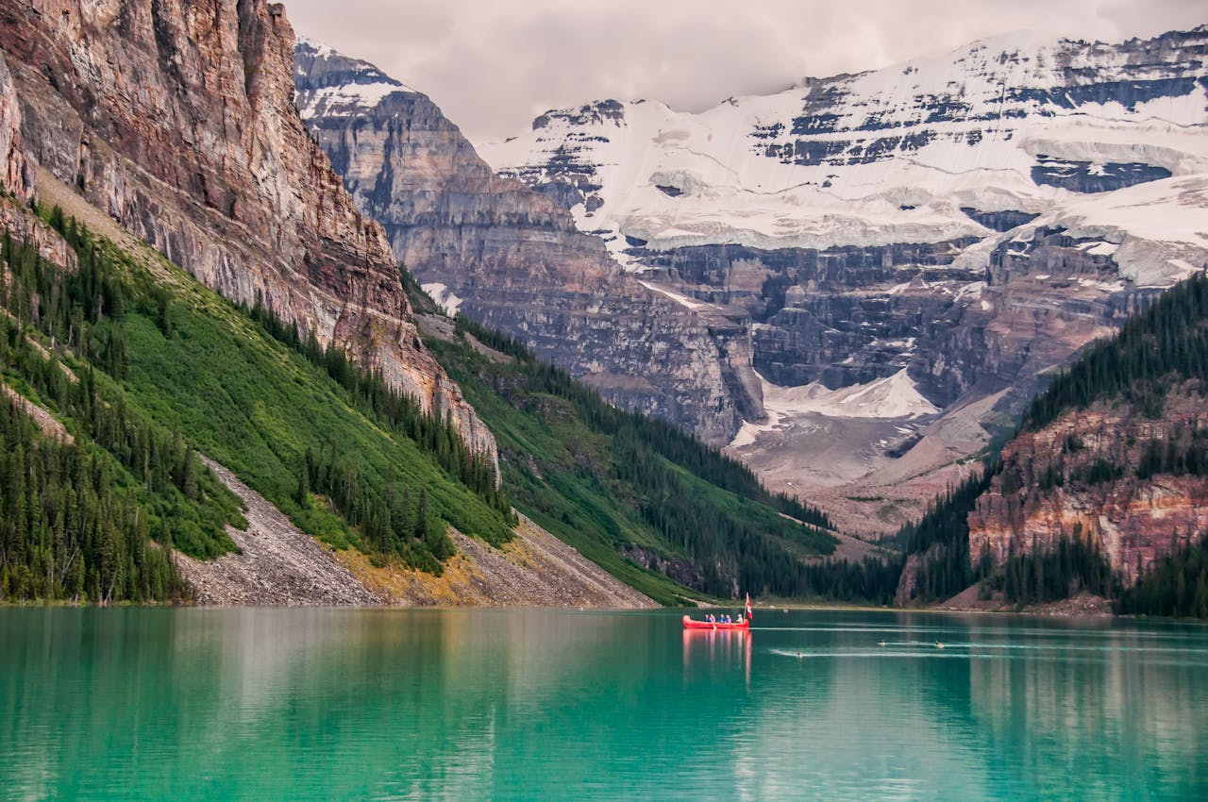

24
https://www.pexels.com/photo/canoes-on-brown-rocky-shore-near-green-trees-and-mountains-3839859/
Nicole Hallden
Banff, AB, Canada
Canoes on Brown Rocky Shore Near Green Trees and Mountains
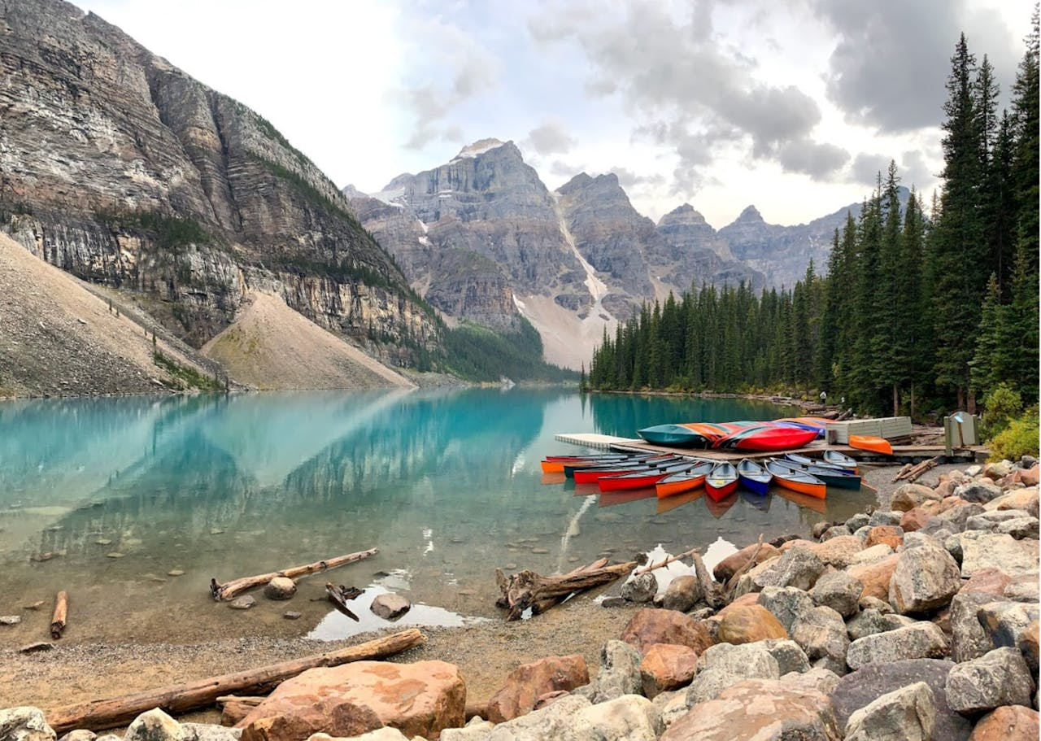

25
https://www.pexels.com/photo/photo-of-river-surrounded-by-trees-1598074/
James Wheeler
Field, BC, Canada
Photo of River Surrounded By Trees
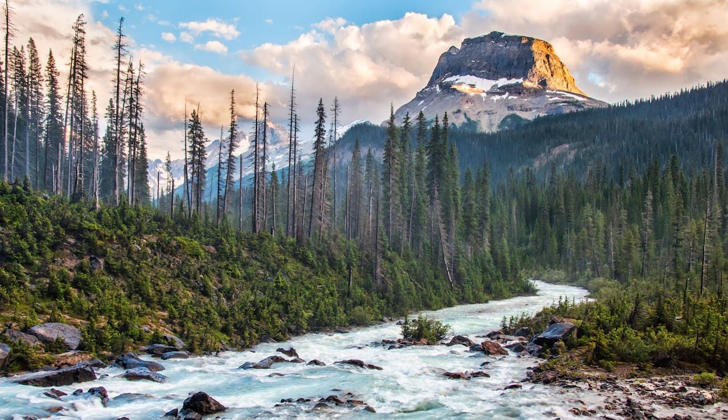

26
https://www.pexels.com/photo/scenic-view-of-night-sky-with-stars-1487009/
James Wheeler
Whistler, BC, Canada
Scenic View Of Night Sky With Stars
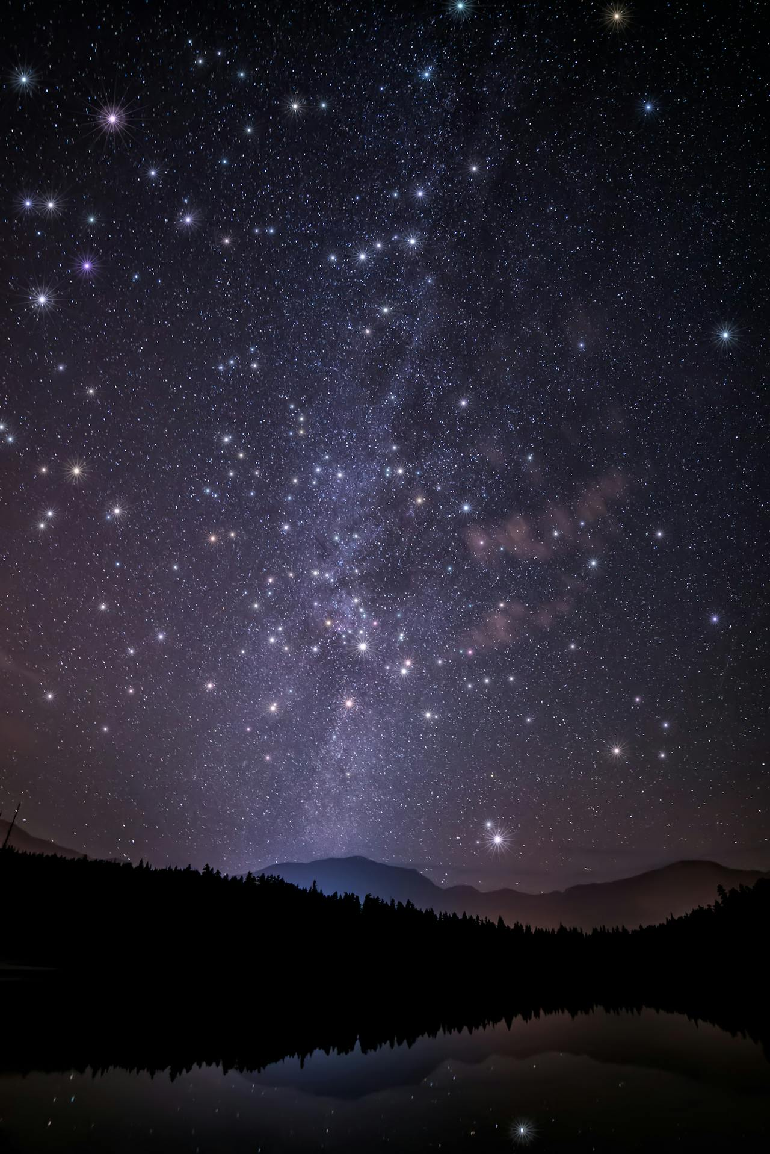
27
https://www.pexels.com/photo/canoeing-on-tranquil-kinaskan-lake-in-canada-30101810/
James Wheeler
Canada
Canoeing on Tranquil Kinaskan Lake in Canada
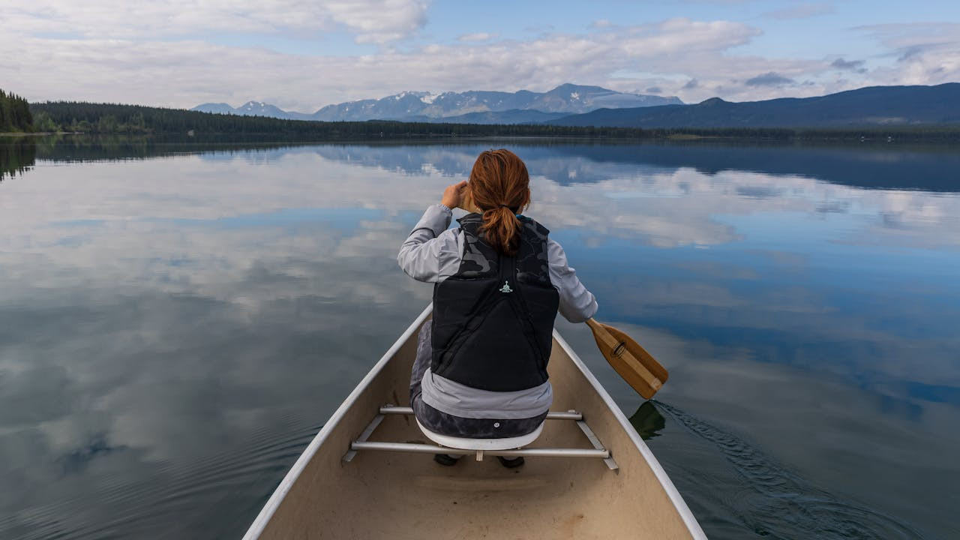

28
https://www.pexels.com/photo/green-trees-near-lake-under-cloudy-sky-5895920/
James Wheeler
Powell River, BC, Canada
Green Trees Near Lake Under Cloudy Sky
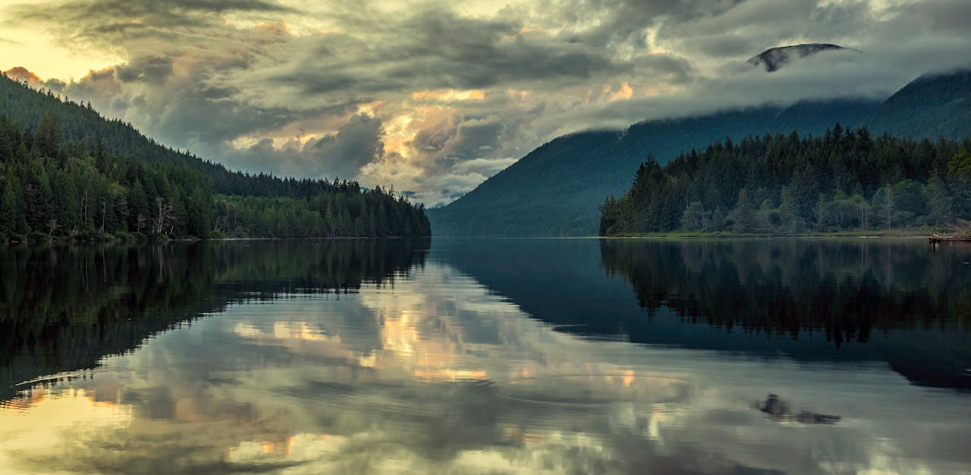

29
https://www.pexels.com/photo/river-in-the-forest-leading-to-a-waterfall-5833888/
James Wheeler
AB, Canada
River in the Forest Leading to a Waterfall
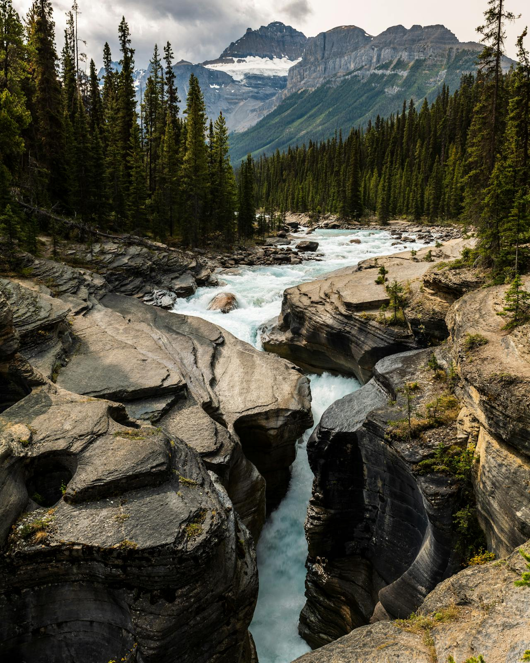

30
https://www.pexels.com/photo/green-pine-trees-near-lake-under-white-clouds-and-blue-sky-5833887/
James Wheeler
AB, Canada
Green Pine Trees Near Lake Under White Clouds and Blue Sky
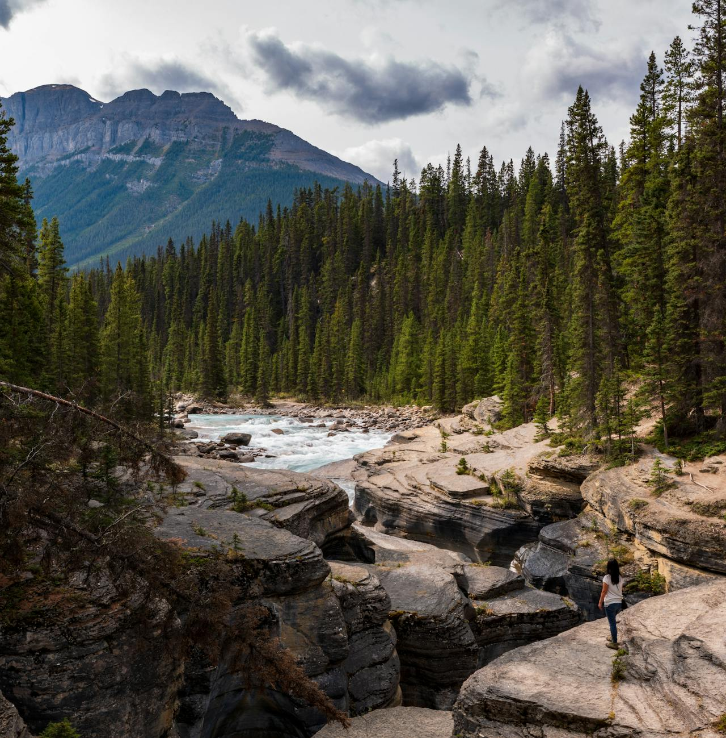

31
https://www.pexels.com/photo/rocky-mountain-near-the-lake-11903613/
Nicole Hallden
BC, Canada
Rocky Mountain Near the Lake
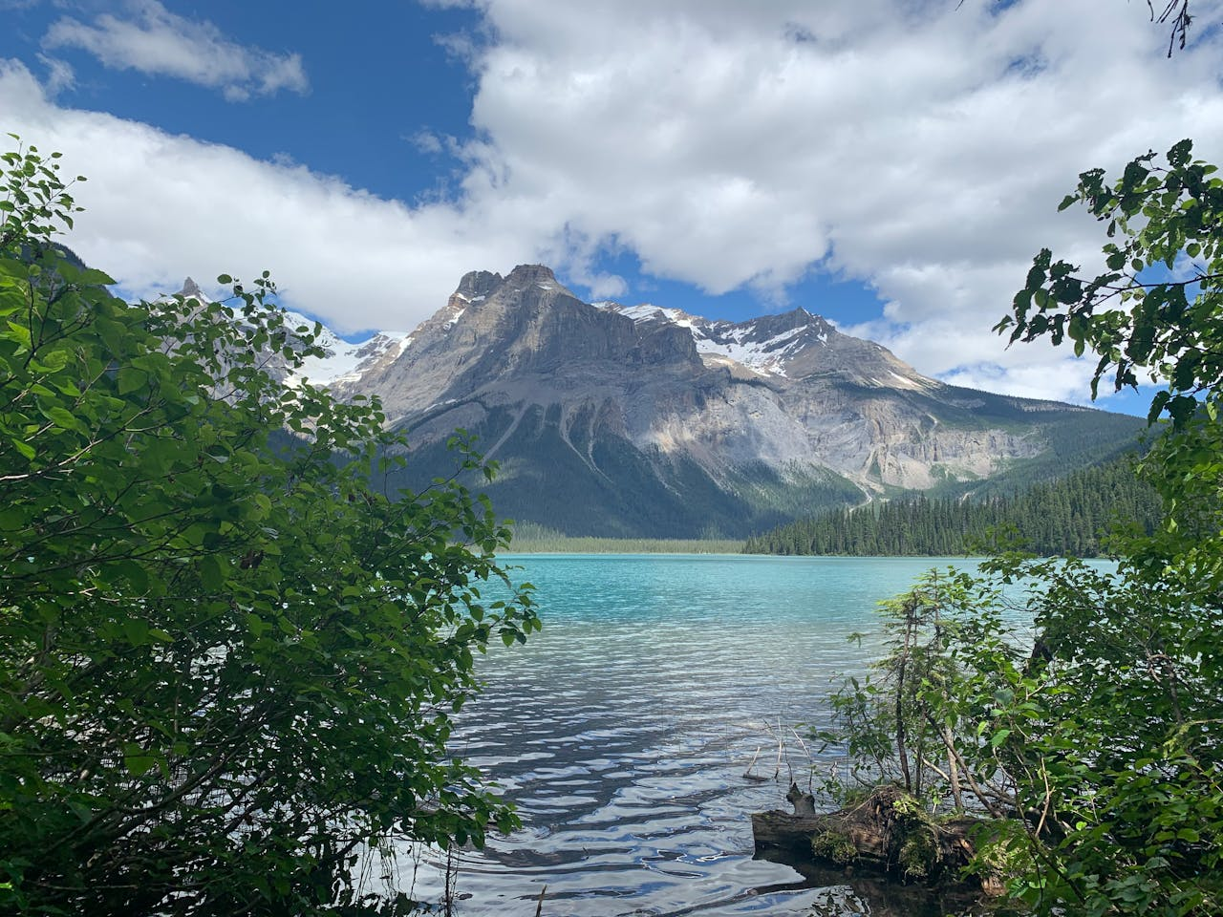

32
https://www.pexels.com/photo/paradise-trail-11903611/
Nicole Hallden
Lake Louise, AB, Canada
Paradise trail
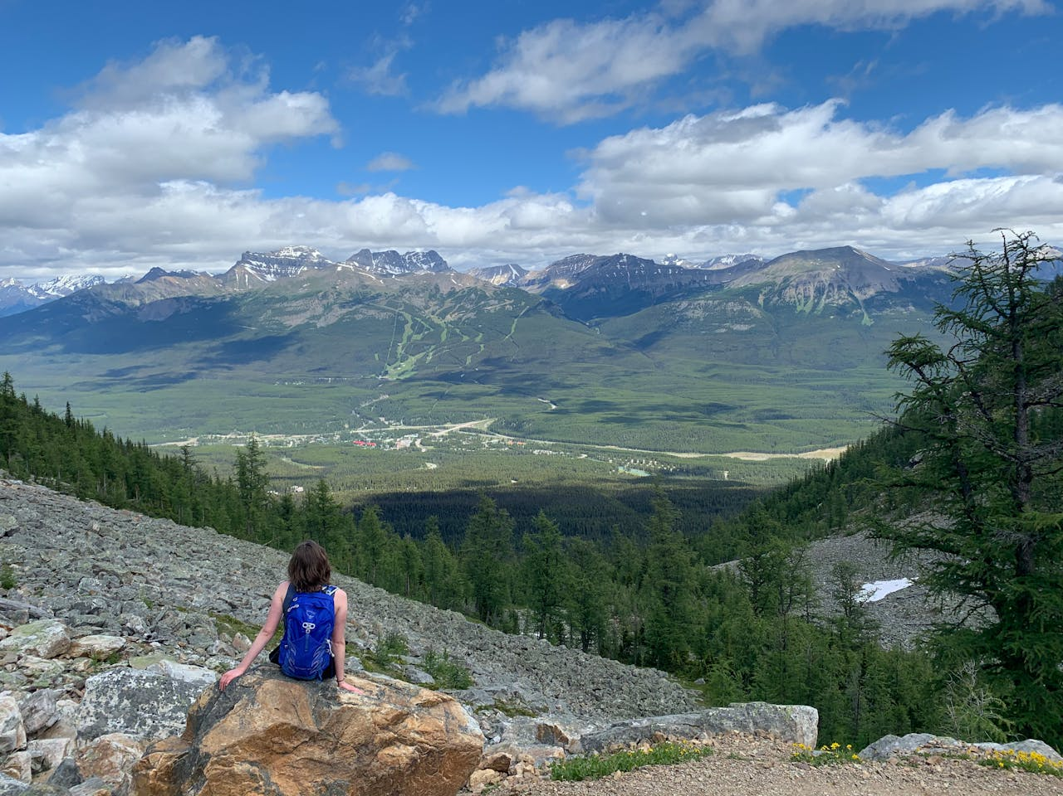

33
https://www.pexels.com/photo/trees-under-starry-night-1516046/
James Wheeler
Thompson-Nicola, BC, Canada
Trees Under Starry Night
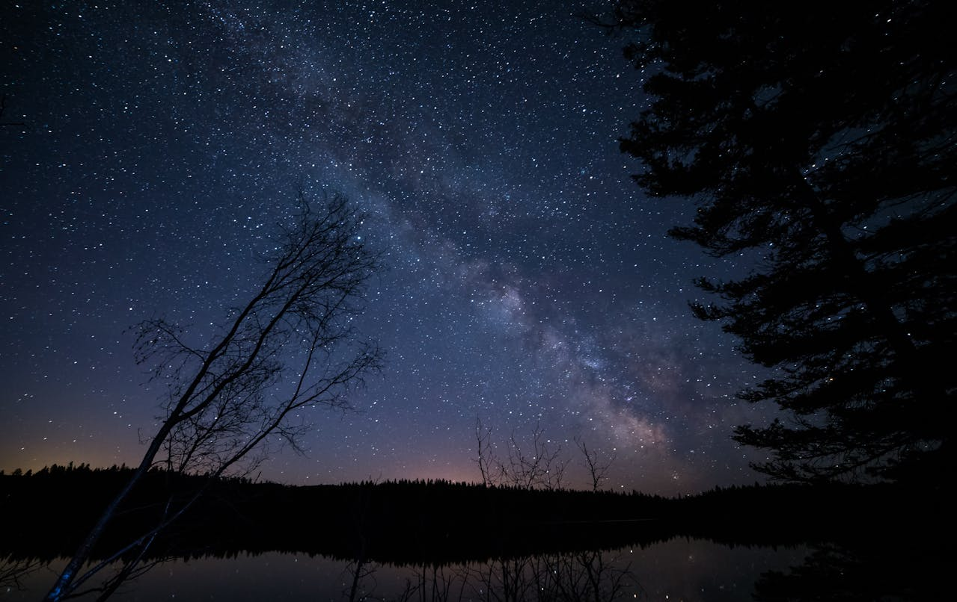

34
https://www.pexels.com/photo/two-mountaineers-in-mountain-914128/
Saikat Ghosh
Unknown
Two Mountaineers in Mountain
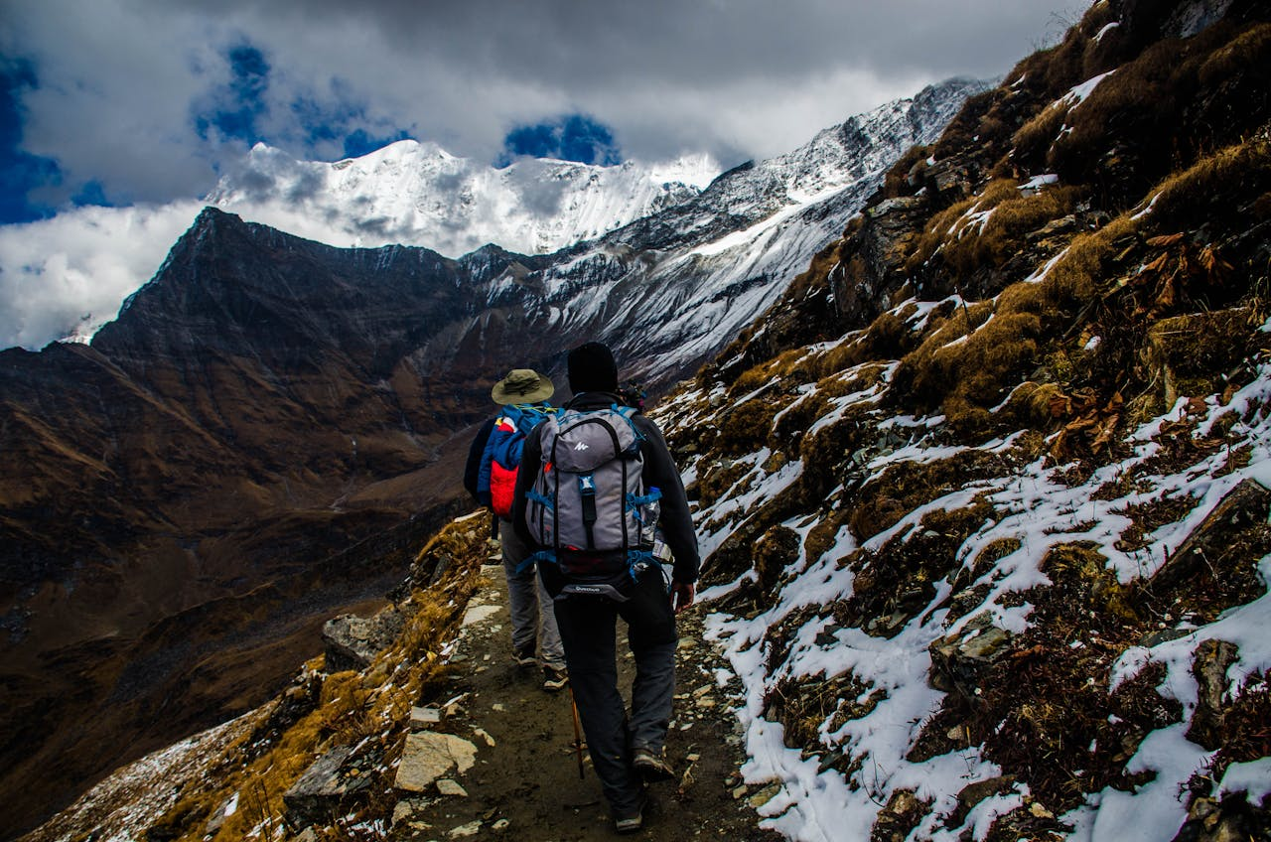

35
https://www.pexels.com/photo/man-lying-next-to-a-bonfire-and-a-tent-in-hills-under-a-starry-sky-13350961/
Dajana Reçi
Theth, Shkodër County, Albania
Man Lying Next to a Bonfire and a Tent in Hills Under a Starry Sky
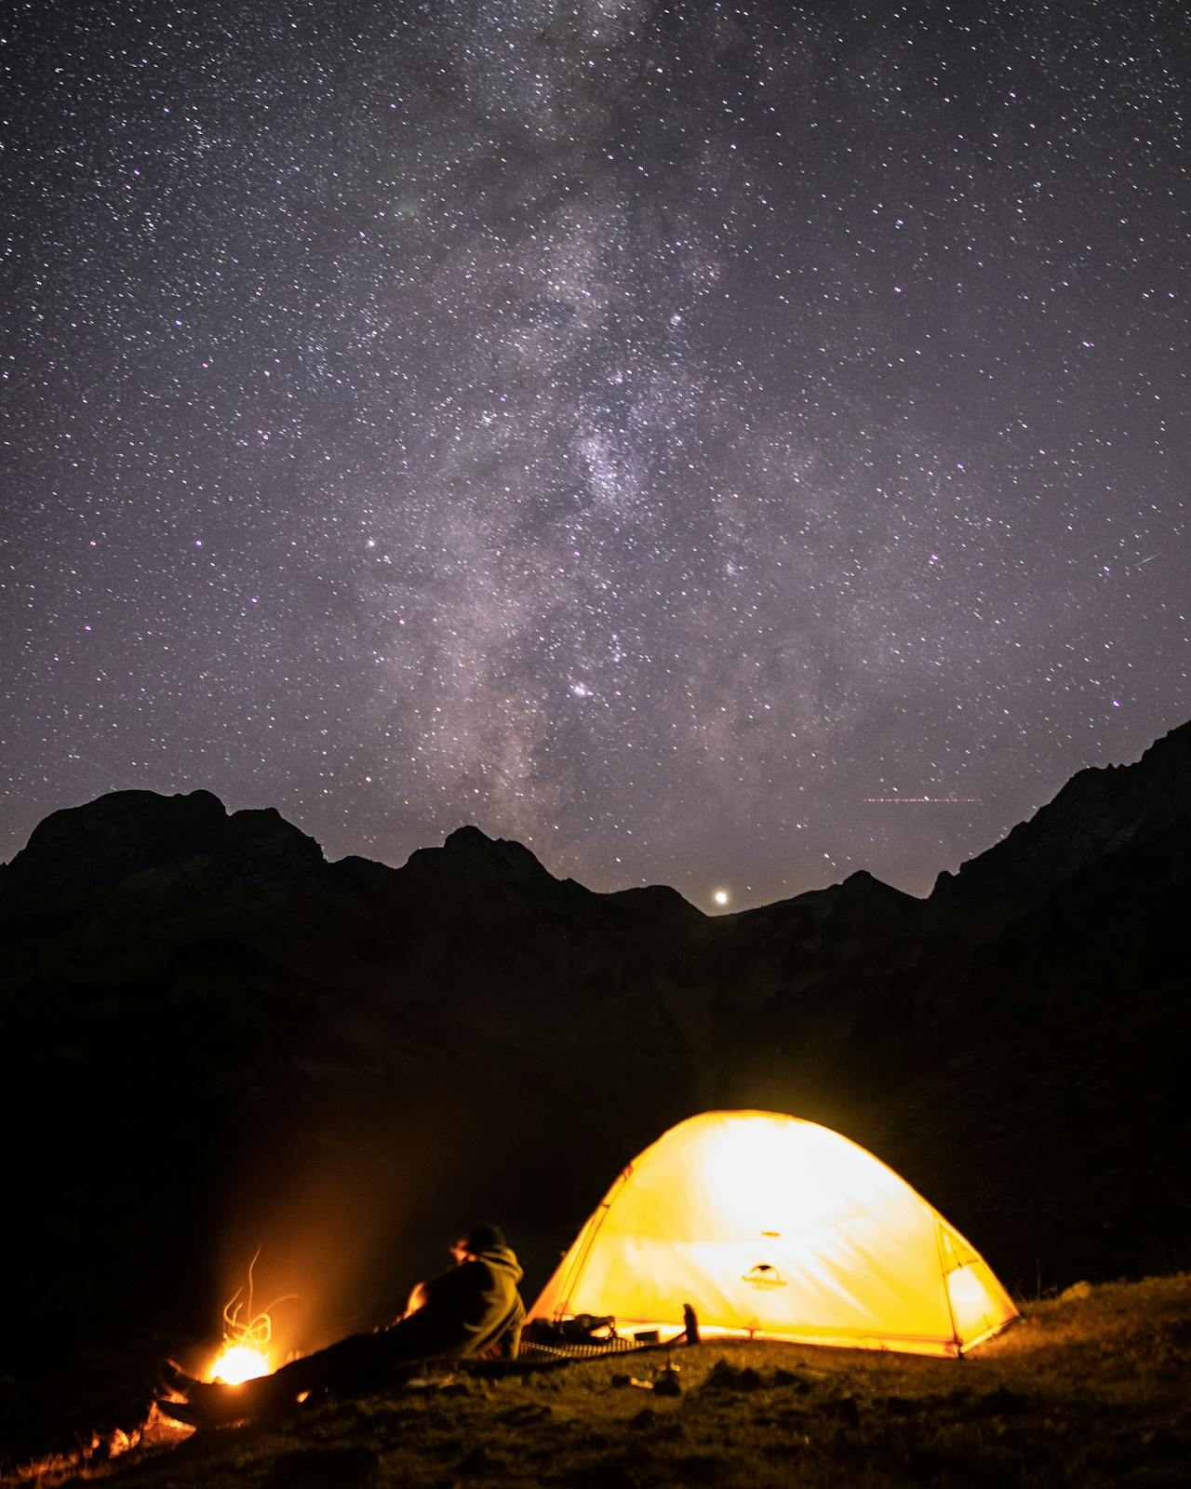

36
https://www.pexels.com/photo/person-sitting-on-rock-at-golden-hour-426893/
Kasuma
Sachseln, OW, Switzerland
Person Sitting on Rock at Golden Hour
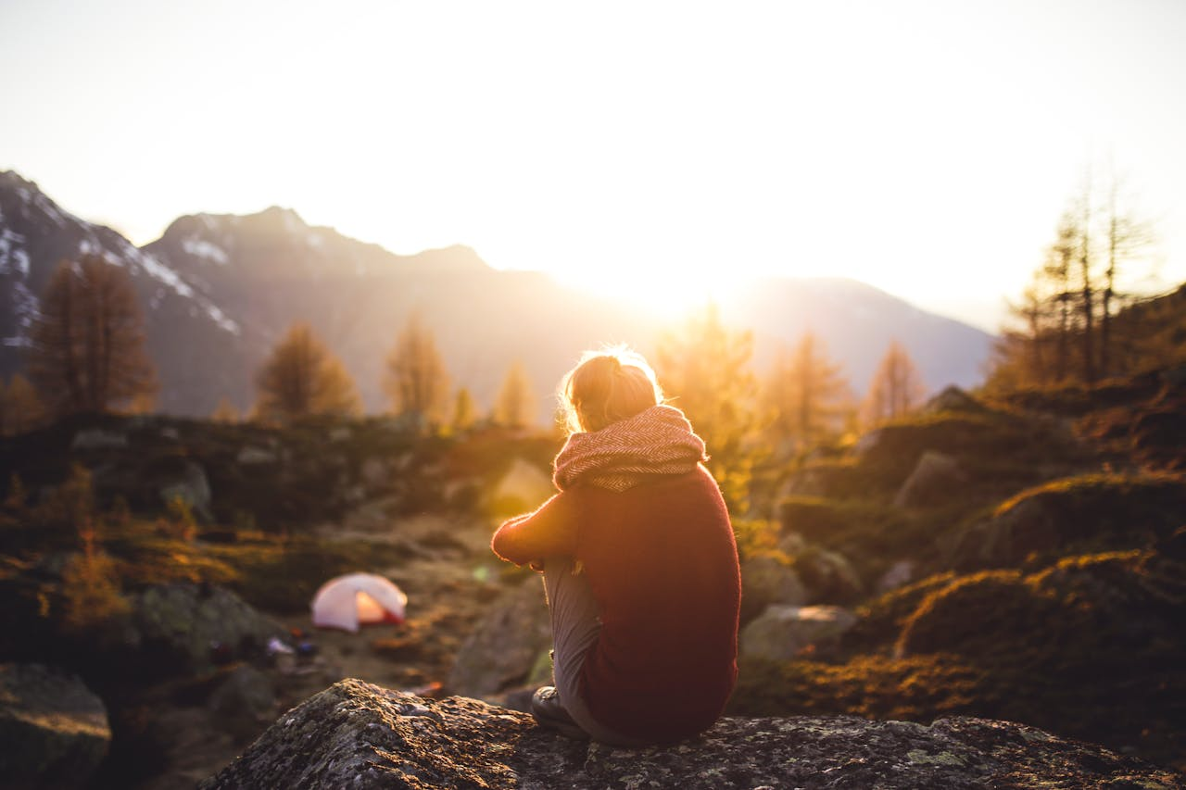

37

