1
Instagram
https://www.meta.com/brand/resources/instagram/instagram-brand/
“IG_brand_asset_pack_2023.zip” on Friday, August 22, 2025
Instagram_Glyph_Gradient.png
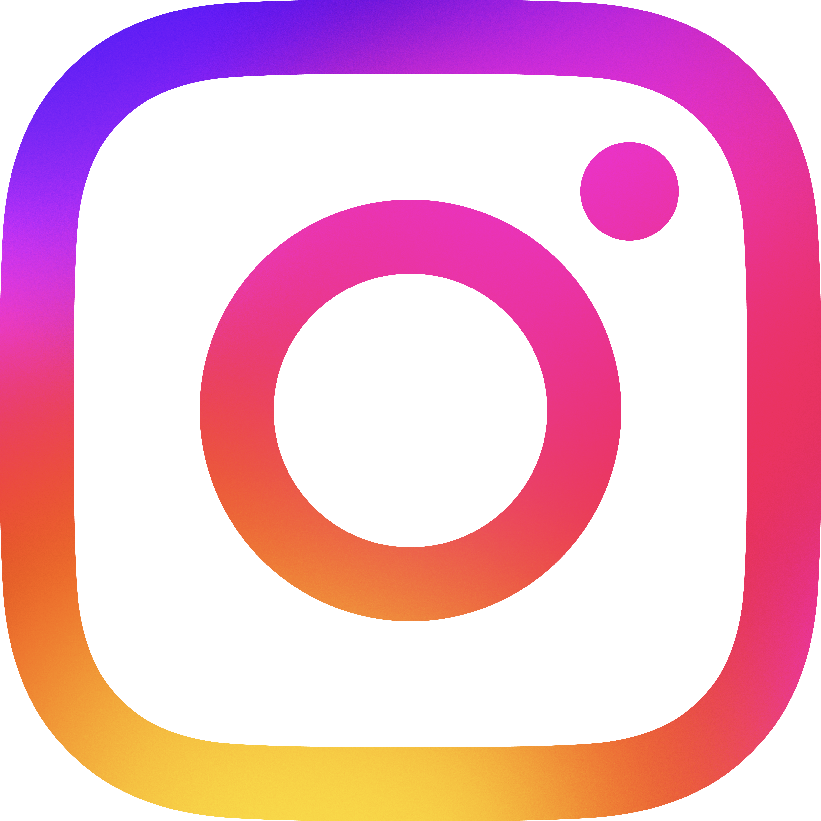

2
Facebook
https://www.meta.com/brand/resources/facebook/logo/
“Facebook-Brand-Asset-Pack.zip” on Friday, August 22, 2025
Facebook_Logo_Primary.png


3
X
https://about.x.com/en/who-we-are/brand-toolkit
“x-logo.zip” on Friday, August 22, 2025
logo-black.png


4
Twitter
https://icons8.com/icons/set/twitter
Friday, August 22, 2025
twitter-bird-100-4.png


5
YouTube
https://icons8.com/icon/qLVB1tIe9Ts9/youtube
Friday, August 29, 2025
youtube-96.png


6

