**Report Template:**

**CS205 C/ C++ Program Design Assignment 1**

**Name**: 罗森滋

**SID**: 3120001095

Part 1. Source Code

#include<iostream>

using namespace std;

int main() {

time_t start, end;

start = clock();

cout << "Please input the dimension of two vectors:" << endl;

int n, i;

float num = 0, sum = 0,judge = 0;

cin >> n;

while (!cin) {

cin.clear();

cin.ignore();

cout << "invalid input,please input again" << endl;

cin>>n;

}

float* v1 = new float[n - 1];

float* v2 = new float[n - 1];

int* wrong = new int[n];

for (i = 0; i <= n; i++) {

*(wrong + i) = 0;

}

cout << "Now please input each number in two vectors:" << endl;

cout << "vector one:" << endl;

for (i = 1; i <= n; i++) {

cin >> *(v1 + i);

if (!cin) {//find out which number is wrong

cin.clear();

cin.ignore();

*(wrong + i) = 1;

judge = 1;

}

}

if (judge == 1) {//modify the number

for (i = 0; i <= n; i++) {

if (*(wrong + i) != 0) {

cout << "The " << i << " number is wrong,please input again" << endl;

cin >> *(v1 + i);

}

}

}

for (i = 0; i <= n; i++) {

*(wrong + i) = 0;

}

cout << "vector two:" << endl;

for (i = 1; i <= n; i++) {

cin >> *(v2 + i);

if (!cin) {

cin.clear();

cin.ignore();

*(wrong + i) = 1;

judge = 1;

}

}

if (judge == 1) {

for (i = 0; i <= n; i++) {

if (*(wrong + i) != 0) {

cout << "The " << i << " number is wrong,please input again" << endl;

cin >> *(v2 + i);

}

}

}

for (i = 1; i <= n; i++) {

num = (*(v1 + i)) * (*(v2 + i));

sum += num;

}

cout << "The dot product of two vectors is:" << sum << endl;

end = clock();

cout << "it cost " << (float)(end - start) * 1000 / CLOCKS_PER_SEC << "ms" << endl;//calaculate the time

return 0;

}

Part 2. Result & Verification

In this part, you should present the result of your program by listing the output of test cases and optionally add a screen-shot of the result.

Test case #1:

3

1 2 3

1 2 3

Screen-short for case #1:

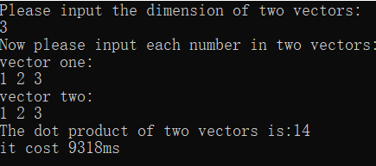

Test case #2:

3

1 a 3

2

1 2 3

Screen-short for case #2:

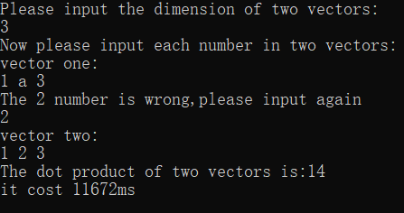

# Part 3. Difficulties & Solutions, or others

1. The biggest problem of the program is Dynamic distribution of stored space.When I want to delete the dynamic memory by using the function delete,I oddly find that the program is broken,I don’t know whether it is because the compile or translator.And I don’t even find a solution of it now.
2. The second problem is its Robust.In this program,you can input some invalid data,and the program can find it and tell you input a valid number again.But it also takes more time to implement the program.So I don’t find a way to make the program implement more quickly.