<Spring 2016- Basic Engineering Design for Electronics Engineering >

Managed Haos

Haos Team

Benjamin Haos

Advisor: Prof. Je-Won Kang

* 1. Abstract

Creativity born of Chaos coupled Fate, finds loss unpredictably routine. This document outlines an implantation of wisdom born from every mother but until now, never realized by this son. Reading further, you will find an obvious truth, coupled to new technologies in a novel but until now, never realized convergence. If you my generous reader, take this proposal to heart and build true to description described, you will never lose the three most critical physical manifestations of life. Doors will always open for you, your personal data will always be at your fingertips, and channels of communication will never fail.

* 1. Introduction

Every child has asked their mother where a lost item is located. Every mother has told their love to try and remember where they last saw the missing item. This age old conundrum has existed since mothers have had children who’ve have had items of value. At some point during the evolution of child rearing, a simple truth was obtained; if you have items you need to live efficient, you need to keep these items from being lost. Woman, the clearly more sensible of the two genders, solved this problem long ago. But man, never known for sensibility eclipsing stubborn-inity; he has never been able to assimilate the catch-all purse. Thus, sons, brothers, and spouses have always been plagued by routine loss of items his partner gender always has at hand.

The three most important material possessions one cannot leave home without can be described as; Access, Communication, and Coin. Access is gained through key rings. Communication is made with ubiquitous networked handhelds. Coin is kept in wraps holding bills and cards. Your keys; your phone; your wallet; these three items are physical manifestations of your person and leaving home for more than a quick excursion requires this trifecta of identification, connection, and data. Amazingly, and most likely due to hard- headed stubbornness, the yin gender male has almost one hundred percent failed to solve a problem that his yang gender female has had essentially one percent solution solved since the beginning of recorded history. This proposal is written with a whole and complete respect and love for the fairest of the sexes and belief that although a gentleman, for

whatever reason, cannot follow a ladies lead and carry a purse; he can follow direction, take a hint, and remember the words every mother has told there child. Put your things where they belong!

* + 1. Motivation

I routinely lose my wallet, my keys, and my phone. I have lost my keys while looking for my phone which i lost while looking for my wallet which i lost looking for my keys which... As embarrassing as it is to admit, i am a loser. I am a card-carrying administrative member of the Confederation of International Airheads (CIA). My motivation is thus completely self- serving. I need to keep track of my Access, my Comm., and my Coin.

* + 1. Related Work

There is nothing that is not in some way related to everything else. This is why items become lost. Mortal tracked Entropic matter is always trying to return to Chaos void. We know this is true because of the many systems, tools, and devices that have been imagined, developed, and created. Although there are countless examples a few common solutions you may already be familiar with are; the age-old catch-all; the long available whistle-to- find keychain; and the more recent tile BlueTooth object tracking device. Although all three of these items is a working solution, they all share one problem, they are not fool-proof. The first requires a person prone to forgetting to actively remember a routine. The second requires a person be able to utter a sound pattern that can easily be forgotten or incorrectly uttered. And the third requires that the person who loses item never lose an item required to locate a lost item! With this in mind, have a look at these three previous solutions and once you are familiar with their patterns of operation and methods of item tracking, you will understand the previous statement.

* + 1. Summary of Expected Contributions

It is expected that the final product of this project will help people keep track of the things they most commonly lose. It is expected to do this better by not allowing these items to be placed anywhere but one spot.

1. Background
   1. There are several types of components involved.
      1. Processing
         1. Arduino
         2. NFC Module
         3. Android Device
         4. Bluetooth Module
      2. Data Handling
      3. NFC Tags
      4. Action and Controlling
         1. Relay Module
2. Proposed Design
   1. Overview of the project

This projects uses several components, all easily obtainable.

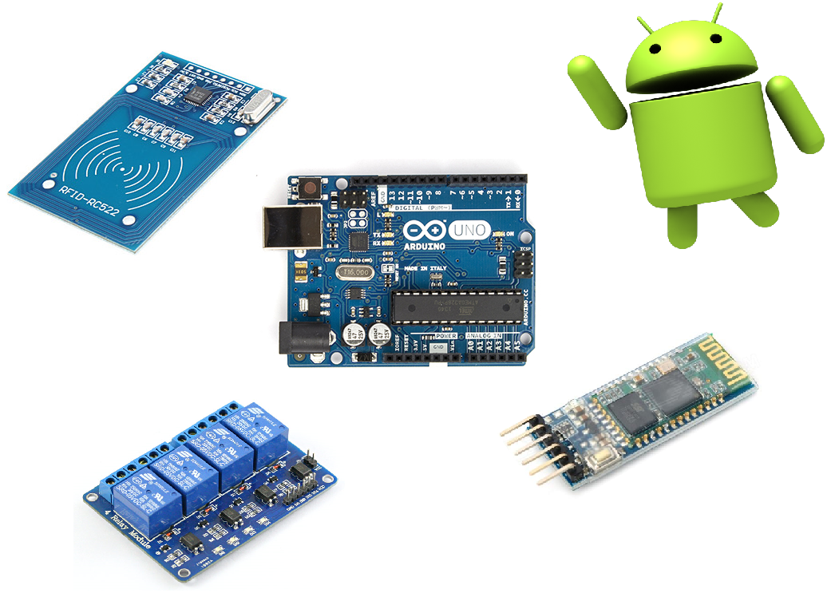

* 1. Implementation

Yes

* 1. Performance evaluation

I did far more work than one person should be required to do.

1. Conclusion
2. References

Source List:

Basic Overview Image

1. https://www.google.com/search?q=arduino&espv=2&source=lnms&tbm=isch&sa=X&ved=0ahUKEwjk4MrFmabNAhXGmZQKHcj9CgAQ_AUICigD&biw=1920&bih=965#imgrc=DtjoP3EzpZIzRM%3A
2. https://www.google.com/search?espv=2&biw=1920&bih=965&tbm=isch&sa=1&q=android&oq=android&gs_l=img.3...1580.4102.0.5650.0.0.0.0.0.0.0.0..0.0....0...1c.1.64.img..0.0.0.YL7uwB4gKVU#imgrc=9ahXktmIjcD3cM%3A
3. https://www.google.com/search?espv=2&biw=1920&bih=965&tbm=isch&sa=1&q=nfc+module&oq=nfc+module&gs_l=img.3...2369.5375.0.5771.0.0.0.0.0.0.0.0..0.0....0...1c.1.64.img..0.0.0.kw_Fs25RTXs#imgrc=odnUX0qyIDseDM%3A
4. https://www.google.com/search?q=bluetooth+module&source=lnms&tbm=isch&sa=X&ved=0ahUKEwiZ_rjnm6bNAhXFspQKHZ5JDlcQ_AUICSgC&biw=1546&bih=654#imgrc=x8DGlTNWRXB2cM%3A
5. https://www.google.com/search?espv=2&biw=1920&bih=965&tbm=isch&sa=1&q=relay+module&oq=relay+module&gs_l=img.3...2693.4893.0.5233.0.0.0.0.0.0.0.0..0.0....0...1c.1.64.img..0.0.0.wXInO-zYdYA#imgrc=uOnmmN-L_N98JM%3A
6. https://www.arduino.cc/en/uploads/Main/ArduinoUno_R3_Front_450px.jpg
7. http://www.parkeasier.com/wp-content/uploads/2015/05/REL-Android.png
8. http://img.dxcdn.com/productimages/sku_152175_1.jpg
9. http://4tronix.co.uk/store/resources/image/18/7e/b.jpg
10. Self-Review

(Review yourself, e.g. ideas from brainstorming, implementation, design components assigned to you, etc.

The contribution of each member after mid-presentation.)