**CSC1101**

**Problem Solving and Programming**

**Fall Term 2015**

**Lab 10**

**50 Points**

**Due on 10/22/2015 10:00 PM**

# **Important notice!**

You should put comments in your take-home assignments. Solutions without comments will be deducted 5 points in grade.

Please note the due date for this lab is 10/22 instead of 10/20. This extension is only for this lab.

# Exercise 1 (15 points)

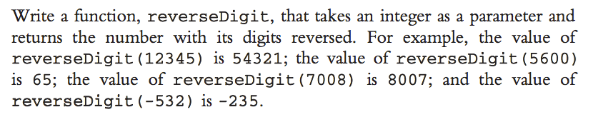

**Grading scheme**: a main function to call reverseDigit - **5 points**; handling positive number correctly - **5 points**; handling negative number correctly - **5 points**.

# Exercise 2 (15 points)

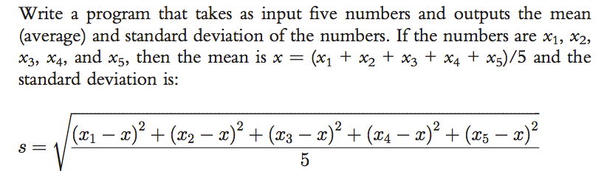

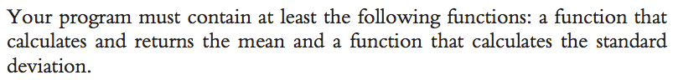

**Grading scheme**: a function to calculate the mean - **5 points**; a function to calculate the standard deviation - **5 points**; a main function to call the two functions above correctly - **5 points**.

# Exercise 3 (20 points)

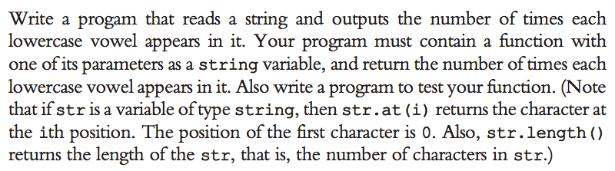

**Grading scheme**: a program reads a string and calls the function correctly - **5 points**; counting each lowercase vowel correctly - **15 points (3 points for each vowel)**.