

Computer Science Department

***CSC 2201: Computer Science II – Lab***

***Lab2***

**Description:**

You will implement your own BlogEntry Class and Date Class.

**Goals:**

Learn how to use C++ classes to implement an abstract data type (ADT).

**Where to Start:**

1. Download Lab2_Work.zip from Blackboard
2. Unzip the file
3. Open the solution in Microsoft Visual Studio
4. Start implementing all the operations of the Text class (Copy of your work in Lab1 including both Text.h and Text.cpp. Make sure it does work!)
5. Implement methods and operations of the Date class:

5.1 Implement *Date::Date(){…}*

5.2 Implement *Date::Date(…) throw (logic_error){…}*

5.3 Implement *int Date::getDay() const{…}*

5.4 Implement *int Date::getMonth() const{…}*

5.5 Implement *int Date::getYear() const{…}*

5.6 Implement *bool Date::isLeapYear(…){…}*

5.7 Implement *int Date::daysInMonth(…){…}*

5.8 Implement *int Date::getDayOfWeek()const{…}*

5.9 Implement *bool Date::operator<(const Date& rhs) const{…}*

5.10 Implement *bool Date::operator==(const Date& rhs) const{…}*

5.11 Implement *bool Date::operator>(const Date& rhs) const{…}*

5.12 Implement *ostream& operator<<(ostream& out, const Date& date){…}*(check show2.cpp)

1. Implement methods and operations of the BlogEntry class:

6.1 Implement *BlogEntry::BlogEntry(){…}*

6.2 Implement *BlogEntry::BlogEntry(…){…}*

6.3 Implement *Text BlogEntry::getAuthor() const{…}*

6.4 Implement *Text BlogEntry::getContents() const{…}*

6.5 Implement *Date BlogEntry::getCreateDate() const{…}*

6.6 Implement *Date BlogEntry::getModifyDate() const{…}*

6.7 Implement *void BlogEntry::setAuthor(const Text& newAuthor){…}*

6.8 Implement *void BlogEntry::setContents(const Text& newContents){…}*

6.9 Implement *void BlogEntry::printHTML(ostream& out) const{…}*

1. Activate all tests in the program test2.cpp by changing the definition of LAB_TESTX from 0 to 1 in config.h and compiling.
2. Test your implementation using the program in the file test2.cpp.

**Expected Results:**

Q1.

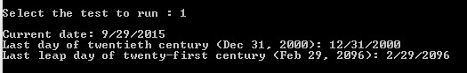

Q2.



Q3.

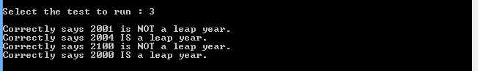

Q4.

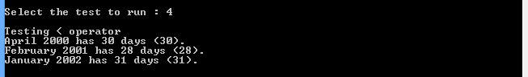

Q5.

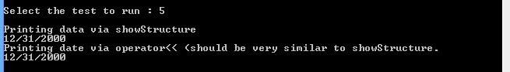

Q6.

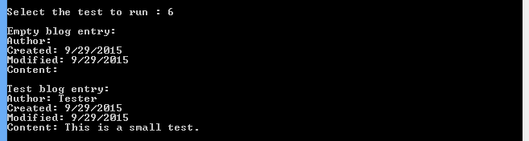

Q7.

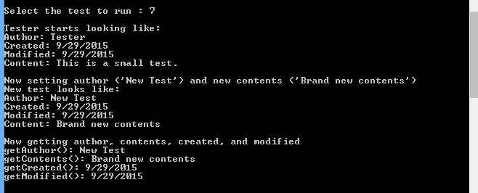

Q8.

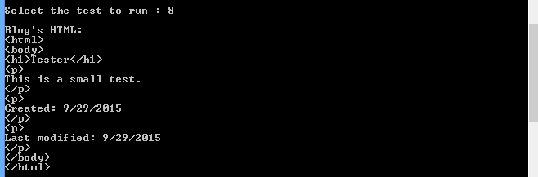

Q9.



Q10.

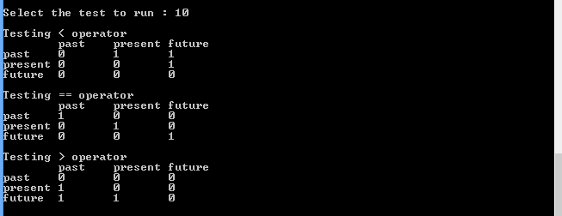

**Create a Zip file of your solution:**

1. Right click on your solution in Solution Explorer
2. Click on “Open Folder in File Explorer”
3. Go one level up in file explorer
4. Right click on your solution folder
5. Add it to archive by creating a zip file

**Upload the zipped file on Blackboard:**

1. Go to Blackboard
2. Click on this course (CSC 2201: Computer Science II Lab)
3. Go to the folder “Labs”
4. Click on the “Lab1_Work” assignment
5. Upload your zipped file