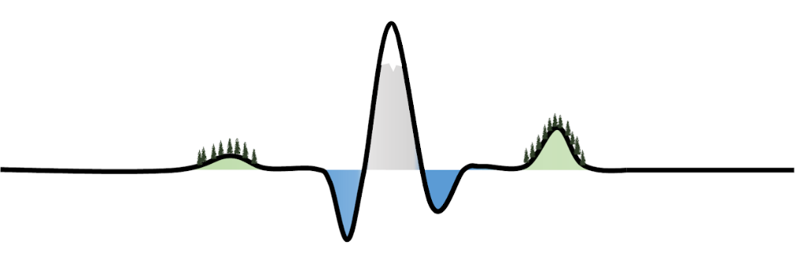

6th International Workshop on High Temporal Resolution
Water Quality Monitoring and Analysis
2nd to 4th September 2022 | Freiburg, Germany
Provisional programme
Date and time | Session | Presenters
Wednesday 2nd September  08:30-09:00  09:00-09:15  09:15-10:30  10:30-11:00  11:00-12:15  12:15-13:30  13:30-15:00  15:00-15:30  15:30-16:45  16:45-17:00 | Arrival and registration  Opening remarks  Increasing high-frequency data in space and time: Pt. 1  Coffee break  Increasing high-frequency data in space and time: Pt. 2  Lunch  Poster Session  Coffee break  Emerging high-frequency measurements  Discussions and close | All  Carolin Winter & Aaron Neill  Joachim Rozemeijer (Invited)  Rémi Dupas  Anita Alexandra Sanchez  Erik Nixdorf  All  Admin Husic  Xiaoyun Wang  Jakob Benisch  Suzanne Jacobs  Pia Ebeling  All  Alessandro Cattapan  Alex Lipp  Anastasija Isidorova  Devikrishna Radhakrishnan  Felina Schwalm  Heinke Paulsen  Jean-Paul Brede  Maximilian Mäder  Roland Bol  Sandali Hasara Siriwardane  Tom König  All  Maria Grundmann  Immanuel Frenzel  Lars Duester  Magdalena Bieroza  Michael Rode  All
Thursday 3rd September  09:00-10:30  10:30-11:00  11:00-12:00  12:00-13:00  13:00-15:00  15:00-15:30  15:30-16:30  16:30-16:45  16:45-17:00 | Smart analytics  Coffee break  Interactive session  Lunch  World café  Coffee break  Discussion and next steps  Closing remarks  Group photo | Julia Knapp (Invited)  Gunnar Lischeid  Walter Hettler  Shulamit Nussboim  Felipe Saavedra  All  Aaron Neill  Heinke Paulsen  + TBC  All  All  All  All  Carolin Winter & Aaron Neill  All
Friday 4th September  09:00  09:15-14:00  14:00 | Meet for field excursion at Rektoratsgebäude  Field excursion  Arrive Freiburg Main Station / University | All  All  All

Guidance for presenters
To ensure smooth running of the workshop, we kindly ask our conference speakers to keep to the following times and formats:

Oral presentations: 12-minute talk in widescreen (16:9) PowerPoint format + 3 minutes Q&A.

Invited speakers: 20-minute talk widescreen (16:9) PowerPoint format + 10 minutes Q&A.

Poster presentations: A0 poster in landscape format.

Venue information
Workshop:
'Großer Saal' (1st Floor), Haus zur Lieben Hand, Löwenstraße 16, 79098 Freiburg, Germany.
Field excursion meeting point:
Rektoratsgebäude, Friedrichstraße 39, 79104 Freiburg im Breisgau

