

**Project Title:**

Book Store Management System

**Submitted by:**

Alishba Javed, 2021-CS-205

**Submitted to:**

Ma’am Maida

**For fulfillment of:**

CS-161 Programming Fundamentals

**Department of Computer Science**

**University of Engineering and Technology**

**Lahore Pakistan**

**Project Description**:

**Book Store Management System** is a system that allows searching, purchasing and reserving of books. It is a web application that can automate all kinds of operations of a book shop. The purpose of this software is to manage the books in a books store. It includes adding of books up till a specific level is reached, stock management, and account management. This maintains records of sales and purchases. This system allows the user to purchase books without any complexity, along with an option to return already purchased books. This allows the owner of the book store management system to add books along with permanently deleting record of a book. It also allows the admin to interact with the user by reading reviews by the user on previously sold books.

This also offers privacy to the admin as any other person other than admin cannot use this system as an admin. A password is required to use this system as an admin which is only known to the admin.

For a user to use this application it needs his name along with user id that might be needed for future actions. A user can add, buy, and return books. Besides that a user can also add review for a certain book along with checking reviews of others is also possible using this system. It also provides a sorting feature due to which user or admin sort books with respect to prices starting from cheap to the most expensive ones. It provides a user friendly interface as any invalid entered command may result as an error without providing a halt in the execution.

**Users of Application:**

This application provides two users to interact with it:

* Admin: Who can be the owner of the system.
* User: Any person who wishes to buy or view books.

**Functional Reqirements:**

**Admin:**

1. The admin must be able to add books according to its user’s requirements.
2. To remove books those were not being sold from a long period of time.
3. To sort the books by price order.
4. Check books that are out of stock to add new ones.
5. To check reviews added by users.

**User:**

1. To buy books of different choices.
2. To sell books individually usually for people running businesses on a small scale.
3. To sort books by price order.
4. To add reviews for specific books.
5. To check book reviews to check the website’s liability.
6. To return already bought books.

**Wireframes:**

* **Main Menu:**

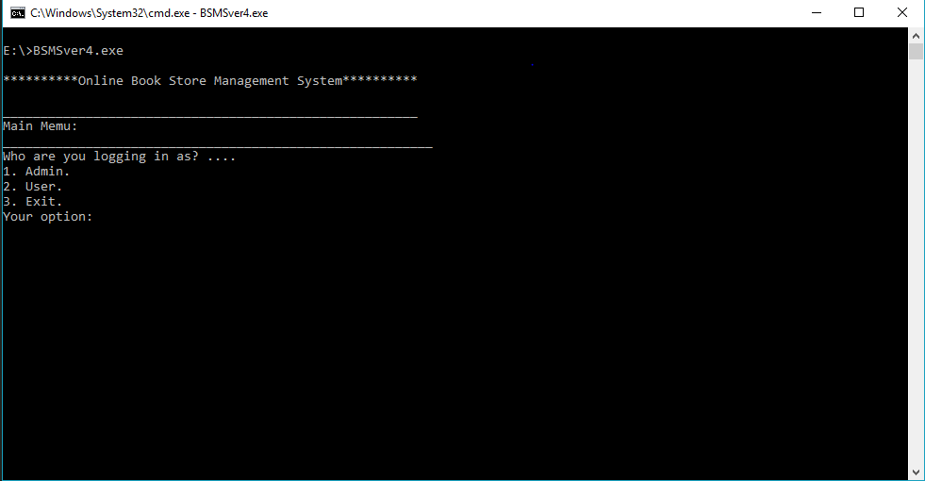

* Selecting 1 to enter as ADMIN

Enter password. Password is “12345”

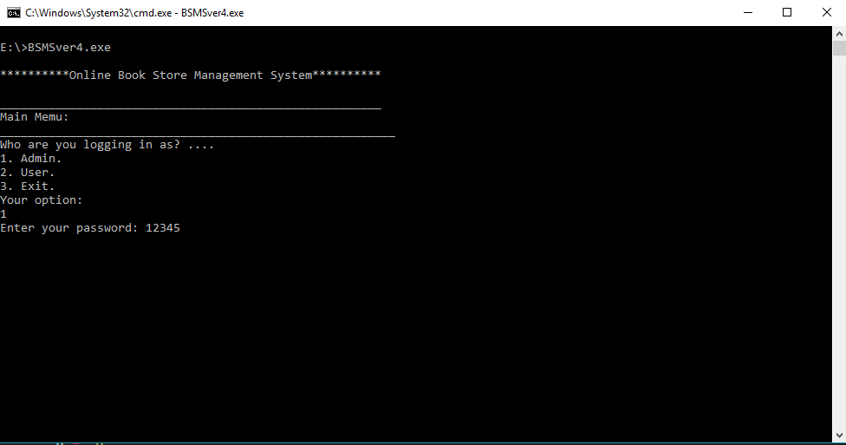

* **Main Menu Admin:**

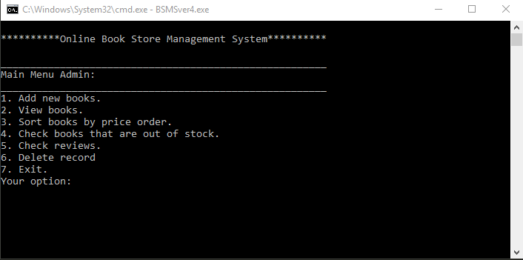

1. Select 1 to Add Books:

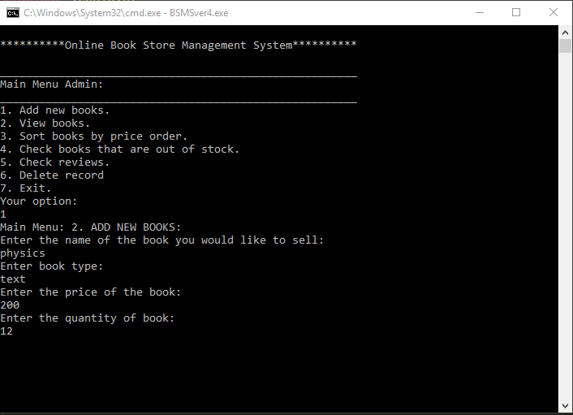

1. Select 2 to View Books:

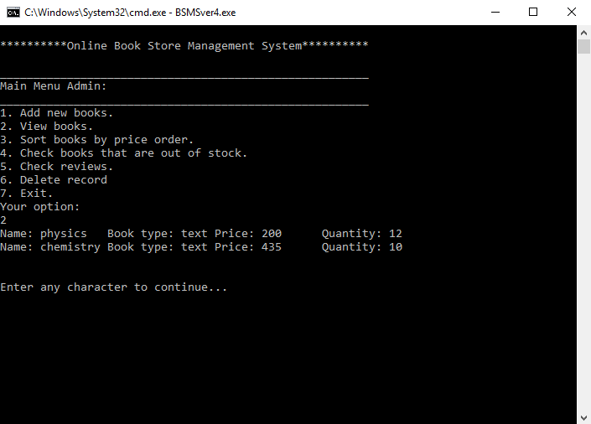

1. Select 3 to Sort Added books by price order.

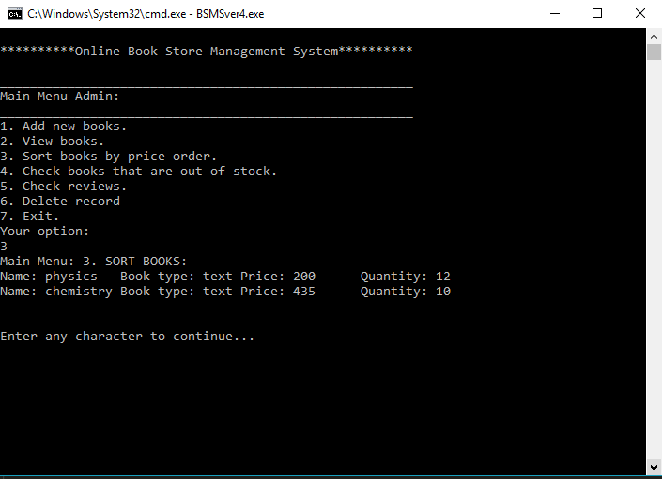

1. Select 4 to check books that are out of stock.

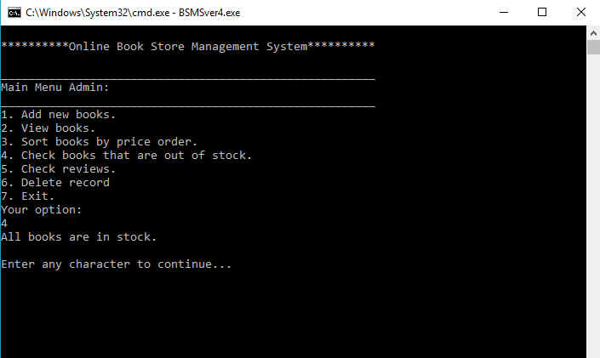

1. Select 5 to Check Reviews added by the user..

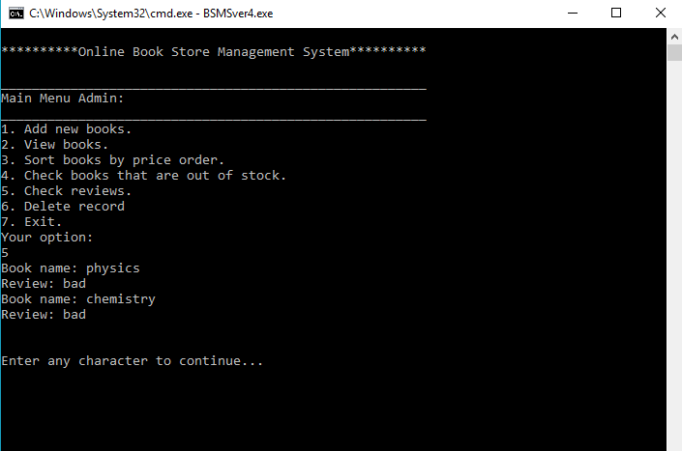

1. Select 6 to Delete Record.

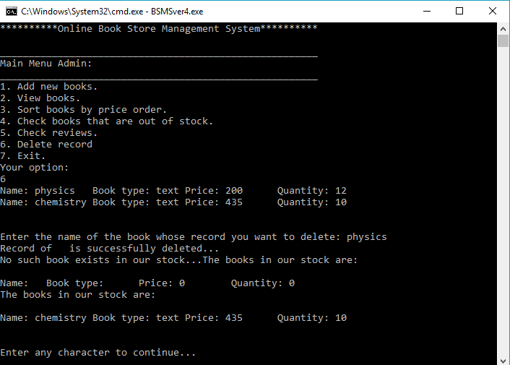

1. Select 7 to Exit as admin and return to Main Menu.

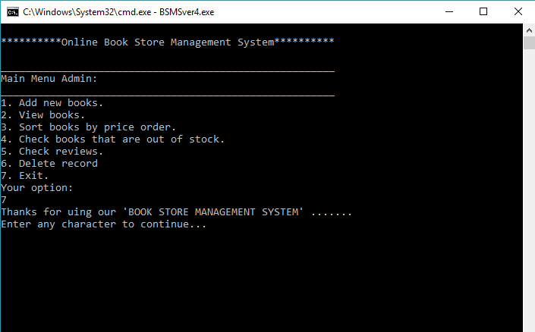

* **Main Menu:**



**Select 2 to enter as User.**

Enter your name and login id

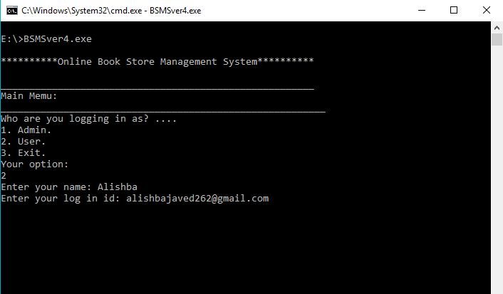

* **Main Menu User:**

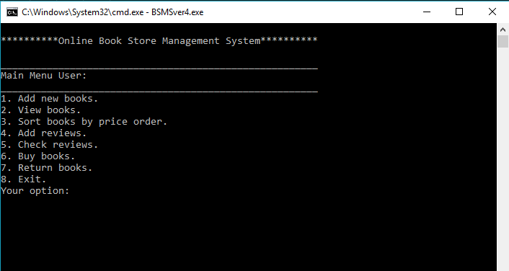

1. Select 1 to add new books…

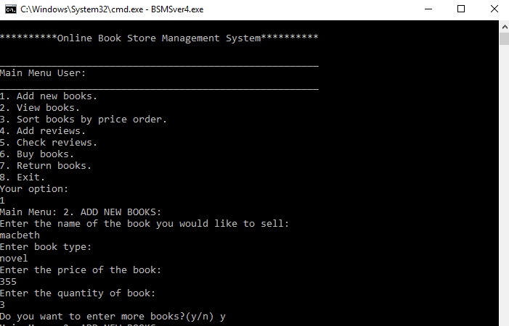

1. Select 2 to View Books.

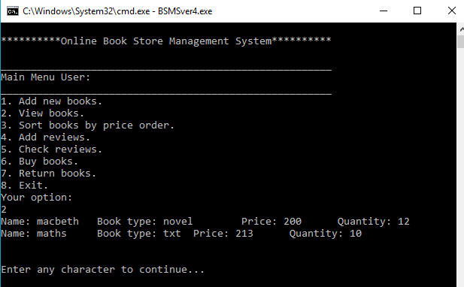

1. Select 3 to Sort Books.

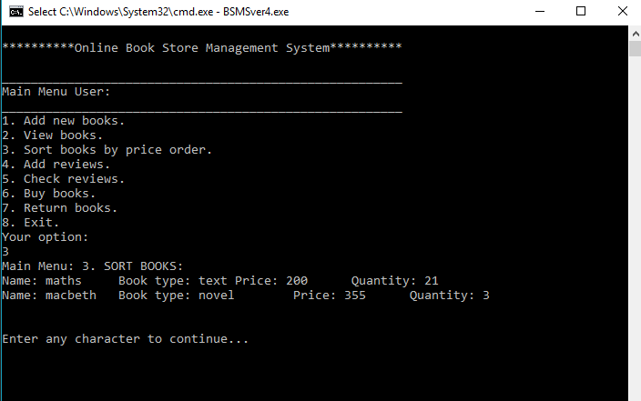

1. Select 4 to Add reviews.

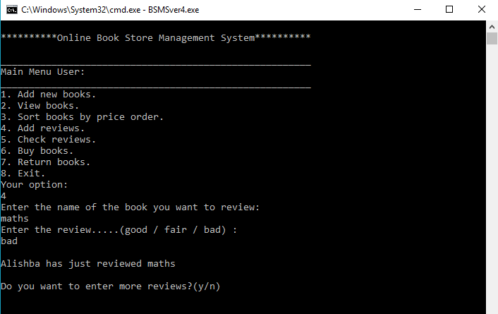

1. Select 5 to Check Reviews.

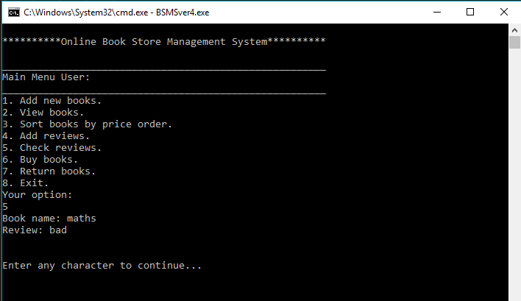

1. Select 6 to Buy Books.

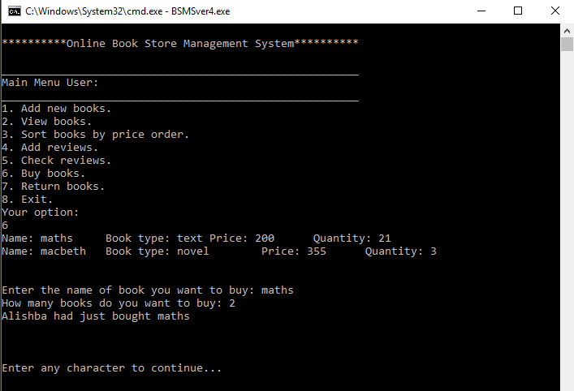

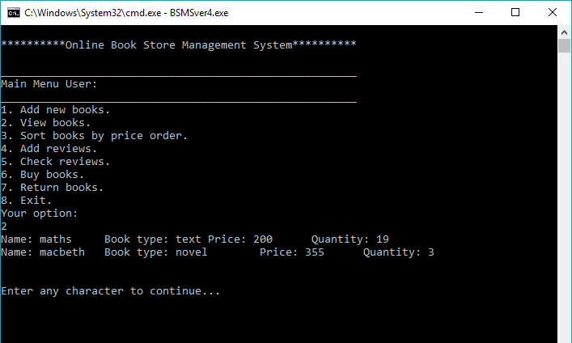

1. Select 7 to Return Books.

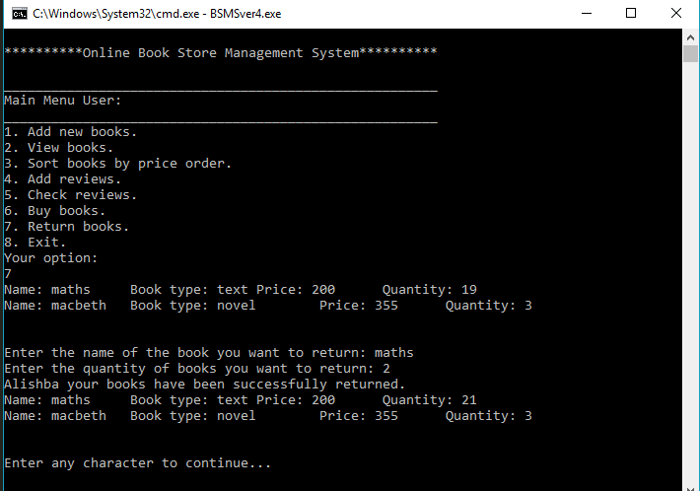

1. Select 8 to Exit as User and to return back to Main Menu.

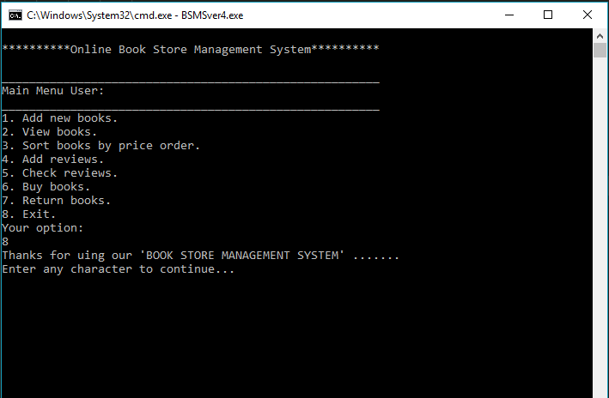

Back to Main Menu:



Select Option 3 to EXIT BOOK STORE MANAGEMENT SYSTEM…

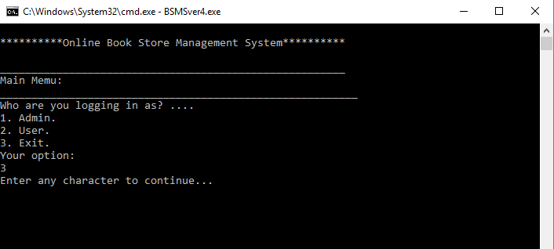

**Storing data in files:**

* A file to store all the added books

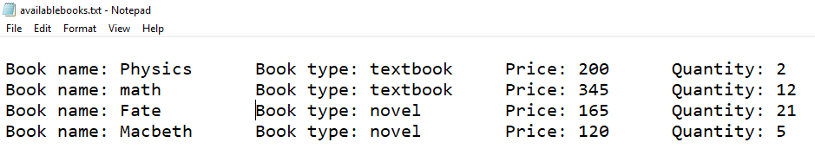

* A text file to store added reviews

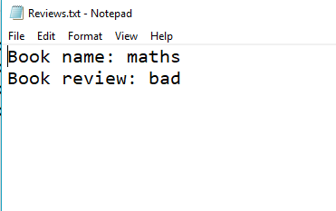

* A text file to store record of bought books.

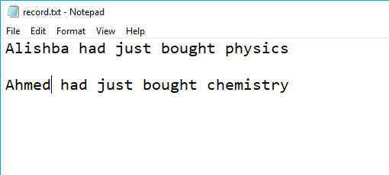

* A text file to store the books in sorted order.

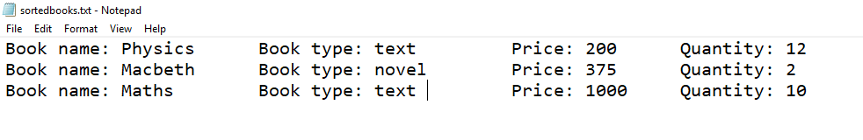

**Data Structures:**

fstream newfile, ffile, file, buy;

*int* price[4], quantity[4], count = 0, a = 0, y = 0, return_quantity = 0, pass, adminpassword = 12345, j = 0, num = 0;

string z, c, d, delete_name, name[4], type[4], book_name[4], book_review[4], return_name, user_name, user_id;

*char* b, n, x, g;

**Function’s Prototypes:**

*char* mainMenu();

string checkPreviousfile();

*char* mainMenuAdmin();

*char* mainMenuUser();

*void* clearScreen();

*void* displayBooks(string *name*, string *type*, *int* *price*, *int* *quantity*);

*void* sortBooks();

*void* outOfStock();

*void* Review(string *book_name*, string *book_review*);

**Working flow diagram:**

main()

checkPreviousfile()

clearScreen()

clearScreen()

Review()

Review()

displayBooks()

sortBooks()

outOfstock()

sortBooks()

displayBooks()

mainMenuUser()

mainMenuAdmin()

mainMenu()

displayBooks()

displayBooks()

**Complete Code:**

 #include <iostream>

#include <fstream>

#include <conio.h>

#include <sstream>

#include <string>

using *namespace* std;

fstream ffile, file, buy, data;

*int* price[20], quantity[20], count = 0, a = 0, y = 0, return_quantity = 0, pass, adminpassword = 12345, j = 0, num = 0, counts = 1, f = 0;

string z, c, d, delete_name, name[20], type[20], book_name[20], book_review[20], return_name, user_name, user_id, line, item;

*char* b, n, x, g;

// function prototypes....

*void* header();

*char* mainMenu();

*char* mainMenuAdmin();

*char* mainMenuUser();

*void* clearScreen();

*void* displayBooks(string *name*, string *type*, *int* *price*, *int* *quantity*);

*void* sortBooks();

*void* outOfStock();

*void* Review(string *book_name*, string *book_review*);

string checkPreviousFile(string *line*, *int* *field*);

main()

{

    data.open("Bookdata.txt", ios::in);

    f = 0;

    while (!data.eof())

    {

        getline(data, line);

        data >> line;

        name[f] = checkPreviousFile(line, 0);

        type[f] = checkPreviousFile(line, 1);

        stringstream var1(checkPreviousFile(line, 2));

        var1 >> price[f];

        stringstream var2(checkPreviousFile(line, 3));

        var2 >> quantity[f];

        f++;

        count = count + 1;

    }

    data.close();

    n = 'd';

    g = 'd';

    // while loop to make sure that the user does not want to exit the program

    while (g != '3')

    {

        // displaying main menu

        g = mainMenu();

        if (g == '1')

        {

            // asking admin for password

            //password is 12345

            cout << "Enter your password: ";

            cin >> pass;

            if (pass == adminpassword)

            {

                while (n != '7')

                {

                    system("cls");

                    //displays admmin's main menu....

                    n = mainMenuAdmin();

                    // if option 1 is selected then books are added...

                    if (n == '1')

                    {

                        for (*int* i = count; i < 20; i++)

                        {

                            cout << "Main Menu: 2. ADD NEW BOOKS: " << endl;

                            cout << "Enter the name of the book you would like to sell: " << endl;

                            cin >> name[i];

                            cout << "Enter book type: " << endl;

                            cin >> type[i];

                            cout << "Enter the price of the book: " << endl;

                            cin >> price[i];

                            cout << "Enter the quantity of book: " << endl;

                            cin >> quantity[i];

                            // to store data entered into file...

                            data.open("Bookdata.txt", ios::app);

                            data << name[i] << "," << type[i] << "," << price[i] << "," << quantity[i] << endl;

                            data.close();

                            count = count + 1;

                            cout << "Do you want to enter more books?(y/n) ";

                            cin >> x;

                            if (x == 'y')

                            {

                                continue;

                            }

                            else if (x == 'n')

                            {

                                break;

                            }

                            else

                            {

                                cout << "You added invalid answer...";

                                break;

                            }

                        }

                        if (count == 4)

                        {

                            cout << "You cannot add more books...";

                        }

                        cout << endl;

                        cout << endl;

                        clearScreen();

                    }

                    // if option 2 is selected then previously added books are displayed...

                    else if (n == '2')

                    {

                        for (*int* i = 0; i <= count - 1; i++)

                        {

                            displayBooks(name[i], type[i], price[i], quantity[i]);

                        }

                        cout << endl;

                        cout << endl;

                        clearScreen();

                    }

                    //if option 3 is selected then previously added books are sorted by price order....

                    else if (n == '3')

                    {

                        sortBooks();

                        cout << endl;

                        cout << endl;

                        clearScreen();

                    }

                    //if option 4 is selected then books that are out of stock are displayed...

                    else if (n == '4')

                    {

                        outOfStock();

                        cout << endl;

                        cout << endl;

                        clearScreen();

                    }

                    // if option 5 is selected then books along with reviews are displayed....

                    else if (n == '5')

                    {

                        if (a == 0)

                        {

                            cout << "No reviews added yet....";

                        }

                        else

                        {

                            for (*int* i = 0; i < a; i++)

                            {

                                Review(book_name[i], book_review[i]);

                                // to store reviews in files

                                file.open("Reviews.txt", ios::app);

                                file << "Book name: " << book_name[i] << endl;

                                file << "Book review: " << book_review[i] << endl;

                                file.close();

                            }

                        }

                        cout << endl;

                        cout << endl;

                        clearScreen();

                    }

                    //if option 6 is selected then record of books is deleted...

                    else if (n == '6')

                    {

                        for (*int* i = 0; i <= count - 1; i++)

                        {

                            displayBooks(name[i], type[i], price[i], quantity[i]);

                        }

                        cout << endl;

                        cout << endl;

                        cout << "Enter the name of the book whose record you want to delete: ";

                        cin >> delete_name;

                        for (*int* i = 0; i < count; i++)

                        {

                            if (delete_name == name[i])

                            {

                                name[i] = " ";

                                type[i] = " ";

                                quantity[i] = 0;

                                price[i] = 0;

                                cout << "Record of " << name[i] << " is successfully deleted..." << endl;

                            }

                            else

                            {

                                cout << "No such book exists in our stock...";

                            }

                        }

                        for (*int* i = 0; i <= count - 1; i++)

                        {

                            cout << "The books in our stock are: " << endl;

                            cout << endl;

                            displayBooks(name[i], type[i], price[i], quantity[i]);

                        }

                        cout << endl;

                        cout << endl;

                        clearScreen();

                    }

                    // if option 7 is selected then back to main menu....

                    else if (n == '7')

                    {

                        cout << "Thanks for uing our 'BOOK STORE MANAGEMENT SYSTEM' ....... " << endl;

                        clearScreen();

                    }

                    //in case of adding invalid command....

                    else

                    {

                        cout << "The command you entered is INVALID... try again..." << endl;

                        clearScreen();

                    }

                }

            }

            else

            {

                cout << "You entered wrong password try again..." << endl;

                clearScreen();

            }

        }

        //users options....

        else if (g == '2')

        {

            // asking user to add his name and id....

            cout << "Enter your name: ";

            cin >> user_name;

            cout << "Enter your log in id: ";

            cin >> user_id;

            system("cls");

            while (n != '8')

            {

                n = mainMenuUser();

                // user's main menu....

                // if option 1 is selected then books are added...

                if (n == '1')

                {

                    for (*int* i = count; i < 20; i++)

                    {

                        cout << "Main Menu: 2. ADD NEW BOOKS: " << endl;

                        cout << "Enter the name of the book you would like to sell: " << endl;

                        cin >> name[i];

                        cout << "Enter book type: " << endl;

                        cin >> type[i];

                        cout << "Enter the price of the book: " << endl;

                        cin >> price[i];

                        cout << "Enter the quantity of book: " << endl;

                        cin >> quantity[i];

                        data.open("Bookdata.txt", ios::app);

                        data << name[i] << "," << type[i] << "," << price[i] << "," << quantity[i] << endl;

                        data.close();

                        count = count + 1;

                        cout << "Do you want to enter more books?(y/n) ";

                        cin >> x;

                        if (x == 'y')

                        {

                            continue;

                        }

                        else if (x == 'n')

                        {

                            break;

                        }

                        else

                        {

                            cout << "You added invalid answer...";

                            break;

                        }

                    }

                    if (count == 4)

                    {

                        cout << "You cannot add more books...";

                    }

                    cout << endl;

                    cout << endl;

                    clearScreen();

                }

                // if option 2 is selected then previously added books are displayed...

                else if (n == '2')

                {

                    for (*int* i = 0; i <= count - 1; i++)

                    {

                        displayBooks(name[i], type[i], price[i], quantity[i]);

                    }

                    cout << endl;

                    cout << endl;

                    clearScreen();

                }

                //if option 3 is selected then previously added books are sorted by price order....

                else if (n == '3')

                {

                    sortBooks();

                    cout << endl;

                    cout << endl;

                    clearScreen();

                }

                // if option 4 is selected then review of books are added....

                else if (n == '4')

                {

                    if (a == 4)

                    {

                        cout << "Cannot add more reviews..." << endl;

                    }

                    for (*int* i = 0; i < 4; i++)

                    {

                        cout << "Enter the name of the book you want to review: " << endl;

                        cin >> book_name[i];

                        cout << "Enter the review.....(good / fair / bad) : " << endl;

                        cin >> book_review[i];

                        cout << endl;

                        cout << user_name << " has just reviewed " << book_name[i] << endl;

                        cout << endl;

                        cout << "Do you want to enter more reviews?(y/n)";

                        cin >> x;

                        a = a + 1;

                        if (x == 'y')

                        {

                            continue;

                        }

                        else if (x == 'n')

                        {

                            break;

                        }

                        else

                        {

                            cout << "INVALID...";

                            break;

                        }

                        if (a == 4)

                        {

                            cout << "No space to add more reviews...";

                        }

                    }

                    cout << endl;

                    cout << endl;

                    clearScreen();

                }

                // if option 5 is selected then books along with reviews are displayed....

                else if (n == '5')

                {

                    if (a == 0)

                    {

                        cout << "No reviews added yet....";

                    }

                    else

                    {

                        for (*int* i = 0; i < a; i++)

                        {

                            Review(book_name[i], book_review[i]);

                            file.open("Reviews.txt", ios::app);

                            file << "Book name: " << book_name[i] << endl;

                            file << "Book review: " << book_review[i] << endl;

                            file.close();

                        }

                    }

                    cout << endl;

                    cout << endl;

                    clearScreen();

                }

                // if option 6 is selected then books are bought....

                else if (n == '6')

                {

                    // firstly displaying all the available books to the user to allowig him to choose from...

                    for (*int* i = 0; i <= count - 1; i++)

                    {

                        displayBooks(name[i], type[i], price[i], quantity[i]);

                    }

                    cout << endl;

                    cout << endl;

                    //asking the user to enter the name of the book he wants to buy....

                    cout << "Enter the name of book you want to buy: ";

                    cin >> z;

                    cout << "How many books do you want to buy: ";

                    cin >> y;

                    for (*int* i = 0; i < count; i++)

                    {

                        if (z == name[i])

                        {

                            if (quantity[i] > 0)

                            {

                                quantity[i] = quantity[i] - y;

                                cout << user_name << " had just bought " << z << endl;

                                cout << endl;

                                // to store data of books bought in files....

                                buy.open("record.txt", ios::app);

                                buy << user_name << " had just bought " << z << endl;

                                buy << endl;

                                buy.close();

                            }

                            else

                            {

                                cout << "This book is not available." << endl;

                                cout << user_name << " you can try searching for some other book.";

                            }

                        }

                        num = num + 1;

                    }

                    if (num == 0)

                    {

                        cout << "This book is not available." << endl;

                    }

                    cout << endl;

                    cout << endl;

                    clearScreen();

                }

                // option 7 to return a book....

                else if (n == '7')

                {

                    for (*int* i = 0; i <= count - 1; i++)

                    {

                        displayBooks(name[i], type[i], price[i], quantity[i]);

                    }

                    cout << endl;

                    cout << endl;

                    cout << "Enter the name of the book you want to return: ";

                    cin >> return_name;

                    cout << "Enter the quantity of books you want to return: ";

                    cin >> return_quantity;

                    for (*int* i = 0; i < 4; i++)

                    {

                        if (return_name == name[i])

                        {

                            quantity[i] = quantity[i] + return_quantity;

                            cout << user_name << " your books have been successfully returned." << endl;

                            break;

                        }

                        j = j + 1;

                    }

                    if (j == 4)

                    {

                        cout << "This book is not a part of our stock..." << endl;

                        cout << endl;

                        clearScreen();

                    }

                    for (*int* i = 0; i <= count - 1; i++)

                    {

                        displayBooks(name[i], type[i], price[i], quantity[i]);

                    }

                    cout << endl;

                    cout << endl;

                    clearScreen();

                }

                //option 8 to EXIT...

                else if (n == '8')

                {

                    cout << "Thanks for uing our 'BOOK STORE MANAGEMENT SYSTEM' ....... " << endl;

                    clearScreen();

                }

                //in case of adding invalid command....

                else

                {

                    cout << "The command you entered is INVALID... try again..." << endl;

                    clearScreen();

                }

            }

        }

        else if (g == '3')

        {

            clearScreen();

        }

        else

        {

            cout << "Invalid command..." << endl;

            clearScreen();

        }

    }

}

// function to display header...

*void* header()

{

    cout << "                                                       " << endl;

    cout << "**********Online Book Store Management System**********" << endl;

    cout << "                                                       " << endl;

    cout << "_______________________________________________________" << endl;

}

//function to display main menu....

*char* mainMenu()

{

    header();

*char* n;

    cout << "Main Menu: " << endl;

    cout << "_________________________________________________________" << endl;

    cout << "Who are you logging in as? ...." << endl;

    cout << "1. Admin." << endl;

    cout << "2. User." << endl;

    cout << "3. Exit." << endl;

    cout << "Your option: " << endl;

    cin >> n;

    return n;

}

*char* mainMenuAdmin()

{

    header();

    cout << "Main Menu Admin: " << endl;

    cout << "_______________________________________________________" << endl;

    cout << "1. Add new books." << endl;

    cout << "2. View books." << endl;

    cout << "3. Sort books by price order." << endl;

    cout << "4. Check books that are out of stock." << endl;

    cout << "5. Check reviews." << endl;

    cout << "6. Delete record" << endl;

    cout << "7. Exit." << endl;

    cout << "Your option: " << endl;

    cin >> b;

    return b;

}

*char* mainMenuUser()

{

    header();

    cout << "Main Menu User: " << endl;

    cout << "_______________________________________________________" << endl;

    cout << "1. Add new books." << endl;

    cout << "2. View books." << endl;

    cout << "3. Sort books by price order." << endl;

    cout << "4. Add reviews." << endl;

    cout << "5. Check reviews." << endl;

    cout << "6. Buy books." << endl;

    cout << "7. Return books." << endl;

    cout << "8. Exit." << endl;

    cout << "Your option: " << endl;

    cin >> b;

    return b;

}

//to clear the screen....

*void* clearScreen()

{

    cout << "Enter any character to continue...";

    getch();

    system("cls");

}

// to display the books with name, type, price and quantity....

*void* displayBooks(string *name*, string *type*, *int* *price*, *int* *quantity*)

{

    cout << "Name: " << name << "\t";

    cout << "Book type: " << type << "\t";

    cout << "Price: " << price << "\t";

    cout << "Quantity: " << quantity << endl;

}

// to sort the books by price order....

*void* sortBooks()

{

    cout << "Main Menu: 3. SORT BOOKS: " << endl;

    for (*int* i = 0; i <= count - 1; i++)

    {

        for (*int* j = 0; j <= count - 1; j++)

        {

*int* temp_quantity, temp_price;

            string temp_name, temp_type;

            if (price[i] < price[j])

            {

                temp_price = price[i];

                price[i] = price[j];

                price[j] = temp_price;

                temp_name = name[i];

                name[i] = name[j];

                name[j] = temp_name;

                temp_quantity = quantity[i];

                quantity[i] = quantity[j];

                quantity[j] = temp_quantity;

                temp_type = type[i];

                type[i] = type[j];

                type[j] = temp_type;

            }

        }

    }

    for (*int* i = 0; i <= count - 1; i++)

    {

        displayBooks(name[i], type[i], price[i], quantity[i]);

        // to store data in files in sorted form...

        ffile.open("sortedbooks.txt", ios::app);

        ffile << "Book name: " << name[i] << "\t";

        ffile << "Book type: " << type[i] << "\t";

        ffile << "Price: " << price[i] << "\t";

        ffile << "Quantity: " << quantity[i] << endl;

        ffile.close();

    }

}

// to check the books that are out of stock....

*void* outOfStock()

{

*int* ccount = 0;

    for (*int* i = 0; i <= count - 1; i++)

    {

        if (quantity[i] == 0)

        {

            cout << name[i] << " is out of stock.";

            ccount = ccount + 1;

        }

    }

    if (ccount == 0)

    {

        cout << "All books are in stock.";

    }

}

// to allow the user to check reviews.....

*void* Review(string *book_name*, string *book_review*)

{

    cout << "Book name: " << book_name << endl;

    cout << "Review: " << book_review << endl;

}

string checkPreviousFile(string *line*, *int* *field*)

{

*int* counts = 0;

    string item;

    for (*int* i = 0; i < line.length(); i++)

    {

        if (line[i] == ',')

        {

            counts = counts + 1;

        }

        else if (counts == field)

        {

            item = item + line[i];

        }

    }

    return item;

}

**Test Cases:**

After logging in as admin the program can perform various functions like adding books, displaying books, reading reviews etc. For adding books press 1.



On pressing ENTER the program asks whether or not you want to add more books. If yes then you can enter more books if no then the program simply returns to Admin’s Main Menu.

After adding a couple of books they can also be sorted by price order.



Users added reviews can also be checked by the Admin as,



On pressing Exit admin can easily log out and the program again returns to the main menu.

A user can easily enter after giving its name and id. Many operations can be performed by the user such as selling books, buying books, adding reviews, checking reviews etc.



Reviews can also be added by the user after specifying name of a books,



The user also has the opportunity to return previously bought books.

