Assignment-1

Name: Aksheshkumar Chaudhari(301087120)

Output:

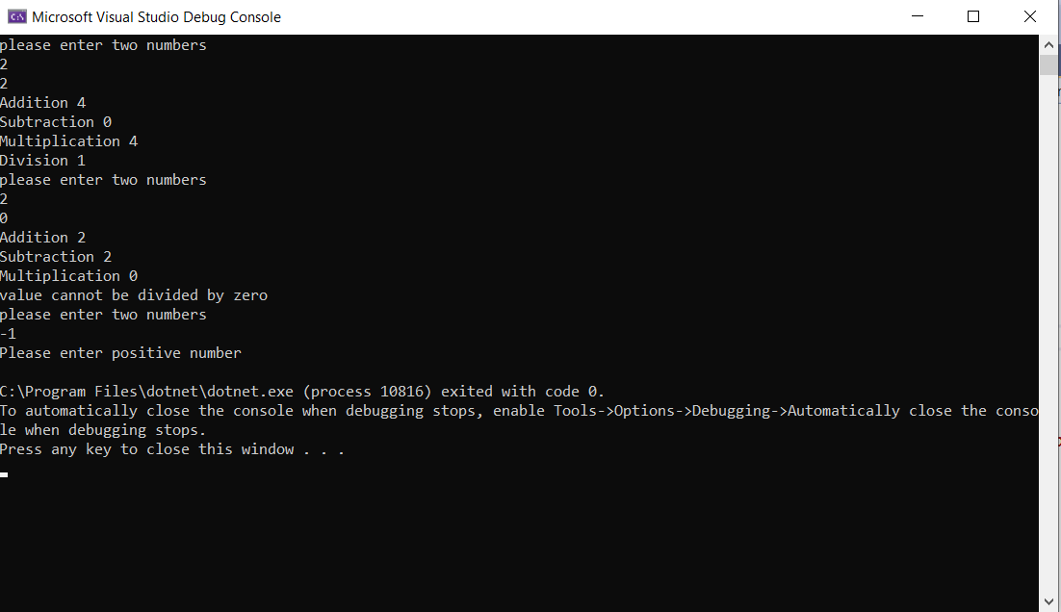

Code:

using System;

namespace Assignment_1

{

delegate void CalculateDel(double a,double b);

class Program

{

public static void addDel(double a, double b)

{

Console.WriteLine("Addition {0} ", a + b);

}

public static void subDel(double a, double b)

{

Console.WriteLine("Subtraction {0} ", a - b);

}

public static void mulDel(double a, double b)

{

Console.WriteLine("Multiplication {0} ", a* b);

}

public static void divDel(double a, double b)

{

if (b == 0)

{

Console.WriteLine("value cannot be divided by zero");

}

else

{

Console.WriteLine("Division {0} ", a / b);

}

}

public static void multiCast(CalculateDel calculateDel,double a,double b)

{

calculateDel(a,b);

}

static void Main(string[] args)

{

while(true)

{

Console.WriteLine("please enter two numbers");

double a = Convert.ToDouble(Console.ReadLine());

if (a == -1)

{

Console.WriteLine("Please enter positive number");

break;

}

double b = Convert.ToDouble(Console.ReadLine());

CalculateDel delAdd = new CalculateDel(addDel);

CalculateDel delSub = new CalculateDel(subDel);

CalculateDel delMul = new CalculateDel(mulDel);

CalculateDel delDiv = new CalculateDel(divDel);

CalculateDel multicastDel=delAdd+delSub+delMul+delDiv;

multiCast(multicastDel, a, b);

}

}

}

}