Lab-1b

AksheshKumar Chaudhari(301087120)

**Output:**

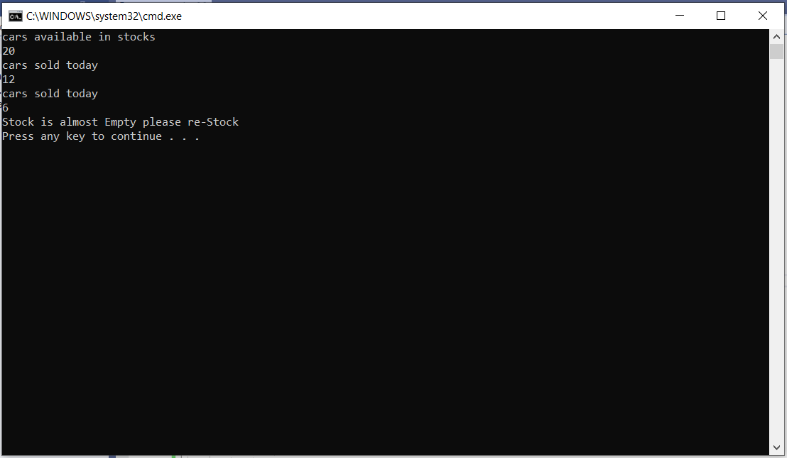

**Code:**

using System;

using System.Collections.Generic;

using System.Linq;

using System.Text;

using System.Threading.Tasks;

namespace Assignment_2

{

class Program

{

public delegate bool Order(int stockAvailability, int sold);

public bool CarSell(int stock, int sold)

{

return stock - sold > 2;

}

static void Main(string[] args)

{

Console.WriteLine("cars available in stocks");

int stockAvailability = Convert.ToInt32(Console.ReadLine());

Program p = new Program();

Order reOrder = new Order(p.CarSell);

while (true)

{

Console.WriteLine("cars sold today");

int soldCar = Convert.ToInt32(Console.ReadLine());

if (reOrder(stockAvailability,soldCar)==false)

{

Console.WriteLine("Stock is almost Empty please re-Stock");

break;

}

else

{

stockAvailability = stockAvailability - soldCar;

}

}

}

}

}