CSE-222 HOMEWORK #4
REPORT

Name: Atakan Kurt
Student# : 200104004044

To run the code
In root directory HW4_200104004044
‘make Scenario1’ command will run the test cases.
‘make clean’ will clean the output samples.

Time Analysis Of Functions:

1. [A Recursive Function] boolean checkIfValidUsername(String username):

- In base case checks if the length of the ‘username’ is less than 1. The time complexity of this check is O(1). Because it just has constant number operations.
- Second operation is checking the first character of ‘username’ is a letter or not. Since it is index check it is O(1). Because of memory with index location.
- Next check is checking if ‘username’ length is 1 or not. This also have time complexity of O(1).
It has constant number operations.
- Recursive case is slicing the ‘username’. Removing first letter and sends rest to the function again. Because of the above checks it will continue until slicing each letter in username. This means it will call recursive case ‘username’ length times. This means it has time complexity of O(n).

Overall this recursive function has O(1) + O(1) + O(1) + O(n) so the time complexity of this is O(n). n is length of the ‘username’.

2. [A Stack Function] boolean containsUserNameSpirit(String username, String password1):

- First two checks of the beginning of the code both have O(1) time complexity. Doing error handling. They have constant number of operations.
- Next there is a for loop to validate ‘password1’ and push elements from beginning to end to Stack. It iterates through each password character. Inside of the loop it does O(1) complexity operations. So this loop has time complexity of O(n). (n is length of ‘password1’.)
- Next there are 2 checks to validate ‘password1’ again checking length of it and brackets inside of it. These are O(1) again because of constant number of operations.
- Lastly we have a while loop that iterates until our stack is empty. So it will iterate inside for number of elements in our stack. Inside there are O(1) complexity operation. There is pop method which is O(1) because there is no searching when popping we use the memory location of last element. Also there is ‘contains’ operation which checks the given character is present in the ‘username’. So it iterates through username of its length. Overall if we call ‘username’ length (m) and ‘password1’ length (n) The overall while loop has O(n*m) time complexity.

Overall this function will have O(1 + n + 1 + n*m) and we can say O(n*m) time complexity this function have.

3. [A Stack Function] boolean isBalancedPassword(String password1):
- First there are password1 validity check. Which is O(1) time complexity. This have constant number of operations.
- Next we have a for loop that iterates through elements of ‘password1’. Inside of it it checks the characters and if it is a opening brackets it pushes to the stack. Pushing has O(1) time complexity. If it is closing brackets it checks whether the last element of stack matches. This operations takes O(1) times. So it will takes O(n) where n is length of ‘password1’.
- At last it checks whether all brackets in stack is matched with their closing brackets by checking the stack is empty or not. It has O(1) time complexity. Doing constant operations.

Overall O(1 + n + 1) = O(n) is the time complexity of this function where n is length of ‘password1’.
4. [A Recursive Function] boolean isPalindromePossible(String password1):
- The first step in the function is to replace all occurrences of the brackets with an empty string, which can be done in linear time O(n) where n is the length of the ‘password1’.
- Next is checing if the new cleaned string length is smaller than 1 or not. This takes O(1) time complexity.
- After that I count the first 2 letter in the ‘password1’. By iterating through it. So this operation costs O(n) time complexity.
- If the count of first character is even, the function creates a new string by removing all selected letter. And call itself with the new string. Removing takes O(n) times.
- If the first letter is odd and second is even, the function creates a new string by removing all selected letter. And call itself with the new string. Removing takes O(n) times.
- If both returns false than there is no palindrome possible. Function will return false. This takes O(1) time.

Overall the time complexity of this function is O(n^2). Because each recursive call it does O(n) times operation and if it calls n times the recursive function it will end up this time complexity.

5. [A Recursive Function] boolean isExactDivision(int password2, int [] denominations):
- First checking password smaller than 0 and after that equal to zero. These checks will take O(1) constant time.
- After that we iterate denominations array and checking if subtracting from ‘password2’ is making the answer 0. If it is making it 0 we return true. This for loop will take O(n) n where number of denominations.
- After that we iterate the every possible subtraction case by looping through them and calling the function itself on each element recursively. If one is returns true it will return true. This for loop takes O(n) times but calling the recursive function itself again takes O(n) times so it is O(n^2) time complexity.
Overall this recursive function has the time complexity of O(n^2).

Provided Sample Test Cases

SecuritySystem s1 = new SecuritySystem();
int[] n = {4, 17, 29};
// Test 1
System.out.println("Test 1");
s1.login("sibelgulmez", "[rac()ecar]", 74, n);
// Test 2
System.out.println("Test 2");
s1.login("", "[rac()ecar]", 74, n);
// Test 3
System.out.println("Test 3");
s1.login("sibel1", "[rac()ecar]", 74, n);
// Test 4
System.out.println("Test 4");
s1.login("sibel", "pass[]", 74, n);
// Test 5
System.out.println("Test 5");
s1.login("sibel", "abcdabcd", 74, n);
// Test 6
System.out.println("Test 6");
s1.login("sibel", "[[[[]]]]", 74, n);
// Test 7
System.out.println("Test 7");
s1.login("sibel", "[no](no)", 74, n);
// Test 8
System.out.println("Test 8");
s1.login("sibel", "[rac()ecar]]", 74, n);
// Test 9
System.out.println("Test 9");
s1.login("sibel", "[rac()ecars]", 74, n);
// Test 10
System.out.println("Test 10");
s1.login("sibel", "[rac()ecar]", 5, n);
// Test 11
System.out.println("Test 11");
s1.login("sibel", "[rac()ecar]", 35, n);

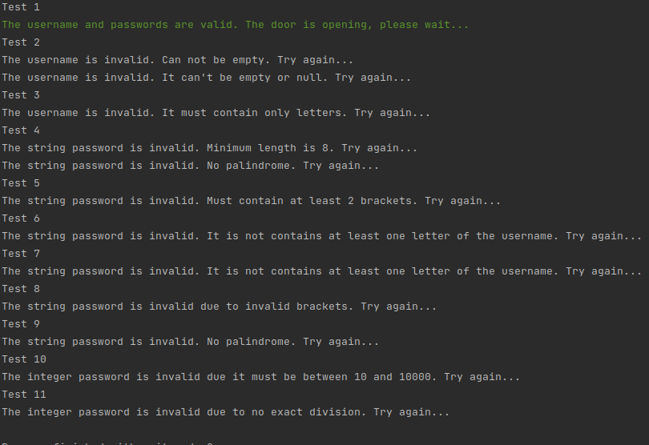
Design Explain:
1. In first function I checked the first letter and than sliced it. And checked it if its letter or not. After that send it to the function itself again. If it can go to length of 1 by not returning 0 it will return true.

2. In this function I also validate the password1 and username. After that I added each password1 character in the stack than some validations I checked each stack pop element if its present in the username. If it is I returned true. If it exist the loop and not returned true than I return false.

3.In this after validation I iterated the password1 and added open brackets to the stack. If I come acrossed with closing bracket then I get the top element in the stack than checked if they are matching. If they are not matching I returned false. If they are I iterated every character of the password1. If one password is succesfully iterated than our stack must be empty. So at last I checked that and returned true based on that.

4. In this function after removing the brackets to not get confused and mess the algorithm I decided a base case. I thinked like to be a palindrome possible each letter must be even number or there can only one odd number of letter and rest must be even number. So even though I come across with odd numbered letter when iterating I had to skip to the next element. Because of that I counted first and second letter of the ‘password1’. If one is odd I have chosen the other one. After I have chosen one I removed it from the string and called function itself on that new string. If both is odd number (first and second) than I returned false.

5. In this function my logic was checking every possible outcome. I applied the logic of binary search kind a like. For example our number is 74 and denominations are 4, 17, 29. I removed one by one each and assigned it to an array. 70, 57, 45. After that I called the function itself on each and continued the same for if one has reached the 0. If not in the end it returns false. If even one reaches the 0 it returns true.

