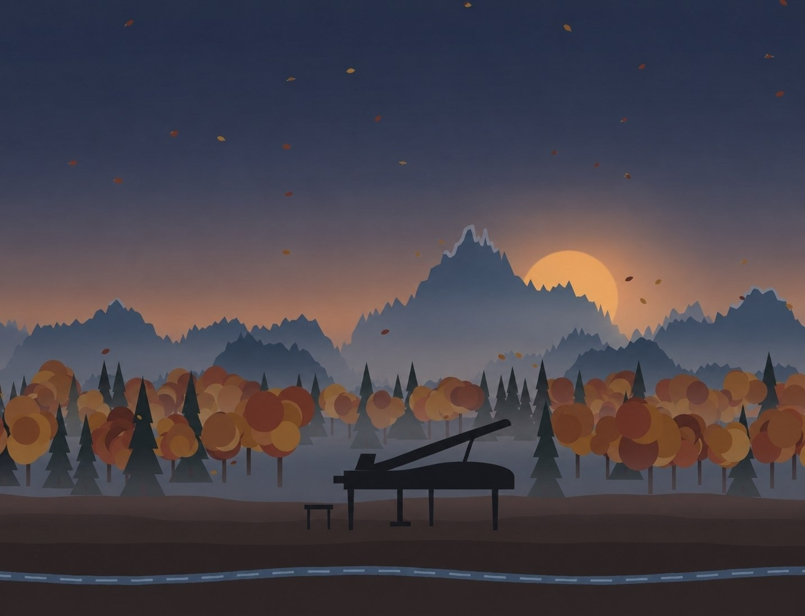

Dream String
Music leisure centre
in the Kishi Almaty valley, Almaty
SITE ANALYSIS, RULES AND CONCEPT · SECTIONS 1–3
Academic year 2026/2027  Prof. Giangabriele Fini | Eva Kulikovskaya  Arch3-26-2r

CONTENTS
Introduction p. 1
SECTION 1 · CONTEXT p. 2
1.0. Topic choice: function and users p. 3
1.0.1. Function and users of the centre p. 3
1.0.2. Does this function already exist? p. 4
1.1. Site choice p. 6
1.1.1. The site p. 6
1.1.2. Cadastre p. 9
1.1.3. Distances p. 14
1.1.4. Terrain p. 20
1.1.5. Water: two rivers at the site p. 23
1.1.6. Geology and natural hazards p. 25
1.1.7. Climate, sun and wind p. 26
1.1.8. The 110 kV line and the substation p. 27
1.1.9. Planning regulations: how high the centre can be p. 27
1.1.10. Conclusion: what the site asks for p. 30
1.2. Genius loci p. 31
1.2.1. Atmosphere p. 31
1.2.2. Associations p. 33
1.2.3. Nature as part of oneself p. 35
1.2.4. Conclusion: from feelings to architecture p. 36
1.3. Architectural language p. 37
1.3.1. Around the site: neighbours and materials p. 37
1.3.2. The whole neighbourhood: style, landmarks and recurring motifs p. 41
1.3.3. Project materials p. 43
1.3.4. Colour palette p. 44
1.3.5. A roof to walk on: from the ground to the amphitheatre p. 45
1.3.6. References p. 47
1.3.7. Conclusion p. 50
1.4. Urban zoning p. 51
1.4.1. Functional zoning p. 51
1.4.2. Street network and access p. 52
1.4.3. Access concept p. 53
1.4.4. Neighbour project: Autumn Dream p. 55
1.4.5. Conclusion p. 56
Sources of Section 1 p. 57
SECTION 2 · RULES p. 59
2.1. Typologies p. 60
2.1.1. Organising the music leisure centre p. 60
2.2. Analogue projects p. 61
2.2.1. King’s College School Music School, London p. 61
2.2.2. Toho Gakuen School of Music, Tokyo p. 63
2.2.3. Cultural Centre and Music School, Meco p. 65
2.2.4. COFCO Cultural & Health Center, Shanghai p. 67
2.2.5. Dushan Leisure Center, Songyang p. 69
2.2.6. Ku.Be – House of Culture and Movement, Frederiksberg p. 71
2.2.7. ACROS Fukuoka Prefectural International Hall, Fukuoka p. 72
2.2.8. Moesgaard Museum, Aarhus p. 74
2.2.9. Fuji Kindergarten, Tokyo p. 75
2.2.10. House of Music (Musikkens Hus), Aalborg p. 76
2.2.11. Kilden Performing Arts Centre, Kristiansand p. 77
2.2.12. Darius Milhaud Conservatory, Aix-en-Provence p. 78
2.2.13. Summary of the twelve analogues p. 80
2.3. Norms and standards p. 81
2.4. Room programme p. 89
2.4.1. Music leisure centre p. 89
2.5. Functional diagram p. 92
2.5.1. Functional diagram of the centre with all rooms p. 93
2.5.2. Routes of the users p. 94
2.5.3. Transformable spaces and unity with nature p. 95
2.6. Variants of the room arrangement p. 97
2.6.1. Comparison and choice p. 100
2.7. Conclusion of Section 2 p. 101
Sources of Section 2 p. 102
SECTION 3 · CONCEPT p. 103
3.1. Concept analyses p. 104
3.1.1. Connections and boundaries: pluses and minuses p. 104
3.1.2. Simple climate analysis: sun and wind p. 106
3.1.3. Positive and negative space, alignment p. 108
3.2. Narrative p. 110
3.2.1. Dream String p. 110
3.2.2. The search for the form: sketches, five variants and the final sketches p. 111
3.2.3. Virtual Lego p. 116
3.3. Inspiration elements p. 118
3.3.1. Elements taken from the analogues: E1–E5 p. 118
3.3.2. What each project gives to the concept p. 120
3.4. Volume study p. 121
3.5. Drawings of the centre p. 125
3.6. Conclusion of Section 3 p. 130
Sources of Section 3 p. 131

Introduction
A place for music, play and quiet movement for the children and families of the valley.
Some places you understand from a map, others with your heart. This site is both: a small triangle of forest at the fork of the Kishi Almaty (Malaya Almatinka) river, where the city ends and the mountains begin.
The modern foothill landscape of Almaty calls for public places that bring together:
- music and play for children after school,
- a meeting place for families of the valley,
- harmony with the surrounding nature – forest, river and mountains.
This project is more than a music school. It is an attempt to catch the spirit of the place – the calm of early autumn in the mountains and the voice of the river that never sleeps – and turn it into architecture. Studying the site, its terrain and climate, the architecture of its neighbours and the functional zoning leads to the concept of a music leisure centre whose façades are a sound track: fins of different heights rise and fall like recorded music around blocks of one, two and three storeys, every roof can be walked on, and at the corner of the hall the building opens to the forest with an amphitheatre.
“On this site time seemed to slow down. I wanted to stay here and live.”
— first impression of the site, September 2026
The Kishi Almaty and its Esentai branch next to the site, September 2026.
01  Topic and site  1.0–1.1: function, users, cadastre, distances, terrain, water, power line, regulations | 02  Genius loci  1.2: atmosphere, five senses, associations, from feelings to form | 03  Architectural language  1.3: neighbours, district, materials, palette, the roof to walk on, references | 04  Zoning  1.4: functions, roads, access and parking, the neighbour project
05  Typologies  2.1: organising a leisure centre: five schemes | 06  Analogues  2.2: 12 music and leisure buildings – pros and cons, functional diagrams | 07  Norms  2.3: accessibility, evacuation, rooms, café, site and parking | 08  Dimensions and functions  2.4–2.7: 73 rooms, functional diagram, routes, variants
09  Concept analyses  3.1: connections, sun and wind, alignment, six placements | 10  Narrative  3.2: Dream String, my sketches, five variants, the sound track, virtual Lego | 11  Elements  3.3: five elements taken from the analogue projects | 12  Volume study  3.4–3.5: the centre among its neighbours, general plan, plans, sections, elevations

SECTION 1
Context
topic · site · genius loci · architectural language · zoning
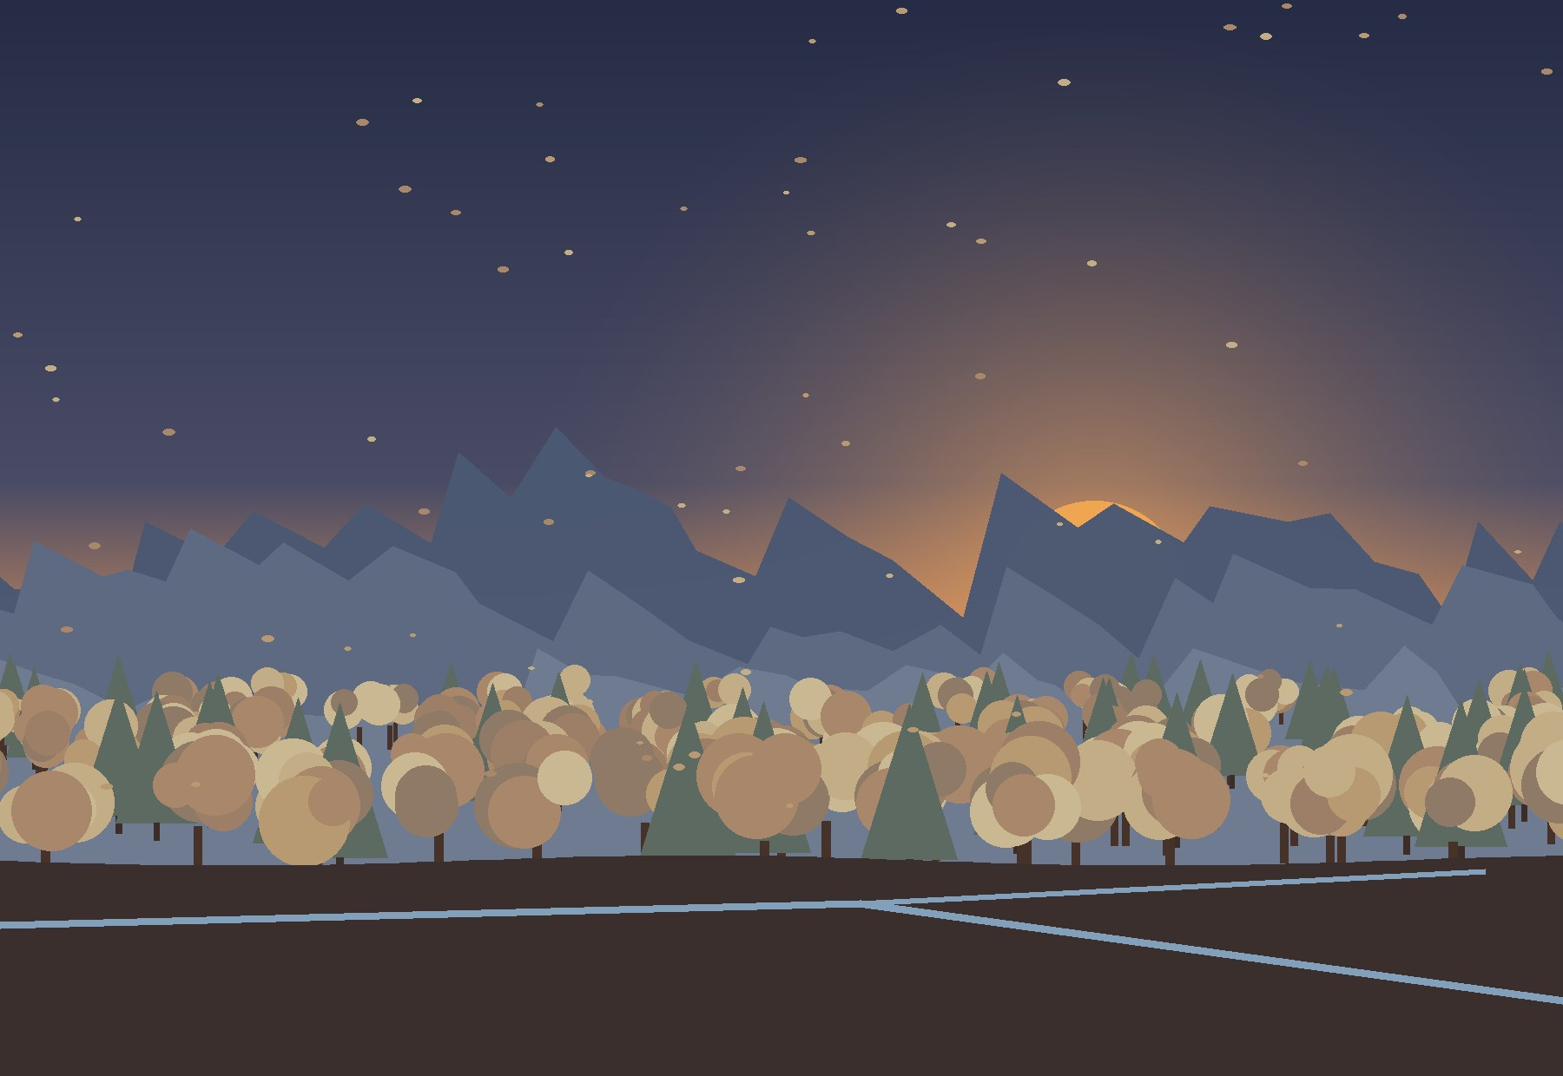
Section 1 answers the question “where and for whom?”: from the choice of topic and site, through the atmosphere of the place and the language of the neighbours, to zoning and the first concept diagram.

1.0. Topic choice: function and users
The course brief is a mid-rise building with a public leisure function for about 250 users. My topic is a music leisure centre for the children and families of the valley. The topic comes from the place, not from an abstraction: families live in the upper Kishi Almaty valley, but there is not a single place for music, culture and children’s free time (1.0.2), and the valley itself sounds – the river, the wind in the poplars, the echo of the mountains (1.2).
Why so low. The foothill zone of Almaty limits housing to three storeys and 12 m; a cultural building may rise up to 25 m (1.1.9). The centre still stays low – at most three storeys and a lower level: the roof garden is at 7.5 m, the highest roofs at 11.7 m (parapets 12 m), and only the free-standing fins of the façade rise higher, to up to 25 m – so that it remains below the crowns of the old poplars and does not argue with the mountains.

1.0.1. Function and users of the centre
The neighbouring plot will host a music leisure centre – not a school with exams, but a place where children and families spend their free time with music: lessons and ensembles, a small concert hall, a recording studio, a café where parents can wait, a children’s club and a quiet hall for movement and meditation.
Children 6–11  after school, often with a parent: music lessons, choir, eurhythmics, games and homework in the club | Teenagers 12–17  bands and rehearsals, recording, their own concerts – a place for independence in the evening | Parents and families  waiting in the café, family classes, weekend concerts and festivals by the river | Valley residents  evening classes for adults, concerts, a café on the terrenkur, a quiet hall for yoga and meditation

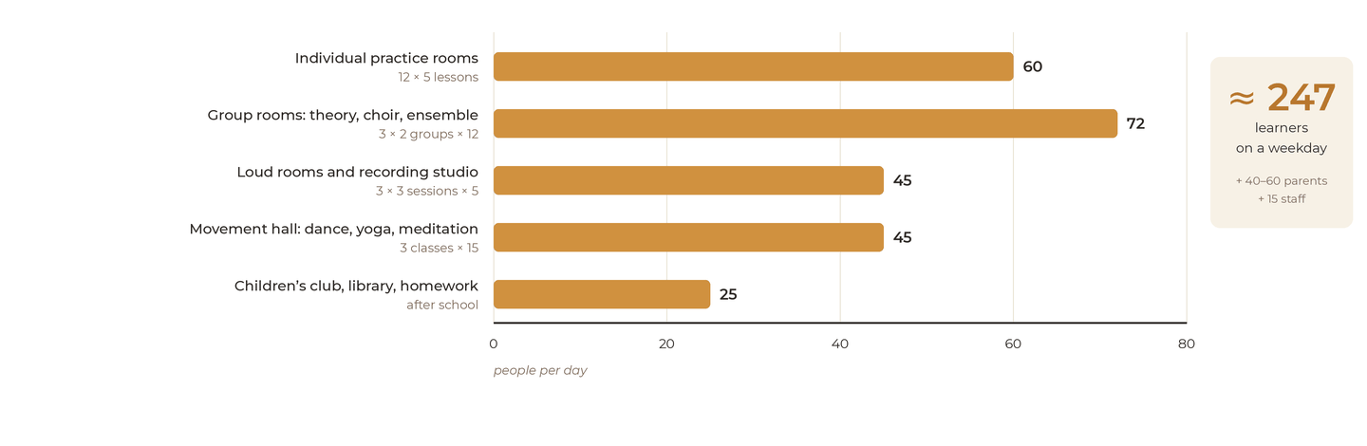
How many people come on a weekday: ≈ 247 learners + 40–60 parents + 15 staff ≈ 300–320 people (calculated from the room programme, 2.4).
The calculation confirms the scale of the brief: with 12 individual rooms, three group rooms, loud rooms and a movement hall, the centre receives about 250 learners a day – this is the user base of the project.
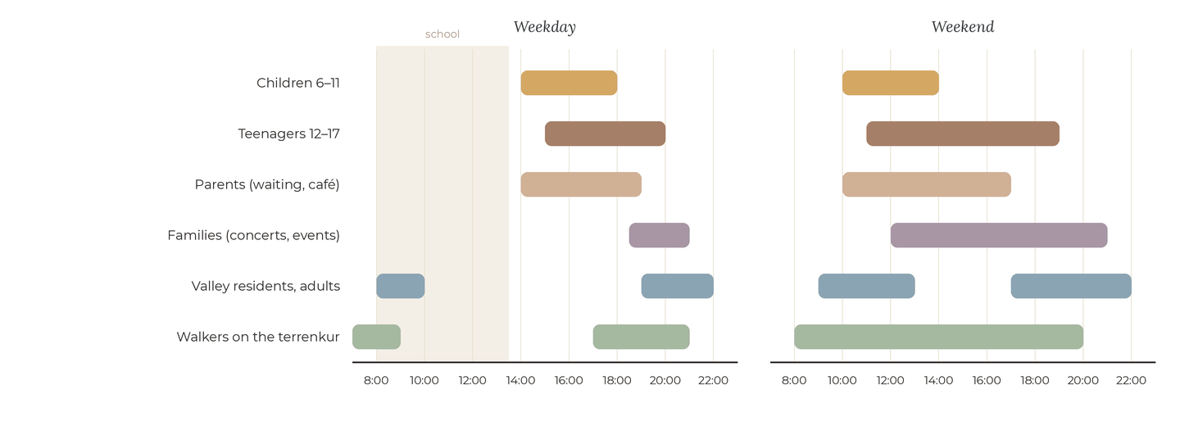
When the centre is used: on weekdays the rhythm follows the school timetable; at weekends the centre becomes a family place.

1.0.2. Does this function already exist?
Nearest facility compared with the catchment radius in the norms (SP RK 3.01-101-2013). Data: 2GIS and OpenStreetMap, September 2026.
2GIS screenshot, search “music school” (September 2026): the nearest studios – Sax & piano (3.2 km), SEN Music Voice, Central – and the Palace of Schoolchildren are in the city lower down the valley; there are no music schools near the site.
In the district. Within 3 km of the site there is no state music or art school, no house of culture and no library. There are only private studios – Sax & piano (≈ 3.2 km) and Artkey (≈ 4.4 km) – and the MaxKids and Faraon clubs (2.1–2.3 km); the nearest state children’s music school is about 5.6 km away, in the dense city below. In the city. Almaty has about eight state children’s music schools (17 state institutions of supplementary education, more than 23,000 children, 2021) and a number of private studios. Almost all of them are in the central districts; in the upper Kishi Almaty valley there is none.
Function | Nearest to the site | In the city | Missing here?
Music lessons for children | private studios, 3.2–4.4 km; state music school, 5.6 km | about 8 state music schools + private studios, mostly in the centre | yes
Concerts, small stage | concert halls in the city centre, ≈ 6 km | many, but far away and rarely for children | yes
Clubs, library, after-school place | private clubs MaxKids (2.1 km) and Faraon (2.3 km); libraries – from 4 km | houses of culture and libraries in the centre | yes
Sport and fitness | Play-Off football pitch, 1.7 km | many | no – only as a quiet addition
Café, meeting place | Vegan café, 0.5 km; Bellagio restaurant, 1.0 km (for adults) | many | partly – a family café

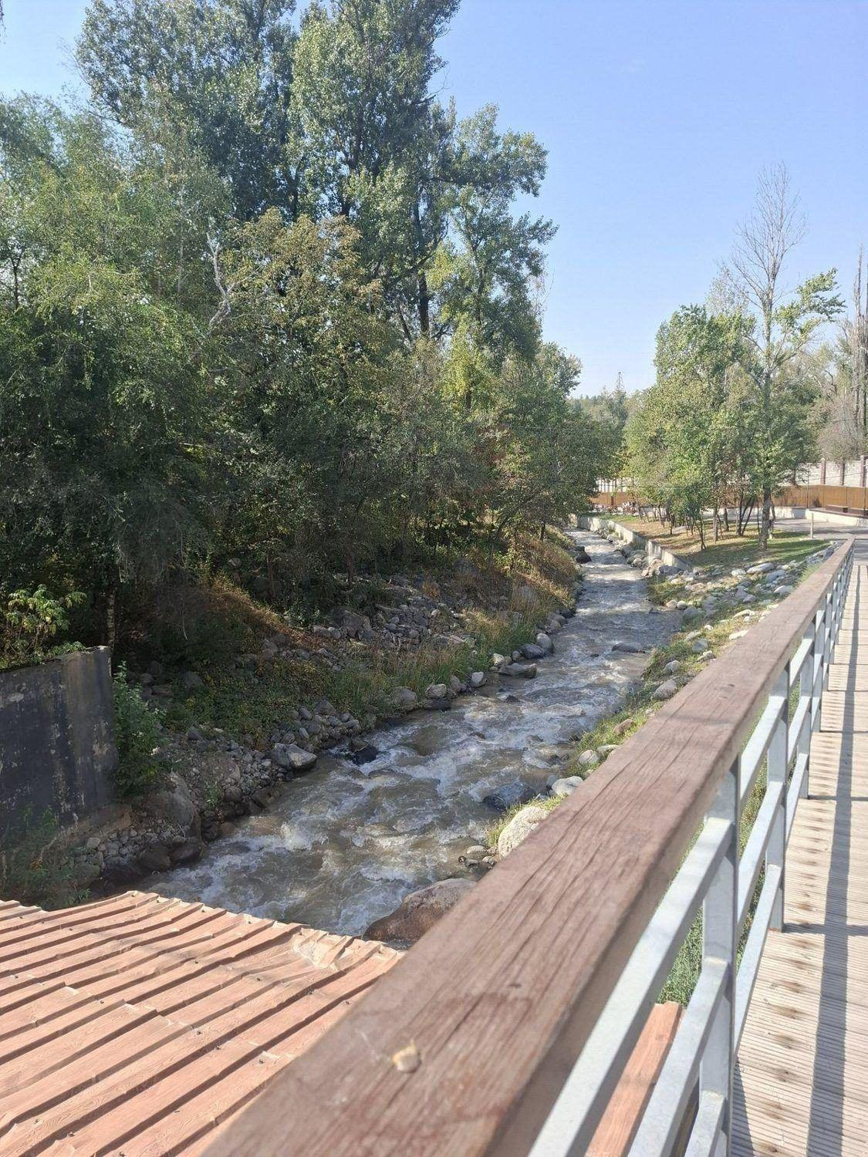
The terrenkur at the site – a safe path along which children can walk to the centre.

CONCLUSION · what it means for the project
The valley has homes, nature and sport, but no place for music, culture and children’s free time: the nearest state music school is 5.6 km away, private studios 3–4 km, and the city’s music schools are concentrated in the centre. The function is missing – so the topic is the right one.
The centre must work after school and in the evening (≈ 250 learners on a weekday – the scale of the brief), be reachable on foot along the terrenkur, have a café where parents wait, and not duplicate sport: movement remains a quiet addition – dance, yoga, meditation.

1.1. Site choice

1.1.1. The site
The chosen site is located:  - in the city of Almaty, Medeu district;  - in the Kishi Almaty (Malaya Almatinka) valley – the “gateway” from the city to Medeu and Shymbulak;  - on Kerei-Zhanibek khandar street – the continuation of Dostyk avenue, about 1.5 km above its end;  - between the two branches of the river – the Kishi Almaty and the Esentai – down to the fork where they divide.  43°11′32″ N · 76°59′17″ E | altitude ≈ 1,155 m  building plot 688 1.48 ha  park plot 278 0.92 ha  to the city centre ≈ 6 km  to Medeu ≈ 7 km  to the terrenkur 0 m

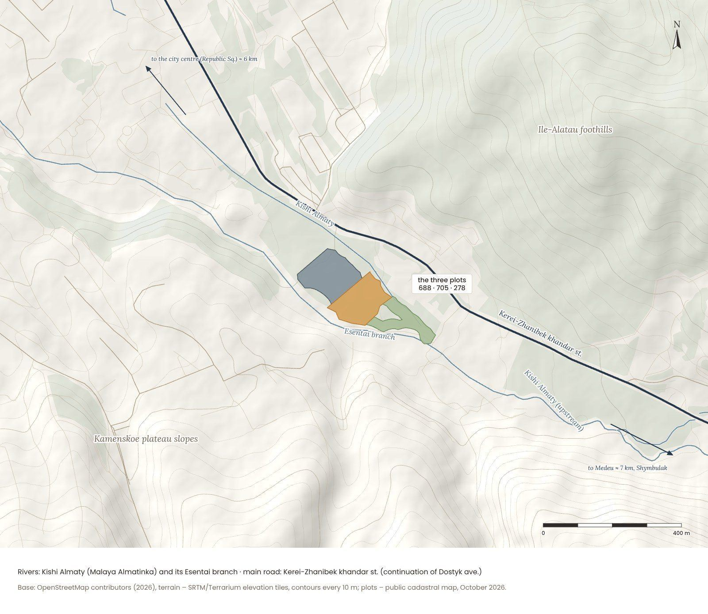
Location of the site in the upper Medeu district: roads, rivers and terrain. Base: OpenStreetMap contributors, SRTM 30 m digital elevation model.

The centre uses two plots between the two branches of the river. Plot 20315904688 (14,844 m², about 167 × 110 m) holds the building; site 278 – a narrow forest wedge about 180 m long down to the fork – becomes the riverside park of the centre. In September 2026 this site was registered again in the cadastre as plot 20315904786 (9,228 m², the same address); the maps of this work use the new outline. The third plot, 20315904705 (16,530 m²) to the north-west, belongs to the neighbouring project – the housing “Autumn Dream” – and is shown on every map. The Kishi Almaty runs along the north-eastern side, the Esentai branch along the south-western one, where the terrenkur goes; the eastern tip of the wedge touches the fork with a small bridge. The main street of the valley runs about 65–110 m to the north-east, behind a belt of trees.
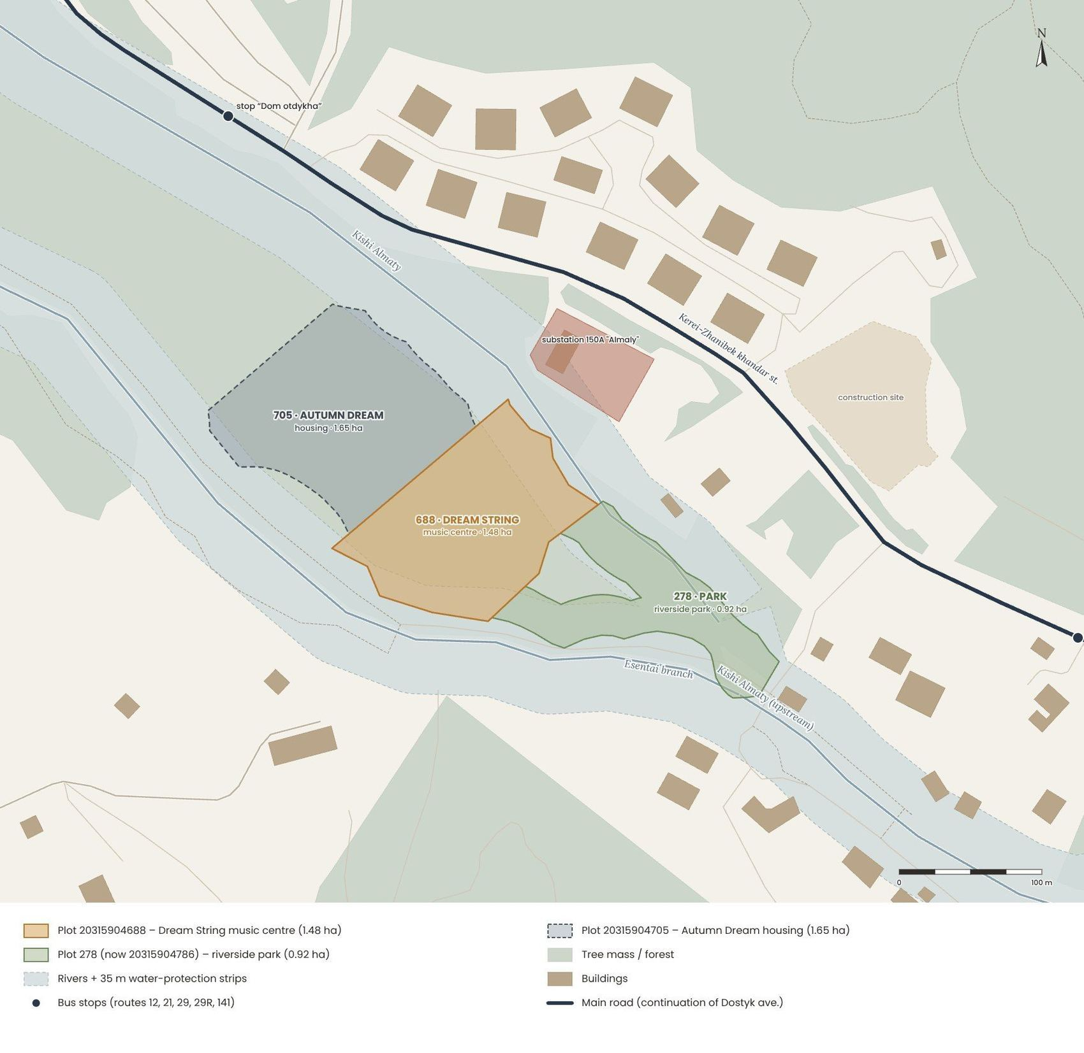
Site plan: the three plots between the river branches – 688 (music centre), 278 / …786 (riverside park) and 705 (Autumn Dream). Outlines from the public cadastral map (map.gov4c.kz, October 2026), base – OpenStreetMap.
This place was chosen for a rare combination of qualities: an untouched stand of trees and two rivers in the middle of an already built-up valley; the terrenkur that brings children here on foot; two bus stops within 300 m; and a real social need – the district has almost no public, cultural or educational facilities. Plot 688 is intended for a public building already (a hotel complex), so a cultural centre continues its purpose.

CONCLUSION · what it means for the project
A rare piece of forest between two rivers – inside the city, 6 km from the centre. Trees and water are the main value of the place: build one compact public building, keep the rest as a park, and give the valley what it lacks – music.

SWOT analysis

Strengths  - unique setting: forest, two river branches, mountain views and clean air  - the cadastral purpose of plot 688 is already public (a hotel complex)  - quiet, low-density and prestigious district  - terrenkur right at the site  - two bus stops within 210–280 m – 5 routes to the city centre and Medeu  Opportunities  - a music leisure centre – a new public heart of the valley  - one landscape route: river + forest + terrenkur (an extension to Medeu was announced in 2026)  - eco-architecture of timber and stone under pitched roofs that echo the mountains  - growing demand for wellbeing near Medeu and Shymbulak  - clubs and studios for children who live far from school |  | Weaknesses  - two narrow plots (1.48 + 0.92 ha) squeezed between two rivers  - the 35 m strips and the 110 kV line leave only ≈ 0.75 ha of free land  - few social facilities: School No. 47 at 1.7 km, a private kindergarten at 1.4 km, a state one at 4.1 km  - mini-market at 1.2 km, supermarket and pharmacy at 1.3 km – car dependence  - cold air pooling in the valley on winter nights  Threats  - mudflows and seasonal floods of the Kishi Almaty  - seismicity of 9–10 points (MSK-64 scale)  - pressure of dense development on the foothills  - weekend traffic to Medeu and Shymbulak  - loss of trees during construction; the moratorium on construction in the foothills (2025)

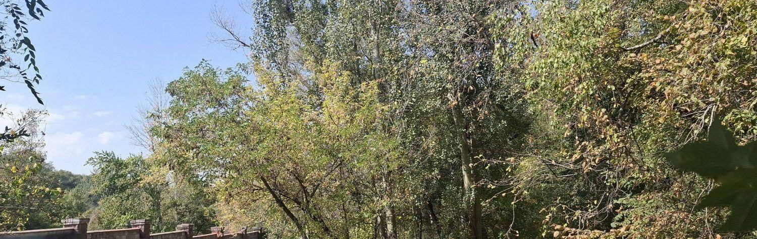
The golden poplars on the site are its main asset, which no project can recreate.

CONCLUSION · what it means for the project
The strengths of the site are natural – they cannot be created artificially – while most of the weaknesses are urban: missing services, distances, car dependence. That is why the concept is one careful public building that keeps the forest and adds what the district lacks – a music leisure centre with a riverside park.

1.1.2. Cadastre
According to the public cadastral map of Kazakhstan (map.gov4c.kz), all three plots belong to settlement land. Plot 688, where the building of the centre stands, is intended for a hotel complex; its public, cultural function continues this purpose. Site 278 was registered again on 15.09.2026 as plot 20315904786 with a smaller area (9,228 m² instead of 11,179 m²) and the purpose of a hotel and apartment complex with an underground car park; in my concept it becomes the riverside park of the centre – most of it lies in the water-protection strips anyway. Plot 705 is given to the neighbouring housing project.
Park plot | riverside park of the centre (proposal)
Cadastral number | 20315904278 → 20315904786 (since 15.09.2026)
Address | Almaty, Medeu district, 151B Dostyk ave.
Land category | settlement land (cities, towns and rural settlements)
Type of right | permanent land use
Intended purpose | construction and operation of a hotel and apartment complex with an underground car park
Area | 9,228 m² (0.92 ha); before: 11,179 m²

Building plot | building plot of the music leisure centre
Cadastral number | 20315904688
Address | Almaty, Medeu district, Kerei-Zhanibek khandar st., plot 147/3
Type of right | joint common ownership
Intended purpose | for the operation and maintenance of a hotel complex
Area | 14,844 m² (1.4844 ha)

Neighbour plot | Autumn Dream housing (separate project)
Cadastral number | 20315904705
Address | Almaty, Medeu district, Kerei-Zhanibek khandar st., plot 147/4
Type of right | code 02 on the public cadastral map
Intended purpose | individual residential house (the project proposes stepped housing)
Area | 16,530 m² (1.653 ha)

 | 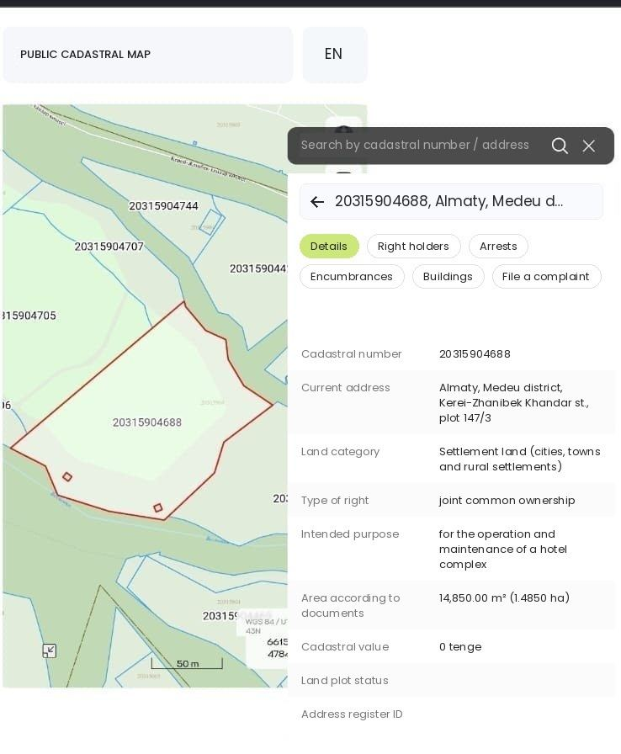 | 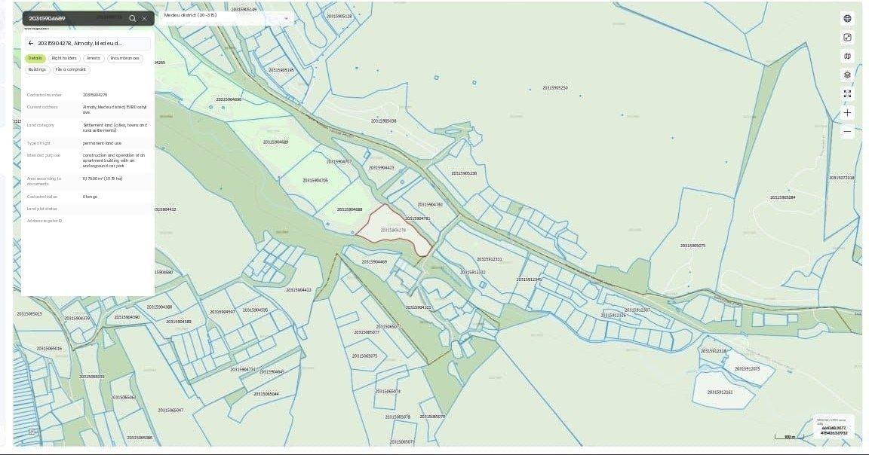
Screenshots of the public cadastral map: the site (left), the neighbouring plot (centre) and their position in the valley (right). The map of 1.1.1 shows all three plots: 688, 278 / …786 and 705.
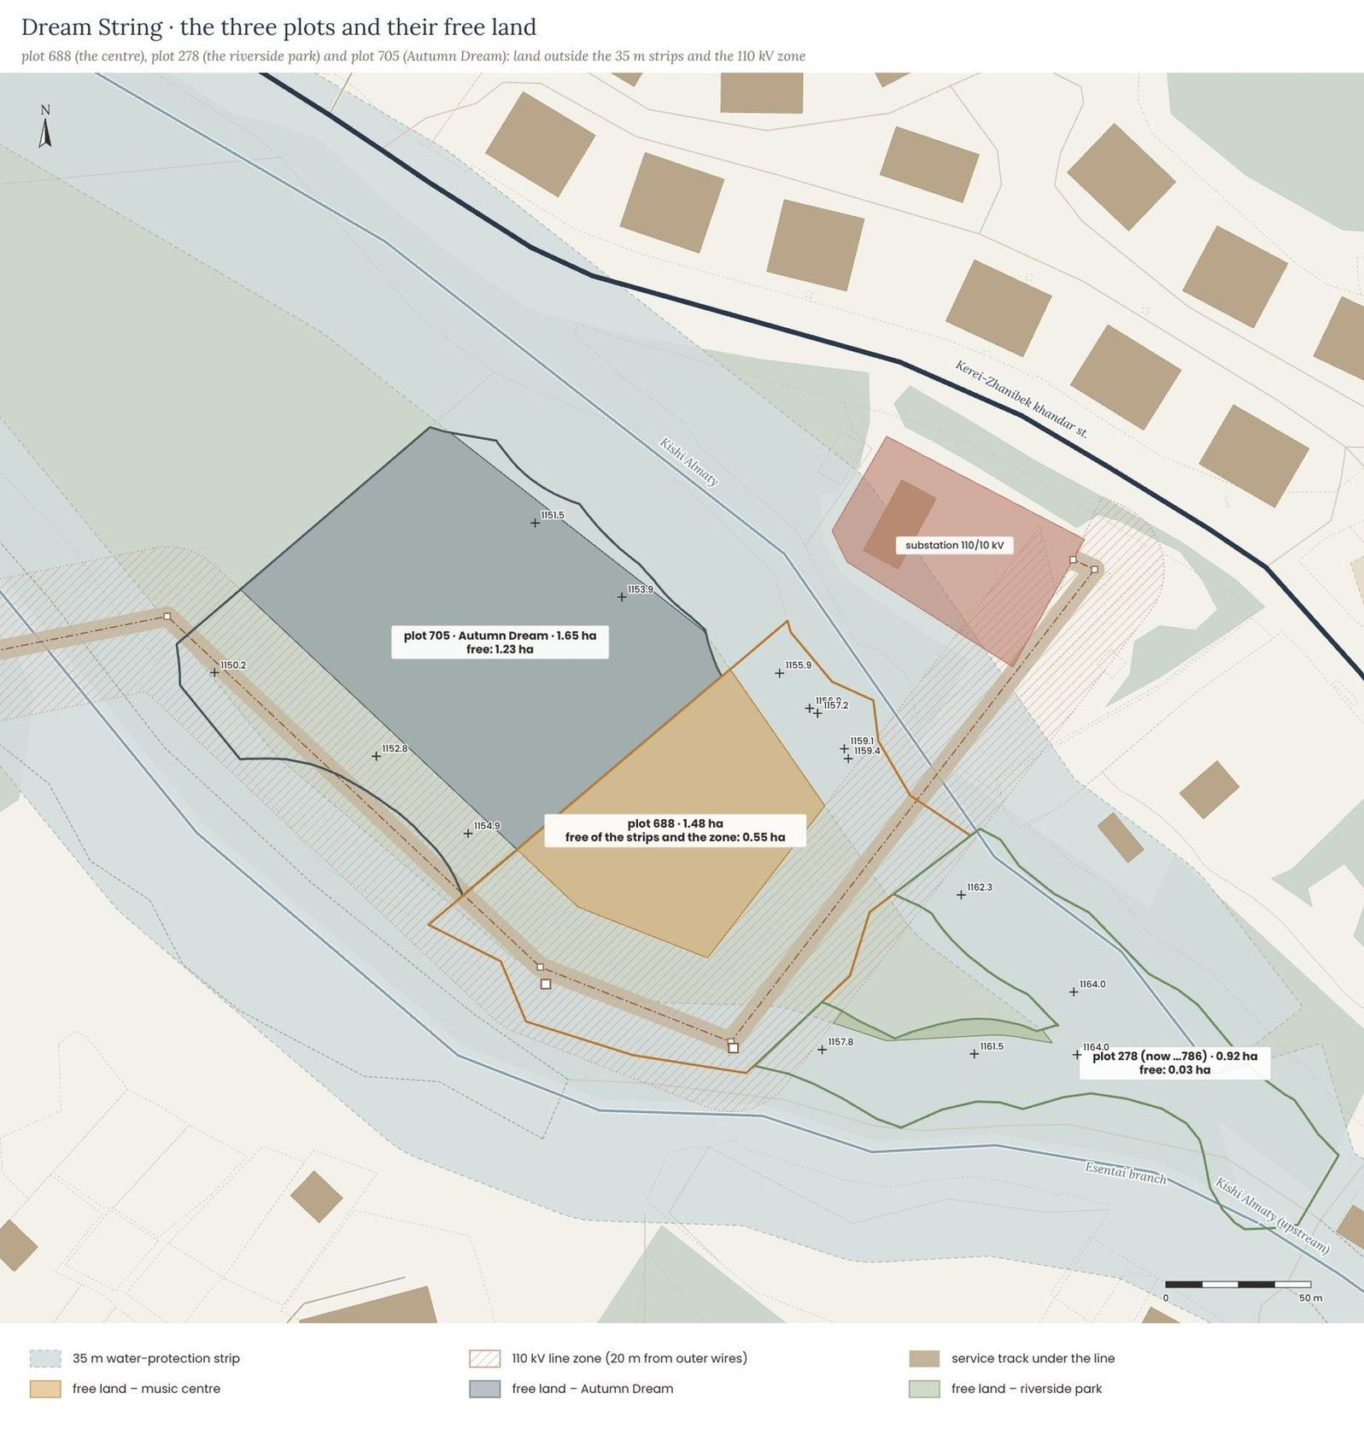
Area: 1.48 ha + 0.92 ha, and 1.65 ha of the neighbouring plot 705. All plots are squeezed between the river branches. Almaty akimat resolution No. 4/580 (2020, amended in 2022) sets a 35 m water-protection strip for the Esentai, and the national Rules of 2025 do not allow a strip narrower than 35 m for the Kishi Almaty either. On top of that the 110 kV line crosses plot 688 and site 278 with its 20 m protection zone and service track (1.1.8). Outside the strips and the zone only about 0.55 ha of plot 688 and 0.03 ha of site 278 remain free for building (1.23 ha of plot 705) – enough for one compact building of about 0.15 ha with its roof walk and amphitheatre.

Dimensions, footprints and ground levels
Along the cadastral outlines plot 688 is about 167 × 110 m, site 278 / …786 a wedge about 180 m long and up to 110 m wide, and plot 705 about 151 × 131 m. All of them are separated from Kerei-Zhanibek street by the Kishi Almaty and a belt of forest. The ground rises by about 21 m across the three plots – from the north-west corner of plot 705 (1,148 m) to the bridge in the south-east (1,169 m); under the centre the ground lies at about 1,154.6–1,158.0 m, so its ground floor is set at 1,155.00 and the amphitheatre uses the rise of about 3 m towards the south-east.
Dimensions of the three plots and ground levels (the zone of the 110 kV line is shown in 1.1.8). Outlines – public cadastral map (October 2026); levels – SRTM 30 m, rounded.
Parameter | Plot 20315904688 (centre) | Site 278 / …786 (park) | Plot 20315904705 (Autumn Dream)
Area | 1.48 ha | 0.92 ha (before 1.12 ha) | 1.65 ha
Size of the cadastral outline | ≈ 167 × 110 m | ≈ 180 × 114 m (wedge) | ≈ 151 × 131 m
Free of the 35 m strips and the 110 kV zone | ≈ 0.55 ha | ≈ 0.03 ha, two small pieces | ≈ 1.23 ha
Ground levels | ≈ 1,153 – 1,162 m · difference ≈ 9 m | ≈ 1,157 – 1,169 m · difference ≈ 12 m | ≈ 1,148 – 1,155 m · difference ≈ 7 m
Distance to Kerei-Zhanibek st. | ≈ 95 m | ≈ 110 m (beyond the river and trees) | ≈ 65 m
Use in the project | the centre (footprint ≈ 1,320 m²), the roof walk, the amphitheatre and the square | riverside park, playground, paths to the fork | Autumn Dream – stepped housing, 4 sections
Ground floor | 1,155.00 (±0.00) | — | separate project

CONCLUSION · what it means for the project
Plot 688 gives the building about 0.55 ha of free land between the river strips and the zone of the line – enough for one compact building, not for a long one. Site 278 is almost all river strip: it becomes the riverside park of the centre. The difference in level (≈ 9 m across plot 688) is an opportunity: the loud rooms and the garage can be tucked into the slope.

Water-protection strips: the law and the neighbours
On site it was visible that some houses stand much closer than 35 m to the Esentai and the Kishi Almaty. So the rules were checked once more in the official legal database (adilet.zan.kz):
Document | What it says for our plots
Almaty akimat resolution No. 4/580 of 15.12.2020 (Annex 2 as amended on 24.08.2022, No. 3/411) | strips of 35 m for the Esentai canal (from the upper edge of the channel) and the Esentai (Vesnovka) river; water-protection zones of about 120 m. The Kishi Almaty is not listed separately.
Rules for establishing water-protection zones and strips, order No. 120-NK of 09.06.2025 | minimum strip of 35 m (wider on steep banks); in settlements the strip cannot be narrower – only the zone may be reduced.
Strip regime (resolution 4/580) | no buildings except water-management structures, bridges and recreation without buildings; no permanent parking of cars.

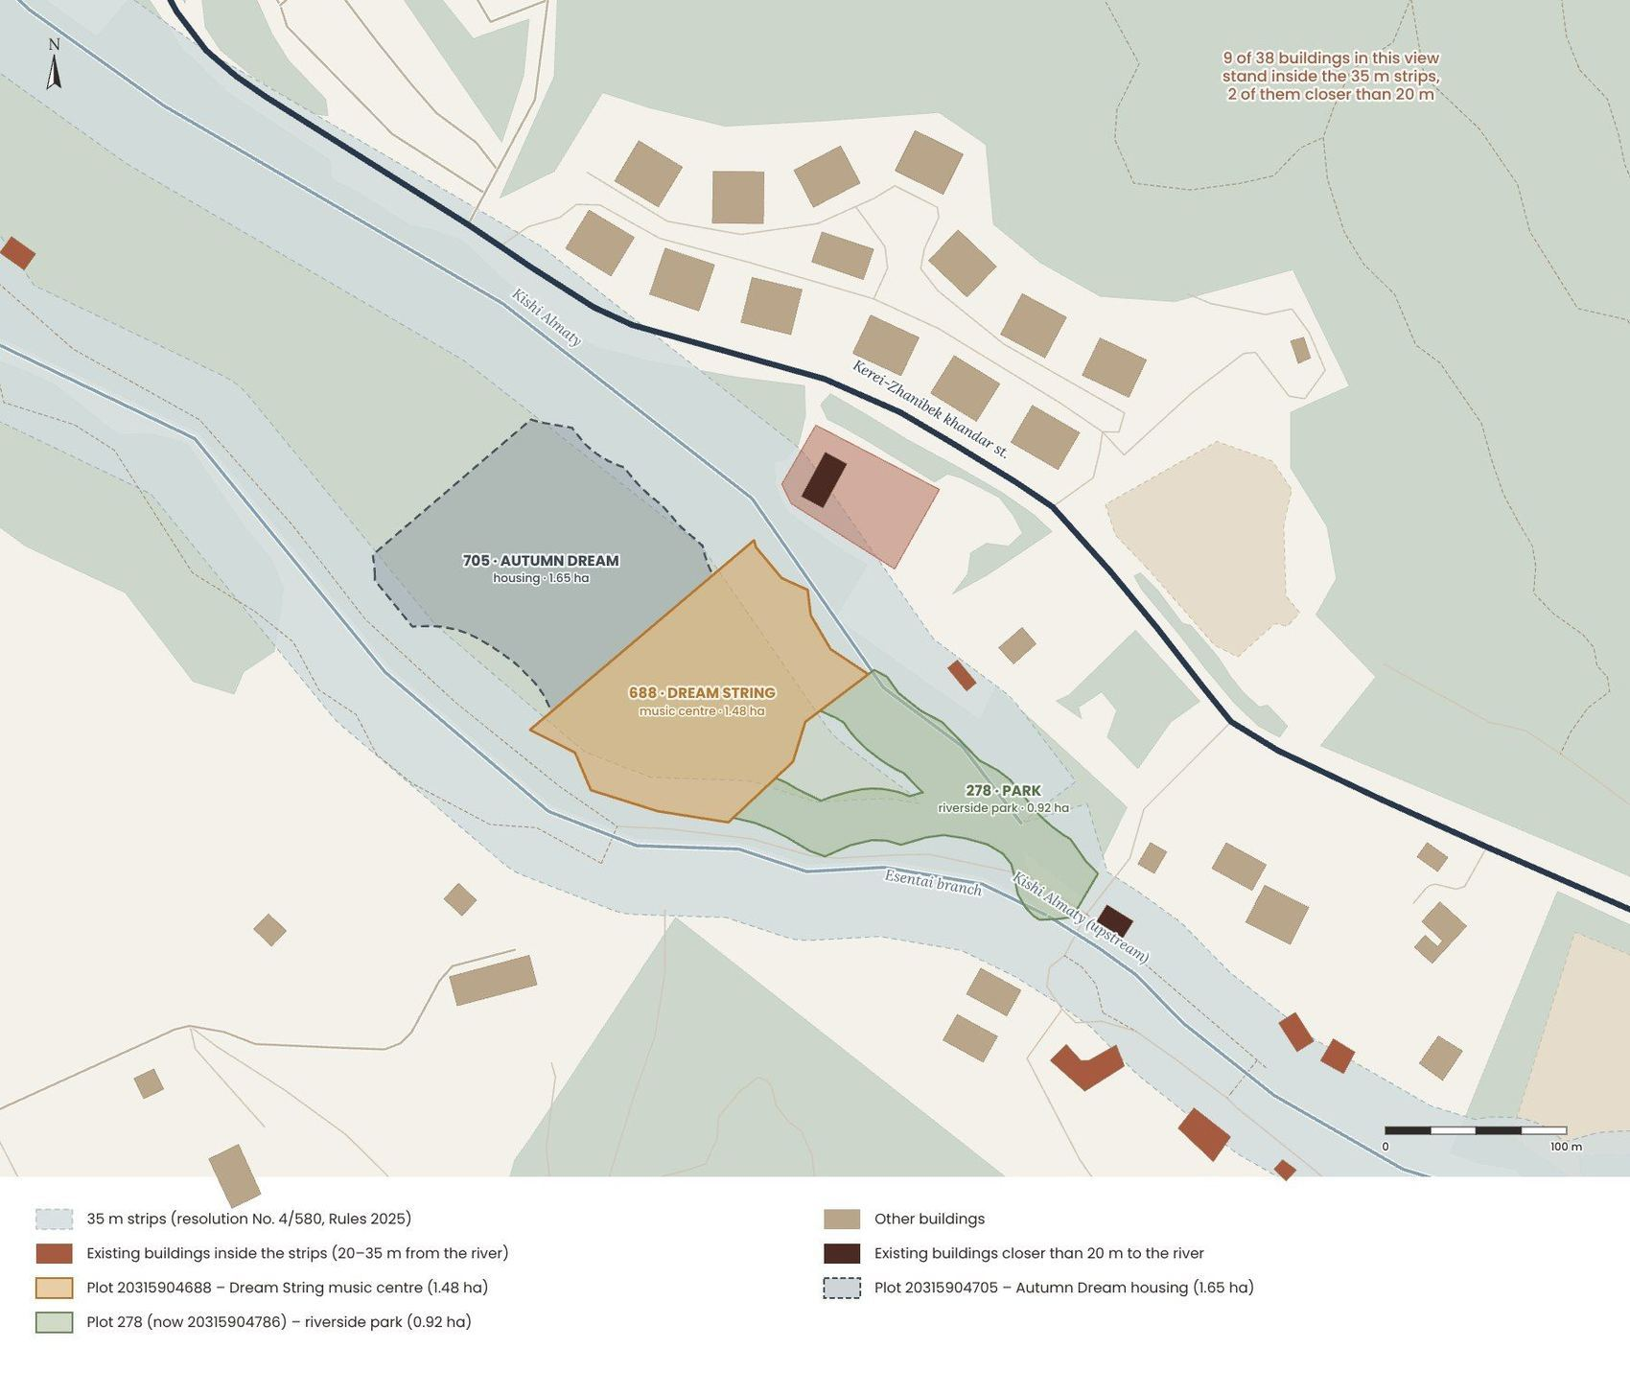
Existing buildings and the 35 m strips around the site: buildings inside the strips are marked. Buildings – OpenStreetMap and Google Earth (2023); pit – imagery and press, 2025.
Why are there houses closer to the water? Until 2009 the strips in Almaty were only 20 m; many cottages were built or registered before they were widened to 35 m. In 2020 the city counted 15,556 private houses inside water-protection strips; the idea of returning to 20 m was discussed but not adopted. On the map around our site 9 of the 38 buildings stand inside the 35 m strips, 2 of them closer than 20 m to the water – mostly old cottages along the canal upstream. New projects are checked: in 2025 the basin inspectorate inspected a housing complex under construction along the Kishi Almaty, and a new pit on a fenced plot near the “Agroleskhoz” stop attracted press attention.

CONCLUSION · what it means for the project
Houses by the water are a legacy of the old 20 m rule, not a permission for new construction. A new building cannot enter the 35 m strips – but the strips can be used as the law allows: park, playgrounds, promenade and garden terraces without buildings.

The plots of the centre: a building on 688, a park on 278
In my first scheme the two plots were merged, and the music centre took the western part of plot 688 by the terrenkur. The survey of the 110 kV line (1.1.8) changed this: its 20 m zone and its service track cut across plot 688 and site 278, so the centre moves to the free land of plot 688 between the zone and the strip of the Kishi Almaty, along the fence of plot 705, and site 278 by the fork becomes its riverside park. The building needs a long, low form that fits this free land – roofs that people can walk on and an amphitheatre in the forest (Section 3).
Music centre | first scheme | final
Plot | western part of plot 688 by the terrenkur | free land of plot 688 between the line zone and the river strip
The centre and the 110 kV line | the hall in the zone of the line | 2 m outside the 20 m zone (22 m from the axis of the line), 51 m from the substation behind a green barrier
Footprint · gross area | ≈ 1,360 m² · ≈ 2,080 m² | ≈ 1,320 m² · ≈ 2,650 m² above ground + lower level and garage
Site 278 | merged with plot 688 into one zone | riverside park of the centre
Car entry and parking | drop-off along the lane by the Esentai | a new bridge, drop-off at the square, garage for 24 cars under the learning section

CONCLUSION · what it means for the project
The centre keeps out of all the strips and zones: one compact building on plot 688, its riverside park on site 278, the old trees kept around them. Changing the purpose of plot 688 from a hotel complex to a cultural centre is a normal step of the next design stage.

1.1.3. Distances
The site lies on the border between the city and the mountains, so distances here are measured not only in metres but also in minutes of walking uphill (about 4.5 km/h, with a route about 1.3 times longer than the straight line). The map is flat and to scale, with the site at the centre; it shows only the nearest places of each type (up to three) and the crossings of the main street that children would use.
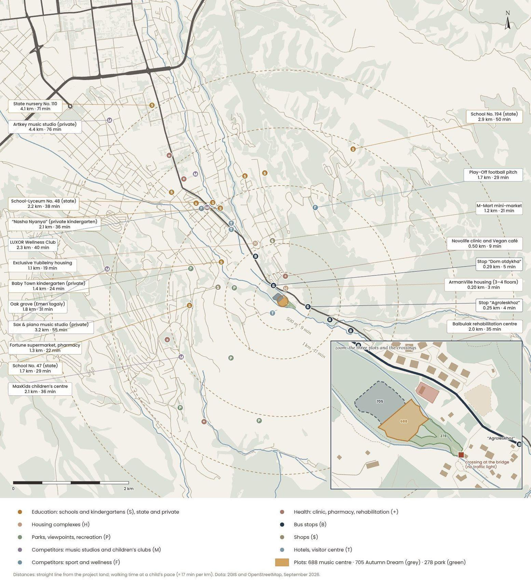
Distance map: nearest schools and kindergartens, housing complexes, parks, competitors (music, culture, sport), shops, health and transport; rings every 0.5–1 km. Data: 2GIS (checked 29.09.2026) and OpenStreetMap contributors.
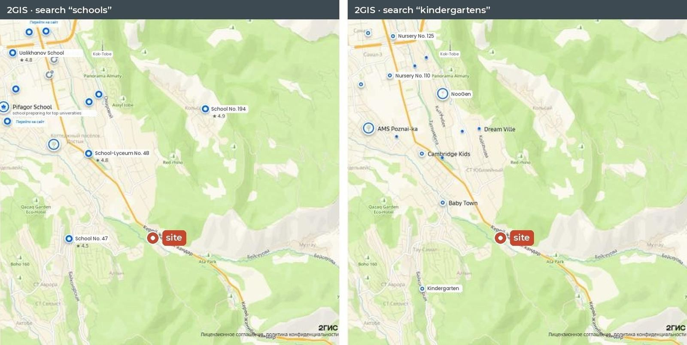
2GIS screenshots (September 2026): schools and kindergartens around the site. The nearest are School No. 47 (1.7 km), School-Lyceum No. 48 (2.2 km) and the private Baby Town kindergarten (1.4 km); state nursery No. 110 is 4.1 km away, in the city lower down the valley.

Satellite view: infrastructure and transport
The same surroundings on a real satellite image, oriented and scaled like the other plans: infrastructure is marked in colour, more distant places are shown with arrows in their real direction. The map confirms what was seen on site – there are two bus stops right next to the plots.
Satellite map of the surroundings with infrastructure in colour, north up. Imagery – Esri World Imagery (Maxar, Airbus); plots – public cadastral map (October 2026); stops and routes – 2GIS (September 2026).
Stop | Distance | Routes | Interval (2GIS)
“Agroleskhoz”, by the site bridge | ≈ 210 m · 3–4 min | 12, 21, 29, 29R, 141 | 21 – every ≈ 8 min; 12 – every ≈ 15 min; 29R – every ≈ 47 min
“Dom otdykha”, opposite plot 688 | ≈ 280 m · 5 min | 12, 21, 29, 29R, 141 | the same routes; zebra crossing at the stop

CONCLUSION · what it means for the project
Public transport is much closer than the general maps suggested: two stops within 300 m, five routes, route 21 every 8 minutes. Children from the city will be able to come to the music centre by bus on their own – the crossings at the stops only need traffic lights and good lighting.

All places within 3 km
Accessibility of key places within 3 km. Data: 2GIS and OpenStreetMap contributors (September 2026); numbers – by distance.
Need | Nearest place | Distance | On foot
Public transport | “Agroleskhoz” and “Dom otdykha” stops (5 routes) | 0.21 · 0.28 km | ≈ 3–5 min
Shops | M-Mart mini-market · Fortune supermarket and Aizis Farm pharmacy | 1.2 · 1.3 km | ≈ 21–23 min
School | School No. 47 · School-Lyceum No. 48 · School No. 194 | 1.7 · 2.2 · 2.9 km | ≈ 30–50 min
Kindergarten | private Baby Town and Nasha Nyanya · state nursery-kindergarten No. 110 | 1.4 · 2.1 · 4.1 km | ≈ 24–71 min
Music and culture | private studios Sax & piano and Artkey · state music school | 3.2 · 4.4 · 5.6 km | ≈ 55–97 min
Health and recreation | Novolife clinic · Balbulak centre · Ak Kaiyn and Kazakhstan sanatoria | 0.5 · 2.0 · 2.5 · 2.8 km | ≈ 9–50 min
Sport | Play-Off football pitch · LUXOR Wellness Club | 1.7 · 2.3 km | ≈ 30–40 min
Nature | terrenkur · Emen togaiy park · Kamenskoe plateau | 0 · 1.8 · 2.2 km | at the doorstep
City and mountains | Republic Square · Medeu · Shymbulak | 6 · 7 · 10 km | bus / car
2GIS screenshot (September 2026): the immediate surroundings – the ArmanVille complex across the road, Novolife clinic (0.5 km), Tau Tamyr hotel, “Mokry Klyuch – Kok Kailau” and the bus stop of route 12 on Kerei-Zhanibek St.; blue lines are the river beds.

CONCLUSION · what it means for the project
The site is close to nature, sport and public transport (two stops within 210–280 m), but everyday social infrastructure is far away: school at 1.7 km, kindergarten – private at 1.4 km (state at 4.1 km), music – only private studios at 3–4 km. Children coming here cross Kerei-Zhanibek street, so the zebra crossings at the stops and the crossing at the bridge must become safe (traffic lights, lighting, a raised crossing). The music centre can become a safe after-school place right next to home and the bus.

What is planned nearby: 2021–2028
To check whether schools, kindergartens or hospitals will appear nearby, the following were reviewed: 2GIS (places and construction sites), the public cadastral map, announcements of the Almaty and Medeu district akimats and materials of the draft 2026 Master Plan. No new kindergartens, schools or hospitals were found within 3 km of the site; the nearest change in the social network is a 300-place extension to School No. 47 (1.7 km). The other plans concern rules and walking routes – and all of them work in favour of the project.
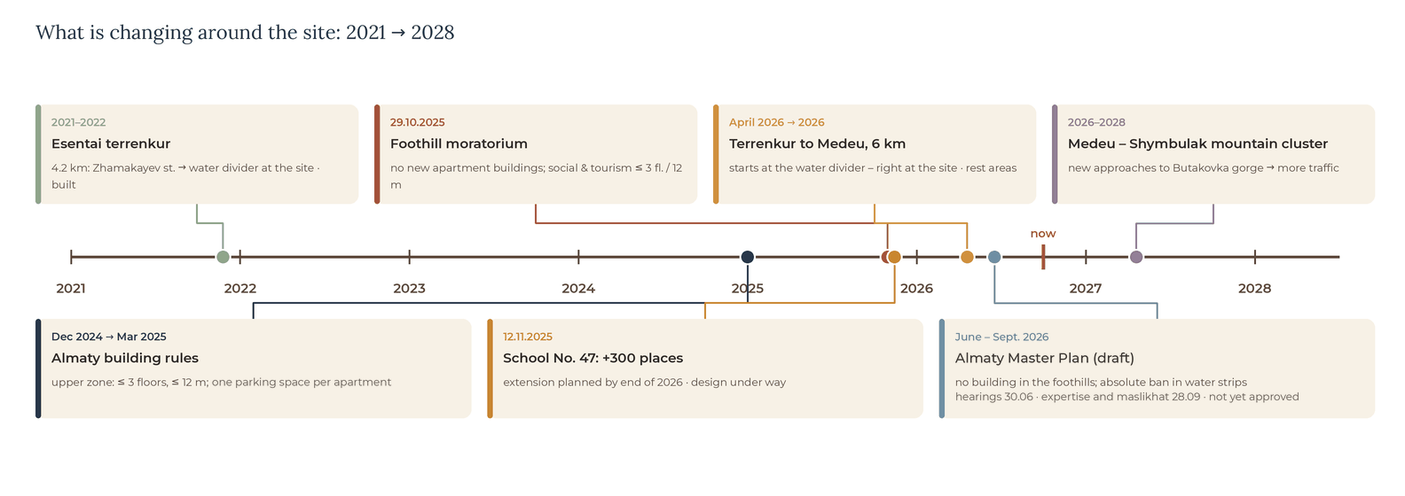
Timeline of changes around the site from open sources (checked in September 2026).
What | When | Status | What it means for the project
300-place extension to School No. 47 | by the end of 2026 | design documentation in progress (announcement of 12.11.2025) | more children at 1.7 km – future learners of the centre
Terrenkur to Medeu, 6 km | announced in April 2026 | will start from the water divider at the site | the site is in the middle of a walking route; entrance to the centre from the trail side
Moratorium on apartment buildings in the foothills | since 29.10.2025 | in force | academic assumption: the project follows the 3-storey / 12 m limit (1.1.9)
Almaty Master Plan | June – Sept. 2026 | draft: hearings 30.06, positive expertise and maslikhat 28.09; government approval pending | the foothills are protected; absolute ban in water-protection strips
Medeu – Shymbulak mountain cluster | 2026–2028 | under way | more traffic on Kerei-Zhanibek st. – noise protection and safe crossings
Construction near the substation | since 2025 | project not identified | follow the news; do not rely on it in the design
New kindergartens and hospitals | — | none found within 3 km | the centre’s children’s club partly covers the shortage

CONCLUSION · what it means for the project
No new school, kindergarten or hospital will appear around the site – the shortage of social functions will remain, so a music centre with a children’s club is needed. The new terrenkur to Medeu will start right at the site: the main entrance of the centre should face the trail. The rules of 2025–2026 limit housing to 3 storeys and 12 m; a cultural building may rise up to 25 m – this is set out in 1.1.9.

1.1.4. Terrain
Terrain analysis is needed to understand how the natural topography affects the placing of buildings, access and drainage. The site lies at the bottom of a V-shaped mountain valley: wooded slopes rise on both sides, and the river flows down, to the north-west, towards the city.
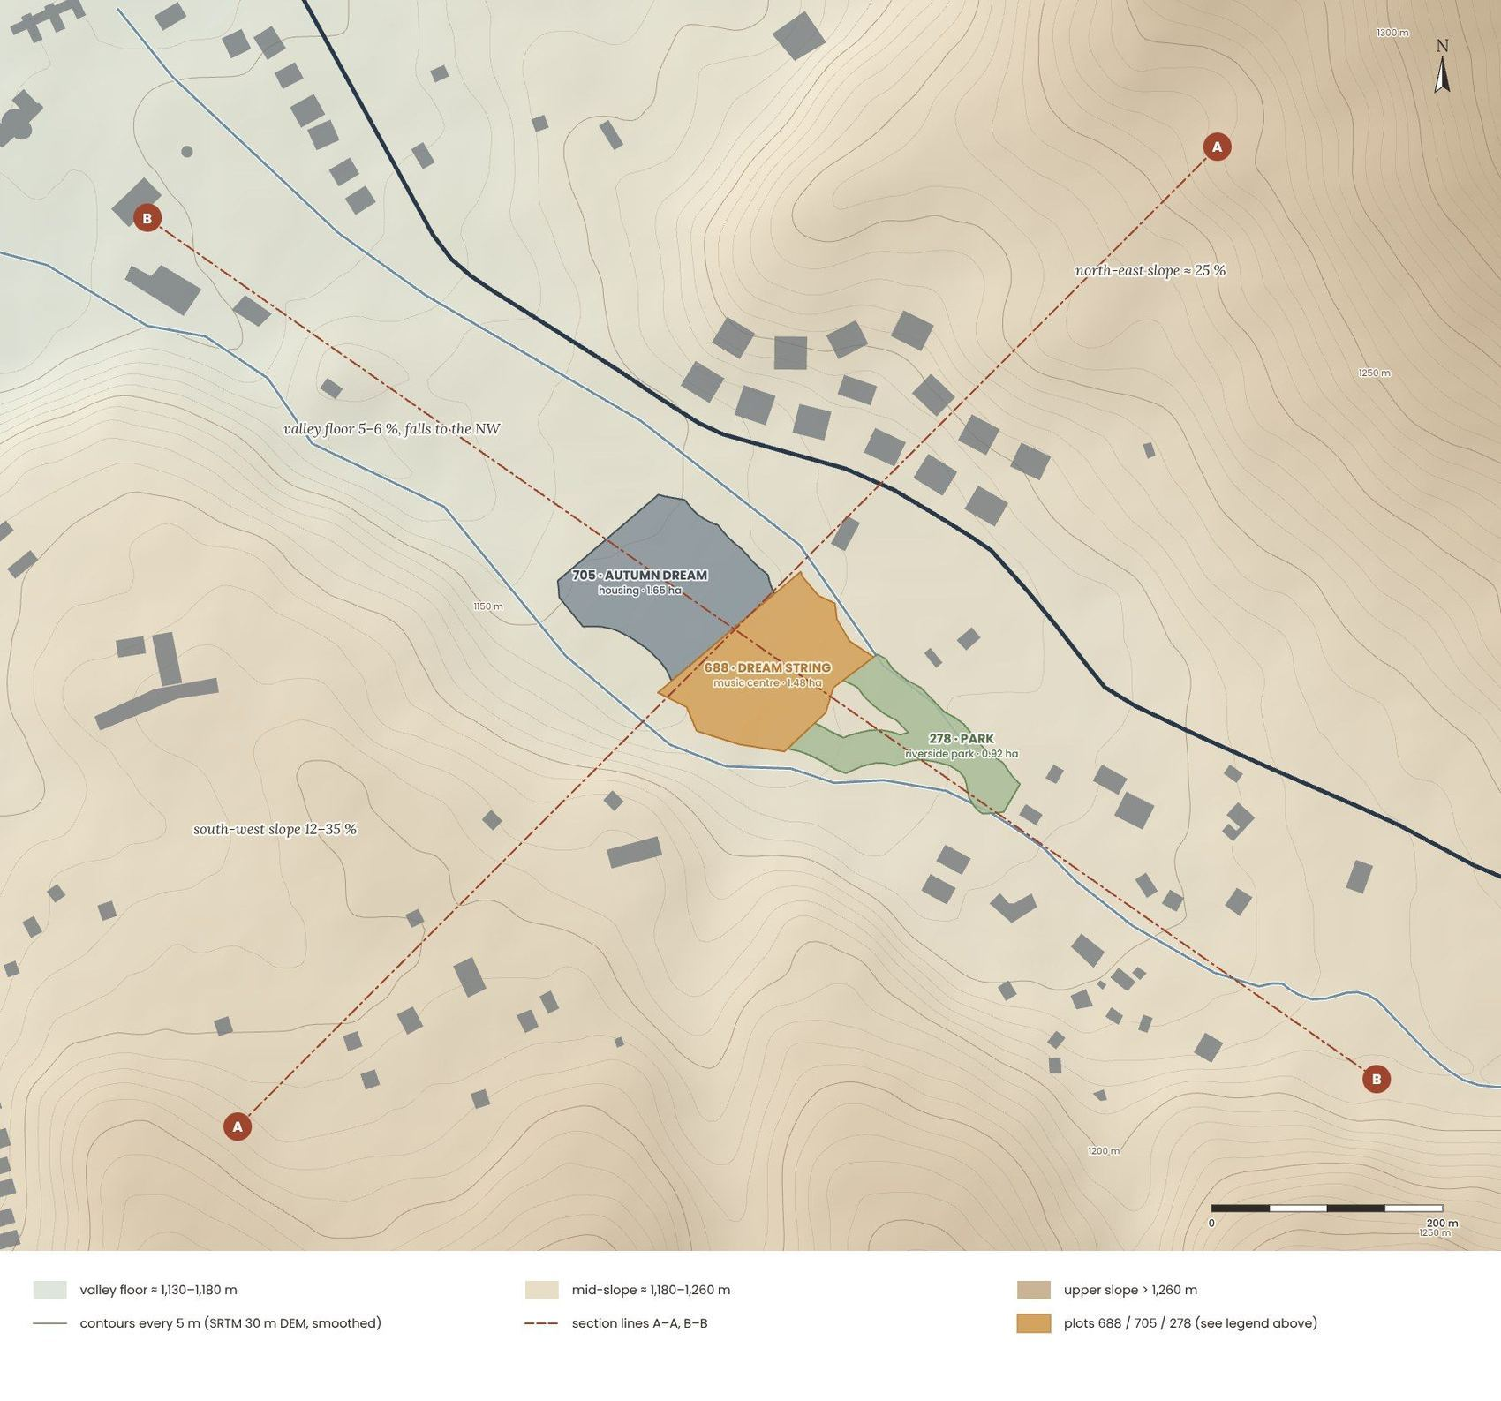+
Terrain of the valley around the site: 5 m contours, the three plots and section lines A–A and B–B. Source: SRTM 30 m digital elevation model (Terrarium tiles), smoothed.
Across the three plots the ground levels vary from about 1,148 to 1,169 m (≈ 21 m); within plot 688 – from about 1,153 to 1,162 m, that is by about 9 m – two to three storeys. The valley floor falls to the north-west with an average slope of 5–8 %, while the local river banks are much steeper – up to 25–30 %. Beyond the valley the slopes rise quickly: about 25 % on the north-eastern side and 12–35 % on the south-western side.

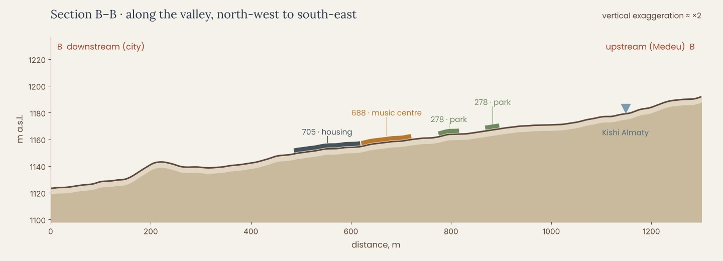
Seven elevation profiles were taken across the site in Google Earth. They confirm a gentle rise from the Esentai branch to the south-east (average slopes of 6–8 %, local peaks of 22–30 % at the banks) and an overall difference of about 15 m between the lowest point of plot 688 and the highest point at the bridge (about 11 m within the site). SRTM sections (above) are smoothed and run 2–3 m higher; site levels in this work are taken from the Google Earth profiles.
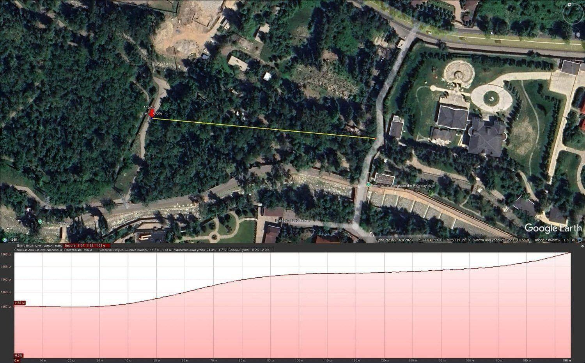
Google Earth elevation profiles across the site: 286 m, 1,153–1,167 m (left) and 196 m, 1,157–1,168 m (right).

CONCLUSION · what it means for the project
The terrain does not require large-scale grading. Under the centre the ground is almost flat (≈ 1,154.7–1,155.7 m), so the ground floor lies at one level, 1,155.00, without steps; the loud rooms, the plant room and the garage go into the slope below it (−4.20). The gentle slope towards the rivers provides natural drainage of rain and meltwater.

Google Earth elevation profiles
All seven profiles drawn across the site in Google Earth Pro (imagery of 6 August 2023). The yellow line on each screenshot is the profile line; the pink chart below shows the change in height along it.
Profile 2 | 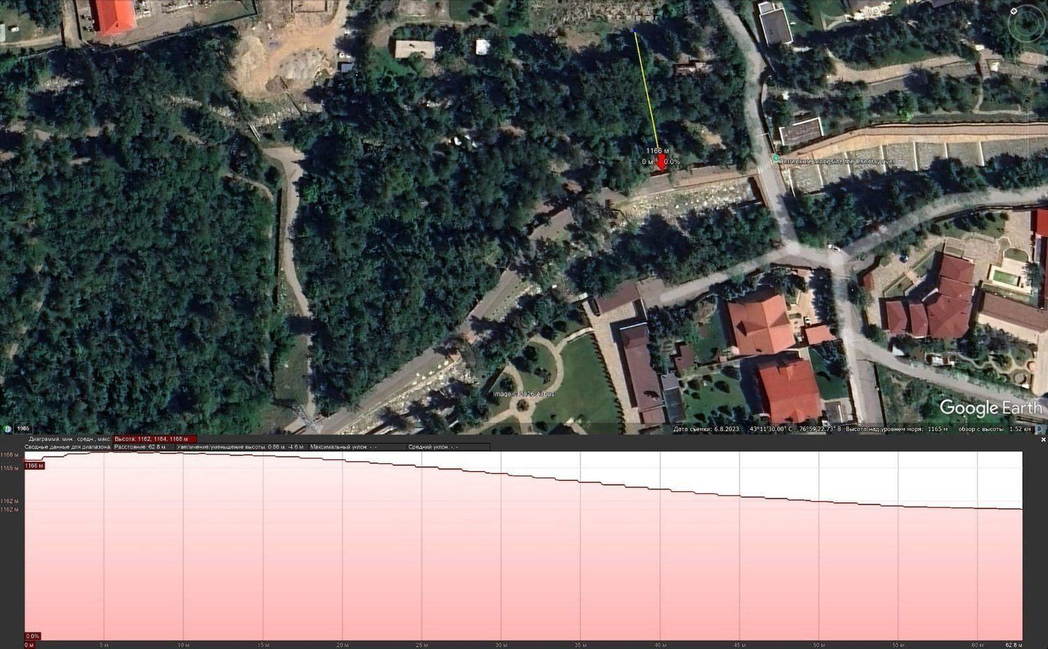  Profile 4
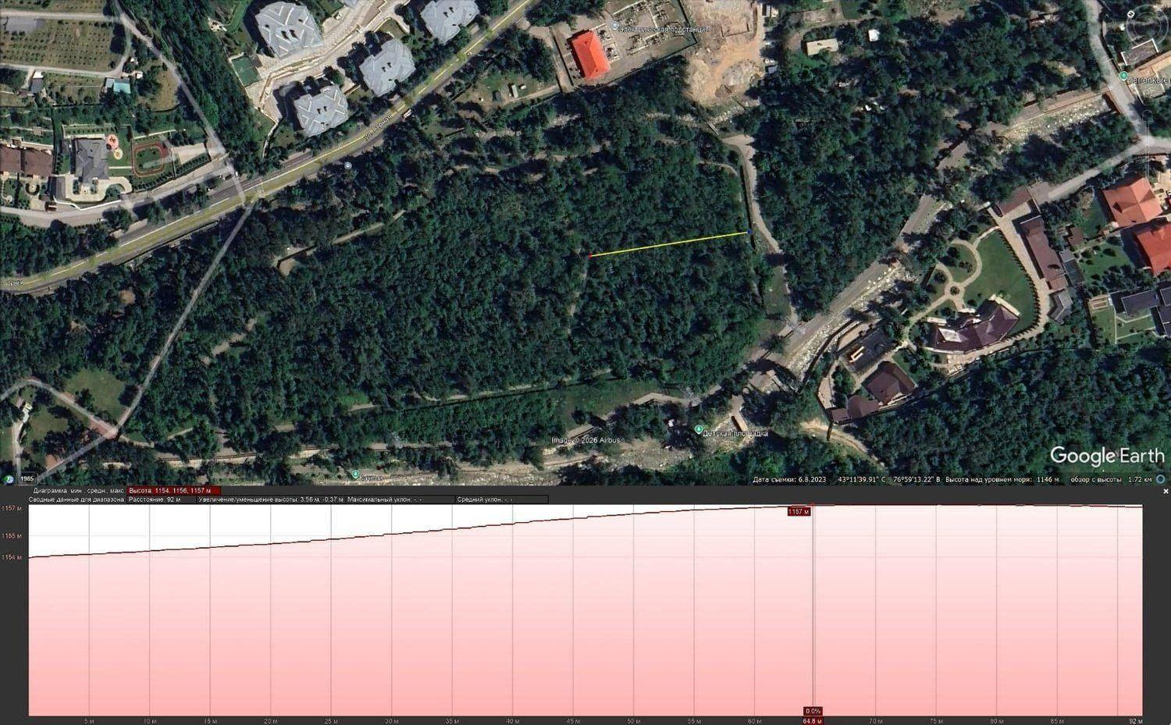  Profile 5 | 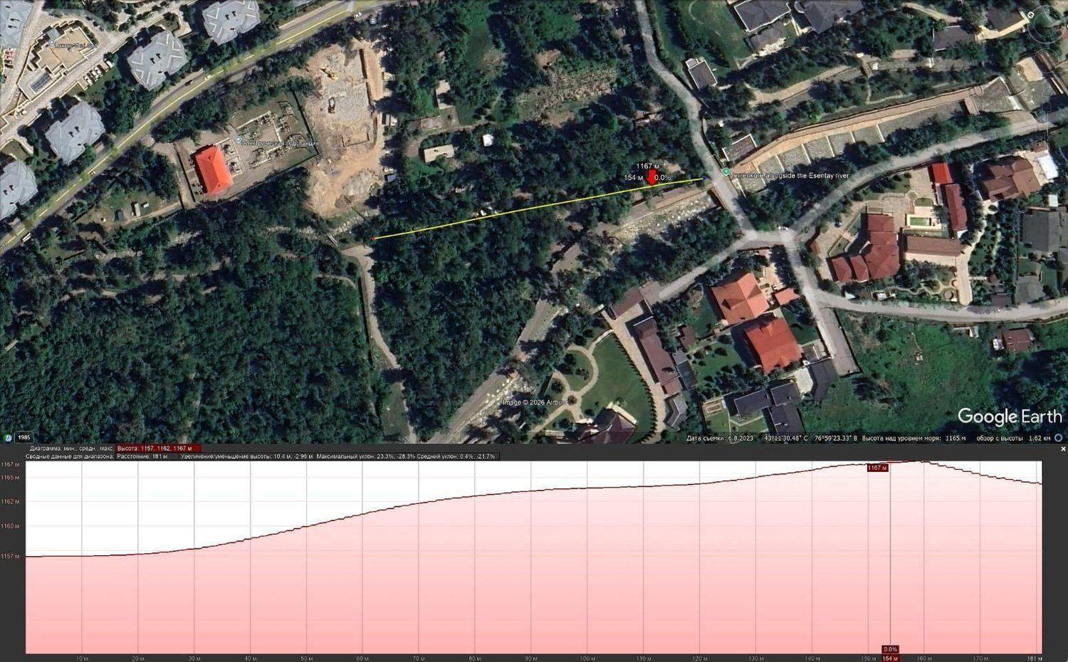  Profile 6
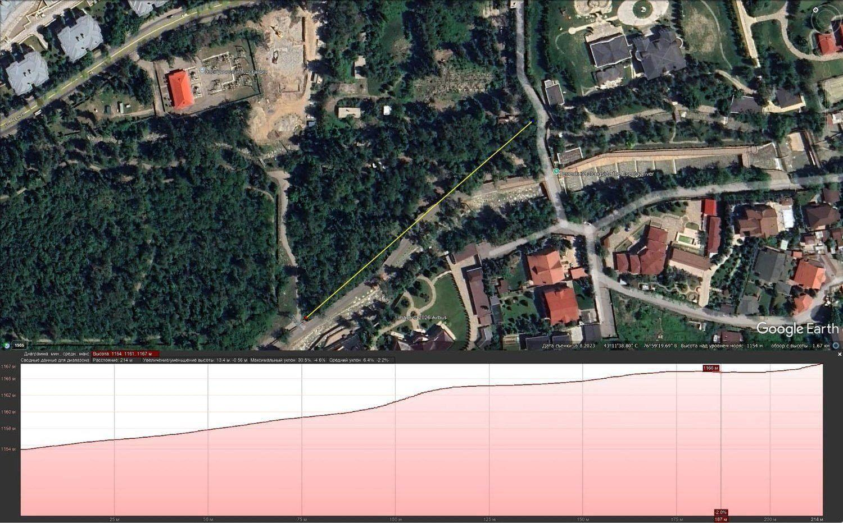  Profile 7
  № | Length | Height, min – max | Difference | Max. slope
  1 | 286 m | 1,153 – 1,167 m | 14 m | 22.9 %
  2 | 114 m | 1,154 – 1,157 m | 3 m | —
  3 | 196 m | 1,157 – 1,168 m | 11 m | 24.4 %
  4 | 63 m | 1,162 – 1,166 m | 4 m | —
  5 | 92 m | 1,154 – 1,157 m | 3 m | —
  6 | 181 m | 1,157 – 1,167 m | 10 m | 28.3 %
  7 | 214 m | 1,154 – 1,167 m | 13 m | 30.5 %
Profiles 1 and 3 are shown on the previous page. Screenshots: Google Earth Pro.

1.1.5. Water: two rivers at the site
The site lies at the water divider, where the artificial Esentai branch leaves the Kishi Almaty. To draw the rivers accurately, their position was compared in five sources: OpenStreetMap, Yandex Maps, 2GIS, Google Maps and a Google Earth satellite image (Airbus, 2023).
The Kishi Almaty (Malaya Almatinka) runs along the north-eastern side of the site, between it and the street. Its bed is narrow and almost completely covered by poplar crowns, so the river cannot be seen on satellite images and on most maps: only OpenStreetMap and Yandex Maps show it. On the diagrams in this work the Kishi Almaty at the site is drawn approximately – after OSM, Yandex and on-site observation; above the fork it runs in a concrete channel with cascades (photo in 1.1.6).
The Esentai branch is an open bed along the southern side of the site; the terrenkur runs along it. All sources show it the same way. The Mokry Klyuch is a small stream further south, marked only on Yandex Maps (shown schematically).
Where does the river divide? According to OSM and the satellite image the fork is at the bridge at the south-eastern end of the site; according to the Yandex map it is about 200–250 m upstream. The difference is small but matters for the bridge and the car-park ramp: a topographic survey will settle it. All three beds are visible in the Yandex Maps screenshot below.
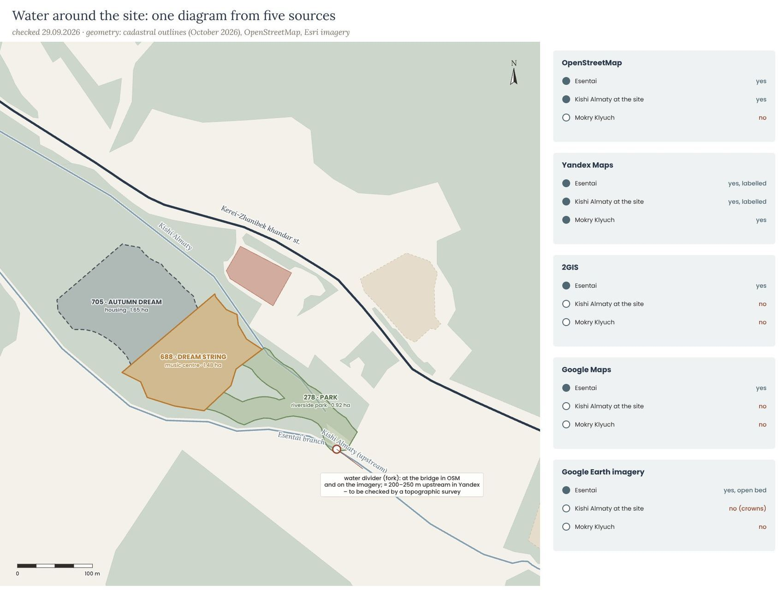
Combined diagram of the rivers at the site and what each source shows (checked 29.09.2026). Dashed line – bed under the tree crowns, position approximate.
Yandex Maps screenshot (September 2026): the Esentai branch, the Kishi Almaty and the Mokry Klyuch stream are labelled at the site; blue icons on Kerei-Zhanibek St. are bus stops.
CONCLUSION · what it means for the project
The rivers are not only a constraint (35 m strips) but the main story of the place: the Kishi Almaty is hidden in the forest, the Esentai is open and has already become a walking street. The project does not touch the banks and makes the bridge at the fork a meeting point. The position of the fork and of the bed under the crowns must be checked by a topographic survey before the sketch design stage.

1.1.6. Geology and natural hazards
The site lies on the alluvial-proluvial fan of the Kishi Almaty, formed by the river and ancient mudflows: under a thin layer of forest soil and loess-like loam lie dense boulder-pebble deposits – rounded granite boulders carried down from the mountains by the river.
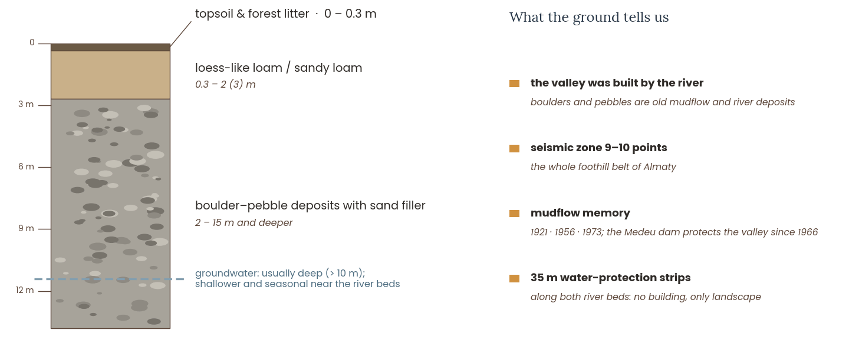
Typical soil profile of the valley floor (diagram). Exact data will come from an engineering-geological survey.
Earthquakes. According to the seismic microzoning of Almaty, the southern foothill part of the city belongs to the 9–10-point zone (MSK-64 scale); the building must be designed with this in mind.
Water and mudflows. The Kishi Almaty is a mountain river fed by the Tuyuksu glacier. The largest mudflows came in 1921, 1956 and 1973; since 1966 the city has been protected by the Medeu mudflow dam. The rivers of Almaty are surrounded by 35 m water-protection strips where building is not allowed – for the project this is not only a constraint but also a gift: the strips become a protected forest park along the river.
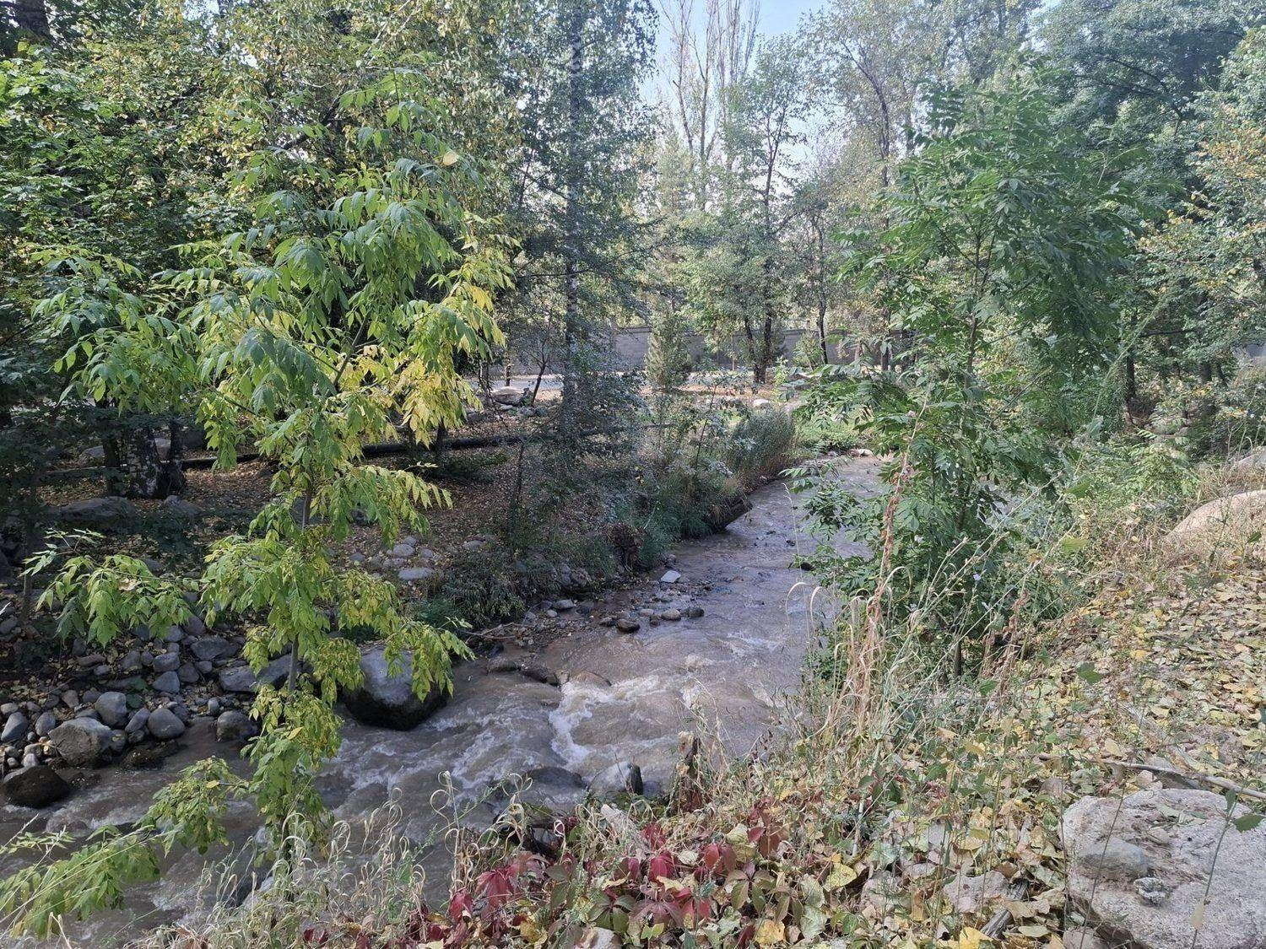 | 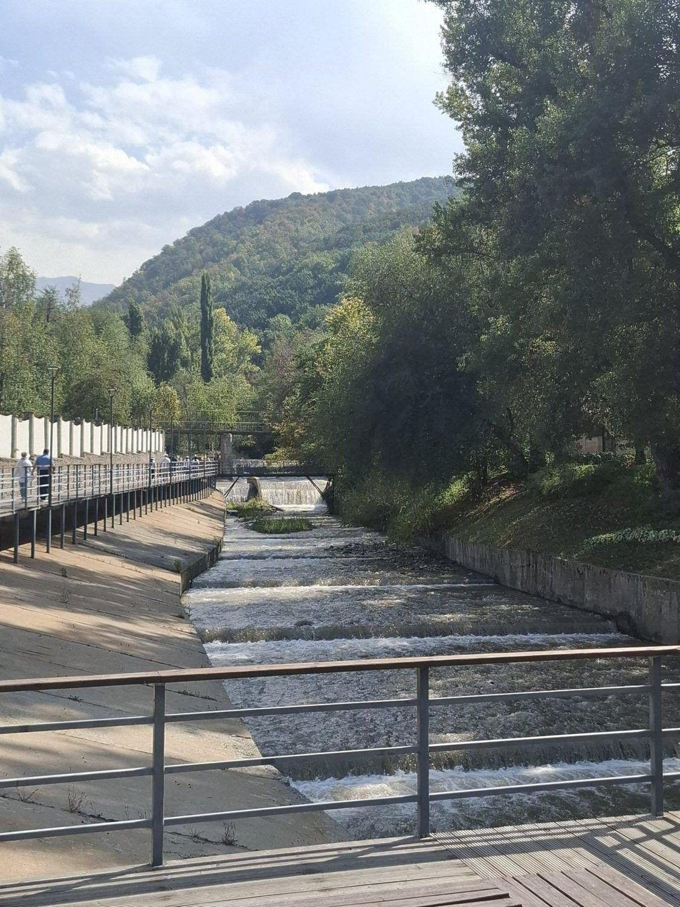
The stony river bed at the site (left) and the Kishi Almaty above the fork – in a concrete channel with cascades (right).

CONCLUSION · what it means for the project
Seismicity of 9–10 points and the history of mudflows call for simple, compact and regular volumes, a seismic joint between the hall and the wing, light upper floors and roofs, and no rooms for children on the lowest level by the water. The boulder-pebble deposits are a good foundation, and the river boulders themselves can become the material of the plinth and the landscape.

1.1.7. Climate, sun and wind
Almaty has a continental climate with hot summers and cold, snowy winters. At an altitude of 1,160 m the site is about 2 °C cooler than the city centre, the air is cleaner, and the golden autumn – dry, sunny and calm – is the most beautiful time of year.
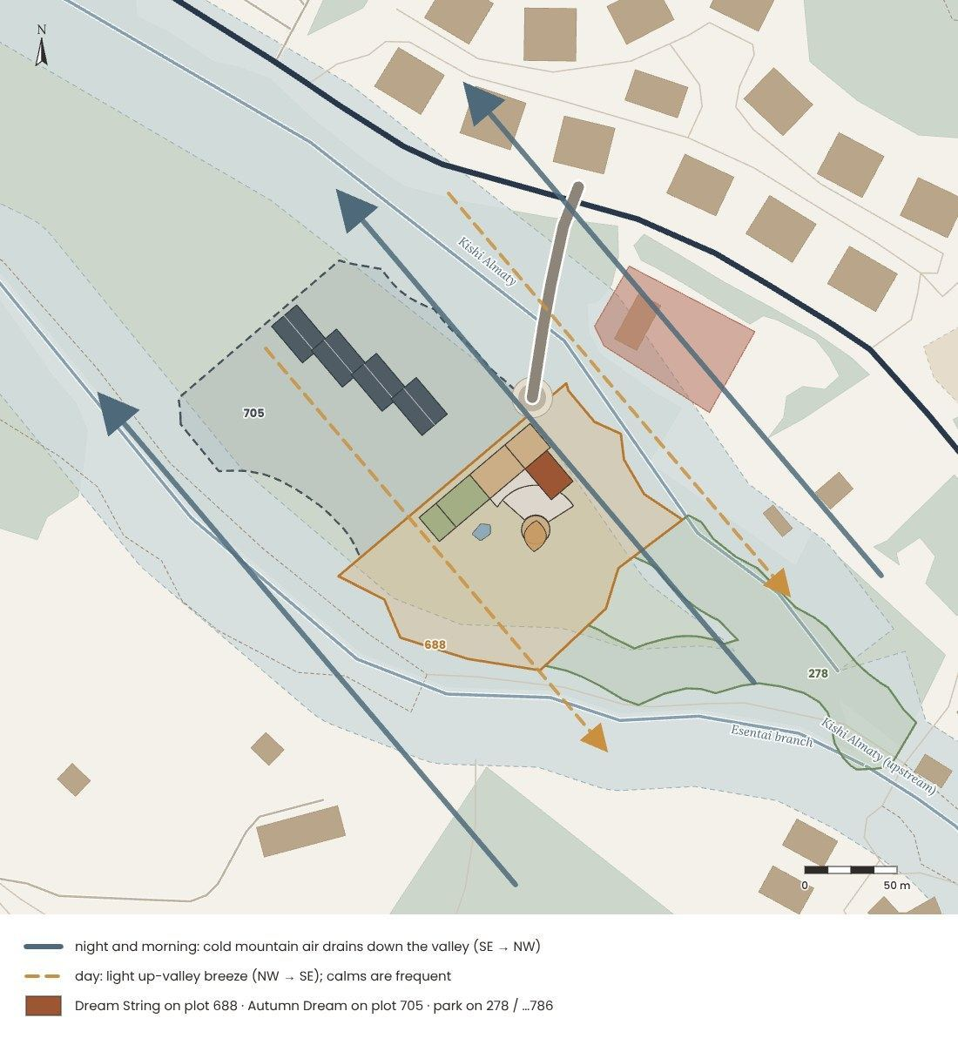

Sun. At 43° N the noon sun rises to 70° in June and only to 23° in December. The valley opens to the south-east and north-west, so the site is well lit, but in winter the low morning and evening sun is partly hidden by the ridges. A southern and south-eastern orientation of living rooms and terraces is preferable.
Wind. Almaty is dominated by mountain-valley winds and frequent calms. At night cold air drains down the valley from the mountains; during the day a light breeze rises towards the peaks. The river corridor works as a natural air channel that refreshes the site.

CONCLUSION · what it means for the project
Classrooms, terraces and the café should face south-east (see 2.3); deep eaves shade the high summer sun and let in the low winter sun. The river corridor ventilates the site, but at night cold air drains down the valley, so the entrance and the terraces need protection on the upstream side.

1.1.8. The 110 kV line and the substation
The strongest boundary of the site is not on the ground but in the air. An overhead 110 kV line on lattice towers (six wires) comes from the city along the forest, crosses plot 688 and site 278 and turns into the substation 150A “Almaly” (110/10 kV), which stands behind a fence between the river and the street. By the Rules for the protection zones of electric networks (order No. 330 of 28.09.2017) nothing may be built within 20 m of the outer wires of a 110 kV line, and under the line runs the service track of the grid company, which must stay free for maintenance.
The 110 kV line, its protection zone and service track and the substation next to the plots; the centre and the distances to them.
Moving the line underground would be a large project of the grid operator, so in my concept the line stays and the centre keeps out of its zone: the building stands 22 m from the axis of the line, 2 m outside the protection zone (the amphitheatre 1.4 m), and 51 m from the substation. Along the boundary on the substation side a green barrier of trees and conifers screens the view and softens the hum; the zone itself stays forest and becomes part of the walks of the park.
CONCLUSION · what it means for the project
The power line and the substation are boundaries that the project respects rather than removes: no building, parking or terrace in the 20 m zone and on the service track, the centre placed on the free land between the zone and the river strip and screened by trees. This decides the place and the compact form of the centre (1.1.2, Section 3).

1.1.9. Planning regulations: how high the centre can be
The site lies in the upper (foothill) zone of Almaty, where several documents limit the height of buildings at once. For a cultural building the limits are different from those for housing.
Document | What it sets | For the centre
Urban Planning Regulation of Almaty (maslikhat decision No. 194 of 25.12.2024, in force since March 2025) | south of the Eastern Ring Road – al-Farabi – Saina – Zhandosov: not more than three storeys plus a plinth storey and 12 m to the top of the parapet (the ridge) from the average planned ground level, except buildings of health, education, culture and religion – up to 25 m | a cultural centre may rise up to 25 m
Akimat moratorium on construction in the foothills (since 29.10.2025) | new apartment buildings in the foothills are not approved; social and tourism facilities – up to 3 storeys / 12 m | academic assumption: the centre stays within 3 storeys / 12 m
Almaty Master Plan – draft correction (hearings June 2026; positive expertise and maslikhat 28.09.2026; government approval pending) | construction in the foothills is restricted; absolute ban in water-protection strips | nothing in the strips; low and compact
Cadastral purpose of plot 688 | “for the operation and maintenance of a hotel complex” | a public building; change of purpose to a cultural centre

Almaty height regulation (diagram, not to scale): the site lies in the upper zone; a cultural building may rise up to 25 m, the centre stays at 11.7 m (12 m at the parapets, up to 25 m at the top of the fins).

How the centre fits into the limits
Parameter | Value | Comment
Number of storeys | 1–3 above ground + 1 lower level | within 3 storeys of the moratorium
Floor-to-floor height | 3.9 m (ground floor) · 3.6 m (first floor) · 4.8 m (second floor, movement hall 4.2 m clear) | classrooms ≥ 3 m clear; the movement hall ≈ 3.9 m
Café and 2-storey blocks | +3.90 café terrace · +7.50 roof garden, terrace over the stage (cube: glass roof, no access) | reached from the stairs S1, S2 and S4
3-storey blocks | +12.30 terrace of the peaks · +11.70 meadow roof over the hall | Section I and the hall; glass railing +13.40
Hall | three storeys high, roof +11.70 | the stage opens to the amphitheatre
Amphitheatre | stage ±0.00 (level with the hall), 5 rows up to +2.25 | at the corner of the hall, opening to the south
Fins (the sound track) | up to 25 m (+25.00) | free-standing screen elements, not storeys; within the 25 m for culture
Lower level and garage | −3.60 · garage for 24 cars, ramp ≤ 15 % from the square | not counted as an above-ground storey
Areas | footprint ≈ 1,320 m² · ≈ 2,650 m² above ground + garage ≈ 700 m² | 73 rooms, hall for 150–200 seats, amphitheatre ≈ 90 seats in four sectors + lawn
* A plinth storey counts as above ground if the top of its floor slab is at least 2 m above the average finished ground level; an underground storey does not. The lower level lies under Section I and the hall; the garage, the loud rooms and the plant room do not need daylight (SN RK 3.02-01-2023).
Why not higher? The Regulation would allow a cultural building up to 25 m, but it is right for the place to stay low: a centre whose highest roofs are at 11.7 m stays below the crowns of the old poplars, does not block the view of the mountains and keeps the scale of the valley – cottages of 2–3 storeys, the ArmanVille complex of 3–4 storeys, the three-storey sections of Autumn Dream next door. The centre gets its presence not by height, but by its sound track of fins and by the roofs that people can walk on.
CONCLUSION · what it means for the project
The height is a choice, not a limit: three storeys at most and a lower level, 11.7 m at the highest roofs (12 m at the parapets, inside the 12 m of the moratorium) and up to 25 m at the top of the free-standing fins – inside the 25 m allowed for culture. The centre stays below the trees and lets the mountains remain the main event.

1.1.10. Conclusion: what the site asks for
Site analysis in one table – from facts to the first design decisions.
Topic | What we found | What it means for the project
Site | a forest between two rivers, 6 km from the city centre | one compact public building, the rest as a park
Cadastre | plot 688 – hotel complex (public); site 278 (now …786) – mostly river strips; plot 705 – Autumn Dream | the centre on 688, the riverside park on 278
Water-protection strips | 35 m under resolution 4/580 and the 2025 Rules | no buildings or parking in the strips; paths and playgrounds instead
Power line | 110 kV line with a 20 m zone and a track across both plots | nothing in the zone; the centre 2 m outside it (22 m from the axis); a belt of conifers
Dimensions | only ≈ 0.55 ha of free land on plot 688 | a long low form along the fence of plot 705, footprint ≈ 1,320 m²
Distances | two stops at 210–290 m; school 1.7 km; music – only private studios at 3–4 km | an after-school music centre is needed; safe crossings at the stops
Users | children 6–17, parents, valley residents | open after school and in the evening; a café for parents
Terrain | under the centre ≈ 1,155 m; the plot falls to the north-west | ground floor 1,155.00; loud rooms and garage in the slope
Geology | boulder deposits, 9–10 points, history of mudflows | compact volumes, a seismic joint between the hall and the wing
Climate | sunny and calm; cold air drains down the valley at night | the amphitheatre and the roof garden to the sun, a sheltered entrance
Water | the Kishi Almaty under the crowns, the Esentai an open canal; fork at the bridge | do not touch the banks; the park and the paths along the water
Regulations | culture up to 25 m; moratorium 3 storeys / 12 m | 1–3 storeys + lower level, 11.7 m at the highest roofs, up to 25 m at the fins
Plans | extension to School No. 47 (+300 places); terrenkur to Medeu (2026) | more children nearby; the centre on the walking route

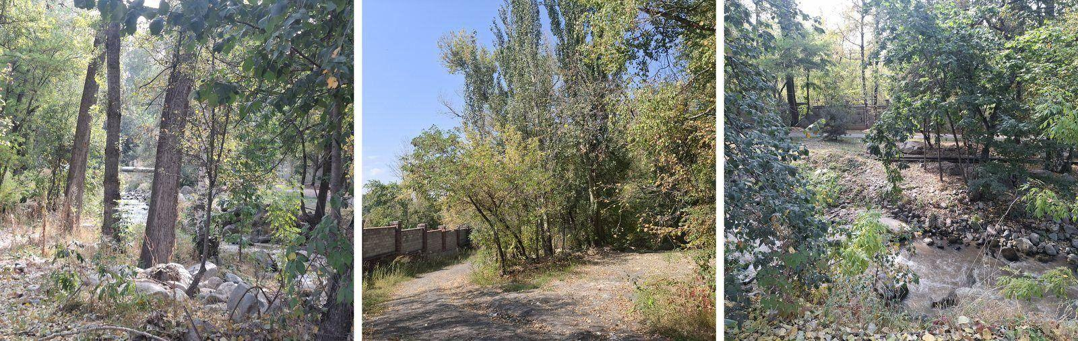
The site asks for a small footprint, a careful height and a big public heart.

1.2. Genius loci

1.2.1. Atmosphere
The first thing I want to say about this place is that it is very beautiful. Standing on the site, I felt lightness and calm, and time seemed to slow down. The beauty of early autumn in the mountains left a quiet, trembling joy in my heart – and a simple wish to stay and live here.
For me a place of music should feel like this valley: free and safe, a place where you do not feel the weight of the school day and which fills you with energy. Here you feel complete unity with nature: the air is so clean and everything around is so serene that the mountains seem to persuade you to stay – and the river keeps the rhythm, like a dombra that never stops playing.
This soft, sleepy atmosphere is diluted by the river. It brings the energy and spirit of the mountains; right at the site it splits in two – this is a meeting point of calm and movement, of sleep and awakening. I want to keep a large layer of trees and unite architecture and nature. The energy of the river that never sleeps becomes the basis of the music centre.
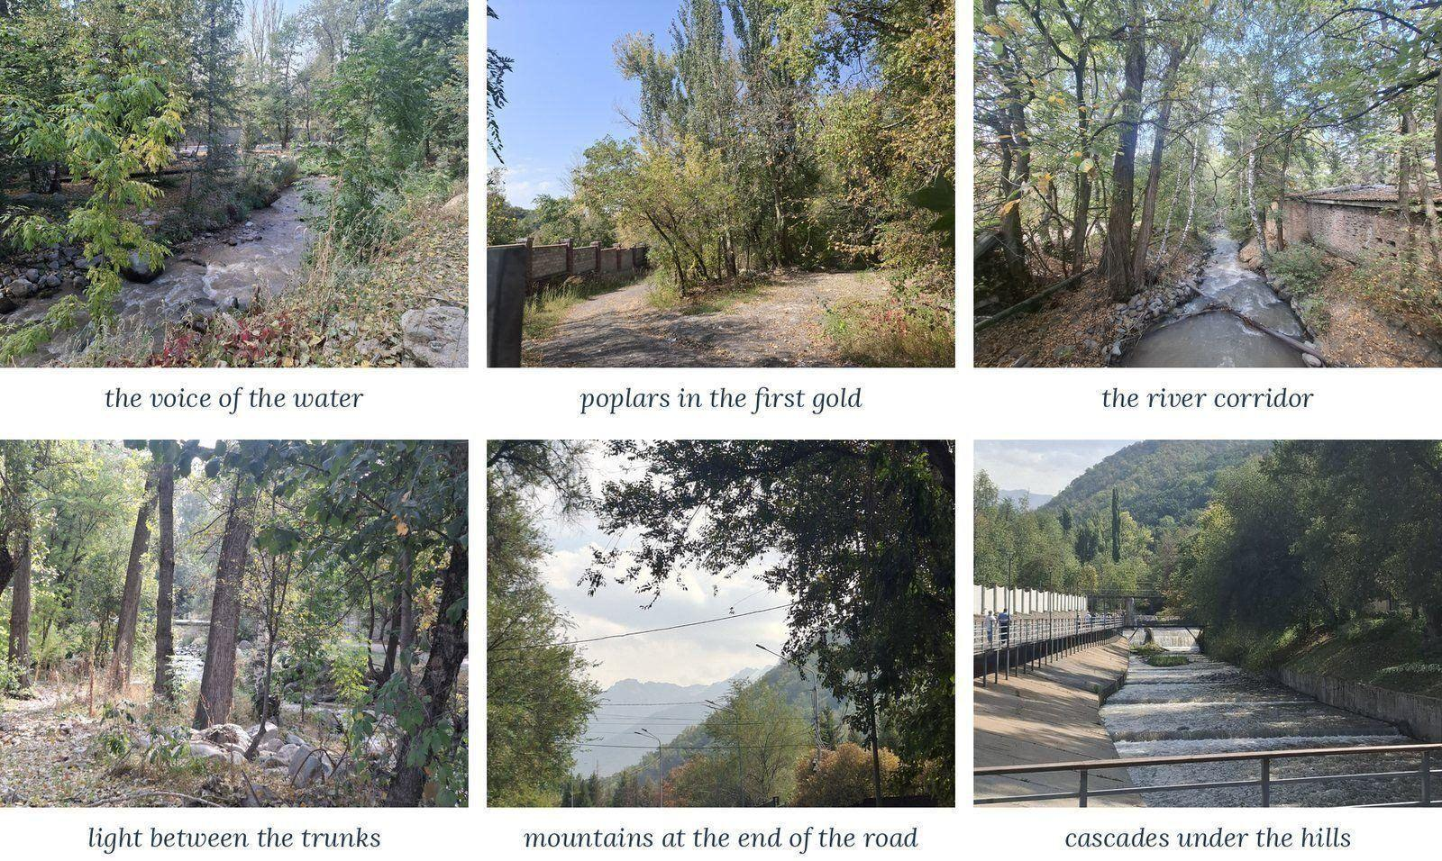
Moments of the place, September 2026.
This place is an autumn dream: soft, slow and golden. Only the river never sleeps.

The site through the five senses
Sound | the murmur of the Kishi Almaty, the cascades of its channel above the fork, the rustle of dry leaves, birds; in the distance – cars driving to Medeu
Smell | wet stones, fallen leaves, spruce resin, and in the evening – snow and cold air from the peaks
Light | soft, filtered through the leaves; golden in autumn, silver in the morning mist, warm under the lamps of the terrenkur at night
Touch | cool, moist air by the water, smooth river boulders, the rough bark of poplars, the warm wood of the footbridges
Time | slow. The valley lives in the rhythm of the day: mist in the morning, sun at noon, cold mountain air at night
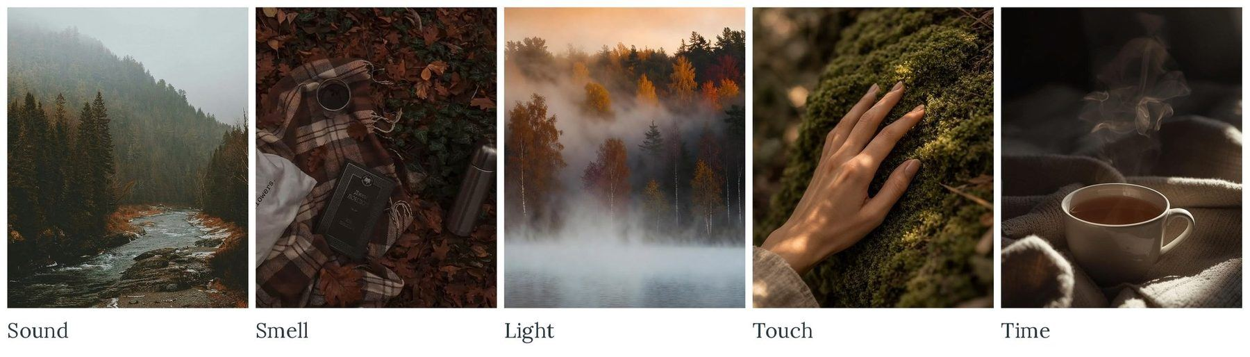
The site through the five senses: sound, smell, light, touch and time (pictures collected by the author).

Day and night  In the morning the valley is filled with mist and the cold air that has drained down from the mountains overnight. By noon the sun warms the slopes, the mist clears and the poplars begin to glow. During the day the terrenkur is full of people, children and dogs; the city is close, but its noise does not reach the forest.  In the evening the stream of cars returns from Medeu, the lamps light up along the trail and only the sound of the river remains. At night the place becomes a space for reflection and rest – and the lit hall of the centre can become its evening heart. | 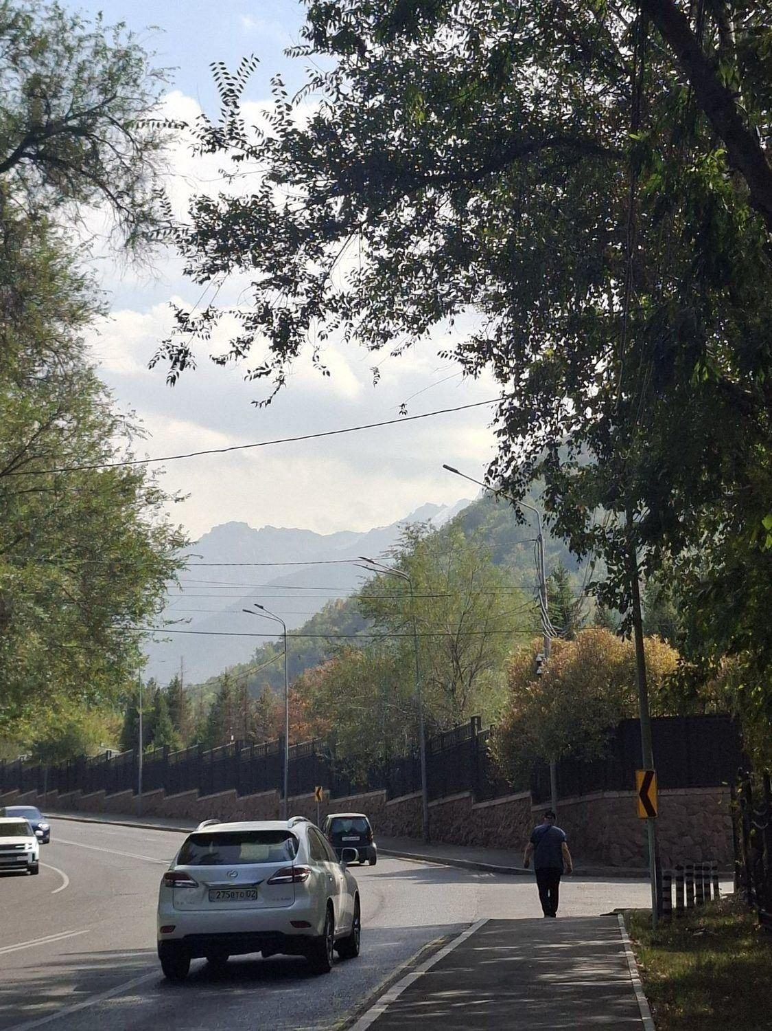
The road up the valley and the ridges of the Trans-Ili Alatau.

CONCLUSION · what it means for the project
All the senses are calm here except hearing: the river always sounds. For the project: use sound as the material of the music centre – water, wind in the poplars and music instead of the noise of cars.

1.2.2. Associations
The place evokes a chain of images. They are not decorations – each of them is a quality that the future music centre should give to the children and families who play, learn and rest here.
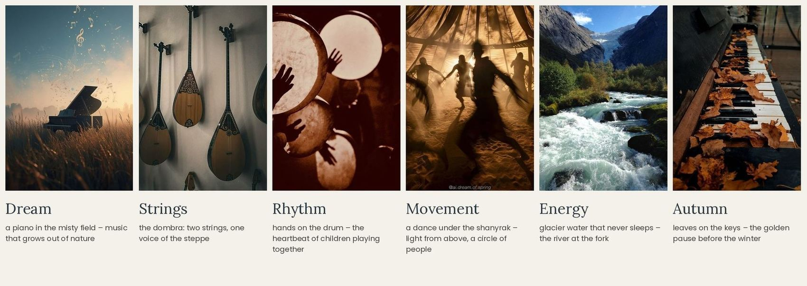
Associations with the project: dream, strings, rhythm, movement, energy, autumn.
Dream. A piano standing in a misty field – music that grows out of nature. The centre is a place where children can dream aloud: the roof walk ends at a stage in the forest.  Strings. The two strings of the dombra and the strings of the piano: thin, tense, sounding. Along the building stand the tall grey fins of a sound track – rising up to 25 m, like recorded music.  Rhythm. Hands on a drum – the heartbeat of children playing together. Lessons, ensembles and the loud rooms give the centre its everyday rhythm. | Movement. A dance under the shanyrak: light from above and a circle of people. The movement hall and the amphitheatre are circles of people around the music.  Energy. Glacier water that never sleeps – the river at the fork brings the energy of the mountains into the calm forest.  Autumn. Leaves on the keys – the golden pause before winter. Larch gold, copper rust and wine are the warm notes of the palette; the fog and the river give the cool ones.

Soundtrack of the place  P. I. Tchaikovsky – “October. Autumn Song” from The Seasons (1876): a slow piano melody, like a walk through the golden forest in the mist; in the middle it becomes warmer and more alive, like the river that wakes the valley. | 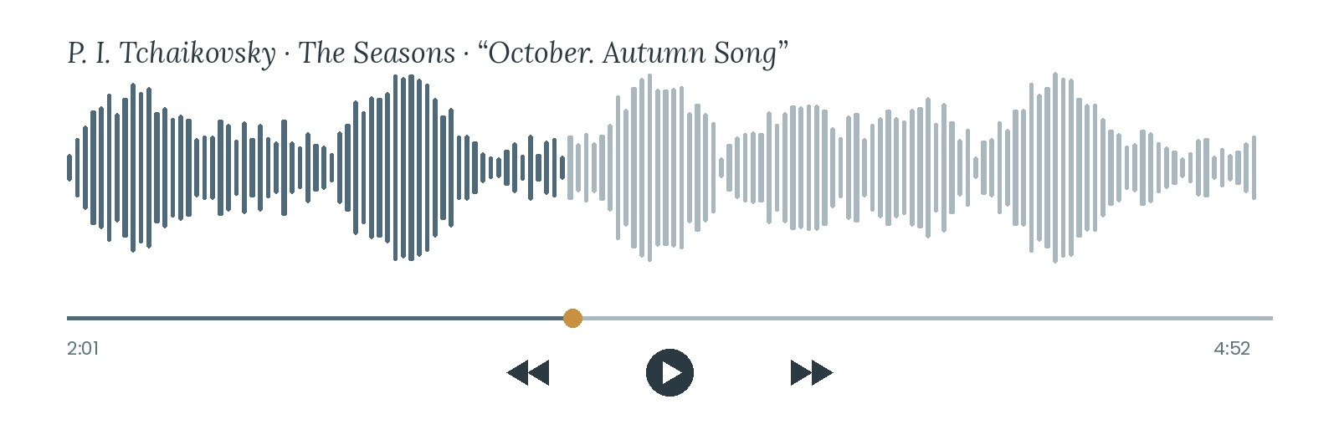
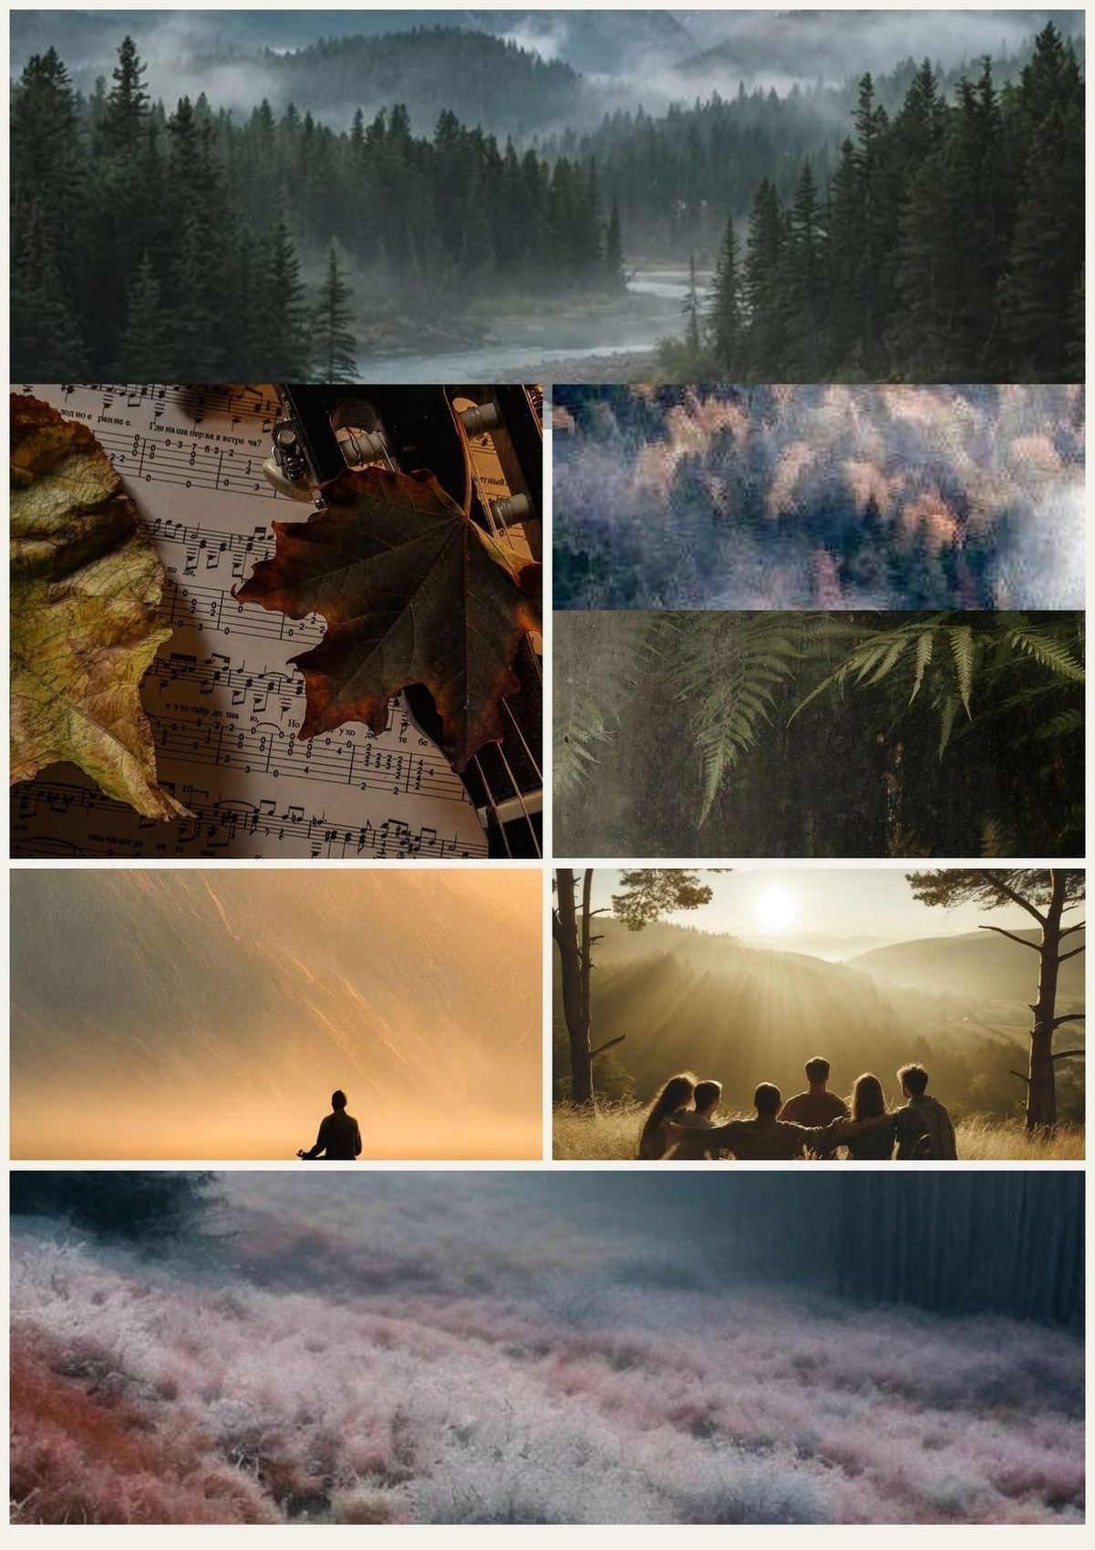
Mood board of “Dream String”: the misty forest by the river, music and autumn leaves, light in the mountains and people together.

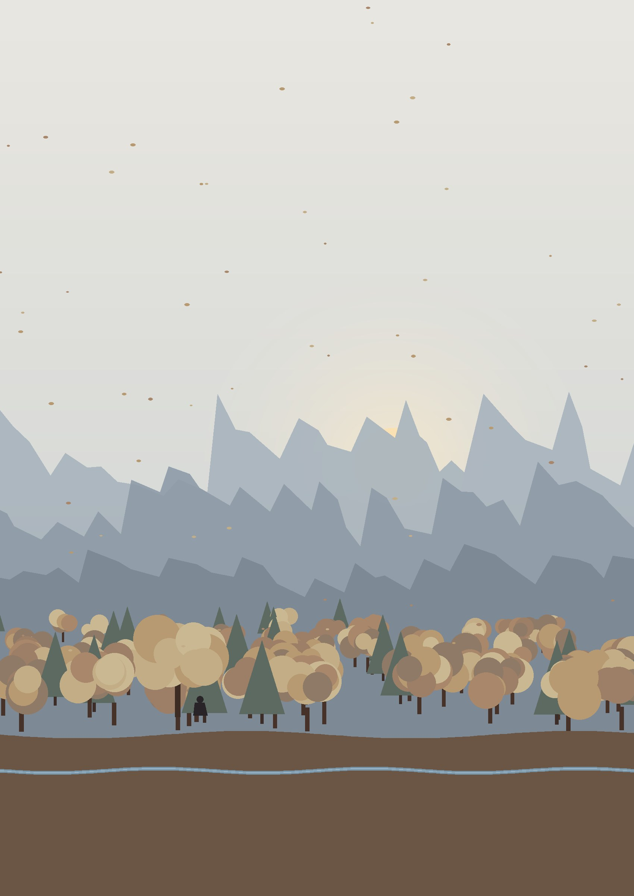

1.2.3. Nature as part of oneself
The main wish of this project is to instil a love of nature in people. Perhaps people begin to notice the state of nature only through the place where they live: the tree outside the window, the river on the way home, the morning air. When nature becomes part of the place where children play and learn, it becomes part of them – and then it is cared for not because it has to be, but because it is one’s own.
That is why the project must be as ecological as possible: build only outside the river strips and keep the trees; use local stone and timber; put the cars underground; collect rainwater from the roofs and use the sun on their southern slopes; plant native trees and let the river corridor ventilate the site.
People are contradictory: we want to be alone and together, to rest and to move, to be free and still have a choice, to live in nature but with the comfort of the city. The project tries to fit these contradictions into one place – quiet practice rooms and a lively hall, a calm forest and a restless river, a closed hall and a terrace open to the forest.
For the music centre the atmosphere of the place is heard rather than seen: the river becomes its voice – the slate blue of the water and the fog, the dark green of the firs and the autumn gold and copper of the details, on a base of river stone (1.3.4).

1.2.4. Conclusion: from feelings to architecture
The place is calm, autumnal, a little sleepy, sheltered by the forest and guarded by the mountains – and at the same time alive thanks to the river. The music centre should therefore convey the energy and joy of the river inside the calm of the forest. Translated into the language of architecture:
The place feels | The project should convey | Form | Colour and material | Light and sound
calm – time slows down | calm, unhurriedness | a low building lying along the forest; the roof steps up slowly from the ground | mist grey, mountain fog, river stone, matt surfaces | soft diffuse light; quiet practice rooms facing the forest
autumnal – golden and warm | warmth, a place to stay | warm roofs to walk on, a café where parents wait | larch gold, copper rust, wine-red seats, terrazzo with river pebbles | warm evening light in the foyer and the café
misty – soft and light | lightness | thin roof edges, a glass cube, light fibre-concrete fins | fog-blue glass, slate-grey fins, larch-gold frames | light through the fins and the glass cube
high – mountains all around | freedom, looking up | the fins rise towards the peaks; the terrace of the peaks +11.70 as a viewing place | green roof garden, fir green, grey basalt plinth | framed views; top light over the foyer
alive by the river – energy | movement, joy, awakening | a sound track of fins and an amphitheatre at the corner of the hall | copper rust and larch gold as accents | music and the sound of water instead of cars
protected by the forest | safety, life inside nature | a compact footprint along the fence; the amphitheatre among the trees | night forest, fir green, stone | dappled light, birds, acoustic silence in the practice rooms

GENIUS LOCI · what it means for the project
The music centre carries the river: its fins rise and fall like music, its roofs can be walked on and it opens to the forest with an amphitheatre. Around it the forest stays as it is.

Playlist of the place
♪ P. I. Tchaikovsky – October. Autumn Song – golden forest  ♪ Erik Satie – Gymnopédie No. 1 – morning mist  ♪ Yiruma – River Flows in You – the river at the fork | ♪ Kurmangazy – Balbyraun (kui) – energy of the river  ♪ Ólafur Arnalds – Saman – light through the leaves  ♪ Claude Debussy – Rêverie – evening, the dream
From the morning mist to the kui of the river and back to the autumn piano: the calm of the “autumn dream” and the energy that wakes it.

1.3. Architectural language

1.3.1. Around the site: neighbours and materials
The architectural language of the valley is shaped not by the city but by the mountains. Development here is sparse and low: individual houses of 2–3 storeys with pitched terracotta or graphite roofs and a low-rise complex of 3–4 storeys right across the road. Its houses – beige render, vertical bay windows in warm wood-look panels, dark roofs with deep eaves and massive stone plinths – stand behind retaining walls and firs and really peep shyly out of the green fringe of trees.

Immediate surroundings (up to 300 m)
Neighbours of the site: colour, material and character. Photos, September 2026; the swatches show the main colours of each place.
Near the site the character is calm, solid and green: warm render and wood of the complex across the road, stone plinths and retaining walls, weathered brick by the river, timber decks of the terrenkur and the clean concrete lines of the Esentai canal. Buildings stand behind trees and walls – the street is formed by greenery, not by façades.

Houses around the site (100–400 m)
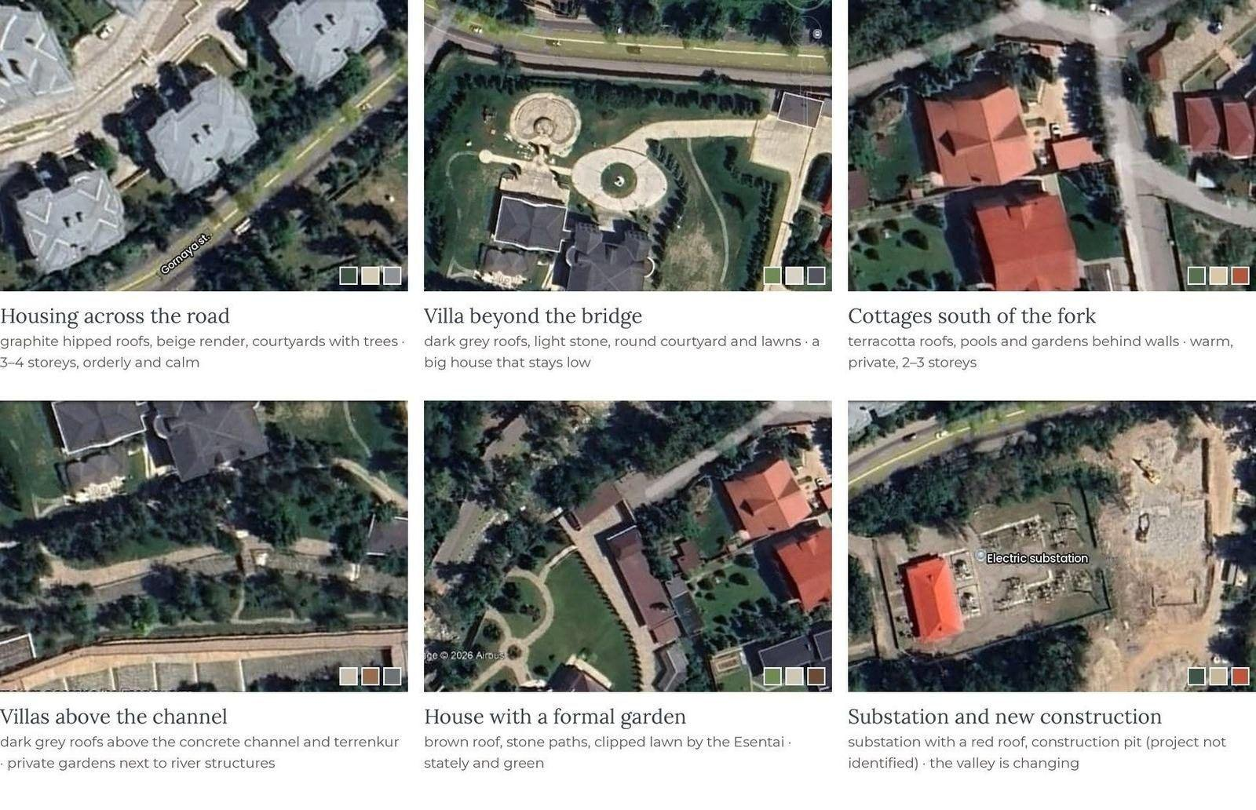
The houses closest to the site from above: colour, material and character. Aerial views – Google Earth Pro (Airbus, 2023 imagery); the swatches show the main colours.
Right around the site stand private houses of 2–3 storeys in large gardens: villas of light stone and render with graphite and terracotta pitched roofs, cottages behind walls south of the fork, a house with a formal garden by the Esentai and a calm, orderly low-rise complex across the road. Near the substation there is a construction site – the project could not be identified from open data; the valley is changing. Everything stays below the tree crowns: from above the view is formed by roofs, not façades.

Direction for new buildings
fresh  light colours, air between volumes, open views | clean  simple forms, few materials, honest details | calm  horizontal rhythm, low silhouette, no loud forms | green  preserved trees, green terraces, courtyards | contemporary  large windows facing the peaks, contemporary wood and stone

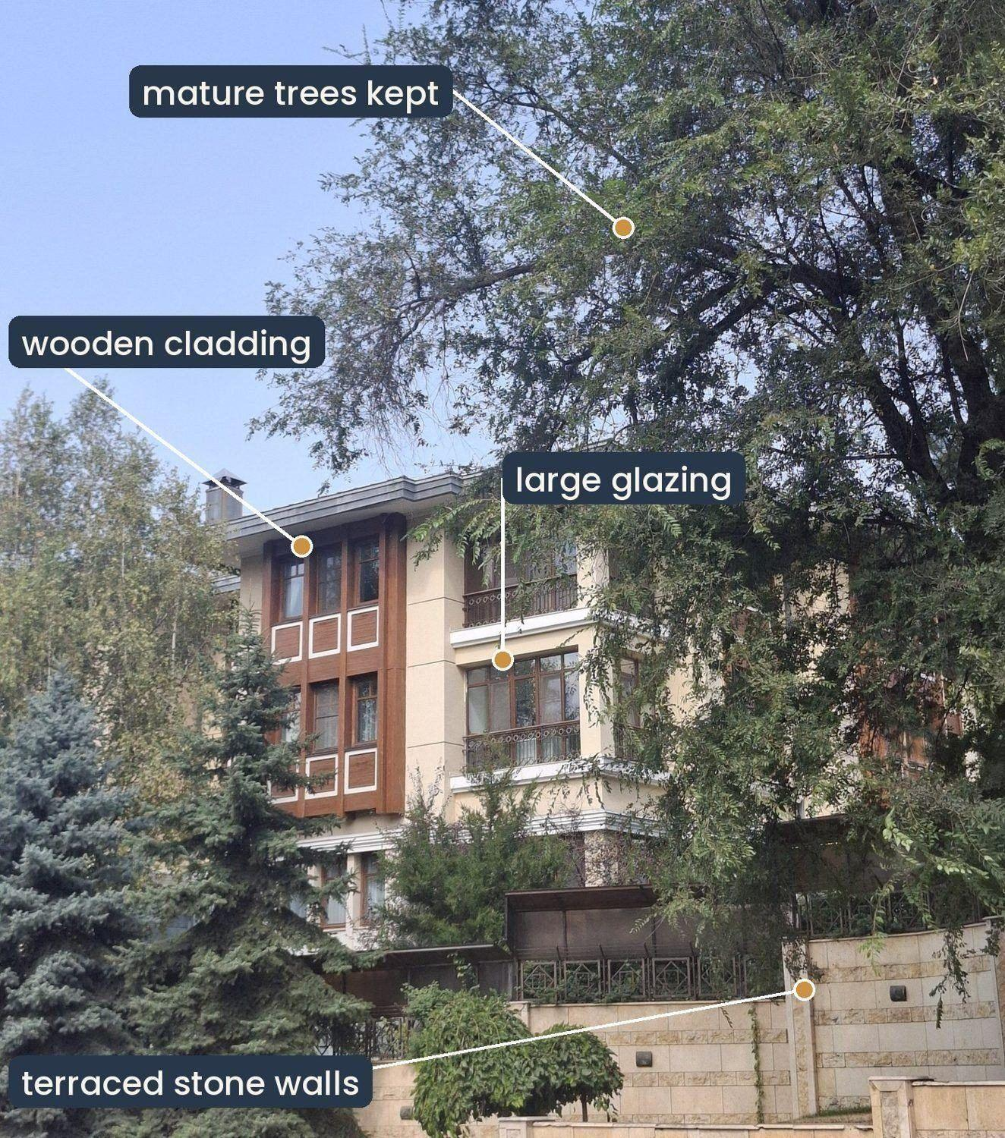
The low-rise housing complex across the road: materials and elements of its architectural language.

Form of the surrounding buildings
On one side of the road stands the low-rise complex: calm horizontal volumes of 3–4 storeys under low hipped roofs with deep eaves. The red lines show its form – two blocks that step back one behind the other, vertical timber bays cutting through the floors, horizontal balcony slabs and a base of stone terraces stepping down to the street.
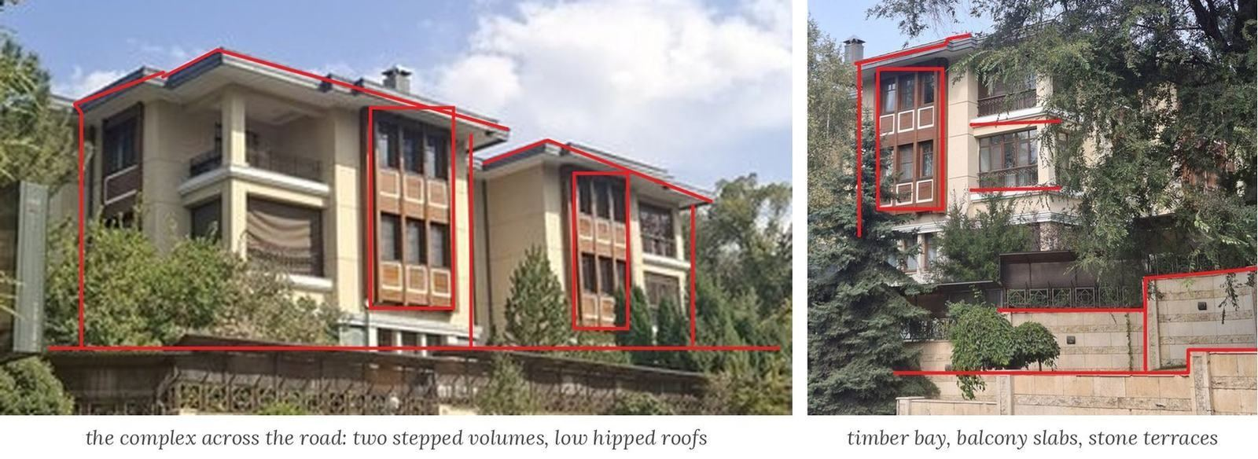
The complex across the road: its form outlined in red. Photos, September 2026.
On the other side, around the fork, are private houses and villas behind walls. We see them mostly from above: their form is simple and compact – almost square plans under hipped terracotta or graphite roofs, one or two volumes in each garden.
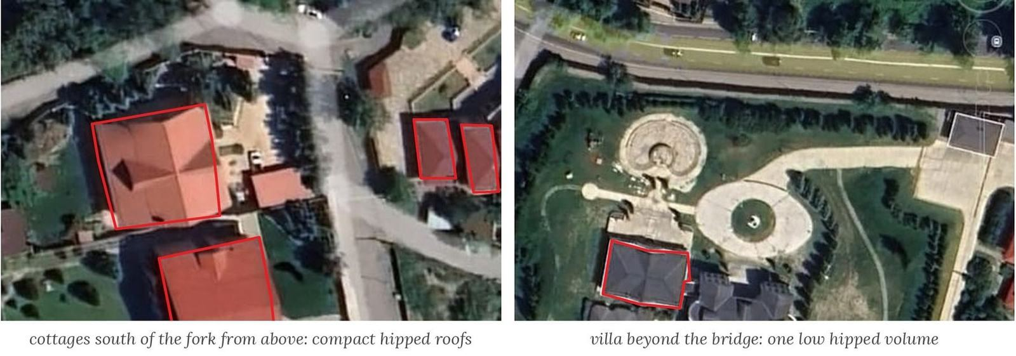
Private houses around the fork: roof outlines in red. Aerial views – Google Earth Pro (Airbus, 2023).
Both families of buildings follow the same rules – low height, a hipped or pitched roof and a heavy stone base – and none of them rises above the trees. The music centre continues these rules; its own character comes from its sound track of fins and from roofs that people can walk on (1.3.5).

Dialogue with the neighbours
The neighbours say… | …the new buildings answer
stone plinths and retaining walls | a heavy stone base stepping down the slope
warm render and timber bay windows | light render and vertical fins of warm grey fibre-concrete
pitched terracotta and graphite roofs | green roofs to walk on; rust-coloured copper only as an accent
buildings hidden behind trees | one low building among the trees, no higher than the old poplars
glass of the new complexes | glass behind the rising fins – the sound track

CONCLUSION · what it means for the project
The surroundings are low, natural and green, and the newest buildings are clean and contemporary. The music centre should continue this language – a stone base, light concrete and render, a roof that answers the mountains, glass facing the forest – and add only one new note: the slate blue of the river and the rust-brown copper of autumn. Fresh, clean, calm, green and contemporary: the new buildings talk to the neighbours instead of shouting over them.

1.3.2. The whole neighbourhood: style, landmarks and recurring motifs
General style of the district. The upper Medeu district is not a single ensemble but a “resort” suburb at the foot of the mountains: Soviet sanatoria and rest homes (Kazakhstan, Ak Kaiyn), modernist sports and science facilities (the Medeu rink, the observatory on the Kamenskoe plateau), and between them private houses and small complexes of the 2000s–2020s in the spirit of the Alpine chalet and contemporary classicism. What unites them is not style but conditions: the slope, the trees, the snow and the view of the mountains.

Landmarks
The site stands on the road that links the city with the mountains. Along this road, like beads on a string, lie the main landmarks of the Almaty foothills – places of sport, science, recreation and nature.
Medeu ice rink  Opened in 1951 at an altitude of 1,691 m, 7 km further up the same road. A famous high-altitude rink with an ice area of 10,500 m², where more than a hundred world records were set. Together with the mudflow dam above it, Medeu shows how architecture and engineering live with a mountain valley. | Kok-Tobe and the TV tower  A tubular steel TV tower 371.5 m high (1983) on Kok-Tobe hill – the vertical landmark of the whole foothill zone. Today the hill is a recreation park with views of the city and the mountains.
Observatory on the Kamenskoe plateau  The observatory of the Fesenkov Astrophysical Institute, founded in 1947 at an altitude of 1,450 m, about 2.5 km from the site. Its white telescope domes look at the sky above the valley; comet 67P/Churyumov–Gerasimenko was discovered here in 1969. | Terrenkur along the rivers  The health trail along the Esentai branch (≈ 4.2 km, 2021–2022) runs from Zhamakayev street to the water divider right at the site; in 2026 its 6 km extension to Medeu was announced, with wooden footbridges, benches and lamps. It is an everyday landmark of the district.

Recurring motifs: materials and colours
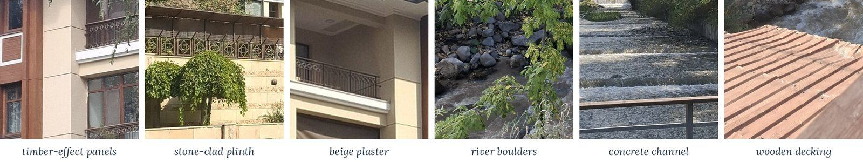
Materials of the surrounding houses and river structures.
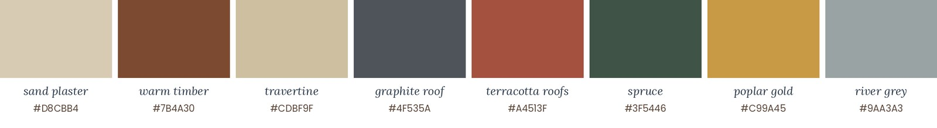
Colours of the surrounding buildings and nature.
The neighbouring buildings are heavy and natural at the base – stone plinths, retaining walls, river boulders – and lighter and warmer at the top: render, wood, glass and pitched roofs. Nothing argues with the mountains.
Motif | Where it appears | How the project takes it
Stone plinth and retaining walls | cottages, the complex across the road, embankments | a stone base for the centre and its terrace
Pitched roofs: terracotta and graphite | almost every house in the valley | roofs of different heights that can be walked on (1.3.5)
Light render + wood | ArmanVille complex, new townhouses | light surfaces and timber bay windows
Vertical bay windows and balconies | the complex across the road | vertical fins in front of the glass – the sound track
Green “fringe”: firs, poplars, hedges | along the street and the rivers | the centre behind trees, a street made of greenery
River stone and canal concrete | the Esentai, terrenkur footbridges | boulders in the landscape; concrete and timber of the promenade
Colours: misty grey, beige, terracotta, poplar gold | the whole valley | the “Dream String” palette (1.3.4)

CONCLUSION · what it means for the project
At the scale of the district the landmarks are stops on the road to the mountains (Medeu, the observatory, the terrenkur), not tall buildings. The recurring motifs are a stone plinth, a pitched roof, light render with wood and the green fringe of trees. The project repeats them and becomes one more quiet stop on the road to Medeu – a landmark through its roofline and public life, not its height.

1.3.3. Project materials
For the music centre I chose materials that continue the stone of the river and the autumn forest: grey basalt and fair-faced concrete below, fibre-concrete fins in one warm grey, copper that weathers to a rust-brown, and glass the colour of the mountain fog. The fins are not made of timber.
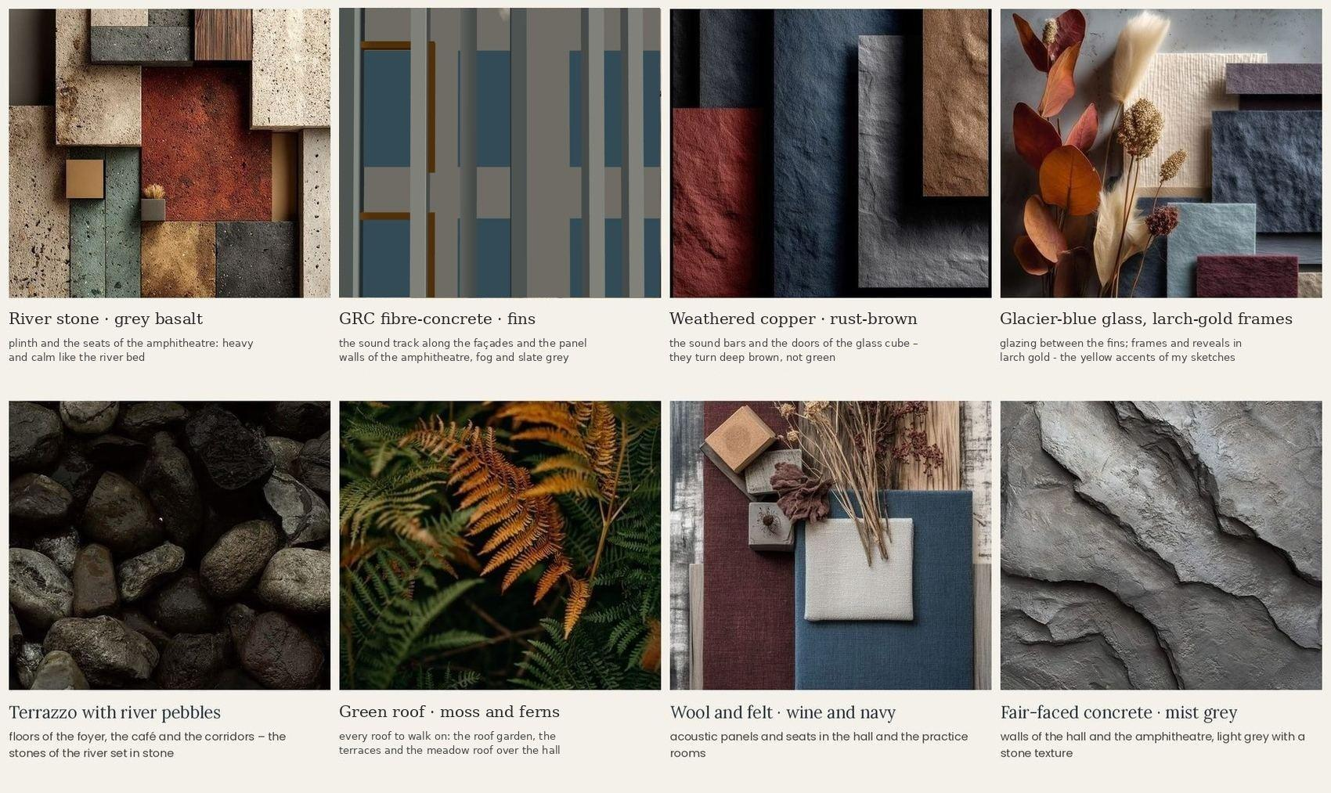
Materials of the music centre: river stone, fibre-concrete fins, weathered copper, fog-blue glass and slate metal, terrazzo, a green roof, wool and felt, fair-faced concrete.
- River stone and concrete – grey basalt for the plinth, the seats of the amphitheatre; fair-faced concrete for the walls of the hall: heavy and calm, like the riverbed.
- Fibre-concrete (GRC) – the fins of the sound track and the panel walls of the amphitheatre, through-coloured in one warm grey: light, durable, without paint and maintenance; no timber on the façade.
- Weathered copper – the sound bars and the doors of the glass cube: it turns rust-brown, like fern in October – not mint green.
- Glass and slate metal – fog-blue glazing between the fins; frames and reveals of larch-gold powder-coated aluminium – the yellow accents of my sketches.
- Inside – terrazzo with river pebbles in the foyer and the café, light ash in the practice rooms, wool and felt in wine and navy for the acoustic panels and the seats.

CONCLUSION · what it means for the project
Stone below, warm grey fibre-concrete fins and fog-blue glass above, larch-gold frames and rust-brown copper as the autumn accents. The same few materials outside and inside, so that the centre reads as one instrument.

1.3.4. Colour palette
For the colour scheme of the music centre I wanted the blue and grey tones of the river and the fog, but not without autumn: the cool colours carry the large surfaces, and the autumn gives the warm notes. The palette has eight colours – night forest, fir green, glacier slate, mountain fog and mist, and the autumn accents larch gold, copper rust and wine leaf. There is no mint in it: copper is used in its weathered, rust-brown state.
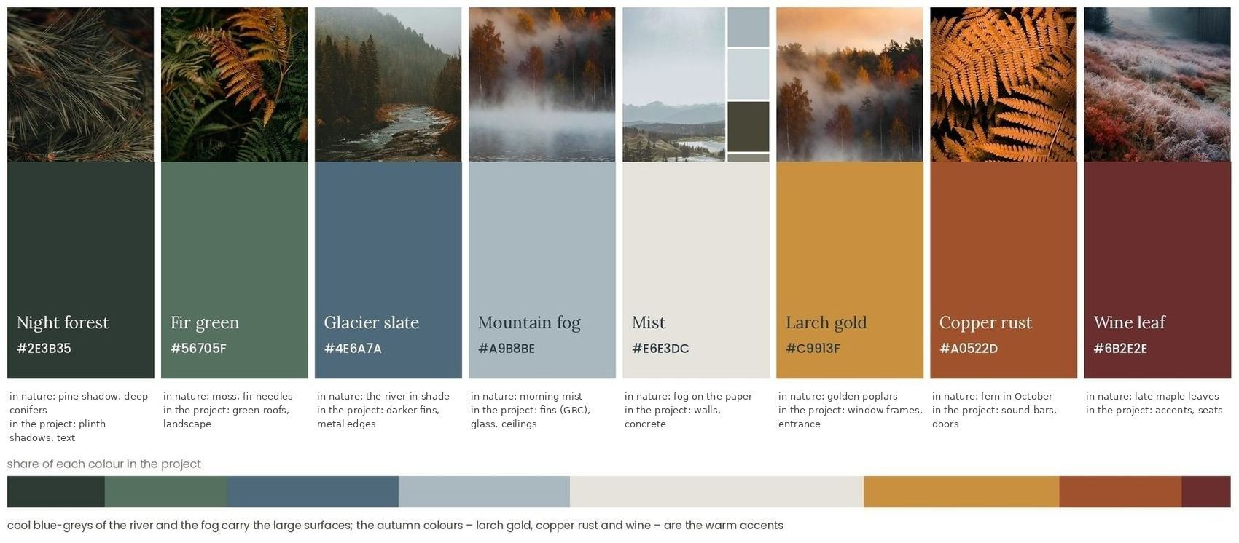
The “Dream String” project palette: colours taken from photographs of the valley and the autumn forest.
The colours were chosen from the photographs of the place and of the season: the river in the shade, the morning fog, pine shadow and fir needles, golden poplars, ferns and maple leaves in October. The centre speaks the language of the misty valley, and the autumn wakes it up.
- Fog and slate – the fins, the glass, the ceilings and the light concrete of the large surfaces;
- Forest greens – the roof garden, the planted steps and the landscape;
- Autumn accents – larch gold of the window frames, copper rust of the entrance, wine-red seats and acoustic panels.

CONCLUSION · what it means for the project
Mist, fog and slate blue for the large surfaces, the forest greens for the roof and the landscape, larch gold and copper rust as the autumn accents – so that the centre belongs to the misty valley and still glows in October.

1.3.5. A roof to walk on: from the ground to the amphitheatre
I want an exploitable roof – roofs that people can walk on, sit on and play on. The ridges of the Trans-Ili Alatau close the view to the south: they rise, fall and rise again (graph 1). My centre answers them with blocks of different heights, like the bars of a sound track: the café roof at +3.90, the roof garden, the cube roof and the terrace over the stage at +7.50, and the terrace of the peaks and the meadow roof over the hall at +11.70. Every roof is reached by a stair, and at the end of the walk the building opens to the forest with an amphitheatre at the corner of the hall.
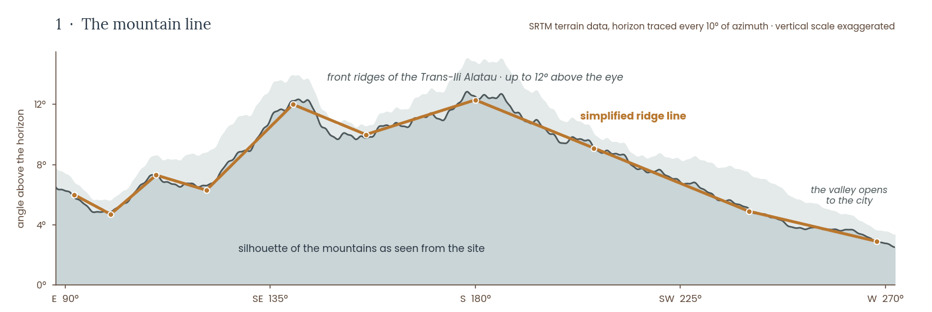
The mountain line: horizon angles calculated from the SRTM 30 m digital elevation model.
The roofs to walk on: the roof garden +7.50 with the terrace of the peaks +11.70 behind it (3D model).
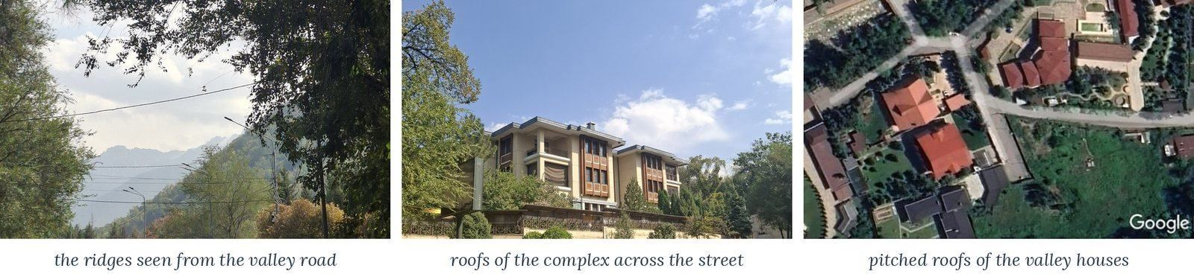
The mountain line and the pitched roofs already found in the valley. Aerial view – Google Earth.
Part of the roof | Height and form | Use | Snow and water
Café roof terrace | +3.90, flat | a quiet terrace for the floor of the practice rooms | holds snow and rain (μ = 0.8), slow drainage
Roof garden of the learning block | +7.50, 33.6 × 11.4 m | meadow, benches and a play deck; open-air lessons | holds snow and rain, slow drainage to the rain garden
Cube roof | +7.50 | a small garden between the two sections | glass edges kept free of snow
Terrace of the peaks | +11.70, stone pavers, glass railing 1.2 m | the view of the peaks, open-air lessons | two gutters; snow guards above the entrance
Meadow roof over the hall | +11.70 | a quiet walk and the view to the forest | extensive green roof, light snow load
Terrace over the stage | +7.50 | a balcony for the amphitheatre | drainage to the forest
Amphitheatre | ±0.00 → +2.25, 5 rows 0.9 × 0.45 m | concerts and cinema for ≈ 90 + the lawn; the end of the walk | snow stays on the rows; open drainage to the forest
The parts of the roof of the centre (μ – snow load shape coefficient, EN 1991-1-3).
A roof for people. Children go up to the roof garden after school, parents wait on the café terrace, and after a concert the audience walks from the terrace over the stage down to the amphitheatre. The rhythm of music. The fins rise and fall like a sound track, and the terrace of the peaks looks straight at the mountains. Safety and climate. Glass railings of 1.2 m along all edges, two ways down from every roof, steps of 15 × 32 cm on the stairs and 45 × 90 cm on the rows; snow guards above the entrances and the stage; roof water is collected in the rain garden.

CONCLUSION · what it means for the project
The roofs are the main gesture of the centre: blocks of one, two and three storeys, each roof a place for people, and an amphitheatre where the building meets the forest. They stay far below the 25 m allowed for culture and below the poplars, and the fins show the rhythm of music from afar.

1.3.6. References
Three leisure centres show the programme and the character I look for. For each I keep only the pictures and what I take; their plans and functional diagrams are in 2.2.4–2.2.6, so the material is not repeated.

COFCO Cultural & Health Center, Shanghai
Steven Holl Architects with ECADI · Shanghai, China · 2016–2021. A cultural and a health centre in a public park on the Punan canal (analysed with plans in 2.2.4).
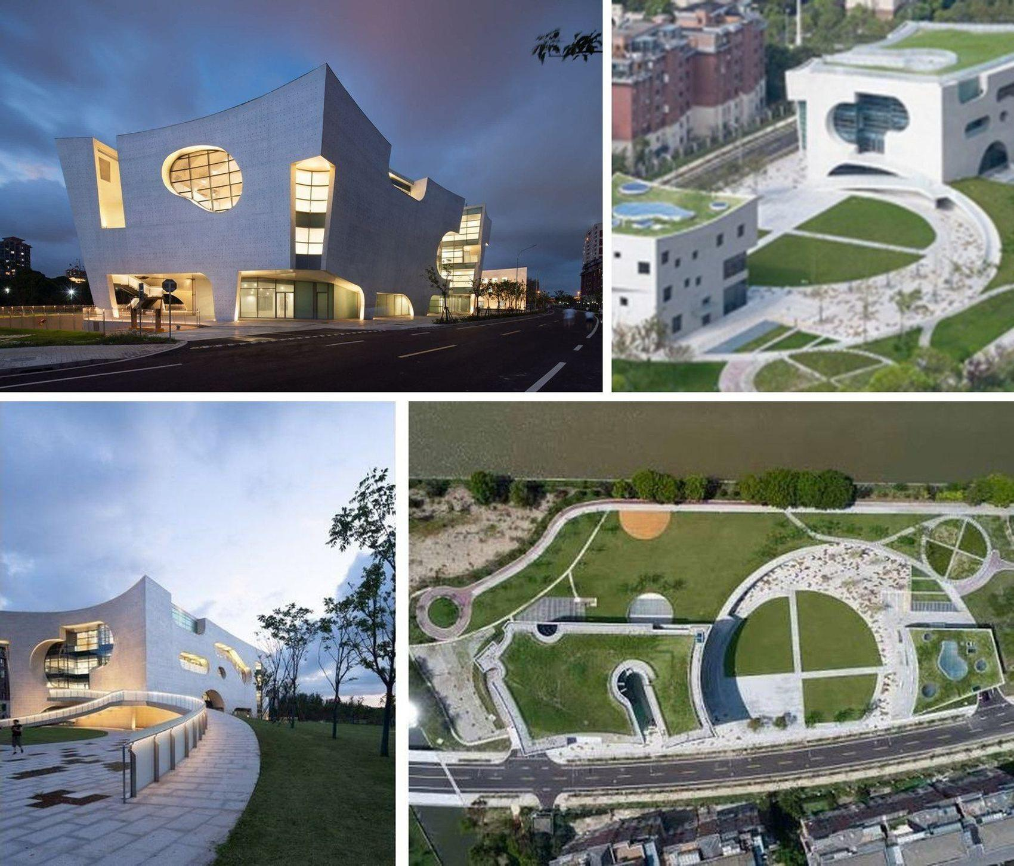
COFCO – a building that is also a park: the cultural centre, the green roofs, the ramp and the park with the “clock” circles.
- Green roofs and ramps continuing the park – you can walk over the building.  - Several functions under one roof – culture, health and sport share one foyer. | - Large round openings framing the trees and the sky.  - For us: the roof of the centre as a garden terrace towards the forest.

Dushan Leisure Center, Songyang
DnA_Design and Architecture · Songyang, China · 2018. A timber visitor and sports centre on a wetland at the foot of Dushan mountain (analysed in 2.2.5).
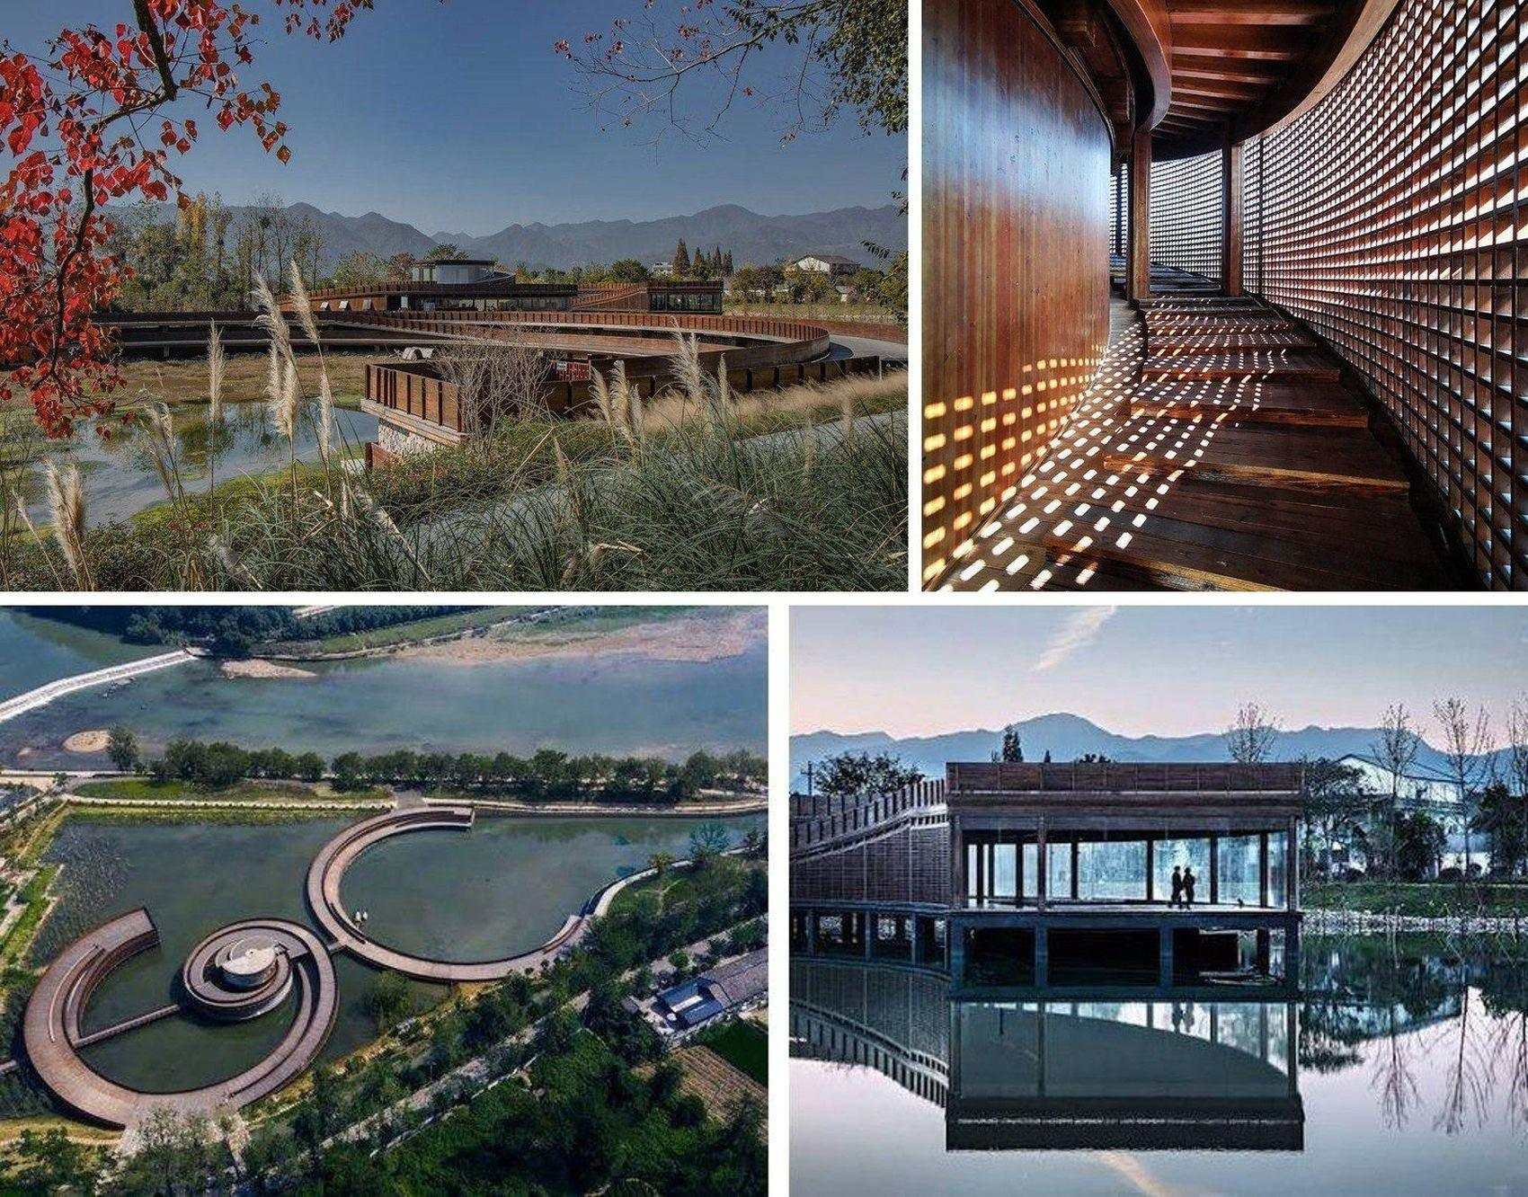
Dushan Leisure Center – unity of building, water and mountains: the spiral walkway, the timber screen and the pavilion over the water.
- A walking path through and around the building – the route itself becomes an experience.  - Glass pavilions over the water – the interior is open to nature on all sides. | - Timber screens – soft diffuse light, like light through leaves.  - For us: a foyer opening onto the amphitheatre in the forest, and a path over the roof to a view of the peaks (1.3.5).

Ku.Be – House of Culture and Movement, Frederiksberg
MVRDV + ADEPT · Frederiksberg, Copenhagen · 2016. A house of culture and movement for all ages (analysed in 2.2.6).
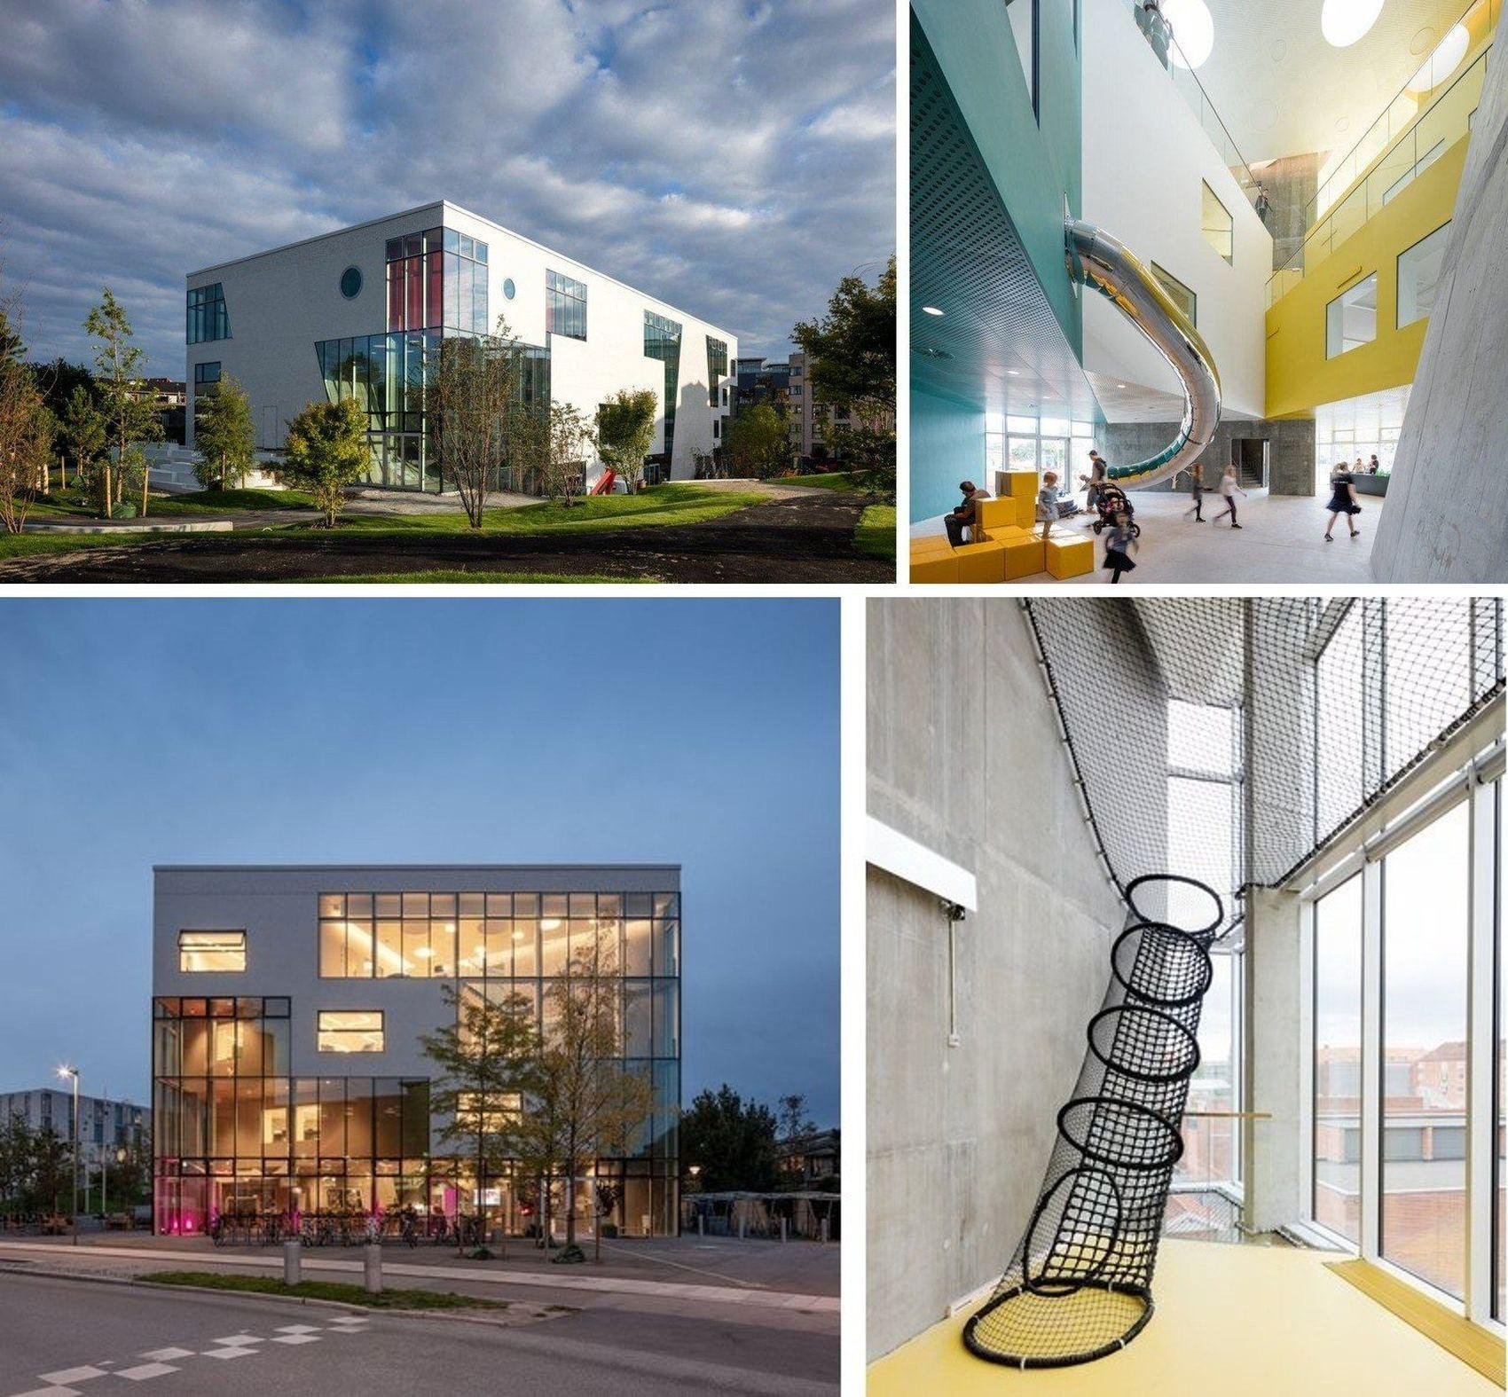
Ku.Be – freedom to use the space: the glazed building in the park, the slide and the climbing net between the volumes.
- No single scenario for a room – visitors decide for themselves what happens where.  - Slides, nets and stairs connect the levels into one play route. | - A glazed ground floor shows the street the life inside.  - For us: a transformable hall with movable partitions and a children’s route between the levels.

CONCLUSION · what it means for the project
From the leisure centres: many routes, body and mind under one roof, the walk and the view as the main event, a roof that is also a park. Section 2.2 adds examples closer to the music programme and to the roof walk.

1.3.7. Conclusion
The architectural language of the surroundings is defined by low height, natural materials and a lot of greenery. The buildings are heavy below and light above, and their pitched roofs never argue with the mountains.
The future centre will fit into this context: low (7.5 m at the roof garden, 11.7 m at the highest roofs), a stone base, fibre-concrete fins and glass, a palette of mist, fog and slate blue with the autumn accents of larch gold and copper rust. Its own character comes from its sound track: fins rise and fall like music around blocks whose roofs people can walk on, and the building opens to the forest with an amphitheatre; inside it gathers music, culture and quiet movement.
keep  - the stand of trees  - the river banks  - a stone base  - a low silhouette | transform  - the forest edge – into an amphitheatre  - music – into a sound track of fins  - the river – into colour  - site 278 – into a riverside park | add  - a music centre  - clubs for children  - a roof to walk on  - a stage in the forest

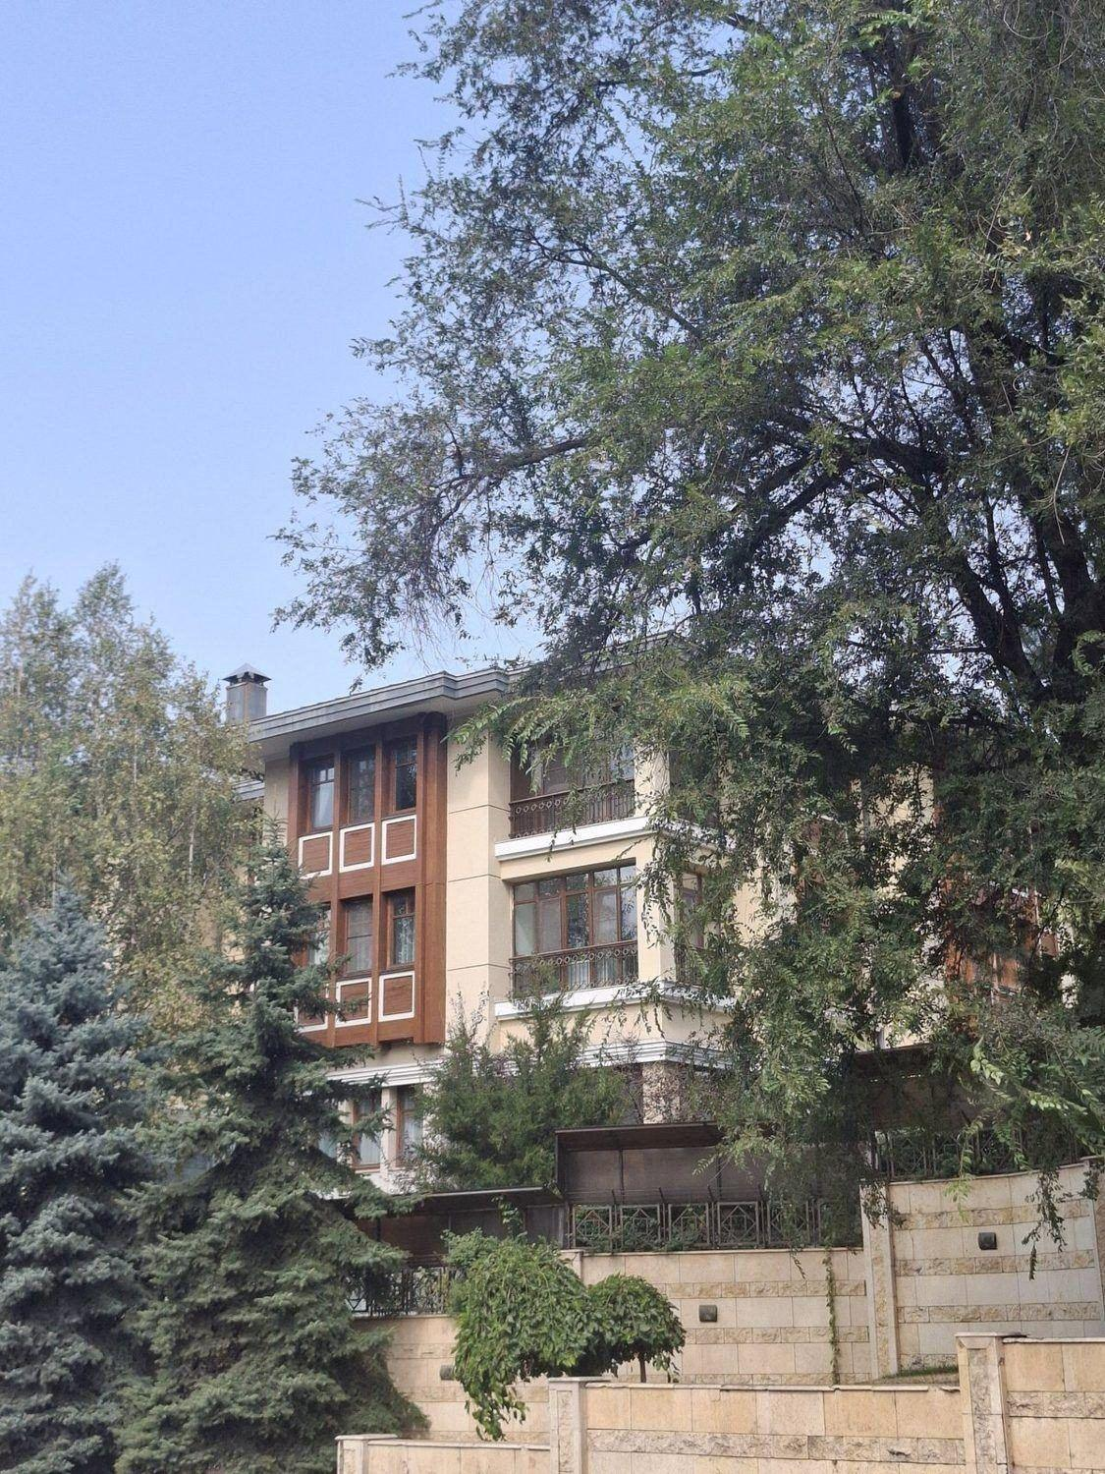 | Unlike a closed school, the centre should become a place of the forest under roofs that can be walked on – a place from which the forest and the peaks are seen, not a wall that hides them.

1.4. Urban zoning
On this site public leisure and protected nature meet on a very small territory, so zoning defines what can be built, where, and what must remain untouched.

1.4.1. Functional zoning
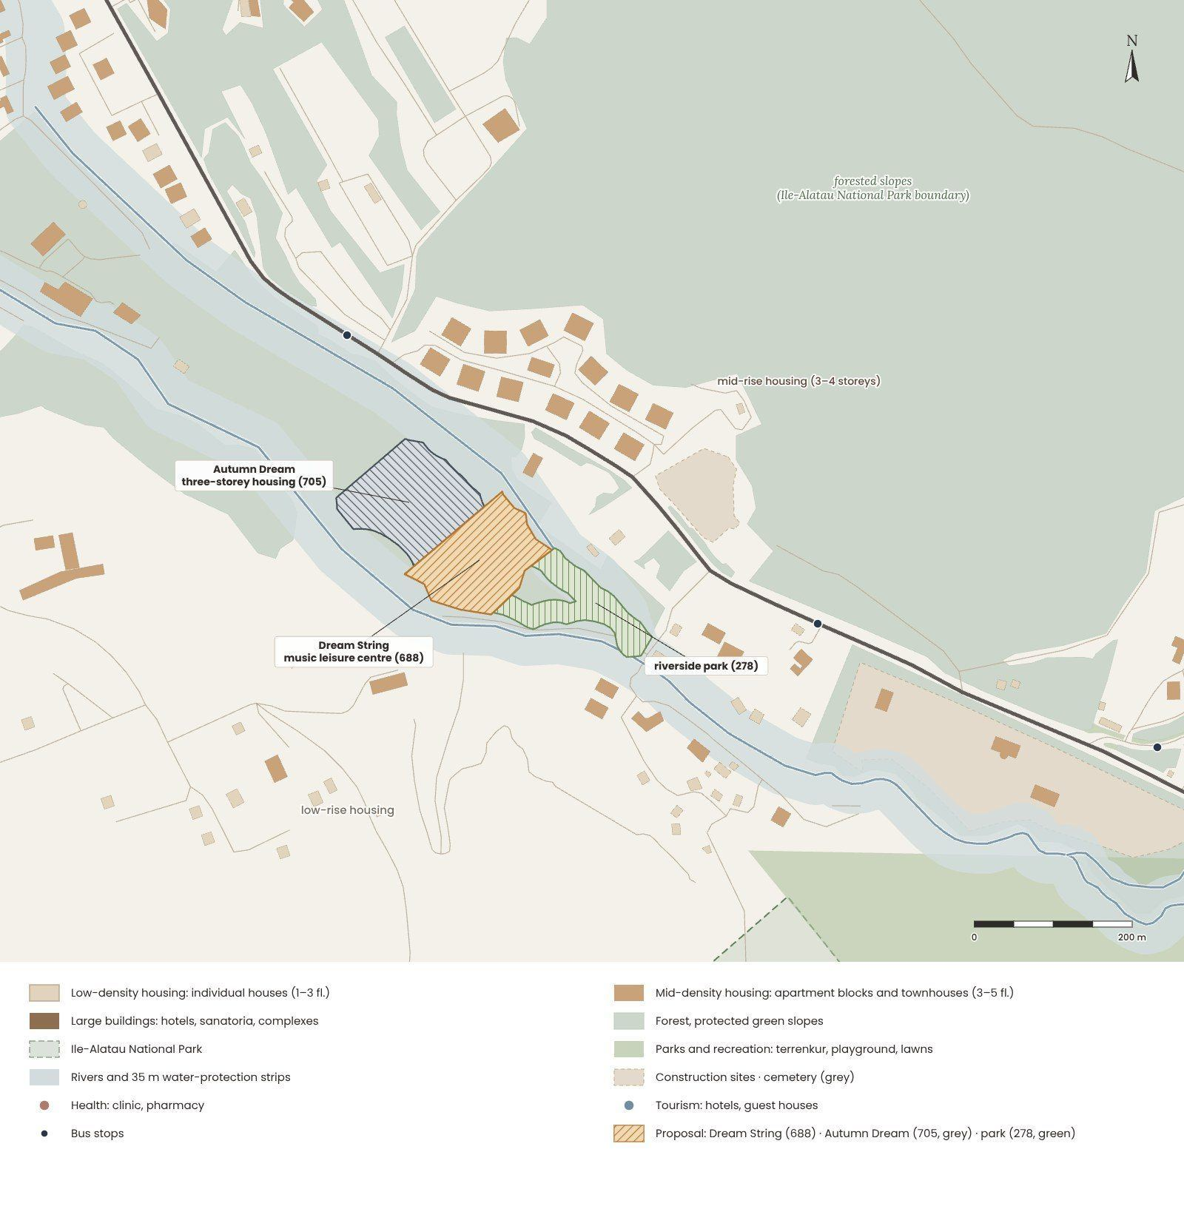
Functional zoning of the surroundings in the course colour code: housing of three densities, greenery, sport, culture, education, health and administration (based on OpenStreetMap data and site observation).
Housing is the dominant function – mostly low-rise individual houses and one mid-rise complex of 3–4 storeys; high-density housing appears only 1.6 km further down the valley. The rest of the territory is taken by wooded slopes on the border of the Ile-Alatau National Park, river corridors and utilities. Sport, culture, education, health and administration are not within walking distance – only a private clinic (0.5 km), the Tau Tamyr hotel, a restaurant and a playground.

CONCLUSION · what it means for the project
The zoning map is almost one-coloured – housing and greenery. The music centre adds the missing colour of “culture”; everything else stays green.

1.4.2. Street network and access
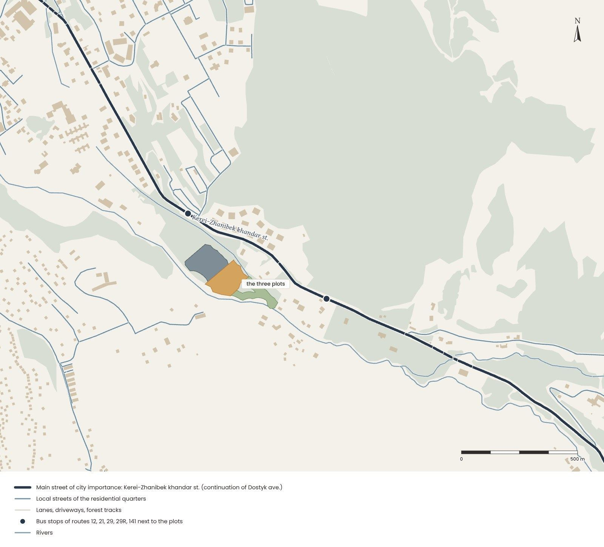  Street hierarchy around the site. | The site is served by one main street of city-wide importance – Dostyk avenue, which continues as Kerei-Zhanibek khandar street to Medeu and Shymbulak. It carries local and tourist traffic, which grows at weekends and in the ski season.  District streets (Ospanov, Beiseuov, Tattimbet) link the valley with the neighbouring districts; the other streets are narrow residential lanes, often without pavements.

Public transport. Buses 12, 21, 29, 29R and 141 run along the main street. The “Agroleskhoz” stop is about 210 m from the site bridge, the “Dom otdykha” stop is about 280 m from plot 688; route 21 runs every ≈ 8 minutes (2GIS).  Cars. The only access is from the main street over the Kishi Almaty, so a new bridge is needed opposite plot 688. The car park must be underground – cars stay out of the forest and out of the water-protection strips.  Pedestrians and cyclists. The terrenkur reaches the site along the Esentai branch – the safest and most pleasant way here runs along the river, not along the road. In 2026 an extension of the terrenkur 6 km up to Medeu was announced – the site will be in the middle of the route. | 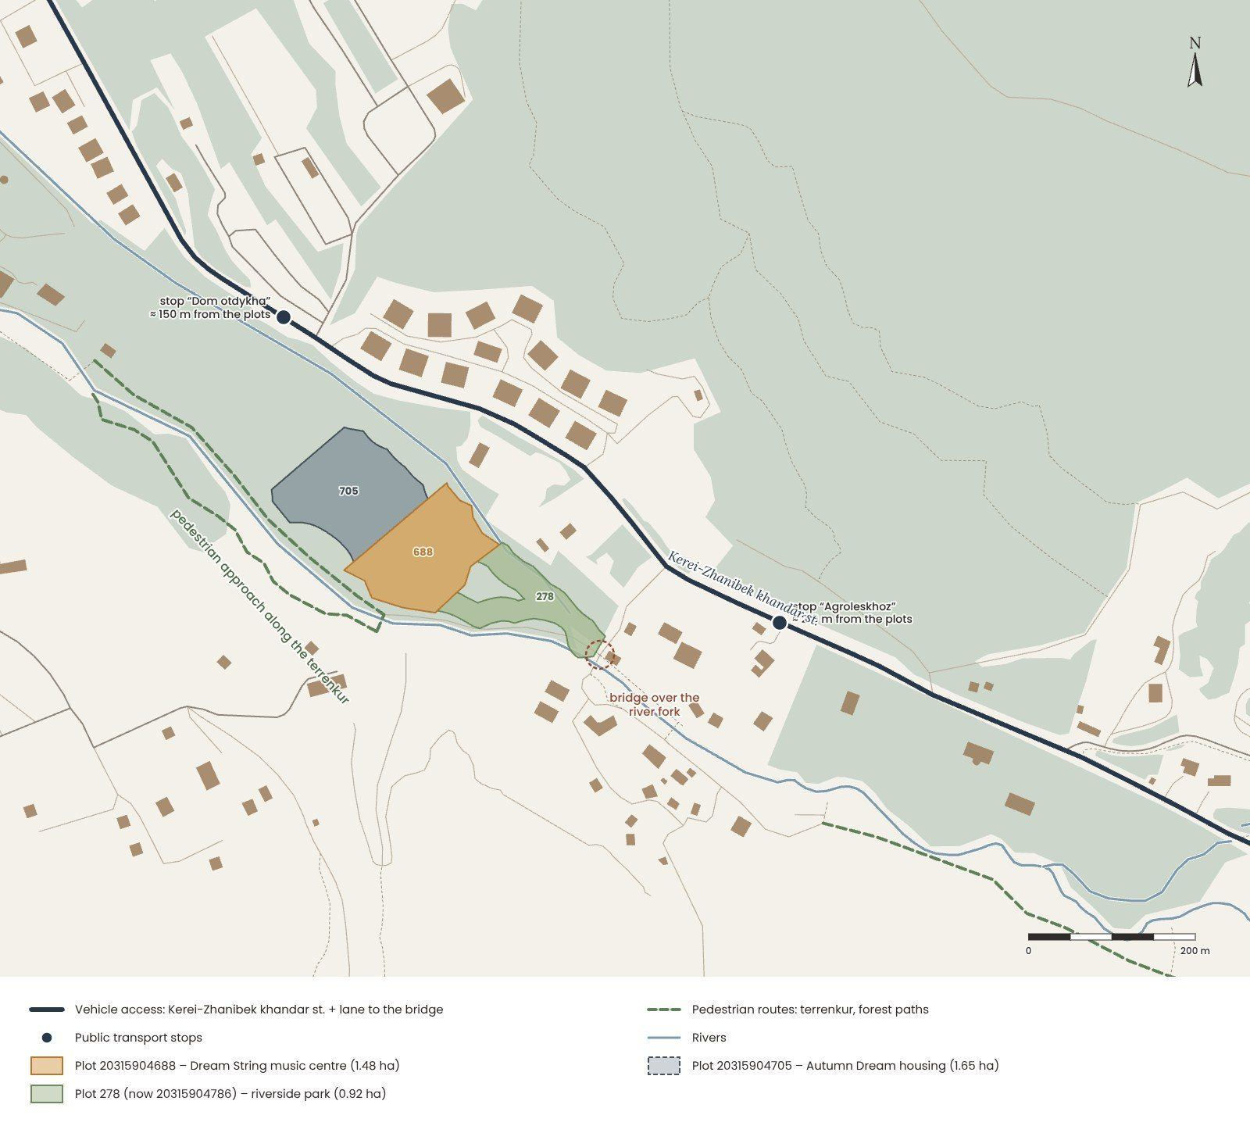  Access: cars, pedestrians, public transport.
Maps: OpenStreetMap data.

CONCLUSION · what it means for the project
One main street, one bridge and one pleasant footpath: the car approach is short and single, the walking route is long and beautiful. The access concept separates them.

1.4.3. Access concept
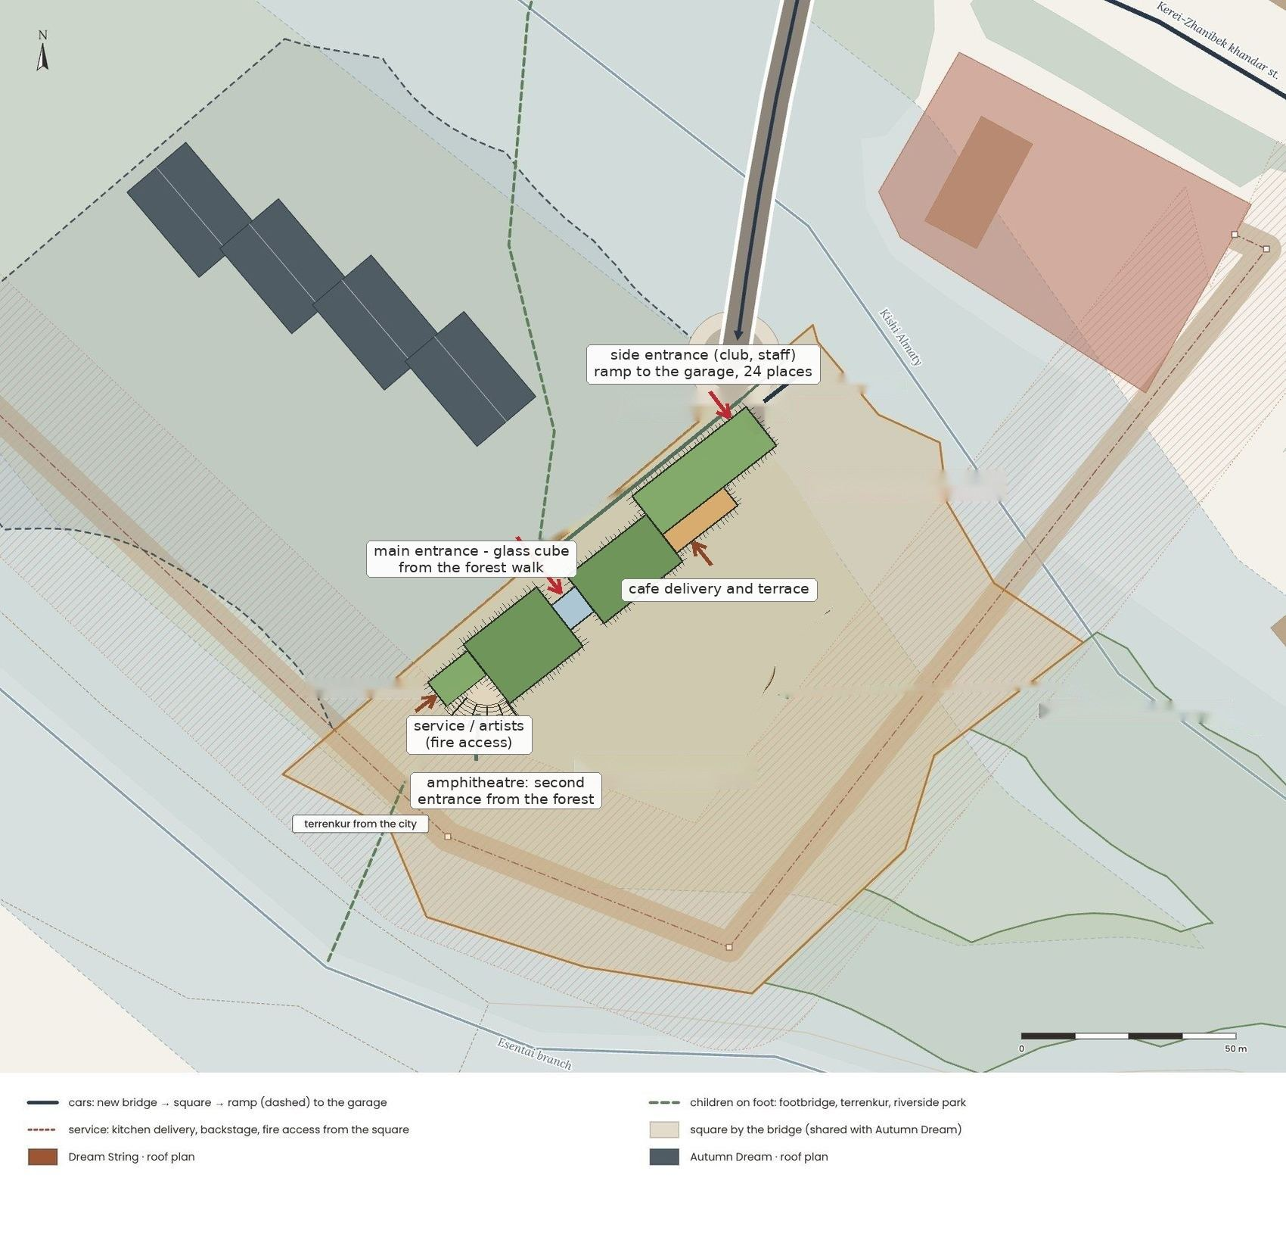
Access concept of the centre: one car entry over a new bridge, a drop-off at the square, the garage ramp, the forest walk to the glass cube, the service lane and the amphitheatre (site plan).
Cars. There is one car entry: from Kerei-Zhanibek khandar street over a new bridge across the Kishi Almaty to a small square with a drop-off loop, where parents, minibuses and taxis stop; the side entrance at the square is the staff entrance of the administration; the main entrance in the glass cube is about 60 m further along the forest walk. From the square a ramp (≤ 15 %) goes down into the garage under the learning section – 24 places. There is no parking on the ground and nothing in the water-protection strips.
How many places. By SP RK 3.01-101-2013∗ (Appendix D, Table D.1) a concert hall needs one place per 10–12.5 seats and one per 4–5 employees: 200 seats ÷ 10 = 20 and 15 staff ÷ 4 ≈ 4, so 24 places in the concert mode. On an ordinary weekday about 133 users are in the building at the same time (≈ 13 places) plus the café (40 seats ÷ 4–7 ≈ 6–10), 19–23 places – fewer than 24. At least 10 % of the places are for people with limited mobility: 3 wide places next to the lift (8.8.6). One underground level needs about 25 m² per car (Table 13-2): 24 × 25 = 600 m² – the garage has 685 m².
Distances. The portal of the ramp is 19 m from the windows of the centre (≥ 15 m, 8.8.8), more than 20 m from the junction with the street and far from the bus stops (≥ 30 m). The “Dom otdykha” stop is about 240 m from the main entrance (≤ 250 m for buildings with many visitors, 8.7.1), the drop-off 40 m (≤ 250 m, 8.8.3).
Pedestrians and service. Children come from the “Dom otdykha” stop over the footbridge and along the forest walk, or along the terrenkur from the city and through the riverside park from the fork. The main entrance is the glass cube between the two sections, on the forest walk; a side entrance for the club and the staff is at the square, and a second, open way leads from the forest to the amphitheatre. The kitchen delivery is at the café, and the artists and the equipment come to the artists' block by the service lane, which is also the fire access to the hall.

Public and private access
Access | Public | Service
On foot | from the stops along the forest walk, the terrenkur and the riverside park → main entrance in the glass cube; the side entrance at the square, the amphitheatre from the forest | staff and club entrance at the square
Cars | drop-off loop at the square (parents, minibuses, taxis) | ramp at the square → garage under the learning section, 24 places, 3 accessible
Service | deliveries to the café kitchen and the backstage from the service lane | waste room by the kitchen delivery; fire access along the lane
Open spaces | the square, the forest walk, the roofs to walk on and the amphitheatre, the riverside park on 278 | the green barrier of trees on the substation side

CONCLUSION · what it means for the project
Separate the flows: cars stop at the square and go underground, children arrive on foot from the two stops, along the terrenkur and through the park. 24 places by the norm, all underground; the service lane is also the fire access.

1.4.4. Neighbour project: Autumn Dream
The neighbouring plot 705, along the Kishi Almaty to the north-west, is given to a separate project – the residential building “Autumn Dream”: four three-storey sections stepping along the river with 40 apartments, shops and a café by the bridge, and a garage under the house. The two projects are designed separately, but they share the place: one car entry over the new bridge, the small square by it and the forest walk between them.
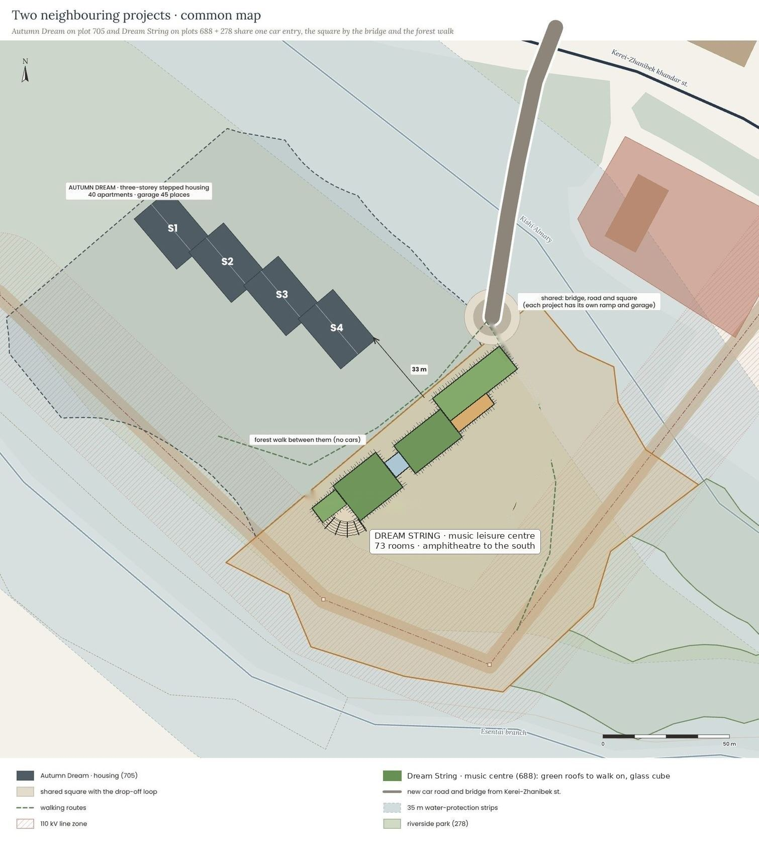
Common map of the two neighbouring projects: Dream String on plots 688 + 278 and Autumn Dream on plot 705, the shared bridge, square and forest walk.
What is shared | How it works | What stays separate
Car entry | one new bridge from Kerei-Zhanibek st. and the small square with a drop-off loop | each project has its own ramp and its own underground garage (24 + 45 places)
Distance | the buildings stand 32 m apart; the forest between them is kept | the hall, the amphitheatre and the loud rooms face away from the house
Paths | the forest walk between the centre and the house; the footbridge to the “Dom otdykha” stop | the gardens of the house are private
Colour | the misty grey-blue and the stone base of the valley are shared | the centre adds the autumn accents: larch gold and copper rust
Life | about 100 neighbours within a few minutes on foot; their children walk to music without crossing a road | the noise of the concerts stays on plot 688
CONCLUSION · what it means for the project
The neighbour is a partner, not a part of the centre: the two projects share one entry, one square and one forest walk, while each has its own garage, its own entrances and its own story.

1.4.5. Conclusion
The context analysis leads to eight principles for the next stage of the project:
- Keep the forest. Build only on the free land of plot 688, outside the 35 m strips and the 110 kV zone, with a compact footprint; site 278 becomes a riverside park.
- A compact form. One long building of about 1,320 m² along the fence of plot 705 – two sections joined by a glass cube, from the square to the edge of the line zone.
- Answer the mountains. A sound track of tall grey fins up to 25 m, blocks of one, two and three storeys and roofs that people can walk on – from the café terrace +3.90 to the terrace of the peaks +11.70.
- The river as the voice. The amphitheatre and the stage open to the forest towards the Esentai; music and the sound of water instead of cars.
- A new heart of the valley. Lessons, ensembles, a small concert hall, a café and quiet movement for children and families.
- Safe access. Cars stop at the square by the new bridge and go underground (24 places); children come by bus and walk through the forest.
- Ecology through everyday life. Local stone and wood, a green roof garden, rainwater for the rain garden and the park, native plants, no cars in the forest.
- Materials and colour. A stone base, warm grey fibre-concrete fins, fog-blue glass with larch-gold frames and rust-brown copper – mist, slate and forest greens with autumn accents: the “Dream String” palette.

Sources of Section 1
1. Public cadastral map of the Republic of Kazakhstan – map.gov4c.kz (plots 20315904688, 20315904278 / 20315904786 and 20315904705, September–October 2026).
2. OpenStreetMap contributors – roads, rivers, buildings, land use and places (data © OpenStreetMap contributors, ODbL), accessed September 2026.
3. SRTM 30 m digital elevation model (Terrarium elevation tiles, AWS Open Data); Google Earth Pro elevation profiles.
4. Wikipedia: “Malaya Almatinka”, “Medeu”, “Medeu tract”, “Dostyk Avenue”.
5. Almaty Metropolitan – engineering-geological conditions of Almaty (metroalmaty.kz); Kazinform – Almaty districts in the 9–10-point earthquake zone (inform.kz).
6. Zakon.kz – “Water-protection strips and zones around rivers in Almaty” (2022).
7. Almaty akimat resolution No. 4/580 of 15.12.2020 on establishing water-protection zones and strips of water bodies in Almaty (Annex 2 as amended by resolution No. 3/411 of 24.08.2022) – adilet.zan.kz, V20R0001672.
8. Rules for establishing water-protection zones and strips, order No. 120-NK of 09.06.2025 – adilet.zan.kz, V2500036238.
9. Informburo.kz – articles on private houses in the water-protection strips of Almaty (16 and 18 June 2020).
10. Kursiv.media – construction near the Kishi Almaty and the “Agroleskhoz” stop (22.05.2025).
11. 2GIS – “Agroleskhoz” and “Dom otdykha” stops, routes and intervals (September 2026); Google Earth Pro – imagery of the valley (Airbus, 2023).
12. Climates to Travel – climate normals Almaty (climatestotravel.com); “Modeling of the Calm Situations in the Atmosphere of Almaty”, Asian Journal of Atmospheric Environment (2022).
13. Steven Holl Architects, “COFCO Cultural & Health Center”, Shanghai – Dezeen, Designboom.
14. DnA_Design and Architecture, “Dushan Leisure Center”, Songyang (Lishui) – Designboom; designandarchitecture.net.
15. MVRDV + ADEPT, “Ku.Be House of Culture and Movement”, Frederiksberg – mvrdv.com, Dezeen.
16. Ku.Be, COFCO and Dushan leisure centres – publications of the architects; mood boards, textures and association images.
17. P. I. Tchaikovsky, “The Seasons”, Op. 37a, “October. Autumn Song” (1876); playlist: E. Satie, Yiruma, Kurmangazy, Ó. Arnalds, C. Debussy.
18. Kazakhstan Today (kt.kz) – state institutions of supplementary education in Almaty (2021); city directories of children’s music schools.
19. Orders of the Minister of Health of the Republic of Kazakhstan No. KR DSM-52 of 16.06.2022 (sanitary requirements, insolation) and No. KR DSM-76 of 05.08.2021 (educational facilities) – adilet.zan.kz.
20. Building norms of the Republic of Kazakhstan: SN RK 3.01-01-2013 and SP RK 3.01-101-2013 (urban planning); SN RK 3.02-01-2023 and SP RK 3.02-101-2012 (apartment buildings); SN RK 3.02-07-2014 (public buildings); SN RK 3.02-20-2011 and SP RK 3.02-120-2012 (cultural and entertainment buildings); SN RK 3.02-09-2019 (multifunctional buildings); SN RK 2.02-01-2023 (fire safety); SP RK 2.03-30-2017 (seismic regions); SN RK 3.06-01-2011 and SP RK 3.06-101-2012 (accessibility); SN RK 3.03-05-2014 and SP RK 3.03-105-2014 (car parks); SN RK 2.04-02-2011 and SP RK 2.04-105-2012 (noise protection) – online.zakon.kz, prg.kz.
21. Hopkins Architects, “King’s College School Music School”, London; Nikken Sekkei, “Toho Gakuen School of Music”, Chofu; Alberich-Rodríguez Arquitectos, “Cultural Centre and Music School”, Meco – ArchDaily project pages.
22. Almaty Building Rules (December 2024, in force since March 2025): height zones, 3-storey / 12 m limit in the upper zone – announcements of the Almaty akimat (almaty.gov.kz) and the media.
23. Moratorium on the construction of apartment buildings in the Almaty foothills (29.10.2025); draft correction of the Almaty Master Plan (public hearings 30.06.2026; positive comprehensive expertise and maslikhat approval 28.09.2026) – akimat announcements, zakon.kz, tengrinews.kz.
24. 300-place extension to School No. 47 (announcement of 12.11.2025); terrenkur along the Esentai (2021–2022) and its extension to Medeu (April 2026) – announcements of the Almaty and Medeu district akimats.
25. 2GIS – schools, kindergartens, clinics, shops, stops (checked 29.09.2026); Yandex Maps – rivers at the site (43.1922, 76.9895); Google Maps.
26. Catalogue of normative technical documents (EGFNTD, new-shop.ksm.kz/egfntd/ntdgo/kds/): SN RK 1.02-03-2022; SN RK 1.03-00-2022; SN RK 1.03-05-2011; SN RK 2.01-01-2013; SN RK 2.02-01-2023; SN RK 2.02-02-2023; SN RK 2.03-01-2011; SN RK 2.03-02-2012; SN RK 2.03-03-2014; SN RK 2.04-01-2011; SN RK 2.04-02-2011; SN RK 2.04-07-2022; SN RK 2.04-15-2024; SN RK 3.01-01-2013; SN RK 3.01-05-2013; SN RK 3.02-01-2023; SN RK 3.02-07-2014; SN RK 3.02-08-2013; SN RK 3.02-09-2019; MSN 2.02-05-2000; MSN 2.03-02-2002; MSN 2.04-03-2005; MSN 3.02-05-2003; MSP 2.04-101-2000; MSP 2.04-102-2005; MSP 3.02-102-2006; MSP 5.01-102-2002; NTP RK 01-01-3.1(4.1)-2012; NTP RK 05-01-1.1-2011; NTP RK 07-01.6-2012; NTP RK 08-01.1-2012; NTP RK 08-01.2-2021; NTP RK 08-01.3-2021; NTP RK 08-01.4-2012; NTP RK 08-05.1-2022; RDS RK 1.04-05-2011; RDS RK 3.01-05-2001.
27. Sanitary rules of the Ministry of Health: KR DSM-52 (2022) and KR DSM-76 (2021) – adilet.zan.kz.
28. Bureau of National Statistics of Kazakhstan – average household size (stat.gov.kz).
29. Codes of practice of the RK: SP RK 2.03-30-2017; SP RK 2.04-01-2017; SP RK 2.04-104-2012; SP RK 3.01-101-2013; SP RK 3.02-101-2012; SP RK 3.02-107-2014; SP RK 3.02-120-2012; SP RK 3.03-105-2014; SP RK 3.06-101-2012; SP RK 4.01-101-2012; SP RK 4.02-101-2012; SN RK 3.02-20-2011; SN RK 3.03-05-2014; SN RK 3.06-01-2011; GOST 30494-2011 – online.zakon.kz, prg.kz.
30. Urban Planning Regulation of Almaty, decision of the Almaty city maslikhat No. 194 of 25.12.2024 (height of buildings; culture up to 25 m) – adilet.zan.kz, G24R000194M; vecher.kz (14.03.2025).
31. Rules for establishing protection zones of electric networks, order of the Minister of Energy No. 330 of 28.09.2017 (20 m for 35–110 kV lines) – adilet.zan.kz; OpenStreetMap – 110 kV line and substation 150A “Almaly”.
32. SP RK 3.01-101-2013∗ “Urban planning”, Appendix D, Table D.1 (parking places for theatres, concert halls and cafés), 8.7.1, 8.8.3, 8.8.6, 8.8.8, Table 13-2 – online.zakon.kz.
33. EN 1991-1-3 Eurocode 1: Snow loads – shape coefficients of roofs.
34. Mood boards, palette and association images: pictures collected by the author (October 2026).
35. Esri World Imagery (Maxar, Airbus) – satellite base of the maps of 1.1.3 and Section 3.

SECTION 2
Rules
zoning · typologies · analogues · norms · room programme · functional diagram
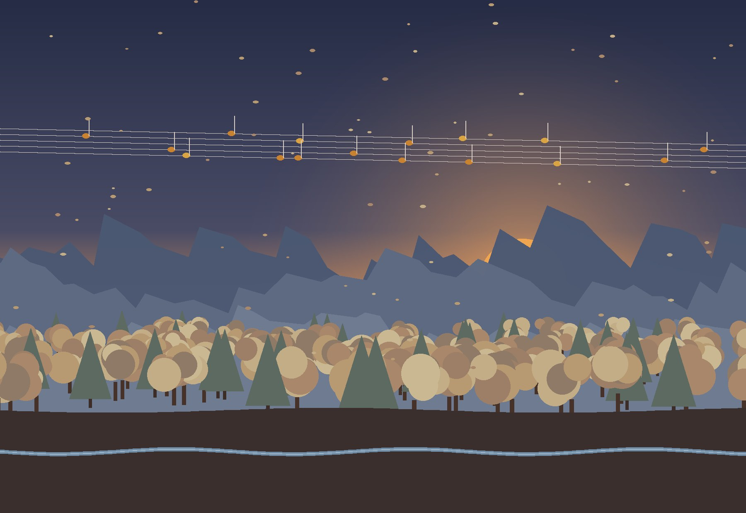
Section 2 answers the question “by which rules?”: the organisation of leisure centres, analogues, norms, the room programme, the functional diagram and the variants of organising the rooms of the music leisure centre “Dream String”.

2.1. Typologies
A typology is the “grammar” of a building: how rooms are grouped and how people reach them. For a music leisure centre there is no ready type, so its organisation is studied through similar buildings – sports, creative, music and cooking centres.

2.1.1. Organising the music leisure centre
There is no single typology of a leisure centre – each one is a mix. To find the right organisation, four kinds of similar centres were compared: which rooms they need and how they link their zones.
Sports centre. Main rooms: large hall, changing rooms, fitness, entrance control. Links: a service strip (entrance – changing rooms – hall) along one large volume; spectators on a gallery. For my centre: one large volume with a service strip: a concert hall with backstage and stores.
Creative studios. Main rooms: workshops and daylit studios, stores, exhibition space. Links: studios around a shared hall where work is shown. For my centre: the foyer as a gallery for small concerts and exhibitions.
Music school. Main rooms: classrooms, individual rooms, ensemble rooms, concert hall. Links: acoustic separation: practice boxes, quiet corridors, loud rooms apart; the hall as the heart. For my centre: box-in-box individual rooms in a cluster; loud rooms in the slope.
Cooking school, café. Main rooms: teaching kitchen, café, dining room, store. Links: the kitchen opens into the café; a separate delivery entrance. For my centre: the café as the “living room” of the centre, open to the park and to parents.
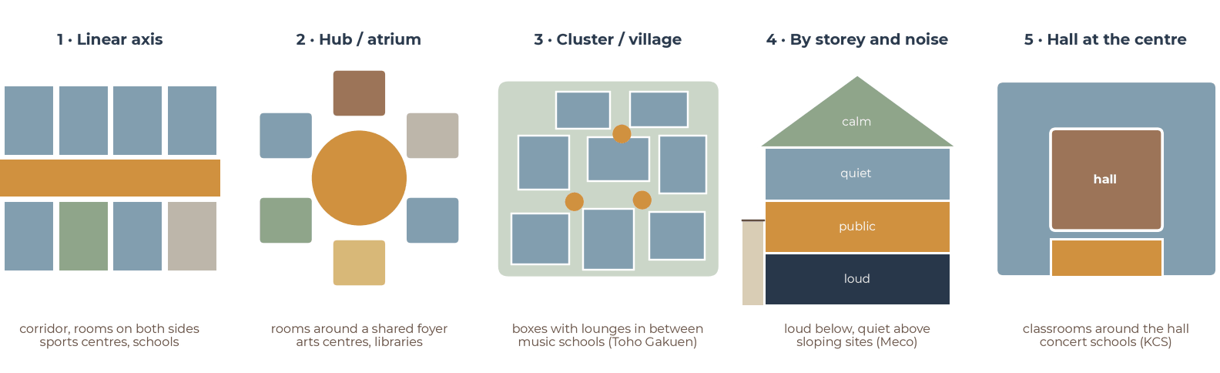
Five ways to organise the zones of a leisure centre (diagrams).

CONCLUSION
Centre: there is no ready type, so it is a mix of three schemes – a hub (foyer and café), a cluster (practice rooms around a waiting lounge) and division by noise (loud rooms in the slope, movement under the roof). The hall is the only large volume and it is transformable.

2.2. Analogue projects
I compare twelve analogues for the music leisure centre: music schools and concert buildings, leisure centres and buildings whose roof is used by people (2.2.1–2.2.12). Each is studied with pictures, plans or sections and my functional diagram. The summary (2.2.13) shows what each project gives to my project and what does not fit. The functional diagrams of all analogues and the study models of 2.2.7–2.2.12 are my own redrawings from the published plans and photographs (schematic, not to scale).
Colours of the zones in my functional diagrams of the analogues.

2.2.1. King’s College School Music School, London
Hopkins Architects · Wimbledon, London · 2018 · 2,160 m². A music school of a private school, on an irregular plot between the big school buildings and old arts-and-crafts houses. It has almost the same area as my centre.
Programme. A concert hall for 200 listeners with room for a 70-piece orchestra on the stage, practice rooms, classrooms, a bar, a cloakroom and a porter’s lodge. Practice rooms for loud rehearsals are in the basement.
How it works. The building is three blocks of different height: the tall concert hall and two lower wings with practice rooms and classrooms. One L-shaped foyer on one level joins all three blocks, so students go from a lesson to the stage without stairs. The foyer is brick and wood and gets daylight from large rooflights. The audience enters the hall by a stair to a screened area behind the seats.
My functional diagram. The hall is at the centre: the teaching rooms wrap around it and the foyer opens in front of it, so every lesson takes place next to the stage; wood and daylight make the building warm.
Interesting. The roof of the hall is a grid of slanted glulam beams – spruce inside, American white oak outside – with triangular oak panels between them. The hall has about 10 m³ of volume per listener. The upper wall panels are smooth and reflect the sound, the panels close to the audience are perforated and absorb it. The walls outside are handmade brick, like the school around it.
What I take. The hall as the heart of the centre with the foyer in front of it; one foyer on one level that links the hall and the classrooms; loud rehearsal rooms below ground; a hall for 200 people, like mine.
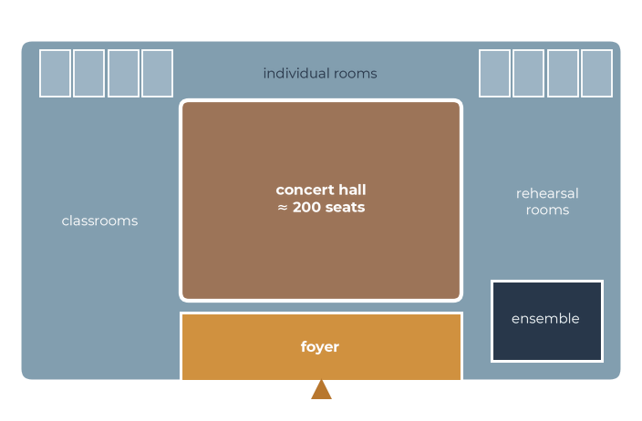
King’s College School: my functional diagram – the hall at the centre, classrooms around it, the foyer in front.
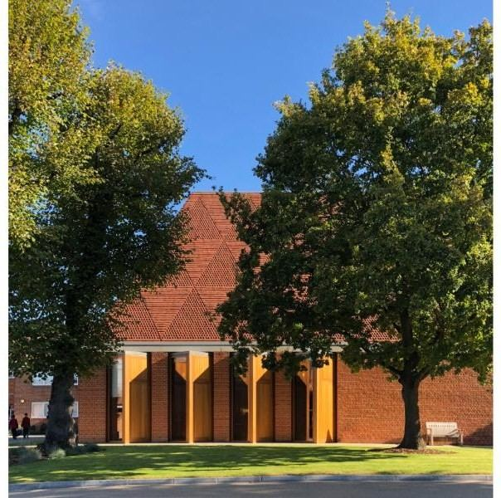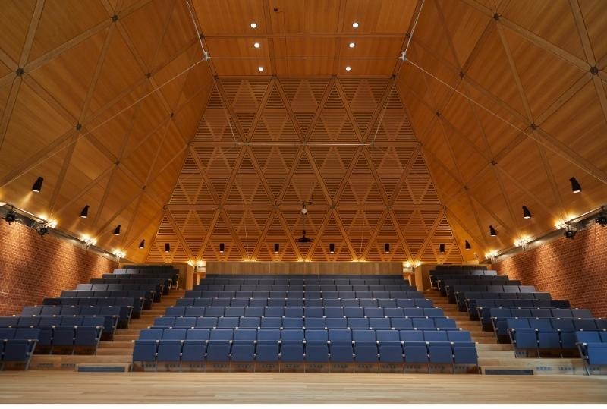
The music school from the garden and the concert hall under the timber roof.
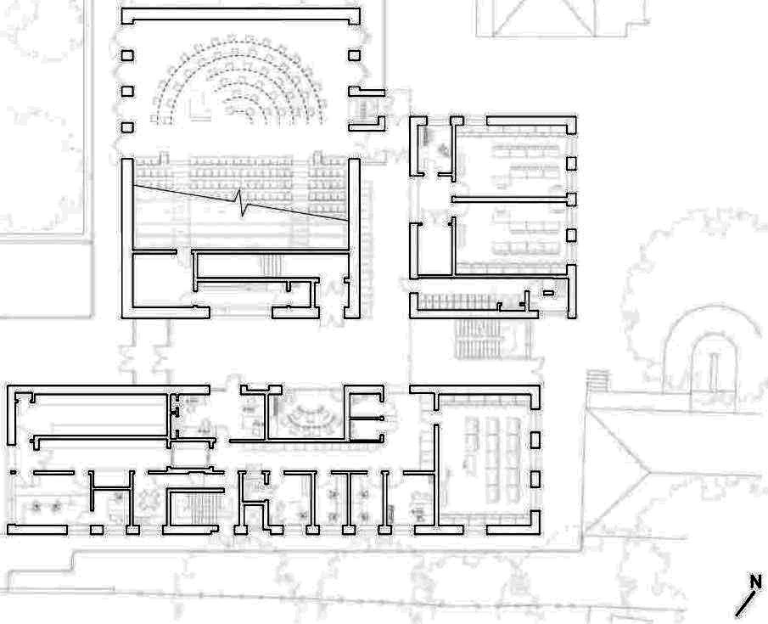
Ground floor plan: the concert hall with its seats (top left), teaching rooms (right) and the wing of practice rooms (bottom), all reached from one foyer.
Section through the concert hall and the lower teaching wing.

2.2.2. Toho Gakuen School of Music, Tokyo
Nikken Sekkei · Chofu, Tokyo · 2014 · 5,828 m². A music school in a residential area, shortlisted for the RIBA International Prize 2018. It is almost three times bigger than my centre, so I look at how the rooms are organised, not at the size.
Programme. Lesson rooms for individual practice, larger rooms for groups and ensembles, lounges, a foyer, light courts, staff rooms, offices, a meeting room and a PC room.
How it works. Most practice rooms are on the first floor. They are not lined up along a corridor but scattered like small houses in a village. The gaps between the rooms separate the sound and become corridors, light courts and places to meet. Larger group rooms and noisy instruments, for example percussion, are in the basement: the ground around them absorbs the sound, and sunken courtyards bring daylight down.
My functional diagram. A “village” of practice boxes: each classroom is a “box in a box” for sound insulation; the gaps between the boxes become lounges and meeting places; loud instruments are in the basement.
Interesting. The practice rooms are partly glazed, so students see each other but do not hear each other: music can be heard in the corridor, but inside the rooms it is quiet. The building is concrete; the rooms have sound-absorbing panels on the ceilings and timber cladding on the walls.
What I take. Practice rooms as separate acoustic boxes with a lounge between them; loud rooms below ground with daylight from a sunken courtyard; glass in the doors so parents can see the lessons.
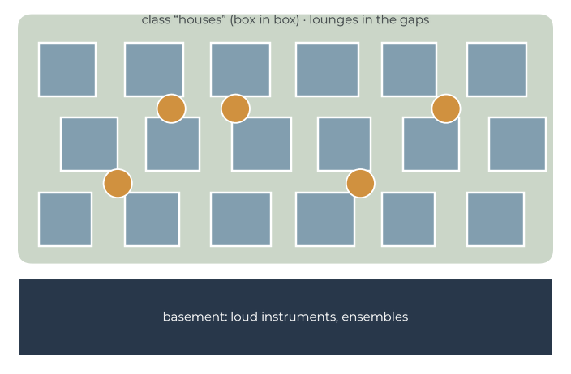
Toho Gakuen: my functional diagram – a village of practice boxes with lounges between them, loud rooms underground.
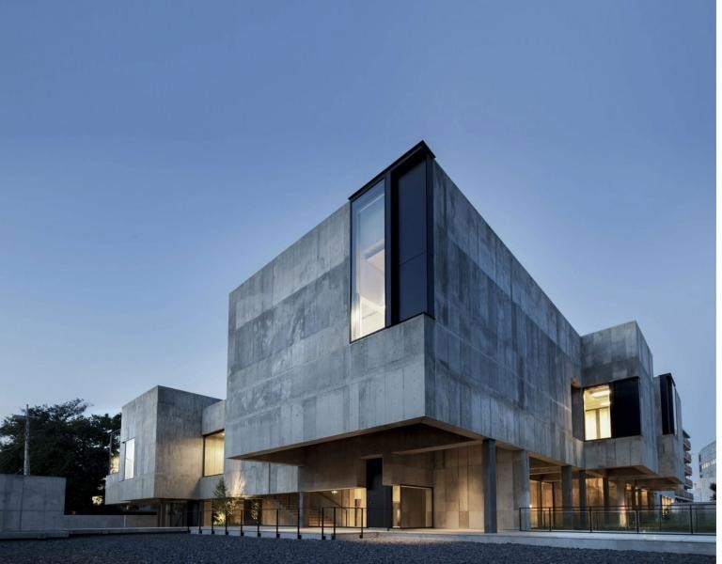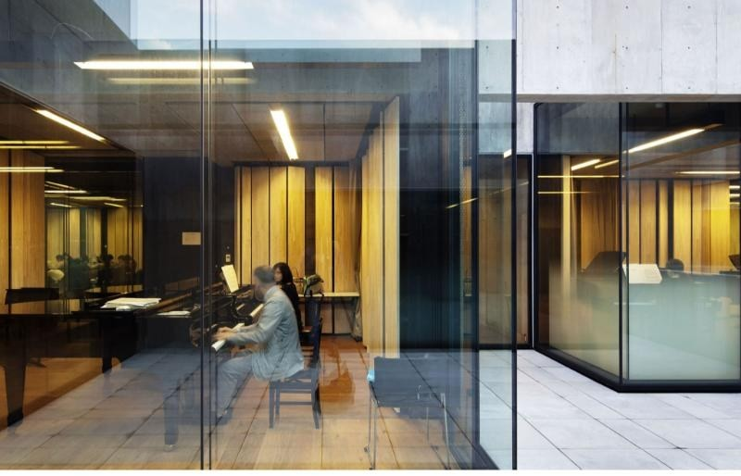
The concrete volumes of the school and a practice room seen from the corridor.
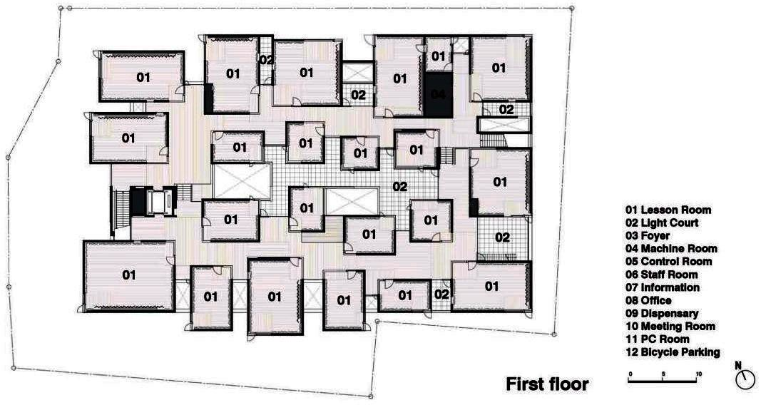
First floor plan: lesson rooms (01) placed like a village with light courts (02) between them.
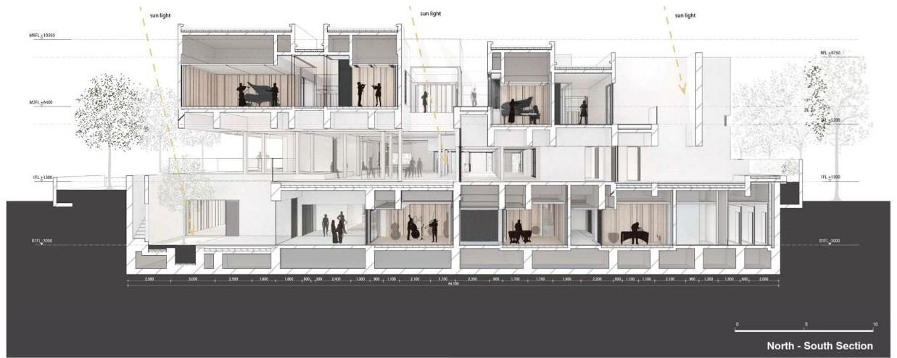
North–south section: practice rooms on the upper floors, large rooms in the basement.

2.2.3. Cultural Centre and Music School, Meco
Alberich-Rodríguez Arquitectos · Meco, Madrid region, Spain · 2006 · 2,148 m². A cultural centre and a music school in one building, on a plot with a drop of about 4 m from north to south – the same size and almost the same slope as my site.
Programme. An auditorium, a music school, a multi-purpose exhibition space and administration; outside – an open-air auditorium and a square on the south side.
How it works. The building has four levels: basement, semi-basement, ground floor and first floor. The functions are stacked in layers that follow the slope. There are two entrances for two different users: from the south the audience goes to the auditorium, from the north the students go to the music school through a covered patio with a concrete lattice. Inside, a long empty space runs through the whole building and joins all levels – it is the main place for moving and meeting.
My functional diagram. The building uses the 4 m level difference: part of the programme lies on lower, semi-sunken levels, and the entrance is on the upper one.
Interesting. The open-air auditorium is a set of wide concrete steps next to the building, reached by a stair-ramp from the square. The building uses only reinforced concrete and white plaster, and the daylight comes through the lattice and the long void.
What I take. Use the slope: the entrance and the foyer on the upper level, the hall and the loud rooms lower; separate entrances for the audience and the students; outdoor steps as a summer stage towards the park.
Meco: my functional diagram – the programme in layers along the slope, the entrance from the upper level.
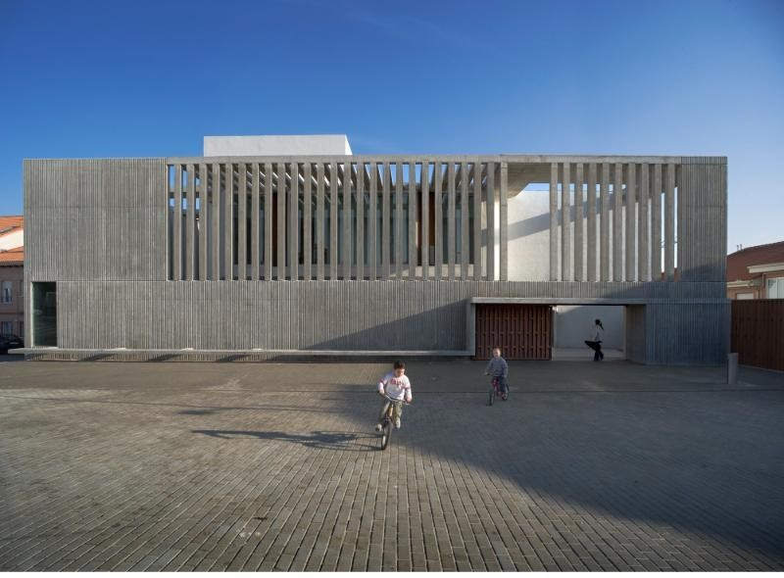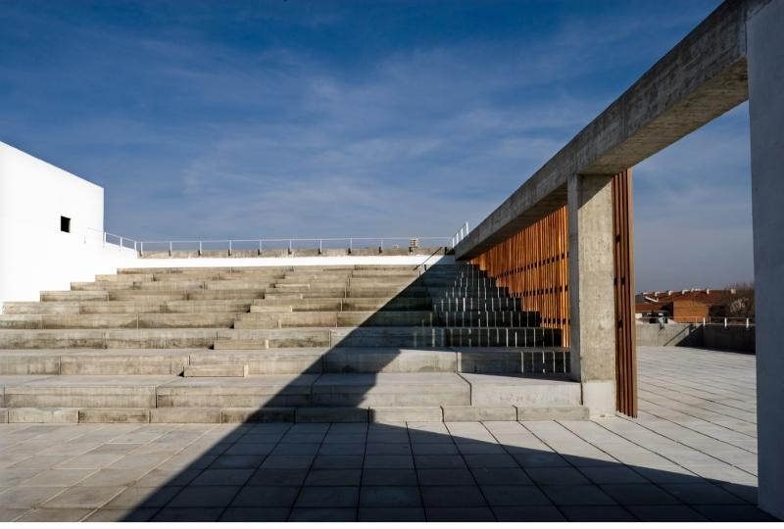
The concrete lattice of the façade and the outdoor steps of the open-air auditorium.
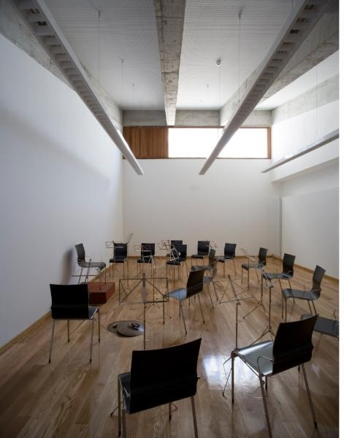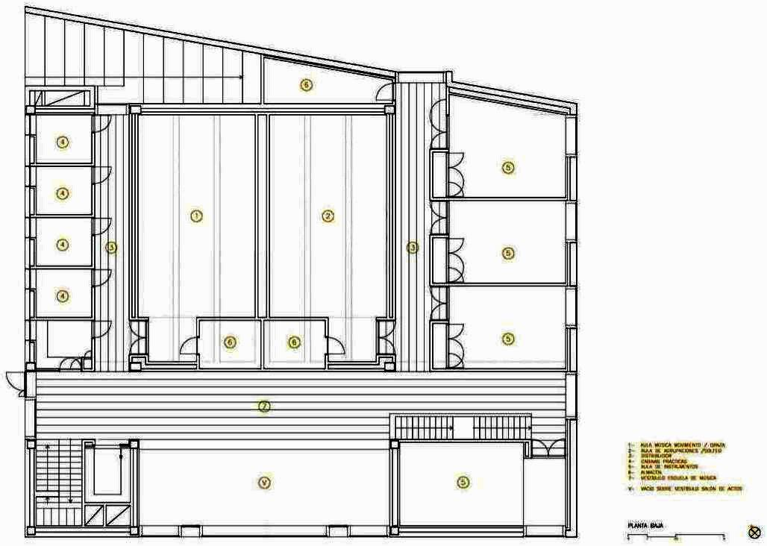
A classroom of the music school and the plan.
Section: the levels of the building follow the slope.

2.2.4. COFCO Cultural & Health Center, Shanghai
Steven Holl Architects with ECADI · Shanghai, China · 2016–2021. A public centre for the residents of a new district, built by the COFCO company along the Punan canal. Two buildings – a cultural centre and a health centre – stand in a public park that is open to everyone.
Programme. The cultural centre has an exhibition area, a café, a library, a gym and rooms for children and young people. The health centre has a pharmacy, consultation and examination rooms, a nursery area and lounges. Between the two buildings there is a public park with paths, lawns and a pool.
How it works. The ground floor of the cultural centre is glazed and open to the park: the café and the exhibition are the first things you see. A curved ramp leads from the park up to the second floor, where the library, the gym and the youth rooms are. The health centre is a separate building with its own entrance, so the patients and the visitors of the cultural centre do not mix. Both roofs are green and continue the park.
My functional diagram. Two buildings around one park: the public rooms (café, exhibition) on the glazed ground floor, the quiet rooms (library, youth rooms) and the gym above; the health centre apart, with its own entrance.
Interesting. The concept comes from the lecture “Of Clouds and Clocks” by the philosopher Karl Popper (1965): the buildings are free, porous “clouds” of white concrete with round openings, and the park is drawn with precise “clock” circles. The quarter-circle pool and the fountain collect rain water; green sedum roofs and geothermal cooling save energy, and the project aims at LEED Platinum.
What I take. The café and the exhibition on a glazed ground floor open to the park; a ramp from the park to the upper floor; green roofs as a part of the park; different users with separate entrances around one shared outdoor space. The scale and the budget are much larger than mine.
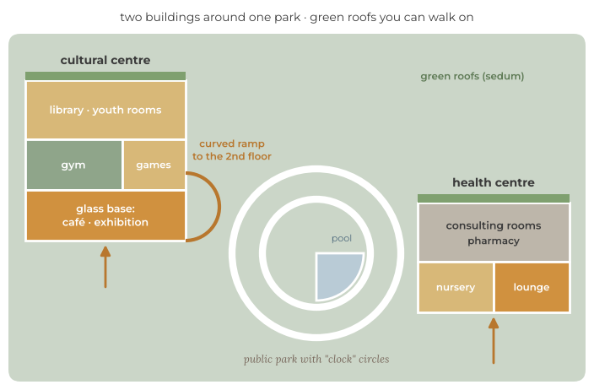
COFCO: my functional diagram – two buildings around one park, the public rooms on the glazed ground floor.
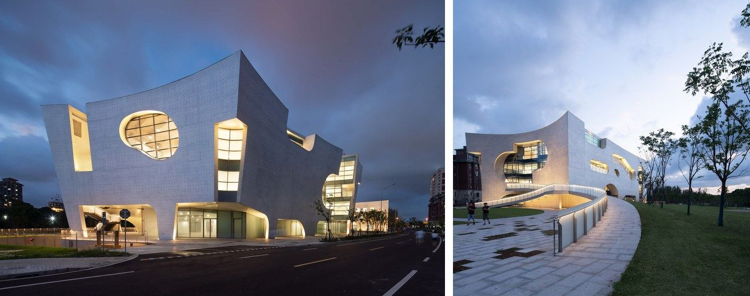
The cultural centre at night and the two buildings with green roofs from above.
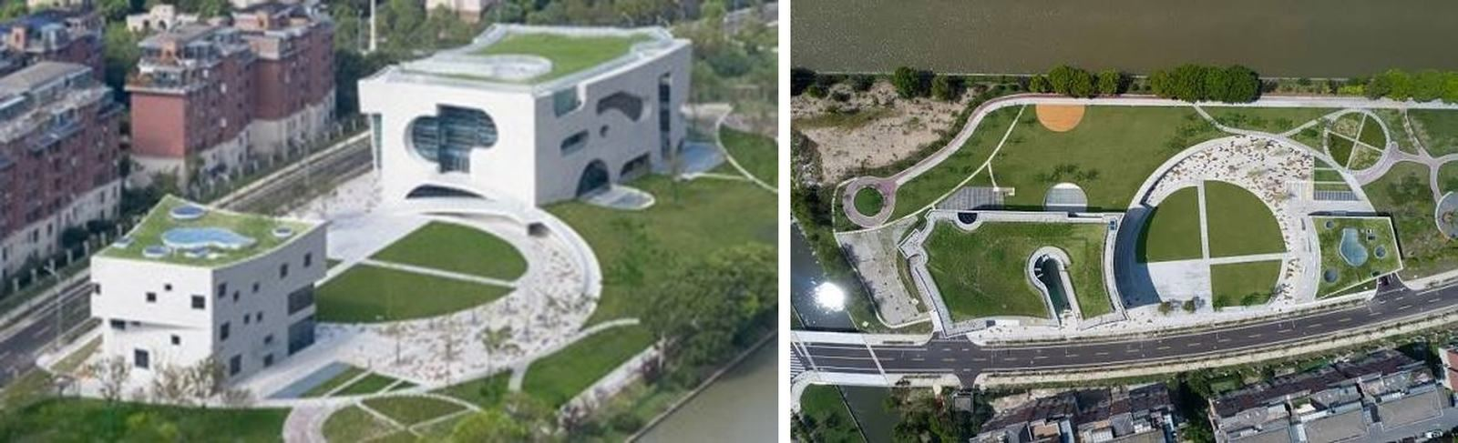
The ramp from the park to the upper floor and the park with the “clock” circles.
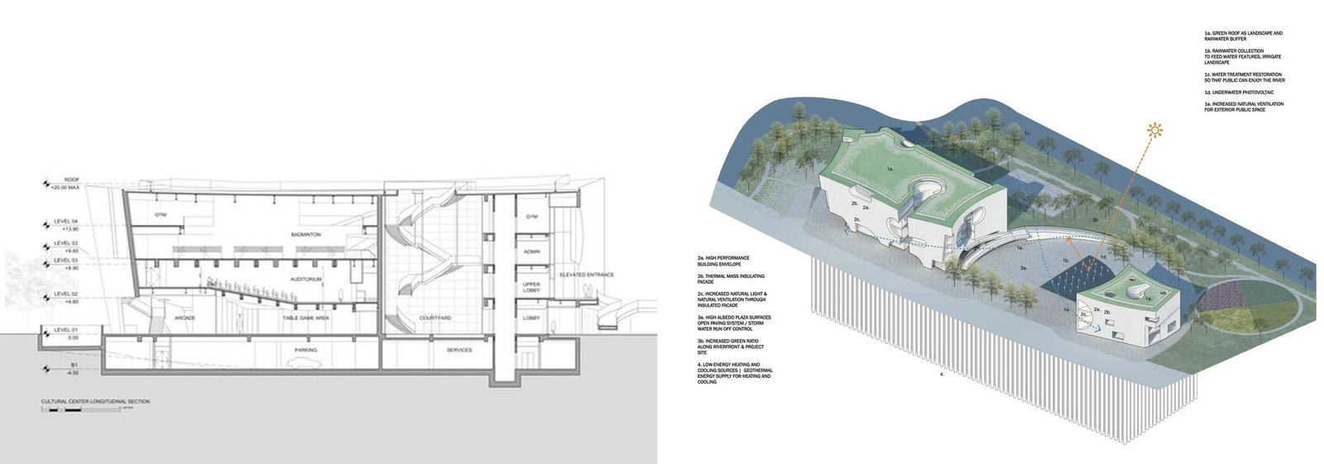
Section of the cultural centre and the axonometric view of the site.

2.2.5. Dushan Leisure Center, Songyang
DnA_Design and Architecture (Xu Tiantian) · Songyang County, Lishui, Zhejiang, China · 2018. A leisure and visitor centre on a triangular wetland at the foot of Dushan mountain, next to the Songyin river. It is one of the small public buildings that DnA built in the villages of Songyang to bring new life to the countryside.
Programme. A visitor centre with information, a tea room and rest areas, a meditation room, rooms for water sports and a gym for rowing athletes; outside – a small harbour for boats.
How it works. All rooms are placed along one spiral: the visitor rooms are in the centre, the gym for the athletes at the outer end. A straight east–west walkway crosses the spiral as a shortcut. Ramps connect the levels and continue onto the roofs, so the walk goes up and opens views of the river, a temple and the mountain. A C-shaped dike around the harbour is a path for people, bicycles and electric shuttles.
My functional diagram. One spiral route: the public rooms in the centre, sport at the end, a shortcut through the middle and a view at every turn.
Interesting. The building is made of timber, and the glass walls have different levels of transparency, so in the rainy season it looks “misty”. In the meditation room on the second floor small openings let in spots of sun that fall on bronze plates marking the 24 solar terms of the Chinese calendar – the building works as a calendar.
What I take. The route itself as an experience: a path from the park over the roof of my centre to a view of the peaks; timber screens with soft light; the public rooms in the middle and the noisy sport at the end. It is a small building without acoustic rooms, so only the idea of the route fits my programme.
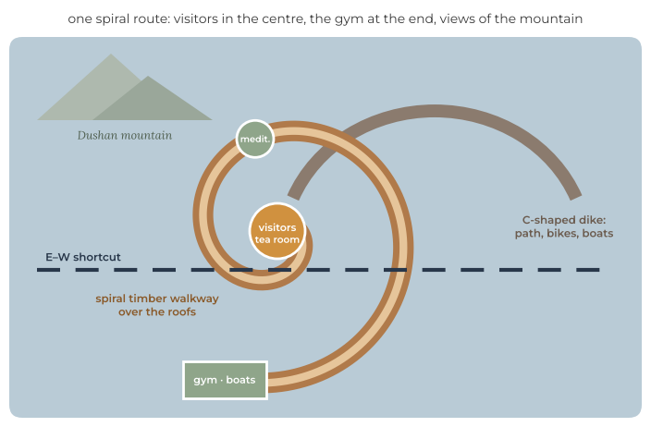
Dushan Leisure Center: my functional diagram – one spiral route with the visitor rooms in the centre.
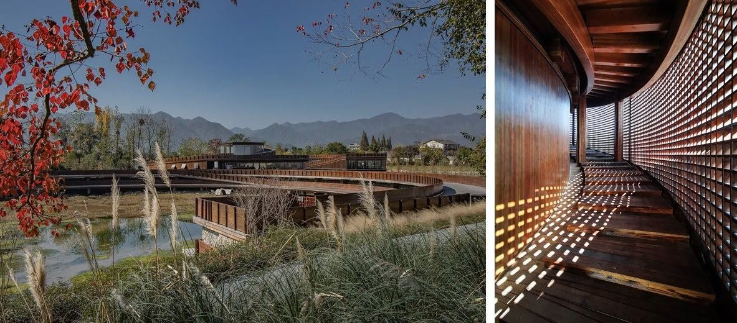
The centre on the wetland at the foot of Dushan mountain and the timber screen of the spiral walkway.
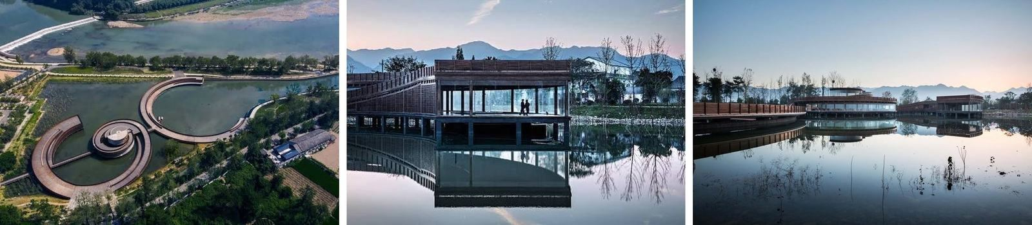
The spiral and the C-shaped dike from above, the glass pavilion over the water and its reflection in the harbour.

2.2.6. Ku.Be – House of Culture and Movement, Frederiksberg
MVRDV + ADEPT, landscape SLA · Frederiksberg, Copenhagen · 2009–2016 · 3,200 m². A municipal “house of culture and movement” for people of all ages and abilities, built by Frederiksberg Municipality with the Danish foundations LOA and Realdania.
Programme. A theatre hall, dance, yoga and meditation, parkour and play, learning, exhibitions and debates, offices; outside – an urban garden and an outdoor amphitheatre.
How it works. Inside a simple box stand six main volumes, each with its own colour, material and activity. The open space between them is the foyer and the meeting place. The volumes are linked by stairs and ramps (step-free for everyone) and also by play routes: the Labyrinth – a 3D network of cubes between the second and the third floors that you crawl through, the Mousetrap – a vertical maze, a net over the void, slides and fireman’s poles.
My functional diagram. Coloured volumes in one box with an open hall between them; the routes between the volumes are a part of the programme.
Interesting. The rooms have no fixed scenario – visitors decide for themselves what happens where. The glazed ground floor shows the street the life inside, and the garden around the building has changing sounds, lights and smells.
What I take. A transformable hall with movable partitions; a children’s route between the levels (a net, a slide) next to the children’s club; a glazed foyer that shows the life of the centre. The noisy play character does not suit the classrooms, so in my centre it stays in the club and the movement zone.
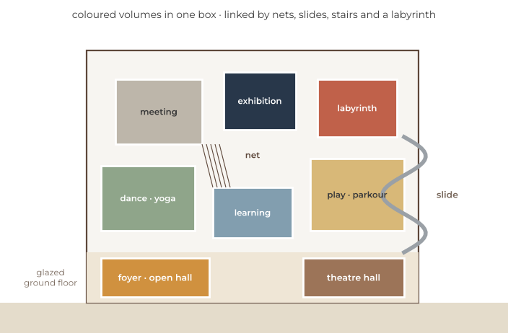
Ku.Be: my functional diagram – coloured volumes in one box, linked by nets, slides and stairs.
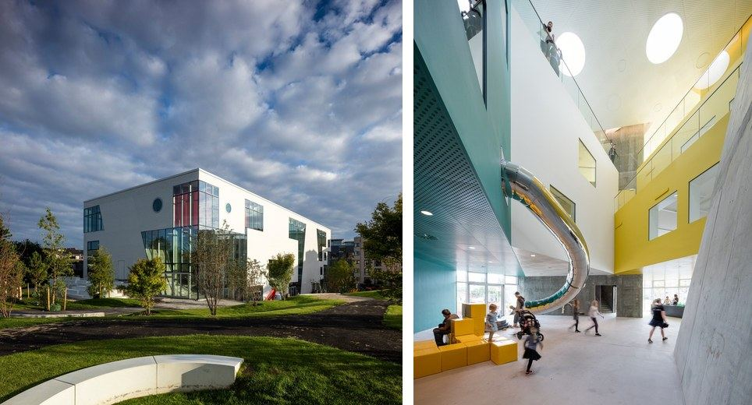
The building in the park and the hall with the slide between the volumes.
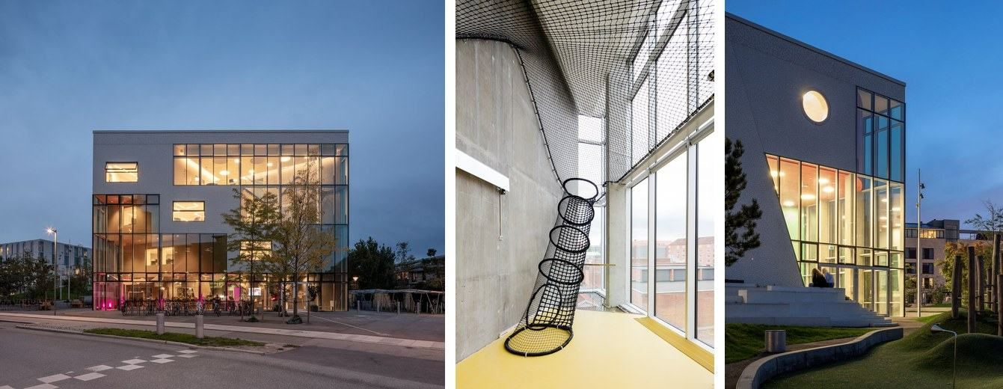
The glazed façade at night, the climbing net and the corner with the outdoor seating.
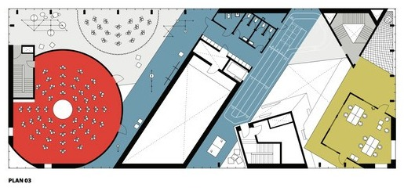
Floor plan: the coloured volumes and the open space between them.

2.2.7. ACROS Fukuoka Prefectural International Hall, Fukuoka
Emilio Ambasz & Associates · Fukuoka, Japan · 1995 · ≈ 97,000 m². A large public building in the centre of Fukuoka, on the edge of Tenjin Central Park. The city needed the land of the park, so the architect gave the park back on the roof. The building is about forty times bigger than my centre, so I look only at its roof.
Programme. The Fukuoka Symphony Hall, an international conference hall, exhibition space, offices of the prefecture and private companies, shops and a tourist information centre.
How it works. The side facing the park is a stepped garden of 14 terraces that climbs about 60 m to a belvedere at the top. Visitors go from the park straight onto the lowest terrace and climb by stairs between the plants; the halls and the offices are inside, under the terraces, and an atrium brings daylight into the middle of the building.
My functional diagram. The park continues over the building: the halls lie inside under the terraces, and one route goes from the park up the steps to a viewpoint.
Interesting. When the building opened the garden had about 76 kinds of plants; today more than 120 grow there, and from the street the building looks like a green hill. The soil and the plants cool the building in summer and hold back the rain.
What I take. A roof as a public garden that starts on the ground and climbs step by step to a view; planted steps that are also seats; the hall inside, under the garden.
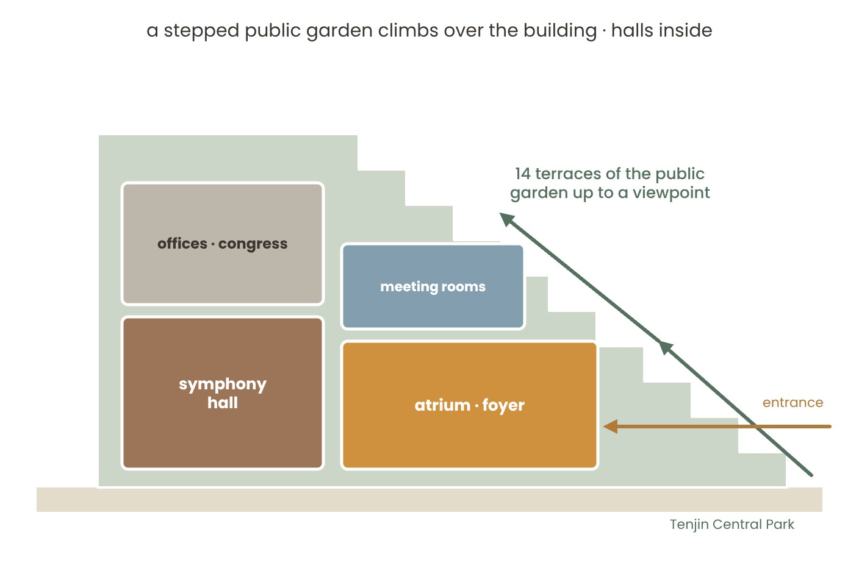
ACROS Fukuoka: my functional diagram – the park climbs over the halls on 14 terraces up to a viewpoint.
ACROS Fukuoka: my study model – the stepped garden on the park side of the building (schematic, from published photographs and drawings).

2.2.8. Moesgaard Museum, Aarhus
Henning Larsen Architects · Højbjerg, Aarhus, Denmark · 2014 · 16,000 m². A museum of prehistory and ethnography on a hillside above Aarhus Bay, in a landscape of forest and fields – a place on a slope, like my site.
Programme. Exhibition halls on three levels (the lowest ones up to 12 m high), a foyer of 750 m² with the ticket desk, the cloakroom and a café, a large multi-purpose hall for temporary exhibitions, conferences and events, lecture rooms and offices.
How it works. A rectangular roof plane of grass, moss and flowers rises out of the landscape; at its upper end a horizontal part juts out as a lookout over the bay. Under the roof the exhibitions step down in terraces, like an archaeological dig, and a wide central staircase links the levels. The foyer runs across the building at the low side and opens through a glass wall to a terrace.
My functional diagram. The roof is a park that can be walked on from the ground; under it are the foyer at the entrance and the exhibition levels in terraces.
Interesting. In summer the roof is used for picnics, barbecues, lectures and the Midsummer bonfire; in winter children sledge down the snowy slope. Openings in the roof form small terraces and bring daylight into the galleries.
What I take. A roof that starts on the ground and is used all year round – events in summer, snow games in winter; a lookout at the highest point; the foyer at the low end, under the roof.
Moesgaard Museum: my functional diagram – a sloping grass roof rises from the ground, the foyer and the terraced exhibitions under it.
Moesgaard Museum: my study model – the roof plane rising from the landscape to the lookout (schematic).

2.2.9. Fuji Kindergarten, Tokyo
Tezuka Architects · Tachikawa, Tokyo, Japan · 2007. A kindergarten for 600 children aged two to six, whose oval roof is the main playground. In 2017 it received the Moriyama RAIC International Prize.
Programme. Classrooms for different ages, a courtyard for games and festivals, a kitchen and staff rooms; on the roof – a playground and a running track.
How it works. A one-storey oval ring stands around a courtyard. The classrooms have no walls between them, and sliding doors open them to the courtyard in good weather. The roof deck is only about 2.1 m above the ground; children climb up by stairs and a bank and come down by a slide. The deck was built around the old zelkova trees, which grow through it.
My functional diagram. A ring of open classrooms around a courtyard; the roof is an endless track; the trees grow through the deck.
Interesting. Children run round and round the roof – the ring has no end. The railings are spaced so that a head cannot get stuck, but children can sit with their legs hanging over the edge. Skylights in the deck let them look down into the classrooms; rainwater runs through spouts into barrels.
What I take. A roof that children use every day, not only on holidays; edges close to the ground; slides and steps from the roof to the garden; trees growing through the roof; safe railings where children can sit.
Fuji Kindergarten: my functional diagram – an oval ring of classrooms around a courtyard, the roof as a running track.
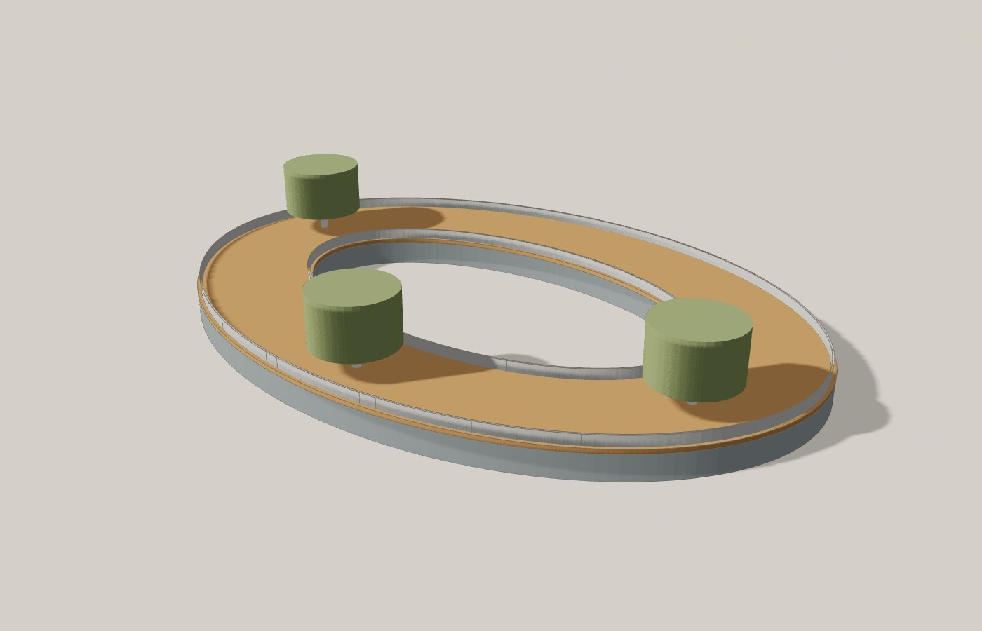
Fuji Kindergarten: my study model – the oval deck with railings and the trees growing through it (schematic).

2.2.10. House of Music (Musikkens Hus), Aalborg
Coop Himmelb(l)au · Aalborg, Denmark · 2014 · 20,257 m² gross. A concert house and a music school on the Limfjord, home of the Aalborg Symphony Orchestra, the Royal Academy of Music and the music department of Aalborg University. It is ten times bigger than my centre; I look at how one building serves both the school and the audience.
Programme. A concert hall for 1,298 listeners; three smaller halls – the intimate hall (300), the classical hall (200) and the rhythmic hall (200); rehearsal and teaching rooms; a foyer for receptions of up to 2,150 people; a restaurant.
How it works. Outside the building is a strict cube. The concert hall stands in the middle, and the rehearsal and teaching rooms wrap around it in a U, so the students practise right next to the stage. The three smaller halls are under the foyer. The foyer rises through five storeys with stairs, balconies and large windows towards the fjord; students, teachers and the audience meet there.
My functional diagram. The hall at the heart, a U of teaching rooms around it, the small halls under the foyer, the foyer as a vertical street towards the water.
Interesting. The concert hall is one of the quietest rooms for symphonic music in Europe (noise rating NR 10): it is built as a box inside a box. The curved balconies inside contrast with the strict cube outside.
What I take. Teaching rooms around the hall, so that students rehearse next to the stage; small halls for 100–200 people on the lower level; the foyer as a street with stairs and balconies where students and the audience meet; large windows to the landscape.
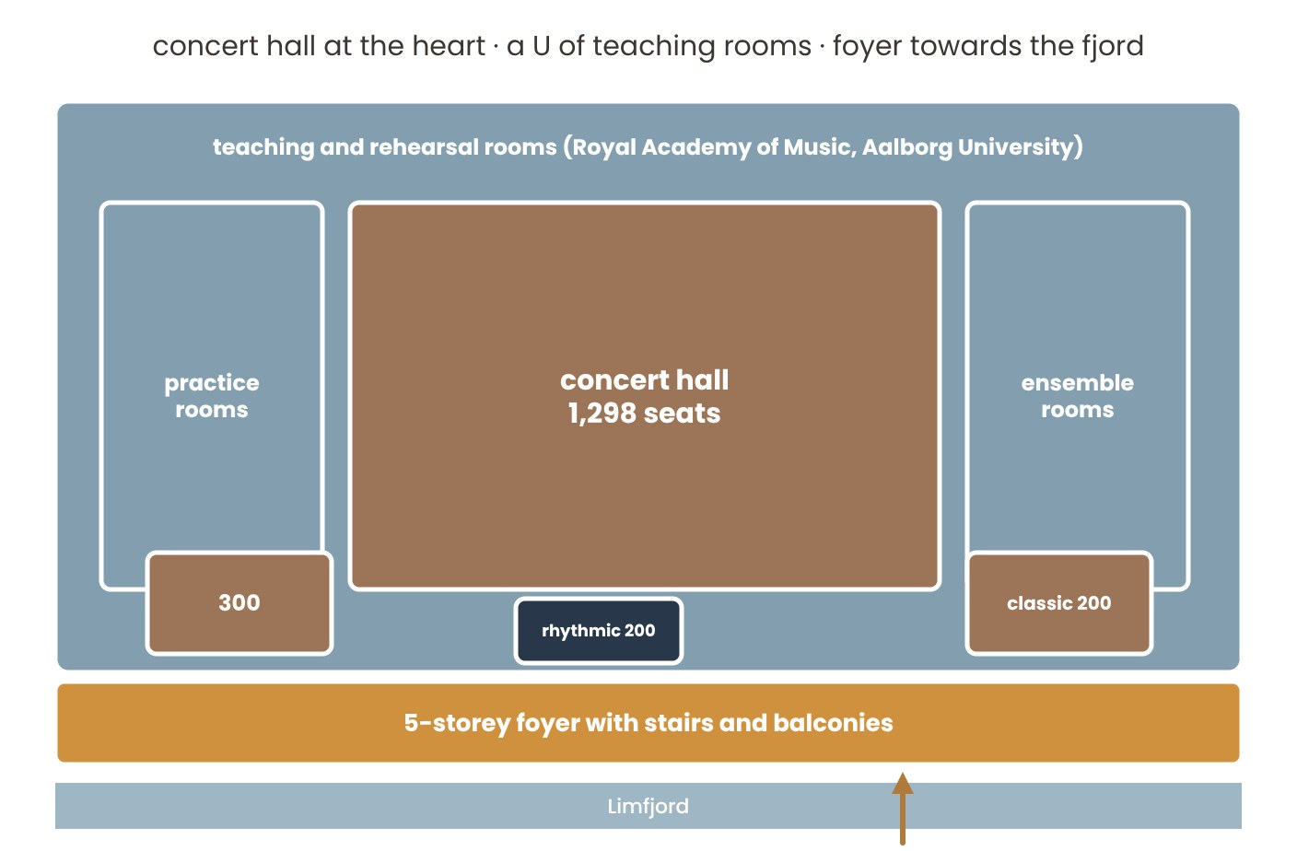
House of Music: my functional diagram – the concert hall at the heart, a U of teaching rooms, the small halls under the foyer.
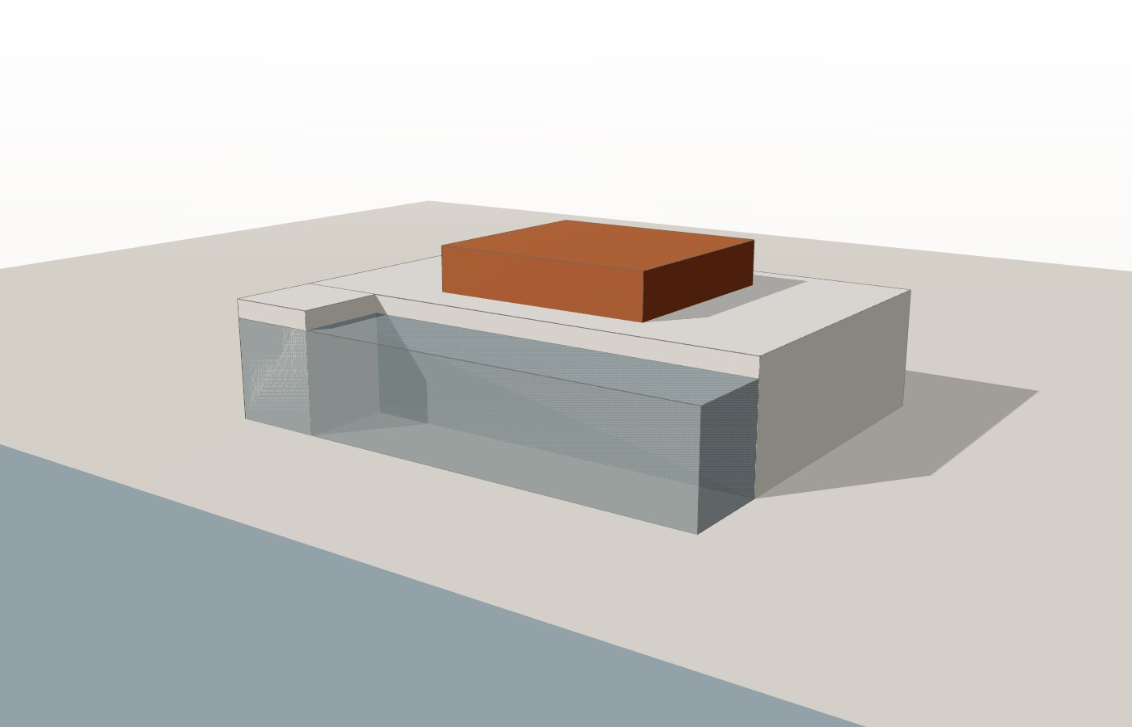
House of Music: my study model – the cube by the fjord with the glazed foyer and the hall in the middle (schematic).

2.2.11. Kilden Performing Arts Centre, Kristiansand
ALA Architects with SMS Arkitekter · Kristiansand, Norway · 2012 · ≈ 16,000 m². A theatre and concert house on an old harbour site next to the centre of Kristiansand, home of the theatre, the symphony orchestra and the opera of the region.
Programme. A concert hall for 1,130, a theatre and opera hall for 700 with a pit for 60 musicians, a multi-purpose room for 220 seated or 400 standing, an intimate hall for 100; a foyer, rehearsal rooms and workshops.
How it works. The four halls stand in a row; the service and backstage rooms are on one side of them, the foyer on the other side, towards the harbour. All four halls are covered by one curved wall of local oak – the “wave” – which bends from the ceiling of the foyer out over the square. The other façades are black, so the wave is the only thing you notice.
My functional diagram. Four halls of different size in a row behind one timber wave; the foyer under the wave; the service behind.
Interesting. The wave is built of overlapping oak boards; it improves the acoustics of the foyer and works like a curtain that the visitor passes through – from the landscape into the world of the performing arts.
What I take. One timber element along the whole building that ties rooms of different size together – in my centre, the fins of the sound track; the foyer under it; the service on the back side.
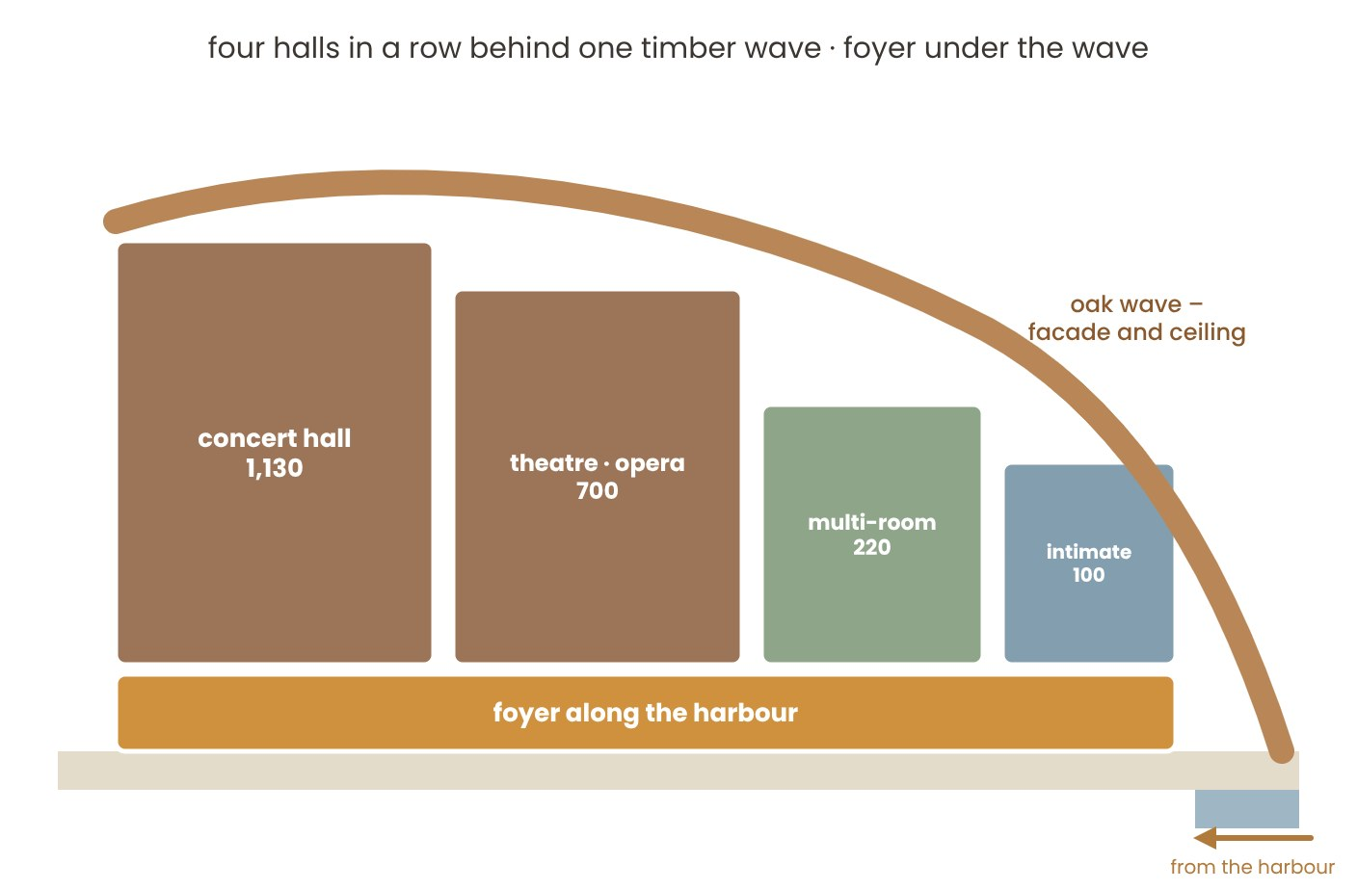
Kilden: my functional diagram – four halls in a row behind one oak wave, the foyer under the wave.
Kilden: my study model – the oak wave over the foyer, rising and falling over the four halls (schematic).

2.2.12. Darius Milhaud Conservatory, Aix-en-Provence
Kengo Kuma & Associates · Aix-en-Provence, France · 2013 · ≈ 7,000 m². A conservatory of music, dance and drama, founded in 1849, in a new building on the edge of the old town, on a site with a large difference in level.
Programme. 62 teaching rooms for six departments (strings and keyboard, wind and voice, percussion, early and traditional music, jazz, electro-acoustic music), 20 rehearsal rooms, four dance studios, two drama rooms and an auditorium for 500.
How it works. All the rooms and the auditorium are wrapped in one skin of grey aluminium, and each façade is folded in its own way. The corners are cut away and give large triangular glazed openings; the largest of them is the main entrance. Inside, the asymmetric hall repeats the folds of the façade, and timber facets and louvres improve the acoustics.
My functional diagram. The auditorium and the classrooms under one folded metal skin; the entrance at a cut, glazed corner (schematic: the published material does not show the plans in detail).
Interesting. The folds shade the windows and frame the views; light and shadow, not the metal, make the façade. The architect refers to the paintings of Cézanne and to origami, and visitors compare the façade to a musical score.
What I take. A façade that reads like music – a rhythm of folds or fins; one material for the whole building; the entrance where the volume opens; timber inside for good acoustics.
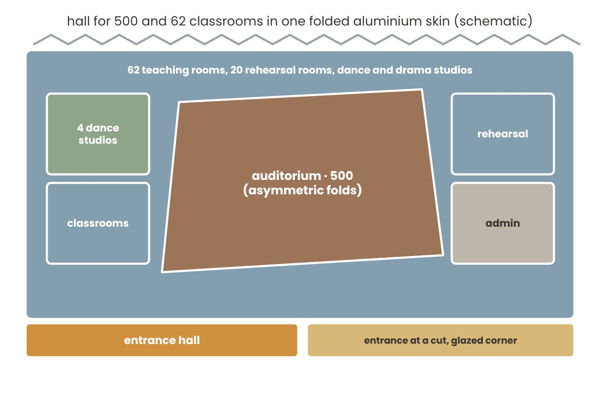
Darius Milhaud Conservatory: my functional diagram – the auditorium and the classrooms in one folded aluminium skin.
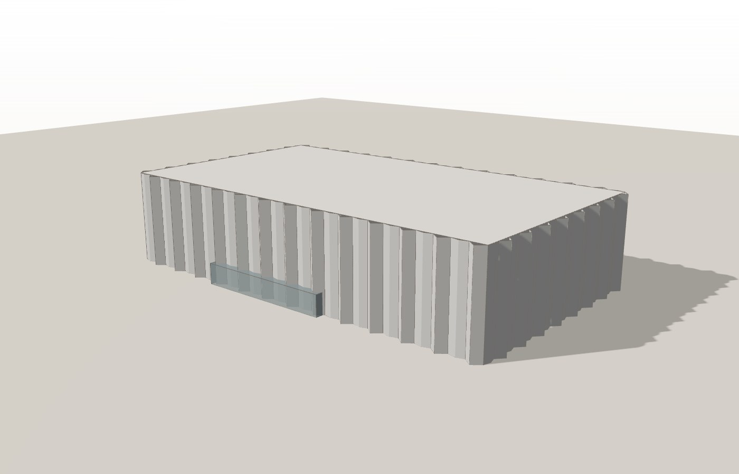
Darius Milhaud Conservatory: my study model – the folded aluminium façades (schematic).

2.2.13. Summary of the twelve analogues
What each project gives to my project (+) and what does not fit (–):

Music leisure centre – twelve analogues
- King’s College School Music School, London (Hopkins) – music school, 2,160 m². + Hall at the centre, classrooms around it, one foyer; the same size. – A closed school, not a leisure centre.
- Toho Gakuen, Tokyo (Nikken Sekkei) – music school, 5,828 m². + Box-in-box practice rooms with lounges between them. – Almost 3 times larger; urban scale.
- Cultural Centre and Music School, Meco (Alberich-Rodríguez) – 2,148 m². + The 4 m slope used for levels, two separate entrances. – Little link to the landscape.
- COFCO Cultural & Health Center, Shanghai (Steven Holl) – a cultural centre and a health centre in a park. + A glazed ground floor open to the park, green roofs, separate entrances around one outdoor space. – Large scale and budget.
- Dushan Leisure Center, Songyang (DnA) – a timber visitor and sports centre. + One spiral route with views of the mountain, public rooms in the middle. – Small, no acoustic rooms.
- Ku.Be, Frederiksberg (MVRDV + ADEPT) – house of culture and movement, 3,200 m². + Freedom of scenarios; movement and meditation. – Noisy play character, not for lessons.
- ACROS Fukuoka (Emilio Ambasz) – congress and concert building, ≈ 97,000 m². + A stepped public garden from the park to a viewpoint, the halls under the terraces. – Forty times larger; a city-centre building.
- Moesgaard Museum, Aarhus (Henning Larsen) – museum, 16,000 m². + A grass roof that rises from the ground and is used for events and sledging; a lookout at the top. – A museum, no music rooms.
- Fuji Kindergarten, Tokyo (Tezuka) – kindergarten for 600 children. + A roof that children use every day; trees through the deck, a slide. – Very low; only for small children.
- House of Music, Aalborg (Coop Himmelb(l)au) – concert house and music school, 20,257 m². + Teaching rooms around the hall, small halls under a five-storey foyer. – Ten times larger; a closed cube.
- Kilden, Kristiansand (ALA) – performing arts centre, ≈ 16,000 m². + One oak wave over four halls and the foyer. – Large halls for 700–1,130; an urban harbour.
- Darius Milhaud Conservatory, Aix-en-Provence (Kengo Kuma) – conservatory, ≈ 7,000 m². + 62 classrooms, 20 rehearsal rooms and dance studios; a façade like a score. – A closed metal skin, little link to the landscape.

CONCLUSION
Music centre: the hall at the heart with one foyer in front of it on one level (King’s College School); practice rooms as separate boxes around a lounge (Toho Gakuen); loud rooms below ground, in the slope (Toho Gakuen, Meco); separate entrances for the audience and the students, outdoor steps as a summer stage (Meco); a walk over the building and a view of the mountain (Dushan); many functions under one green roof (COFCO); one hall with many scenarios (Ku.Be).
From the six new analogues: a stepped roof as a public garden (ACROS), a grass roof that rises from the ground and hosts events (Moesgaard), a roof that children use every day (Fuji), teaching rooms around the hall and the foyer as a music street (Aalborg), one timber element along the whole building (Kilden) and a façade that reads like music (Aix). Together they support my main idea – a roof that people can walk on.
Size check: King’s College School has 2,160 m² and Meco 2,148 m², both with a hall for about 200 people. My centre with ≈ 2 080 m² and a hall for 150–200 seats is realistic.

2.3. Norms and standards
I chose only the requirements that change the plan of my centre: accessibility, evacuation, stairs, sizes of rooms and passages, daylight and sun, the café kitchen, sanitary rooms, parking and distances. For each one: the norm in my own words → a small sketch → what I take for my project (→). The documents are from the catalogue of the Unified State Fund of Normative Technical Documents (new-shop.ksm.kz/egfntd/ntdgo/kds/) and the sanitary and fire rules of the Republic of Kazakhstan (adilet.zan.kz). Where Kazakh and European values differ, I use the Kazakh one – for example a 1.4 m turning circle instead of 1.5 m.
A. ACCESSIBILITY
1. SN RK 3.06-01-2011, SP RK 3.06-101-2012 – Accessibility: turning space for a wheelchair  A person in a wheelchair needs a free circle to turn around: in Kazakhstan it is 1.4 m in diameter (the European rule is 1.5 m). → In the centre the entrance lobby, the space in front of the lift and the accessible toilets will each leave a free circle of at least 1.4 m (1.5 m where there is space). | 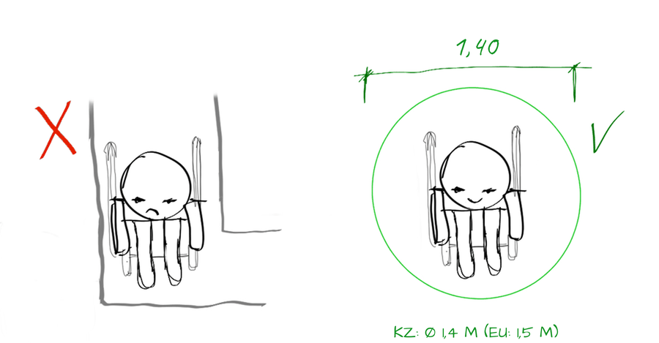
2. SN RK 3.06-01-2011 – Accessibility: ramps  A ramp must be gentle – no steeper than 1 : 20 (5 %). One run of a ramp rises at most 0.8 m; in practice a run is 10–12 m long (about 0.5–0.6 m of height), then comes a flat landing of 1.5 m; handrails on both sides at 0.7 and 0.9 m. → Under the centre the ground is almost flat, so the main entrance, the café door and the hall are at ground level; where there is a level change (the amphitheatre and the stage) I will use 5 % ramps in runs of 10–12 m with 1.5 m landings. | 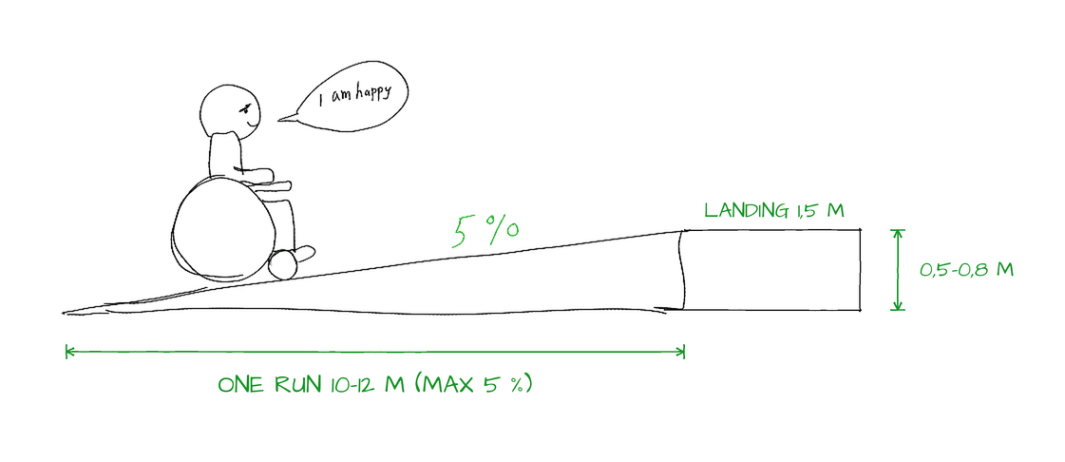
3. SN RK 3.06-01-2011 – Accessibility: doors and thresholds
A door on the route of a wheelchair user should be at least 0.9 m wide, and the threshold no higher than 1.4 cm. → All main doors of the centre will be at least 0.9 m wide and without steps.
4. SP RK 3.06-101-2012 – Accessibility: entrance platform  In front of an accessible entrance there should be a flat, covered platform of about 2.2 × 2.2 m, so a wheelchair user can stop, open the door and stay out of the rain. → The main entrance of the centre will have a canopy and a flat platform at the same level as the floor inside. | 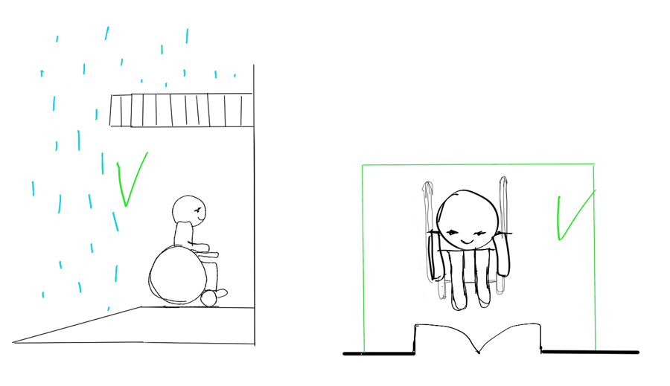
5. SN RK 3.06-01-2011 – Accessibility: lift  A lift for a wheelchair user needs a cabin of at least 1.1 × 1.4 m and a free turning zone (Ø 1.4 m) in front of the doors. A lift that must carry a person on a stretcher needs a cabin of 1.1 × 2.1 m . → The centre will have a lift between its three levels and the garage – 1.1 × 2.1 m, so that it can also carry a piano. | 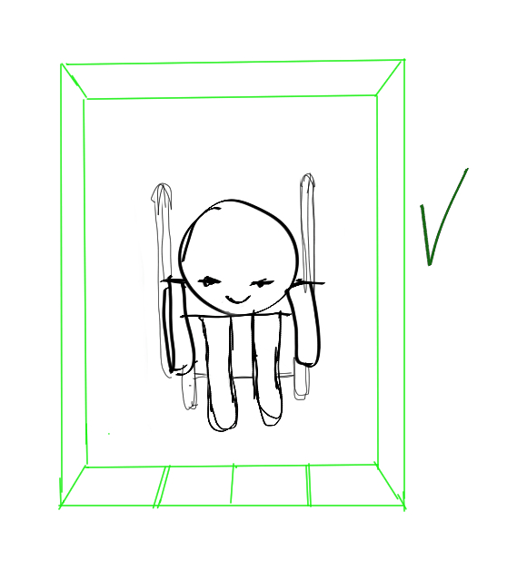
6. SN RK 3.06-01-2011 – Accessibility: toilet cubicle  At least one toilet cubicle on each floor must fit a wheelchair. The minimum by the norm is about 1.65 × 1.8 m, but with the 1.4 m turning circle, grab bars, a washbasin and a door opening outwards it really ends up about 1.8 × 2.1 m (≈ 4 m²). → Every level of the centre gets one accessible WC of about 4 m² – four in total. | 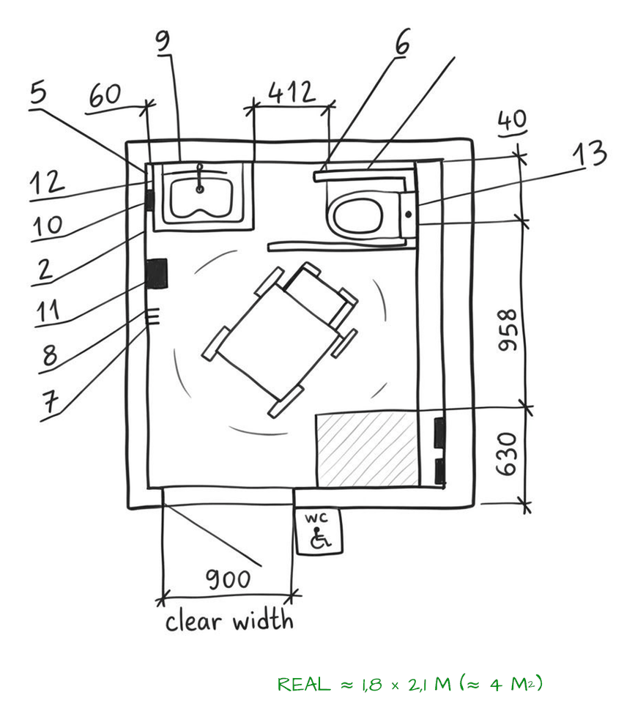
7. SN RK 3.03-05-2014, SP RK 3.06-101-2012 – Accessibility: parking space  A normal parking space is about 2.5 × 5.5 m. A space for a disabled driver is wider – 3.6 × 5.5–6.0 m – because the person needs about 1.1 m next to the car to get into the wheelchair. About 10 % of the spaces are accessible, and they are no further than 50 m from the entrance. → Accessible spaces will be right next to the lift in the garage under the learning section (3 of 24 places); the drop-off at the square is 40 m from the entrance. | 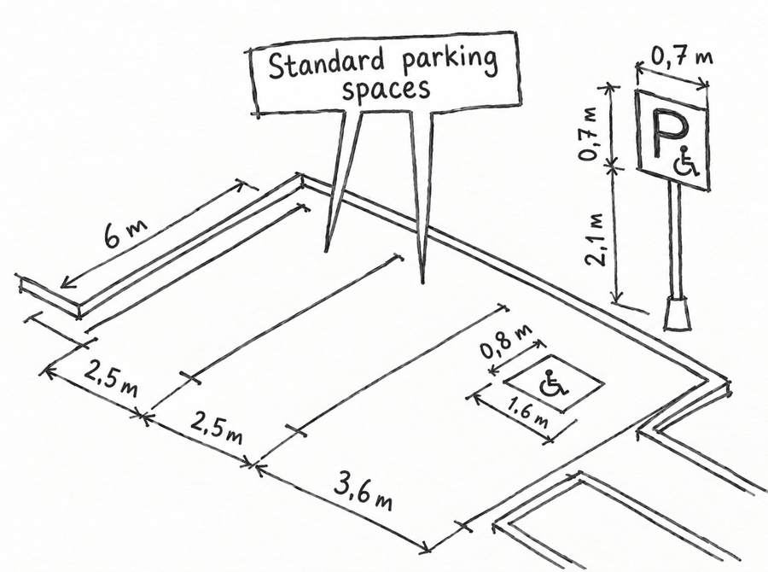
B. FIRE SAFETY AND EVACUATION
8. SN RK 2.02-01-2023 – Fire safety: width of escape routes
A corridor is an escape route. If more than 50 people can use it, it must be at least 1.2 m wide and at least 2 m high. → The corridors of the centre will be at least 1.2 m wide – and 1.8 m where wheelchairs pass each other.
9. SN RK 2.02-01-2023 – Fire safety: two exits  A room or floor where more than 50 people gather needs at least two exits, placed far from each other, so that one fire cannot block both. → The concert hall will have at least two exits on opposite sides, and every floor of the centre will have two ways out. | 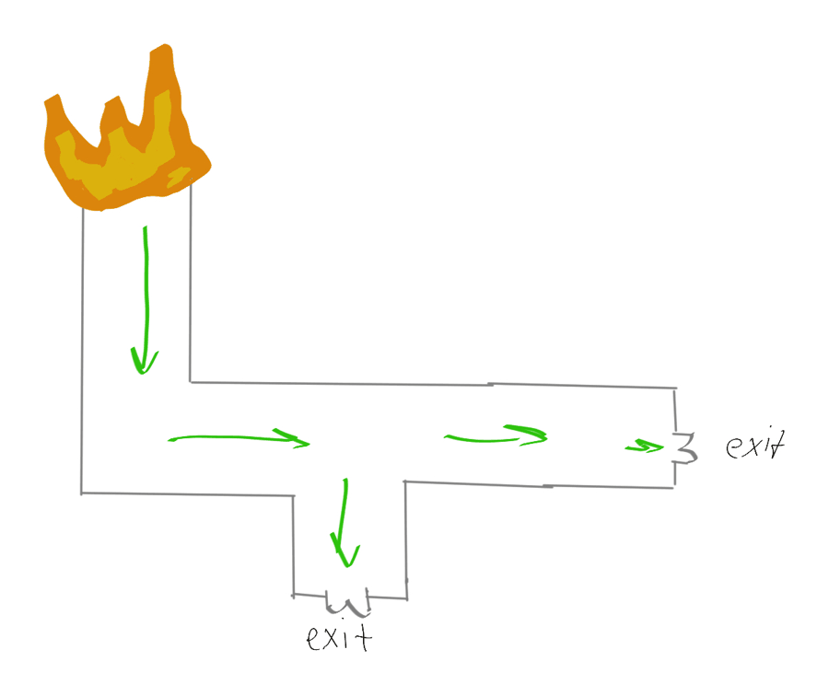
10. Fire Safety Rules (MES order No. 55, 2022), SN RK 2.02-01-2023 – Fire safety: doors open outwards  Doors on escape routes open in the direction people run out, so a crowd can push them open; only rooms with up to 15 people may have doors opening inwards. An open door must not narrow the corridor. → The doors of the hall, the group rooms, the movement hall and the café will open outwards, and the classroom doors will sit in small niches so they do not block the corridor. | 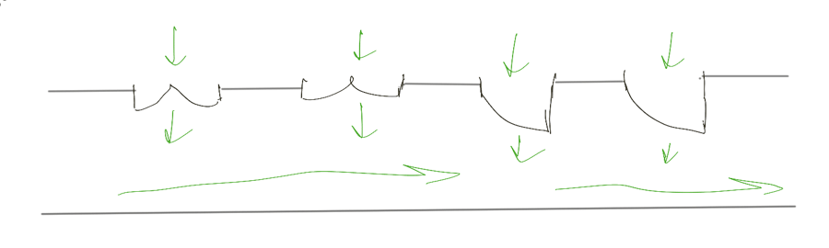
11. SNiP RK 3.02-02-2009 (table 9), technical regulation “General requirements for fire safety” – Fire safety: distance to an exit  The way from the door of the farthest room to the nearest exit (outside or into a stair) is limited, so that people get out before the smoke comes. The limit depends on the fire resistance of the building and on how crowded the corridor is: in a building of I–III fire resistance it is from 60 m (up to 2 people per m²) down to 20 m (more than 5 people per m²) if the room lies between two exits, and from 30 m down to 10 m if it opens into a dead-end corridor. For educational buildings the norm takes the column for 2–3 people per m²: ≤ 50 m and ≤ 25 m. Rooms that open into a dead-end corridor may hold no more than 80 people. → My centre is a building of I–II fire resistance: no classroom, office or practice room will be further than 50 m from a stair or an outside door (in my plan about 40 m), dead-end corridors stay shorter than 25 m, and the hall has its own exits outside. | 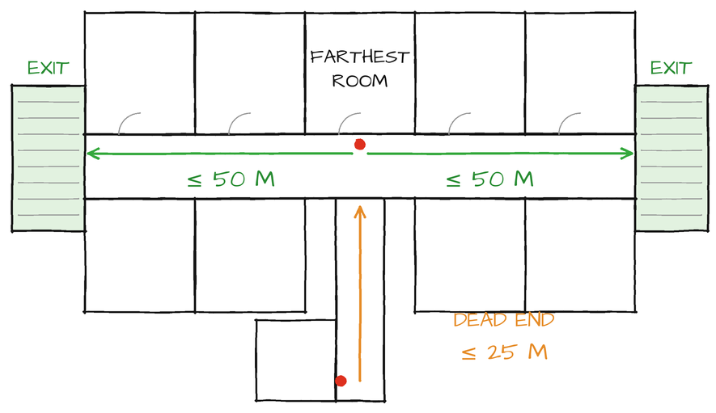
12. SN RK 2.02-01-2023 – Fire safety: exit signs and emergency light  Escape routes must stay visible when the power goes off: emergency lighting of at least 1 lx on the floor and lit “EXIT” signs above the exits. → Every exit of the centre will have a lit sign, and the corridors will have emergency lights. | 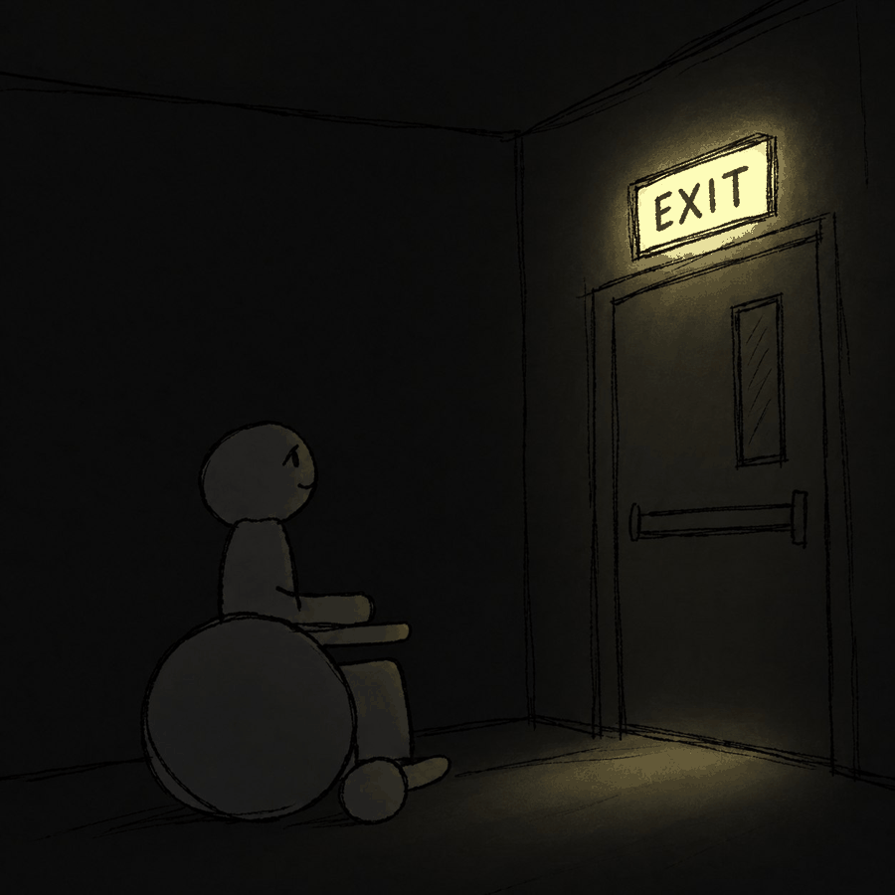
13. SN RK 2.02-01-2023 – Fire safety: fire engine access
A fire engine must be able to drive up to the building: a road at least 3.5 m wide, 5–8 m from the wall. → The square and the service lane (3.5 m) will also be the fire access to the hall and both wings.
C. STAIRS
14. SN RK 3.06-01-2011, SN RK 2.02-01-2023 – Stairs of the public building: width
In a public building the stairs must be wide enough for people to pass each other; on routes used by people with limited mobility a flight is at least 1.35 m wide. → The stairs of the centre will be at least 1.35 m wide.
15. SN RK 3.06-01-2011 – Stairs of the public building: steps  All steps in a flight must be the same. For a public building the step is about 15 cm high and 28–35 cm deep, with 3 to 16 steps in one flight. The usual 15 × 30 cm comes from the Soviet module – it follows the norm, but it is not the most comfortable step (see 16). → The steps of the centre will be 15 cm high, which is also comfortable for children. | 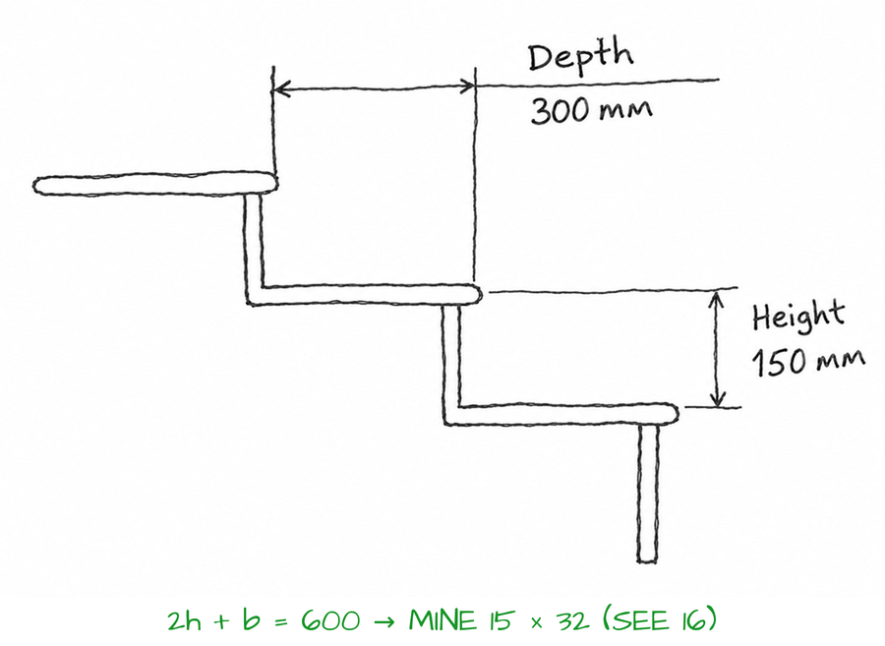
16. SNiP RK 3.02-43-2007 (4.4.6) – Stairs: the comfortable step 2h + b  A stair is comfortable when two risers and one tread together equal one human step. The norm writes it as 2b + a = 60–64 cm, where a is the tread and b the riser; 60–64 cm is the size of an average human step. With h = 150 mm, 15 × 30 cm gives only 600 – the lower limit; 15 × 32 cm gives 620 – right in the middle. → The stairs of the centre will have steps of 150 × 320 mm (2h + b = 620). | 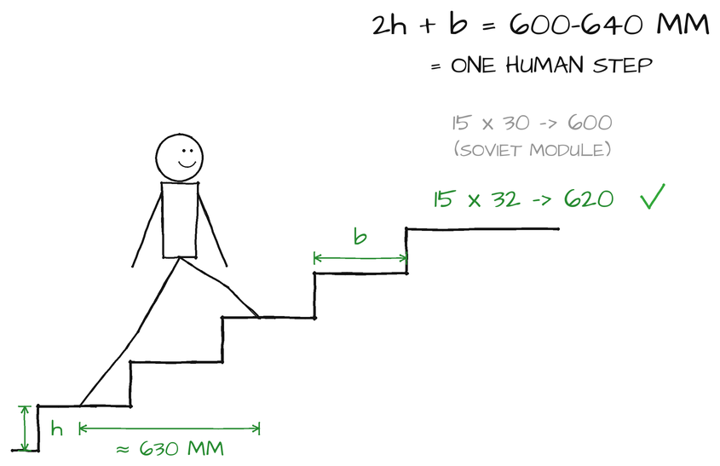
17. SN RK 3.06-01-2011, KR DSM-76 – Stairs: handrails and railings for children  Handrails go on both sides of a stair at about 0.9 m, with a lower one at about 0.7 m for children. Where children walk, railings are at least 1.2 m high, with vertical bars no more than 10 cm apart. → The stairs and galleries of the centre will have two handrails and 1.2 m railings. | 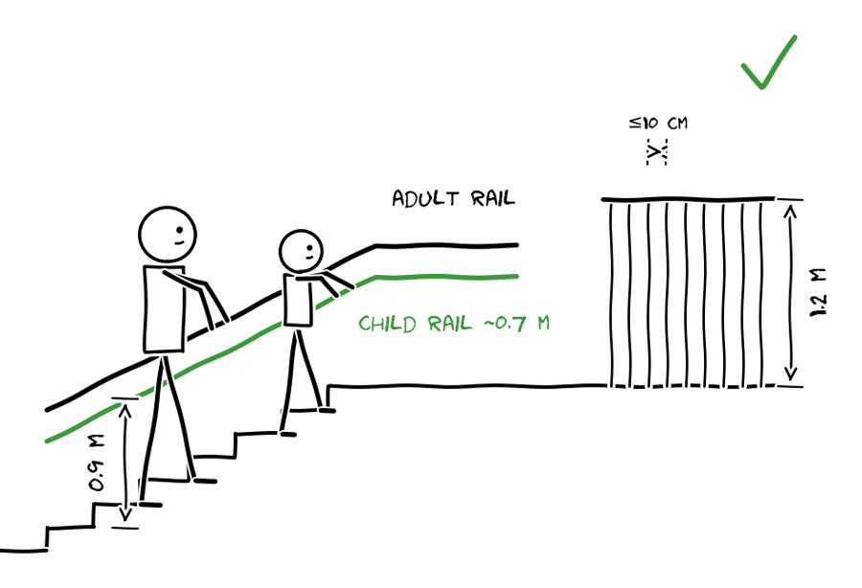
D. ROOMS OF THE MUSIC LEISURE CENTRE
18. SN RK 3.02-20-2011 – Concert hall: rows and seats
A seat is at least 0.5 m wide, and rows are at least 0.9 m apart so a person can walk past seated people. A row can have up to 26 seats if there are aisles on both sides, and aisles are at least 1.0 m wide. → The seating in my hall will follow these sizes, with aisles on both sides.
19. SN RK 3.02-20-2011 – Concert hall: sightlines
Every listener must see the stage over the head of the person in front. The line from the eyes of each row to the focus point F at the front edge of the stage must pass at least C = 12 cm above the eyes of the row in front (6 cm if the seats are staggered), so the floor rises row by row. → In my transformable hall the front rows stand on the flat floor and the back rows on telescopic tiers that rise about 12–15 cm per row, with staggered seats; for lessons and dance the tiers are pushed back to the wall.
20. KR DSM-76 – Classrooms: size  An individual music room needs about 12–18 m² – enough for a piano, a student and a teacher – and a group room at least 2.5 m² per student, with a ceiling of about 3 m or more. → My practice rooms will be about 4 × 4 m (16 m²), and the group rooms 50 m² for up to 20 students (choir and ensembles). | 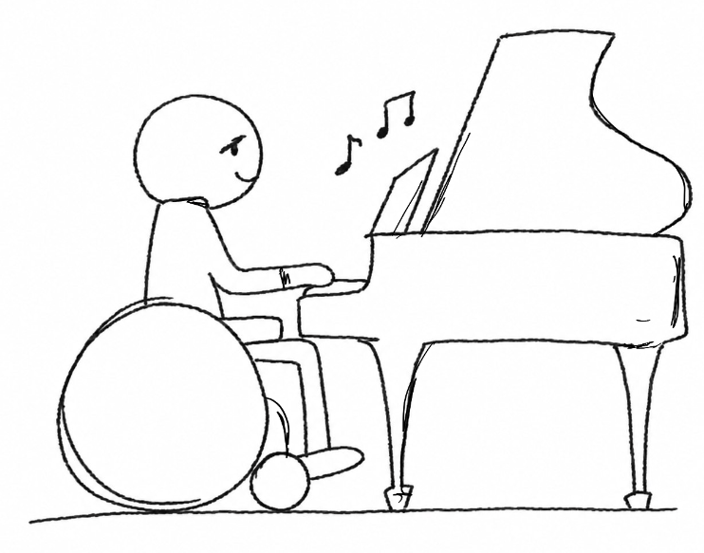
21. KR DSM-76, SN RK 2.04-01-2011 – Classrooms: daylight from the left  Classrooms need daylight from the side, and it must come from the left of the student (KR DSM-76: the furniture is placed for left-side light), so the writing hand does not shade the paper or the music stand. With windows on one side a room should not be deeper than about 6 m from the window, and the light on the desk or music stand should be 300–500 lx. → In every classroom the window wall will be on the left of the students and the board or the teacher’s piano at the front wall; no room deeper than 6 m. | 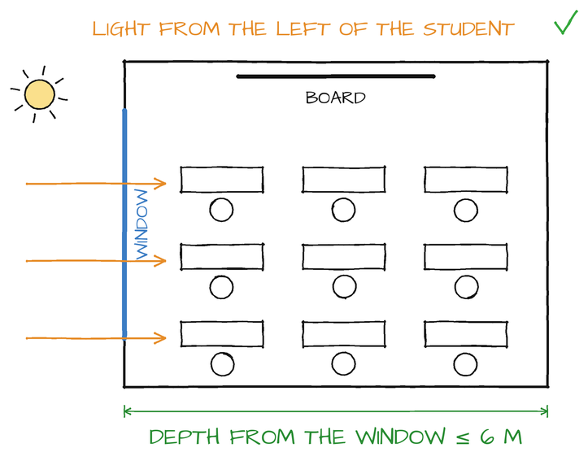
22. KR DSM-76, SN RK 2.04-01-2011 – Daylight decides the depth of the building  From norm 21 follows the shape of the building: a classroom at most 6 m deep + a corridor of about 2.5–3 m (many children) + a classroom of 6 m = a wing of about 15 m, at most 18 m. A deeper block, for example 30 m, would have dark rooms in the middle, because only the first 6 m from the window get enough light. → The learning wing and the administration of the centre will be about 15 m deep with windows on both long sides; only the hall, the stores and the loud rooms in the slope can be deeper. | 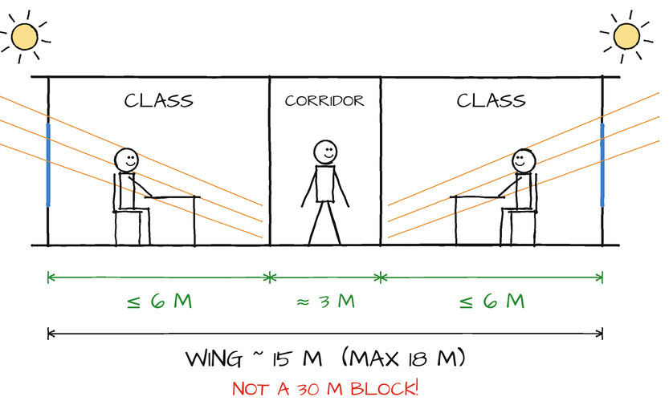
23. KR DSM-52, sanitary rules for schools – Orientation of the rooms to the sun  Different rooms need different sun: classrooms – south, south-east or east (morning sun, no hot afternoon sun); art studios and computer rooms – north (even light without glare); bedrooms – east (morning sun); living rooms – south or west; stairs, toilets and stores can face north. → In the centre the group rooms, the hall terrace and the café face the forest to the south-east; half of the practice rooms face north-west – even light for the pianos, which must not stand in the sun; the practice rooms on the south-east side are shaded by the fins. | 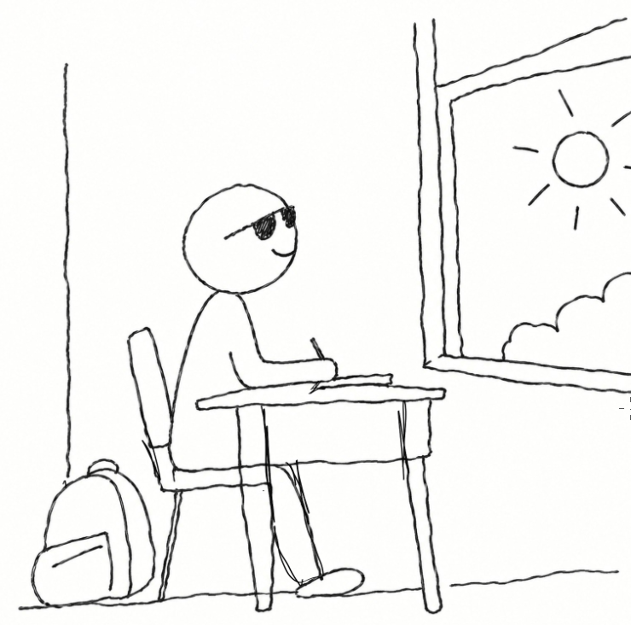
24. SN RK 3.02-07-2014 – Movement hall (dance, yoga)  For dance and yoga you need about 4–6 m² per person and a ceiling of at least about 4 m, so people can jump and raise their arms. Changing rooms with showers should be next to the hall. → My movement hall (130 m² for 20–30 people) will be a high room with changing rooms right next to it. | 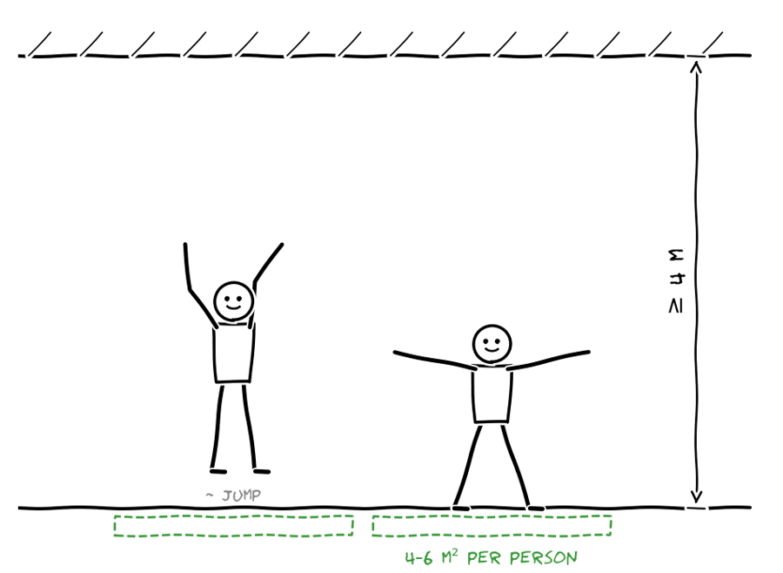
25. SN RK 3.02-07-2014 – Cloakroom  A public building needs a cloakroom for the coats of all visitors who are inside at the same time, with a counter and space in front of it for a queue. → The cloakroom of the centre will be next to the entrance, on the way to the hall. | 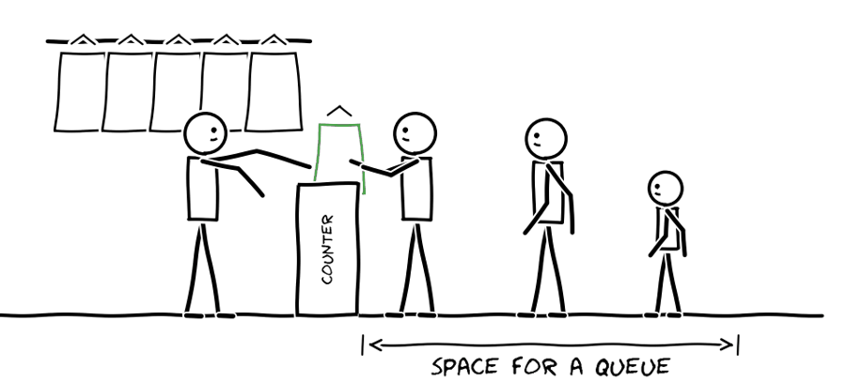
26. KR DSM-76 – Toilets for children  Toilets are separate for girls and boys, and for children the washbasins and WCs are placed lower so they can use them without help: washbasins about 0.5 m high for younger children and 0.7–0.8 m for older children and adults. → The toilets next to the classrooms will be separate for girls and boys, with washbasins at two heights (0.5 and 0.8 m), plus one accessible WC. | 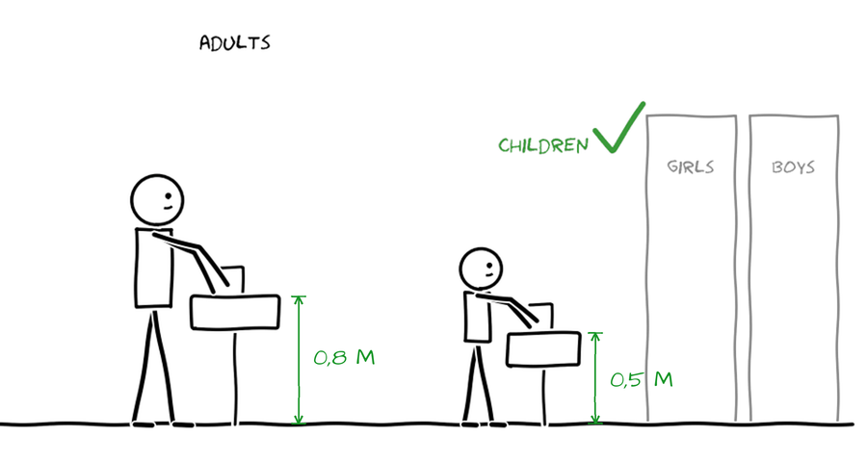
E. CAFÉ AND ITS KITCHEN
27. Sanitary rules for catering facilities – Café kitchen: one-way flow  In a kitchen food moves in one direction – delivery → storage → preparation → cooking → serving – so raw and cooked food never meet. Dirty dishes also go back by their own route. The kitchen needs its own delivery door. → The café kitchen will be arranged in a line from the delivery door to the serving counter (see 28). | 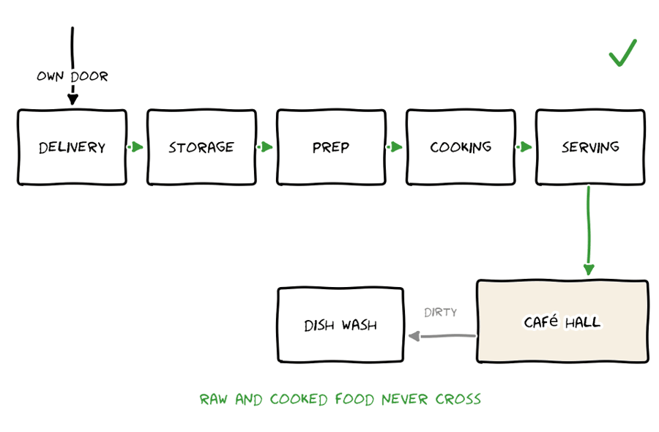
28. Sanitary rules for catering facilities – Café kitchen: staff and separate rooms  In Kazakhstan a kitchen also needs a separate staff entrance, a changing room and a toilet with a shower for the staff, who go to work through them – never through the dining room. The stores are divided: dry goods, a cold store (fridges) and vegetables; raw food is prepared in separate rooms – meat and fish apart from vegetables. → My café kitchen gets a staff door, a changing room and a WC, three small stores and two preparation rooms in the line delivery → stores → preparation → hot kitchen → serving. | 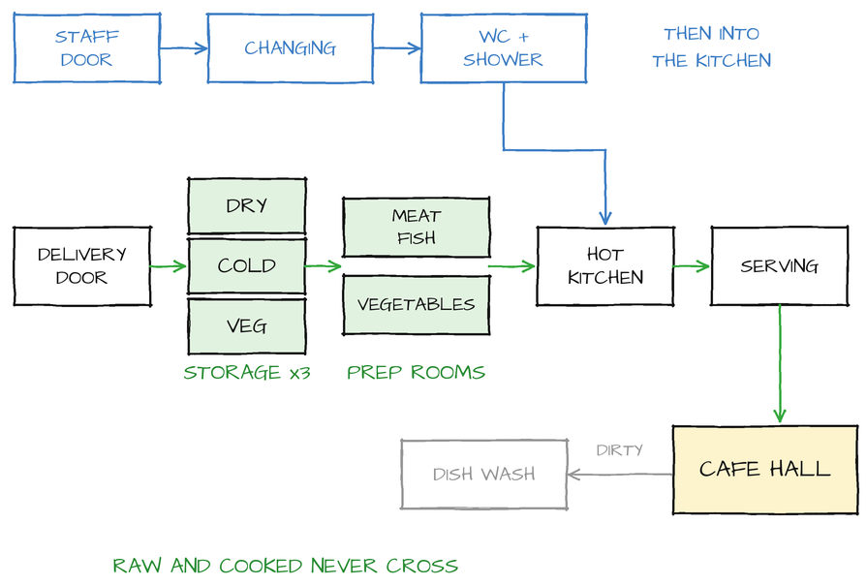
29. Sanitary rules for catering facilities – Café kitchen: space for the cook
The passages between kitchen equipment should be at least about 1.0–1.2 m, so a cook can open an oven door and another person can still pass behind. → The café kitchen will have wide passages between the stoves and the worktables.
30. SN RK 3.02-07-2014 – Café: dining room  A dining room needs about 1.6 m² per seat, so people can sit comfortably and waiters can walk between the tables. The café also needs a separate extract shaft that goes out above the roof. → The café (65 m² for 40 seats) will be next to the foyer, and its kitchen extract will rise above the roof. | 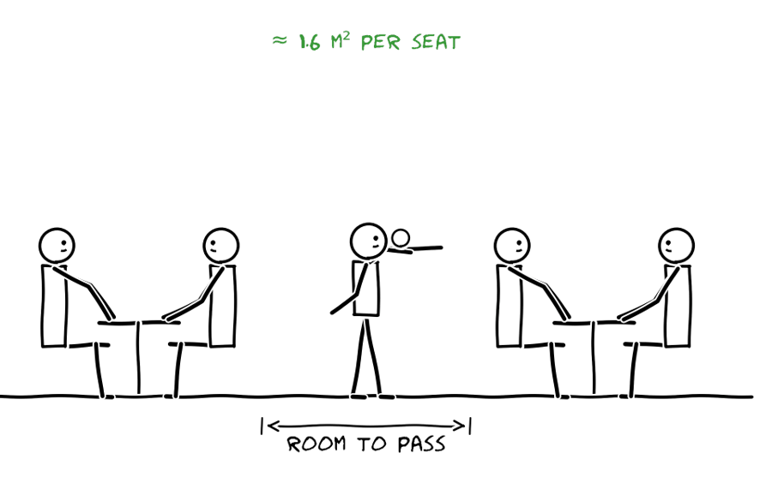
F. SITE AND PARKING
31. SN RK 3.03-05-2014 – Underground parking  A parking space is 2.5 × 5.5 m (5.3 m is the absolute minimum), the driving aisle in front of 90° spaces about 6 m, and the clear height at least 2.2 m. → My underground garage will have 24 spaces of 2.5 × 5.5 m along a 6 m aisle under the learning wing. | 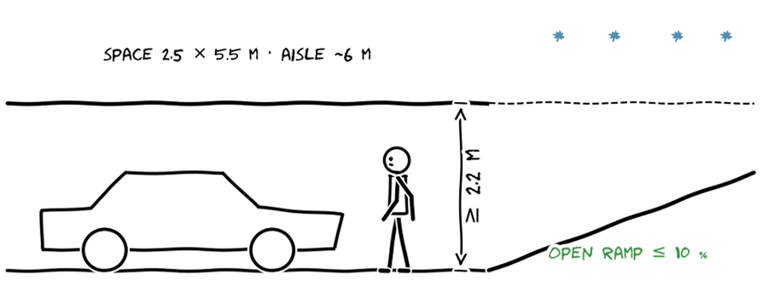
32. SN RK 3.03-05-2014, SP RK 3.03-105-2014 – Car ramps and turning radius  A ramp for cars may be at most 18 % steep if it is covered and heated, 13 % if it is curved, and only 10 % if it is open to snow and ice; at the top and the bottom of a steep ramp there are short gentler parts so that cars do not scrape. A one-lane ramp is at least about 3.5 m wide (two lanes about 6–7 m). A car turns on a radius of about 5.5–6 m, so a curved ramp needs an outer radius of about 7.5 m and the aisles 6 m. → My ramp will start at the square: an open straight part of 25 m at max. 10 % and a covered curved part of 23 m (≤ 13 % is allowed, mine ≈ 10 %) into the garage; one lane 3.5 m with a traffic light (only 24 cars), outer radius ≥ 7.5 m. | 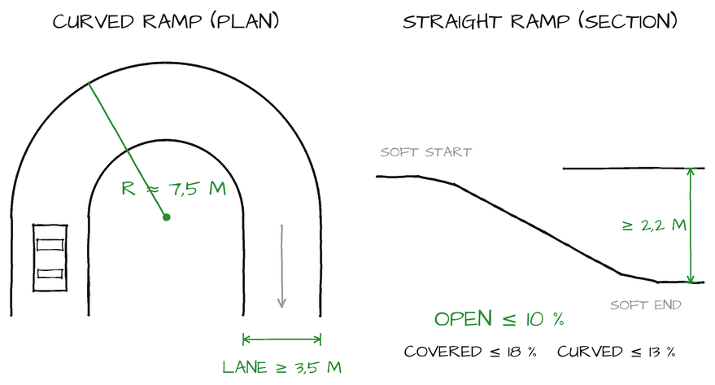
33. SP RK 3.01-101-2013 – Playgrounds and bins: distances  A children’s playground must be at least 12 m from the windows of the house, and waste bins at least 20 m from windows but no more than 100 m from the entrances. → The centre’s waste room is next to the kitchen delivery door on the service lane; the children’s play area is in the riverside park, more than 12 m from the windows of the classrooms. | 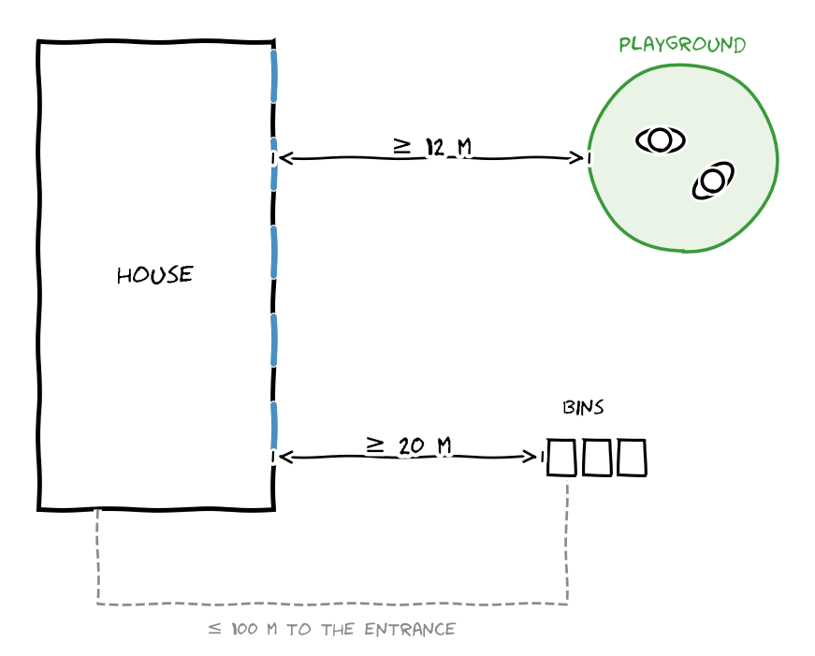
34. Water Code of the RK – Distance from the river  Within 35 m of a river bank you cannot build, park cars or cut trees; only paths, small bridges and playgrounds are allowed. → My centre stands behind the 35 m line (13 m from it); site 278 along the river becomes a park with paths and a playground. | 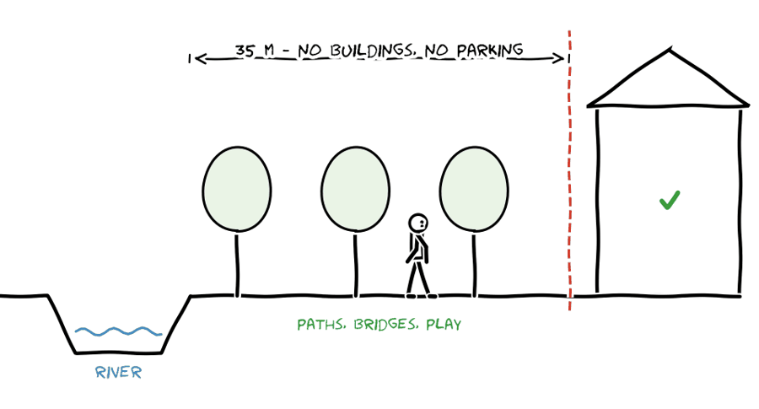
35. SP RK 3.01-101-2013∗, Appendix D (Table D.1) – Number of parking places  The number of parking places depends on the building: for a theatre or a concert hall one place per 10–12.5 seats and one per 4–5 employees, for a café one place per 4–7 seats. For specialised buildings at least 10 % of the places are for people with limited mobility (8.8.6), and one underground level needs about 25 m² of building per car (Table 13-2). → My centre: 200 seats ÷ 10 = 20 + 15 staff ÷ 4 ≈ 4 = 24 places, 3 of them accessible; on a weekday 19–23 places are needed. The garage under the wing has 725 m² (≥ 24 × 25 = 600 m²). | 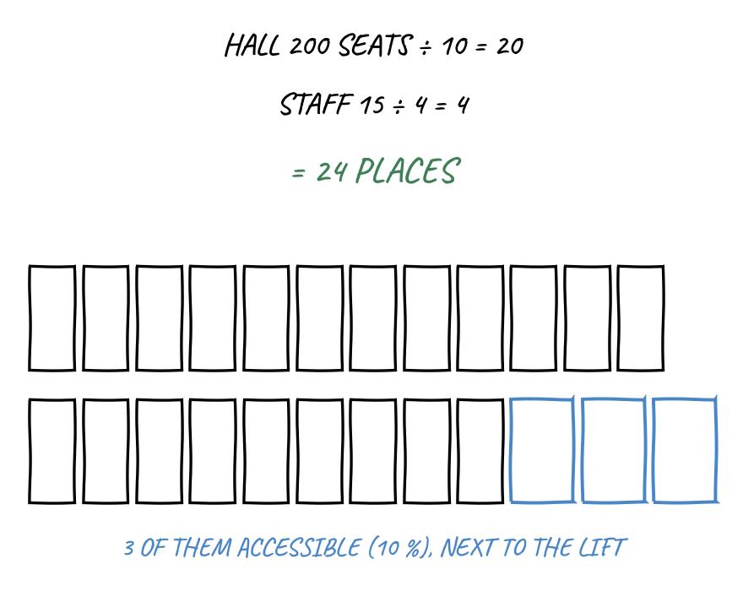
36. SP RK 3.01-101-2013∗, 8.8.8 – Entries of underground garages  The entry or exit of an underground garage must be at least 15 m from the windows of homes and of work rooms of public buildings and from the plots of schools, kindergartens and hospitals, at least 20 m from a junction of local streets and 30 m from a public transport stop. → The portal of my ramp at the square is 19 m from the windows of the centre, more than 20 m from the junction with the street and far from the bus stops. | 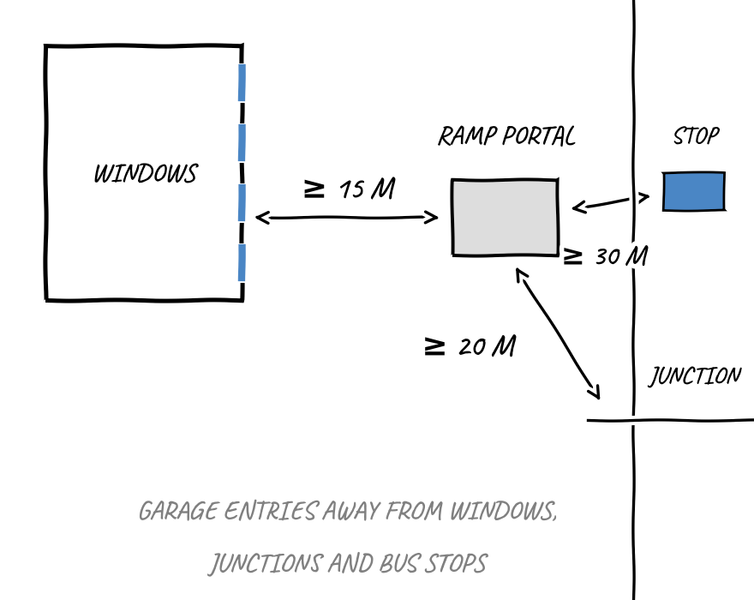
37. SP RK 3.01-101-2013∗, 8.7.1 and 8.8.3 – Walking distances  Public transport stops should be no more than 250 m from buildings that many people visit, and temporary parking no more than 250 m from the entrance of a public building (100 m for housing). → The “Dom otdykha” stop is about 240 m from the main entrance of the centre, the drop-off at the square 40 m. | 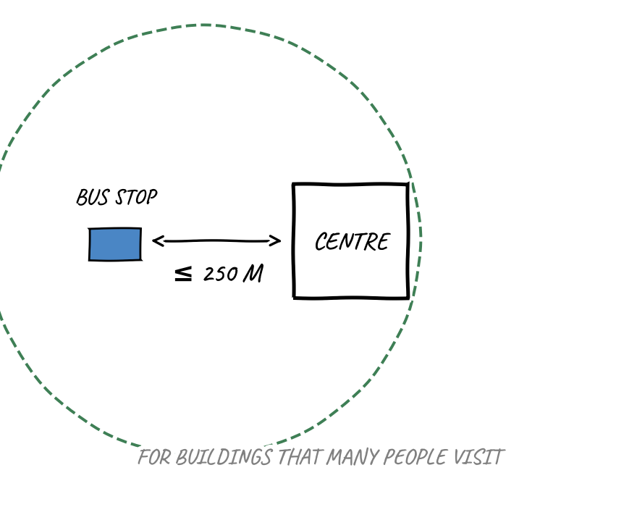

CONCLUSION
Accessibility (1–7): step-free entrances with a covered 2.2 × 2.2 m platform; 5 % ramps in runs of 10–12 m with 1.5 m landings; doors ≥ 0.9 m; a lift between all levels and the garage; free 1.4 m circles in lobbies, at the lift and in accessible WCs of about 1.8 × 2.1 m; accessible parking 3.6 × 5.5 m next to the lift.
Evacuation (8–13): corridors 1.8 m (minimum 1.2 m); the hall has at least two exits; doors of rooms with more than 15 people open outwards and stand in niches; ≤ 50 m from the farthest room to an exit, no dead ends over 25 m; the service lane is the fire access (3.5 m).
Stairs (14–17): flights ≥ 1.35 m, steps 15 × 32 cm (2h + b = 620 mm), handrails at 0.9 and 0.7 m, railings 1.2 m.
Rooms of the centre (18–26): seats 0.5 m, rows 0.9 m apart, C ≥ 12 cm on telescopic tiers; practice rooms 16 m², group rooms 2.5 m² per student; light from the left, rooms ≤ 6 m deep → wings about 15 m; pianos away from the sun; movement hall 4–6 m² per person and ≥ 4 m high.
Café (27–30): 1.6 m² per seat → 65 m²; a kitchen with a staff entrance, three stores and two preparation rooms in one line.
Site and parking (31–37): 24 places by the norm, all underground, 3 accessible; parking places 2.5 × 5.5 m, aisles 6 m; a ramp ≤ 10 %, a 3.5 m lane, outer radius ≥ 7.5 m; the portal ≥ 15 m from windows; the stop ≤ 250 m; nothing is built within 35 m of the river.

2.4. Room programme
The room list comes from the users (Section 1), the analogues (2.2) and the norms (2.3). The sizes of the rooms follow the norms: a practice room 16 m², a group room 50 m² for up to 20 students (2.5 m² per student), the café 65 m² for 40 seats, the movement hall 130 m² for 20–30 people and an accessible WC of about 4 m² on every level. The table follows the format: Room – number (#) – size of one room – total. Each zone ends with its total (TOT) and the total with corridors (×1.15).

2.4.1. Music leisure centre
Room | # | Size, m² | Tot, m²
Entrance and foyer
Entrance lobby (tambour and lobby) | 1 | 18 | 18
Foyer and children’s gallery | 1 | 120 | 120
Cloakroom | 1 | 30 | 30
Toilets – women | 1 | 18 | 18
Toilets – men | 1 | 18 | 18
Accessible WC | 1 | 4 | 4
TOT |  |  | 208 m²
Corridors | 1.15 |  | 239 m²
Café – seating and kitchen
Café hall, 40 seats | 1 | 65 | 65
Hot kitchen | 1 | 24 | 24
Dry store | 1 | 6 | 6
Cold store (fridges) | 1 | 6 | 6
Vegetable store | 1 | 4 | 4
Preparation room – meat and fish | 1 | 8 | 8
Preparation room – vegetables | 1 | 6 | 6
Dishwashing | 1 | 8 | 8
Delivery | 1 | 10 | 10
Waste room | 1 | 6 | 6
Kitchen staff changing room | 1 | 8 | 8
Kitchen staff WC with shower | 1 | 4 | 4
TOT |  |  | 155 m²
Corridors | 1.15 |  | 178 m²
Administration
Reception | 1 | 6 | 6
Security | 1 | 9 | 9
Secretary (in front of the director) | 1 | 10 | 10
Director | 1 | 18 | 18
Deputy director | 1 | 12 | 12
Accountant | 1 | 18 | 18
Meeting room | 1 | 18 | 18
Teachers’ room | 1 | 30 | 30
Employees’ rest room | 1 | 18 | 18
Archive | 1 | 6 | 6
Storage for cleaning | 1 | 4 | 4
Wardrobe | 1 | 4 | 4
Toilets | 2 | 6 | 12
TOT |  |  | 165 m²
Corridors | 1.15 |  | 190 m²
Transformable hall
Hall, 150–200 seats (or 3 classrooms) | 1 | 280 | 280
Chair and stage store | 1 | 40 | 40
Backstage | 2 | 15 | 30
Light and sound booth | 1 | 10 | 10
TOT |  |  | 360 m²
Corridors | 1.15 |  | 414 m²
Learning (quiet)
Practice room | 12 | 16 | 192
Group room (theory, choir, ensemble) | 3 | 50 | 150
Waiting lounge | 1 | 40 | 40
Instrument store | 1 | 20 | 20
Toilets – girls | 1 | 12 | 12
Toilets – boys | 1 | 12 | 12
Accessible WC | 1 | 4 | 4
TOT |  |  | 430 m²
Corridors | 1.15 |  | 495 m²
Loud rooms (lower level)
Band room | 1 | 40 | 40
Drum room | 1 | 24 | 24
Recording studio – live room | 1 | 30 | 30
Recording studio – control room | 1 | 15 | 15
Accessible WC | 1 | 4 | 4
TOT |  |  | 113 m²
Corridors | 1.15 |  | 130 m²
Movement (upper level)
Movement hall (dance, yoga) | 1 | 130 | 130
Changing room with shower | 2 | 20 | 40
Equipment store | 1 | 10 | 10
Accessible WC | 1 | 4 | 4
TOT |  |  | 184 m²
Corridors | 1.15 |  | 212 m²
Children’s club
Club / playroom | 1 | 62 | 62
Library and homework room | 1 | 50 | 50
TOT |  |  | 112 m²
Corridors | 1.15 |  | 129 m²
Technical (lower level)
Plant room (ventilation, heating) | 1 | 60 | 60
Electrical room | 1 | 10 | 10
Storage for cleaning | 2 | 4 | 8
TOT |  |  | 78 m²
Corridors | 1.15 |  | 90 m²
Music leisure centre – all zones
TOT |  |  | 1 805 m²
Corridors | 1.15 |  | 2 076 m²

In total the centre has 73 rooms, 1 805 m², and with corridors 2 076 m². The biggest zones are learning (495 m²), the transformable hall (414 m²) and the entrance with the foyer (239 m²). The café became its own zone together with its kitchen, stores and staff rooms (178 m²). The hall can be divided into three classrooms, so the centre needs only three group rooms. In the administration the director has the largest office (18 m²) behind the secretary, and the deputy director a smaller one (12 m²) with its own door to the corridor.
CONCLUSION
Centre: 73 rooms in 9 zones, 1 805 m² of rooms, 2 076 m² with corridors (×1.15) – the size of King’s College School (2,160 m²) and Meco (2,148 m²).
Administration: 13 kinds of rooms, 165 m², 190 m² with corridors; its own staff entrance and wardrobe; the director is reached only through the secretary.
Café: its own zone – 40 seats, a kitchen, three stores, two preparation rooms and staff rooms – 155 m², 178 m² with corridors.
Garage: 24 places by the norm (2.3, norm 35) under the learning section – about 725 m² with the aisle, the ramp outside the building.

2.5. Functional diagram
The diagram is built from the room programme: every circle is one room from the table in 2.4.1 (73 rooms), and its size is to scale of the area. Every zone is a box, and inside it the rooms stand in the order people use them – along a corridor (ochre band) or around a hub. Lines show doors and links; no route goes through another room.
Entrance and foyer. The entrance lobby leads into the foyer. The foyer is the hub: the cloakroom (on the way to the hall), the toilets, the café, the hall, the children’s club and the corridor to the learning zone open from it.
Administration. The reception and the security room stand at the entrance lobby and see everybody who comes in. Behind them a short staff corridor leads past all offices: the secretary sits in front of the director, so the director is reached only through the secretary, while the deputy director, the accountant, the meeting room and the teachers’ room have their own doors to the corridor – nobody walks through another office. The staff come through their own entrance and the wardrobe; the rest room, the toilets, the archive and the cleaning store are along the same corridor. A staff door leads from this corridor straight into the learning zone, so the teachers reach the classrooms without the foyer. Visitors reach only the reception desk.
Transformable hall. The hall opens from the foyer. The chair and stage store, two backstage rooms and the light and sound booth are next to it. The backstage is linked with the service entrance, so artists and instruments do not go through the foyer.
Learning. The waiting lounge is a small hub for students. From it one corridor leads past the three group rooms, six practice rooms and the instrument store to the stair and lift; a second short corridor leads to six more practice rooms, a third to the children’s toilets (girls, boys, accessible WC). The stair and lift go down to the loud rooms (band room, drum room, recording studio) and up to the movement hall with two changing rooms; each of these levels has an accessible WC.
Children’s club and library. Next to the foyer and the café, so parents can wait in the café and see the children.
Café and kitchen. The café opens from the foyer and onto the terrace. Its kitchen works in one line: delivery → three stores (dry, cold, vegetables) → two preparation rooms (meat and fish, vegetables) → hot kitchen → serving hatch to the café; dirty dishes → dishwashing → waste room → service road. The kitchen staff come through their own door, changing room and WC and never pass the foyer.
Technical. The plant room, the electrical room and the cleaning stores are on the lower level under the hall, because the hall needs the most fresh air; they are reached by the service route.

2.5.1. Functional diagram of the centre with all rooms
Functional diagram of the music leisure centre. Every zone is a box; the rooms stand in the order of use along corridors (ochre) or around hubs. Circles to scale of the room areas (rooms under 10 m² are drawn at one minimum size). Grey line – door or link; red dashed – stair and lift to another level; dotted – service link. Dashed frames – rooms on another level.

2.5.2. Routes of the users
Routes: orange – visitors and audience; green – students and parents; blue dashed – teachers and staff; brown – delivery and kitchen staff; violet dashed – artists and equipment. No route passes through another room.

The routes were checked with four rules: a visitor does not go through the administration; the delivery does not use the main entrance; the kitchen staff do not cross the visitor zone; a student does not pass the café or the hall to get to a classroom.
- Visitors and audience (main entrance): lobby → cloakroom → foyer → hall or café. They never enter the administration, the kitchen or the classrooms.
- Students and parents (main entrance): lobby → foyer → corridor → waiting lounge → practice or group room; from the lounge by stair or lift to the loud rooms and the movement hall; younger children – from the foyer to the club.
- Teachers and staff (staff entrance): wardrobe → staff corridor → teachers’ room → staff door → learning zone. The administration staff reach their offices without the foyer.
- Delivery and kitchen staff (service entrance): delivery → stores → preparation → kitchen → serving hatch; the kitchen staff through their own door and changing room. Waste goes out to the service road.
- Artists and equipment (service entrance): delivery → backstage → stage. Instruments and stage platforms do not go through the foyer.
Entrances. Three entrances are enough: the main entrance in the glass cube between the hall and the learning section, on the forest walk from the square and the “Dom otdykha” footbridge (Section 1), the staff entrance next to the administration and the service entrance (kitchen delivery, backstage) from the service lane, which is also the fire access. The café has a fourth door to its terrace, and the hall opens onto the amphitheatre.

2.5.3. Transformable spaces and unity with nature
The main rooms of the centre are assigned, but users can change them themselves. The large hall is divided by transparent sliding partitions: on weekday afternoons it is three classrooms, in the evening the partitions are put away and chairs and the stage come out of a special store, at weekends the glass façade opens to the forest. The idea follows the Dushan Leisure Center, where building, water and mountains are one space.
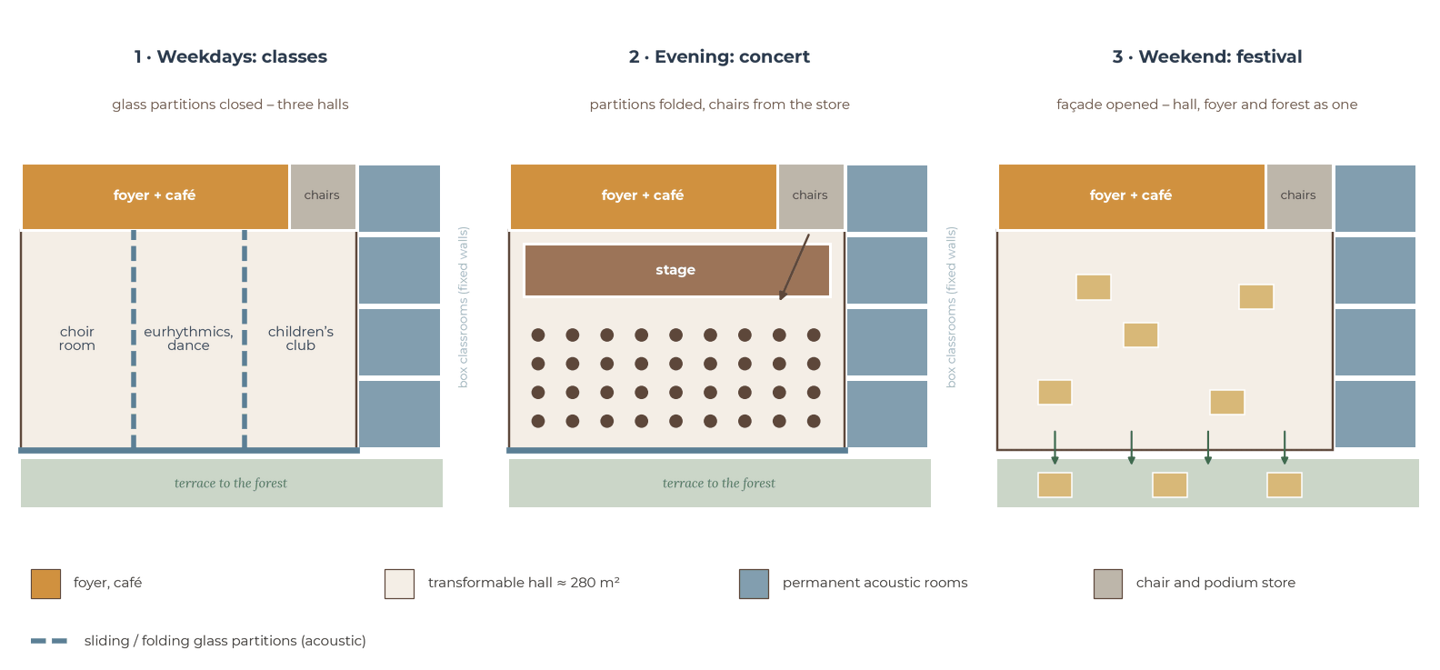
Three modes of the transformable hall (schematic plans): weekday lessons, evening concert, weekend festival.
- Sliding glass partitions – double acoustic glass panels on ceiling tracks, stored in wall recesses; divide the hall into 2–3 rooms in a few minutes; the hall works all week, not only on concert evenings; the rooms stay visible and bright.
- Chair and stage store – ≈ 40 m² next to the hall with wide doors: 200 stackable chairs on trolleys, stage platforms, music stands, mats; users themselves turn a classroom into a concert hall or a dance floor.
- Folding glass façade – the long side of the hall folds away and opens onto the outdoor stage and the amphitheatre; festivals and summer concerts in the forest – building and nature become one (as in Dushan).
- Roofs to walk on – every roof can be used: the café terrace (+3.90), the roof garden and the cube roof (+7.50), the terrace of the peaks and the meadow roof over the hall (+11.70) and the terrace over the stage; the route ends at the amphitheatre in the forest – a place to rest and look at the mountains.
- Permanent acoustic rooms – individual rooms, the ensemble room with drums and the recording studio remain closed “box in a box” rooms; glass partitions give about 40–50 dB of insulation – enough between choir and dance, but not enough for drums.
CONCLUSION
Entrances: main (forest walk and square), staff (administration), service (the service lane = fire access), the café door to its terrace and the hall door to the amphitheatre. Hubs: the foyer for visitors, the waiting lounge for students, the staff corridor for the administration. Separation: the kitchen line delivery → stores → preparation → kitchen → hatch and the artists’ route to the backstage never touch the foyer; visitors never enter the administration; nobody passes through another office. Levels: loud rooms and the plant room in the slope, the movement hall above the foyer, linked by a stair and a lift.

2.6. Variants of the room arrangement
All three variants have the same 73 rooms with the same areas (2.4.1) and the same entrances. Inside each zone the rooms keep the same order as in the functional diagram (2.5.1); only the position of the zones and the links between them change.
Variant 1: the foyer as a hub.
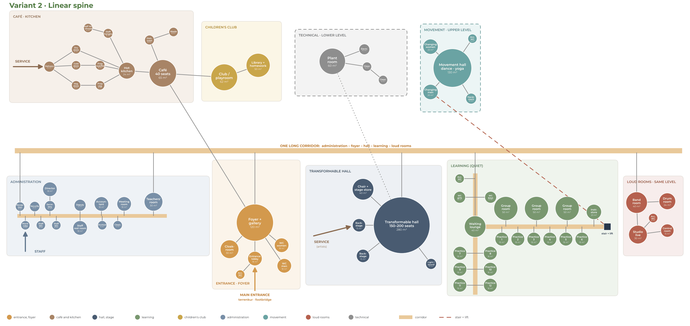
Variant 2: a linear spine – one long corridor from the administration to the loud rooms, all on one level.
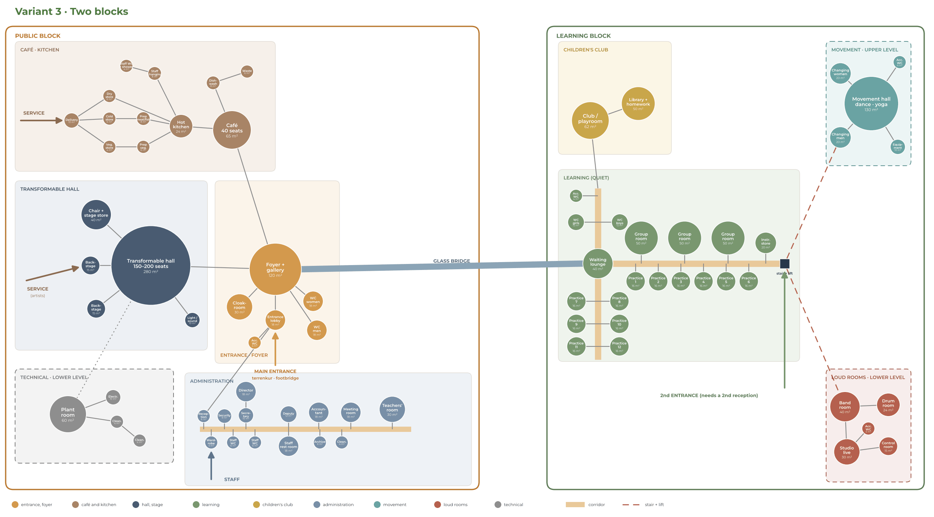
Variant 3: two blocks – a public block and a learning block linked by a glass bridge.

2.6.1. Comparison and choice
Variant 1 – the foyer as a hub. The foyer is in the middle: the hall on one side, the learning zone on the other, the administration at the main entrance, the kitchen between the café and the backstage, the loud rooms under and the movement hall over the learning zone.
- + every zone is one step from the foyer, the routes are the shortest;
- + one reception controls the only public entrance;
- + the hall and the foyer can be opened into one space for concerts;
- + a compact volume – less wall and roof, less heat loss, easier for seismic design;
- – the foyer must be large (120 m²), because all visitor routes cross it.
Variant 2 – a linear spine. Administration, foyer and café, hall, learning and loud rooms stand in one line along a long corridor; the kitchen and the plant room are behind.
- + a clear order from noisy and public to quiet; the building can follow the contour lines;
- – students walk past the café and the hall to get to the classrooms – this breaks one of the four rules;
- – a very long corridor and a long building, which cuts more trees on my site.
Variant 3 – two blocks. A public block (foyer, café, hall, kitchen, administration) and a learning block (classrooms, loud rooms, movement, children’s club) linked by a glass bridge, with a second entrance to the learning block.
- + the best sound separation between the hall and the classrooms; the learning block can work alone in the daytime;
- – two entrances need two receptions; the children’s club is far from the café where the parents wait;
- – more façades and roofs, so more heat loss and a higher cost.

CONCLUSION
I choose Variant 1 – the foyer as a hub. It is the only variant where all four route rules work with one reception and the shortest routes: visitors stay in the foyer zone, students go straight from the foyer to the waiting lounge, the delivery and the artists use the service entrance, and the staff have their own entrance.
The noise is separated by levels, not by distance: loud rooms in the slope, movement under the roof. This variant goes into the concept in Section 3.

2.7. Conclusion of Section 2
- Where to build: only outside the 35 m river strips and the 110 kV zone – the centre on the free land of plot 688, its riverside park on site 278 (Section 1).
- Organisation: no ready type – a hub, a cluster and division by noise around one transformable hall (2.1).
- From the analogues: twelve music and leisure buildings – one foyer for the hall and the classrooms, practice rooms as separate boxes around a lounge, loud rooms in the slope, separate entrances for the audience and the students, a walk over the roof, a stepped roof garden and a roof for children, one timber element along the whole building (2.2).
- From the norms: a 1.4 m circle for a wheelchair, corridors 1.8 m, ≤ 50 m to an exit, steps 15 × 32 cm, rows 0.9 m apart with C ≥ 12 cm, light from the left and wings about 15 m deep, practice rooms 16 m², a kitchen with staff rooms; 24 parking places underground; 35 m from the river (2.3).
- Room programme: the centre – 73 rooms, 1 805 m², 2 076 m² with corridors (2.4).
- Functional diagram: three entrances – main, staff and service – and separate routes for visitors, students, staff, kitchen and artists that never pass through another room (2.5).
- Arrangement: Variant 1 – the foyer as a hub, with the noise separated by levels (2.6).

Sources of Section 2
1. OpenStreetMap contributors – roads, rivers, buildings, land use and places (data © OpenStreetMap contributors, ODbL), accessed September 2026.
2. 2GIS – “Agroleskhoz” and “Dom otdykha” stops, routes and intervals (September 2026); Google Earth Pro – imagery of the valley (Airbus, 2023).
3. Almaty akimat resolution No. 4/580 of 15.12.2020 on establishing water-protection zones and strips of water bodies in Almaty (Annex 2 as amended by resolution No. 3/411 of 24.08.2022) – adilet.zan.kz, V20R0001672.
4. Rules for establishing water-protection zones and strips, order No. 120-NK of 09.06.2025 – adilet.zan.kz, V2500036238.
5. Almaty Building Rules (December 2024, in force since March 2025): height zones, 3-storey / 12 m limit in the upper zone – announcements of the Almaty akimat (almaty.gov.kz) and the media.
6. Steven Holl Architects, “COFCO Cultural & Health Center”, Shanghai – Dezeen, Designboom, Metalocus (metalocus.es), stevenholl.com.
7. DnA_Design and Architecture, “Dushan Leisure Center”, Songyang – Designboom, gooood.cn, Architizer, The Plan No. 120 (2020).
8. MVRDV + ADEPT, “Ku.Be House of Culture and Movement”, Frederiksberg – mvrdv.com, Dezeen, Danish Architecture Centre (dac.dk).
9. Hopkins Architects, “King’s College School Wimbledon Music School” – ArchDaily (archdaily.com/936960); “Mathematics and music meet in a classic setting” – Trä magazine 2019/4, Swedish Wood (swedishwood.com).
10. Nikken Sekkei, “Toho Gakuen School of Music” – Metalocus (metalocus.es); RIBA International Prize 2018 shortlist – Archinect / Bustler.
11. Alberich-Rodríguez Arquitectos, “Cultural Centre and Music School”, Meco – ArchDaily (archdaily.com/798738); Architonic.
12. Catalogue of normative technical documents (EGFNTD, new-shop.ksm.kz/egfntd/ntdgo/kds/): SN RK 1.02-03-2022; SN RK 1.03-00-2022; SN RK 1.03-05-2011; SN RK 2.01-01-2013; SN RK 2.02-01-2023; SN RK 2.02-02-2023; SN RK 2.03-01-2011; SN RK 2.03-02-2012; SN RK 2.03-03-2014; SN RK 2.04-01-2011; SN RK 2.04-02-2011; SN RK 2.04-07-2022; SN RK 2.04-15-2024; SN RK 3.01-01-2013; SN RK 3.01-05-2013; SN RK 3.02-01-2023; SN RK 3.02-07-2014; SN RK 3.02-08-2013; SN RK 3.02-09-2019; MSN 2.02-05-2000; MSN 2.03-02-2002; MSN 2.04-03-2005; MSN 3.02-05-2003; MSP 2.04-101-2000; MSP 2.04-102-2005; MSP 3.02-102-2006; MSP 5.01-102-2002; NTP RK 01-01-3.1(4.1)-2012; NTP RK 05-01-1.1-2011; NTP RK 07-01.6-2012; NTP RK 08-01.1-2012; NTP RK 08-01.2-2021; NTP RK 08-01.3-2021; NTP RK 08-01.4-2012; NTP RK 08-05.1-2022; RDS RK 1.04-05-2011; RDS RK 3.01-05-2001.
13. Codes of practice of the RK: SP RK 2.03-30-2017; SP RK 2.04-01-2017; SP RK 2.04-104-2012; SP RK 3.01-101-2013; SP RK 3.02-101-2012; SP RK 3.02-107-2014; SP RK 3.02-120-2012; SP RK 3.03-105-2014; SP RK 3.06-101-2012; SP RK 4.01-101-2012; SP RK 4.02-101-2012; SN RK 3.02-20-2011; SN RK 3.03-05-2014; SN RK 3.06-01-2011; GOST 30494-2011 – online.zakon.kz, prg.kz.
14. Building norms of the Republic of Kazakhstan: SN RK 3.01-01-2013 and SP RK 3.01-101-2013 (urban planning); SN RK 3.02-01-2023 and SP RK 3.02-101-2012 (apartment buildings); SN RK 3.02-07-2014 (public buildings); SN RK 3.02-20-2011 and SP RK 3.02-120-2012 (cultural and entertainment buildings); SN RK 3.02-09-2019 (multifunctional buildings); SN RK 2.02-01-2023 (fire safety); SP RK 2.03-30-2017 (seismic regions); SN RK 3.06-01-2011 and SP RK 3.06-101-2012 (accessibility); SN RK 3.03-05-2014 and SP RK 3.03-105-2014 (car parks); SN RK 2.04-01-2011 (natural and artificial light); SP RK 4.02-101-2012 (ventilation); SN RK 2.04-02-2011 and SP RK 2.04-105-2012 (noise protection) – online.zakon.kz, prg.kz.
15. Orders of the Minister of Health of the Republic of Kazakhstan No. KR DSM-52 of 16.06.2022 (sanitary requirements, insolation, natural light) and No. KR DSM-76 of 05.08.2021 (educational facilities: left-side light, 2.5 m² per student) – adilet.zan.kz, zakon.uchet.kz.
16. Orders of the Minister for Emergency Situations of the Republic of Kazakhstan No. 55 of 21.02.2022 “Fire safety rules” (doors on escape routes) and No. 405 of 17.08.2021, technical regulation “General requirements for fire safety” (escape routes) – prg.kz.
17. SNiP RK 3.02-02-2009 “Public buildings and structures”, table 9 – distance from a room to the nearest escape exit – kbexpert.kz.
18. SP RK 3.01-101-2013∗ “Urban planning”, Appendix D, Table D.1 (parking places), 8.7.1, 8.8.3, 8.8.6, 8.8.8, Table 13-2 – online.zakon.kz.
19. Emilio Ambasz & Associates, “ACROS Fukuoka Prefectural International Hall” – ambasz.com; Studio Matrx guide (studiomatrx.org/guides/acros-fukuoka); Platform Architecture and Design, “Emilio Ambasz and the ACROS Centre in Fukuoka 25 years later”.
20. Henning Larsen Architects, “Moesgaard Museum”, Aarhus – Dezeen (20.10.2014); Arch2O (arch2o.com).
21. Tezuka Architects, “Fuji Kindergarten”, Tokyo – Dezeen (02.10.2017); Azure, “Moriyama RAIC Prize 2017 goes to Tezuka Architects’ Fuji Kindergarten”.
22. Coop Himmelb(l)au, “House of Music (Musikkens Hus)”, Aalborg – e-architect.com; Wikipedia, “Musikkens Hus”.
23. ALA Architects and SMS Arkitekter, “Kilden Performing Arts Centre”, Kristiansand – Dezeen (2008); Wikipedia, “Kilden Performing Arts Centre”.
24. Kengo Kuma & Associates, “Darius Milhaud Conservatory of Music”, Aix-en-Provence – kkaa.co.jp; Dezeen (26.06.2014).

SECTION 3
Concept
concept analyses · narrative · inspiration elements · volume study
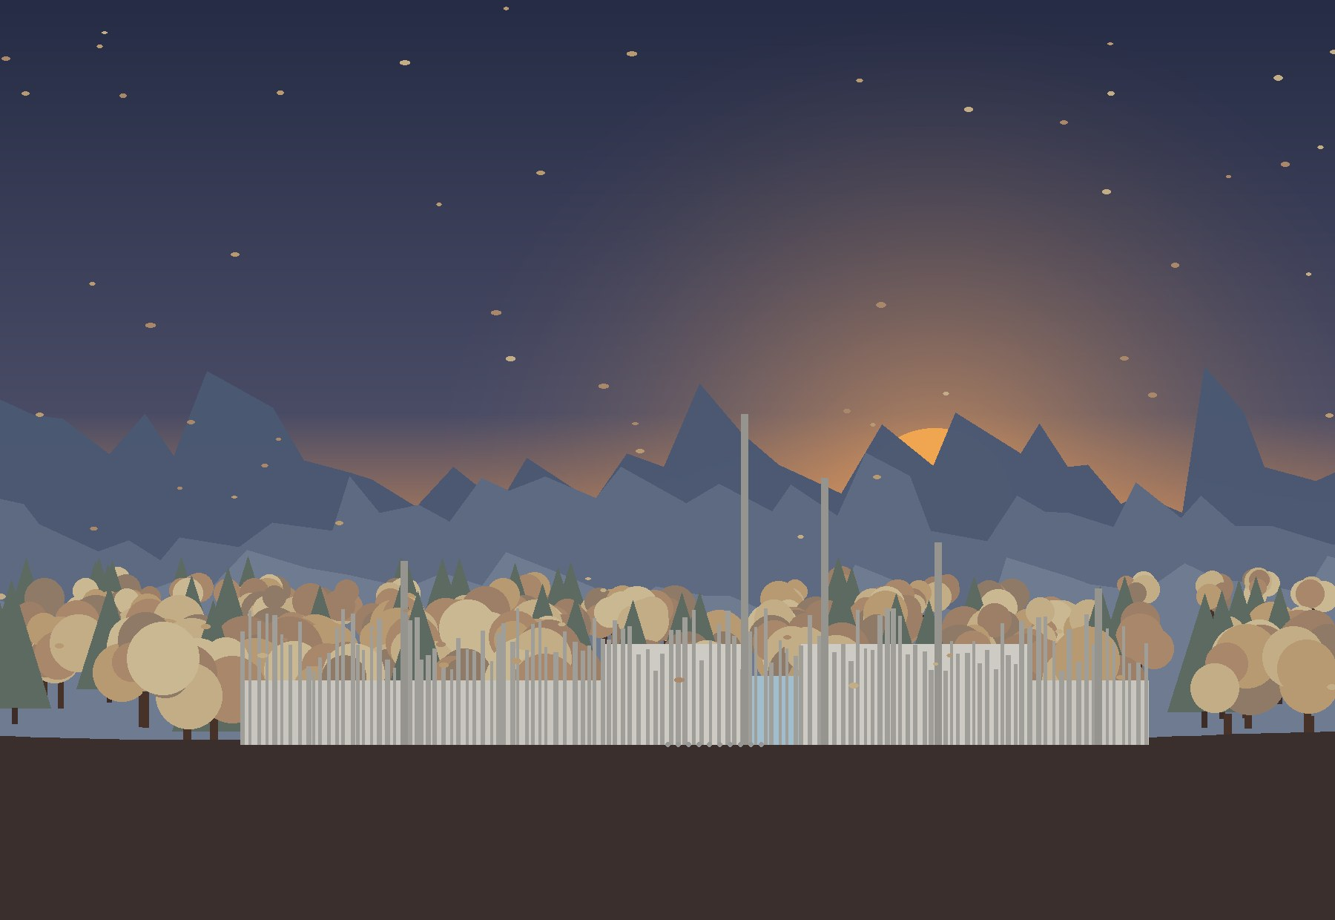
Section 3 answers the question “how?”: it turns the analysis of the site into a concept – connections and boundaries, sun and wind, alignment and six placements, the search for the form in my sketches, the sound track and the roofs to walk on, the virtual Lego, the elements, the volume study with the neighbouring houses and the drawings of the centre.

3.1. Concept analyses
Before drawing the building I looked at the site once more – this time not as a list of data, but as the material of the concept. The three analyses describe the place as it is, on satellite plans with north up; only at the end of 3.1.3 the chosen placement appears, so that the step from the analysis to the idea is visible. All three plots are shown: 688 (the music centre), 278 / …786 (its riverside park) and 705 (Autumn Dream).

3.1.1. Connections and boundaries: pluses and minuses
Everything around the site is either a plus – something to keep, open and use – or a minus – something to hide from, soften or keep away from. I drew them on two satellite plans with north up: the arrows show the directions of the views, sounds and routes. Plot 688 of the centre (lilac) and site 278 of the riverside park (ochre) are analysed together, because they will work as one place; the numbers on the plans are the same as in the table.
Pluses of the site: views, sun, the sound of the rivers, ways to come on foot and by car (1–11).
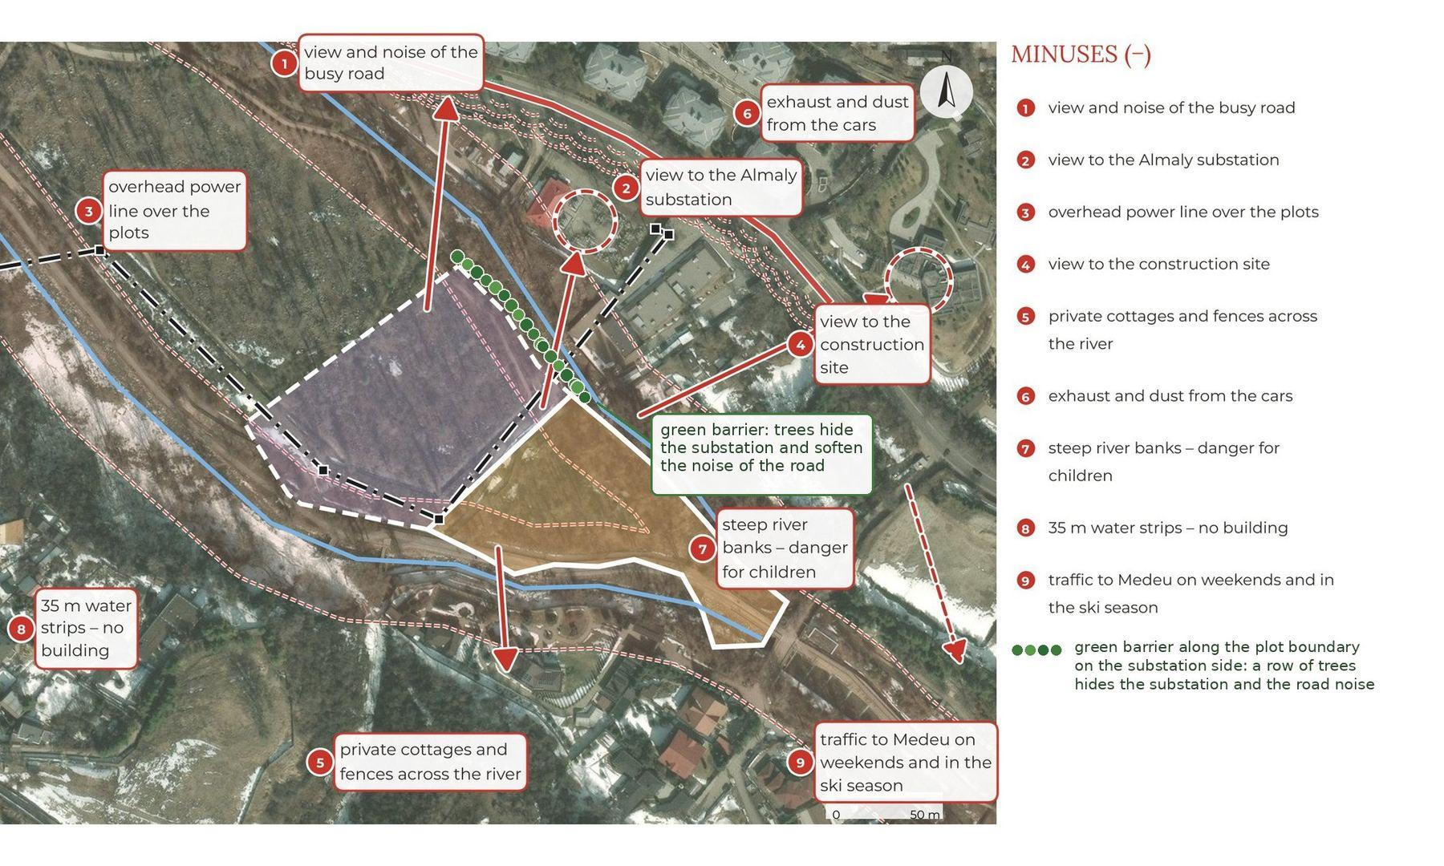
Minuses of the site: the busy road, the substation, the power line, the construction site, the river banks and the water strips (1–9). Green dots – the barrier of trees along the plot boundary on the substation side.
Kind | Connections (+) | Boundaries (−)
Visual | 1 the peaks of the Ile-Alatau · 2 up the valley towards Medeu · 3 the Esentai river · 4 the Kishi Almaty river · 5 the forest park and the old poplars | 2 the Almaly substation · 4 the construction site · 5 private cottages and fences across the river
Sound and air | 7 murmur of the rivers · 11 smell of resin, leaves and wet stones | 1 view and noise of the busy road · 6 exhaust and dust from the cars · 9 traffic to Medeu on weekends and in the ski season
Movement | 8 terrenkur – children come on foot · 9 bus stops 210 m and 280 m · 10 bridge – car access from the city | 7 steep river banks – danger for children
Climate | 6 sun from the south all day | —
Rules | — | 3 overhead power line over the plots · 8 35 m water strips – no building
Answer | the centre opens to the pluses: the amphitheatre to the south, the roofs to the peaks | a green barrier – a row of trees along the boundary on the substation side hides the substation and softens the noise of the road
Pluses and minuses of the site (the numbers refer to the two plans).

The power line
The strongest minus is not on the ground but in the air: the 110 kV line runs from the substation across plot 688 and site 278, with a protection zone of 20 m on each side and a service track. Moving it underground is a project of the grid operator, so in my concept the line stays and the centre keeps out of its zone: the building stands 22 m from the axis of the line (2 m outside the zone), the amphitheatre 1.4 m outside it, and the substation is 51 m away. Along the boundary on the substation side I plant a green barrier – a row of trees and conifers that hides the substation and softens the noise of the road.
CONCLUSION
The site is open to the south – the sun, the forest, the Esentai and the peaks – and closed to the north-east, where the road, the substation and the line are. So the centre turns its public side – the amphitheatre, the café and the roofs – to the south and the south-east, keeps its back to the line and the substation and hides them behind a green barrier of trees. Children come from the terrenkur and the footbridge, cars only over the new bridge.

3.1.2. Simple climate analysis: sun and wind
The sun path was calculated for the site (43.19° N, 76.99° E, local time UTC+5) for the key days – the summer and the winter solstice and the equinox – and for 22 February, when the norm starts counting the hours of sun (2.3). The arcs are drawn on the plan with north up; the small numbers are the hours of the day. The shadows are checked for the highest part of the centre, the 3-storey blocks (11.7 m).
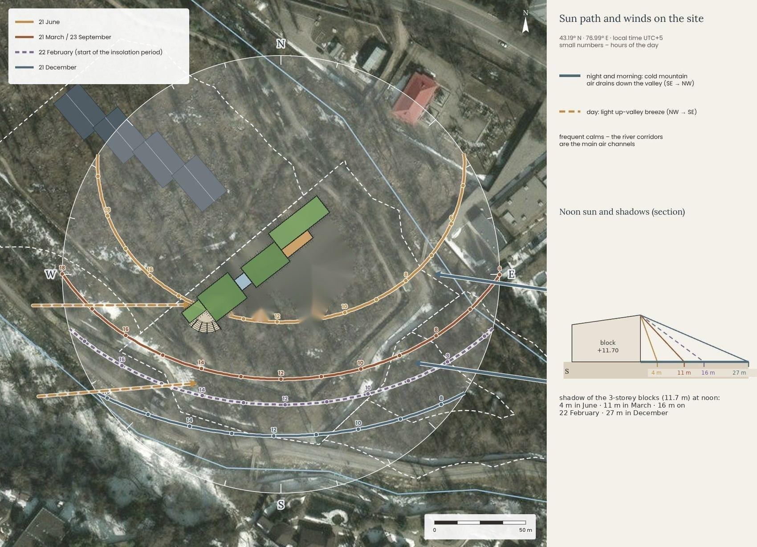
Sun path on 21 June, 21 March / 23 September, 22 February and 21 December with sunrise and sunset, the winds of the valley and the noon shadows of the 3-storey blocks.
Day | Sunrise · azimuth | Sunset · azimuth | Day length | Noon altitude | Shadow of the 11.7 m blocks
21 June | 4:12 · 56° | 19:35 · 304° | 15 h 23 min | 70.3° | 4 m
21 March / 23 Sept. | 5:57 · 90° | 18:04 · 271° | 12 h 07 min | 46.7° | 11 m
22 February | 6:42 · 104° | 17:30 · 256° | 10 h 48 min | 36.3° | 16 m
21 December | 7:21 · 122° | 16:19 · 238° | 8 h 58 min | 23.4° | 27 m
Sunrise, sunset and the noon sun on the key days (NOAA solar position algorithm).
In summer the sun rises in the north-east and sets in the north-west, so even the north-west façade towards Autumn Dream gets almost six hours of morning and evening sun; in winter it gets none. The south-east side – the café terrace, the lawn and the roof garden – gets 7.6–8.7 hours of sun in every season. In winter the noon sun stands only 23° above the horizon, and the 3-storey blocks throw a 27 m shadow to the north – onto the forest walk, not onto the windows of Autumn Dream.
Façade · direction | 21 June | 21 March | 22 Feb. | 21 Dec.
North-west – the forest walk and Autumn Dream · 322° | 5.7 h | 2.8 h | 1.6 h | 0.0 h
South-east – the café, the lawn and the forest · 142° | 8.7 h | 8.2 h | 7.9 h | 7.6 h
North-east – the side entrance and the square · 52° | 6.1 h | 3.6 h | 2.5 h | 1.0 h
South-west – the artists’ block and the stage · 232° | 8.3 h | 7.4 h | 7.1 h | 6.6 h
Hours of direct sun on the main façades of the centre (without trees and mountains).
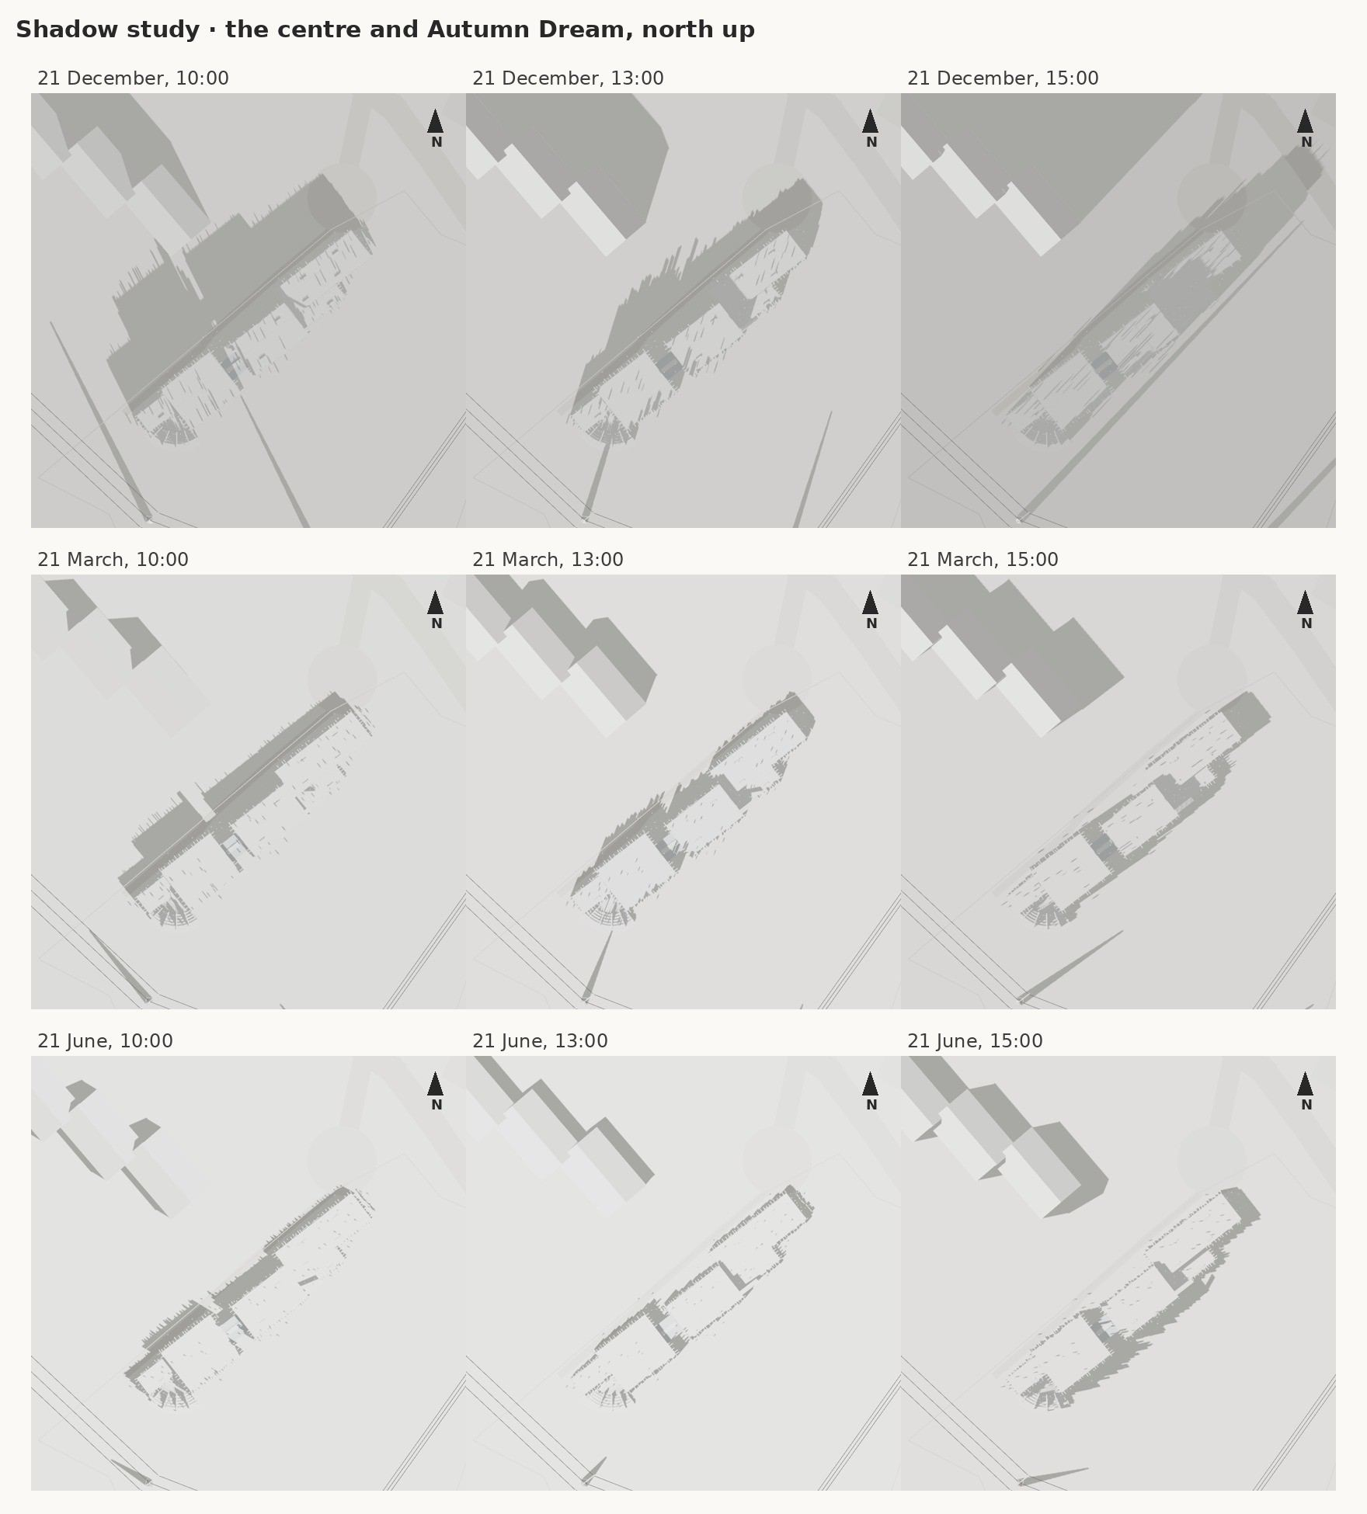
Shadow study of the 3D model: the centre and Autumn Dream at 10:00, 13:00 and 15:00 on 21 December, 21 March and 21 June (north up). Even in December the shadow of the centre does not reach the windows of the housing.
The wind of the valley is a mountain-valley breeze. At night and in the morning cold air from the mountains slides down the valley from the south-east to the north-west; in the afternoon a light breeze goes up towards the peaks; calms are frequent, and the rivers are the main channels of air. So the south-east is the cold side in the morning: the main entrance is on the sheltered north-west side in the glass cube, and the stage lies low at the corner of the hall.
The amphitheatre opens to the south (187°): the audience looks north-east to the stage at the corner of the hall and, behind it, at the fins and the green roofs. At midday the sun is behind the audience and the stage is lit; at evening concerts the sun sets behind the building (304° in June), so nobody is blinded, and the hall and the artists’ block shade the stage.
CONCLUSION
The south and the south-east are the sunny sides in every season: the amphitheatre, the café terrace and the roof garden face them, and the fins shade the windows from the low sun. The north-west façade towards Autumn Dream gets little sun – it holds the stairs and the practice rooms that need even light. The cold morning wind comes from the south-east, so the main entrance is on the sheltered north-west side, in the glass cube between the two sections.

3.1.3. Positive and negative space, alignment
Alignment means finding the lines that the place already draws – fences, river banks, the street, the lines of view. A building that follows them looks as if it belongs here. I traced all such lines and chose three: the fence between plots 688 and 705 for the long side of the centre, the edges of the 110 kV zone and of the river strip for its two ends, and the line of view to the peaks – due south – for the axis of the amphitheatre.
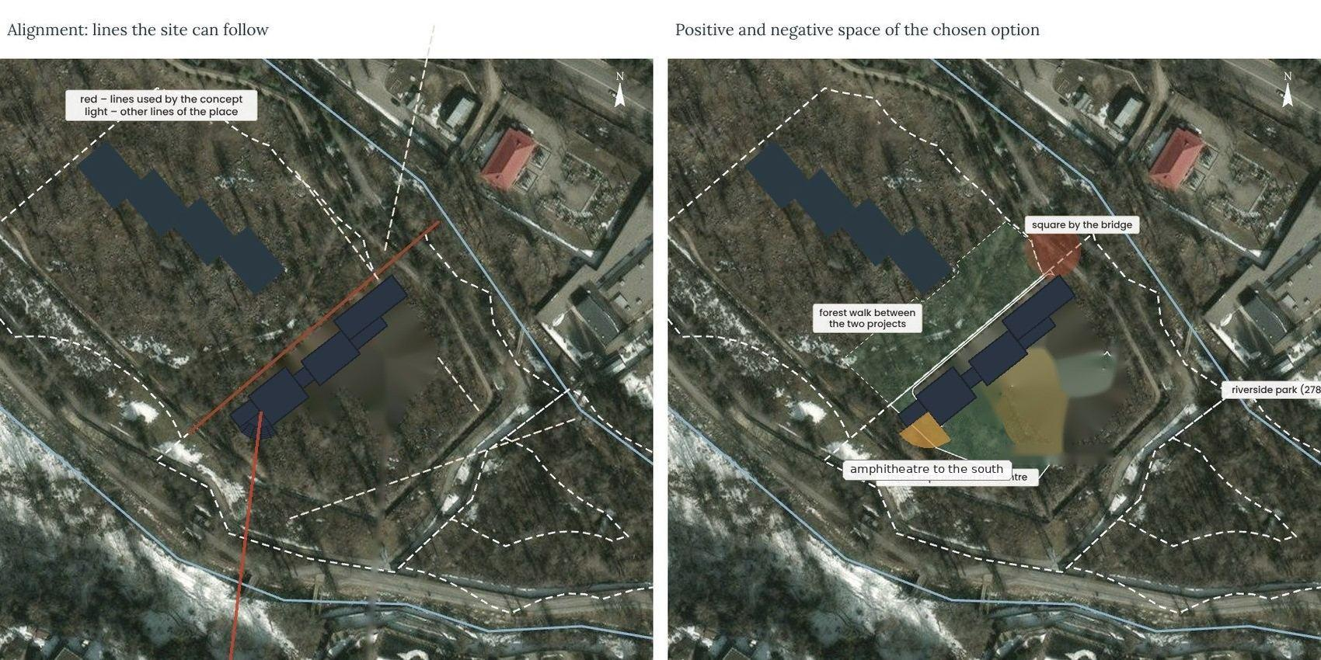
Left: alignment lines (red – used in the concept, light – other lines of the place). Right: positive and negative space of the chosen placement with the final form.
The negative space is not what is left over – it is designed as carefully as the building: the forest kept between the centre and Autumn Dream (32 m), the forest walk along the north-west façade, the lawn and the amphitheatre to the south, the square by the new bridge and the riverside park on site 278.

Six placements
To find the right place I tried six placements of the same programme on the satellite plan – about 1,300 m² of footprint with a hall and an outdoor stage – and checked each against the pluses and minuses, the sun and the alignment lines. The sixth placement is shown with the final form of the centre.
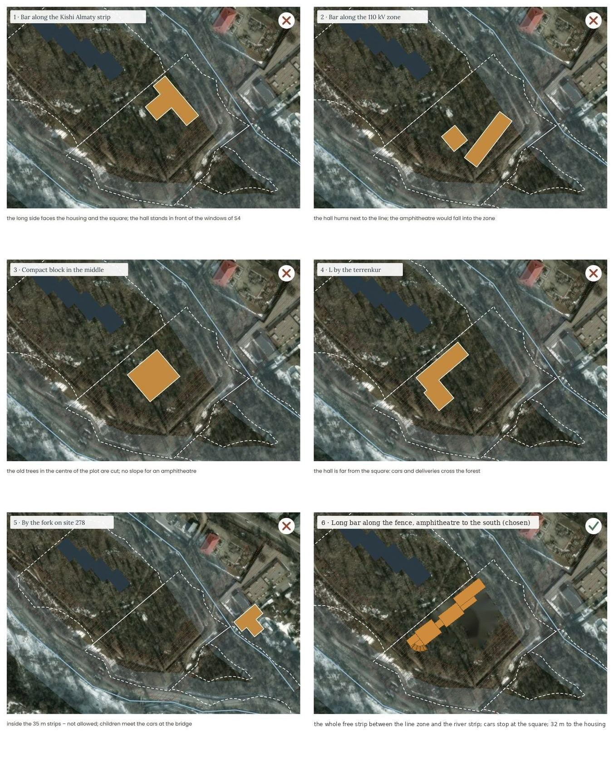
Six placements of the centre (ochre) next to Autumn Dream (dark): five are rejected, the sixth is chosen and shown with the final form.
Placement | Why
1 · Bar along the Kishi Almaty strip | the long side faces the housing and the square; the hall stands in front of the windows of section S4
2 · Bar along the 110 kV zone | the hall hums next to the line; the amphitheatre would fall into the zone
3 · Compact block in the middle | the old trees in the centre of the plot are cut; no slope for an amphitheatre
4 · L by the terrenkur | the hall is far from the square: cars and deliveries cross the forest
5 · By the fork on site 278 | inside the 35 m strips – not allowed; children meet the cars at the bridge
6 · Long bar along the fence, amphitheatre to the south | chosen: the building fills the free strip between the 110 kV zone and the river strip; cars stop at the square, the amphitheatre opens to the forest, 32 m to the housing
CONCLUSION
Chosen: placement 6 – a long, low centre along the fence of plot 705, from the square by the new bridge to the edge of the 110 kV zone, with the amphitheatre at its south-west end opening to the south. It stays outside the water strips and 2 m outside the zone of the line, and the forest between the centre and Autumn Dream stays as one body.

3.2. Narrative
The narrative is the story that holds the project together. It grows out of the genius loci of Section 1 – the calm of the “autumn dream” and the energy of the river that never sleeps – and out of my own first drawings of the centre.

3.2.1. Dream String
In Section 1 I wrote that this place is an autumn dream – soft, slow and golden – and that only the river never sleeps. A dream needs something that makes it sound: a string. When I imagined the centre, I saw a piano standing in a misty forest at sunset, and its strings rising out of the ground like the mountains of the Ile-Alatau – “imitation of mountains?” I wrote on my first sketch.
So the music centre is Dream String: a long building in the forest whose façades are a sound track. Fins of warm grey fibre-concrete stand along both long sides like the bars of a recorded melody – short and tall, close and far apart – and rise high above the roofs where the music is loudest – the dominant fin on the right of the glass entrance to +25.00, the second one further right over the hall to +21.50, the other main fins to +15–19 m: at the glass entrance and over the hall. Behind them the building steps in blocks of one, two and three storeys, and every roof can be walked on. At the south-west end the fins step out into the forest as tall panel walls between the rows of an amphitheatre, with a stage at the corner of the hall.
The story gives the rules for the form: one long building along the fence instead of separate boxes; two sections – the learning section and the hall section – joined by a glass cube that is the entrance; the fins as the only vertical element; roofs that are public places; the amphitheatre as the place where the building opens to the forest; and the colours of the misty valley with the autumn accents.
Two neighbours, one valley. Autumn Dream and Dream String are two separate projects on neighbouring plots by the fork of the Kishi Almaty. The house is the calm of the valley; the music centre is its voice. They share one car entry over the new bridge and one small square, and between them the forest stays as a layer of silence about 32 m wide: the children of the house walk to music without crossing a road, and the amphitheatre turns away from the bedrooms, towards the forest.
My first sketch of the idea (October 2026): strings like mountains, the main entrance, the roof to walk on and the stage with the amphitheatre (processed scan) – the beginning of the search.

3.2.2. The search for the form: sketches, five variants and the final sketches
I looked for the form first by hand. The sketches below are my primary sketches from October 2026; I only cleaned the scans – straightened the pages and evened the paper. Each variant has a short note in Russian: what I wanted to try. Then I worked in computer graphics: I built all five variants in 3D at one scale, on the chosen placement, to compare them honestly.
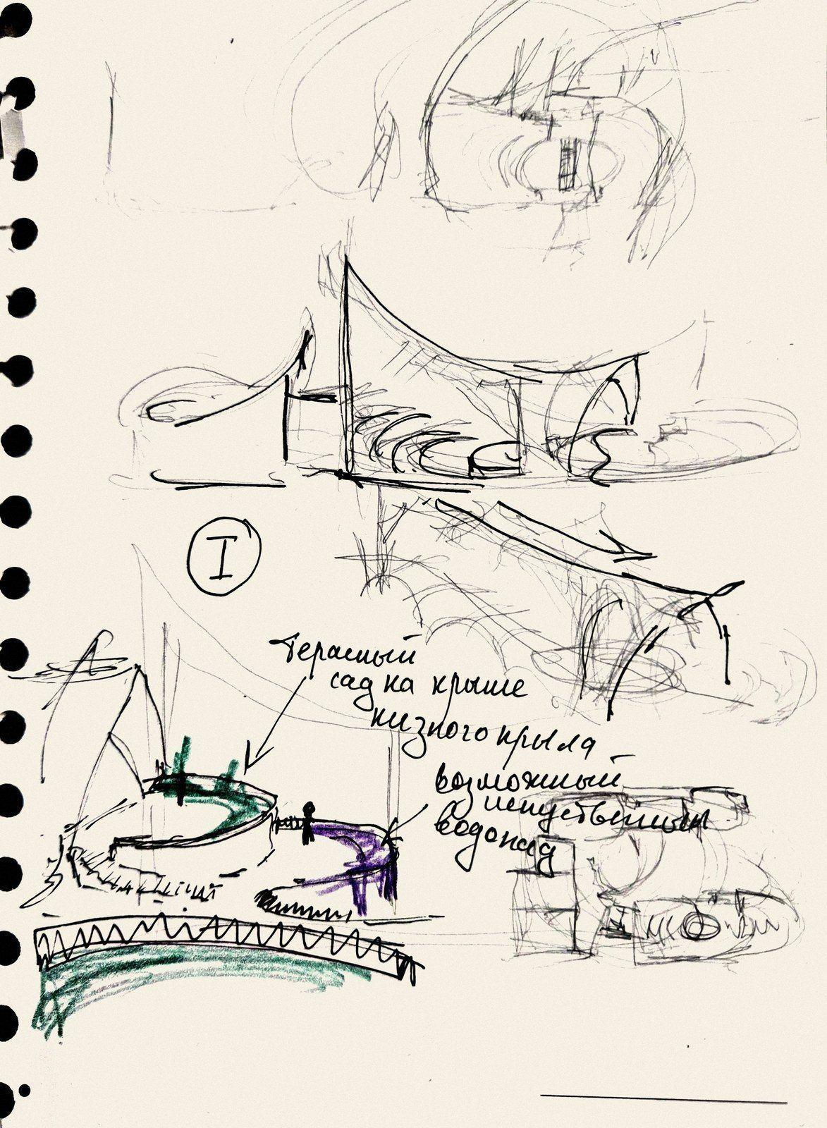
Variant I: the exploitable roof, the stage and the amphitheatre; a roof garden on the low wing and the rows going down from the roof.
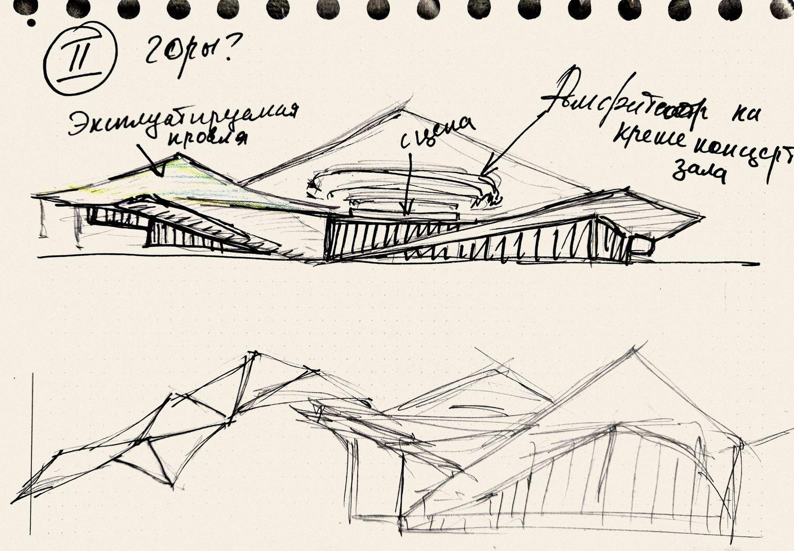
Variant II, “mountains?”: sharp peaks over the hall, the exploitable roof, the stage and the amphitheatre on the roof of the concert hall.
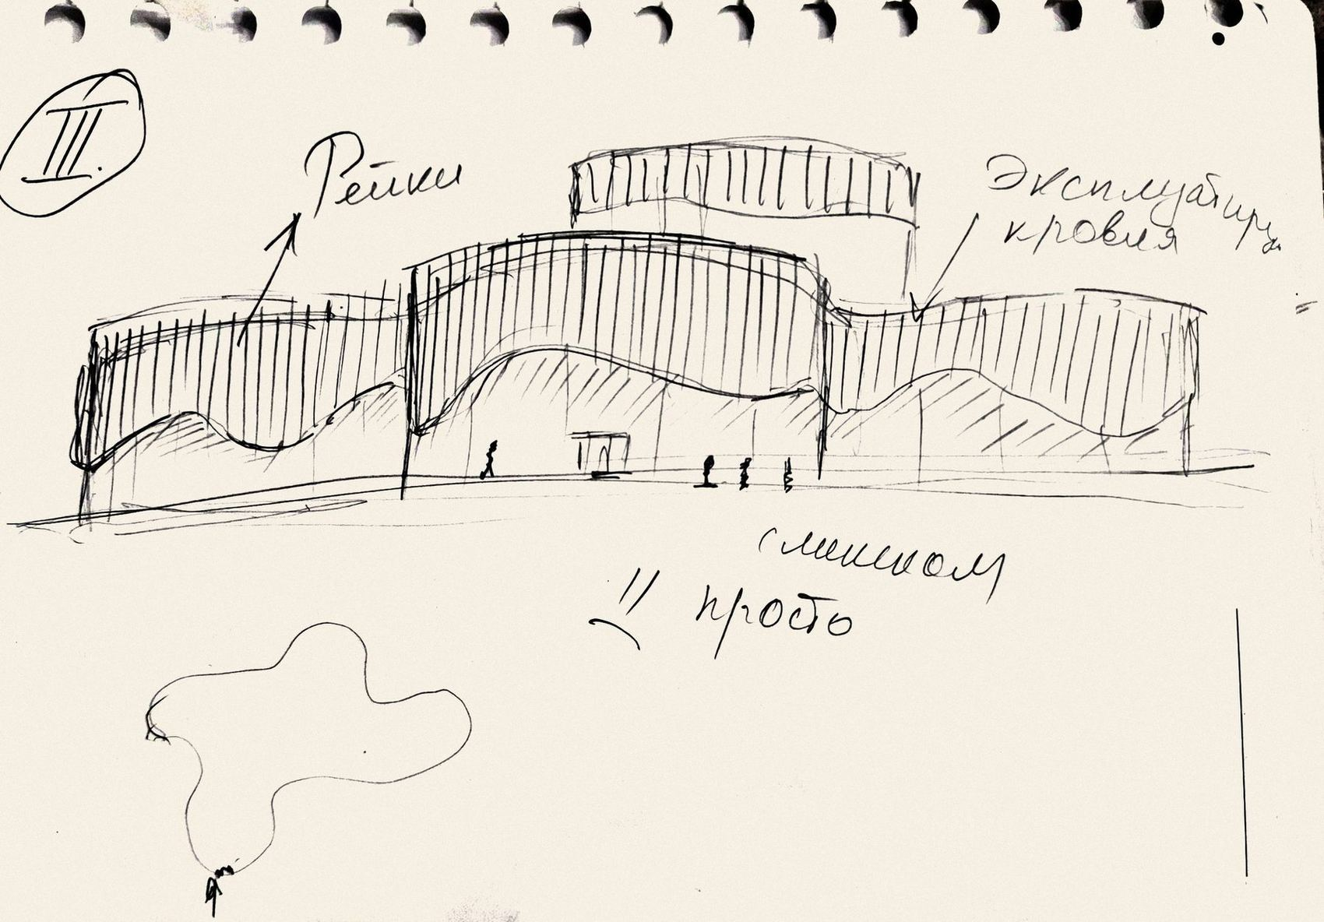
Variant III: vertical slats along a wavy edge and the exploitable roof – my note: “too simple”.
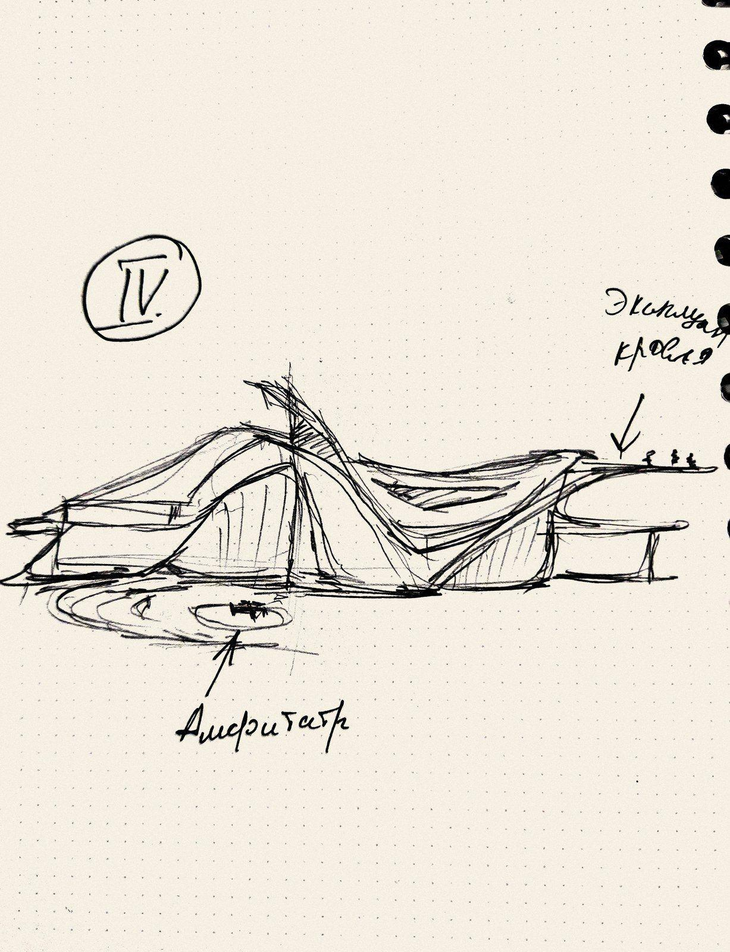
Variant IV: a wave of the exploitable roof with the amphitheatre (left). Variant V, “Leaf!!”: one thin shell like an autumn leaf (right).
The five variants translated into 3D on the chosen placement, at one scale (my computer model): I strings and a roof to walk on, II mountains, III slats and waves, IV wave, V leaf.
Variant | My note on the sketch | Roof to walk on | Roof → amphitheatre | Room for the programme | Verdict
I · strings and a roof to walk on | imitation of mountains? · main entrance · exploitable roof · stage, amphitheatre | along the whole building | yes – the terrace flows into the rows | yes – two simple wings | kept: roofs and amphitheatre
II · mountains | mountains? · exploitable roof · amphitheatre on the roof of the concert hall | only small parts | the rows sit on the hall | yes | the peaks argue with the real mountains
III · slats and waves | slats · exploitable roof · too simple | the green top | no | yes | a good façade, but the roof and the stage are not linked
IV · wave | exploitable roof · amphitheatre | yes, a wave | no – the amphitheatre stands apart on the ground | partly | the descent into the amphitheatre is lost
V · leaf | Leaf!! | no | — | no – the edges are too low | the most poetic: it becomes the canopy over the stage
Comparison of the five variants.

Final sketches: the sound track
My last sketches came from a recording of music. On a screen a song is a row of vertical bars – a sound track: short and tall, dense and sparse. I drew this track along the plan of the centre and it became its façade: every bar is a fin, and the building stands behind the fins like an instrument behind its sound. The blocks follow the programme and get one, two or three storeys; on my plan of the roof heights blocks of one colour have the same height.
The centre has two sections. Section I holds the learning: the long two-storey block with the practice rooms, the one-storey café and the three-storey block with the administration, the group rooms and the movement hall. Section II is the transformable hall, three storeys high, with the block of the artists and the staff. Between them stands a glass cube – the main entrance and the foyer; next to its door volumes shaped like the fins – the “sound bars” – mark the entrance. In the corner between the hall and the artists’ block the amphitheatre opens to the forest: a stage, four sectors of seats with two through passages and tall panel walls that continue the fins. The red arrows on my plan are the entrances and fire exits; the drawings in 3.5 keep them.
My sketch of the final idea: the sound wave becomes the fins; the plan and the perspective of the centre (October 2026).
My plans: the functions and the entrances (red arrows), the plan of the roof heights (I and II – 3 storeys, the rest 2 and 1 storeys) and the entrance – a glass cube between the two sections.
My perspective of the amphitheatre: the rows of seats, the panel walls, the fins with blue windows and yellow accents and the exploitable roof above.
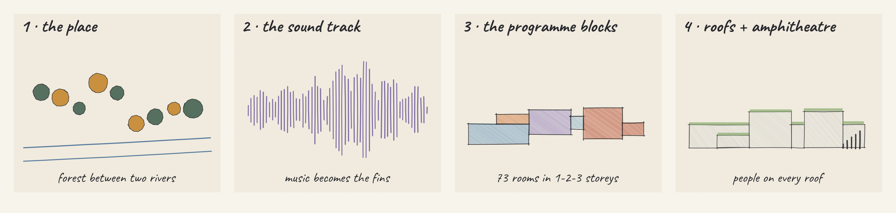
From the place to the form: the forest between two rivers → the sound track → the programme in blocks of 1–3 storeys → roofs to walk on and the amphitheatre.
CONCLUSION
Of all the versions I take the last one – the sound track. Variants I–V each left something: variant I – the roofs that people walk on and the amphitheatre, variant III – the vertical slats, variant V – the wish for one strong, light gesture. In the final sketches they came together: the sound wave became a row of tall grey fins that rise high above the roofs and give the building its volume, two sections are joined by a glass cube, the blocks have one, two and three storeys with roofs to walk on, and the amphitheatre sits at the corner of the hall. The plans, the model and the drawings in 3.4–3.5 are built on this last version.

3.2.3. Virtual Lego
The norms and the room programme of Section 2.4 turn into blocks of fixed size – a “virtual Lego” at one scale: 73 rooms and the garage. The blocks have to fit the chosen form, not the other way round.
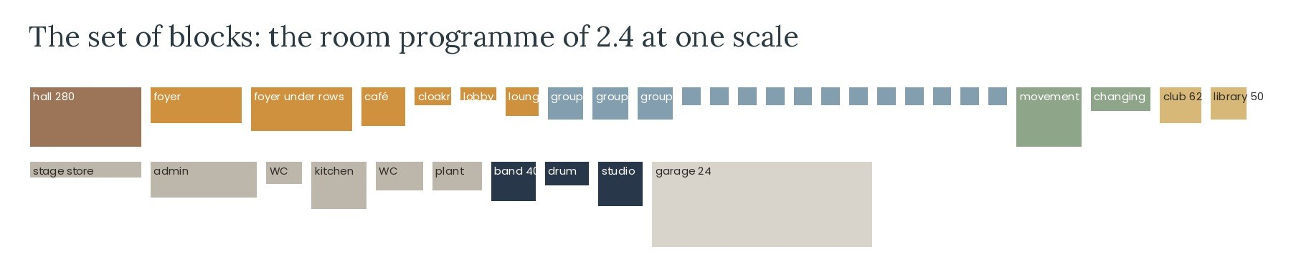
The set of blocks: the programme of 2.4 at one scale.
I assembled the blocks inside the new form, keeping the order of the functional diagram (2.5, variant 1). On the ground floor (±0.00) the glass cube is the entrance lobby; the foyer with the children’s gallery runs from it through the three-storey block, with the cloakroom, the toilets, the reception and the security room; the club and the library open from the foyer next to the café, so parents can wait in the café. The café kitchen works in one line from the delivery door, and the administration sits at the north-east end with its own staff entrance from the square. The transformable hall fills Section II with its chair store and backstage. On the first floor (+3.90) twelve practice rooms line the corridor of the long block, and the three group rooms, the waiting lounge and the instrument store are in the three-storey block; on the second floor (+7.50) the movement hall opens onto the roof garden. In the lower level (−3.60) the garage for 24 cars lies under Section I, and the loud rooms and the plant room under the hall.
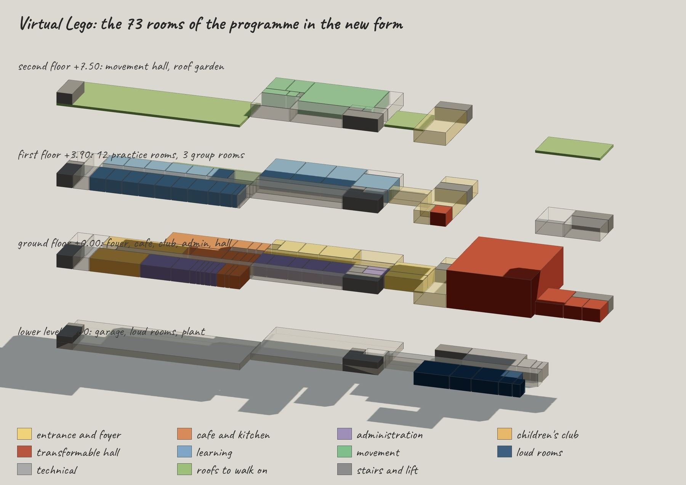
Virtual Lego: the 73 rooms assembled in the new form – second floor +7.50, first floor +3.90, ground floor ±0.00 and lower level −3.60, pulled apart.
All 73 rooms fit with the areas of the programme (2.4). The building is larger than the bare programme – about 2,650 m² above ground and 320 m² of rooms in the lower level instead of 2,076 m² – because the glass cube is two storeys high, every stair goes up to a roof and the corridors widen into lounges and study corners. This is the price of the roofs that people walk on.
CONCLUSION
The story gives the character of the centre: a sound track of fins, two sections joined by a glass cube and roofs that people walk on, down to an amphitheatre in the forest. The virtual Lego proves that the 73 rooms fit into the blocks of my drawings without changing their form.

3.3. Inspiration elements

3.3.1. Elements taken from the analogues: E1–E5
The elements of my concept come from the projects I chose as examples (1.3.6 and 2.2). For each element I show the photo of the project that inspired me next to the same element in my 3D model, and say what exactly I took and where it is in Dream String.
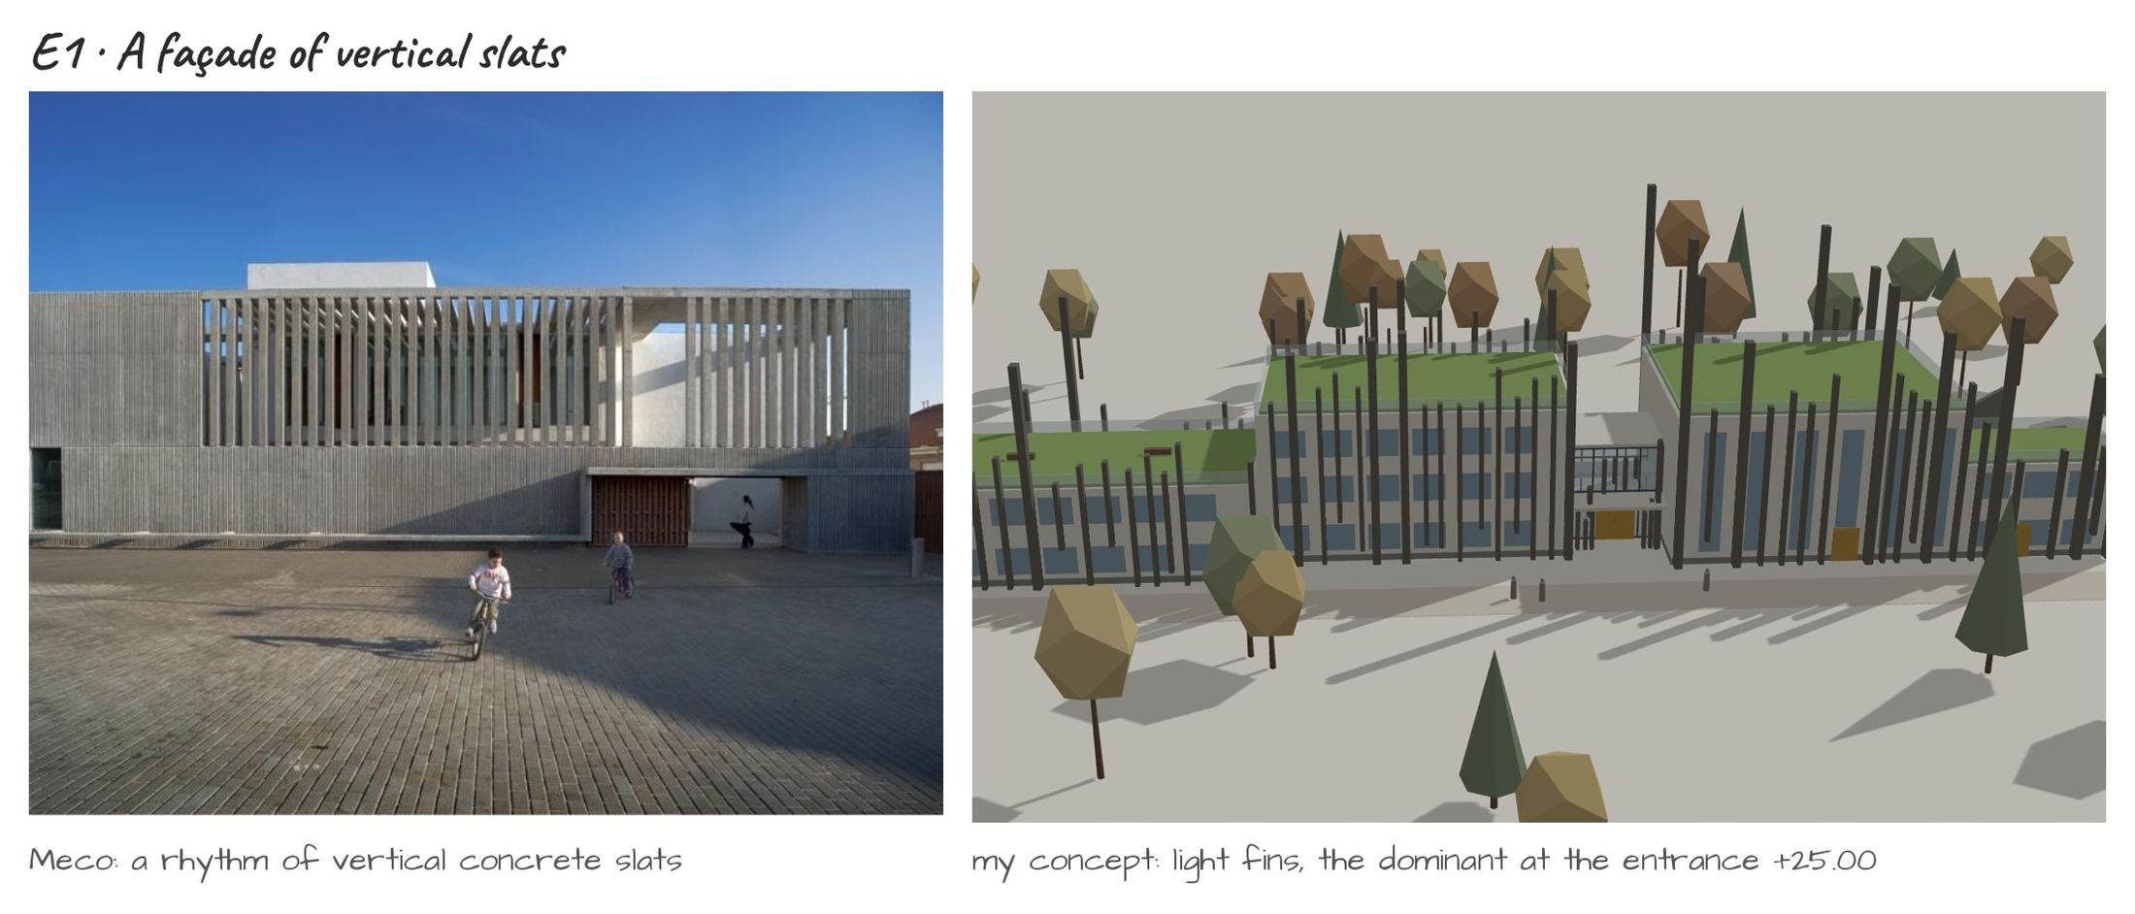
E1 · A façade of vertical slats. Cultural Centre and Music School, Meco (2.2.3): the façade is a rhythm of vertical concrete slats that filters the light. I take the rhythm of one vertical element – in my concept it becomes the grey fins of the sound track, which rise high above the roofs and give the building its volume.
E2 · Roofs that people walk on. COFCO Cultural & Health Center, Shanghai (2.2.4): the green roof is a public park with paths and ramps. I take the exploitable roof – every roof of Dream String is a place: the roof garden +7.50, the café terrace +3.90, the terrace of the peaks +11.70.
E3 · A glass volume that shows the life inside. Ku.Be, Frederiksberg (2.2.6): a glazed volume lit from inside invites people in. I take the glass entrance – the glass cube between the learning section and the hall section is the main entrance and the foyer.
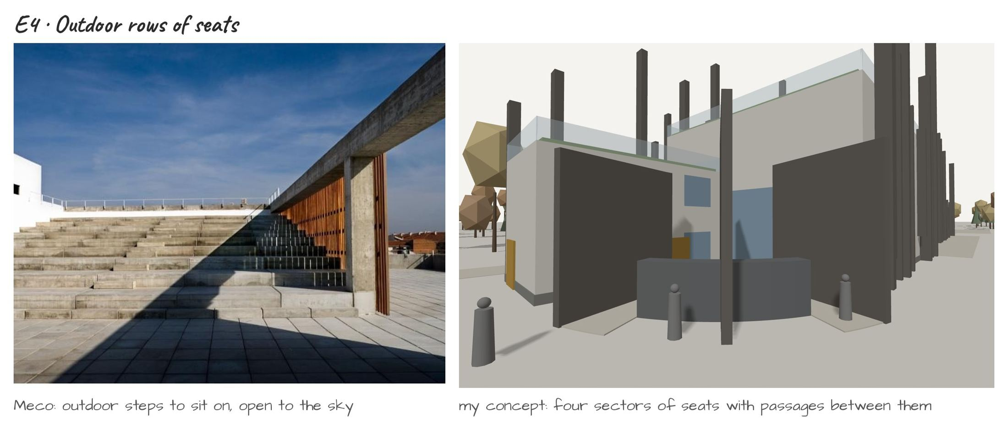
E4 · Outdoor rows of seats. Cultural Centre and Music School, Meco (2.2.3): wide outdoor steps to sit on, open to the sky. I take the outdoor rows – the amphitheatre at the corner of the hall has four sectors of seats with two through passages, open to the forest.
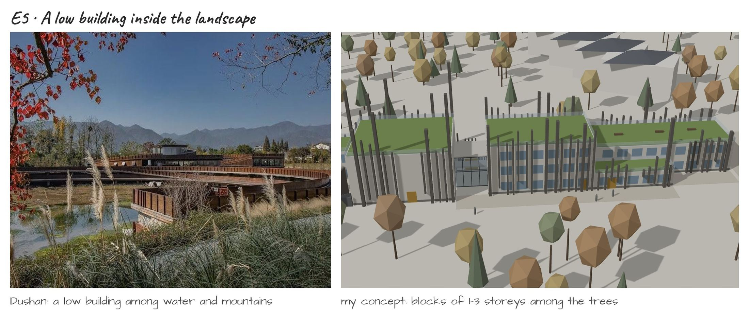
E5 · A low building inside the landscape. Dushan Leisure Center, Songyang (2.2.5): a long, low building among water and mountains, with light filtered by slats. I take the low, long line – blocks of one, two and three storeys that stay below the crowns of the trees, with only the fins rising above them.

3.3.2. What each project gives to the concept
The table sums up what each project gives to my concept and where it appears in Dream String; the plans and diagrams of the projects are in 2.2.
Element | Project | What I take → where it is in my concept
E1 · Vertical slats | Meco (2.2.3); Dushan (2.2.5) | a rhythm of one vertical element → the grey fins of the sound track
E2 · Exploitable roof | COFCO, Shanghai (2.2.4); Fuji Kindergarten (2.2.9) | roofs used every day → roof garden, café terrace, terrace of the peaks
E3 · Glass volume | Ku.Be (2.2.6); House of Music, Aalborg (2.2.10) | a glazed volume that shows the life inside → the glass cube between two sections
E4 · Outdoor seats | Meco (2.2.3); Moesgaard Museum (2.2.8) | outdoor steps to sit on → four sectors of seats with two through passages
E5 · Low building in nature | Dushan (2.2.5) | a long, low line in the landscape → blocks of 1–3 storeys below the tree crowns
CONCLUSION
Every element of Dream String has a source in the projects I studied: the rhythm of vertical slats, roofs used every day, a glass volume that shows the life inside, outdoor rows of seats and a low building inside the landscape. Together with my sketches they make the concept.

3.4. Volume study
The volume study checks the form in 3D from four angles – south-east, north-east, south-west and north-west – among the trees and the neighbouring buildings: the heights of the blocks, the tall grey fins, the roofs to walk on and the amphitheatre. A few grey figures show the scale.
Volume | Floors | Levels | Size
Learning block – club, library, kitchen; practice rooms | 2 + lower level | roof garden +7.50 | 33.6 × 11.4 m · 383 m²
Café | 1 | roof terrace +3.90 | 18.0 × 5.4 m · 97 m²
Three-storey block – administration, group rooms, movement hall | 3 + lower level | terrace of the peaks +11.70 | 23.4 × 13.8 m · 323 m²
Glass cube – entrance and foyer | 2 storeys high | cube roof +7.50 | 7.2 × 7.2 m · 52 m²
Hall (Section II) | 3 storeys high + lower level | meadow roof +11.70 | 21.6 × 17.4 m · 376 m²; hall ≈ 280 m², 150–200 seats
Artists’ block | 2 | terrace over the stage +7.50 | 12.0 × 7.2 m · 86 m²
Amphitheatre | — | stage ±0.00 (level with the hall), 5 rows up to +2.25 | four sectors of seats with two through passages · ≈ 90 seats + lawn
Fins – the sound track | — | main fins +10.5 – +25.00 (dominant), the lower fins just above the roofs, some hanging above the ground | warm grey fibre-concrete in one colour; 23 main fins 0.6 m wide, ≈ 90 lower fins 0.35 m
Total | 3 above ground + lower level | parapet +12.00 | footprint 1,317 m² · ≈ 2,650 m² above ground · garage ≈ 700 m²
Volumes of the centre (±0.00 = 1,155.00).
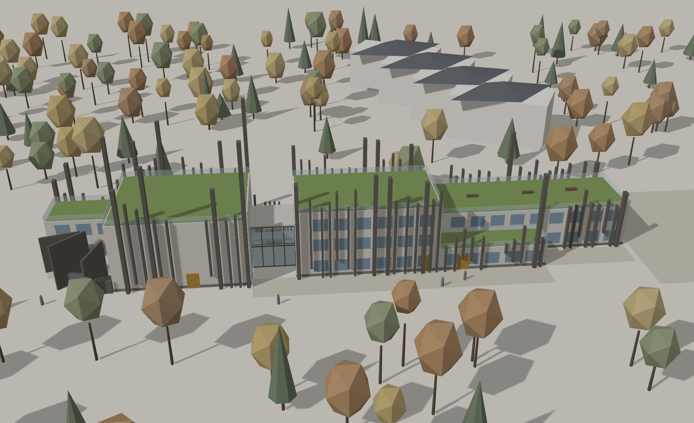
1 · The centre from the south-east: the café terrace, the glass cube and the grey fins rising high above the roofs.
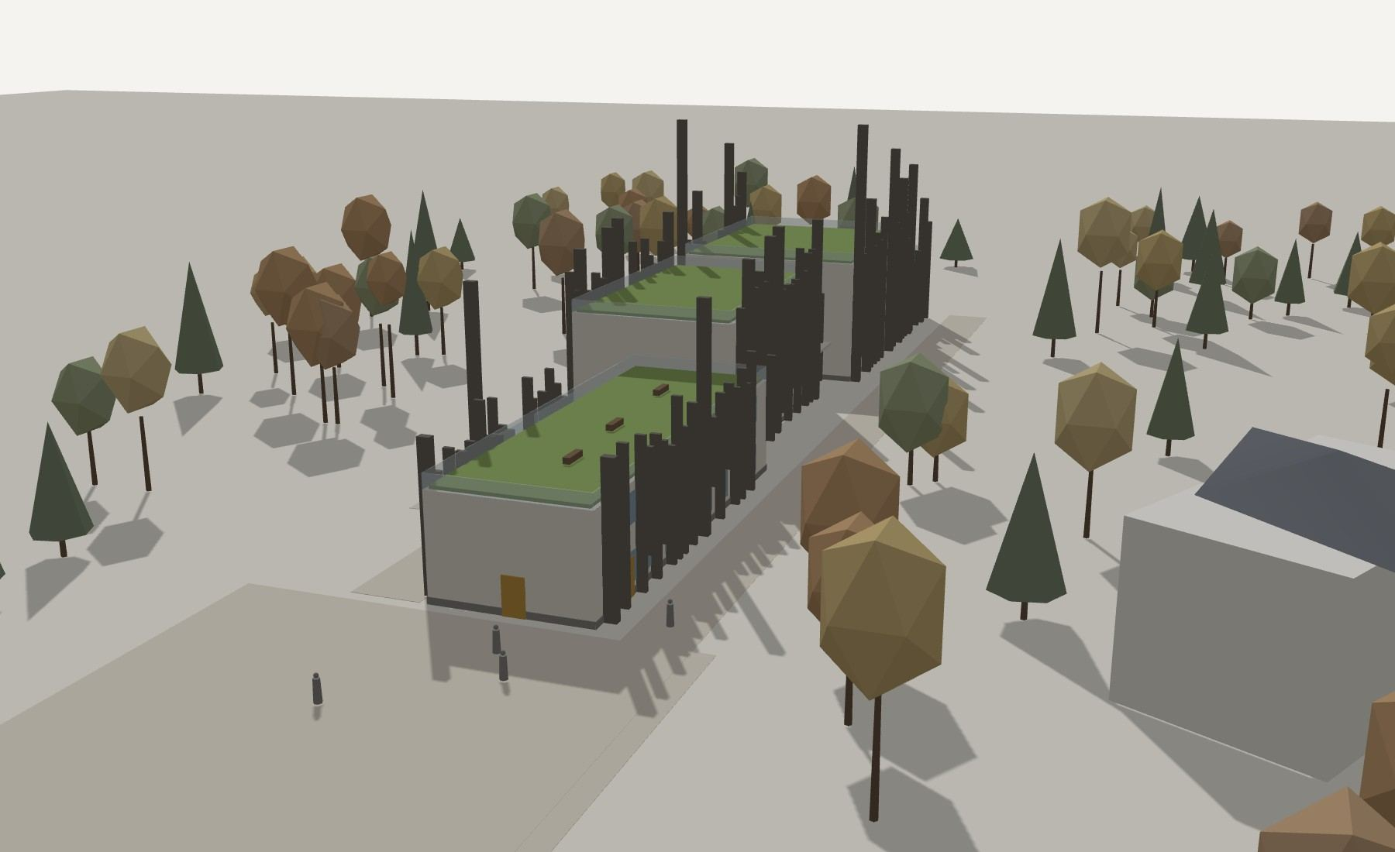
2 · The centre from the north-east, from the square: the side entrance and the learning block with the roof garden; Autumn Dream on the right.
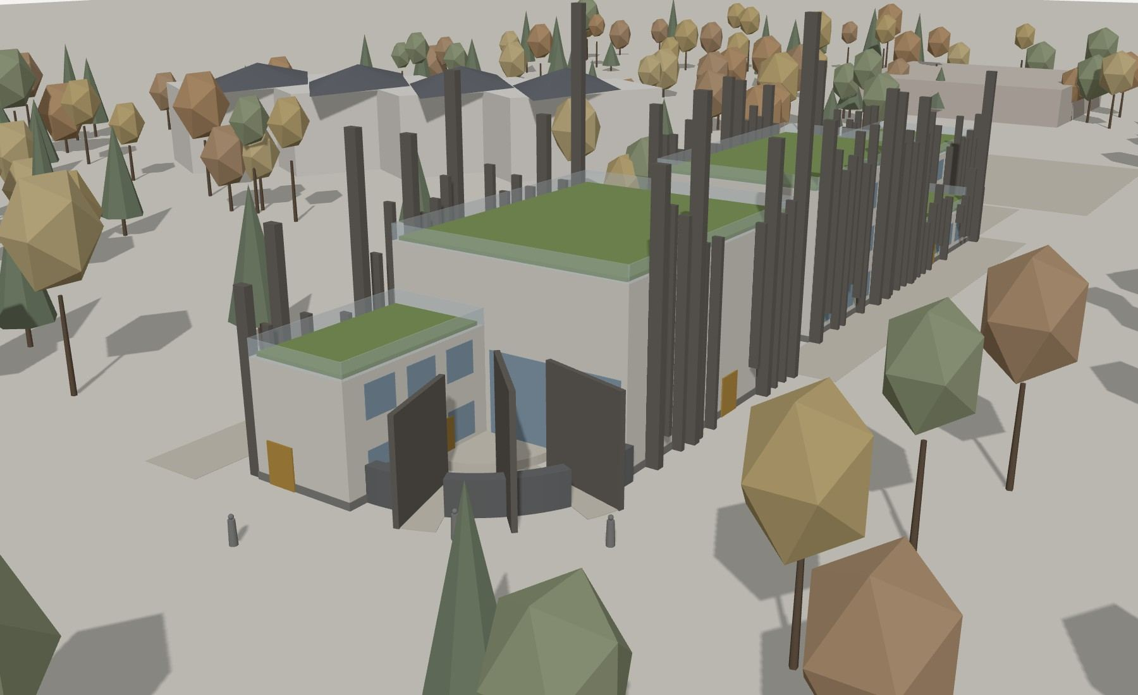
3 · The amphitheatre from the south-west: the stage at the corner of the hall, four sectors of seats, two through passages and the panel walls.
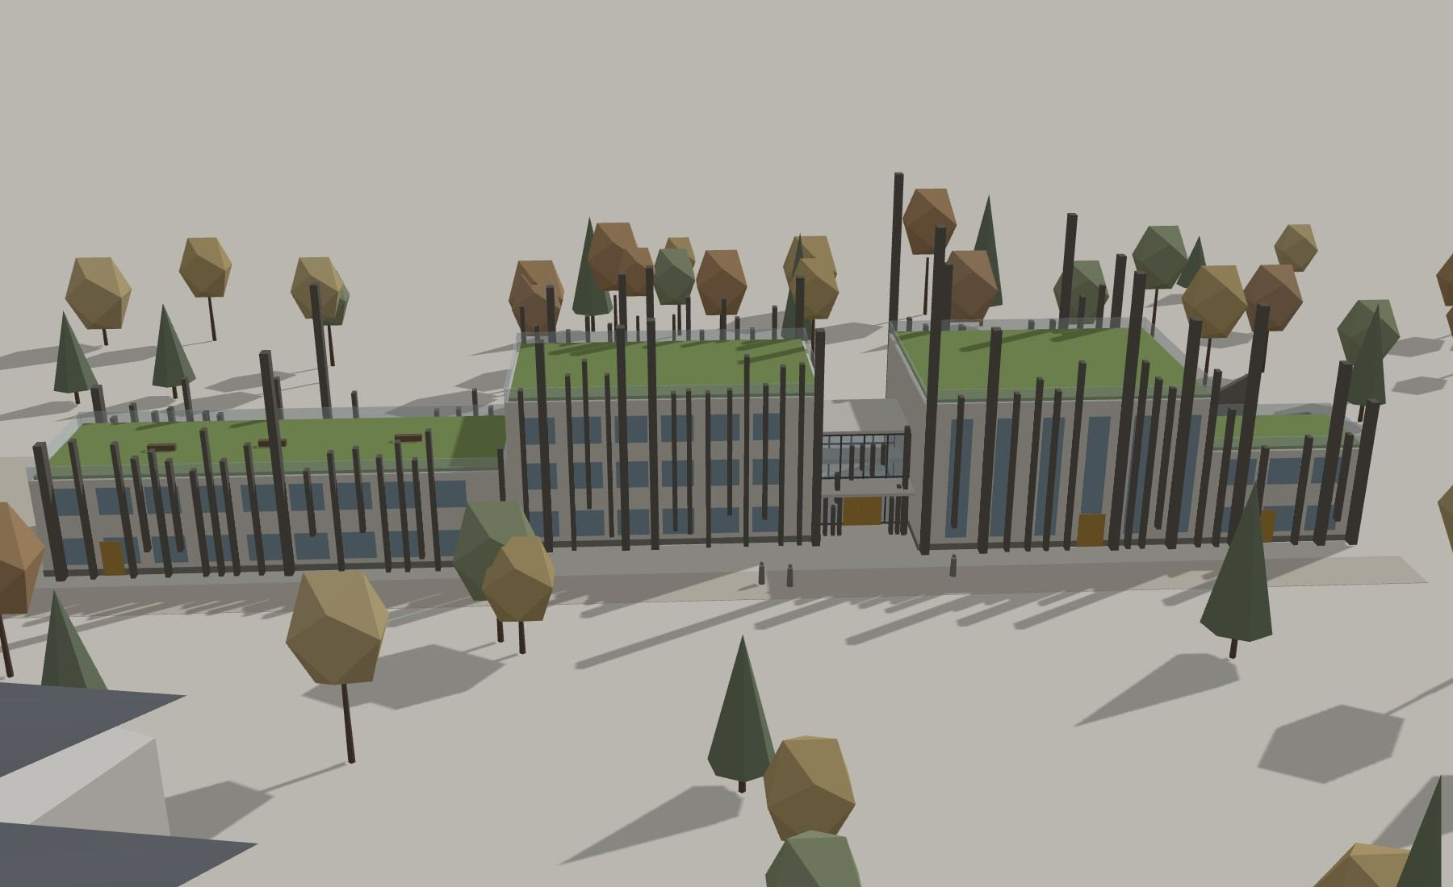
4 · The centre from the north-west, from the forest walk: the main entrance in the glass cube and the sound track of the fins over both sections.

The centre among the neighbouring houses
To show the scale, the model includes the buildings around: the four sections of Autumn Dream (three floors), the substation and the power line. The white model shows that the centre is a low, long line among the trees – its roofs stay below the crowns of the poplars, and the grey fins rise above the roofs and give it its silhouette, with the dominant fin at the entrance.
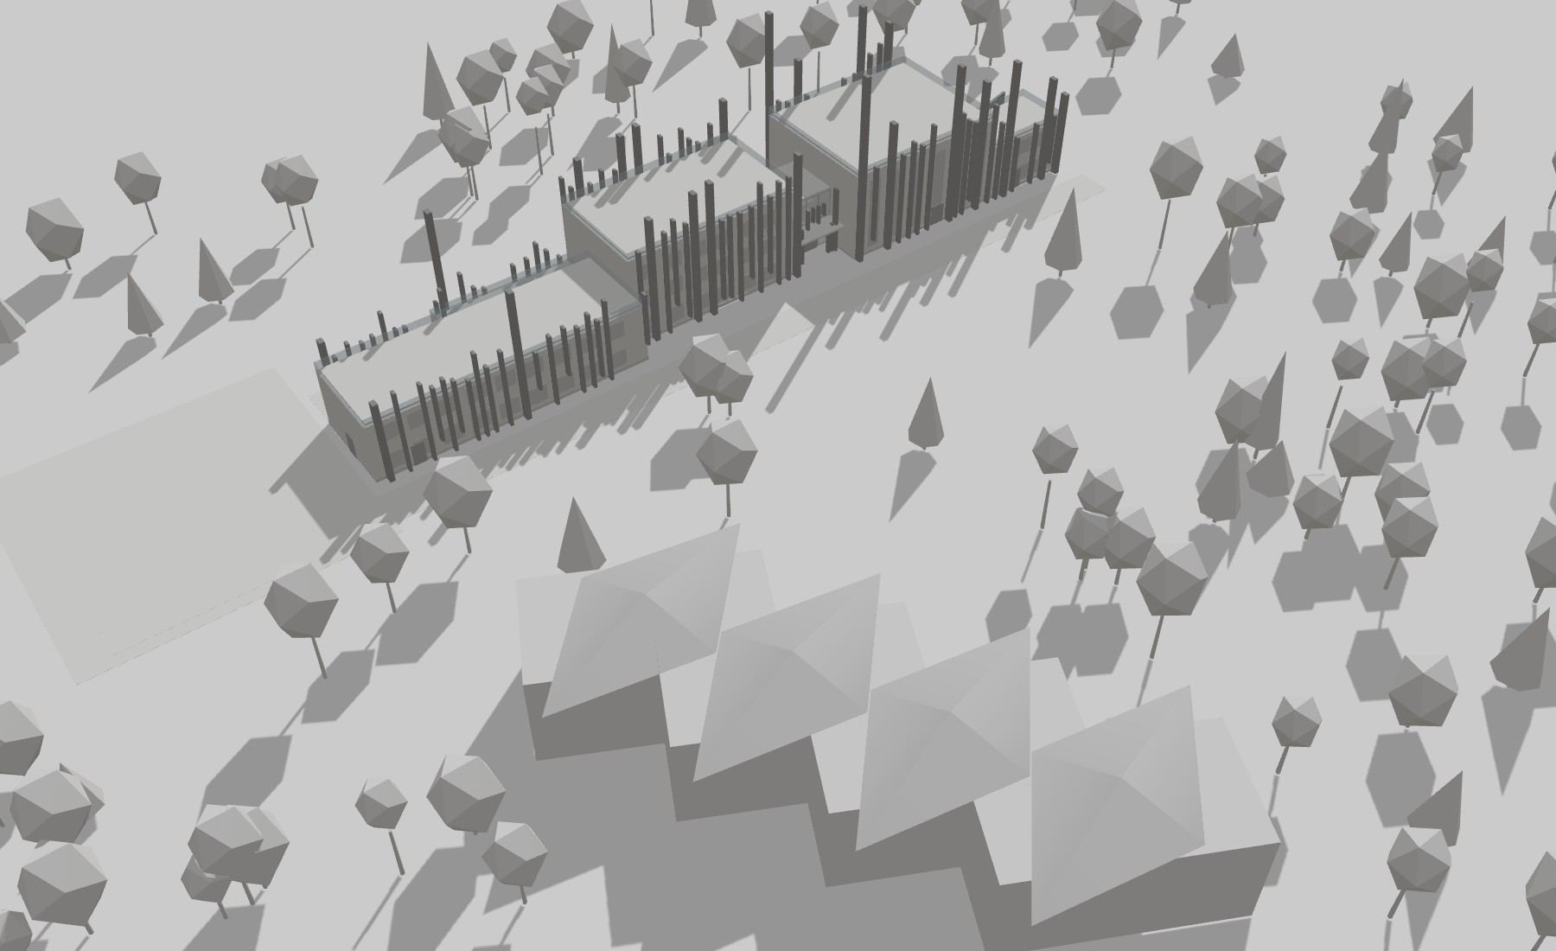
White model with the neighbouring buildings: Autumn Dream (plot 705), the substation and the 110 kV line.
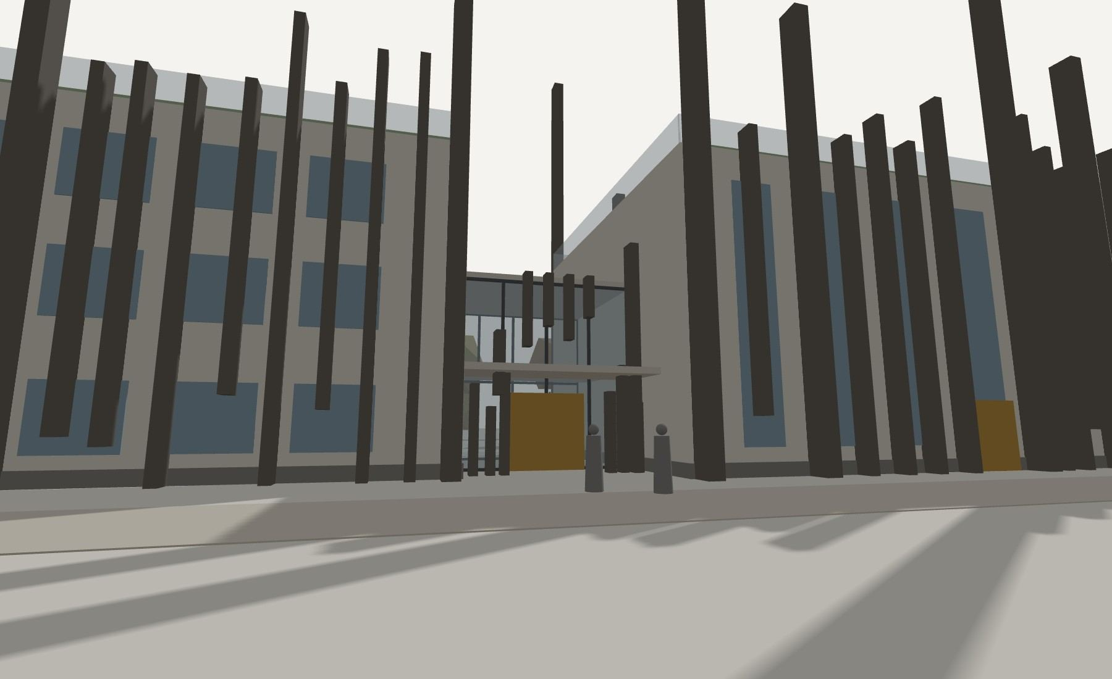
The main entrance – the glass cube between the two sections, decorated with fins, some of them hanging above the ground – seen from the forest walk (3D model).

Materials and colours of the façade
My palette (1.3.4) stays, but the fins are not made of timber. The fins are the main material of the façade, so they get one warm grey colour, like river stone in the sun, and the warm autumn colours appear only in small places where people come close to the building: frames, doors and seats.
- Fins and panel walls – through-coloured glass-fibre reinforced concrete in one warm grey: the rhythm of tall and short fins, some hanging above the ground, reads clearly from afar.
- Walls behind the fins – light fair-faced concrete and fibre-cement panels in mist; a plinth of grey basalt.
- Windows – fog-blue glass (the blue spots of my sketches) in slim frames; the frames and reveals of some windows in larch-gold powder-coated aluminium – the yellow accents of my sketches.
- Glass cube – clear glass with a few panels of coloured glass in larch gold and copper rust; the sound bars at the door in weathered copper and gold.
- Roofs – green roofs of moss, ferns and grasses (fir green), paths of light stone pavers, glass railings.
- Amphitheatre – seats of grey basalt with wine-leaf cushions, a stage of light stone, panel walls of the same GRC as the fins.
- Inside – terrazzo with river pebbles in the foyer and the café, light ash in the practice rooms, wool and felt in wine and navy for the acoustic panels.
So from afar the building is light volumes behind a rhythm of grey fins, calm like the valley in the fog, and warm when you come close – the autumn is in the details.
CONCLUSION
The volumes fit the site and the norms: three storeys at most, +11.70 at the highest roofs and +12.00 at the parapets; only the free-standing fins rise above them, up to +25.00 (the dominant fin), within the 25 m allowed for culture. The building fills the free strip between the line zone and the river strip, the forest between it and Autumn Dream remains, and every roof is a place for people.

3.5. Drawings of the centre
The drawings fix the concept at the scale of the building: the site plan, the general plan, the plans of four levels and the roof, two sections and two elevations, drawn by hand on the tablet on a white background. On the plans every room has its name and area, and the colours are the zones of the functional diagram (2.5); there are no people on the plans – a few grey figures on the elevations and sections show the scale. The full set at scale – site plan 1:1000, general plan 1:500, plans, elevations and sections 1:100 – is in the separate drawing file.
Entrances and safety. The main entrance is from the forest walk into the glass cube; the side entrance is from the square at the north-east end; the café has its own door to the terrace, and goods come to the kitchen from the service lane. The hall has four exits (two to the foyer, two outside) and opens to the outdoor stage through a folding glass wall; the artists’ block has a service door and an exit from stair S4. Four stairs (S1–S4) go from the lower level to the roofs and lead directly outside or into the entrance hall, a lift links all levels, every room is within 50 m of a stair or an exit, and every roof has two ways down. The forest walk (4.5 m) is the fire-engine access; the red arrows on the ground floor plan show all entrances and exits. Structure. Almaty is a seismic region (SP RK 2.03-30-2017), so Section I, the glass cube and Section II are separate frames with seismic joints between them.
Site plan (reduced, the drawing file has it at 1:1000): the centre between the Kishi Almaty, the Esentai and the 110 kV line; Autumn Dream on plot 705 to the north-west.
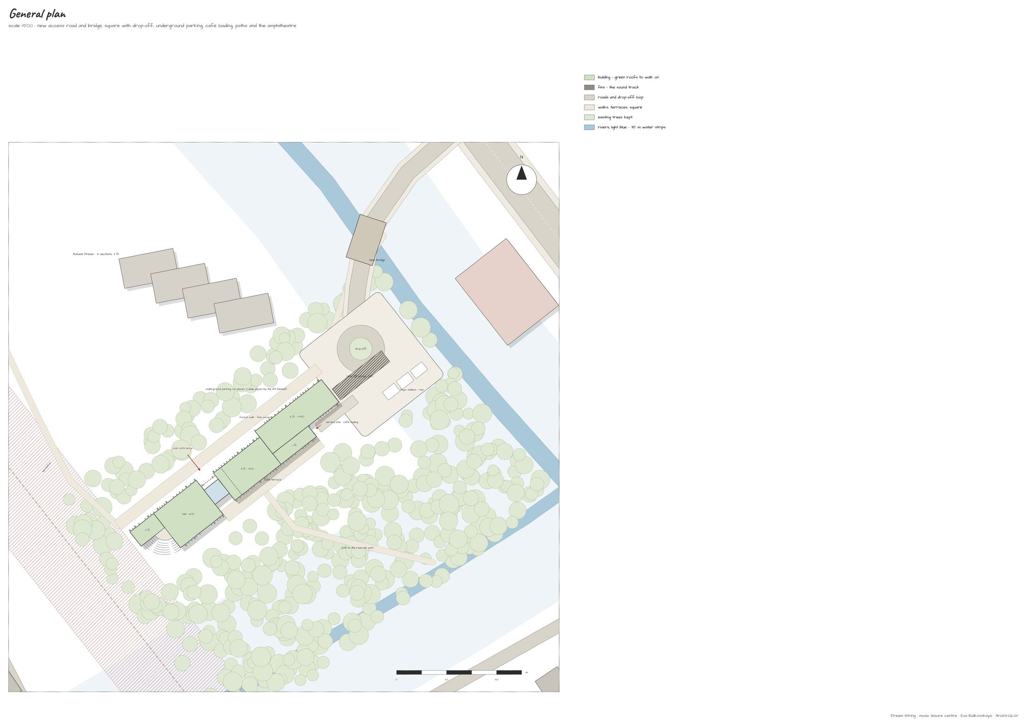
General plan (reduced, the drawing file has it at 1:500): the new road and bridge from Kerei-Zhanibek street, the square with the drop-off loop and the bays for minibuses and taxis, the ramp to the underground garage for 24 cars (the parking, dashed), the service lane with the café loading bay, the forest walk with fire access, the café terrace, the amphitheatre and the lawn; the forest is kept.
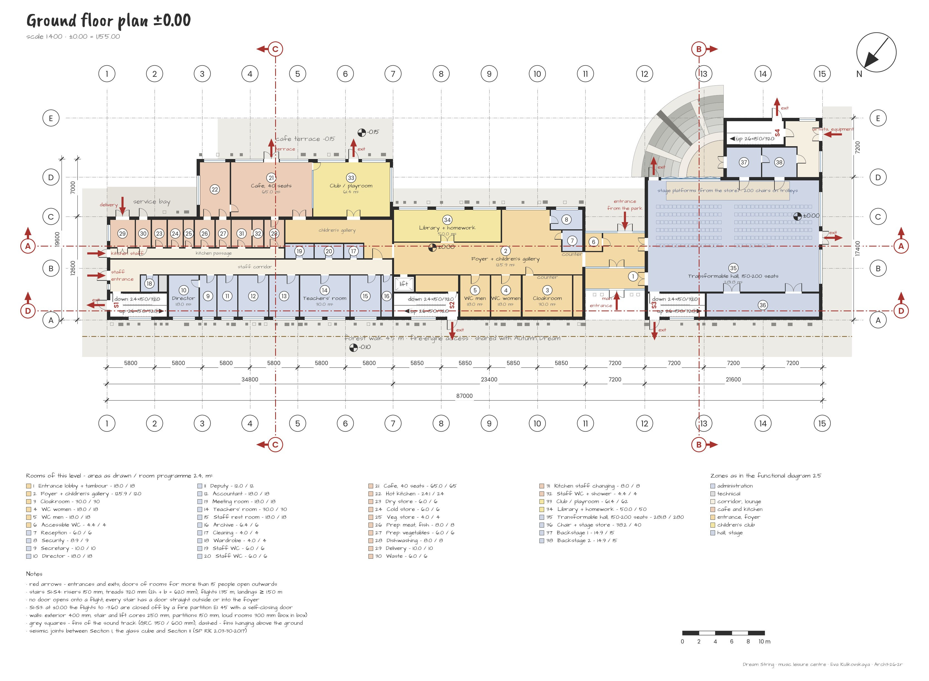
Ground floor plan ±0.00 (1,155.00), organised as the functional diagram (2.5, variant 1 – the foyer as a hub): the main entrance into the glass cube, the foyer with the children’s gallery, the cloakroom and the toilets; the club and the library next to the café, behind a glass wall; the café kitchen in one line from the delivery door; the administration with its own staff entrance from the square; the transformable hall with the semicircular stage, the chair store and the backstage. Every room has the number and the area of the room programme (2.4); red arrows – entrances and exits.
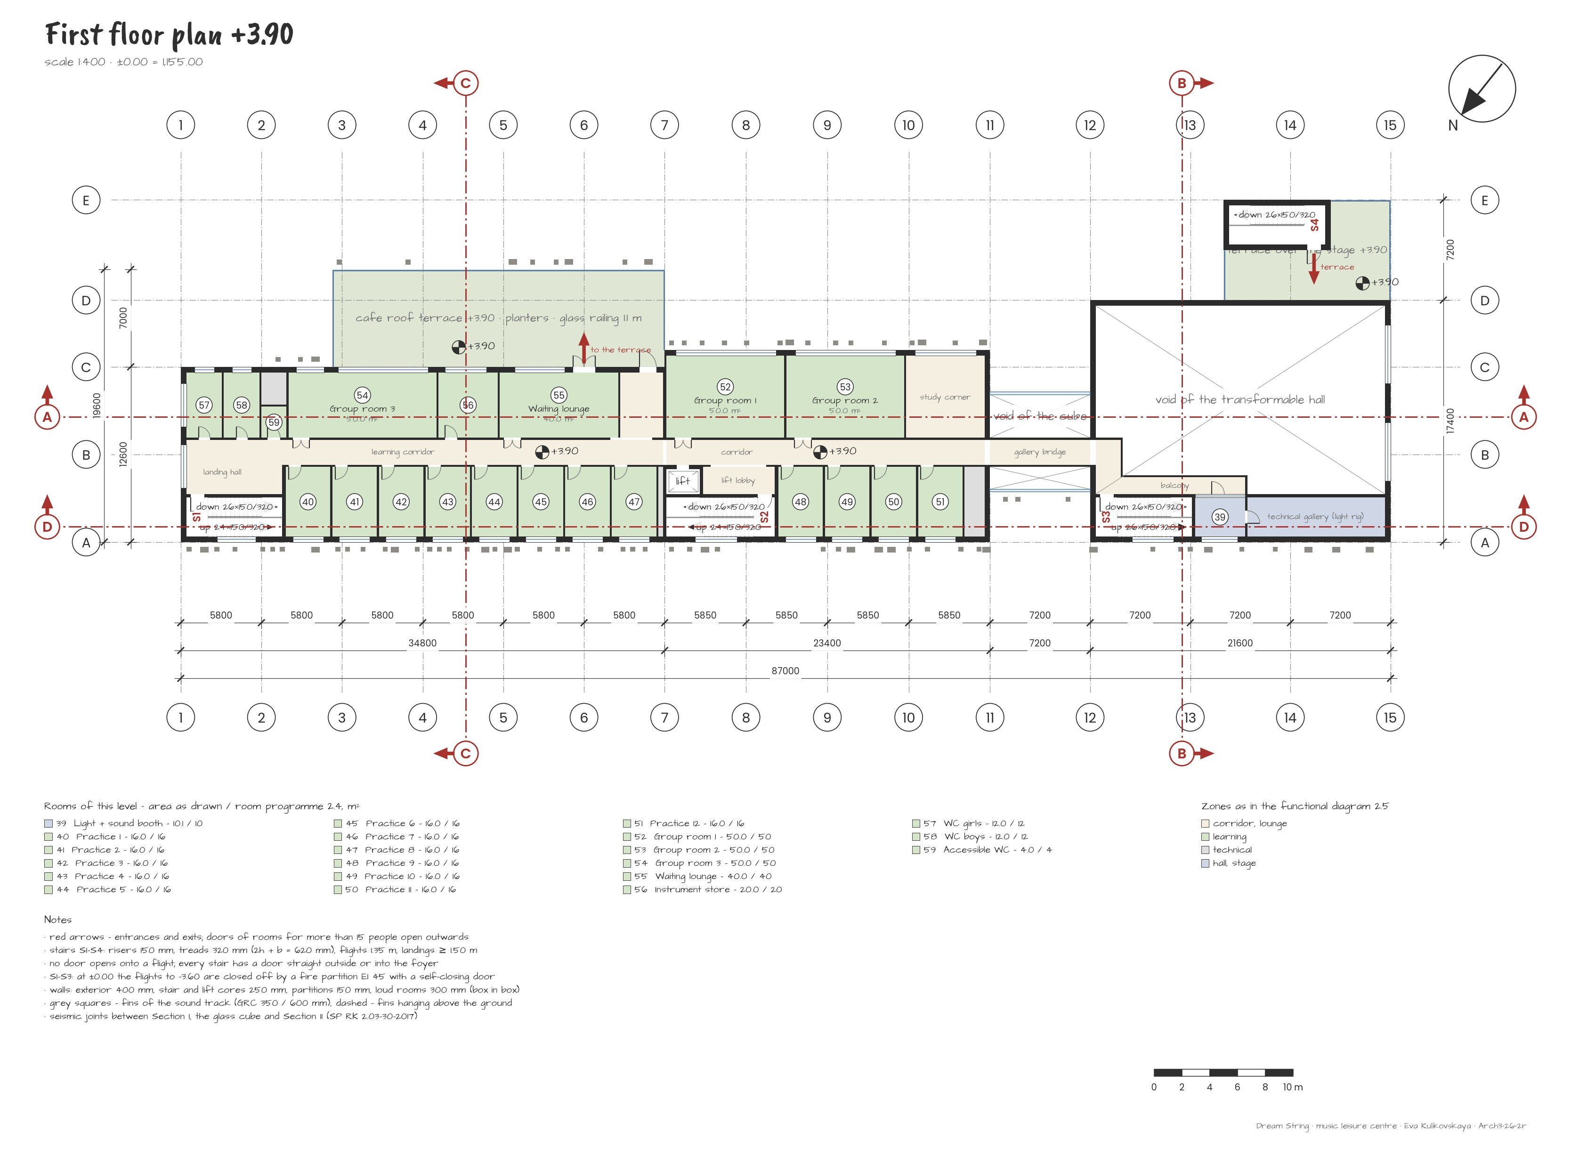
First floor plan +3.90 – the learning zone: twelve practice rooms of 16 m², three group rooms of 50 m², the waiting lounge by the stair S2 and the lift, the instrument store, the toilets for girls and boys and an accessible WC, a study lounge with the door to the café terrace; the gallery bridge across the cube and the light and sound booth over the hall foyer.
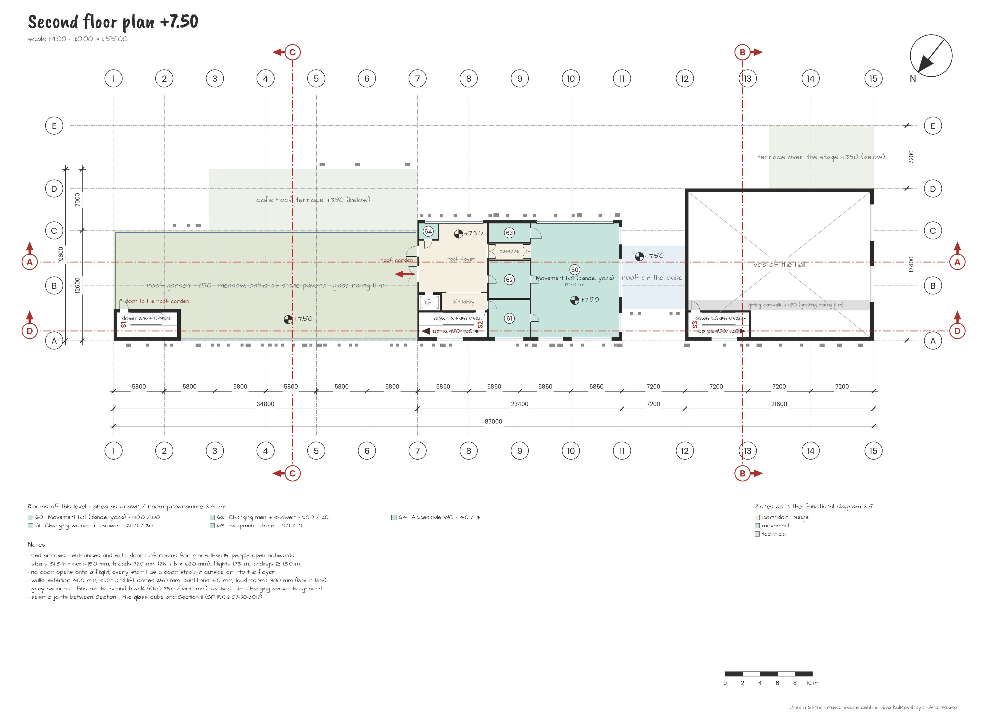
Second floor plan +7.50 – movement: the movement hall of 130 m², two changing rooms, the equipment store and an accessible WC; the roof foyer opens to the roof garden and to the cube roof.
Lower level plan −3.60: the garage for 24 cars (3 wide places 3.6 × 6.0 m by the lift) under Section I; under the hall the loud rooms – band room, drum room, recording studio with its control room – and the plant room, the electrical room and the cleaning stores.
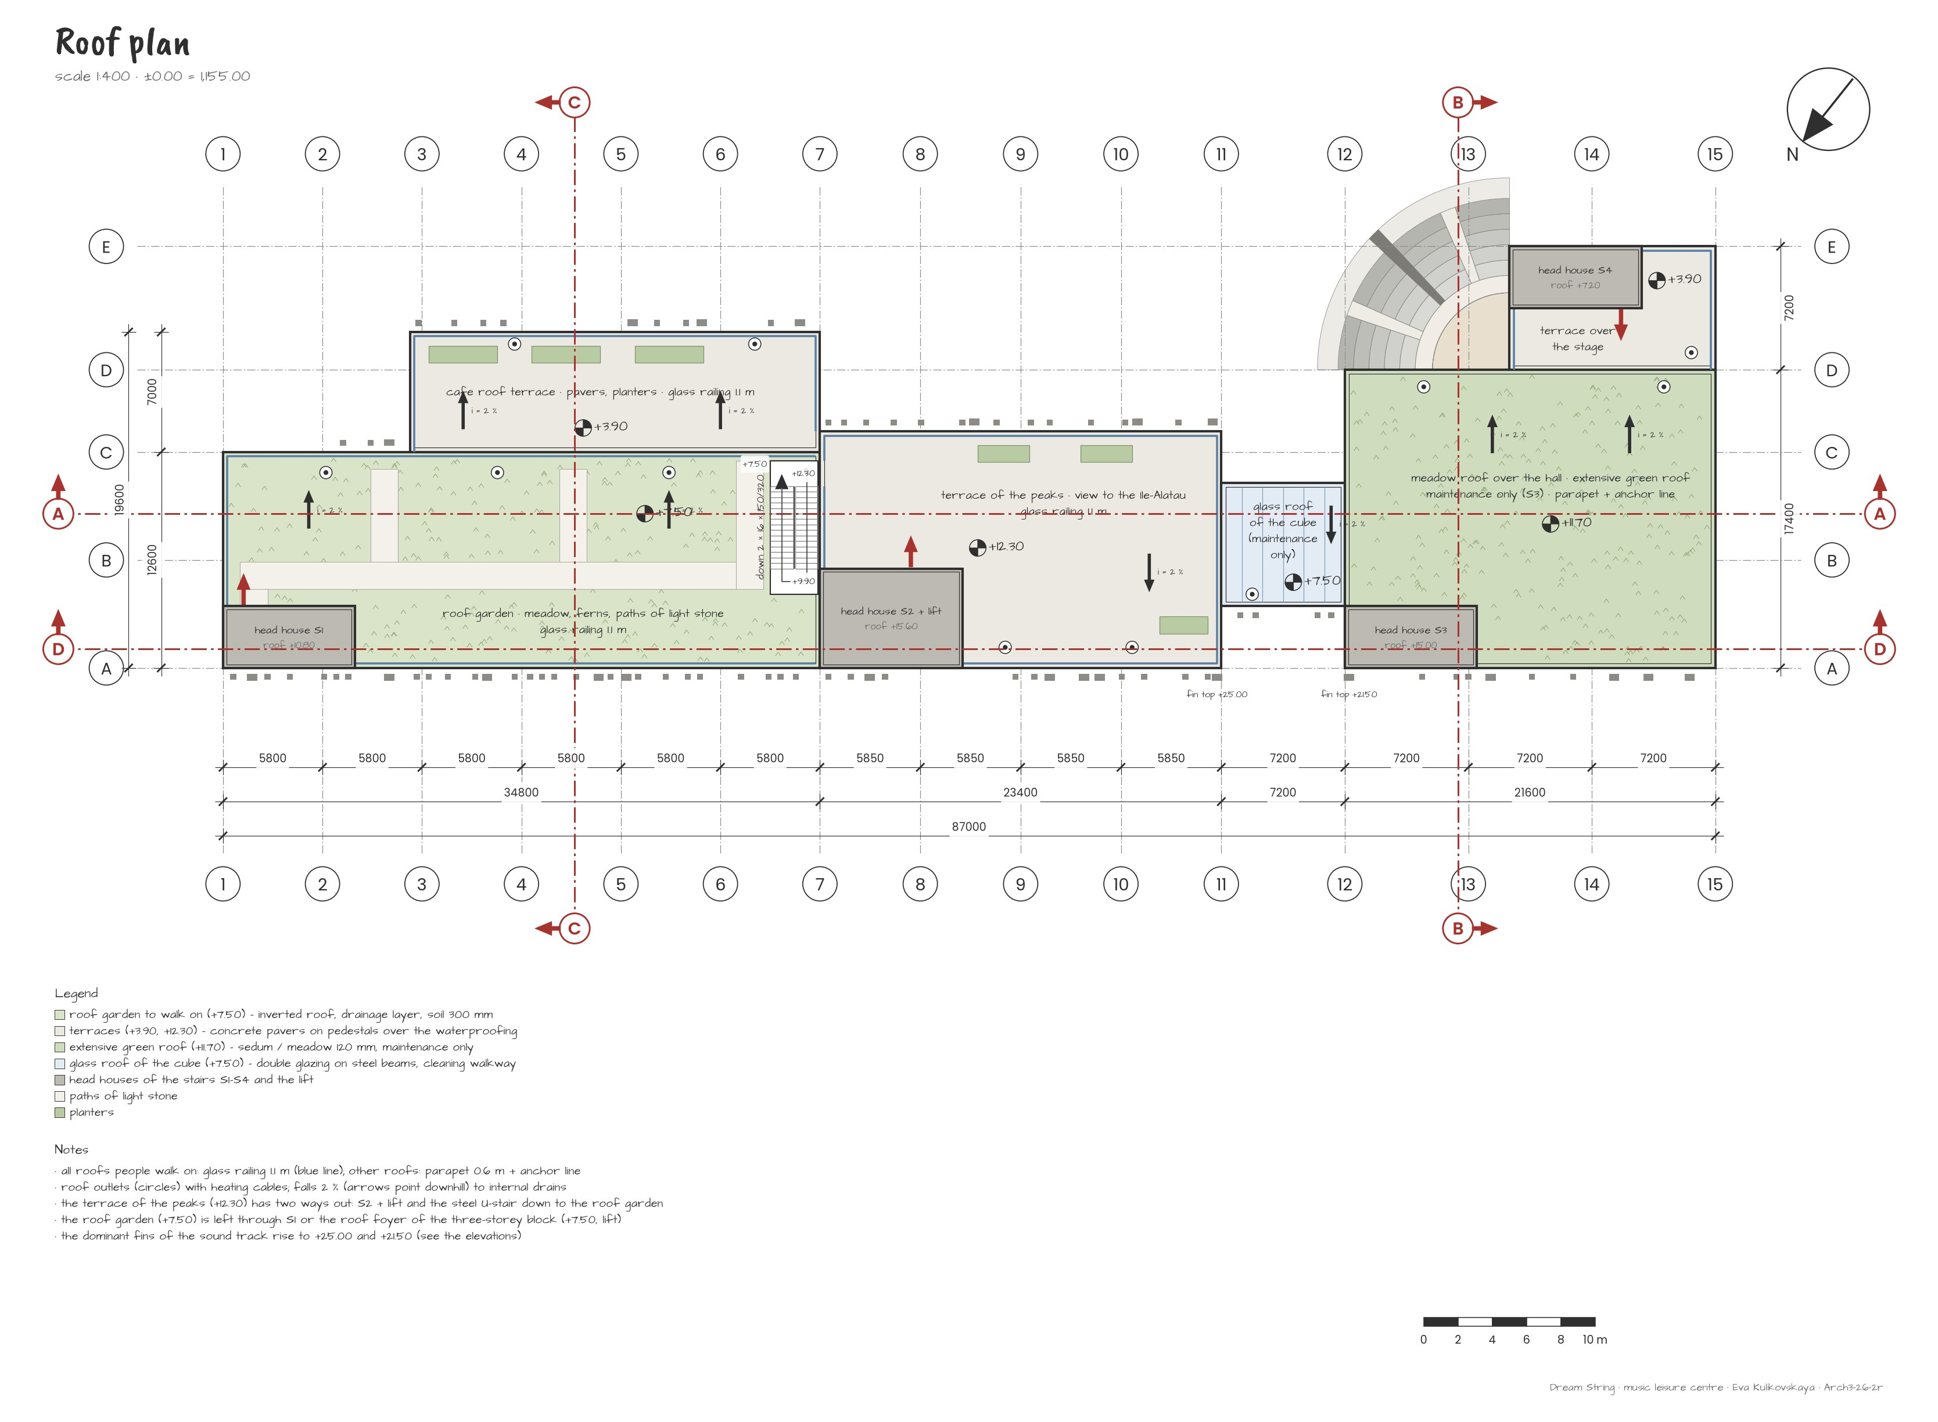
Exploitable roof: the roof garden +7.50, the café terrace +3.90, the terrace of the peaks +11.70, the cube roof, the meadow roof over the hall and the terrace over the stage – two ways down from every roof.
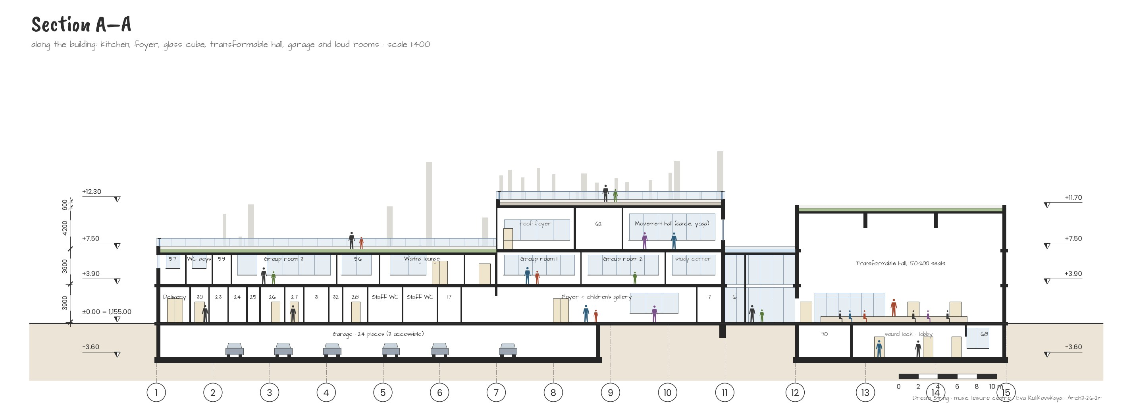
Section A–A along the building: the learning block, the three-storey block, the glass cube, the hall and the artists’ block; the garage and the loud rooms below.
Section B–B through the artists’ block and the amphitheatre: four sectors of seats with two through passages, the panel wall and the terrace over the stage.
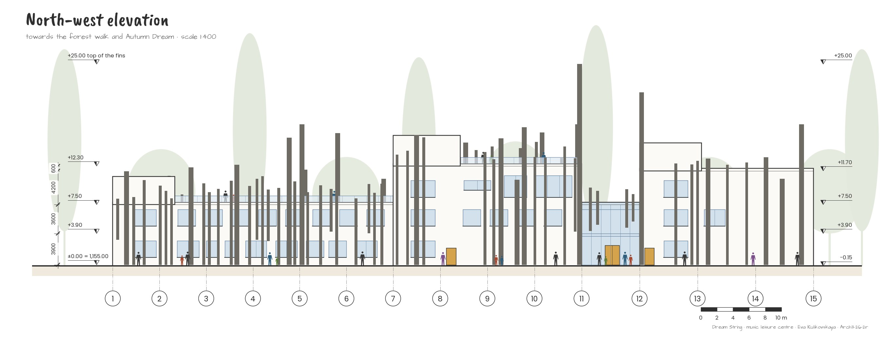
North-western elevation (towards the forest walk and Autumn Dream): the sound track of the fins and the main entrance in the glass cube with its fins. The colours of the façade are still being worked out.
South-eastern elevation (towards the park): the amphitheatre, the hall, the glass cube and the café terrace. The colours of the façade are still being worked out.

3.6. Conclusion of Section 3
Section 3 turned the analysis of the site into a concept. The pluses and minuses showed where the centre belongs – on the free land of plot 688, open to the south and to the forest, away from the line, the substation and the road, behind a green barrier of trees. The sun and the wind gave the orientation; the alignment and the six placements gave the place and the axis. My sketches gave the form: a sound track of fins along two sections joined by a glass cube, roofs that people walk on and an amphitheatre at the corner of the hall.
Concept | In short
Story | Dream String: a sound track of fins in the misty autumn forest – music that you can see, around a building whose roofs people walk on
Analysis | open to the south – sun, forest, peaks; closed to the line, the substation and the road; a green barrier of trees on the substation side
Form | my sketches: two sections joined by a glass cube, blocks of 1–3 storeys, grey fins with the dominant at +25.00, an amphitheatre at the corner of the hall
Roof | café terrace +3.90, roof garden and cube roof +7.50, terrace of the peaks and meadow roof +11.70, terrace over the stage
Music centre | 73 rooms, 1,805 m²: hall for 150–200, foyer and café, 12 practice rooms, 3 group rooms, movement hall, loud rooms below
Materials | warm grey GRC fins, fog-blue glass, larch-gold frames, green roofs, basalt; no timber fins
Landscape | the forest kept, the forest walk to Autumn Dream, the lawn and the amphitheatre, the riverside park on site 278
Next step | the structure of the fins, the acoustics of the hall and of the outdoor stage, the details of the roofs

Sources of Section 3
1. Public cadastral map of the Republic of Kazakhstan – plots 20315904688, 20315904786 (former 278) and 20315904705 – map.gov4c.kz (October 2026).
2. OpenStreetMap contributors – roads, buildings, rivers, the power line (ODbL) – openstreetmap.org.
3. Esri World Imagery (Maxar, Airbus) – satellite base of the maps of 3.1.
4. SRTM 30 m digital elevation model (Terrarium elevation tiles, AWS Open Data) – terrain of the 3D model.
5. Rules for establishing protection zones of electric networks, order No. 330 of 28.09.2017 (20 m for 35–110 kV lines) – adilet.zan.kz.
6. NOAA Global Monitoring Laboratory – solar position calculation – gml.noaa.gov/grad/solcalc/calcdetails.html.
7. SP RK 2.03-30-2017 “Construction in seismic regions” – online.zakon.kz.
8. Snøhetta – The Norwegian National Opera and Ballet, Oslo – snohetta.com; Dezeen (2010), European Prize for Urban Public Space.
9. Analogues of Section 2.2 – Meco, COFCO, Ku.Be, Dushan, Fuji Kindergarten, Moesgaard Museum, House of Music Aalborg, Kilden, ACROS Fukuoka, Darius Milhaud Conservatory – sources of Section 2.
10. My sketches and notes (October 2026); 3D model, renders and drawings by the author.
11. Sections 1 and 2 of this project – site, genius loci, programme, norms.

