GitHub: https://github.com/a-liut/ase-fall-18

Description:

The _ACTIVEPOLLS dictionary contains all the Poll objects and represents active polls. The dictionary itself and the _POLLNUMBER counter guarantee the uniqueness of the polls.

1. *all_polls()*: handles operations over the entire collection of polls. It implements ‘/doodles’ endpoint handling the following HTTP methods:
   1. GET: returns the list of currently active polls
   2. POST: create a new poll reading data from the JSON body of the request and add the new object to the _ACTIVEPOLLS dictionary using the _POLLNUMBER counter as index.
2. *single_poll(id)*: handles operations on a single poll. The endpoint decoration converts the id into an integer and allow the following HTTP methods:
   1. GET: simply returns the JSON representation of the poll at position *id* in the _ACTIVEPOLLS dictionary.
   2. DELETE: removes from the _ACTIVE_POLLS dictionary the poll at position id using *pop* method.
   3. PUT: handles the vote operation on a specific poll implemented by the function vote which simply read from the request the person who vote and the option and update the Poll instance. If the option doesn’t exist, a NonExistingOptionException is thrown and the service reply with status code 400, as the client invalid data to be processed by the service.
3. *person_poll(id, person)*: handles operations over a poll done by a person. The endpoint decoration converts id to an integer and the person identifier as a string. The allowed HTTP methods are:
   1. GET: returns a (jsonified) dictionary with the voted options by the selected person
   2. DELETE: returns a (jsonified) dictionary whose key ‘removed’ is set to True whether the votes of the selected person have been removed.

Pytest result:

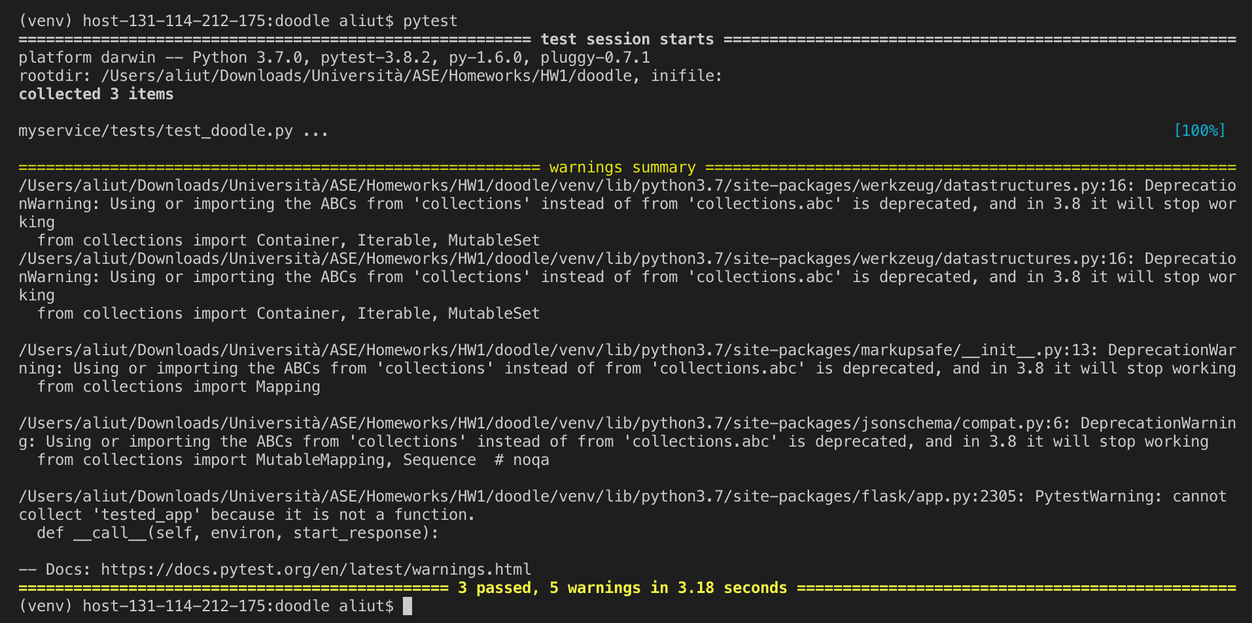

POST /doodles

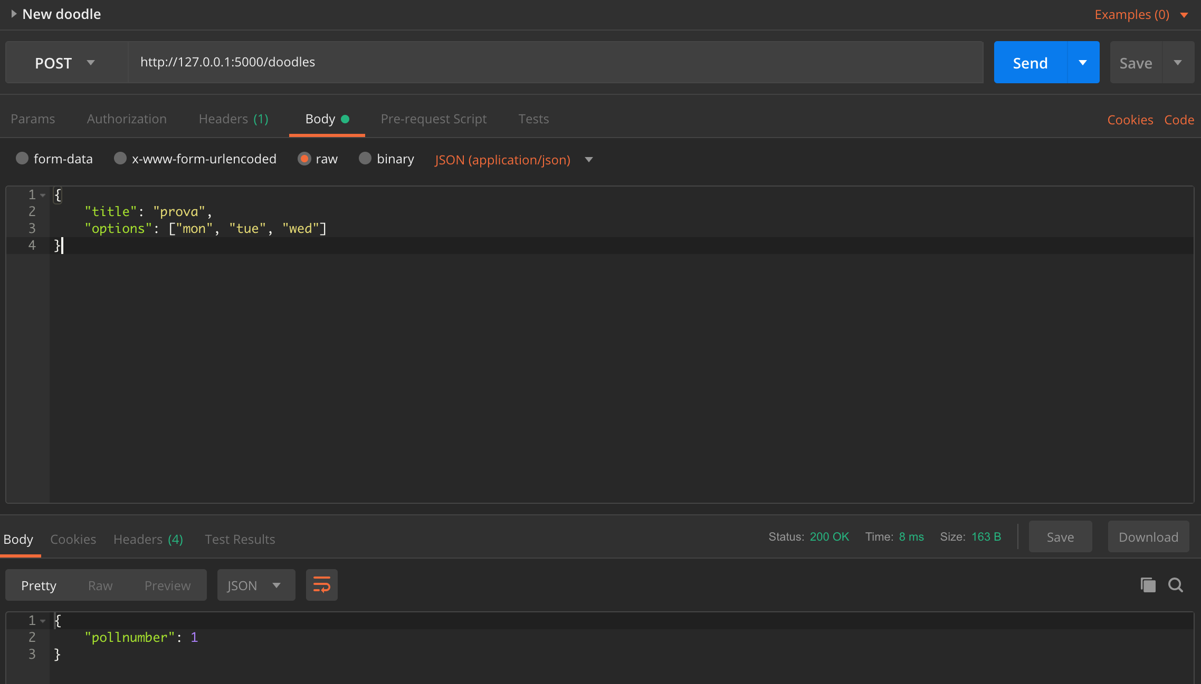

GET /doodles/<id>

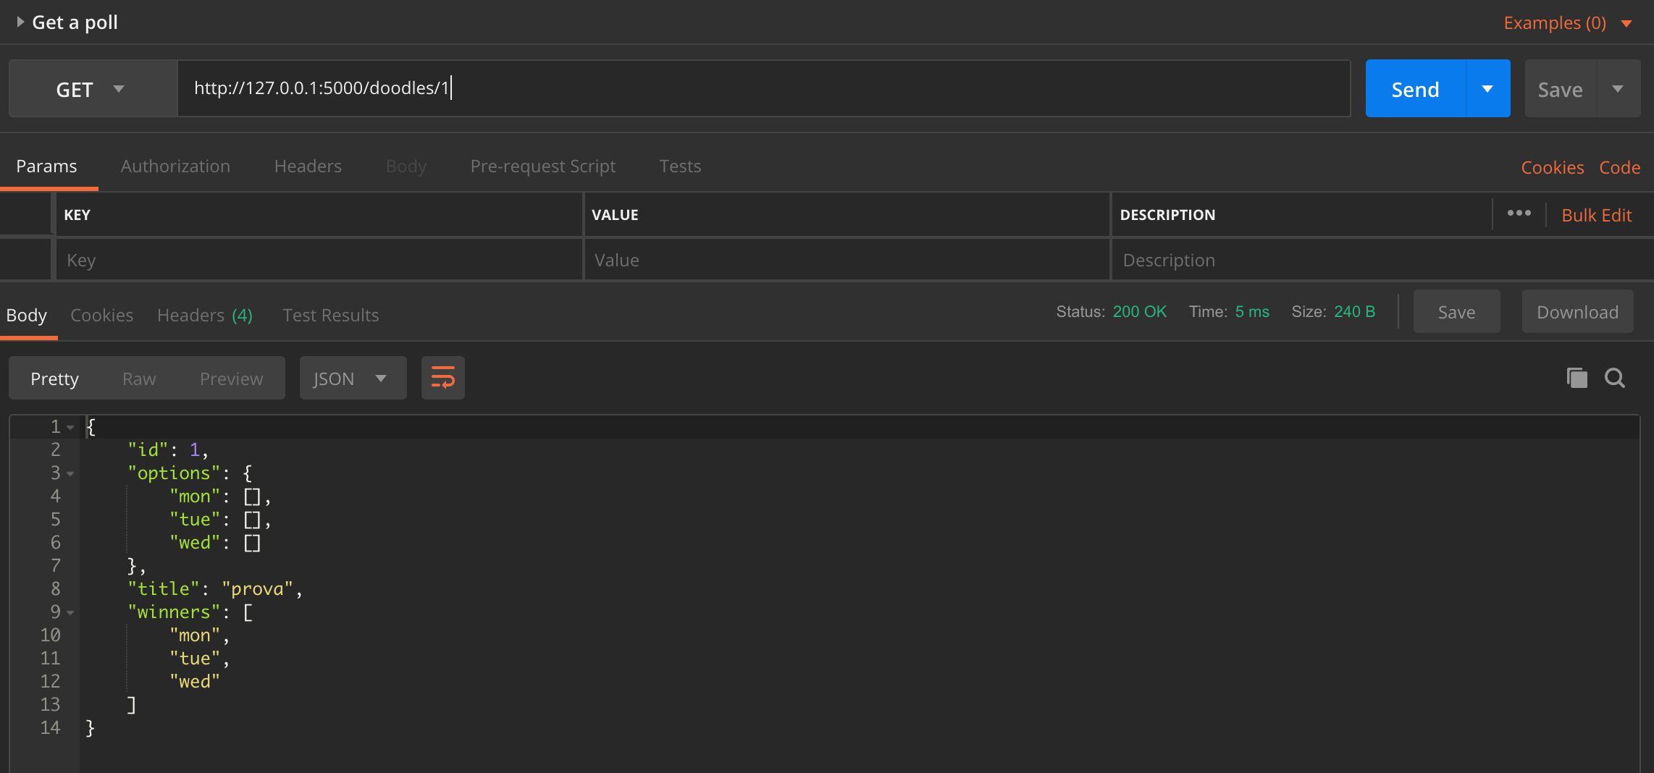

PUT /doodles/<id>

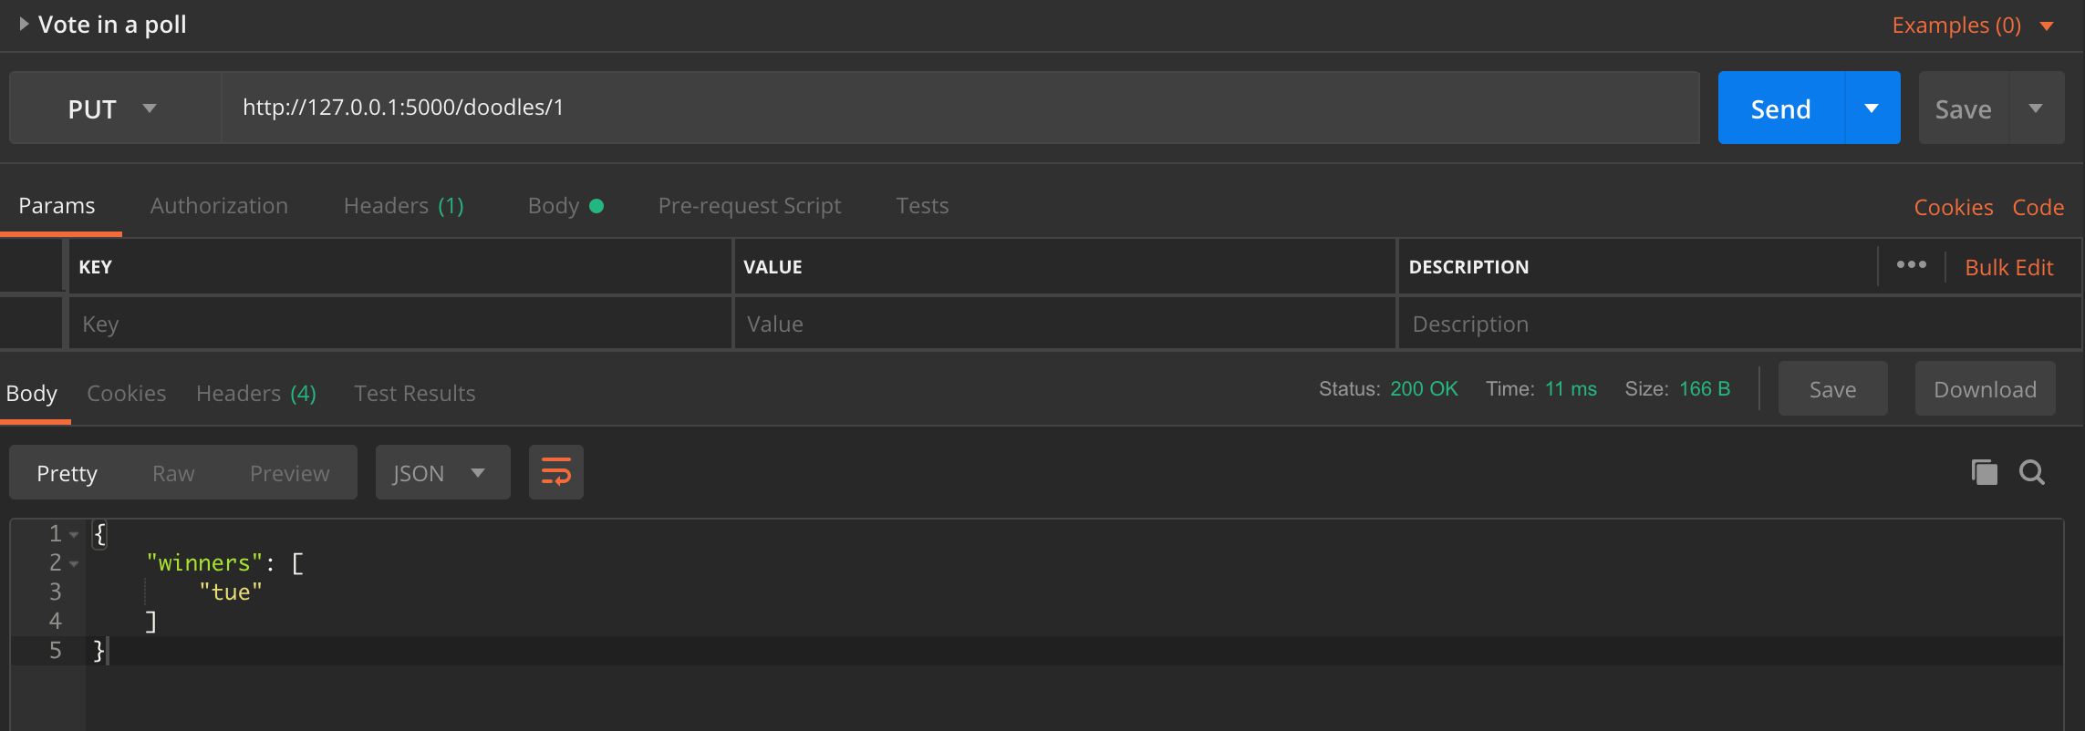

GET /doodles/<id>/<person>

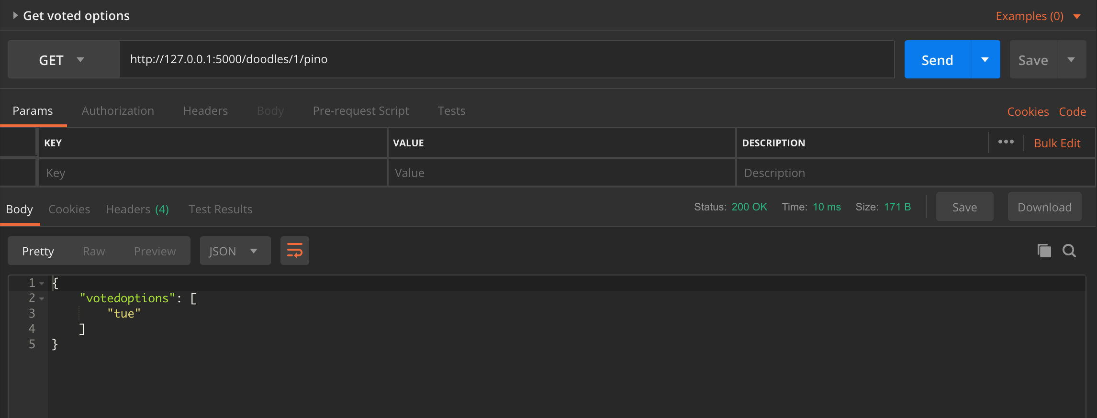

DELETE /doodles/<id>/<person>

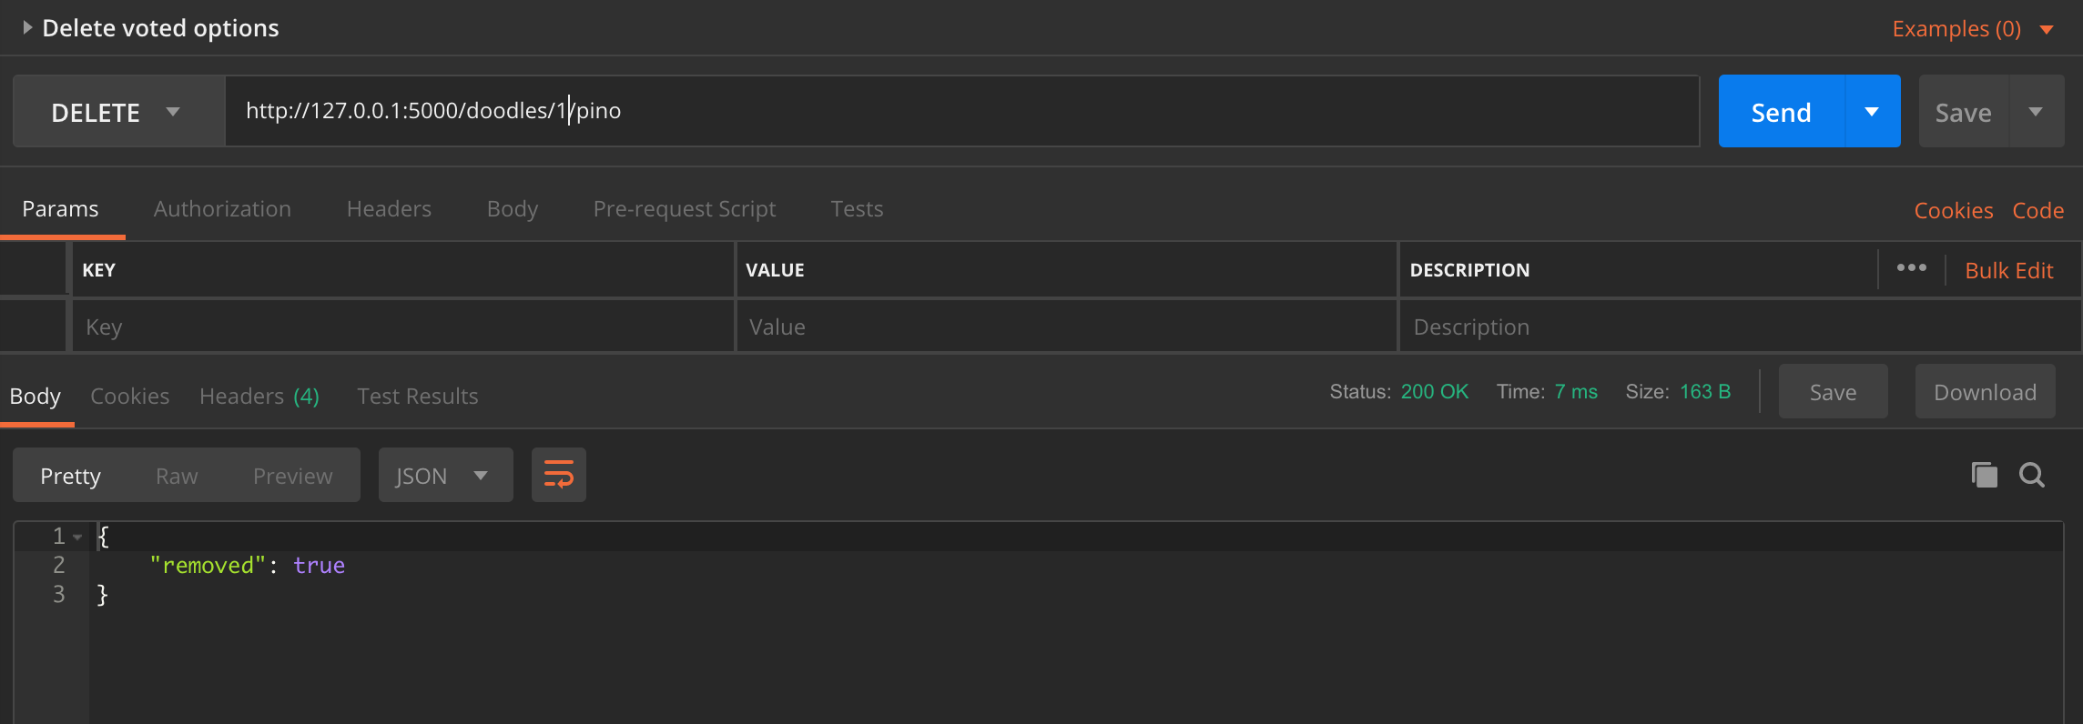

GET /doodles

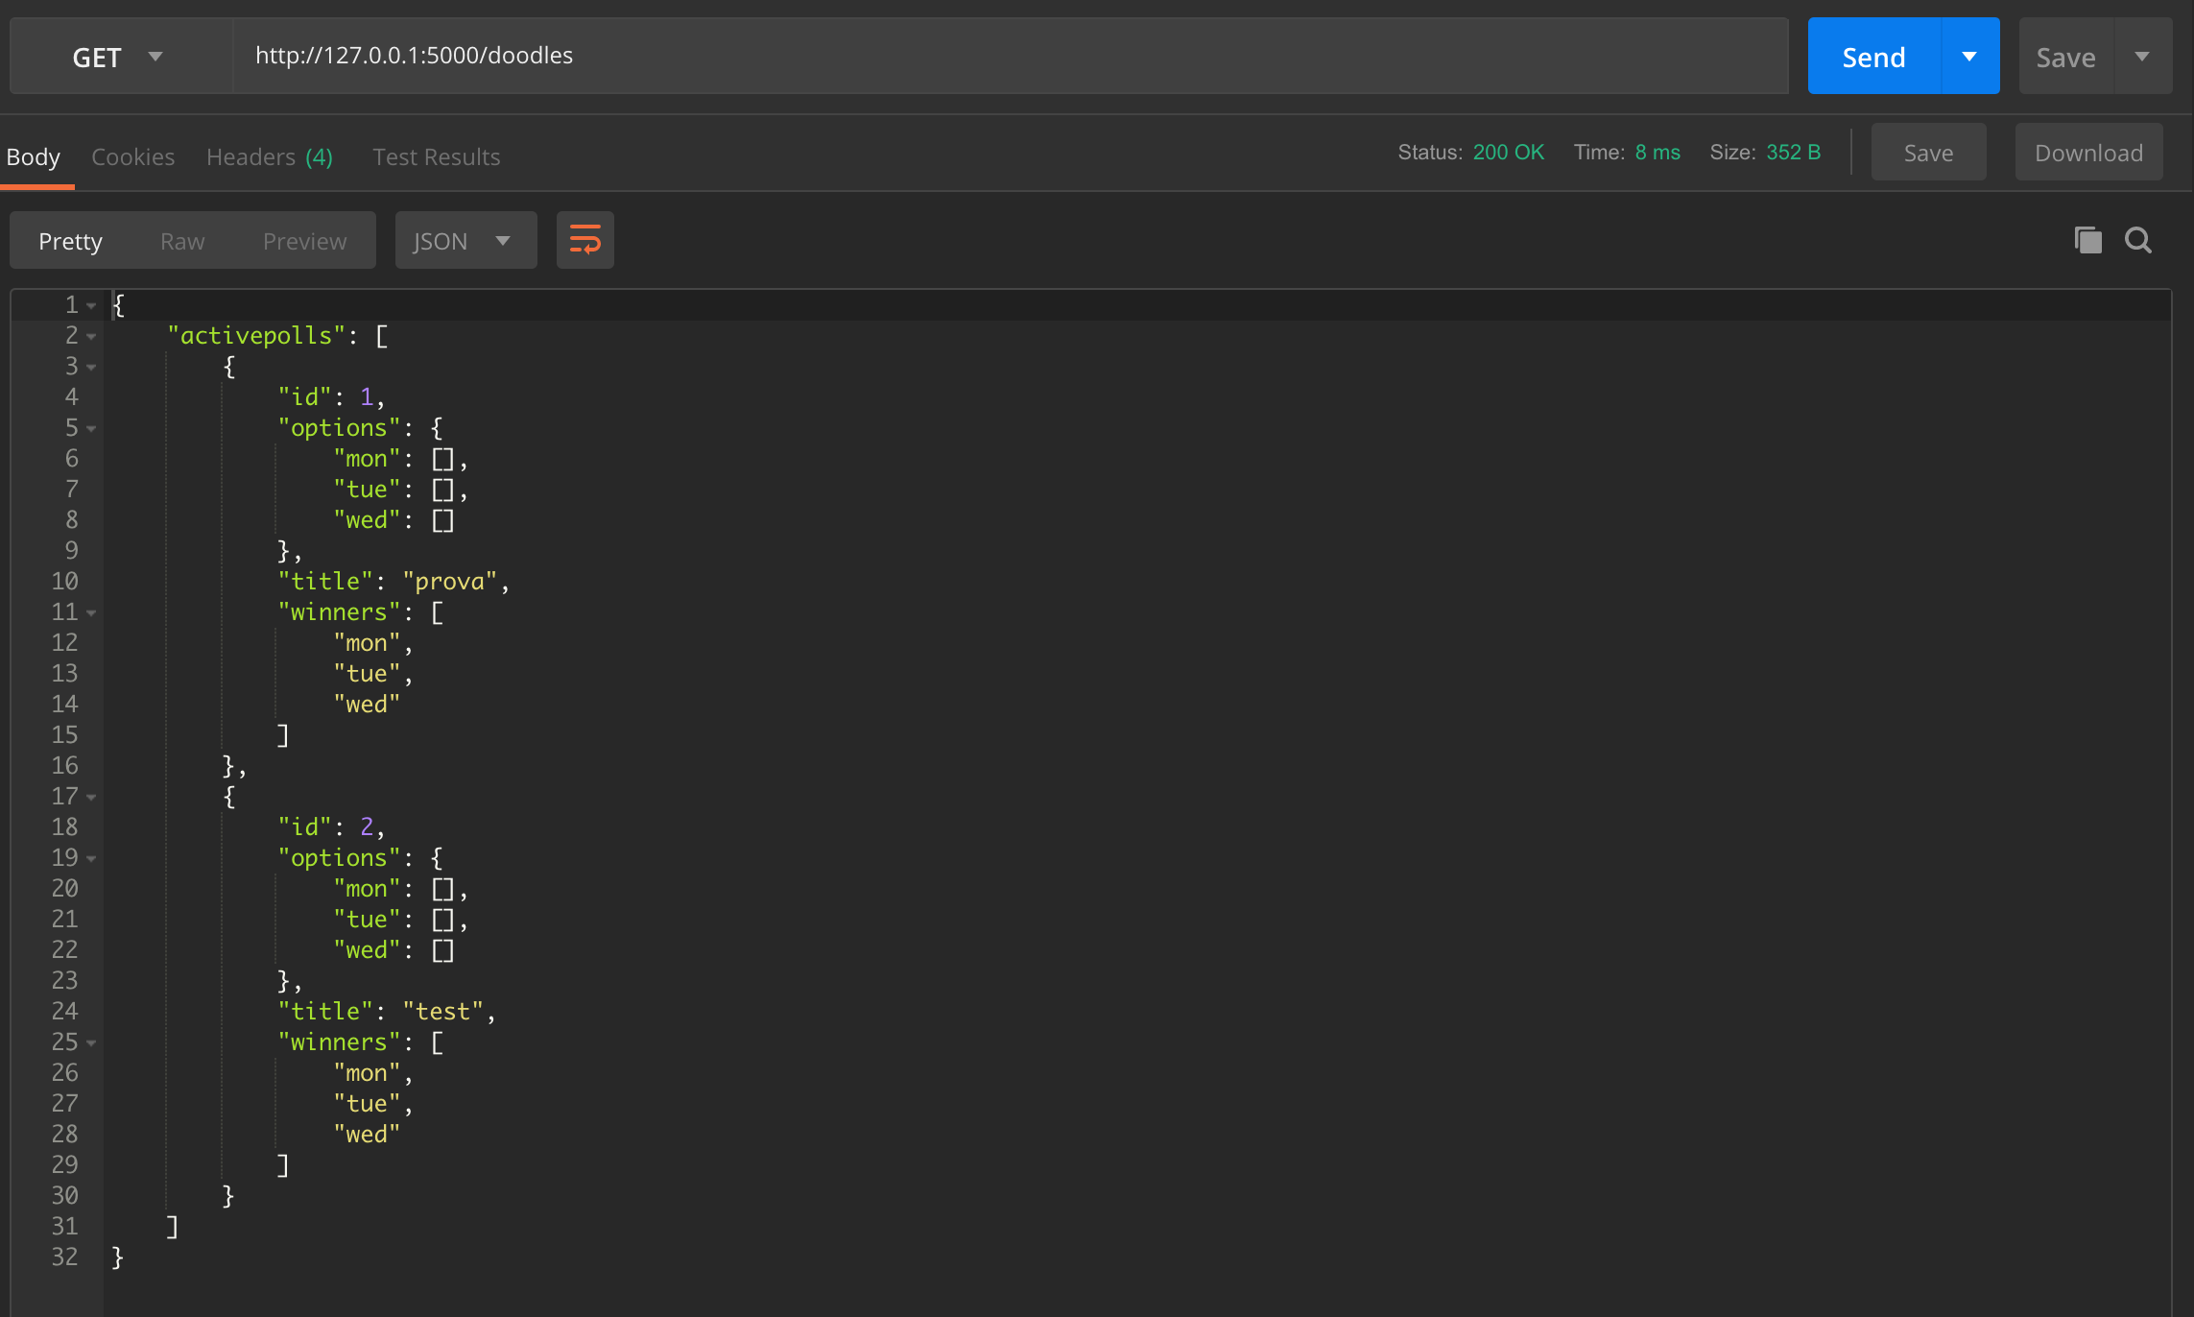

DELETE /doodles/<id>

