
DDI TUTOR
SYSTEM DESIGN DOCUMENT
Architecture, Data Flow, ER, Gantt, Interface, and Class Diagrams for a Free Drug Interaction Learning Tool for Medical Students
Submitted by
Allen Binoy – 2548005
&
Stebin Limson – 2548053
Under the guidance of
Dr. Jawahar S
Department of Statistics and Data Science
Christ (Deemed to be) University
November 2026

CONTENTS
1. System Architecture 3
1.1 Layered Architecture Overview 3
1.2 System Modules 4
2. Data Flow Diagram 5
2.1 Level 0 — Context Diagram 5
2.2 Level 1 — Main System Processes 6
2.3 Level 2.1 — Model Evaluation 7
2.4 Level 2.2 — Interaction Check 7
2.5 System Flow 8
3. ER Diagram 9
3.1 Entities 9
3.2 Attribute Schema 10
3.3 Relationships 11
3.4 Design Notes 11
4. Gantt Diagram 12
5. Interface Design / Wireflow Diagram 13
6. Class Diagram 14
7. Conclusion 16

1. System Architecture
DDI Tutor’s architecture, as planned for this project, is organised as a layered block diagram with two sides that meet at one data store: a build-time side that runs offline on the team’s laptops, and a run-time side that a student uses in a web browser. Figure 1 shows the five tiers: Input Sources, the Presentation Layer, Application Logic, the Processing Modules, and Data Storage. Solid boxes are built and tested. Dashed boxes are planned. Arrows show data moving at build time from the sources into storage, and at run time from the student’s browser down to storage and back.

1.1 Layered Architecture Overview
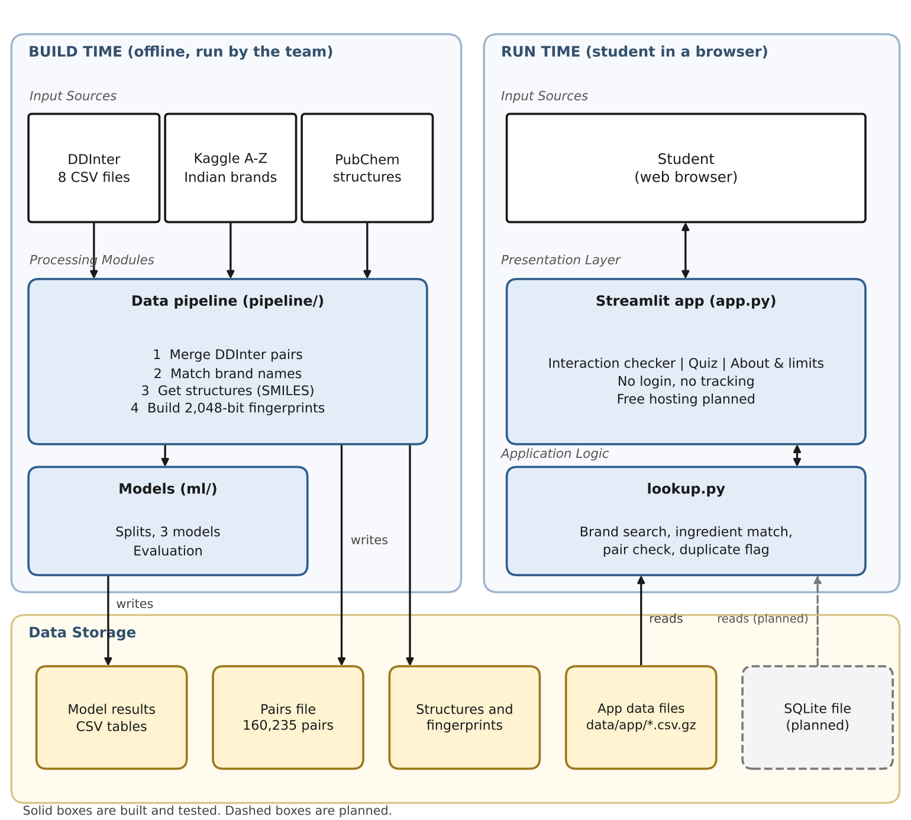
Figure 1: DDI Tutor System Architecture (Block Diagram)
The Input Sources tier has four inputs. Three are data sources used offline: DDInter, a free drug interaction database delivered as eight CSV files; the A-Z Medicine Dataset of India from Kaggle, which supplies Indian brand names and their ingredients; and PubChem, a free chemistry database that supplies each drug’s structure as SMILES text. The fourth input is the student, who uses the site in a web browser. Everything is free, and DrugBank is not used.
The Presentation Layer is a single Streamlit app (app.py) with three tabs: Interaction checker, Quiz, and About & limits. There is no login and no tracking, because the site is for learning only. Free hosting on Hugging Face Spaces or Streamlit Community Cloud is planned.
The Application Logic tier is lookup.py. It searches brand and generic names, maps a brand to its ingredients, treats paracetamol and acetaminophen as the same drug, checks every ingredient pair in both orders, and flags the same ingredient appearing in two medicines as duplicate therapy. The quiz draws its questions from graded pairs only. This tier does not run any model today.
The Processing Modules tier holds the offline data pipeline (pipeline/) and the model code (ml/). The pipeline merges the eight DDInter files into one list of 160,235 unique pairs, matches brand ingredients to DDInter names, collects structures from PubChem, and turns each structure into a 2,048-bit Morgan fingerprint. The model code cuts the graded pairs into training and test parts in three ways (random, one drug unseen, both drugs unseen) and scores three models: always Moderate, nearest neighbour, and XGBoost. Nothing in this tier runs while a student waits for a page. All of it is computed ahead of time.
The Data Storage tier holds the merged pairs file, the structure and fingerprint files, the small compressed files that the app loads (data/app/), and the model results. A single SQLite file that holds the app data and, later, predictions is planned. Predictions will be labelled “Predicted, not confirmed” and kept apart from recorded interactions.

1.2 System Modules
Table 1 summarises the principal system modules behind the architecture above. The same module boundaries (P1 to P6) are used in the data flow, ER, and class diagrams in the rest of this document. A seventh module, the prediction layer (a yes/no model, a calibration check and a “Predicted, not confirmed” display), is planned and is not drawn yet.
Sl.no | Module | Role in System
1 | Data Merge (P1) | Merges the eight DDInter files into one list of unique pairs, each marked Minor, Moderate or Major, and checks for conflicting repeats (160,235 unique pairs, 0 conflicts).
2 | Brand Matching (P2) | Links Indian brand ingredients to DDInter drug names (paracetamol = acetaminophen). 68.1% of medicines are fully matched and 85.9% have at least one ingredient matched.
3 | Structures & Fingerprints (P3) | Collects each drug’s structure (SMILES) from PubChem and builds a 2,048-bit Morgan fingerprint from the largest piece of the structure. 1,655 of 1,939 drugs have one.
4 | Model Evaluation (P4) | Builds the three splits, scores the three models, and reports macro-F1 and balanced accuracy over several random seeds.
5 | Interaction Check (P5) | Searches brand and generic names, maps brands to ingredients, checks every pair in both orders, and flags duplicate therapy.
6 | Quiz (P6) | Builds practice questions from graded interaction pairs and gives feedback on the answer.

2. Data Flow Diagram
The Data Flow Diagram (DFD) set decomposes DDI Tutor across three levels of detail, following standard DFD conventions: a Level 0 context diagram treating the system as a single process, a Level 1 diagram decomposing the system into its six processes and four data stores, and two Level 2 diagrams that decompose the two processes with the most internal steps, Model Evaluation (P4) and Interaction Check (P5).

2.1 Level 0 — Context Diagram
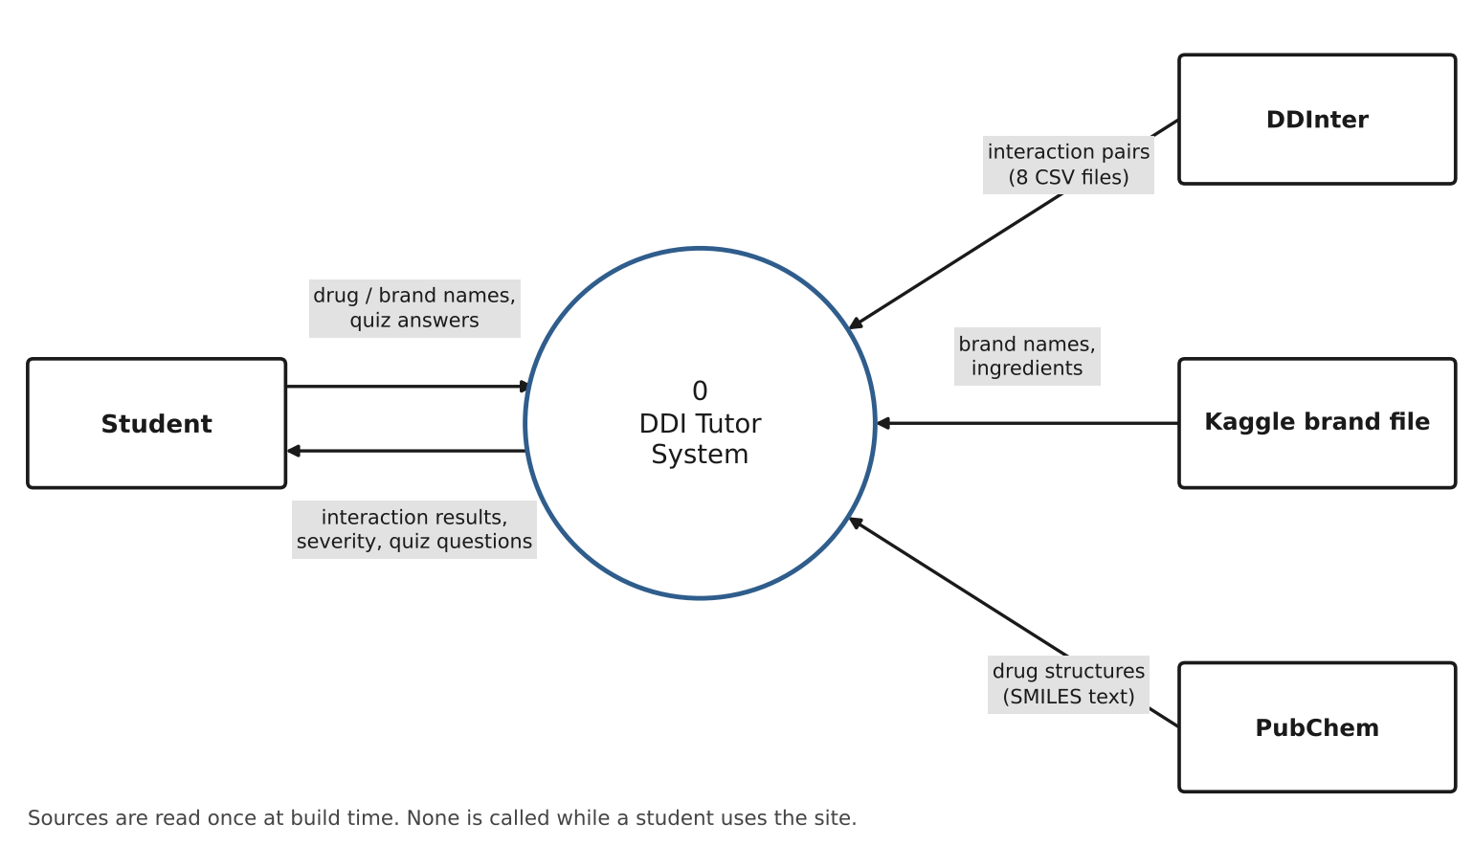
Figure 2: DFD Level 0 — Context Diagram
At the context level, DDI Tutor is treated as a single process bounded by four external entities: the Student, DDInter, the Kaggle brand file, and PubChem. The Student supplies drug or brand names and quiz answers, and receives interaction results, severity labels, and quiz questions in return. DDInter supplies the eight interaction files, the Kaggle file supplies brand names and their ingredients, and PubChem supplies drug structures as SMILES text. All three sources are read once at build time. None of them is called while a student uses the site.

2.2 Level 1 — Main System Processes
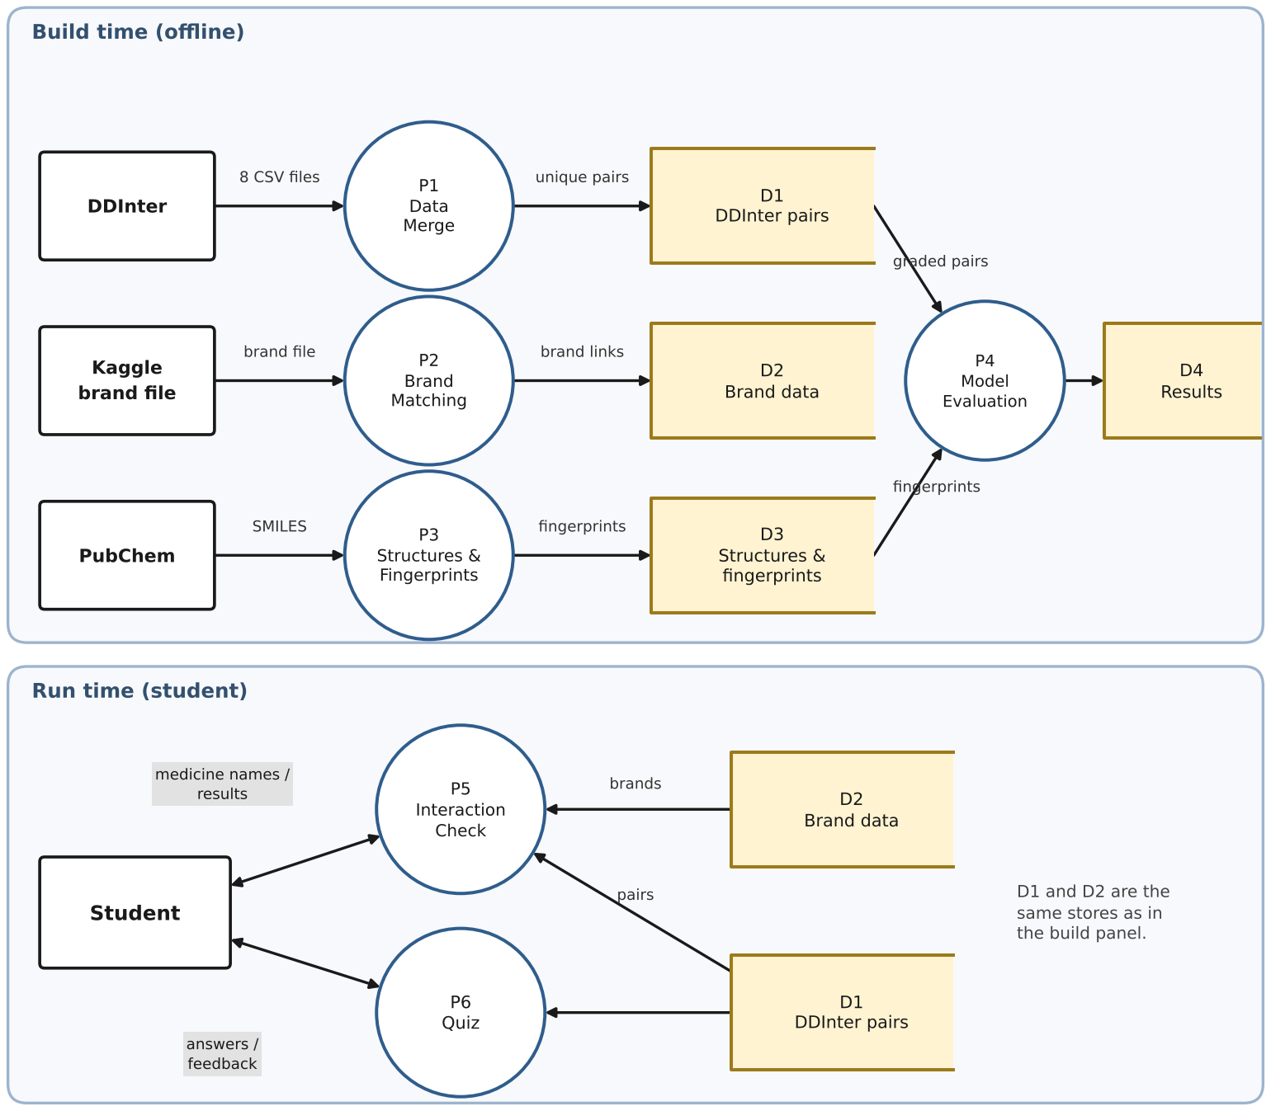
Figure 3: DFD Level 1 — Main System Processes
The Level 1 diagram decomposes the system into six processes — P1 Data Merge, P2 Brand Matching, P3 Structures & Fingerprints, P4 Model Evaluation, P5 Interaction Check, and P6 Quiz — operating against four data stores: D1 (DDInter pairs), D2 (Brand data), D3 (Structures and fingerprints), and D4 (Model results). The figure is drawn in two panels.
The top panel is the build-time chain. DDInter feeds P1, which writes D1. The Kaggle file feeds P2, which writes D2. PubChem feeds P3, which writes D3. P4 reads D1 and D3 and writes D4. P2 and P3 also read the drug names in D1, to know which drugs to match and look up. Those small reads are left out of the figure to keep it readable.
The bottom panel is the run-time chain. The Student exchanges medicine names and results with P5, and answers and feedback with P6. P5 reads D2 and D1, and P6 reads D1. D1 and D2 appear in both panels because they are the same stores.

2.3 Level 2.1 — Model Evaluation
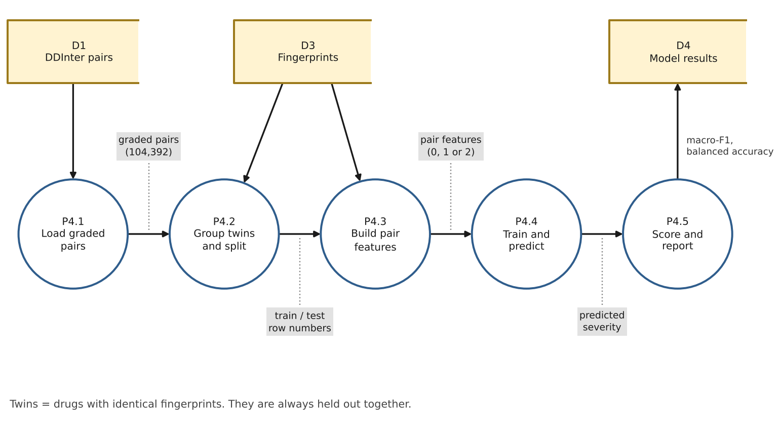
Figure 4: DFD Level 2.1 — Model Evaluation (decomposition of P4)
This diagram decomposes P4 into a pipeline of five sub-processes. P4.1 (Load Graded Pairs) reads D1 and keeps only pairs graded Minor, Moderate or Major where both drugs have a fingerprint, which gives 104,392 pairs. P4.2 (Group Twins and Split) reads the fingerprints in D3, puts drugs with identical fingerprints into one group, and makes the three splits. Twins are held out together, so a drug that is meant to be unseen never has an identical twin in training.
P4.3 (Build Pair Features) adds the two drugs’ fingerprints, so each of the 2,048 positions is 0, 1 or 2 and the order of the two drugs does not matter. P4.4 (Train and Predict) fits XGBoost, runs nearest neighbour, and runs the always-Moderate floor. P4.5 (Score and Report) computes macro-F1 and balanced accuracy and writes them to D4.

2.4 Level 2.2 — Interaction Check
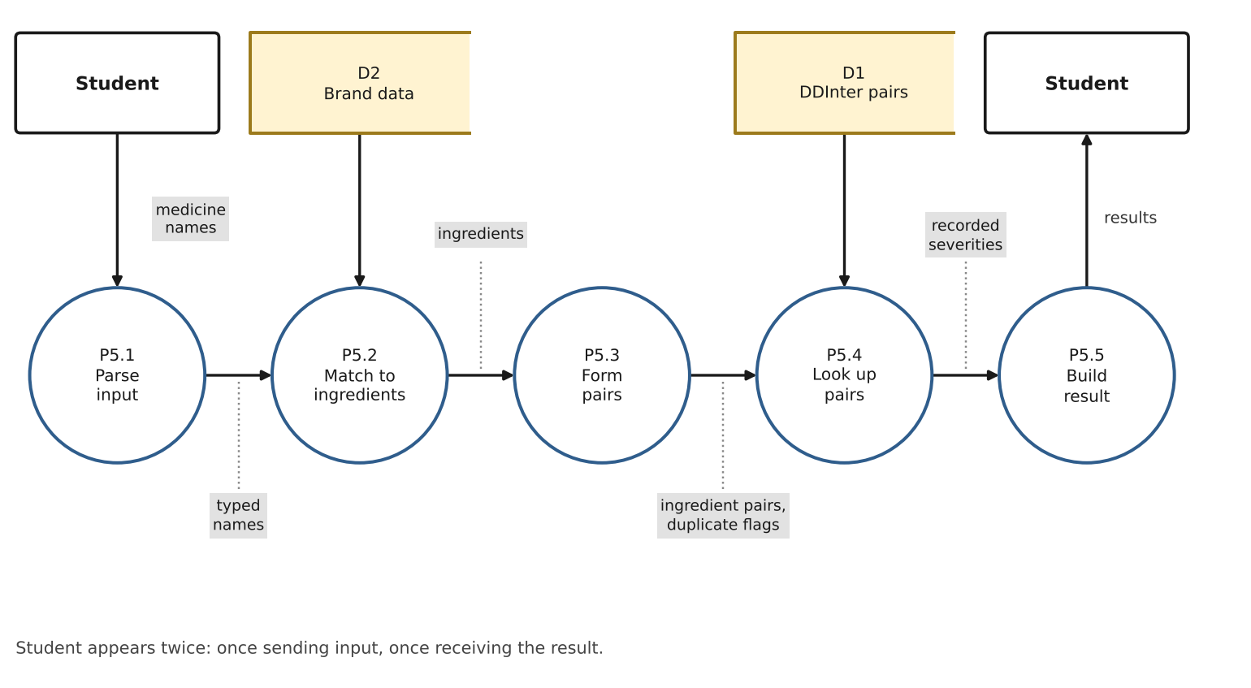
Figure 5: DFD Level 2.2 — Interaction Check (decomposition of P5)
This diagram decomposes P5 into five sub-processes. P5.1 (Parse Input) takes the names the student types. P5.2 (Match to Ingredients) uses D2 to turn a brand into its ingredients and to treat different spellings, such as paracetamol and acetaminophen, as one drug. P5.3 (Form Pairs) builds every pair of ingredients across the chosen medicines and flags the same ingredient in two medicines as duplicate therapy. P5.4 (Look Up Pairs) tries each pair in both orders in D1. P5.5 (Build Result) returns the severity of each recorded pair to the Student.

2.5 System Flow
Student Flow — Search to Quiz
Step | Action | Output
1 | Open the site | Three tabs are shown: Interaction checker, Quiz, and About & limits. No login is needed.
2 | Type two or more medicines (brand or generic) | A Matches list shows each brand with the ingredients behind it.
3 | Read the result | Severity (Minor, Moderate or Major) for each recorded ingredient pair. Duplicate therapy is flagged. A pair listed without a grade is shown as Unknown, with an explanation.
4 | Open the Quiz tab | A question is built from a graded pair. Pairs with no grade are never used.
5 | Answer the question | Feedback on the answer is shown.
6 | Read About & limits | The data sources and what the site covers.

Team Flow — Data to Evaluated Model
Step | Action | Output
1 | Download the 8 DDInter CSV files and the Kaggle brand files | Raw files kept in the project’s data folder.
2 | Run the merge (P1) | 160,235 unique pairs, 0 conflicts.
3 | Run brand matching (P2) | Links from brand ingredients to DDInter drug names.
4 | Run structures and fingerprints (P3) | 1,655 of 1,939 structures from PubChem, each turned into a 2,048-bit fingerprint.
5 | Run the splits and models (P4), repeated with several seeds | A results table of macro-F1 and balanced accuracy, as mean and spread for each model and split.
6 | Build the app data files | Small compressed files in data/app/ that the app loads.

3. ER Diagram
The entity-relationship schema is the planned design for the single SQLite file that will hold the app data. Today the same content lives in a few CSV files. The design moves it into related tables, so that the app and the planned prediction layer read one source. The diagram uses boxes for entities with their attributes listed inside, and diamonds for relationships. PK marks a primary key and FK a foreign key. A dashed box marks a planned entity. Column names for the brand tables are proposed, because the current app reads compressed CSV files directly.
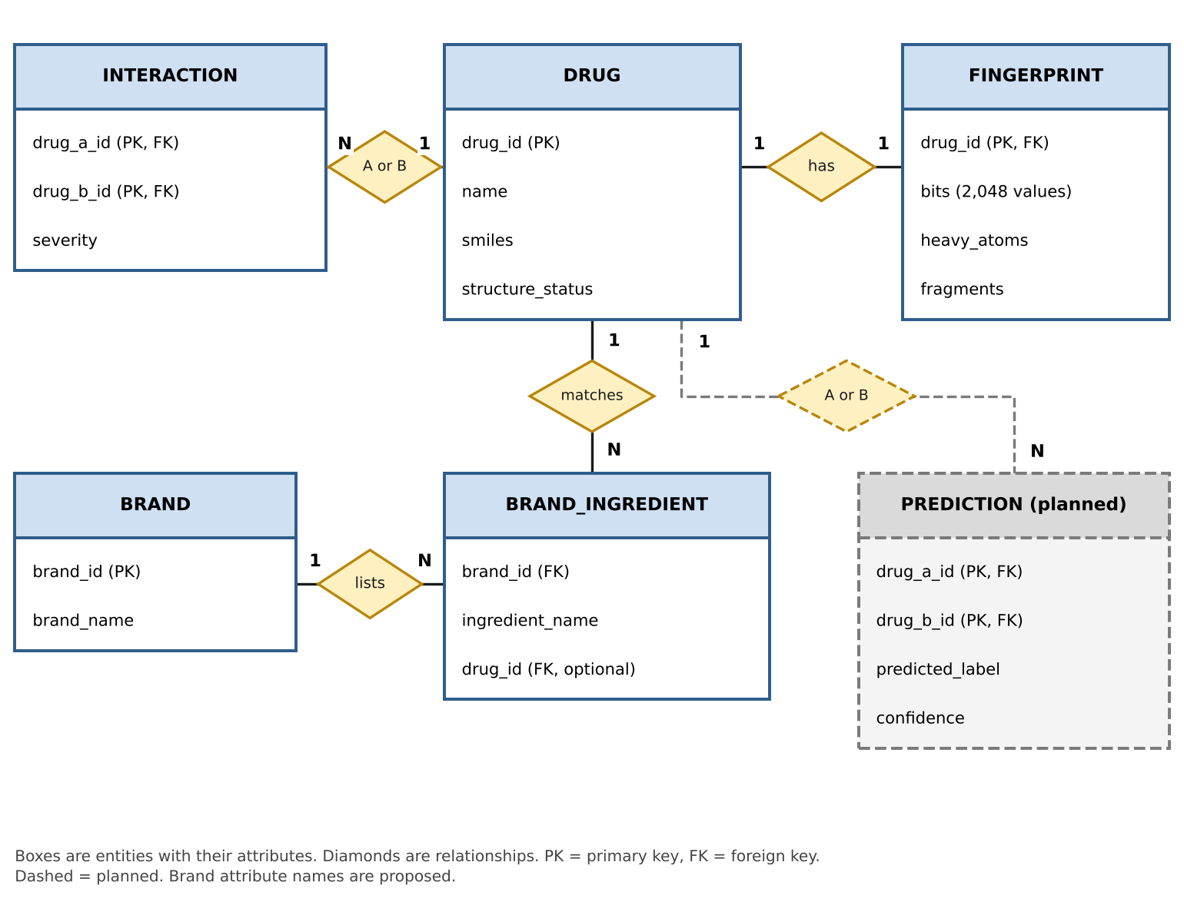
Figure 6: DDI Tutor Entity-Relationship Diagram (planned SQLite schema)

3.1 Entities
DRUG — One row per drug in DDInter (1,939 drugs), with the drug name and, where PubChem returned one, the structure as SMILES text. 1,655 drugs have a structure.
FINGERPRINT — The 2,048 yes/no values built from each drug’s largest structural piece, with its heavy-atom count and the number of pieces in the original structure. One row for each drug that has a structure.
INTERACTION — One row per recorded drug pair (160,235 unique pairs), with a severity of Minor, Moderate or Major, or Unknown where DDInter lists an interaction without a grade.
BRAND — One row per Indian brand in the app data (214,753 rows today). Prices and side-effect text are not kept.
BRAND_INGREDIENT — Links a brand to each of its ingredients. The drug link is left empty when an ingredient could not be matched to a DDInter drug, so the brand can still be shown as “could not be checked” instead of being dropped.
PREDICTION (planned) — A model’s guess for a drug pair that has no recorded interaction. Every row carries the label “Predicted, not confirmed” and is stored apart from INTERACTION.

3.2 Attribute Schema
DRUG
Attribute | Notes
drug_id (PK) | DDInter drug identifier
name | Drug name as written in DDInter
smiles | Structure as text. Empty when no structure was found
structure_status | “found” when PubChem returned a structure
FINGERPRINT
Attribute | Notes
drug_id (PK, FK) | One row for each drug that has a structure
bits | 2,048 yes/no values (Morgan, radius 2)
heavy_atoms | Number of atoms in the largest piece of the structure
fragments | Number of pieces in the original structure (more than one for salts)
INTERACTION
Attribute | Notes
drug_a_id (PK, FK) | First drug of the pair. Each pair is stored once
drug_b_id (PK, FK) | Second drug of the pair. A lookup tries both orders
severity | Minor / Moderate / Major / Unknown
BRAND
Attribute | Notes
brand_id (PK) | Proposed key for each brand row
brand_name | Name as on the pack
BRAND_INGREDIENT
Attribute | Notes
brand_id (FK) | The brand this ingredient belongs to
ingredient_name | Ingredient as written on the pack
drug_id (FK, optional) | The matched DDInter drug. Empty if no match was found
PREDICTION (planned)
Attribute | Notes
drug_a_id (PK, FK) | First drug of the pair
drug_b_id (PK, FK) | Second drug of the pair
predicted_label | The model’s guess. The final fields depend on the planned yes/no model
confidence | Calibrated probability (planned)

3.3 Relationships
From | Relationship | To | Cardinality
DRUG | has | FINGERPRINT | 1:1 (optional)
DRUG | is drug A or B in | INTERACTION | 1:N
DRUG | matches | BRAND_INGREDIENT | 1:N
BRAND | lists | BRAND_INGREDIENT | 1:N
DRUG | is drug A or B in | PREDICTION (planned) | 1:N

3.4 Design Notes
Every table connects through DRUG. INTERACTION links to DRUG twice, once for drug A and once for drug B. BRAND reaches DRUG only through BRAND_INGREDIENT, because one brand can contain several ingredients and one drug appears in many brands.
Each pair is stored once, and a lookup tries both orders. This was checked on 2,000 random pairs typed in both orders, with 0 failures.
PREDICTION is kept apart from INTERACTION on purpose, so that a model’s guess can never be mistaken for a recorded interaction.
BRAND_INGREDIENT.drug_id is optional. A brand whose ingredient has no matching DDInter drug stays in BRAND and is shown as “could not be checked”, instead of being dropped.
There is no user table. The site has no login and no tracking. Groups of drugs with identical fingerprints are worked out when the splits are built and are not stored in the schema.

4. Gantt Diagram
The Gantt chart lays out the remaining work as a proposed eight-week plan in four swim-lanes — Checks, Model, App, and Wrap-up — plus a Completed lane for work already done. Week lengths are planning estimates, not deadlines. The project deadlines are still an open question and will move the chart once the guide confirms them.
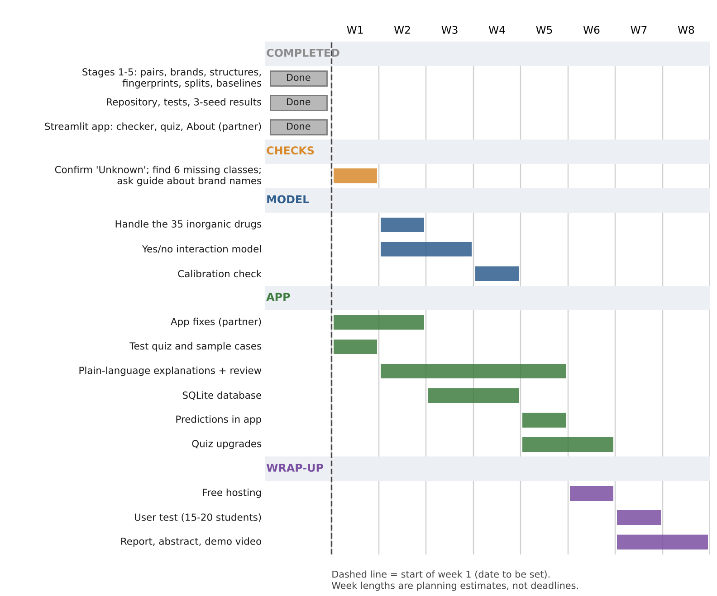
Figure 7: DDI Tutor Project Gantt Chart (proposed plan)
The Completed lane covers Stages 1 to 5 (merged pairs, brand matching, structures, fingerprints, splits and baseline models), the code repository with its tests and licence, the three-seed results, and the partner’s Streamlit app with its lookup logic. The remaining items in Figure 7 have not been completed yet.
Week 1 holds the small checks that decide what the model and the site may claim: confirming that “Unknown” is a real DDInter record, finding the six missing DDInter classes (C, G, J, M, N, S), and asking the guide whether the site may show brand names from the Kaggle data. In the same weeks the partner fixes the app: keeping brands with no matched ingredient, keeping both versions of duplicate brand names, listing pairs checked with no record, and balancing the quiz.
The order of the Model lane follows its dependencies. The yes/no model starts only after the Unknown check. Calibration follows the model. Predictions enter the app only after calibration and after the SQLite database exists. The Wrap-up lane closes the plan with free hosting, a user test with 15 to 20 students (which needs consent and possibly college ethics approval), and the report, abstract and demo video.

5. Interface Design / Wireflow Diagram
The wireflow diagram lays out the screens of the site and the paths between them, translating the Presentation Layer tier of the system architecture (Section 1) into a concrete interface design. Three tabs are built, and four more screens are planned. There is no register or login screen, because the site stores nothing about the student.
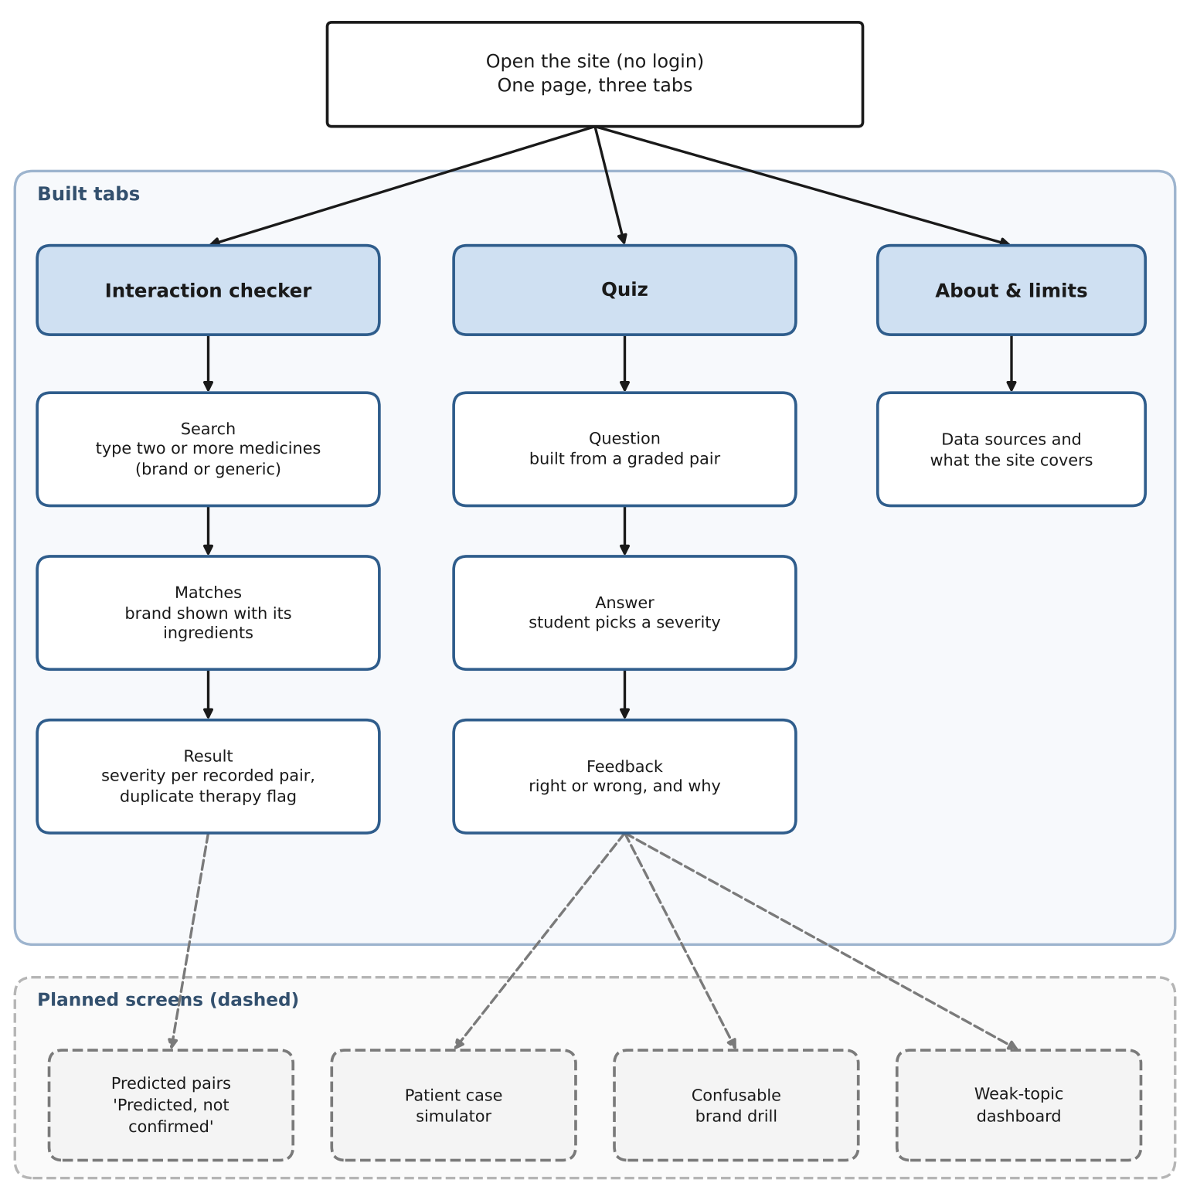
Figure 8: DDI Tutor Interface Design / Wireflow Diagram
The site opens on a single page with three tabs, and the student can move between them freely. The Interaction checker is the main path: the student searches for two or more medicines, sees the Matches list with the ingredients behind each brand, and then reads the result for each recorded pair, with duplicate therapy flagged. The Quiz tab follows a short loop of question, answer, and feedback, built from graded pairs only. The About & limits tab holds the data sources and what the site covers.
The dashed panel shows planned screens. A predicted-pairs view, labelled “Predicted, not confirmed”, would extend the checker result. A patient case simulator, a confusable brand drill, and a weak-topic dashboard would extend the quiz. These are shown below the built tabs so that the plan is clear without changing what exists today.

6. Class Diagram
The class diagram presents the object-oriented structure of the planned system in three groups: the app and its services (StreamlitApp, LookupService, QuizService), the core data classes (Drug, Brand, Interaction), and the build-time classes (FingerprintBuilder, SplitBuilder, Evaluator). The code today is written as modules of functions. The classes group those functions by responsibility, so the design can be reviewed before more is built.
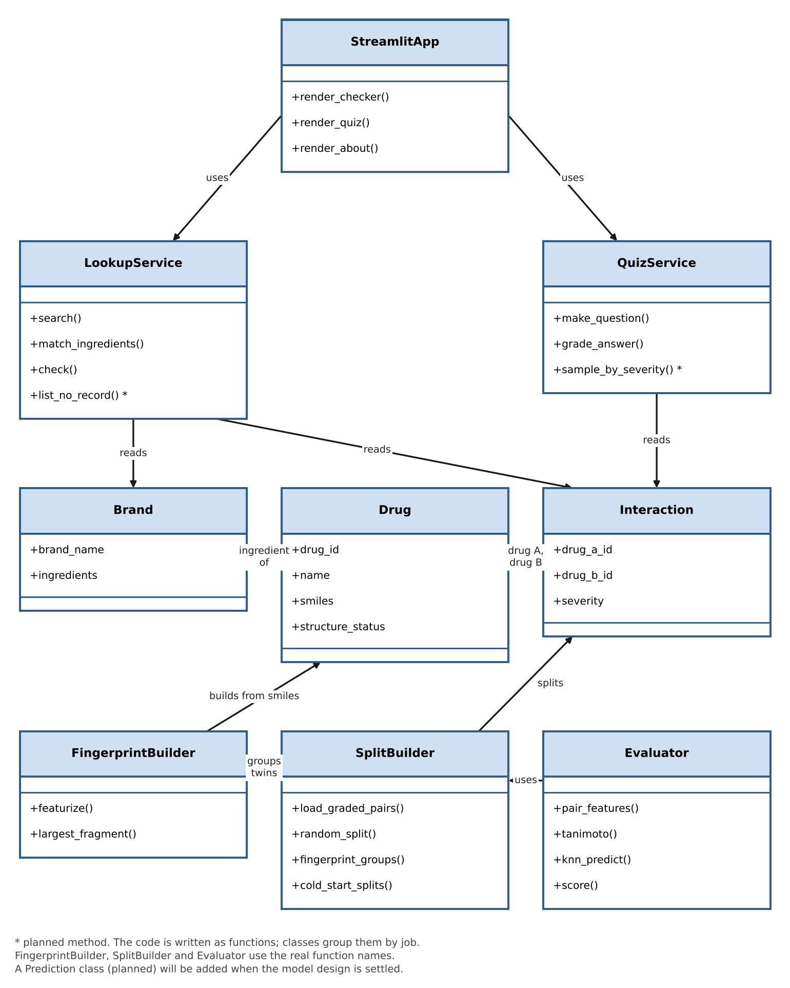
Figure 9: DDI Tutor Class Diagram
StreamlitApp is the only class a student touches. It uses LookupService for the Interaction checker and QuizService for the Quiz. LookupService reads Brand and Interaction: it matches a brand to its ingredients and looks up each pair. QuizService reads Interaction to build questions. Interaction refers to Drug twice, as drug A and drug B, and a Brand is made of ingredients that point to Drug.
On the build side, FingerprintBuilder turns a drug’s structure into a fingerprint. SplitBuilder groups drugs with identical fingerprints and builds the three splits from the graded pairs. Evaluator builds the pair features, runs nearest neighbour, and scores the results. The method names for these three classes are the real function names in the code. LookupService and QuizService use descriptive names, apart from check(). Methods marked with an asterisk are planned.
Read together with the ER diagram in Section 3, this class diagram shows that the data model and the service layer agree on the same boundaries. Interaction stays separate from Brand, every service reads data through the entity classes, and the planned Prediction class will stay apart from Interaction, as PREDICTION does in the ER diagram.

7. Conclusion
This document consolidates the design artefacts for DDI Tutor, a free learning tool that lets medical students check whether two medicines interact and how serious it is. The architecture block diagram separates the build-time work that runs offline from the run-time site that a student uses, and joins them at one data store. The data flow diagrams trace data from the three sources through the pipeline, and then down to the sub-processes of model evaluation and the interaction check.
The ER diagram and the class diagram give two views of the same design. The ER diagram defines a planned SQLite schema centred on DRUG, with INTERACTION, BRAND, BRAND_INGREDIENT, FINGERPRINT, and a separate PREDICTION table. The class diagram groups the existing code into app, data, and build-time classes. Together they keep recorded interactions apart from predictions, and they keep a brand with an unmatched ingredient in the data instead of dropping it.
The Gantt chart sets out a proposed eight-week plan for the remaining work, and the wireflow shows the three built tabs and the four planned screens. Together, these artefacts show that DDI Tutor is consistent across every level of abstraction: the same six processes, the same data stores, and the same separation between recorded interactions and predictions appear in the architecture, the data flow diagrams, the ER diagram, and the class diagram.
This document will serve as the planning reference for the remaining implementation, testing, and evaluation of DDI Tutor under the guidance of Dr. Jawahar S.

