Detecting Unfair Clauses in Online Terms of Service Agreements Using Natural Language Processing

Table of Contents
Table of Contents 2
1. Introduction 3
2. Literature Survey 3
2.1 Lippi et al. (2019) — CLAUDETTE 3
2.2 Ruggeri et al. (2022) — Memory-Augmented Neural Networks 4
2.3 Chalkidis et al. (2020) — LEGAL-BERT 4
2.4 Dadas et al. (2025) — A Support System for Detecting Abusive Clauses in B2C Contracts 4
2.5 Xu and Markert (2022) — Adversarial Robustness of Unfair-ToS Classifiers 5
3. Research Gap and Problem Statement 5
4. Dataset 5
5. Text Preprocessing 7
5.1 Preprocessing for the TF-IDF baseline 7
5.2 Preprocessing for the DistilBERT model 7
6. NLP Technique Implementation 8
6.1 Baseline: TF-IDF + One-vs-Rest Logistic Regression 8
6.2 Fine-tuned Transformer: DistilBERT 8
6.3 Threshold Tuning and Model Comparison 8
6.4 Deployment 9
7. Evaluation 9
8. Critical Analysis: Strengths and Limitations 10
8.1 Strengths 10
8.2 Limitations 11
9. System Screenshot 12
10. Conclusion 12
References 13

1. Introduction
Online platforms routinely require users to accept lengthy Terms of Service (ToS) agreements before granting access to a service. These documents are written in dense legal language and frequently run to several thousand words, making it impractical for the average consumer to read them in full. Prior empirical studies of consumer contracts have repeatedly found that such agreements often contain clauses that are unilaterally unfavourable to the user — for example, clauses that let the provider terminate the contract at will, unilaterally modify the terms without notice, remove user content, or limit the provider's liability — while imposing binding obligations on the consumer. Because ToS agreements are effectively “click-to-accept” contracts, most users consent to these terms without ever reading them, a phenomenon widely referred to as the consent gap.
This creates a real-world application domain for Natural Language Processing: automatically scanning a ToS document and flagging sentences that are likely to belong to one or more categories of potentially unfair clauses, so that a consumer, journalist, or regulator can review the flagged sentences instead of the entire document. This is naturally framed as a multi-label sentence classification problem, since a single sentence in a ToS document can simultaneously fall under more than one category of unfairness (for instance, a sentence that both reserves a unilateral right to terminate the contract and to remove user content).
This report documents an end-to-end system, the Unfair ToS Clause Detector, that was built to address this problem: from exploratory data analysis on a benchmark legal NLP dataset, through a classical machine learning baseline and a fine-tuned transformer model, to a deployed backend and web front end that a user can paste ToS text into and receive per-sentence unfairness predictions.

2. Literature Survey
Automated detection of unfair terms in consumer contracts is an established sub-area of legal NLP. The following five works were reviewed to situate this project within existing research.

2.1 Lippi et al. (2019) — CLAUDETTE
Lippi et al. introduced CLAUDETTE, the first large-scale system for automatically detecting potentially unfair clauses in online Terms of Service. The authors built a corpus of 50 English-language European consumer contracts, sentence-annotated across eight categories of unfairness (the same eight categories used in this project), and compared classical models — Support Vector Machines, Hidden Markov Models, and Tree Kernels — against CNN and LSTM architectures. Their pipeline separated detection (is a sentence potentially unfair) from classification into unfairness type, and demonstrated that machine learning could meaningfully assist legal review of consumer contracts. This work is the origin of the UNFAIR-ToS category taxonomy adopted in this project via the LexGLUE benchmark.

2.2 Ruggeri et al. (2022) — Memory-Augmented Neural Networks
Building on CLAUDETTE, Ruggeri et al. extended unfair-clause detection with memory-network architectures that not only classify a clause but also retrieve legal rationales explaining why it is unfair. Their explanation-oriented approach highlighted that raw classification accuracy is not sufficient for a legal-tech tool: a system intended for consumers or legal reviewers benefits from interpretable output, not just a label, a consideration that motivates the disagreement view used in this project's front end.

2.3 Chalkidis et al. (2020) — LEGAL-BERT
Chalkidis et al. showed that domain-adapted transformer models, pre-trained on legal corpora rather than general text, outperform general-purpose language models on legal NLP tasks such as unfair-clause detection. Their work established that transfer learning from a transformer backbone is generally superior to purely lexical baselines like TF-IDF on legal text, providing part of the motivation for including a fine-tuned DistilBERT model alongside the TF-IDF baseline in this project.

2.4 Dadas et al. (2025) — A Support System for Detecting Abusive Clauses in B2C Contracts
Dadas et al. proposed a retrieval-augmented support system for flagging abusive clauses in business-to-consumer contracts, aimed explicitly at practical deployment rather than benchmark performance alone. Their emphasis on building a usable end-user support tool, rather than stopping at a leaderboard score, directly informed this project's decision to pair the classification models with a deployed FastAPI backend and a browser-based front end.

2.5 Xu and Markert (2022) — Adversarial Robustness of Unfair-ToS Classifiers
Xu and Markert studied the robustness of fine-tuned LEGAL-BERT classifiers on the CLAUDETTE dataset and found that universal adversarial triggers could flip correct unfair predictions to fair with small, almost imperceptible input perturbations. This finding is a caution against treating high macro-F1 scores as a complete measure of a deployed system's reliability, and is referenced in the limitations discussed in Section 8 of this report.

3. Research Gap and Problem Statement
The literature establishes that unfair-clause detection is feasible and that transformer models generally outperform classical lexical models on this task. However, most published work (i) reports benchmark-only results without a comparably documented deployment path from a saved model to a usable interface, and (ii) rarely reports a transparent, reproducible comparison between a lightweight classical baseline and a fine-tuned transformer on identical splits with per-category thresholds tuned separately for each model, which matters because the eight unfairness categories are highly imbalanced (as shown in Section 4) and a single global decision threshold of 0.5 is not equally appropriate for a category with 191 positive training examples and one with 28.
This project addresses that gap with the following problem statement: given a sentence extracted from an online Terms of Service document, predict which, if any, of eight categories of unfairness (limitation of liability, unilateral termination, unilateral change, content removal, contract by using, choice of law, jurisdiction, and arbitration) apply to it, using a multi-label classification approach; compare a classical TF-IDF and Logistic Regression baseline against a fine-tuned DistilBERT model with per-category tuned thresholds on identical chronological data splits; and deploy the better-performing model behind a backend API and browser interface so that a full ToS document can be pasted in and reviewed sentence-by-sentence.

4. Dataset
The project uses coastalcph/lex_glue (unfair_tos configuration), the UNFAIR-ToS task from the LexGLUE benchmark, sourced as Parquet files from the Hugging Face Hub. This dataset descends from the CLAUDETTE corpus described in Section 2.1 and retains its eight-category unfairness taxonomy. Each example is a single sentence extracted from a real online ToS document, multi-hot labelled across the eight categories (a sentence with no unfair category is labelled “neutral”).
A deliberate design choice, carried over from the LexGLUE benchmark, is that the train/validation/test splits are chronological rather than randomly shuffled: training sentences are drawn from contracts dated 2006–2016, while both validation and test sentences are drawn from 2017 contracts. This was kept as-is (rather than reshuffled for a larger training set) specifically to remain comparable with previously published LexGLUE results.
Table 1: Dataset split sizes
Split | Sentences
Train (2006–2016) | 5,532
Validation (2017) | 2,275
Test (2017) | 1,607

Table 2: Category frequency in the training split
Category | Train count | % of train sentences
Limitation of liability | 191 | 3.45%
Unilateral termination | 139 | 2.51%
Unilateral change | 122 | 2.21%
Contract by using | 76 | 1.37%
Content removal | 73 | 1.32%
Choice of law | 39 | 0.70%
Jurisdiction | 34 | 0.61%
Arbitration | 28 | 0.51%

Class imbalance is severe: 4,902 of the 5,532 training sentences (88.6%) carry no unfairness label at all, and even among the flagged sentences the rarest category (Arbitration, 28 examples) has under one-seventh the support of the most frequent category (Limitation of liability, 191 examples). Sentence length also varies considerably — a median of 26 words, a 95th percentile of 75 words, and a 99th percentile of 122 words — which was used later to size the transformer's maximum input length.

5. Text Preprocessing
Preprocessing was tailored separately to the two modelling approaches, since a lexical TF-IDF model and a subword-based transformer benefit from different treatments of raw text.

5.1 Preprocessing for the TF-IDF baseline
- Lower-casing and scikit-learn's default tokenisation pattern applied inside TfidfVectorizer.
- Both unigrams and bigrams (ngram_range=(1,2)) retained, since a grid search (Section 6) showed bigrams consistently outperformed unigrams alone — legal phrases such as “reserves the right” and “without notice” carry meaning as a unit that unigrams lose.
- No aggressive stopword removal or stemming/lemmatisation was applied before vectorisation, since legal boilerplate phrasing (e.g. modal verbs like “may”, “shall”) is itself discriminative for this task and stripping it would remove signal rather than noise.
- Sentences shorter than a minimal length were already filtered out at the dataset-construction stage of the underlying UNFAIR-ToS benchmark.

5.2 Preprocessing for the DistilBERT model
- Text was tokenised using the pretrained distilbert-base-uncased WordPiece tokenizer, which performs its own lower-casing and subword segmentation — no separate manual normalisation was applied, since transformer tokenizers are trained to handle raw text directly.
- Maximum sequence length was chosen empirically rather than assumed: the tokenizer was run over the training sentences to obtain the actual token-count distribution (subword tokens run roughly 1.3× longer than raw word counts on legal text), and the smallest candidate length from {64, 96, 128, 192, 256} that covered the 99th percentile of token counts was selected, avoiding both wasted computation from an oversized length and truncation of long sentences from an undersized one.
- Labels were converted to a multi-hot vector matching the eight-category taxonomy for the multi_label_classification loss configuration.

6. NLP Technique Implementation
Two complementary NLP techniques were implemented and compared: a classical bag-of-n-grams linear model, and a fine-tuned transformer language model. Both were trained as multi-label classifiers over the same eight categories.

6.1 Baseline: TF-IDF + One-vs-Rest Logistic Regression
The baseline pipeline vectorises each sentence with TF-IDF over unigrams and bigrams, then fits a One-vs-Rest Logistic Regression classifier with class_weight="balanced" to counteract the severe per-category imbalance shown in Table 2. A grid search was run over ngram_range ∈ {(1,1), (1,2)} and C ∈ {0.1, 1, 5, 10}, scored on validation macro-F1. Since macro-F1 was still increasing at the largest C in the initial grid (C=10), the search was extended to C ∈ {10, 20, 30, 50} rather than accepting a boundary optimum; validation macro-F1 peaked at C=30 (0.7113) and declined at C=50 (0.7097), confirming a genuine interior maximum.

6.2 Fine-tuned Transformer: DistilBERT
distilbert-base-uncased was fine-tuned end-to-end for multi-label classification (problem_type="multi_label_classification") using a custom Trainer with a weighted BCEWithLogitsLoss. Per-category pos_weight values (computed as the ratio of negative to positive training examples for each category) were used as the multi-label analogue of the class_weight="balanced" setting used in the baseline, so that rare categories such as Arbitration are not drowned out by the abundant neutral sentences during training. The checkpoint with the highest validation macro-F1 across training epochs was retained (load_best_model_at_end=True) rather than simply the final epoch's weights.

6.3 Threshold Tuning and Model Comparison
Both models produce a probability per category rather than a hard label. Rather than applying a flat 0.5 cut-off — which is a reasonable default but not calibrated to each category's base rate — per-category decision thresholds were swept on validation-set probabilities separately for each model, and the tuned thresholds for both models are stored and applied at inference time in the backend, rather than a single shared threshold.

6.4 Deployment
Both frozen models (the TF-IDF/Logistic Regression pipeline and the DistilBERT checkpoint, with their respective tuned thresholds) are loaded once at start-up by a FastAPI backend, which exposes /predict and /predict/batch endpoints and supports a dual-model comparison mode. A browser-based front end (“Redline”) splits a pasted ToS document into sentences, batches them to /predict/batch, and renders per-sentence unfairness flags alongside a view that highlights sentences where the baseline and DistilBERT disagree.

7. Evaluation
Both models are evaluated with macro-averaged and micro-averaged F1 across the eight unfairness categories, since accuracy alone is uninformative on a task where 88.6% of sentences are neutral. Macro-F1 in particular is the primary metric, since it weights every category equally regardless of how rare it is — which matters here, given that Arbitration has only 28 training and 9 validation examples.
Table 3: Baseline validation performance by category (C = 30, ngram_range = (1,2))
Category | Precision | Recall | F1 | Support
Jurisdiction | 0.84 | 0.89 | 0.86 | 18
Choice of law | 0.93 | 0.72 | 0.81 | 18
Unilateral termination | 0.71 | 0.80 | 0.75 | 59
Contract by using | 0.61 | 0.94 | 0.74 | 18
Content removal | 0.74 | 0.62 | 0.68 | 32
Limitation of liability | 0.61 | 0.76 | 0.68 | 67
Unilateral change | 0.56 | 0.68 | 0.61 | 28
Arbitration | 0.56 | 0.56 | 0.56 | 9
Macro average | 0.69 | 0.75 | 0.71 | 249

Table 4: Final head-to-head comparison (test set, per-category tuned thresholds)
Model | Macro-F1
TF-IDF + Logistic Regression (baseline) | 0.761
Fine-tuned DistilBERT | 0.795

On the baseline's validation-set breakdown, the weakest three categories are Arbitration (F1 0.56, only 9 validation examples — too few to draw a firm conclusion), Unilateral change (F1 0.61, plausibly confused with Unilateral termination given their semantic overlap and correlated occurrence), and Limitation of liability (F1 0.68 — the largest category, so its errors weigh heavily on the macro average in absolute terms even though its F1 is mid-range). With per-category thresholds tuned on the validation set and applied to the held-out test set, DistilBERT outperforms the TF-IDF baseline by roughly 3.4 macro-F1 points (0.795 vs 0.761), consistent with the literature reviewed in Section 2 showing transformer models generally outperforming lexical baselines on legal text, while the baseline remains a fast, fully interpretable, and computationally cheap point of comparison.

8. Critical Analysis: Strengths and Limitations

8.1 Strengths
- Chronological rather than random data splitting avoids optimistic leakage between similarly-worded contracts from the same time period, and keeps results comparable to published LexGLUE benchmarks.
- Per-category class weighting (class_weight="balanced" for the baseline, pos_weight for DistilBERT) directly addresses the 88.6% neutral-class imbalance rather than ignoring it.
- Per-category threshold tuning, instead of a flat 0.5 cut-off, respects the fact that categories with very different base rates (28 to 191 training examples) do not share a single optimal decision boundary.
- The system was carried through to a working deployment (FastAPI backend plus a browser front end), rather than stopping at a benchmark number, addressing the practical-usability gap identified in Section 3.
- An extended hyperparameter search (grid re-run past its original boundary once the trend suggested a better value lay outside it) reflects sound experimental practice rather than accepting a truncated-grid artifact.

8.2 Limitations
- The rarest categories (Arbitration: 28 train / 9 validation examples; Jurisdiction and Choice of law: 18 validation examples each) are too small to yield statistically reliable per-category F1 estimates; a single misclassified sentence measurably swings these scores.
- The dataset originates from a small set of 2006–2017 European consumer contracts; a model trained on it may not generalise to contracts drafted after 2017, to non-European jurisdictions, or to service categories not represented in the original 50-contract corpus (cf. Section 2.1).
- Sentence-level classification cannot capture unfairness that only becomes apparent across multiple sentences or in the context of a whole clause or section — a limitation inherited directly from the underlying dataset's sentence-level annotation scheme.
- As shown by Xu and Markert (2022, Section 2.5), fine-tuned transformer classifiers on this exact task family have been shown to be vulnerable to small adversarial input perturbations; robustness against adversarially or even accidentally unusual phrasing was not evaluated in this project.
- Evaluation at a flat 0.5 threshold during DistilBERT's own training loop (Section 3 of the fine-tuning notebook) is explicitly provisional and only used for a training sanity-check — the reported final comparison relies on the separate, tuned per-category thresholds, and this distinction should not be conflated when reading the two numbers.
- The exploratory data analysis notebook's class-imbalance summary section was left as a fill-in-the-blank template in the submitted notebook rather than populated with the actual run's numbers, which this report has filled in directly from the executed cell outputs.

9. System Screenshot
The following space is reserved for a screenshot of the deployed “Redline” front end (index.html), showing pasted Terms of Service text with per-sentence unfairness flags and the baseline-vs-DistilBERT disagreement view.
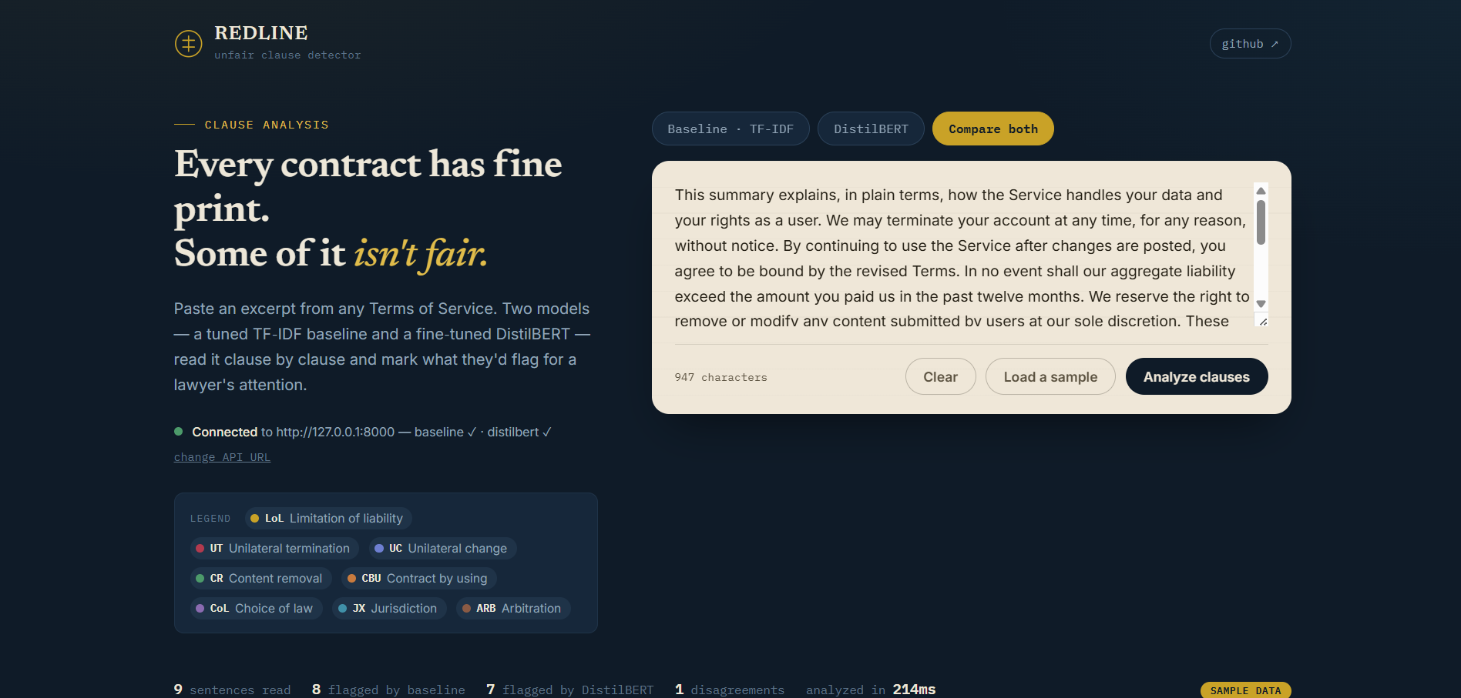
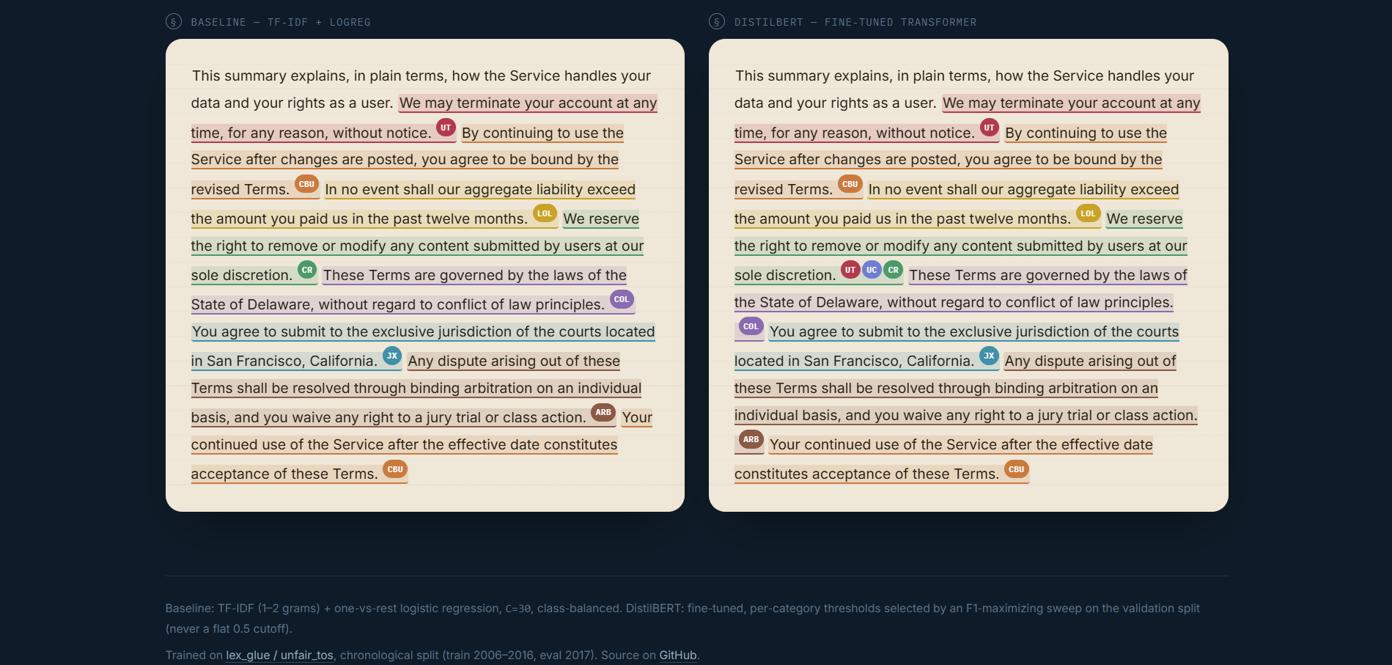
Figure 1: Redline front end — sentence-level unfair-clause flagging interface

10. Conclusion
This project implemented and compared two NLP approaches — a TF-IDF and Logistic Regression baseline, and a fine-tuned DistilBERT transformer — for multi-label detection of unfair clauses in online Terms of Service documents, using the UNFAIR-ToS configuration of the LexGLUE benchmark. With per-category tuned decision thresholds, DistilBERT achieved a macro-F1 of 0.795 against the baseline's 0.761 on the held-out test set, consistent with prior legal-NLP literature favouring domain-adapted transformer models over purely lexical ones. The better-performing model was deployed behind a FastAPI backend and a browser-based front end, moving the work from a benchmark exercise toward a usable consumer-facing tool, while the analysis in Section 8 identifies the small-category data scarcity, dataset recency, sentence-level annotation granularity, and adversarial robustness as the main limitations to address in future work.

References
Lippi, M., Palka, P., Contissa, G., Lagioia, F., Micklitz, H.-W., Sartor, G., & Torroni, P. (2019). CLAUDETTE: An automated detector of potentially unfair clauses in online terms of service. Artificial Intelligence and Law, 27(2), 117–139.
Ruggeri, F., Lagioia, F., Lippi, M., & Torroni, P. (2022). Detecting and explaining unfairness in consumer contracts through memory networks. Artificial Intelligence and Law, 30(1), 59–92.
Chalkidis, I., Fergadiotis, M., Malakasiotis, P., Aletras, N., & Androutsopoulos, I. (2020). LEGAL-BERT: The Muppets straight out of law school. In Findings of the Association for Computational Linguistics: EMNLP 2020 (pp. 2898–2904904).
Dadas, S., Kozłowski, M., Poświata, R., Perełkiewicz, M., Białas, M., & Grębowiec, M. (2025). A support system for the detection of abusive clauses in B2C contracts. Artificial Intelligence and Law, 33(4), 913–951.
Xu, S., & Markert, K. (2022). Attack on unfair ToS clause detection: A case study using universal adversarial triggers. In Proceedings of the 2022 Natural Legal Language Processing Workshop (NLLP).
Chalkidis, I., Jana, A., Hartung, D., Bommarito, M., Androutsopoulos, I., Katz, D., & Aletras, N. (2022). LexGLUE: A benchmark dataset for legal language understanding in English. In Proceedings of the 60th Annual Meeting of the Association for Computational Linguistics.

