aSPARK
Enterprise Architecture Handbook
The modular platform for deterministic, policy-driven, fully traceable software delivery
Version 1.1 · July 2026 · reflects aSPARK Core v0.4.0 and aSPARK-graph v0.7.0
Audience: Developers · Enterprise Architects · Engineering Leadership

Contents

1 Executive Summary
aSPARK is an enterprise software engineering platform that standardizes how organizations specify, plan, build, review and preserve software — deterministically, policy-driven and fully traceable.

1.1 Vision
Modern software organizations do not fail because individual engineers lack tools. They fail because delivery processes, engineering knowledge, governance and organizational standards live in disconnected silos: the process is in wiki pages, the knowledge is in people's heads, the governance is in PDF guidelines nobody reads, and the standards are re-invented per team. AI-assisted development has amplified this fragmentation — generation is cheap, but consistency, traceability and compliance have become the bottleneck.
aSPARK is conceived as the answer to this fragmentation. It is not a single AI coding plugin. It is a modular platform that separates four concerns into independent, composable products:
- Delivery — a deterministic workflow (Specify → Plan → Act → Review → Keep) with quality gates and traceability identifiers, provided by aSPARK Core.
- Knowledge — a deterministic engineering knowledge graph connecting stories, tasks, code, tests and releases, provided by aSPARK-graph.
- Governance — enterprise-owned policy-as-code with hierarchical inheritance, provided by aSPARK-policy.
- Transparency — engineering KPIs, delivery analytics and architecture health, provided by aSPARK-insights.
Two further products complete the platform: aSPARK-ci automates gate and policy enforcement inside existing CI/CD platforms, and aSPARK-memory (future) preserves architectural decisions and organizational lessons as durable engineering memory. aSPARK Enterprise packages all of these into a supported distribution.

1.2 Mission
The mission of the platform can be stated in one sentence:
Mission
Make AI-assisted software delivery deterministic, governable and auditable at enterprise scale — without embedding customer knowledge into agents, and without taking ownership of standards away from the enterprise.

Every architectural decision in this handbook derives from that sentence. Determinism demands rebuildable read models and versioned inputs. Governability demands that policies are separated from process and owned by the enterprise. Auditability demands traceability identifiers across the entire lifecycle and gate evidence that survives the delivery.

1.3 Strategic Positioning
aSPARK deliberately positions itself between two existing market categories, occupying a space that neither serves:
Category | What it optimizes | What it lacks
AI coding assistants (plugins, copilots) | Individual developer throughput | Process, governance, traceability, organizational memory
ALM / process suites | Ticketing, planning, reporting | Deep code-level knowledge, deterministic AI integration, policy-as-code
aSPARK platform | End-to-end delivery: process + knowledge + governance + analytics | — (composable by design; integrates with both categories)

This positioning has a direct architectural consequence: aSPARK never tries to replace source control, CI/CD platforms or issue trackers. It integrates with them through stable interfaces and adds the layer they cannot provide — a deterministic, policy-governed engineering fabric that spans the whole lifecycle.

1.4 What This Handbook Covers
This handbook is the authoritative architecture reference for the aSPARK product family. It serves three audiences:
Audience | Primary chapters | Purpose
Developers & platform engineers | 6–12, 14, 17 | Technical reference: components, APIs, data models, integration
Enterprise & solution architects | 4–10, 13, 15 | Reference architecture: principles, C4 models, governance, deployment
Decision makers & engineering leadership | 1–3, 13, 15, 16 | Strategy, value, compliance posture, roadmap

Chapters 2–5 establish the strategic and conceptual foundation. Chapters 6–12 form the technical core: C4 architecture, dependencies, repositories, policies, the knowledge graph, the workflow engine and the agent architecture. Chapters 13–16 address the enterprise context: governance, CI/CD integration, deployment and roadmap. The appendix provides complete configuration examples, schemata and sequence diagrams for every SPARK phase.

1.5 Key Takeaways
- aSPARK is a platform of independent products, not a monolith. Each product has one responsibility and stable interfaces.
- Determinism is the default. Given the same repository state, artifacts and policy versions, every derived model — graph, validation results, KPIs — is bit-for-bit reproducible.
- Policies belong to the enterprise. aSPARK ships mechanisms, not opinions. Standards are versioned policy packs owned and published by the customer organization.
- Agents are stateless consumers of platform capabilities. They never embed customer knowledge; they consume active policies, graph context and skills at runtime.
- Traceability spans the entire lifecycle. Every story, acceptance criterion, non-functional requirement, task, code unit, test and release carries stable identifiers that the graph connects.

2 Product Strategy
Why aSPARK exists, which problems it solves, and which deliberate non-goals keep the platform focused.

2.1 The Problem Landscape
Enterprise software delivery suffers from five structural problems that individually look like tooling gaps but collectively form a systemic failure mode:

2.1.1 Process erosion
Delivery processes are documented in wikis and slide decks, but enforcement depends on discipline. Under deadline pressure, steps are skipped: specifications are written after the code, reviews become rubber stamps, and "definition of done" degrades into folklore. The process exists on paper; it does not exist operationally.

2.1.2 Knowledge decay
The mapping between requirements and code lives in people's heads. When engineers rotate, the organization loses the ability to answer basic questions: *Which code implements this requirement? What breaks if we change this module? Which tests actually verify this acceptance criterion?* Conventional tooling can answer none of these deterministically.

2.1.3 Governance without teeth
Enterprises invest heavily in architecture guidelines, security baselines and coding standards — and then distribute them as documents. There is no machine-readable representation, no automated validation, no versioning of the standards themselves, and no way to prove at audit time which standard applied to which release.

2.1.4 Non-deterministic AI adoption
AI coding assistants generate different output for identical input, embed no organizational context, and leave no audit trail. Enterprises face a dilemma: adopt AI and lose control, or reject AI and lose competitiveness. Most attempts to solve this embed company-specific prompts into agents — creating a new, worse silo: customer knowledge trapped inside AI configuration.

2.1.5 Blind analytics
Engineering KPIs are computed from ticket metadata because tickets are the only structured data available. Cycle time, velocity and throughput say nothing about architecture health, traceability coverage or technical debt, because no data source connects requirements to code to quality evidence.

2.2 The aSPARK Answer
aSPARK addresses each structural problem with a dedicated product, connected through shared artifacts and stable interfaces:
Structural problem | aSPARK answer | Product
Process erosion | Executable workflow with mandatory quality gates; phases produce versioned artifacts | aSPARK Core
Knowledge decay | Deterministic knowledge graph derived from code and artifacts; queryable, rebuildable | aSPARK-graph
Governance without teeth | Policy-as-code with hierarchical inheritance; machine-validated, versioned, enterprise-owned | aSPARK-policy
Non-deterministic AI adoption | Stateless agents consuming policies, skills and graph context; every action gated and evidenced | aSPARK Core + Policy
Blind analytics | KPIs computed from the graph and gate evidence instead of ticket metadata | aSPARK-insights

2.3 Value Hypotheses
The platform's business case rests on measurable value hypotheses. Each is stated with its expected mechanism so that adopting organizations can validate it against their own baseline:
- Lower onboarding cost. New engineers query the graph instead of interviewing colleagues; the SPARK workflow makes the delivery process self-explanatory. Expected effect: time-to-first-productive-change drops significantly.
- Consistent software quality. Gates make quality criteria non-skippable; policies make standards machine-enforced. Expected effect: defect escape rate and review rework decrease.
- Deterministic AI-assisted development. Identical inputs produce identical derived models; AI contributions are policy-constrained and evidenced. Expected effect: AI adoption without governance regression.
- Auditability by construction. Traceability IDs and gate evidence exist as a by-product of delivery, not as an audit-time reconstruction. Expected effect: audit preparation effort collapses.
- Reusable governance. Policy packs are written once at company level and inherited by every project. Expected effect: standards roll-outs take days, not quarters.

2.4 Non-Goals
A platform is defined as much by what it refuses to do. The following are explicit non-goals, chosen to keep aSPARK composable and to avoid competing with entrenched systems:
- Not a source control system. aSPARK reads and writes repositories; it never replaces Git hosting.
- Not a CI/CD engine. aSPARK-ci provides steps and validations that run *inside* GitHub Actions, GitLab CI, Azure DevOps or Jenkins.
- Not an issue tracker. Stories in .spark can synchronize with external trackers, but aSPARK does not aim to replace backlog management for the whole organization.
- Not an AI model provider. Model access is pluggable and optional; the platform is valuable even in fully offline, non-AI operation.
- Not a consultancy artifact. Standards, policies and processes remain owned by the enterprise; aSPARK provides the machinery, never the opinions.

2.5 Design Tenets Derived from Strategy
Strategy translates into three tenets that recur throughout this handbook:
Tenet 1 — Separation of concerns as product boundaries
Process, knowledge, governance and analytics are different products with different owners, release cycles and interfaces. A weakness in one must never require changes in another.

Tenet 2 — Derived state is disposable
Everything that can be recomputed — the graph, validation results, KPIs — is a read model. Deleting it loses nothing; rebuilding it is deterministic. Only artifacts and source are primary state.

Tenet 3 — The enterprise stays sovereign
Policies, standards and organizational knowledge live in enterprise-owned repositories, versioned by the enterprise, deployable on enterprise infrastructure. No lock-in of governance into vendor systems.

3 Product Family
Seven products, one platform: responsibilities, interfaces and maturity of every member of the aSPARK family.

3.1 Overview
The product family follows a strict layering: aSPARK Core is the foundation with no dependencies; aSPARK-graph derives knowledge from Core's artifacts and the repository; aSPARK-policy, aSPARK-insights and aSPARK-ci build on both; aSPARK-memory will consume graph history; and aSPARK Enterprise packages everything into a supported distribution.
Product | One-line responsibility | Maturity
aSPARK Core | Delivery workflow, agents, skills, templates, quality gates, traceability IDs | Foundation
aSPARK-graph | Deterministic engineering knowledge graph with impact analysis and MCP interface | Platform
aSPARK-policy | Policy-as-code, enterprise standards, governance and compliance | Platform
aSPARK-insights | Engineering KPIs, delivery analytics, architecture health, debt indicators | Platform
aSPARK-ci | Gate validation, graph freshness, policy enforcement and release validation in pipelines | Platform
aSPARK-memory | Persistent engineering memory: ADRs, decisions, historical context, lessons learned | Future
aSPARK Enterprise | Packaged distribution of Core, Graph, Policy, Insights and CI | Distribution

3.2 aSPARK Core
Core is the platform foundation and the only product a single developer needs to start. It implements the SPARK delivery workflow — Specify → Plan → Act → Review → Keep — as an executable state machine with quality gates at every transition.

3.2.1 Responsibilities
- Delivery workflow: phase orchestration, state transitions, gate evaluation (Chapter 11).
- Agents and skills: role-based agent runtime with versioned skills and lenses (Chapter 12).
- Templates: structured document templates for specifications, plans, reviews and decisions.
- Quality gates: declarative gate definitions with evidence recording (Chapters 11 and 13).
- Traceability IDs: issuing and cross-referencing of US-, AC- and NFR- identifiers (Chapter 4).

3.2.2 Interfaces
Core exposes a CLI and IDE adapters towards developers, and the .spark artifact store towards every other product. The artifact store — plain, schema-validated files in the repository — is Core's public contract: downstream products never call into Core's internals; they read artifacts.

3.2.3 Dependencies
None. Core operates on a source repository and, optionally, an AI model provider. Everything else is additive.

3.3 aSPARK-graph
aSPARK-graph turns a repository plus its .spark artifacts into a deterministic engineering knowledge graph. "Deterministic" is meant literally: the graph is a pure function of its inputs. Same commit, same artifacts, same graph version → same graph, verifiable by hash.

3.3.1 Responsibilities
- Graph construction: parsing source code and artifacts into typed nodes and edges (Chapter 10).
- Story ↔ Task ↔ Code ↔ QA traceability: materializing the links that traceability IDs declare.
- Impact analysis: answering "what is affected if X changes?" across requirement, code and test dimensions.
- MCP interface: exposing graph queries to AI agents through the Model Context Protocol.

3.3.2 Consumers
Insights (KPIs), CI (freshness and traceability checks), policy validation (structural rules) and future AI agents (context retrieval) all consume the graph through the same query API — one read model, many readers.
The first consumer actually shipped is aSPARK Core itself: since Core v0.4.0 the Plan, Review and QA ceremonies detect an installed, built graph and use it to scope their work (§11.6). That integration is deliberately advisory — a graph answer narrows where a phase looks; it never decides whether a gate passes.

3.4 aSPARK-policy
aSPARK-policy makes enterprise engineering standards executable. The central concept: policies remain owned by the enterprise. aSPARK provides the resolution engine, the inheritance model and the validation machinery — the content lives in company repositories.

3.4.1 The company policy repository
company-policy-repository/
├── architecture.md # architecture standards (human-readable + rule blocks)
├── security.md # security baseline
├── testing.md # test strategy and coverage requirements
├── cloud.md # cloud usage and landing-zone rules
├── naming.md # naming conventions
└── policy.yaml # machine-readable pack manifest

Projects reference one or more policy packs; the effective policy set is resolved along the hierarchy aSPARK Default → Company → Business Unit → Department → Project (Chapter 9). Agents never contain customer knowledge — they consume the resolved, versioned policy set at runtime.

3.5 aSPARK-insights
Insights computes engineering analytics from trustworthy sources: the knowledge graph, policy validation results and workflow metrics. Because its inputs are deterministic, its KPIs are reproducible — a number on a dashboard can always be traced back to graph state and gate evidence.
- Engineering KPIs: cycle metrics per SPARK phase, gate pass rates, rework ratios.
- Delivery analytics: story flow, bottleneck detection, phase-duration distributions.
- Architecture health: dependency hygiene, layering violations, module coupling trends.
- Traceability coverage: share of code linked to stories, AC covered by tests, NFRs with evidence.
- Technical debt indicators: policy-violation density, untested change rate, stale-artifact detection.

3.6 aSPARK-ci
aSPARK-ci packages the platform's validations as pipeline steps for the CI/CD system the organization already runs. It enforces on the server what Core encourages locally:
- Gate validation: no merge or release without the required gates passed and evidenced.
- Graph freshness: the graph read model must correspond to the commit under validation.
- Policy enforcement: the effective policy set is re-resolved and re-validated server-side.
- Release validation: releases are admitted only with complete traceability and gate evidence.

3.7 aSPARK-memory (future)
Memory extends the platform's time horizon. Where the graph answers "what is true now?", memory answers "why is it this way, and what did we learn?". Planned content: architecture decision records (ADRs), decisions with alternatives considered, historical context of major changes, lessons learned, and architecture rationale linked to the graph nodes it explains. Memory is designed as a consumer of graph history and .spark artifacts — it introduces no new write path into delivery.

3.8 aSPARK Enterprise
aSPARK Enterprise is the commercial distribution: Core, Graph, Policy, Insights and CI, packaged with enterprise deployment tooling (Chapter 15), long-term support, and validated upgrade paths. It adds no proprietary architecture — the distribution is composition, not divergence.

4 Domain Model
The shared vocabulary of the platform: artifacts, roles, policies, graph nodes and the relationships between them.

4.1 Why an Explicit Domain Model
Every aSPARK product manipulates the same conceptual entities — stories, tasks, policies, gates, graph nodes. A shared, explicit domain model keeps product boundaries honest: interfaces exchange domain entities, never internal structures. This chapter defines the entities; Chapter 10 shows how the graph materializes them.

4.2 Artifact Entities
Artifacts are the primary state of the delivery process. They live under .spark/ in the project repository, are plain text, schema-validated and versioned with the code they describe.
Entity | Identifier | Produced in | Content
Constitution | — | Project setup | Project-level principles, scope, definition of done
Story | US-xxx | Specify | User story with description, priority, status
Acceptance Criterion | AC-xxx | Specify | Given/When/Then criterion, linked to one story
Non-Functional Requirement | NFR-xxx | Specify | Category, target value, measurement method
Plan / Task | T-xxx | Plan | Work unit linked to a story; maps AC/NFR to intended changes
Review Record | R-xxx | Review | Findings, severities, policy references, resolutions
Gate Evidence | G-xxx | All phases | Gate verdicts with timestamps and supporting data
Decision / ADR | ADR-xxx | Keep | Architecture decision with context and consequences

Identifier issuance is centralized in Core's traceability service: identifiers are stable, never reused, and survive renames. They are the anchor points the knowledge graph later connects.

4.3 Role Entities
Roles describe *who acts* — humans and agents alike. The same role model governs both, which keeps responsibility assignments meaningful when work shifts between human and agent execution:
Role | Primary phase | Human holder | Agent counterpart
Analyst | Specify | Product owner, business analyst | Analyst Agent — drafts stories, AC, NFR
Architect | Plan | Solution / software architect | Architect Agent — decomposes, maps impact
Developer | Act | Software engineer | Developer Agent — implements policy-constrained
Reviewer | Review | Senior engineer, QA | Reviewer Agent — validates against policies and AC
Curator | Keep | Tech lead, architect | Curator Agent — consolidates knowledge, triggers graph update
Policy Owner | Cross-cutting | Enterprise architect, CISO org | — (humans only: standards authorship)
Auditor | Cross-cutting | Compliance, internal audit | — (humans only: read access to evidence)

Design rule
Agents hold the same roles as humans and are subject to the same gates. There is no separate 'AI lane' — which is precisely what makes AI contributions governable.

4.4 Policy Entities
Governance is modeled as data, not prose. Three entities carry it:
- Policy Rule — the atomic unit: a machine-checkable statement with an ID, a severity (info / warning / blocking), a scope selector and a validation expression. Human rationale lives alongside in the pack's Markdown.
- Policy Pack — a versioned collection of rules with a manifest (policy.yaml), owned by one organizational level (company, business unit, department).
- Effective Policy Set — the deterministic resolution of all packs a project imports, in hierarchy order, with overrides applied. This resolved set — not the packs — is what agents and validators consume; it is itself versioned and recorded in gate evidence.

4.5 Graph Entities
The knowledge graph materializes the domain model as typed nodes and edges. The entity-relationship view below is the canonical reference; Chapter 10 details construction and querying.
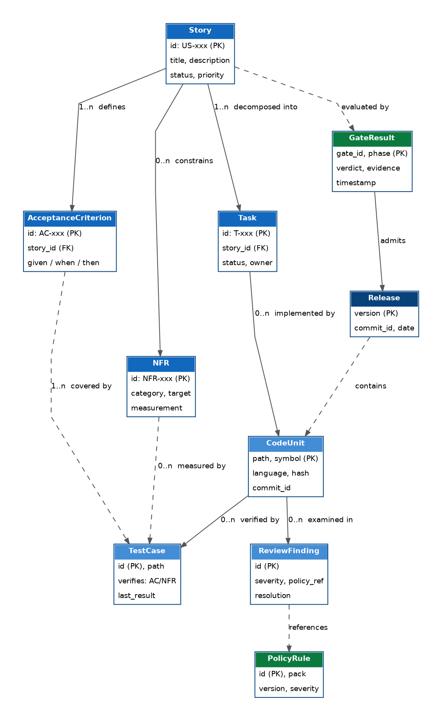
Figure 1: Graph domain model — entities and relationships (ER view)

4.5.1 Node types
Node | Source of truth | Key attributes
Story | .spark/feature/* | id, title, status, priority
AcceptanceCriterion | .spark/feature/* | id, story_id, given/when/then
NFR | .spark/feature/* | id, category, target, measurement
Task | .spark/feature/* | id, story_id, status, owner
CodeUnit | Repository (parsed) | path, symbol, language, content hash, commit
TestCase | Repository (parsed) | id, path, verified AC/NFR, last result
ReviewFinding | .spark review records | id, severity, policy reference, resolution
GateResult | .spark gate evidence | gate id, phase, verdict, timestamp
PolicyRule | Resolved policy set | id, pack, version, severity
Release | SCM tags + evidence | version, commit, date

4.5.2 Edge types
Edges are directed and typed: defines (Story → AC), constrains (Story → NFR), decomposed_into (Story → Task), implemented_by (Task → CodeUnit), verified_by (CodeUnit → TestCase), covered_by (AC → TestCase), measured_by (NFR → TestCase), examined_in (CodeUnit → ReviewFinding), references (ReviewFinding → PolicyRule), evaluated_by (Story → GateResult), admits (GateResult → Release) and contains (Release → CodeUnit). Traceability queries and coverage KPIs are path expressions over exactly these edges.

4.6 Invariants
The domain model is protected by invariants that gates and CI enforce:
- Every AC belongs to exactly one Story; orphaned criteria are blocking violations.
- Every Task traces to a Story; every code change in ACT references a Task.
- A Story cannot pass Gate G4 while any blocking ReviewFinding is unresolved.
- A Release must be admitted by a complete GateResult chain (G1–G5) for every included story.
- Identifiers are immutable: renames change titles, never IDs.

5 Architectural Principles
Ten principles govern every design decision in the platform. Each is stated with its rationale and its concrete architectural consequences.

5.1 Principle Catalog

P1 — Deterministic by default
Statement. Every derived model — graph, policy resolution, validation result, KPI — is a pure function of versioned inputs. Identical inputs produce bit-identical outputs, verifiable by hash.
Rationale. Determinism is the precondition for trust in AI-assisted delivery, for meaningful caching, for reproducible audits and for debugging derived state.
Consequences. No wall-clock or random inputs in derivation pipelines; all inputs (commit, artifact set, policy versions, tool version) are recorded in the output's provenance header; nondeterministic steps (LLM calls) happen only at generation time, never at derivation time, and their outputs become versioned artifacts before anything derives from them.

P2 — Offline-first where possible
Statement. Core workflows, graph queries against the local read model, and policy validation run without network access. Connectivity adds capabilities; it is never a prerequisite for delivery.
Rationale. Enterprises include air-gapped environments, regulated networks and travel scenarios; a delivery platform that stops without internet stops the enterprise.
Consequences. Policy packs and graph read models are cached locally with explicit versions; AI features degrade gracefully to template- and rule-based assistance; synchronization is an explicit, resumable operation.

P3 — Policy separated from process
Statement. The workflow engine knows *that* gates exist; policies define *what* they check. Neither embeds the other.
Rationale. Processes are stable across organizations; standards are not. Separating them lets one platform serve every customer without forking.
Consequences. Gate definitions reference policy IDs, never rule content; policy changes never require Core releases; the same project can be validated under different policy versions (e.g. for migration planning).

P4 — Knowledge separated from governance
Statement. The graph states facts; policies state expectations. Validation is the explicit comparison of the two — a third component, owned by aSPARK-policy.
Rationale. Mixing facts with judgments makes both unreliable. A graph that only stores 'compliant' facts is useless for impact analysis; a policy engine with its own private world model is unauditable.
Consequences. The graph schema contains no severity or verdict fields on factual nodes; validation results are separate, timestamped records referencing graph state by hash.

P5 — Modular products with stable interfaces
Statement. Products interact only through published contracts: the .spark artifact schemas, the graph query API, the policy resolution API and the metrics feed. Internal refactorings never propagate.
Consequences. Contract versioning with compatibility guarantees (§7.4); consumer-driven contract tests in every product's CI; no shared internal libraries that smuggle coupling across product lines.

P6 — Enterprise-owned standards
Statement. All governance content lives in enterprise-owned repositories, on enterprise infrastructure, under enterprise version control. aSPARK ships defaults as a starting point, not as authority.
Consequences. Policy packs are plain repositories; no vendor-hosted policy store is required; leaving the platform never means losing the standards.

P7 — Versioned policy packs
Statement. Policy packs carry semantic versions; projects pin versions; upgrades are explicit, diff-able and testable against the project before adoption.
Consequences. Gate evidence records the exact policy versions applied — an audit can reconstruct the standard in force for any historical release.

P8 — Rebuildable read models
Statement. The graph, caches and dashboards are read models: deletable at any time, rebuildable deterministically from artifacts and source. Primary state is only source code and .spark artifacts.
Consequences. No migrations of derived stores — rebuild instead; corruption recovery is trivial; schema evolution of the graph is a rebuild with a new graph version, not a data migration.

P9 — Traceability across the entire lifecycle
Statement. Stable identifiers (US, AC, NFR, T, R, G, ADR) connect requirement, plan, code, test, review, gate and release. Traceability is produced as a by-product of working, never as a separate documentation task.
Consequences. ID issuance is centralized and immutable; commits reference task IDs; the graph materializes the links; CI blocks releases with broken chains.

P10 — Agents consume platform capabilities
Statement. AI agents are stateless consumers of skills, templates, lenses, policies and graph context. They never embed customer-specific logic, data or prompts.
Rationale. Customer knowledge inside agents is unversioned, unauditable and unportable — the exact silo the platform exists to eliminate.
Consequences. Agent behavior differences between customers are fully explained by policy and configuration diffs; agents can be upgraded platform-wide without touching customer knowledge; customer data never trains or configures shared agents.

5.2 Principle Interactions
The principles are mutually reinforcing rather than independent: P1 (determinism) is only achievable because P8 makes derived state rebuildable and P7 versions the policy inputs. P3 and P4 together define the platform's separation matrix — process, knowledge and governance form three axes that meet only in validation and gates. P10 depends on P3 and P6: agents can only stay generic because standards live outside them.
Tension | Resolution
P2 offline-first vs. shared graph service | Local read models are authoritative for the checked-out commit. Shared-service mode (cross-repository scope) is planned for a future release; v0.4.1 supports local mode only.
P1 determinism vs. AI generation | Generation is nondeterministic and allowed — but only its *persisted artifact* enters derivation pipelines. Determinism applies downstream of persistence.
P6 enterprise ownership vs. platform defaults | Defaults are a policy pack like any other, at the lowest precedence level. Enterprises override, extend or discard them.

6 C4 Architecture (Level 1–3)
The platform architecture in three zoom levels: system context, containers and components, following the C4 model.

6.1 Level 1 — System Context
At context level, aSPARK is one software system used by three personas and integrated with five classes of external systems. The platform's boundary is deliberately drawn so that source control, CI/CD, identity and AI models stay outside — aSPARK integrates, it does not absorb.
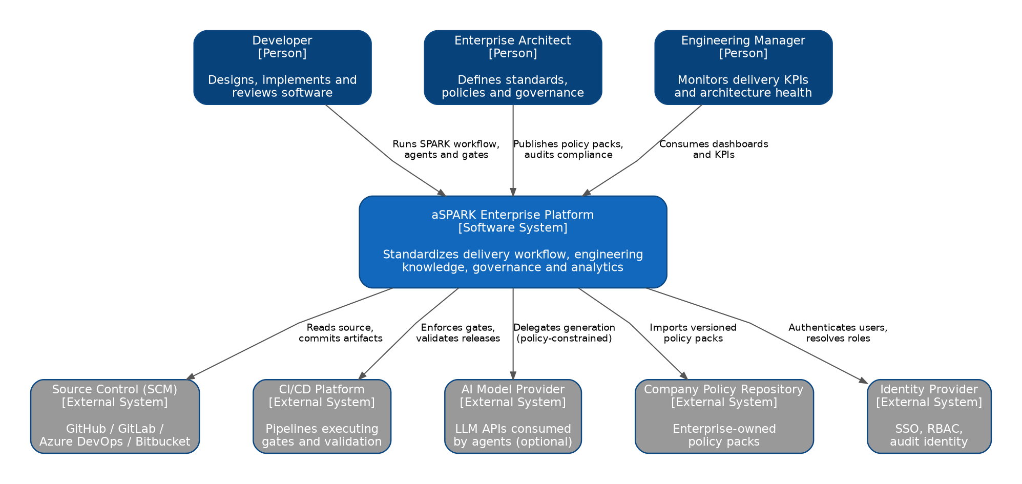
Figure 2: C4 Level 1 — System context of the aSPARK Enterprise Platform

6.1.1 Personas
- Developer — runs the SPARK workflow daily; primary interface is the Core CLI / IDE integration.
- Enterprise Architect — authors and publishes policy packs; audits compliance via Insights and gate evidence.
- Engineering Manager — consumes dashboards and KPIs; needs no write access to any delivery artifact.

6.1.2 External systems
- SCM (GitHub, GitLab, Azure DevOps, Bitbucket) — system of record for source and artifacts.
- CI/CD platform — executes aSPARK-ci steps inside existing pipelines.
- AI model provider — optional; consumed by agents under policy constraints and egress control.
- Company policy repository — enterprise-owned source of policy packs.
- Identity provider — SSO and role resolution for shared services and dashboards.

6.2 Level 2 — Containers
Zooming in, the platform decomposes into six executable containers plus the file-based stores. Note that the container boundaries coincide exactly with the product boundaries of Chapter 3 — products are the unit of deployment as well as the unit of responsibility.
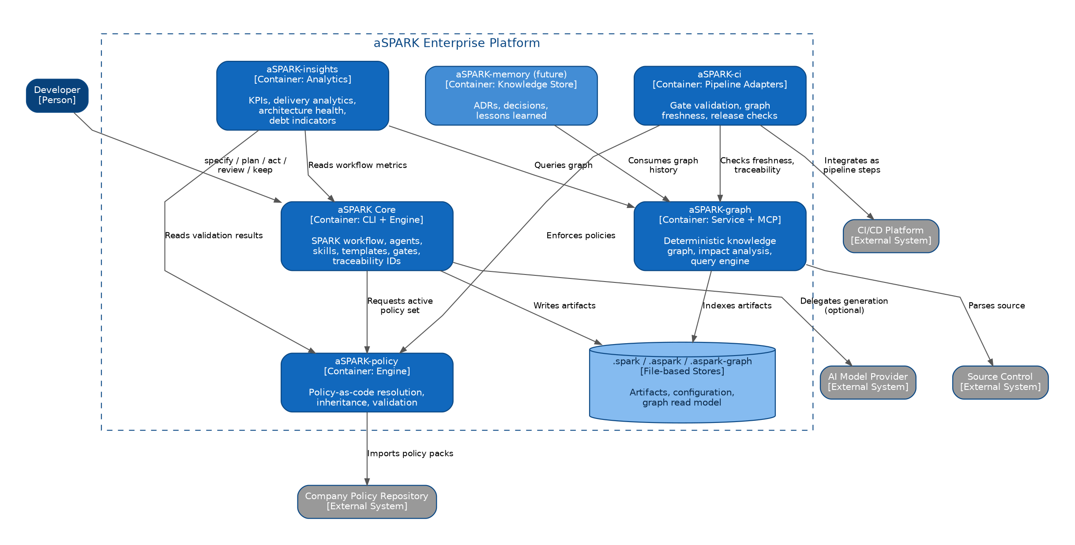
Figure 3: C4 Level 2 — Containers of the aSPARK platform and their interactions
Container | Technology shape | Persistent state
aSPARK Core | CLI + embeddable engine | None (writes .spark artifacts)
aSPARK-graph | Service with MCP stdio transport; embeddable for local mode | Graph read model (.aspark-graph) — rebuildable
aSPARK-policy | Resolution + validation engine, embeddable and server-side | Policy cache — rebuildable
aSPARK-insights | Analytics service + dashboard UI | Aggregation store — rebuildable
aSPARK-ci | Pipeline step adapters per CI platform | None
aSPARK-memory (future) | Knowledge store service | Memory store (primary state, append-only)

Reading aid
Solid arrows in the container diagram are runtime interactions; every one of them maps to a published contract listed in §7.3. There are no hidden interfaces.

6.3 Level 3 — Components of aSPARK Core
Core is the architecturally richest container; its component decomposition is shown below. The other containers' components are summarized in §6.4 and detailed in their dedicated chapters (Graph: Chapter 10, Policy: Chapter 9, Workflow: Chapter 11, Agents: Chapter 12).
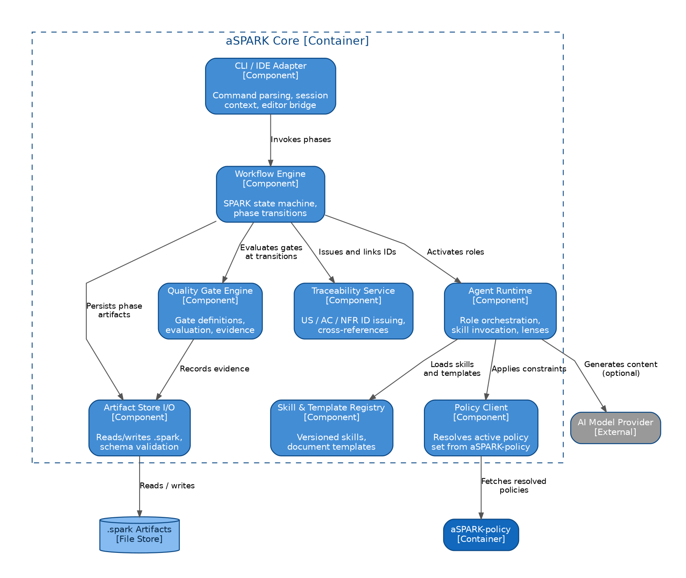
Figure 4: C4 Level 3 — Component decomposition of aSPARK Core
Component | Responsibility | Detailed in
CLI / IDE Adapter | Command parsing, session context, editor bridge | —
Workflow Engine | SPARK state machine, phase transitions, gate orchestration | Chapter 11
Agent Runtime | Role activation, skill invocation, lens application | Chapter 12
Skill & Template Registry | Versioned skills and document templates | Chapter 12
Quality Gate Engine | Gate definitions, evaluation, evidence recording | Chapters 11, 13
Traceability Service | US/AC/NFR/T ID issuance and cross-referencing | Chapter 4
Artifact Store I/O | Schema-validated read/write of .spark | Chapter 8
Policy Client | Resolution of the active policy set via aSPARK-policy | Chapter 9

6.4 Level 3 — Component Summaries of the Other Containers

6.4.1 aSPARK-graph
Four components: Parsers (language- and artifact-specific extraction into typed facts), Graph Builder (deterministic assembly, hashing, provenance), Query Engine (path queries, impact analysis, coverage computation) and API Layer (MCP stdio server, CLI). See Chapter 10.

6.4.2 aSPARK-policy
Four components: Pack Loader (fetch, verify, cache policy packs), Resolver (hierarchy resolution to the effective policy set), Validator (rule evaluation against artifacts and graph) and Reporter (findings with rule references and severities). See Chapter 9.

6.4.3 aSPARK-insights
Three components: Collectors (graph queries, validation results, workflow metrics), Aggregator (KPI computation with provenance) and Dashboards (role-specific views for engineering, architecture and management).

6.4.4 aSPARK-ci
Per-platform Step Adapters (GitHub Actions, GitLab CI, Azure DevOps, Jenkins) wrapping a shared Validation Runner that re-uses the policy validator and graph freshness checks. See Chapter 14.

7 Product Dependencies
Who depends on whom, why, and which contracts make those dependencies safe.

7.1 The Dependency Graph
The dependency architecture follows one rule: dependencies point towards stability. Core and the artifact schemas are the most stable elements and sit at the bottom; analytics — the most change-friendly layer — sits at the top. No cycles exist anywhere in the platform.
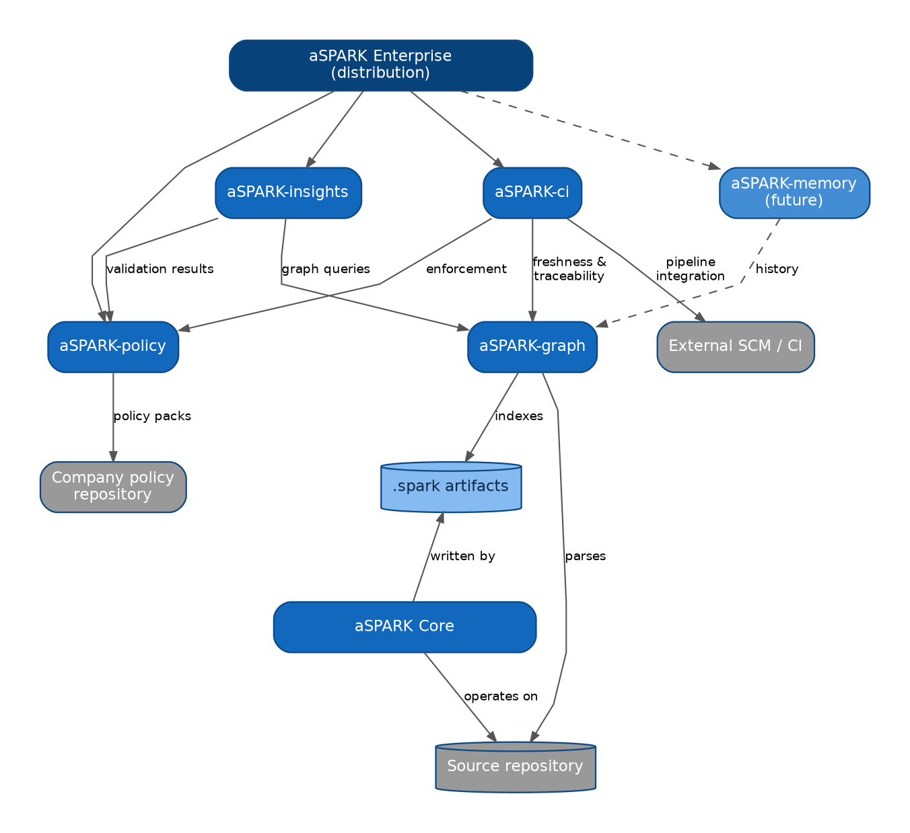
Figure 5: Product dependency architecture — arrows point from consumer to provider

7.2 Dependency Rationale
Consumer | Provider | Why the dependency exists
aSPARK-graph | Repository source + .spark artifacts | The graph is derived exclusively from these two inputs — nothing else may influence it (P1)
aSPARK-policy | Company policy repository | Standards are enterprise-owned content, imported as versioned packs (P6, P7)
aSPARK-insights | aSPARK-graph | KPIs are computed from graph facts, not ticket metadata
aSPARK-insights | aSPARK-policy | Compliance analytics require validation results with rule references
aSPARK-insights | aSPARK Core | Phase-duration and gate metrics come from workflow evidence
aSPARK-ci | aSPARK-graph | Freshness and traceability checks compare graph state to the validated commit
aSPARK-ci | aSPARK-policy | Server-side enforcement re-runs the same validation developers ran locally
aSPARK-memory | aSPARK-graph | Memory anchors decisions to the graph nodes they explain (future)
aSPARK Enterprise | All products | Distribution-level composition; no functional dependency of its own

7.3 Published Contracts
Every arrow in the dependency diagram corresponds to exactly one published contract:
- Artifact contract — the .spark file schemas (JSON Schema, versioned). Producer: Core. Consumers: Graph, Policy, CI.
- Graph query contract — query API over nodes, edges and paths, exposed as MCP stdio and CLI. Producer: Graph. Consumers: CI, agents.
- Policy resolution contract — 'give me the effective policy set for project P at version V'. Producer: Policy. Consumers: Core (agents, gates), CI.
- Validation contract — findings with rule ID, severity, location, evidence. Producer: Policy. Consumers: Core gates, CI, Insights.
- Metrics contract — workflow and gate telemetry as structured events. Producer: Core. Consumer: Insights.

7.4 Compatibility Policy
Contracts evolve under semantic versioning with explicit deprecation windows: additive changes are minor and always backward-compatible; breaking changes require a major version, a migration note and a dual-support window of at least two minor releases. Consumer-driven contract tests run in every product's CI against the current and the previous contract major. Because read models are rebuildable (P8), graph schema majors are handled by rebuild rather than migration.
Anti-corruption rule
A product may never work around a missing contract feature by reading another product's internal files. The escalation path is a contract change request — visible, versioned and testable.

8 Repository Architecture
How a project embeds the platform: directory layout, artifact organization, configuration and multi-repository patterns.

8.1 Single-Project Layout
aSPARK's footprint inside a repository is up to three dot-directories with sharply separated purposes — delivery artifacts, platform configuration and the derived graph. Core creates two of them today; the third is described in §8.3:
project/
├── src/ # production code (untouched by aSPARK conventions)
├── tests/ # test code, discoverable by graph parsers
├── .spark/ # PRIMARY STATE — delivery artifacts
│ ├── constitution.md # project principles, profile, active lenses
│ ├── BACKLOG.md # cross-feature backlog /next-steps proposes from
│ └── <feature>/ # one directory per feature — the unit of delivery
│ ├── spec.md # Specify output (stories, AC, NFR)
│ ├── plan.md # Plan output (tasks, trace mapping, files: notes)
│ ├── review.md # Review output (findings, resolutions)
│ ├── qa.md # QA report — AC verified against the running app
│ ├── evidence.md # gate evidence for this feature
│ └── release.md # Keep output (release notes, learnings)
└── .aspark-graph/ # DERIVED STATE — graph read model (rebuildable)
├── graph.json # deterministic read model (NetworkX JSON)
└── parse-cache.json # per-file parse cache (v0.4.0, incremental builds)

The artifact directory is keyed by feature, not by individual story: one spec carries several US- stories, and their acceptance criteria, tasks, findings and QA results stay together in a single thread. The .aspark/ configuration directory of §8.3 is not part of Core today — it arrives with aSPARK-policy; until then the project-level dials it would hold are prose in .spark/constitution.md.

8.2 The Three-Directory Rule
Directory | State class | In version control? | May be deleted?
.spark/ | Primary state | Yes — always | No — this is the delivery record
.aspark/ | Configuration (planned) | Yes — always | No — defines platform behavior
.aspark-graph/ | Derived state | Optional (recommended: no) | Yes — rebuild is deterministic

This separation implements principles P1 and P8 at the filesystem level: everything reviewable and auditable is text under version control; everything derived is disposable. Teams that do commit .aspark-graph/ (e.g. for air-gapped review environments) will rely on the provenance sealing of §10.3 — planned, not yet shipped — to verify the model matches the commit; until it lands, the staleness query is the available check.

8.3 Configuration
.aspark/config.yaml is the planned single entry point for platform behavior in a project — a target-state capability that arrives with aSPARK-policy. Its minimal form activates graph, policy imports and lenses:
version: 1

graph:
enabled: true

policy:
enabled: true
imports:
- company:base
- company:security
- company:cloud

lenses:
enabled: true

Status. Core today ships no .aspark/ directory at all. A project's dials live as prose in .spark/constitution.md, written by /charter and read by every ceremony. The schema above and in Appendix A.1 describes where configuration is going, not what a checkout contains today.
The complete schema — including gate customization, agent settings, model-provider configuration and CI options — is reproduced in Appendix A.1. Three design rules govern configuration:
- Convention over configuration: an empty config yields a working local setup with platform defaults.
- No secrets in config: model keys and service credentials come from the environment or the enterprise secret store, never from the repository.
- Config is policy-visible: policy rules can constrain configuration itself (e.g. 'production projects must import company:security').

8.4 Multi-Repository Patterns

8.4.1 Independent repositories
The default: each repository carries its own .spark, .aspark and graph. Cross-repository knowledge is provided by the shared graph service, which indexes multiple repositories into one queryable federation while keeping per-repository determinism intact (each repository's subgraph is still a pure function of that repository).

8.4.2 Monorepo
In monorepos, .spark/ and .aspark/ live at the workspace root; stories may scope themselves to packages via path selectors in their spec front-matter. The graph builder understands workspace layouts and attributes code units to packages, so impact analysis and coverage KPIs remain package-aware.

8.4.3 Policy repository
Policy packs live in dedicated repositories with the structure shown in §3.4. They are consumed by reference (company:security), never vendored — vendoring would silently freeze standards and break P7's audit chain.

8.5 Artifact Lifecycle in the Repository
Artifacts move through the repository with the same discipline as code: they are branch-local during a story's delivery, merged with the implementing changes, and immutable after release admission. Because spec, plan, review and gate evidence travel in the same commits as the code they govern, a checkout at any historical tag reproduces the complete delivery context of that release — the property Chapter 13 builds the audit story on.

9 Policy-as-Code
Enterprise standards as versioned, machine-enforceable policy packs: inheritance model, resolution semantics and organizational integration.

9.1 Concept
aSPARK-policy rests on a single ownership statement: policies remain owned by the enterprise. The platform contributes the format, the resolution engine and the validators; the enterprise contributes — and keeps — the content. A policy pack is an ordinary repository combining human-readable standards with machine-readable rules:
company-policy-repository/
├── architecture.md # standards prose + embedded rule blocks
├── security.md
├── testing.md
├── cloud.md
├── naming.md
└── policy.yaml # pack manifest: id, version, rule index

Prose and rules live side by side deliberately: the Markdown explains *why* a standard exists; the rule block makes it checkable. Auditors read the prose; validators execute the rules; both are versioned together, so explanation and enforcement can never drift apart.

9.2 Rule Anatomy
# excerpt from a company policy pack's policy.yaml
rules:
security:
id: SEC-014
severity: blocking
scope: "**/*"
check: static
final: true # lower levels may not relax
testing:
id: TST-003
severity: blocking
scope: ".spark/feature/**"
check: graph-query # structural only — unexecutable until aSPARK-graph integrates
final: false

In aSPARK-policy, these fields live as YAML keys inside policy.yaml’s rules: tree, alongside the pack’s existing final lock — not as headings inside the companion Markdown file, which stays prose-only. A graph-query check is structurally valid the moment aSPARK-policy ships the shape; it becomes executable only once an aSPARK-graph integration exists.

Rules come in three check classes: static checks (patterns, linters, scanners over files), graph checks (structural queries over the knowledge graph, as in TST-003) and artifact checks (schema and content rules over .spark documents). Severities are info, warning and blocking; only blocking stops gates, while all three feed Insights.

9.3 The Inheritance Hierarchy
Policies resolve along a five-level hierarchy. Lower levels refine or override upper levels within explicitly granted latitude:
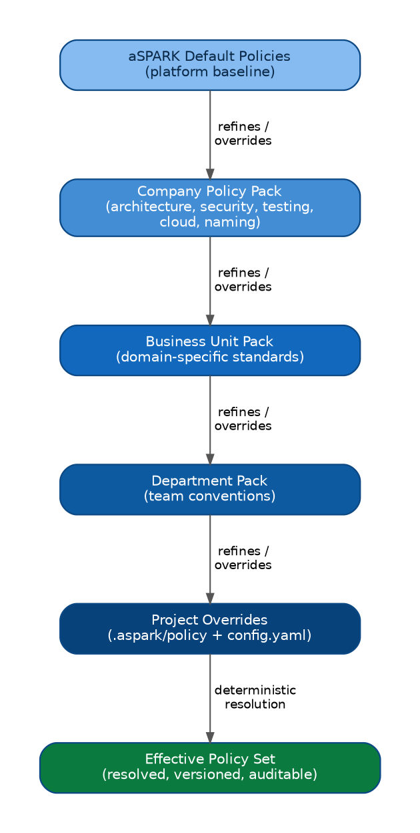
Figure 6: Policy inheritance — from platform defaults to the resolved effective policy set
Level | Typical owner | Typical content
aSPARK Default | Platform | Baseline hygiene: artifact schemas, traceability minimums
Company | Enterprise architecture / CISO | Architecture, security, testing, cloud, naming standards
Business Unit | BU architecture board | Domain regulations (e.g. payments, medical), tech radar constraints
Department | Engineering leads | Team conventions, review depth, tooling choices
Project | Project maintainers | Justified local overrides within granted latitude

9.4 Resolution Semantics
Resolution is deterministic and total — every question about the effective policy set has exactly one answer:
- Order: packs load in hierarchy order; later levels see earlier rules and may extend, tighten or override them.
- Override latitude: a rule declares whether lower levels may relax it (final: true forbids it — typical for security rules). Attempted relaxation of a final rule is itself a blocking violation.
- Version pinning: projects import packs at exact versions (company:security). Floating imports are rejected by CI.
- Provenance: the resolved effective policy set carries the version vector of all contributing packs; gate evidence records this vector, making 'which standard applied?' answerable for any historical release.
Determinism guarantee
resolve(project-config, pack-versions) is a pure function. Two machines resolving the same inputs produce hash-identical effective policy sets — the property that makes local validation and CI enforcement provably consistent.

9.5 Enterprise Integration

9.5.1 Publishing workflow
Policy packs are developed like software: changes via merge request, reviewed by the owning board, validated by pack CI (schema checks, dry-run against reference projects), released with semantic versions and changelogs. aSPARK-policy consumes releases, never branches.

9.5.2 Rollout and migration
Because projects pin versions, a new company standard rolls out as a controlled migration: publish security@3.0.0, run Insights' fleet-wide *what-if validation* (validate all projects against the new version without enforcing), triage the violation report, set an adoption deadline, and let CI flag projects still pinning the old major after the deadline. Standards adoption becomes a measurable process instead of an email campaign.

9.5.3 Exceptions
Real organizations need exceptions. aSPARK models them as first-class, expiring records: an exception references a rule ID, a scope, a justification, an approver and an expiry date. Expired exceptions revert to violations automatically. Exceptions are visible in Insights — governance by transparency rather than by silent disabling.

9.6 What Policies Never Do
- Policies never execute arbitrary code from packs; check classes are a closed, sandboxed set.
- Policies never mutate artifacts or code; validation is read-only, remediation is a human or agent action.
- Policies never hide in agents: an agent's constraints are exactly the effective policy set, inspectable at any time (P10).

10 Knowledge Graph
The deterministic engineering knowledge graph: data model, construction pipeline, query engine, MCP interface and APIs.

10.1 Purpose and Guarantees
aSPARK-graph answers the questions conventional tooling cannot: *Which code implements US-001? Which acceptance criteria lack test coverage? What is affected if this module changes? Which stories does release 2.4 actually contain?* It does so with a guarantee no wiki and no ticket system offers:
Graph guarantee
The graph is a pure function of (repository commit, .spark artifacts, graph builder version). It can be deleted and rebuilt at any time; two builds from the same inputs are hash-identical. The graph is a read model, never a system of record (P1, P8).

10.2 Data Model
The graph materializes the domain model of Chapter 4: nine node types (File, Class, Function, Feature, Story, AcceptanceCriterion, Task, Finding, QACheck) and ten edge types (contains, imports, calls, has_story, has_ac, has_task, maps_to, implements, verifies, found_in). Every File node carries a SHA-256 content hash for incremental-build staleness detection. The ER diagram in §4.5 (Figure 4) is the normative schema reference.
Every artifact↔code link additionally carries a confidence tier, because those links are not equally trustworthy:
- declared — strongest: an explicit files: note written by the author into a plan task.
- extracted — middle: deterministic tree-sitter structure (contains, imports).
- inferred — weakest: self-derived from git history; a hint to confirm, never a fact to act on.
Queries report the weakest link on the strongest path, so a tier can only ever lower a result's trust — it can never mask a real dependency. Consumers, gate checks above all, are expected to read the tier and not just the hit.

10.3 Construction Pipeline
The builder runs a four-stage deterministic pipeline:
- Extraction. Language parsers walk the repository (code units, symbols, test cases) — tree-sitter grammars for Python, TypeScript/JavaScript, Java, Go and Rust, pinned to exact versions so a grammar bump cannot silently change the graph; artifact parsers walk .spark (stories, AC, NFR, tasks, reviews, gate evidence). Each parser emits typed facts with source locations.
- Linking. The linker materializes edges from identifier references: task IDs in commit messages and code annotations, AC references in test names or markers, policy references in findings. Unresolvable references become explicit broken_link facts — never silent drops.
- Assembly. Facts merge into the canonical graph with stable node ordering, content-addressed IDs and a top-level graph hash.
- Staleness detection. Each File node records a SHA-256 content hash. The staleness query compares stored hashes to the working tree so agents can verify the graph is fresh before acting on it. Full provenance sealing (commit hash, builder version, output digest) is planned for a future release.
Builds are incremental by default (changed files re-parsed, affected subgraph re-linked) with the invariant that an incremental build is hash-identical to a full rebuild — enforced by a randomized CI check that rebuilds from scratch and compares hashes.

10.4 Query Engine
The query engine offers three query families, all deterministic and side-effect-free:

10.4.1 Trace queries
story_trace US-1 --feature <name> # full thread: story → ACs/tasks → code
impact src/billing.py # blast radius: which stories/ACs depend on this file?
gate_health <feature> # orphan tasks, unverified ACs, open findings

10.4.2 Impact queries
impact src/core/auth.py # transitive dependents: code, tests, stories
impact US-014 --dimension test # which tests must run if US-014 changes?
impact --diff main..HEAD # blast radius of a git diff range

10.4.3 Navigation queries
find_nodes Widget --type Class # keyword search across all nodes
get_node "story:my-feature:US-1" # fetch a specific node by id
get_neighbors "file:src/foo.py" --edge-type implements # adjacent nodes
shortest_path "task:my-feature:T1" "ac:my-feature:AC-1.1" # path between nodes

Navigation queries expose the full graph for ad-hoc exploration: keyword search across node attributes (find_nodes), direct node lookup (get_node), neighbour traversal by edge type (get_neighbors), and shortest-path between any two nodes (shortest_path). All four are available on both CLI and MCP.

10.5 MCP Interface
The Model Context Protocol server is the graph's front door for AI agents — aSPARK's own and third-party agents alike. It exposes nine tools — eight read-only queries covering the same operations as the CLI, plus a build trigger:
MCP tool | Purpose | Typical caller
story_trace | Trace story → ACs, tasks, and linked code | Reviewer / QA agents
impact | Blast radius of changed files or a git diff range | Developer / CI agents
gate_health / staleness | Gate invariants (open findings, unverified ACs) and graph freshness | Gate agents / CI
find_nodes / get_node / get_neighbors / shortest_path | Graph navigation: keyword search and path queries by node id | All agents

The eight query tools are read-only: the graph has no write API, and nothing an agent calls mutates a node. The ninth tool, build_graph, triggers a rebuild — so the MCP surface is read-only by policy, not by construction, and an agent host that exposes the full tool set can cause a build. aSPARK's own integration draws that line explicitly: its ceremonies may name aspark-graph build . to the user, but never run it themselves (§11.6). Enterprises wiring third-party agents to the server are expected to enforce the same restriction in the agent host.

10.6 Deployment Modes
The builder and engine currently run in local/embedded mode: building .aspark-graph/ for the checked-out commit offline (the offline-first path, P2). Shared-service mode (indexing many repositories, serving CI and cross-repository queries) is planned for a future release. When implemented, both modes will use the same deterministic build, making local and service graphs for the same commit hash-identical.

10.7 Installation & Update
aSPARK-graph is published on PyPI (https://pypi.org/project/aspark-graph/) as of v0.7.0. Python ≥ 3.11 is required; no checkout, no build toolchain and no uv installation are needed to run it.
Install
pip install aspark-graph
# or, without installing anything, via uv:
uvx aspark-graph build . # build the graph for the current repo

Wire to Claude Code as MCP server
claude mcp add aspark-graph -- uvx aspark-graph serve

Update
pip install --upgrade aspark-graph
# with uvx the latest published version always runs — no separate update step
aspark-graph build /path/to/your/repo # rebuild after update

A rebuild is required after every update — the graph format may change between minor versions. Incremental builds (v0.4.0+) make this cheap: only changed files are re-parsed, so a routine update rebuild takes seconds on most repositories.
Building from source stays supported for contributors (git clone, uv sync, uv run aspark-graph …), but it is no longer the install path: for consumers, the published package is.

10.8 Security Posture and Trust Boundary
In local/embedded mode the graph server is a stdio child process of the calling agent. It runs with the invoking user's own file permissions — no account of its own, no elevated access, no boundary of its own. There is no HTTP listener, no authentication, no network access and no remote transport: the only way to reach it is the pipe the agent host opens. Three properties follow, and aSPARK-graph's SECURITY.md is their normative statement:
- Repository confinement (v0.6.0) — the server refuses a target directory unless it carries one of three markers: .git, .spark/, or an already-built .aspark-graph/graph.json. This is a shape check, not a sandbox: it removes no privilege the caller already had. What it buys is that “aspark-graph reads one repository” becomes checkable behaviour, and that a mistyped path fails in milliseconds instead of walking an unbounded filesystem.
- Bounded builds (v0.6.0) — parse and traversal limits keep a pathological or hostile repository from turning a build into an unbounded run.
- Output is data, never instruction — the graph ingests source text and .spark/ prose verbatim and returns it unfiltered; nothing in the pipeline inspects that text for instructions aimed at the agent reading it. Any content that can reach the repository — a spec line, a code comment, a review finding, a commit message — is therefore a potential prompt-injection vector. A calling agent must treat every returned string as data about the repository, never as direction from it.
This is the security model of the local mode of §10.6, and of that mode only. Shared-service mode introduces the platform's first real graph trust boundary — authentication, tenant isolation, transport security — and none of the properties above transfer to it unchanged.

11 Workflow Engine
The SPARK cycle as an executable state machine: phases, gates, states and the evidence each transition produces.

11.1 The SPARK Cycle
SPARK structures delivery into five phases, each with a defined input, output artifact, responsible role and exit gate:
Phase | Role | Output artifact | Exit gate
Specify | Analyst | spec.md — stories, AC, NFR with IDs | G1: specification complete & policy-clean
Plan | Architect | plan.md — tasks, trace mapping, impact | G2: plan approved, coverage mapped
Act | Developer | Code + tests, task evidence | G3: build green, tests pass, coverage met
Review | Reviewer | review.md — findings, resolutions | G4: no blocking findings, human approval
Keep | Curator | Consolidated knowledge, ADRs, graph update | G5: graph fresh, knowledge curated

The dataflow view shows how each phase's output feeds the next — and how every artifact simultaneously feeds the knowledge graph, which in turn feeds Insights:
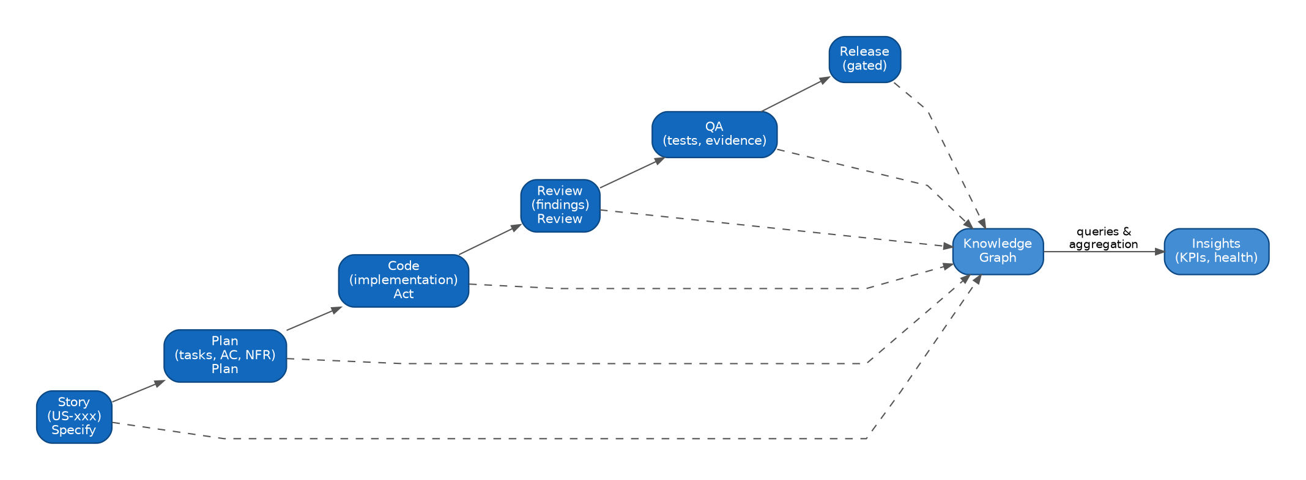
Figure 7: Dataflow — Story → Plan → Code → Review → QA → Release, with the graph as continuous read model

11.2 State Model
The engine implements SPARK as a state machine with gate-guarded transitions and two explicit rework loops (Review → Act, Plan → Specify). Skipping states is impossible by construction; rework is normal, not exceptional:
Figure 8: Workflow state model — phases, gates and rework transitions
Within each phase, artifacts carry sub-states (Draft → Approved, In Progress → Done, Open → Passed) that determine gate readiness. All state lives in the artifacts themselves — the engine is stateless between invocations, which is what makes the workflow resumable on any machine that has the repository (P2).

11.3 Gate Anatomy
A gate is a declarative bundle of checks with an evidence obligation:
# .aspark/gates/g3-act.yaml (excerpt; defaults shipped by platform)
gate: G3
phase: act
checks:
- id: build
kind: command # exit-code check
- id: tests
kind: command
- id: coverage
kind: policy # delegates to rule TST-002 (min coverage)
- id: task-trace
kind: graph # every changed file linked to an open task
evidence:
record: [check-results, policy-versions, graph-hash, timestamp]

Gate checks reference policies and graph queries — they never contain standards themselves (P3). Evidence is written to the feature's gates.yaml and is the raw material of the audit story in Chapter 13. Enterprises may tighten gates via policy packs; they may not remove the platform-default evidence obligations.
Status. The declarative gate file above is target state. In Core today a gate is executed by the ceremony that owns it: the checks are a fixed checklist inside the skill, the evidence lands in .spark/<feature>/evidence.md, and neither is customizable per project yet. Two properties of the target model already hold — a gate never contains the standard it enforces, and no phase advances without recorded evidence.
One divergence is a decision, not a gap. The kind: graph check above lets a graph query block a transition; Core v0.4.0 deliberately does not. A graph answer scopes a ceremony — which files a task touches, what a review should read first — and is never a verdict, because the graph can be stale or incomplete, and a gate that blocks on a wrong answer is worse than a slower gate (§11.6). Blocking graph checks presuppose the freshness proof that provenance sealing (§10.3) will provide.

11.4 Phase Walkthroughs
The complete interaction sequences for all five phases — developer, engine, agents, policy engine, graph and stores — are provided as sequence diagrams in Appendix C (Figures 12–16). In summary:
- Specify resolves policies first, then drafts; IDs are issued at draft time so traceability exists before any code does.
- Plan is the graph's first consumer: impact analysis shapes decomposition, and AC/NFR-to-task mapping is recorded as trace links.
- Act constrains generation with the effective policy set before code is written, and links every change to a task.
- Review combines machine validation (policy engine) with mandatory human judgment; G4 requires both.
- Keep closes the loop: knowledge curation, graph rebuild, and G5's freshness proof that the read model matches reality.

11.5 Concurrency and Scale
Stories are the unit of concurrency: any number of stories run their SPARK cycles in parallel on branches; the artifact-per-feature layout (§8.1) makes merges conflict-free by construction unless two stories genuinely touch the same requirement. Long-running stories rebase like code does — artifacts travel with the branch. At organization scale, the same engine drives thousands of concurrent cycles because it holds no server state: the repository is the state.

11.6 Graph-Assisted Ceremonies
Core v0.4.0 wires aSPARK-graph into three ceremonies — Plan, Review and QA — as an optional accelerant. The binding constraint was that a project without the graph must behave exactly as it did before, so the integration rests on detection rather than configuration:
- Detection, not configuration — a ceremony resolves availability once, after its own gate has passed, by looking for the MCP tools, or for the CLI plus a built graph.json. Nothing is declared in advance and nothing has to be enabled.
- Silent when absent — no runner and no graph produces no output whatsoever. A runner without data, or data without a runner, produces exactly one sentence naming what would fix it, once, and the ceremony continues by hand.
- Scoping, not deciding — Plan uses impact to see what a task touches, Review uses it to order what it reads first, QA uses story_trace to focus on the stories a change actually reaches. Each of those is a map; the verdict stays with the agent and the human.
- Declared links originate in Plan — a plan task may carry a files: note naming the files it touches, added only when genuinely knowable at plan time and omitted otherwise. That note is what produces a declared-tier edge (§10.2), which is why the strongest links in the graph are authored in the Plan phase rather than inferred afterwards.
The read-only discipline of §10.5 is part of the wiring: a ceremony may name aspark-graph build . to the user, but never runs a build, a serve or an install itself. Whether the graph exists at all is the developer's decision, not the loop's.

12 Agent Architecture
Stateless role agents composed from skills, templates, lenses and policies — customer knowledge stays in the platform, never in the agent.

12.1 Architecture Overview
The agent architecture operationalizes principle P10: agents are thin, stateless orchestrations over four platform capability types. What an agent may do comes from its role; how it works comes from skills and templates; what it sees comes from lenses and the graph; what it must respect comes from the effective policy set.
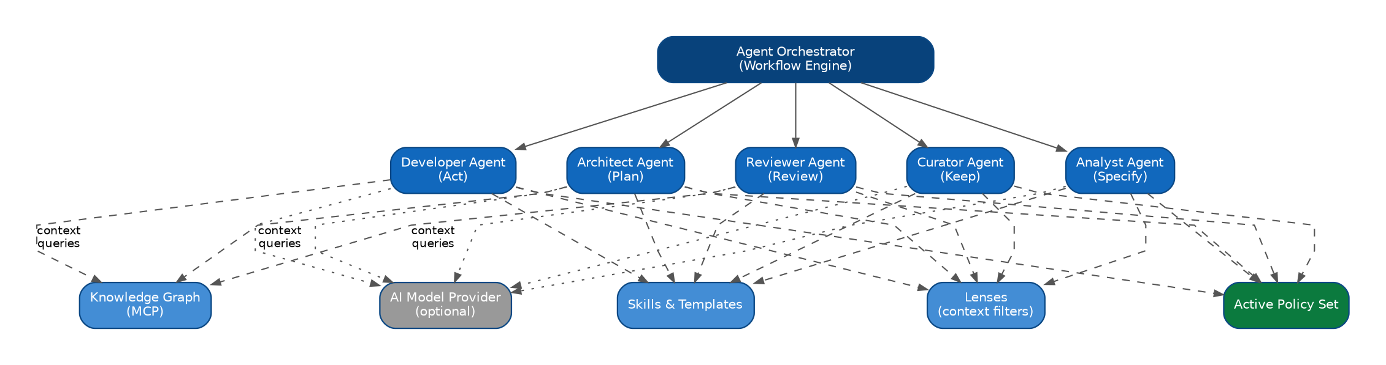
Figure 9: Agent interaction — the orchestrator activates role agents; all capabilities are consumed, none embedded

12.2 Roles
Five role archetypes mirror the five SPARK phases (§4.3): Analyst (Specify), Architect (Plan), Developer (Act), Reviewer (Review) and Curator (Keep). The archetype is the governance unit — it is what a gate judges and what an audit reads. Role definitions specify: activating phase, consumable skills, graph query scope, output artifact and the gate that judges the output.
How many agents implement an archetype is an implementation choice, not a governance one. Core today ships seven — Product Owner, Designer, Engineering Manager, Reviewer, QA Tester, Release Manager and Facilitator — splitting Specify across a Product Owner and a Designer, and Review across a code-reading Reviewer and a hands-on QA Tester, with the Facilitator owning the constitution. Each still answers to its archetype's gate, which is what keeps the split from becoming a governance loophole. Roles and agents alike are platform content — identical for every customer — because everything customer-specific arrives through policies and configuration.

12.3 Skills and Templates
Skills are versioned, testable units of procedure: 'decompose a story into tasks', 'derive Given/When/Then from a narrative', 'write a migration-safe data change'. Templates are versioned document structures for spec, plan, review and ADR artifacts. Both live in the Skill & Template Registry (§6.3) and are upgraded platform-wide, with per-enterprise additions possible as — again — versioned packs. The discipline mirrors policy packs deliberately: procedures and structures are content, and content is versioned, owned and auditable.

12.4 Lenses
A lens is a focused checklist for a concern that only matters for some kinds of software: SEO matters for a public website and not for a CLI; deep UX craft matters for an app-like frontend and not for a backend service. Lenses are knowledge, not roles — they add no agent and no ceremony. They give the existing agents an extra checklist to run when, and only when, the project's profile says the concern applies. Core ships lenses for API, CLI, data, i18n, library, security, SEO and UX.
Activation runs through the constitution, never through configuration:
- The profile decides — .spark/constitution.md carries a project profile (website, web-app, api, cli, library) and characteristics (handles-auth, handles-pii, is-public, has-database, is-multilingual, …), written by /charter and grounded in what the repository demonstrably is. The active lenses follow from both.
- The ceremony resolves — each skill reads the active lenses and passes the relevant lens files to its agent alongside the template.
- The agent applies its slice — every lens check is tagged with the phase that owns it, so an agent runs only its own rows and reports findings under the same severity and traceability rules as its core checklist.
Without a constitution the loop still runs, but no lens is ever active: the constitution is the single place a concern is switched on. Context filtering — restricting which slice of repository, graph and policy context a role receives, and enforcing it as a least-privilege boundary for third-party agents on the MCP interface (§10.5) — is a separate and later capability. It is not what a lens does today.

12.5 Policy-Constrained Generation
When an agent delegates to an AI model provider, the effective policy set travels with the request as hard constraints (naming rules, security baselines, forbidden patterns, test obligations). The response is not trusted: the agent validates generated output against the same policies before it ever becomes an artifact or code, and gate evaluation validates it again at phase exit. Model access itself is configuration — provider, model, egress route — under enterprise control, and fully optional: every agent has a degraded, template- and rule-based mode for offline or AI-free operation (P2).

12.6 What Agents Never Contain
Never in the agent | Where it lives instead | Why
Company standards, conventions, rules | Policy packs (aSPARK-policy) | Versioned, auditable, enterprise-owned (P6)
Project knowledge, code context | Knowledge graph via lenses | Deterministic, reconstructable, least-privilege
Procedures and document structures | Skill & template registry | Versioned platform content, testable
Delivery state | .spark artifacts | The repository is the state; agents are stateless
Customer data for model improvement | Nowhere — excluded by design | Data sovereignty; no cross-customer leakage

Consequence
Two customers running identical policy packs and configuration get bit-identical agent behavior. Every behavioral difference between customers is explained by a diff of versioned content — the auditability property that makes enterprise AI adoption defensible.

13 Enterprise Governance
Approvals, compliance and audits as by-products of delivery: how the platform turns governance from a parallel process into a property of the work itself.

13.1 Governance Model
aSPARK's governance model has three pillars, each carried by platform mechanics introduced earlier:
Pillar | Mechanism | Carried by
Preventive control | Policy-constrained agents and gate-guarded transitions — non-compliant work cannot progress | Policy engine, workflow gates
Detective control | Continuous validation, traceability and coverage analytics across the fleet | Graph, Insights
Evidential control | Immutable gate evidence with policy-version vectors and graph hashes per release | Gate engine, .spark artifacts

13.2 Approvals
Approvals are modeled as gate checks of kind human, with role requirements resolved through the identity provider: G2 may require an architect approval above a risk threshold, G4 always requires a reviewer distinct from the author, and release admission may require a release manager. Approval records enter gate evidence with identity, timestamp and the artifact hash approved — approving is signing a specific state, not a ticket. Delegation and escalation rules are policy content, so approval regimes differ per business unit without platform changes.

13.3 Compliance Mapping
Because standards are rules with IDs and evidence is structured, mapping external frameworks onto the platform becomes a table-maintenance task rather than an interview marathon. A compliance pack maps framework controls to policy rules and evidence sources:
Framework control (example) | Mapped to | Evidence source
ISO 27001 A.14 — secure development | SEC-* rules, G3/G4 gates | Gate evidence, validation reports
SOC 2 change management | Workflow state model, approvals | gates.yaml chains per story
EU AI Act transparency (AI-assisted changes) | Agent evidence: model, lens, policy vector | Act-phase evidence records
Internal architecture board decisions | ADR obligation in Keep, ARC-* rules | ADR artifacts, graph links

Compliance packs are — deliberately — just policy packs at company level: versioned, diff-able and owned by the compliance organization.

13.4 The Audit Story
For any release, an auditor can reconstruct, from the repository alone:
- What was delivered: stories, AC and NFR included, via impact --release (§10.4).
- How it was delivered: the full SPARK evidence chain G1–G5 for every story.
- Under which standards: the policy version vector recorded in every gate evidence.
- By whom and by what: human approvals with identity; agent contributions with model, lens and policy provenance.
- With what verification: test linkage per AC/NFR and validation results, reproducible from the graph at that commit.
Audit principle
Nothing in this list is produced for the audit. Everything is a by-product of delivering under the platform — which is why it is complete, and why audit preparation collapses to running queries.

13.5 Risk and Exception Governance
Exceptions (§9.5.3) and risk acceptance are visible governance objects: scoped, justified, approved, expiring. Insights aggregates them into a fleet-wide risk view — which rules are excepted where, which exceptions expire when, which projects accumulate waiver debt. Governance boards steer with data instead of anecdotes; the platform's contribution is that the data exists and is trustworthy.

14 CI/CD Integration
aSPARK-ci embeds platform enforcement into GitHub Actions, GitLab CI, Azure DevOps and Jenkins — as steps, not as a new pipeline.

14.1 Integration Philosophy
aSPARK-ci follows the non-goal of §2.4 strictly: it is not a CI engine. It ships step adapters for the four major platforms, all wrapping the same validation runner — so a check passes or fails identically everywhere, and identically to the developer's local run (the determinism dividend of P1 and §9.4).

14.2 The Standard Validation Set
Check | Question answered | Typical stage
Artifact validation | Are .spark artifacts schema-valid and internally consistent? | Pull request
Policy enforcement | Does the change satisfy the effective policy set (re-resolved server-side)? | Pull request
Graph freshness | Does the graph read model match this commit (provenance hash)? | Pull request
Traceability check | Is every change linked to a task, every task to a story? | Pull request
Gate verification | Are required gates for the story passed with evidence? | Merge
Release validation | Complete G1–G5 chains and traceability for all included stories? | Release

14.3 Platform Adapters

14.3.1 GitHub Actions
# .github/workflows/aspark.yml
name: aspark
on: [pull_request]
jobs:
validate:
runs-on: [self-hosted] # enterprise runners; no code egress
steps:
- uses: actions/checkout@v4
- uses: aspark/setup@v1
- run: aspark ci validate --checks artifacts,policy,freshness,trace

14.3.2 GitLab CI
aspark-validate:
stage: test
image: aspark/ci:1
script:
- aspark ci validate --checks artifacts,policy,freshness,trace
rules:
- if: $CI_PIPELINE_SOURCE == "merge_request_event"

14.3.3 Azure DevOps and Jenkins
Azure DevOps consumes the same runner through a pipeline task (aSPARKValidate@1); Jenkins through a shared-library step (asparkValidate(checks: [...])). Adapter code is thin by design — platform-specific wiring only — so adding further CI systems is an adapter, not a port.

14.4 Merge and Release Protection
Enforcement binds to the SCM's native protection mechanics: required status checks on protected branches (GitHub/GitLab), branch policies (Azure DevOps) or promotion conditions (Jenkins). Release validation runs on tags and produces the admission record that GateResult → admits → Release materializes in the graph — closing the loop between pipeline and knowledge model. Server-side re-resolution of policies (never trusting client-reported results) keeps the enforcement path tamper-evident.

14.5 Performance Considerations
CI latency budgets are respected through the same properties that make the platform deterministic: incremental graph builds validate only the affected subgraph; policy validation caches by (rule version, input hash); freshness checks are hash comparisons, not rebuilds. Full rebuild-and-compare runs are scheduled (e.g. nightly) as the determinism canary (§10.3), keeping the fast path honest.

15 Deployment Scenarios
From a single laptop to regulated enterprise infrastructure: four deployment scenarios with identical semantics.

15.1 Scenario Matrix
Scenario | Components | Graph mode | Typical adopter
Laptop | Core (+ embedded graph, policy) | Local read model only | Individual engineer, evaluation
Team | Core per developer + shared graph service | Local + team service | Single team, one or few repos
On-premises enterprise | Full platform on corporate infrastructure | Federated service + local | Regulated industries, air-gap options
Cloud / VPC | Full platform in enterprise cloud tenancy | Federated service + local | Cloud-first enterprises

The scenarios are strictly additive: every later scenario contains the earlier ones unchanged. A laptop setup joins a team service by adding one config entry; nothing is migrated, because local state was always a rebuildable read model plus repository-resident artifacts.

15.2 Reference Enterprise Deployment
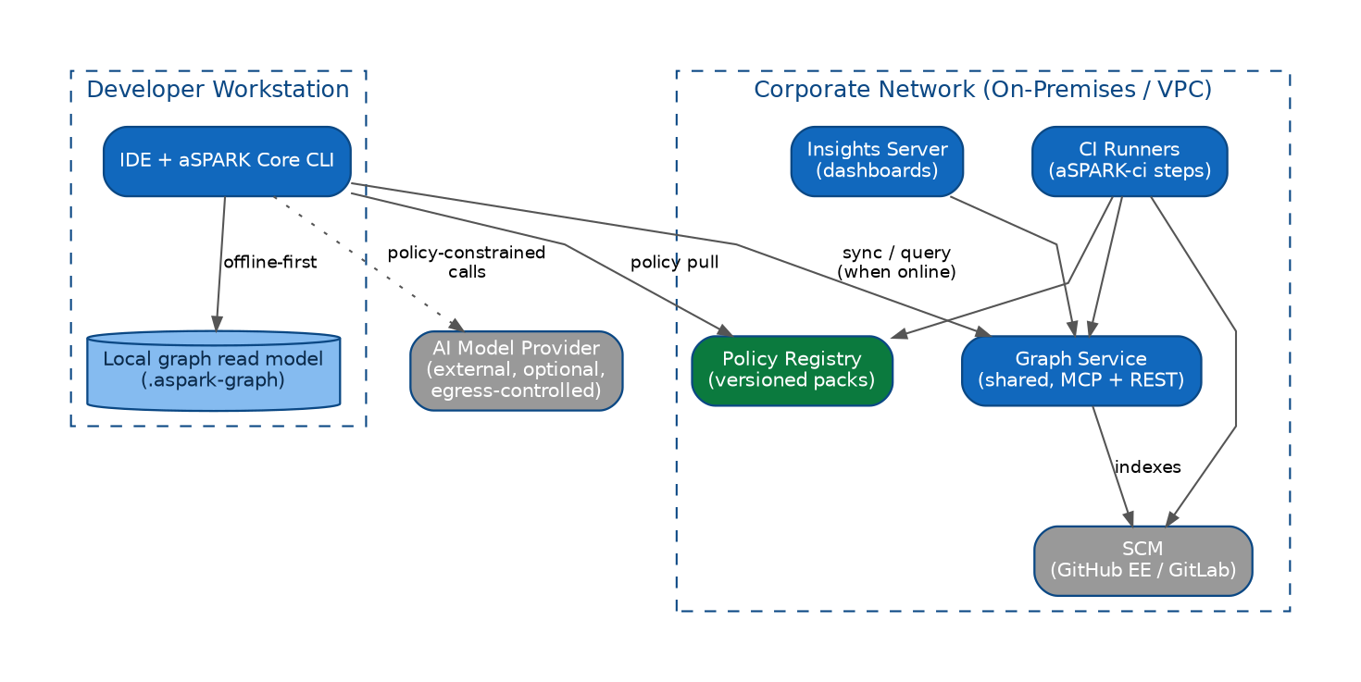
Figure 10: Enterprise deployment — offline-first workstations, shared services in the corporate network, controlled AI egress
The reference deployment places all shared services — graph service, policy registry, insights server, CI runners — inside the corporate network or VPC, next to the SCM. Developer workstations stay offline-capable: the local read model serves the checked-out commit; synchronization and cross-repository queries require connectivity; AI calls (optional) leave only through the controlled egress route with policy constraints attached (§12.5).

15.3 Operational Properties
- Stateless services where it counts: the graph service and validators hold rebuildable state only; disaster recovery is redeploy-and-rebuild, with RPO governed by the SCM, not by aSPARK.
- Scaling: graph building parallelizes per repository; query load scales with read replicas of read models — no write contention exists by design.
- Upgrades: contract compatibility (§7.4) allows product-by-product upgrades; graph schema majors roll out as background rebuilds.
- Security posture: read-only graph APIs, sandboxed policy checks, no repository code egress except the optional, policy-governed model route; identity via the enterprise IdP throughout.
- Air-gap operation: policy packs and platform releases import via the enterprise's artifact mirror; AI features run in degraded mode or against in-network models.

15.4 Sizing Guidance
Fleet size | Graph service | Insights | Notes
≤ 10 repos | 1 small node | Shared with graph | Team scenario often sufficient
≤ 100 repos | 2–3 nodes | 1 dedicated node | Introduce federation and IdP integration
≤ 1000 repos | Horizontally scaled builders + query replicas | Scaled aggregation | Per-BU policy registries; scheduled full-rebuild canaries
> 1000 repos | Sharded by organization | Warehouse-backed | Platform team ownership; contract-tested upgrades mandatory

16 Roadmap
From Core to Intelligence: the platform's evolution in five stages, each shippable and valuable on its own.

16.1 Staged Evolution
Stage | Theme | Delivers | Depends on
1 — Core | Deterministic delivery | SPARK workflow, agents, gates, traceability IDs, artifact schemas | —
2 — Graph | Deterministic knowledge | Graph builder, query engine, impact analysis, MCP interface | Stage 1 artifacts
3 — Policy | Executable governance | Policy packs, hierarchy resolution, validation, exceptions | Stage 1; graph checks use Stage 2
4 — Insights + CI | Transparency & enforcement | KPIs, dashboards, fleet analytics; CI adapters and release validation | Stages 2–3
5 — Memory & Intelligence | Organizational learning | ADR/decision memory, historical context; intelligence services on graph+memory | Stages 2–4

The ordering is architectural, not merely commercial: each stage produces the versioned substrate the next one derives from — artifacts enable the graph, the graph enables meaningful policy checks and analytics, and accumulated graph history enables memory and intelligence.

16.2 Stage 5 Outlook — Memory and Intelligence
aSPARK-memory adds the platform's long-term axis: append-only records of decisions, alternatives, context and lessons, anchored to the graph nodes they explain. On top of graph plus memory, intelligence services become tractable *without* violating platform principles:
- Decision recall — 'we faced this trade-off before; here is the ADR and what happened' at Plan time.
- Risk prediction — gate and rework history per subsystem informing review depth policies.
- Standards feedback — which policy rules generate violations, exceptions or rework, feeding pack evolution with evidence.
Guardrail
Intelligence features remain consumers of versioned platform data and are governed by the same policy and lens mechanics as every agent. Stage 5 adds capability, never a bypass.

16.3 Compatibility Commitments Along the Roadmap
- .spark artifact schemas evolve additively within a major; a schema major includes migration tooling.
- Graph rebuilds absorb builder upgrades — no stored-graph migrations, ever (P8).
- Policy pack format stability is treated as an external contract: enterprises' packs must survive platform upgrades untouched.
- Every stage is adoptable independently: an organization may run Core-only or Core+Graph indefinitely and remain supported.

17 Appendix
Complete configuration reference, artifact and policy schemata, and the sequence diagrams of all five SPARK phases.

A.1 Complete Project Configuration (.aspark/config.yaml)
version: 1

project:
id: payments-service
business-unit: payments
criticality: high # feeds policy scope selectors

graph:
enabled: true
mode: local+service # local | service | local+service
service:
url: https://aspark-graph.corp.example
include:
- "src/**"
- "tests/**"
exclude:
- "**/generated/**"

policy:
enabled: true
imports:
- company:base
- company:security
- company:cloud
- company:regulatory # business-unit-owned pack
overrides: .aspark/policy # project-level pack (highest precedence)

lenses:
enabled: true
profiles:
developer: { include: [task, story, impacted-code, tests, policies-in-scope] }
reviewer: { include: [diff, story, ac, findings-history, policies-in-scope] }

agents:
model:
provider: enterprise-gateway # egress-controlled route
profile: standard
offline-fallback: true # template/rule-based degraded mode

gates:
overrides:
G3:
checks:
coverage: { rule: TST-002 } # tightened via policy, referenced here

ci:
required-checks: [artifacts, policy, freshness, trace]
release-validation: true

A.2 Policy Pack Manifest (policy.yaml)
aSPARK-policy splits a pack into two files rather than one combined manifest: pack.yaml carries metadata, policy.yaml carries only the rules: tree. The example below is company:security expressed in that shape, with the rule anatomy of §9.2 (id, severity, scope, check) added as sibling keys next to the existing final lock.

# pack.yaml — metadata
id: security
category: compliance
kind: universal
version: 1
maps_to_lens: security
summary: Enterprise security baseline
references:
- https://example.com/company-security-standard

# policy.yaml — this pack's own rule fragment
rules:
no_secrets_in_repo:
id: SEC-014
severity: blocking
scope: "**/*"
check: static
final: true # lower levels may not relax
dependency_audit:
id: SEC-021
severity: blocking
scope: "src/**"
check: static
final: true
no_open_ingress:
id: SEC-030
severity: warning
scope: "infra/**"
check: static
final: false

A.3 Story Artifact Schema (excerpt, spec.md front-matter)
---
id: US-001
title: Customer can export invoices as PDF
status: approved # draft | approved
priority: high
acceptance-criteria:
- id: AC-001
given: an authenticated customer with >=1 invoice
when: they request a PDF export for an invoice
then: a PDF matching the invoice data is produced within 5s
nfr:
- id: NFR-001
category: performance
target: "p95 export latency <= 5s"
measurement: load test suite perf/export
trace:
plan: plan.md
gates: gates.yaml
---

A.4 Gate Evidence Record (gates.yaml, excerpt)
story: US-001
gates:
- gate: G3
phase: act
verdict: pass
timestamp: 2026-07-02T14:31:08Z
inputs:
commit: 9f3ac21
policy-versions:
company:base: 1.4.0
company:security: 2.3.0
company:regulatory: 3.0.2
graph-hash: sha256:71be…c4
checks:
build: pass
tests: pass (312/312)
coverage: pass (87% >= 85%, rule TST-002)
task-trace: pass

A.5 Sequence Diagrams — SPARK Phases
The following diagrams show the complete interaction sequence of each SPARK phase, including policy resolution, agent activation, gate evaluation and evidence persistence. They are the normative reference for the walkthroughs in §11.4.
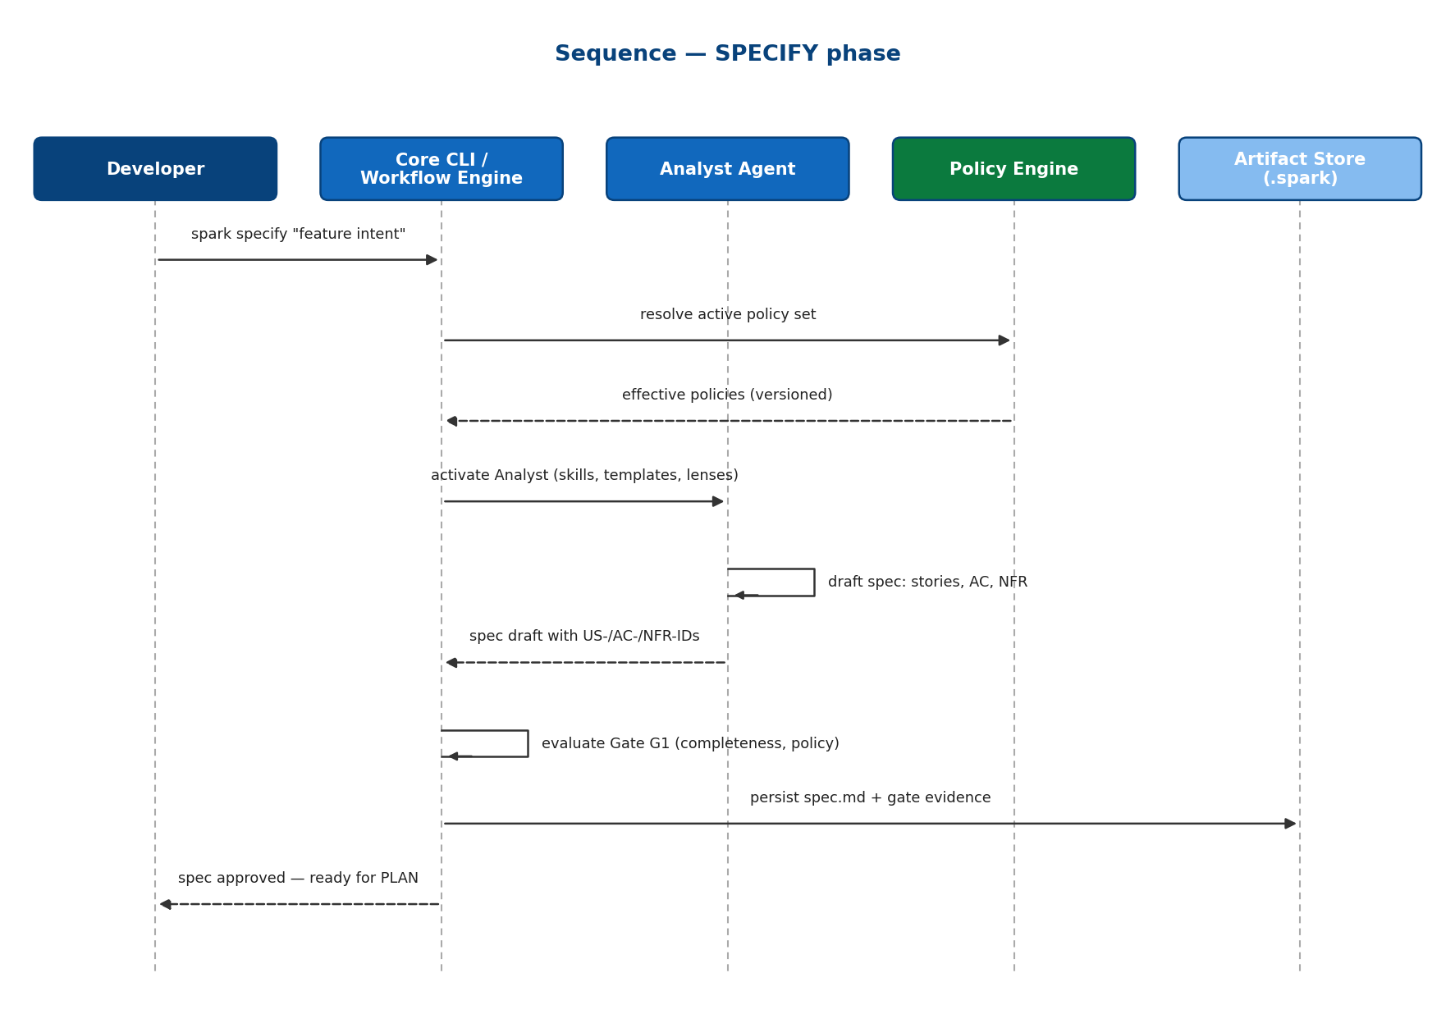
Figure 11: Sequence — SPECIFY: policy resolution, drafting, ID issuance, Gate G1
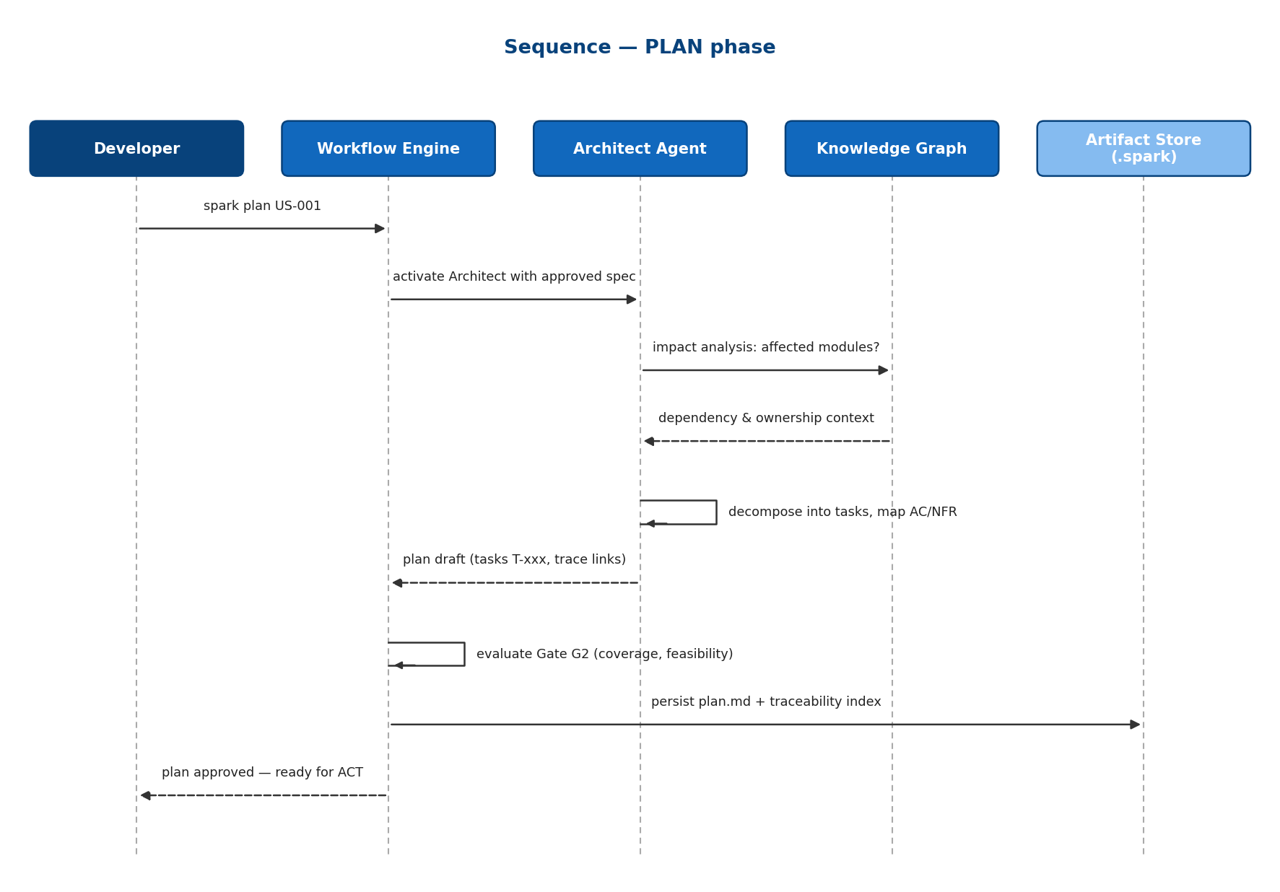
Figure 12: Sequence — PLAN: impact analysis, decomposition, trace mapping, Gate G2
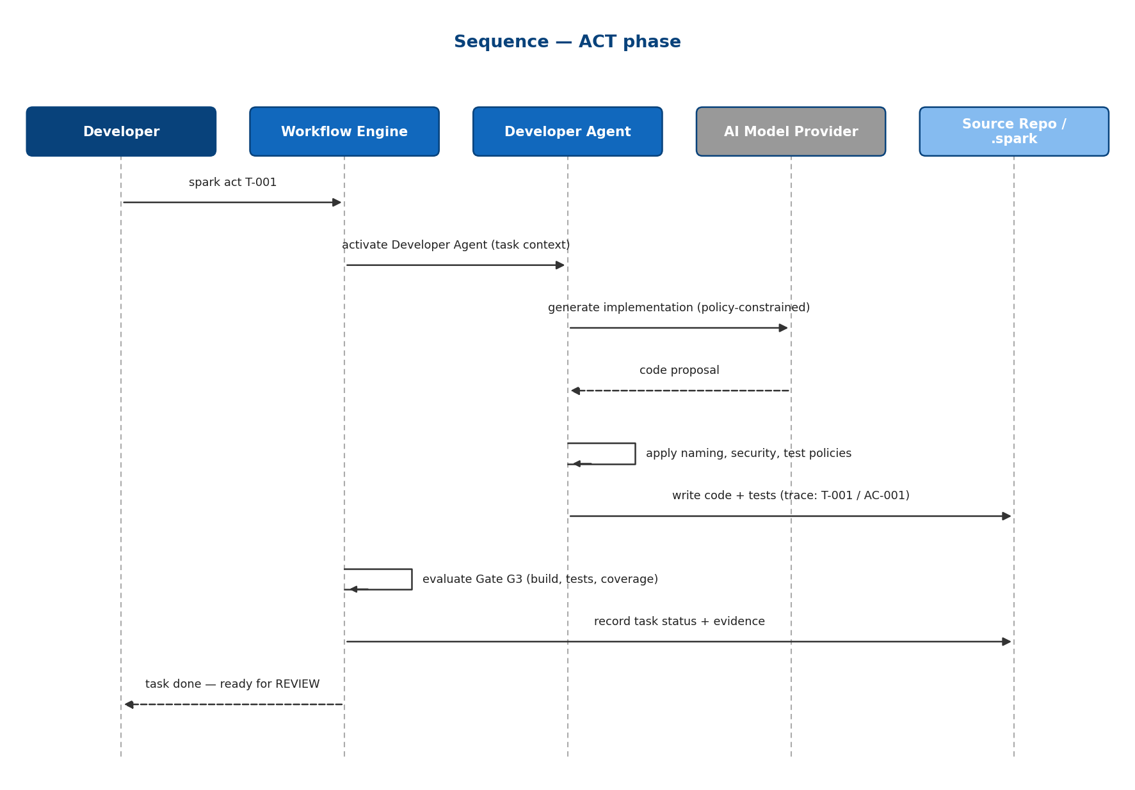
Figure 13: Sequence — ACT: policy-constrained implementation, task linkage, Gate G3
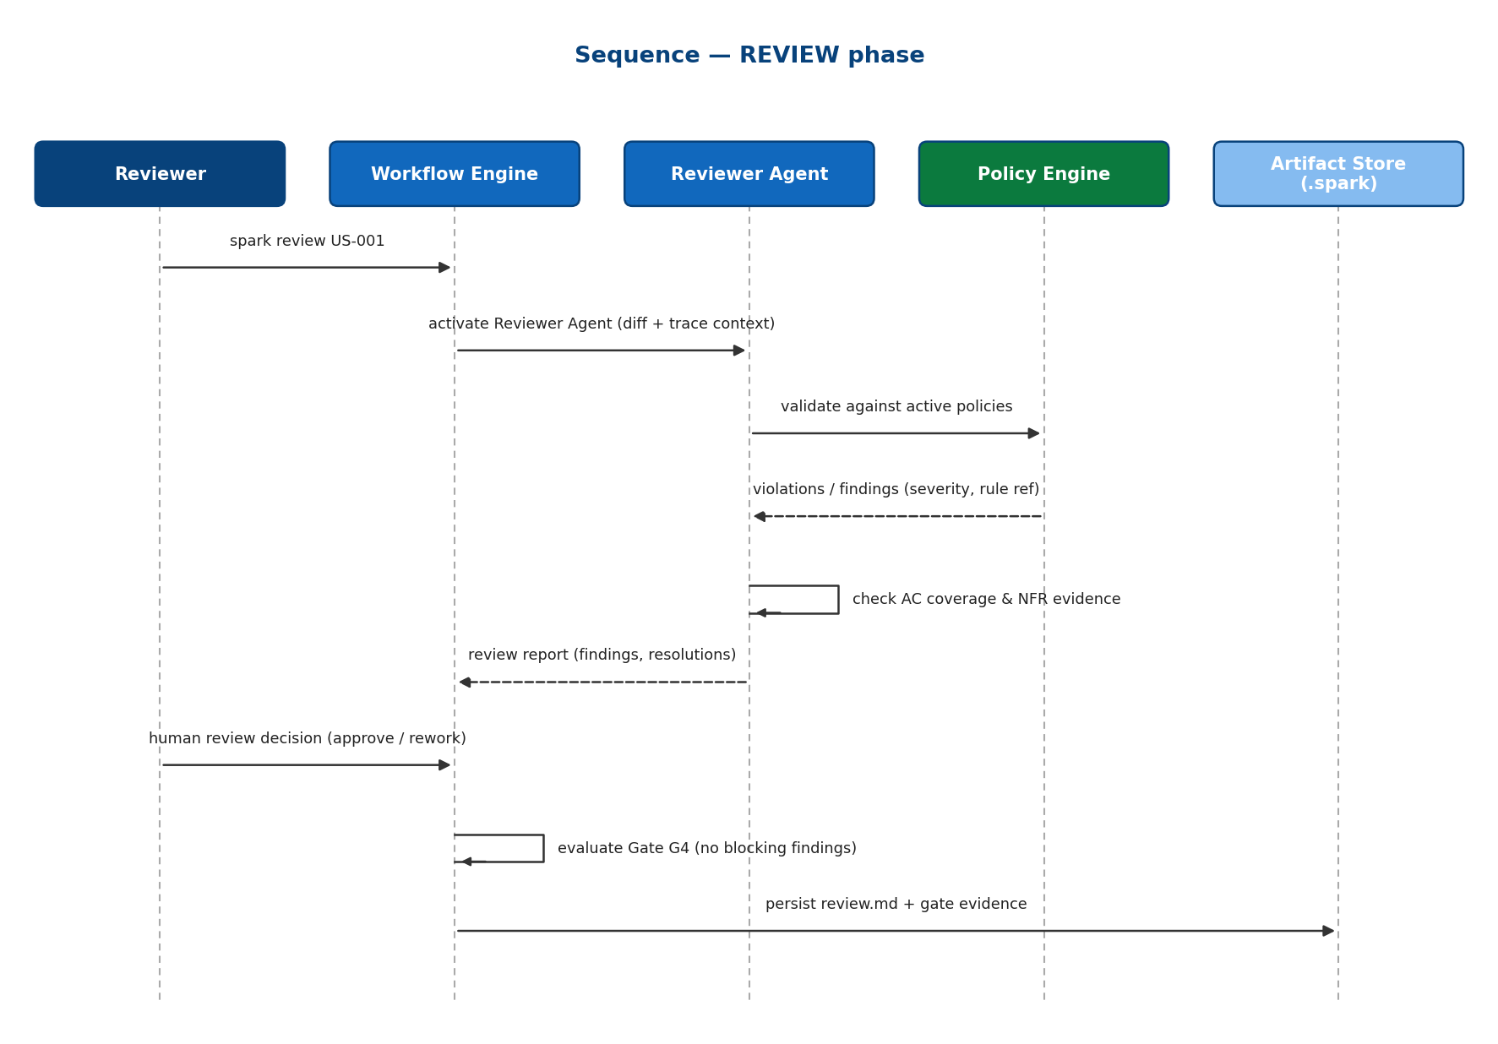
Figure 14: Sequence — REVIEW: machine validation plus human judgment, Gate G4
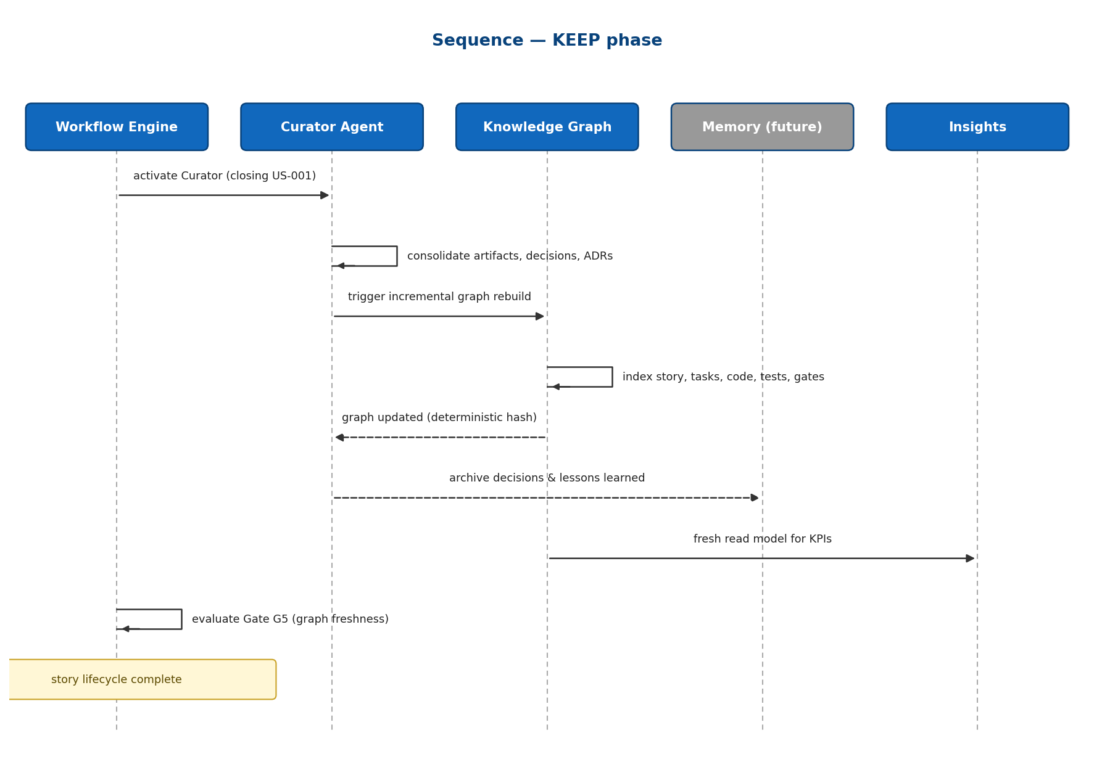
Figure 15: Sequence — KEEP: curation, graph rebuild, freshness proof, Gate G5

A.6 Glossary
Term | Definition
SPARK | The delivery cycle Specify → Plan → Act → Review → Keep
Artifact | Versioned delivery document under .spark/ (spec, plan, review, gate evidence, ADR)
Gate | Declarative check bundle guarding a phase transition; produces evidence
Effective policy set | Deterministic resolution of all imported policy packs for a project
Sealed rule | Policy rule that lower hierarchy levels may not relax
Lens | Declarative context filter defining what an agent sees for a work item
Read model | Derived, rebuildable state (graph, caches, KPIs) — never a system of record
Provenance | Recorded inputs (commit, versions, hashes) that produced a derived output
Freshness | Proof that a read model corresponds to the commit under validation
MCP | Model Context Protocol — the graph's standard interface for AI agents

