**WEEK 1 Assignment**

1. i) Local Repository





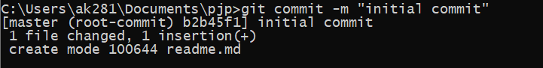

1. Remote Repository

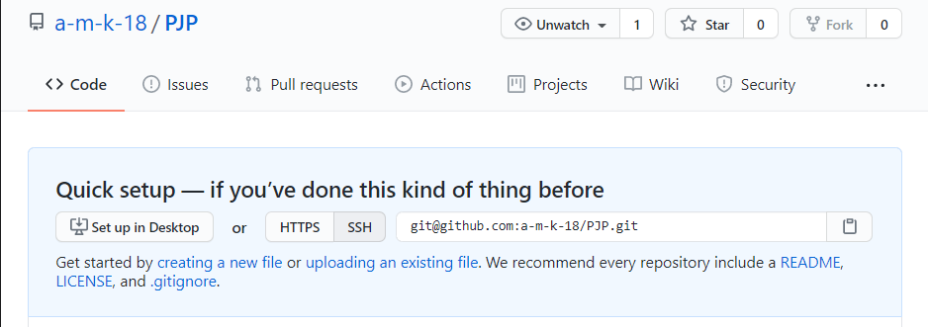

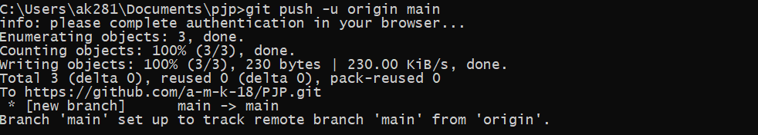

1. Adding Local branches

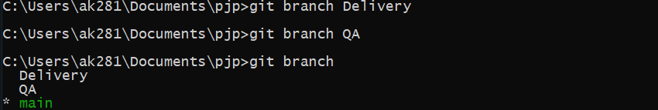

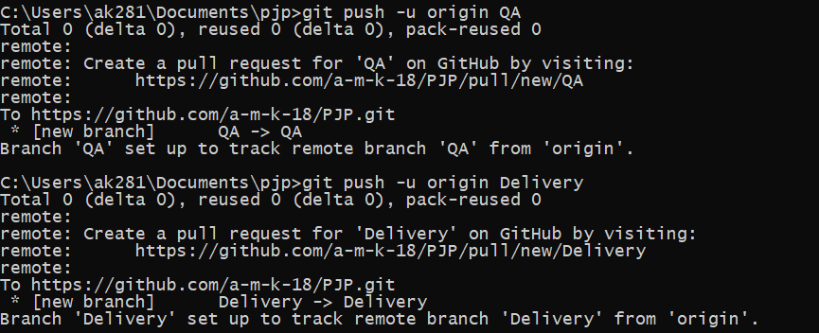

1. Remote Branches

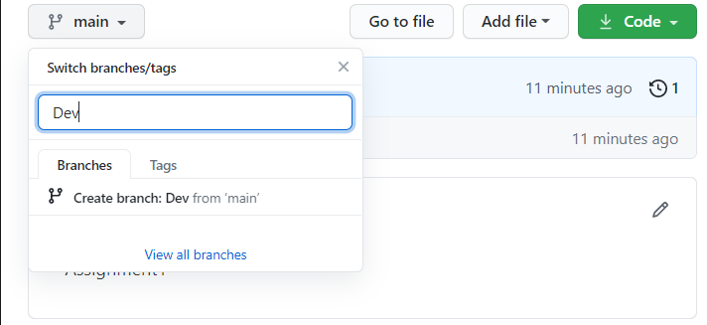

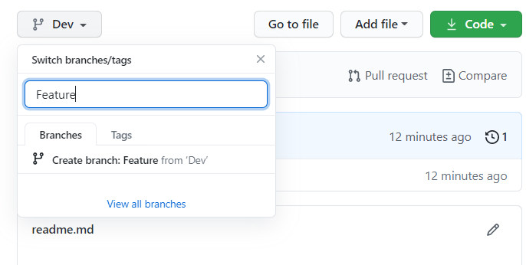

v) & vi) Adding files and folders and commit to Feature Branch



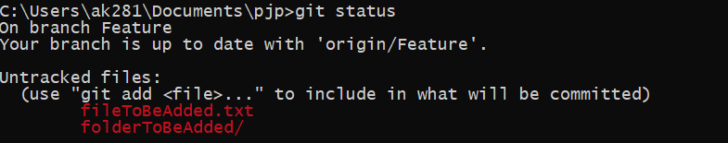

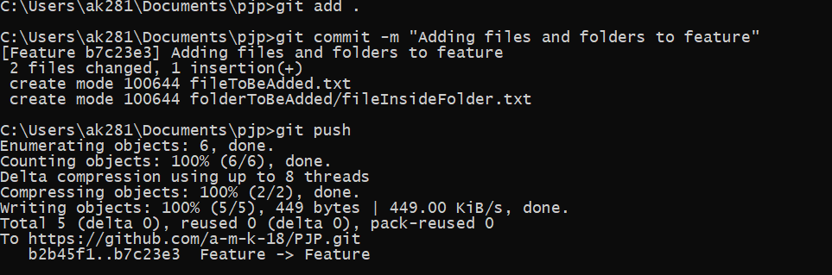

vii)

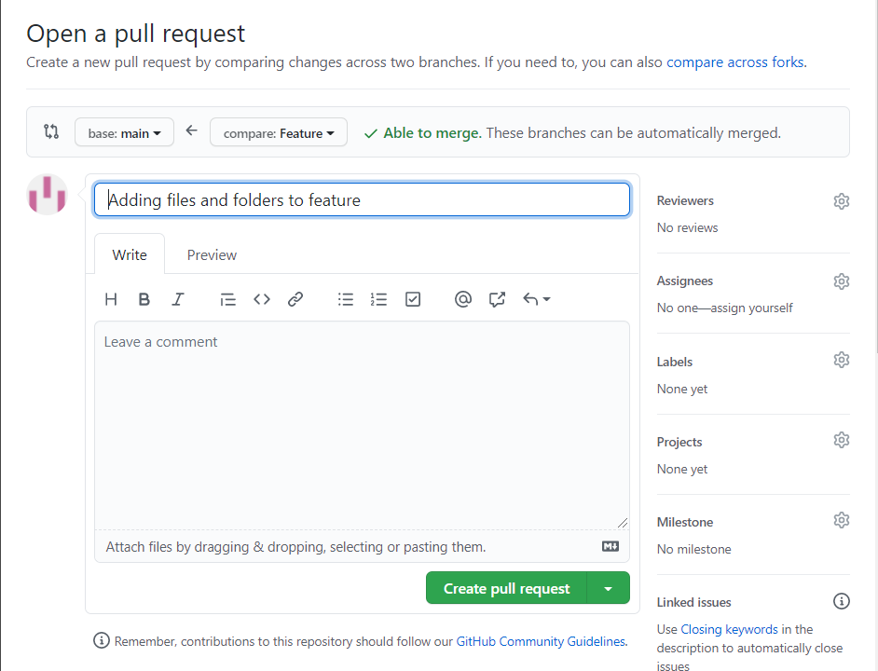

viii)

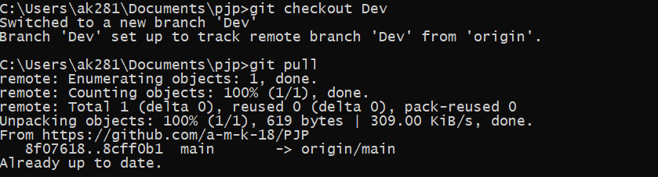

ix) In the case of **Checkout,** it checks for the files and does not merge where as in the case of **Pull** , the files are requested and merged with the branch.

x)

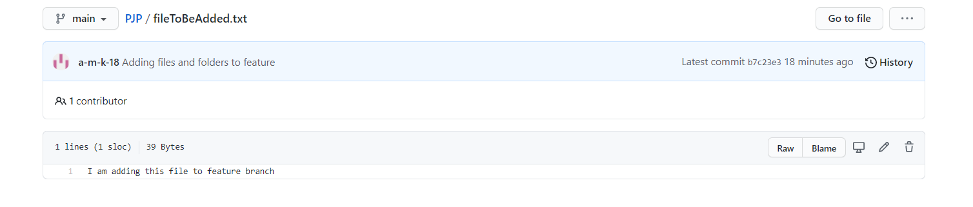

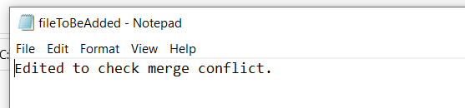

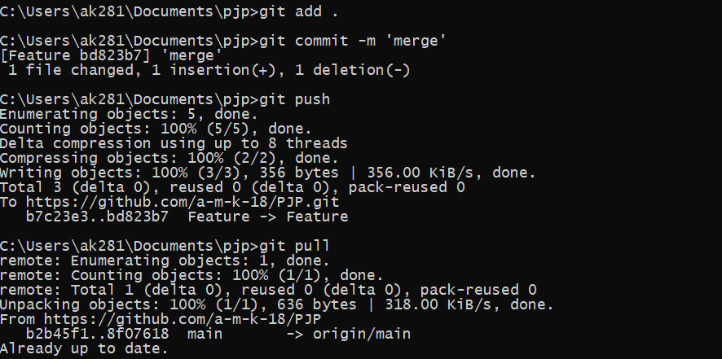

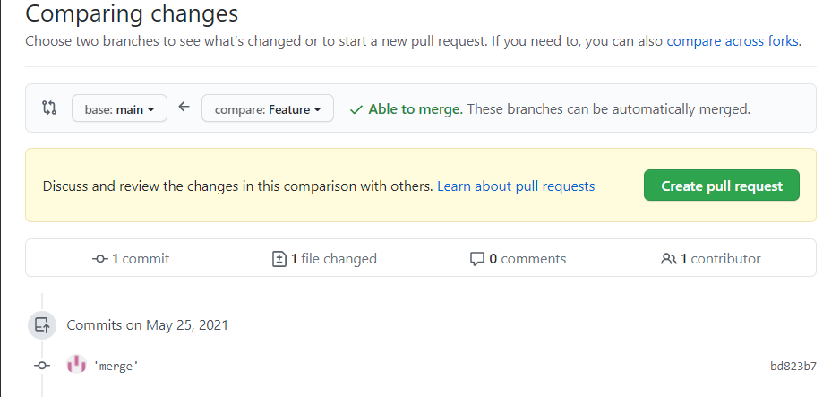

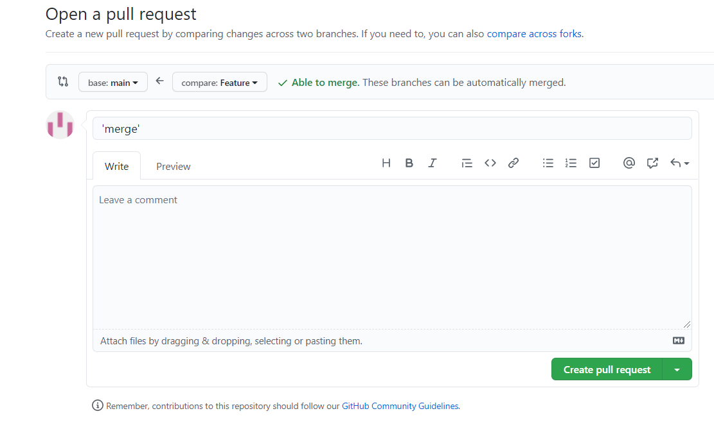

3)

i)

**Hard reset.**

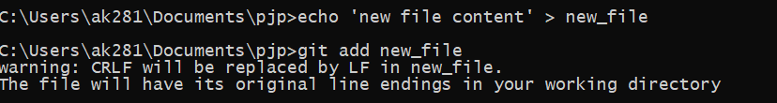

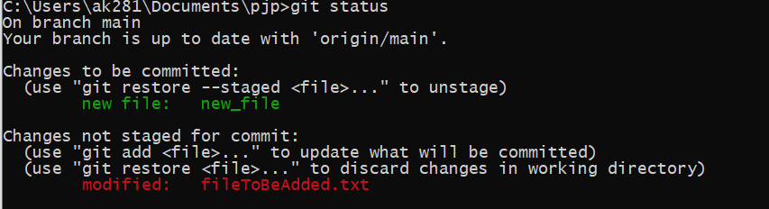

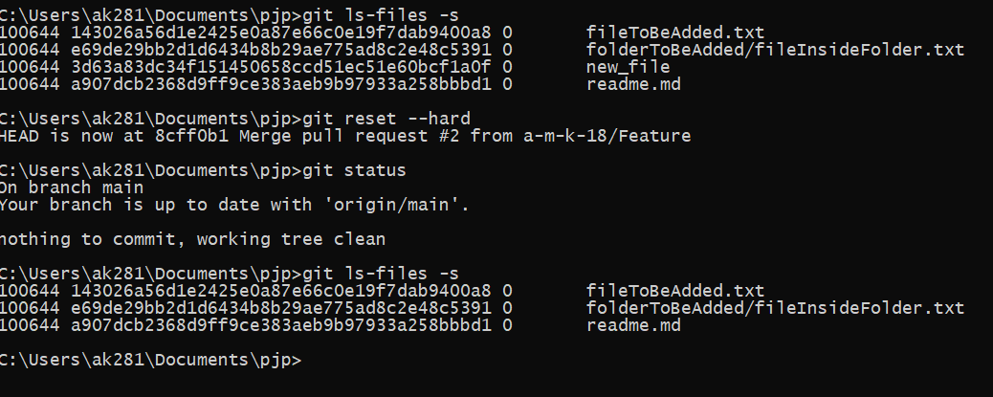

**Soft reset.**

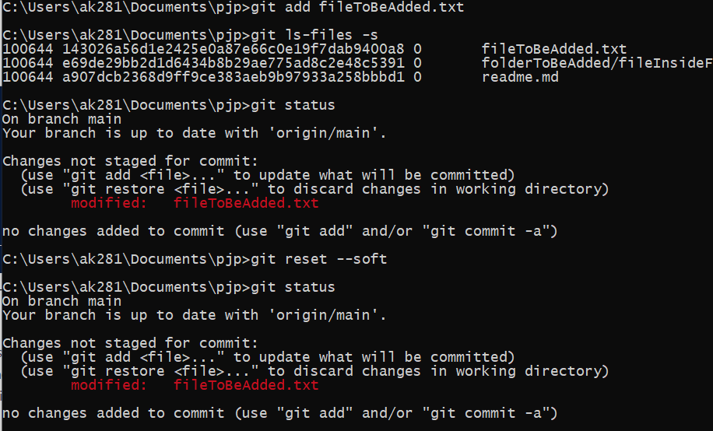

(ii) (iii) (iv)

