* Please anyone of you, who has an access to the Admin Interface of Portal and ArcGIS Server, can download the tool.
* Please unzip the  folder (using 7-zip)
* In the uncompressed folder, execute the application



* You will have following Graphical User Interface:

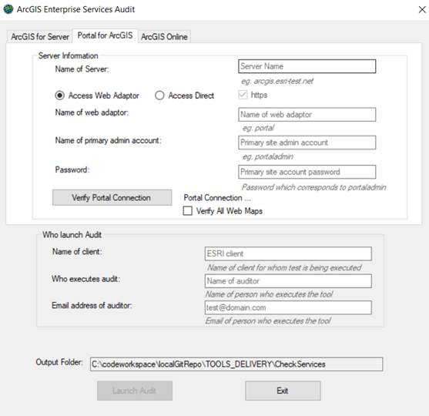

* Click on Portal, provide machine name (or external DNS for Portal for ArcGIS), Web adaptor Name, User name which corresponds to “Portal Administrator account” and Corresponding Password. Once all fields are completed, click the button “Verify Portal Connection”:

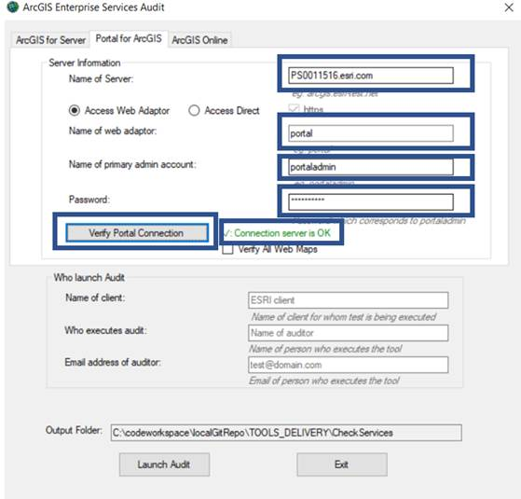

* If the message is : Connection Server is OK
* Please give the Name of client: City of Dallas, Name of person who executes the report and Email address. Then click “Launch Audit”, which will show the following window:

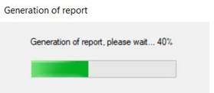

* It can take from few minutes to few tens of minutes (which depends on users and items).
* At the end, the report will be generated as an Excel file:

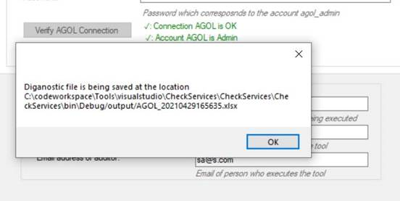

* The report will be generated in output folder:

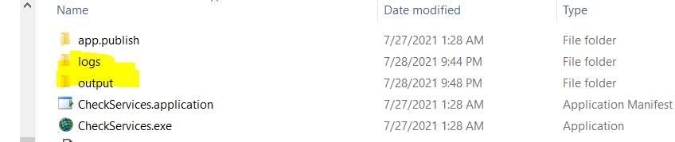

* If you have any problem you can share with me logs folder as well.
* Regarding ArcGIS Server. Please go to ArcGIS Server tab and provide the information ArcGIS Server (external DNS if manager access is available), Web Adaptor, Site admin account and corresponding password:

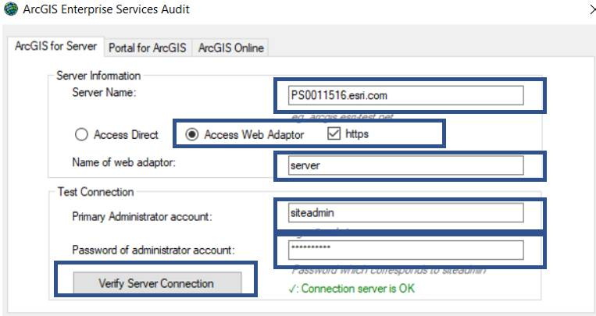

* Then click on Verify Server Connection

Please generate the report as explained above for all Portals and ArcGIS Servers