Date: May 17, 2024
To: Perry Cox, M.D., Chief of Medicine
From: Aid Marchoud
Subject: Analysis of Variances for Admissions and Births

Sacred Heart has provided the data set taken from American Hospital Association Guide to the Health-Care Field, published in Chicago, Illinois. The company has been provided an opportunity to expand and change the type of ownership. Before moving forward with testing the data, the company wants to make sure that the sample size and data are viable. This report will provide the Analysis of Variances (ANOVA) for admissions and births by geographical region and/or control. The data will help the company understand how different groups respond by comparing the samples to see whether there is a significant or no significant differences in the data and therefore approve the dataset for further analytical testing.

Contents of the report:
- Define Data terms
- ANOVA for Admissions
  - One- Factor ANOVA with:
    - Geographical Region
    - Control
  - Two-Factor ANOVA with Geographical Region and Control
- ANOVA for Births
  - One- Factor ANOVA with:
    - Geographical Region
    - Control
  - Two-Factor ANOVA with Geographical Region and Control
- Conclusion

DEFINE DATA TERMS:

Hospital: The numeric value given to a hospital on the report to make running the report easier
Geographic Region: The variable is coded from 1 to 7, and the numbers represent the following regions-
1 = South
2 = Northeast
3 = Midwest
4 = Southwest
5 = Rocky Mountain
6 = California
7 = Northwest
Control: A type of ownership. Four categories of control are included in the database-
1 = government, nonfederal
2 = nongovernment, not-for-profit
3 = for-profit
4 = federal government
Service: The type of hospital. The two types of hospitals used in this database are-
1 = general medical
2 = psychiatric
Beds: Number of beds in the hospital
Admissions: The number of people admitted to the hospital
Census: Average number of patients per day in a hospital over a given period of time; admitted patients and outpatients are counted separately
Outpat. (Outpatient) Visits: Any visit made during the person's reference period to a hospital outpatient department
Births: Number of births in the hospital
Tot. Exp. (Total Expenditure): All costs and expenses reasonably and properly incurred in units of $1,000.
Payroll Exp. (Payroll Expense): The amount of salaries and wages paid to employees in exchange for services rendered by them to a business in units of $1,000
Personnel: Number of people that work in the hospital

ANOVA for Admission:

One-Factor ANOVA for Admissions with Geographical Region

Sacred Heart wants to know if there is a significant difference in the population means between Admissions and Geographical Region. After running the test, the data shows that the null hypothesis can’t be rejected due to the statistical value, which is not small (as shown below).
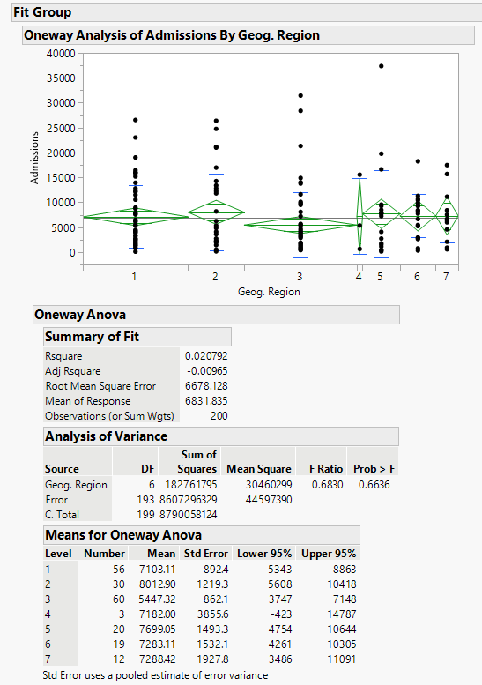

One-Factor ANOVA for Admissions with Control

Sacred Heart wants to know if there is a significant difference in the population means for Admissions and Control. After running the test, the data shows that the null hypothesis can be rejected due to the statistical value (as shown below), which is small. Because the null hypothesis was rejected, the data needs further analyzation by considering the whether the variances are equal or not.

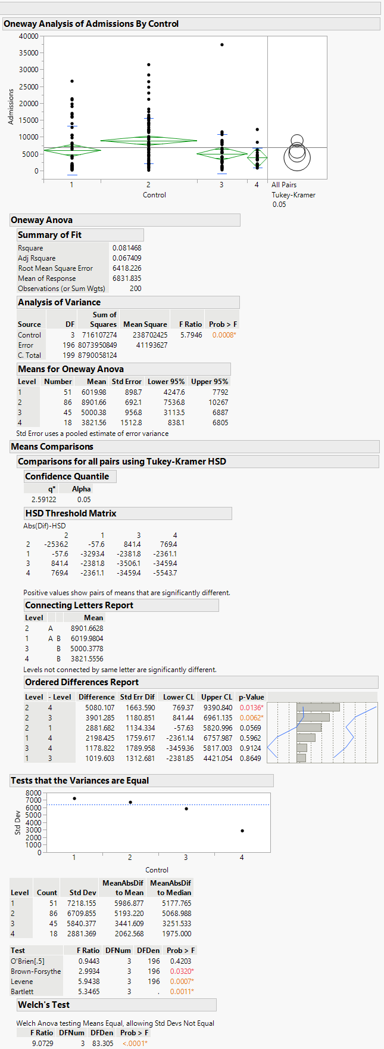

To consider the equality of the variances, the data needs to be run and analyzed (as shown below). Based on the data, the statistical values are small and the variances are assumed to be unequal, which means that the ANOVA output can’t be trusted and the null hypothesis continues to be rejected.

Due to the variances proving to be unequal, the next step is to check the Welch’s Test (as shown below). Based on the Welch’s Test there is a significant difference in the population meant of control (government (nonfederal), nongovernment (not-for-profit), for-profit, federal government).

The last step is to compare the means by using the Tukey-Kramer Honest Significant Difference, the most desired of the methods. To identify mean differences, the Connecting Letters Report needs to be examined. Based on the Connecting Letters Report (as shown below); For-Profit and Federal Government ownership have means that are similar, but their means are significantly different from the Nongovernment (not-for-profit) ownership. The Government (nonfederal) mean falls somewhere in between.

Two-Factor ANOVA for Admissions with Geographical Region and Control

Sacred Heart would like a comparison of the mean differences for Geographical Region and Control to see if there is an interaction between Geographical Region and Control and Admissions. Based on the small statistical value, it shows that there are significant differences in the means and therefore we can initially reject the null hypothesis. The means can be compared individually by Geographical Region, Control, and Geographical Region and Control.
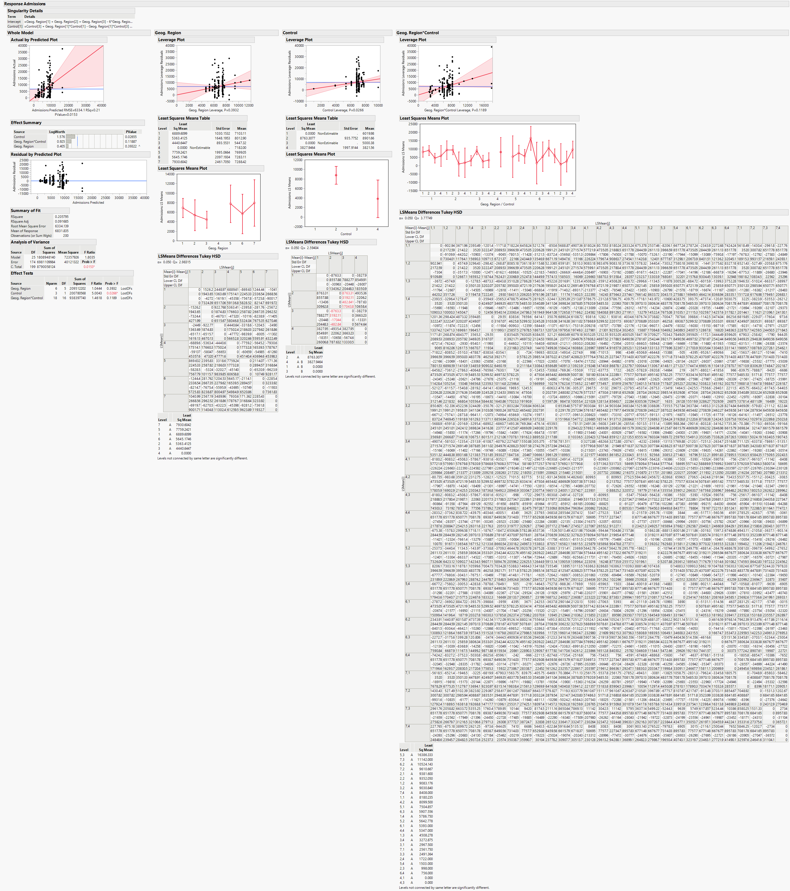

For Geographical region, the result is similar to the one-factor ANOVA that was done previously. The statistical value is not small, therefore the null hypothesis can’t be rejected. This means that there is no significant differences in the means.

For Control, the result is similar to the one-factor ANOVA that was done previously. The statistical value is small coupled with the Connecting Letters Report, which shows 2 different letters (A and B), therefore the null hypothesis can be rejected. Based on the information below, there is a significant difference among the means.

The comparison of Geographical Region and Control shows a not small statistical value coupled with the Connecting Letters Report, which only shows letter A, confirms that there is no significant difference among the means.

ANOVA for Births:

One-Factor ANOVA for Births with Geographical Region

Sacred Heart wants to know if there is a significant difference in the population means for Births and Geographical Region. After running the test, the data shows that the null hypothesis can’t be rejected due to the statistical value, which is not small (as shown below).

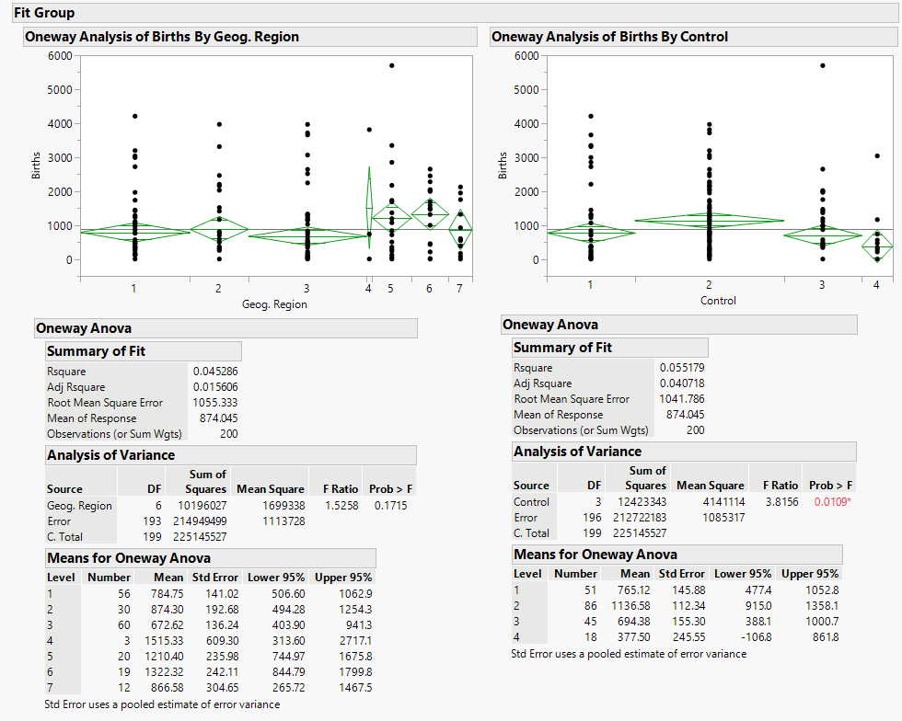

One-Factor ANOVA for Births with Control

Sacred Heart wants to know if there is a significant difference in the population means for Admissions and Control. After running the test, the data shows that the null hypothesis can be rejected due to the statistical value (as shown below), which is small. Because the null hypothesis was rejected, the data needs further analyzation by considering the whether the variances are equal or not.

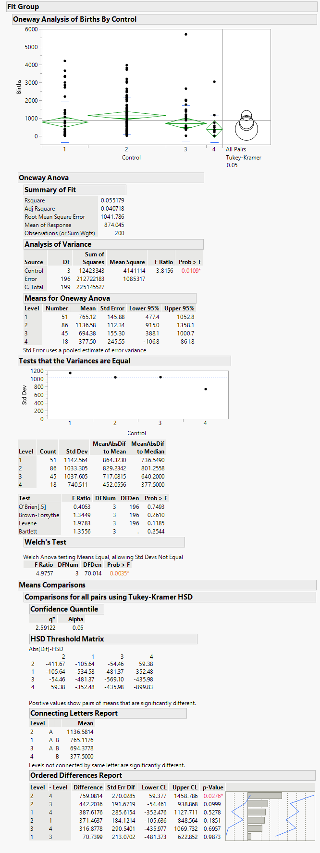

To consider the equality of the variances, the data needs to be run and analyzed (as shown below). Based on the data, the statistical values are not small and the null hypothesis can’t be rejected. In this case, the Welch’s Test can be skipped.

The last step is to compare the means by using the Tukey-Kramer Honest Significant Difference. To identify mean differences, the Connecting Letters Report needs to be examined. Based on the Connecting Letters Report (as shown below); Government (nonfederal) and For Profit ownership have means that are similar and fall in the middle. The means are significantly different between the Nongovernment (not-for-profit) ownership and the Federal Government.

Two-Factor ANOVA for Births with Geographical Region and Control

Sacred Heart would like a comparison of the mean differences for Geographical Region and Control to see if there is an interaction between Geographical Region and Control and Births. Based on the small statistical value, it shows that there are significant differences in the means and therefore we can initially reject the null hypothesis. The means can be compared individually by Geographical Region, Control, and Geographical Region and Control.

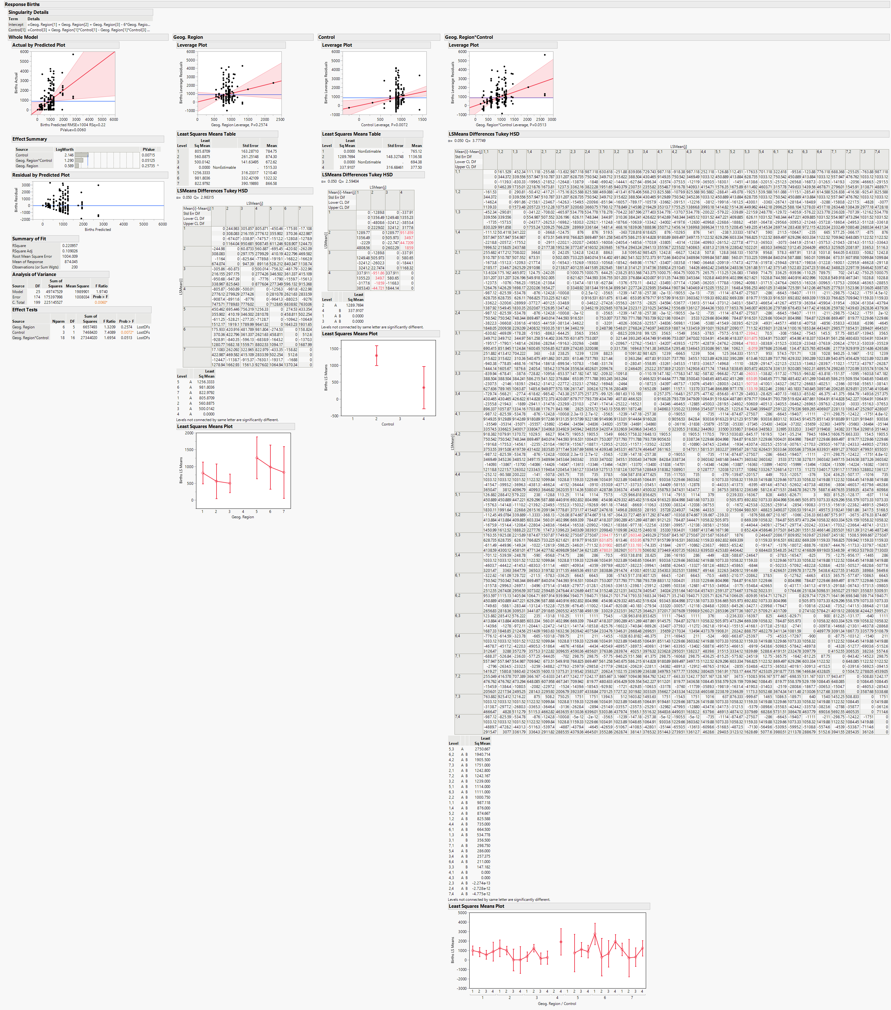

For Geographical region, the result is similar to the one-factor ANOVA that was done previously. The statistical value is not small, therefore the null hypothesis can’t be rejected. This means that there is no significant differences in the means.

For Control, the result is similar to the one-factor ANOVA that was done previously. The statistical value is small coupled with the Connecting Letters Report, which shows 2 different letters (A and B), therefore the null hypothesis can be rejected (as shown below).

The comparison of Geographical Region and Control shows statistical value that is slightly not small, but the Connecting Letters Report, which shows a majority of a combination of A and B. This seems to have conflicting information and overall shows that there is a slight significance in the means.

CONCLUSION:

Based on the ANOVA tests conducted, there are a few things that can be taken away. Firstly, the Geographical Region variable consistently had no significance differences among the population means regardless of whether it was in relation to Admissions or Births, which makes Geographical Region a good set of data to use. Secondly, the control variable consistently showed significant differences among the population means regardless of whether it was in relation to Admissions or Births, which makes it not a good set of data to use on its own. Finally when Geographical Region and Control were used in conjunction with each other, there was different effects for Admissions and Births. When the test was conducted for Admissions with Geographical region and Control, there was no significant differences to the population means. When the test was conducted for Births with Geographical region and Control, there was no significant differences to the population means based on the statistical value, but when you look at the Connecting Letter Report it showed a significant difference among the population means.

