Alex Lilley

Alex Mori

Ethan Balzer

Software Design – ACIT 2515

To get our code to work, click on File, then click on Project Structure.

Once you are in the Project Structure window, click on Modules, then click Dependencies.

You then have to add a Dependency by clicking the green “+” button.

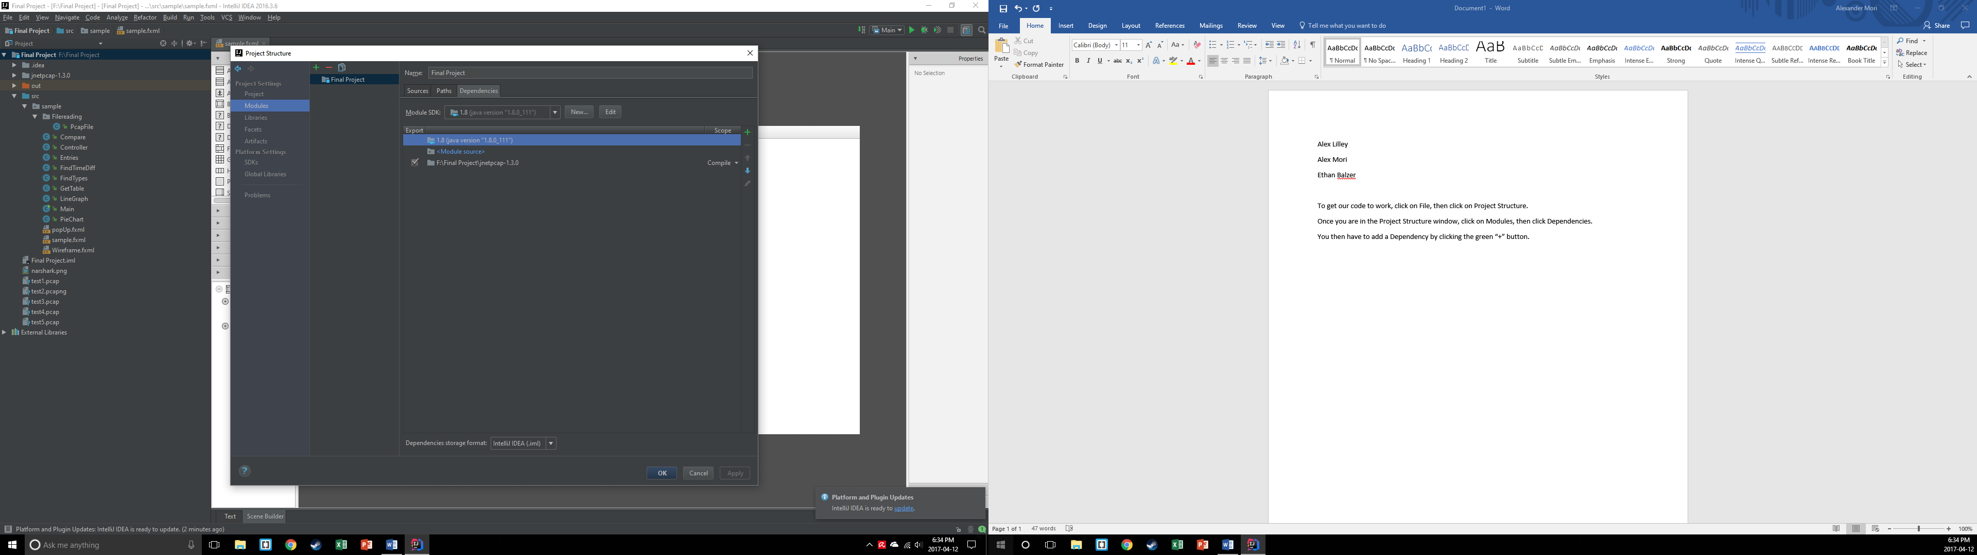

Click JARs or Directories once you have done that.

Navigate to our project folder and click on the jnetpcap-1.3.0 folder. Click OK.

You will be brought back to the Project Structure window. Ensure that there is a check mark beside the jnetpcap folder.

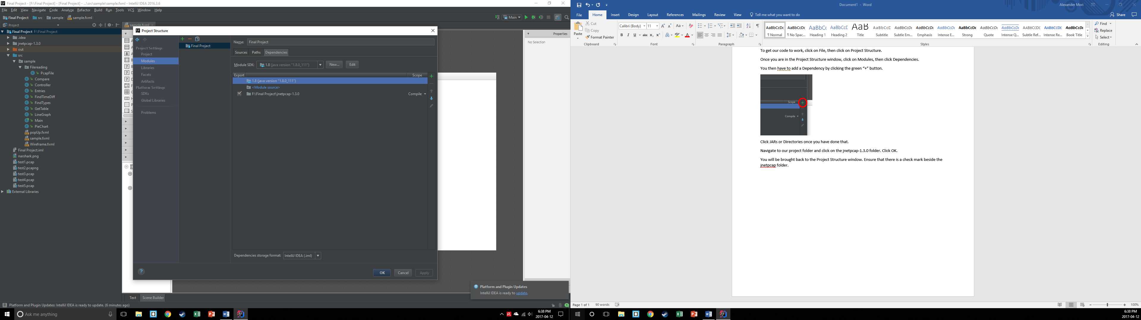

Click OK.

Our project should now be set up to work on your computer.