DECISION TREE FOR BREAST CANCER ANALYSIS - TASK 1



NAME | ABDUL MUIZZ, MUHAMMAD ABDULLAH
REGISTRATION NUMBER | FA23-BCS-117, FA23-BCS-108
DATE OF SUBMISSION | 26TH SEPTEMBER 2025
MODERATOR | SIR UMAR NAUMAN

Table of Contents:
Abstract: 3
Problem Statement: 4
Dataset Description: 5
Feature Categories: 5
Data Split: 5
Methodology: 6
1. Data Preprocessing 6
2. Exploratory Data Analysis 6
3. Feature Selection Strategies 6
4. Model Configuration 6
Data Analysis and Visualization: 7
Hypothesis Validation: 7
Feature Correlation Analysis: 7
Feature Selection Approaches: 9
Approach 1: All Original Features (30 features) 9
Approach 2: Reduced Correlation Set (3 features) 9
Approach 3: PCA Transformation (5 components) 9
Model Implementation: 10
Decision Tree Configuration: 10
Tree Structure Analysis: 10
Results and Analysis: 13
Performance Comparison: 13
Key Findings: 13
Feature Importance Analysis: 13
Model Interpretability: 13
Random Forest Comparison: 15
Implementation: 15
Results: 15
Analysis: 15
Random Forest Advantages: 15
List of Figures: 17
Conclusion: 18
Key Findings: 18
Medical Relevance: 18
Limitations: 18
Future Work: 18
Practical Applications: 19
References: 20

Abstract:
This project implements Decision Tree classification algorithms to predict breast cancer diagnosis using the Wisconsin Breast Cancer Dataset. The study compares three different feature selection approaches: using all original features, reducing correlated features, and applying Principal Component Analysis (PCA). A Random Forest classifier is also implemented for performance comparison. The original feature set achieved the highest test accuracy of 94% with Decision Trees, while Random Forest achieved 97% accuracy.

Problem Statement:
Breast cancer is one of the most common cancers affecting women worldwide. Early and accurate diagnosis is crucial for effective treatment. This project aims to:
- Build a Decision Tree classifier to predict breast cancer diagnosis (malignant vs benign).
- Compare different feature selection techniques and their impact on model performance.
- Analyze which features are most important for cancer prediction.
- Evaluate Decision Trees against Random Forest for this classification task.
- Provide interpretable models that can assist in medical decision making.

Dataset Description:
Source: sklearn.datasets - Breast Cancer Wisconsin Dataset
Total Samples: 569 cases
Classes: 2 (Malignant, Benign)
Features: 30 numerical features

Feature Categories:
All features are computed from digitized images of cell nuclei and include measurements for:
- Radius: Mean distances from center to points on perimeter
- Texture: Standard deviation of gray scale values
- Perimeter: Perimeter of cell nuclei
- Area: Area of cell nuclei
- Smoothness: Local variation in radius lengths
- Compactness: (perimeter²/area - 1.0)
- Concavity: Severity of concave portions of contour
- Concave Points: Number of concave portions of contour
- Symmetry: Symmetry of cell nuclei
- Fractal Dimension: "Coastline approximation" - 1
Each feature has three measurements: mean, standard error, and worst (largest) value.

Data Split:
- Training Set: 80% (455 samples)
- Test Set: 20% (114 samples)

Methodology:

1. Data Preprocessing
- Loaded breast cancer dataset from sklearn
- Split data into training and testing sets (80-20 split)
- No missing values to handle
- Features were already normalized in the dataset

2. Exploratory Data Analysis
- Generated hypothesis: Size and shape of cell nuclei are good predictors
- Created visualization to validate hypothesis
- Analyzed feature correlations

3. Feature Selection Strategies
Three approaches were implemented:
- All Features: Using complete 30-feature set
- Correlation-Based Reduction: Manual selection of low-correlation features
- PCA Transformation: Dimensionality reduction to 5 principal components

4. Model Configuration
- Algorithm: DecisionTreeClassifier
- Parameters: max_depth=3, min_samples_leaf=12
- Evaluation: Training and test accuracy comparison

Data Analysis and Visualization:

Hypothesis Validation:
The initial hypothesis stated that cancerous cell nuclei are typically larger and more misshapen than benign ones. This was validated through:
- Mean Area Analysis: KDE plots showed clear separation between malignant and benign tumors based on mean area measurements
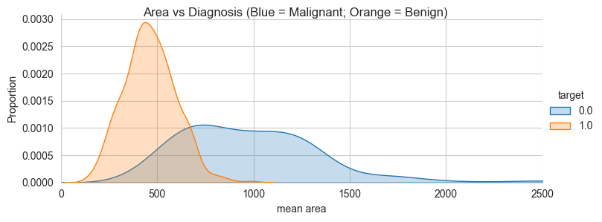
Figure 1: Kernel Density Estimate plot of 'mean area' distribution for malignant vs benign tumors

- Concave Points Analysis: Distribution plots revealed distinct patterns in mean concave points between the two classes.
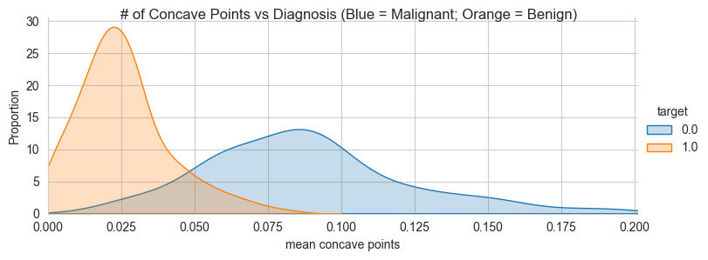
Figure 2: KDE plot of 'mean concave points' showing class separation

Feature Correlation Analysis:
A correlation heatmap revealed high correlation among many features, particularly between:
- Area, perimeter, and radius measurements
- Different statistical measures (mean, error, worst) of the same feature
- Compactness and concavity measurements
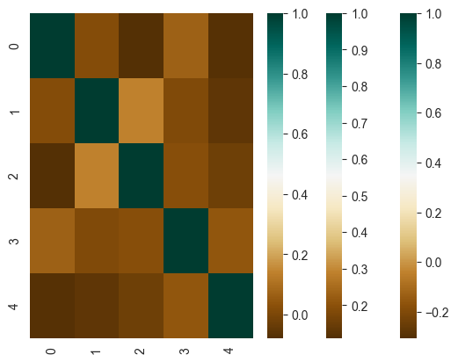
Figure 3: Correlation heatmap of all 30 original features

Feature Selection Approaches:

Approach 1: All Original Features (30 features)
- Advantage: Complete information retention
- Disadvantage: High correlation between features
- Result: Potential overfitting due to redundant information

Approach 2: Reduced Correlation Set (3 features)
Selected features with low inter-correlation:
- mean texture
- mean area
- mean symmetry
Rationale: These features represent different aspects of cell nuclei characteristics

Approach 3: PCA Transformation (5 components)
- Applied Principal Component Analysis to reduce dimensionality
- Retained 5 principal components
- Advantage: Uncorrelated features while preserving most variance
- Disadvantage: Loss of feature interpretability

Model Implementation:

Decision Tree Configuration:
python
DecisionTreeClassifier(max_depth=3, min_samples_leaf=12)
Parameter Justification:
- max_depth=3: Prevents overfitting while maintaining interpretability
- min_samples_leaf=12: Ensures each leaf has sufficient samples for reliable predictions

Tree Structure Analysis:
Each decision tree was visualized to understand the decision-making process:
- Tree 1 (All Features): Focused on 'worst perimeter' and 'worst concave points'.
- Tree 2 (Reduced Features): Used 'mean area' and 'mean texture' as primary decision nodes.
- Tree 3 (PCA Features): Based on principal components (less interpretable).
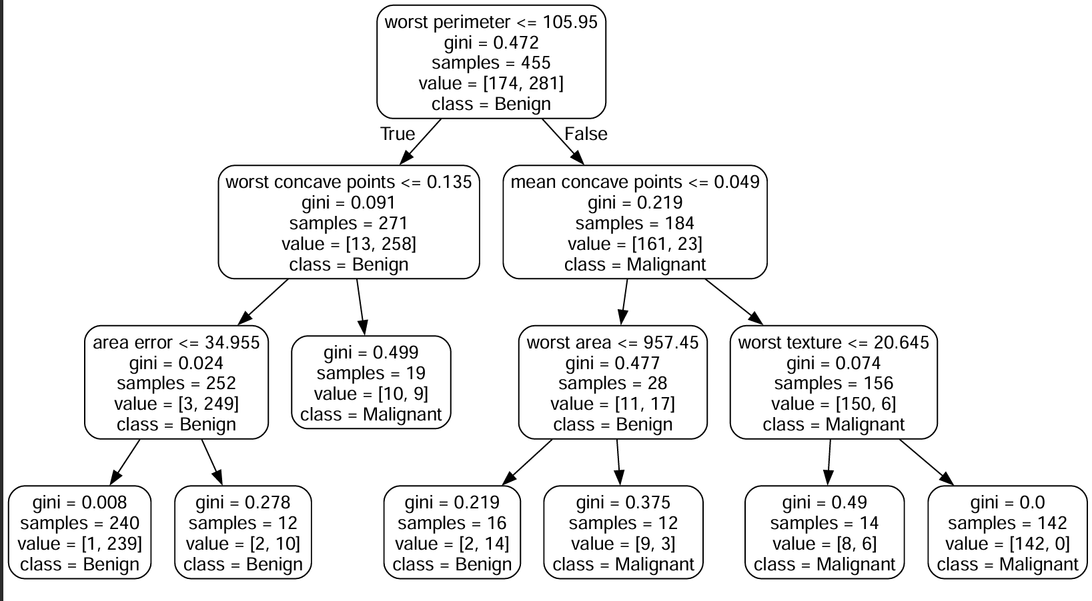
Figure 4: Decision Tree visualization using all original features

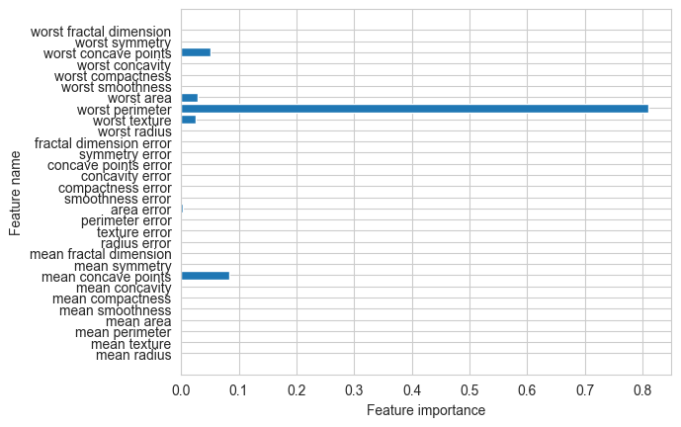
Figure 5: Feature importance plot for Decision Tree with all features.
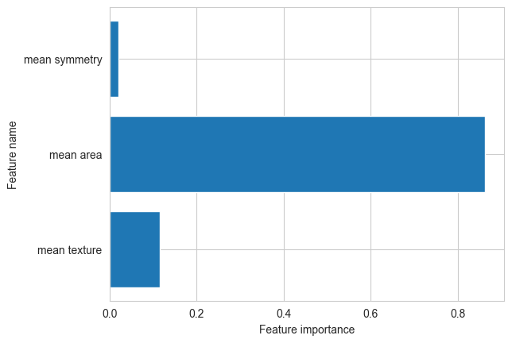
Figure 6: Retain only features that were produced through PCA transformation.

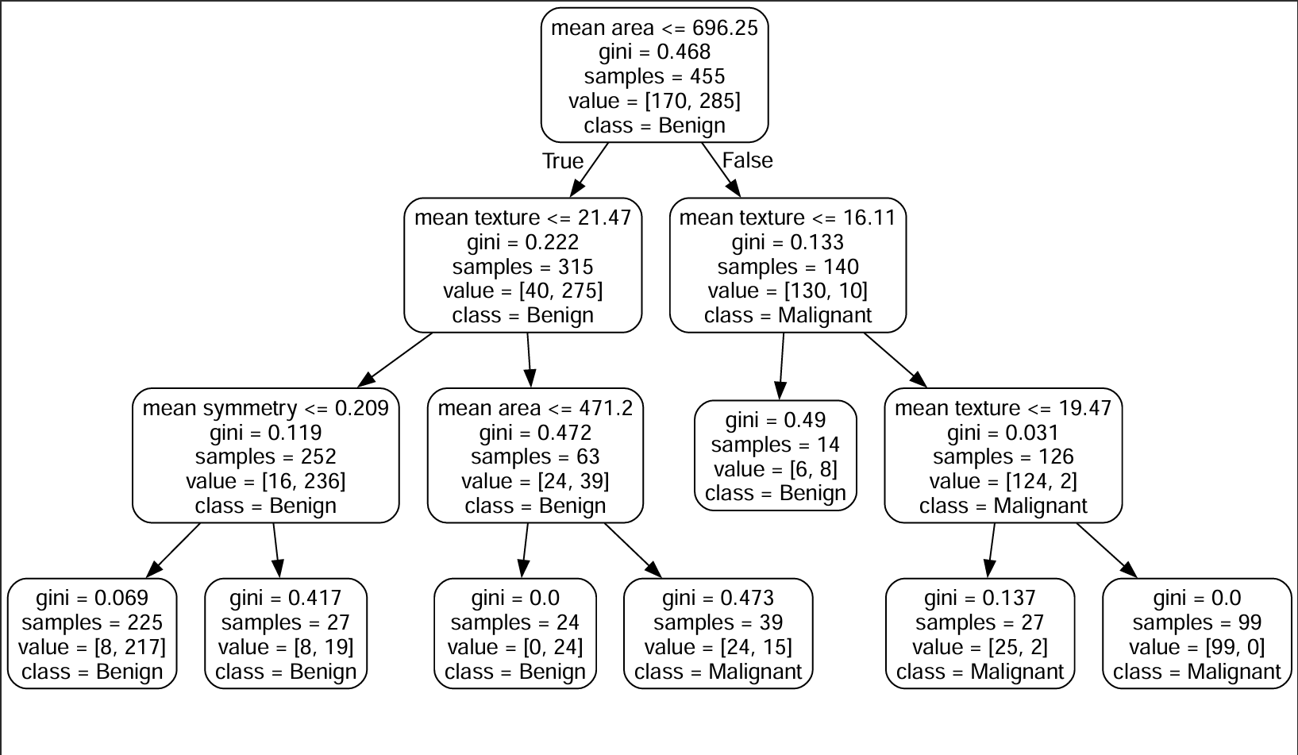
Figure 7: Decision Tree visualization using reduced feature set (3 features)

Results and Analysis:

Performance Comparison:
Feature Set | Training Accuracy | Test Accuracy | Number of Features
All Original Features | 95% | 94% | 30
Reduced Correlation | 91% | 84% | 3
PCA Transformed | 96% | 91% | 5

Key Findings:
- Best Performance: All original features achieved highest test accuracy (94%)
- Feature Importance: 'worst perimeter' was identified as the most important feature
- Reduced Features: Significant accuracy drop (84%) when using only 3 features
- PCA Results: Good balance between dimensionality reduction and performance (91%)

Feature Importance Analysis:
From the complete feature set model:
- worst perimeter: Most important predictor
- worst concave points: Second most important
- mean area: Strong predictor in reduced feature set
- mean texture: Consistent across different models

Model Interpretability:
Decision trees provided clear, interpretable rules:
- If worst perimeter > threshold → Check worst concave points
- If mean area > threshold → Likely malignant
- Combination of size and shape features provides best discrimination

Random Forest Comparison:

Implementation:
- Algorithm: RandomForestClassifier
- Feature Set: All original 30 features
- Evaluation: Learning curves and confusion matrix analysis

Results:
- Training Accuracy: 100%
- Test Accuracy: 97%

Analysis:
- Learning Curve: Small gap between training and cross-validation scores
- Interpretation: Low bias but potential variance (slight overfitting)
- Confusion Matrix: Minimal false positives and false negatives
- Performance: Superior to single Decision Tree (97% vs 94%)

Random Forest Advantages:
- Higher Accuracy: 3% improvement over single Decision Tree
- Robustness: Better generalization through ensemble method
- Reduced Overfitting: Averaging multiple trees reduces variance
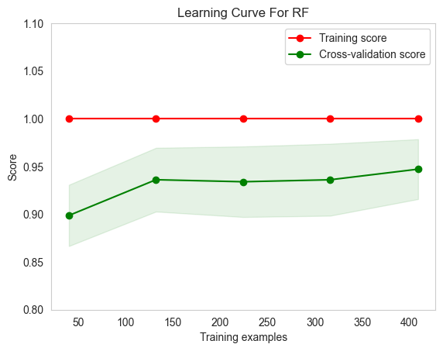
Figure 8: Learning curve for Random Forest classifier
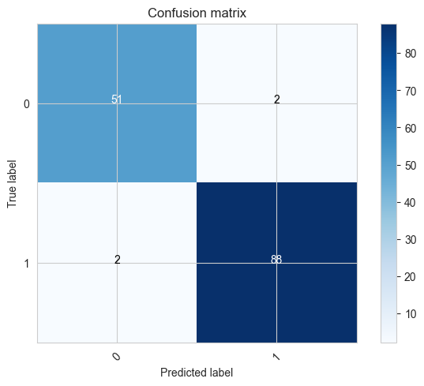
Figure 9: Confusion matrix for Random Forest test predictions

List of Figures:
- Figure 1: Kernel Density Estimate plot of 'mean area' distribution for malignant vs benign tumors. Page 8
- Figure 2: KDE plot of 'mean concave points' showing class separation. Page 8
- Figure 3: Correlation heatmap of all 30 original features. Page 9
- Figure 4: Decision Tree visualization using all original features. Page 11
- Figure 5: Feature importance plot for Decision Tree with all features. Page 12
- Figure 6: Retain only features that were produced through PCA transformation. Page 12
- Figure 7: Decision Tree visualization using reduced feature set (3 features). Page 13
- Figure 8: Learning curve for Random Forest classifier. Page 17
- Figure 9: Confusion matrix for Random Forest test predictions. Page 17

Conclusion:

Key Findings:
- Optimal Feature Set: All 30 original features provided the best single Decision Tree performance (94%)
- Critical Features: 'worst perimeter' and 'worst concave points' were most important for classification
- Feature Reduction Impact: Aggressive feature reduction (30→3) caused 10% accuracy drop
- PCA Effectiveness: Good compromise between dimensionality and performance
- Random Forest Superiority: Ensemble method achieved 97% accuracy, outperforming single trees

Medical Relevance:
- The model successfully validates the medical hypothesis that larger, more irregular cell nuclei indicate malignancy
- High accuracy (94-97%) makes it suitable for diagnostic assistance
- Interpretable features help medical professionals understand the reasoning

Limitations:
- Small Dataset: Only 569 samples may limit generalizability
- Feature Correlation: High correlation among features may affect stability
- Binary Classification: Only distinguishes malignant vs benign (no cancer staging)

Future Work:
- Cross Validation: Implement k fold cross validation for robust evaluation
- Feature Engineering: Create new features combining existing measurements
- Advanced Algorithms: Test Support Vector Machines and Neural Networks
- Clinical Validation: Validate model performance on independent medical datasets
- Ensemble Methods: Explore other ensemble techniques beyond Random Forest

Practical Applications:
- Diagnostic Support: Assist pathologists in cancer diagnosis
- Screening Programs: Automated preliminary screening of cell samples
- Research Tool: Identify which cellular features are most predictive of malignancy
- Educational Tool: Help medical students understand cancer classification features

References:
- Dua, D. and Graff, C. (2019). UCI Machine Learning Repository. University of California, Irvine
- Wolberg, W.H., Street, W.N., and Mangasarian, O.L. (1995). "Machine learning techniques to diagnose breast cancer from image-processed nuclear features of fine needle aspirates"
- Breiman, L. (2001). "Random Forests". Machine Learning, 45(1), 5-32
- Quinlan, J.R. (1986). "Induction of Decision Trees". Machine Learning, 1(1), 81-106
- Scikit-learn Documentation: Decision Trees and Random Forest Classifiers

