anupam tarai

Uttarayani

Odisha

**Cirtificate completion**

**Date:** 23/04/2024.

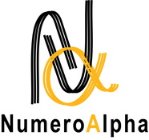

TO WHOM IT MAY CONCERN

This is to certify that anupam tarai, S/O Ajay Tarai has successfully completed his internship program from **01/02/2024 to 23/04/2024** as a **Full Stack developer** at Numeroalpha LLP.

During his tenure at Numeroalpha LLP, anupam tarai demonstrated a strong commitment to his role, contributing effectively to the tasks and projects assigned to him. His dedication to learning and his professional approach have been commendable.

We appreciate his efforts and the knowledge he has gained during this period, which we believe will be valuable for his future career development. We wish him all the best in his future endeavors and success in his professional journey.

Best Regards,



Shruthi K L Director Numeroalpha LLP