Intelligent Agents: Individual E-Portfolio
E-portfolio URL: https://a-nahhas.github.io/modules/intelligent-agents/
Student number: 40721 Student ID: 12702305· MSc Artificial Intelligence, University of Essex
Word count: reflective commentary 899; rest of e-portfolio 1171; total 2070.

1. Portfolio overview
This document accompanies my e-portfolio. The full evidence (posts, exercises, code, tests, slides and diagrams) is on the website, and the table maps each assessment requirement to its entry. Screenshots are evidence and are not part of the word count.
Requirement | Portfolio entry (see URL above)
Exercises, code, agent implementations and system designs | 02 Creating Agent Dialogues (KQML/KIF); 04 Creating Parse Trees; 03 Team Project design; 07 Individual Presentation (code, 125 tests, remediation log, slides)
Analysis of data and forum contributions | 01 Collaborative Discussion 1 (initial post, peer feedback, summary, reflection); 05 Collaborative Discussion 3; 06 Deep Learning in Action; 07.4 Evaluation results
Critical evaluation of the final project | 03.3 Design-phase evaluation; 07.5 Design to implementation; Section 2 below
Group contribution | 03.2 My contribution (Figure 2 below)
Three reflective case studies | 08 Reflective Case Studies; Section 3 below
Reflective commentary (1000 words) | 09 Final Reflection; Section 4 below

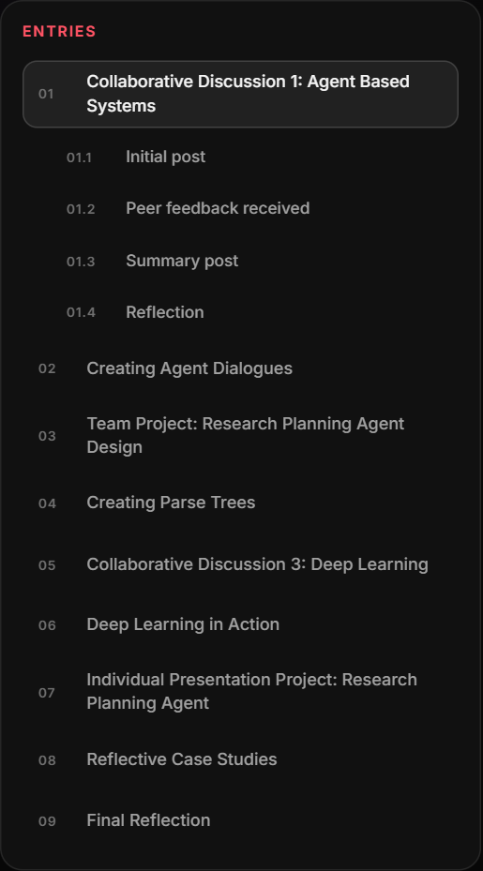
Figure 1: E-portfolio entries for the module.
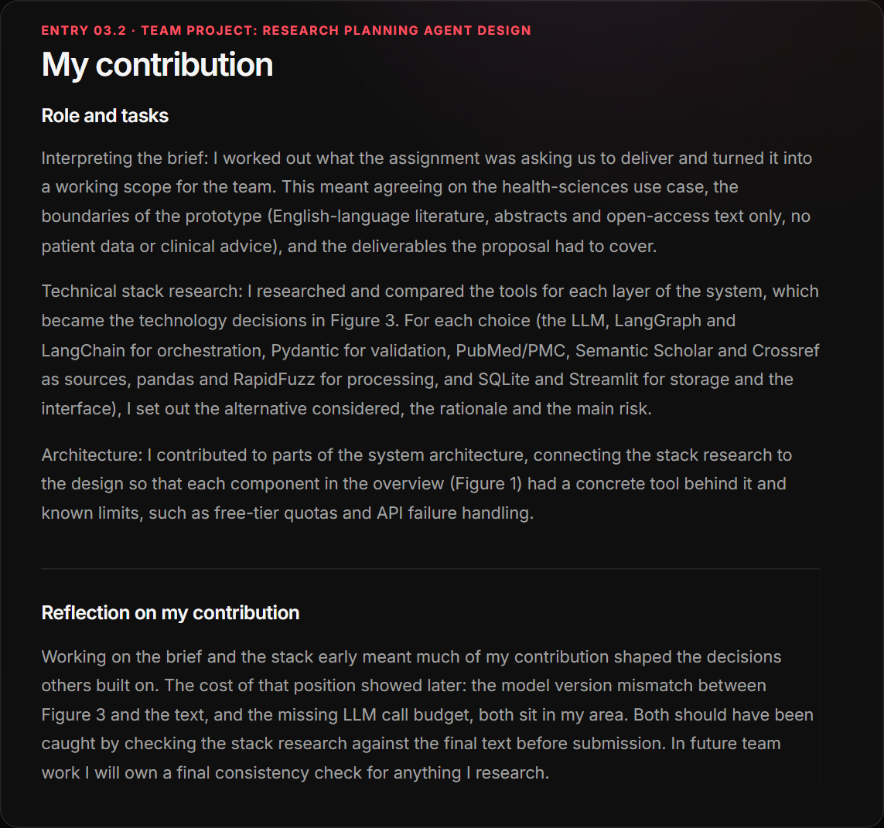
Figure 2: My contribution to the Group B design proposal (entry 03.2).

2. Critical evaluation of the final project
Design (Unit 6). Every major decision in the group design was justified against an alternative, including choosing a schema-validated JSON buffer over KQML, and the success criteria were measurable. Its weaknesses were an inconsistent model version between Figure 3 and the text, no LLM call budget despite a free-tier dependency, a recall target of 0.80 that was ambitious for a two-source prototype, and a BDI model described only conceptually.
Implementation (Unit 11). The core design held: the hybrid planner, validated hand-off and human gate translated directly into code, and keeping deduplication, validation and storage outside the LLM made the system testable (125 offline tests, 97% line coverage). Reality differed in three ways. Free-tier quota became the dominant engineering problem, requiring failover across four models and a rule-based ReAct thought. Silent degradation, named in the design, actually happened and was caught by code review rather than by tests. And the success criteria were met on weaker evidence than planned: recall was 1.0 (0.9 with the default cut-off) and 18 of 19 audited claims were faithful, but on 28 AI-checked records rather than 50 hand-screened abstracts, so one record moves recall by 0.1. The planner also never re-plans on its own; re-planning is triggered by the reviewer, a simplification of the proposal’s BDI model.
Overall the prototype meets most design requirements, but its evaluation is indicative rather than conclusive. With hindsight I would build the human-screened evaluation set first, secure a Semantic Scholar key at the start, and test what the system reports when it fails from the outset.

3. Reflective case studies
Each case study is grounded in the research planning agent I designed with Group B and implemented individually, and follows Rolfe, Freshwater and Jasper’s (2001) What, So what, Now what framework.

Case study 1: AI safety constraints

What
The design placed a human gate before the evidence store, and the implementation added further bounds: three re-prompts before escalating to a human, a step budget that reports unfinished subgoals as failed, a circuit breaker on failing sources, and eligibility criteria the planner cannot change. During one live run Semantic Scholar was rate-limited on every call, yet the run report showed full coverage.

So what
Each bound is a small version of what Amodei et al. (2016) call avoiding unsafe exploration, and the gate keeps the agent open to correction in the sense of Hadfield-Menell et al.’s (2017) off-switch game: nothing enters the store without approval. The incident showed the limit of that gate. The reviewer was in the loop, but was approving a picture that looked complete. A kill switch only protects you if the person holding it can see what is happening. Parasuraman and Riley (1997) describe this as misuse: over-reliance on automation that cannot be inspected. I had treated “human in the loop” as the safety measure, when the real measure was the quality of what the human sees (Braun et al., 2024).
I felt uneasy finding this, because I had named silent degradation as a risk in the design and still built it. That discomfort showed me that naming a risk is not the same as testing for it.

Now what
I will treat every constraint as two requirements: the constraint itself and a visible signal when it fires. I will test what a system reports when parts fail, set step and call budgets from the start, and keep irreversible actions behind a human decision with the agent’s uncertainty shown beside it.

Case study 2: Explainable decisions

What
The Curation Agent must justify every screening decision with verbatim extracts, shown beside each claim on the review card with PMID and DOI links. In testing, the fidelity check accepted an extract whose effect size had changed from 2.1 to 3.1, and later extracts that flipped “no significant” to “a significant” or “increased” to “decreased” (defects R6 and R10). I replaced the similarity check with a word-level validator in code that rejects any difference in a number, negation or direction word.

So what
The model’s justifications looked convincing even when wrong. Turpin et al. (2023) show that language-model explanations can be unfaithful to what actually drove the output, so the model could not be trusted to explain itself. Rudin (2019) argues that high-stakes systems should be interpretable by design rather than explained after the fact. The validator follows that logic: the explanation is a quote checked deterministically, not a rationale to be believed. Miller (2019) adds that useful explanations are selective; a reviewer needs the sentence that supports inclusion, not the model’s full reasoning. The limit remains: the validator proves an extract is genuine, not that a claim built on it is faithful, and the audit found one overgeneralisation.
R6 alarmed me: a one-digit change could have reached a reviewer looking fully referenced. It changed what “cited” means to me.

Now what
For agents whose output people act on, I will separate the decision from its evidence, verify the evidence in code where possible, state what an explanation does not prove, and test explanations adversarially with altered numbers and negations.

Case study 3: Bias in autonomous decision-making

What
Three biases appeared in my agent, none of them demographic. PubMed retrieval was filtered to English. Without an API key Semantic Scholar was unavailable, so the agent was effectively single-source. The BM25 cut-off sent only the top twenty records to the LLM, lowering recall from 1.0 to 0.9. In screening, a trial measuring pain sensitisation rather than pain intensity was included in all three runs.

So what
In my Deep Learning in Action post I argued that facial recognition bias depends on the operating threshold, not only the model (Grother, Ngan and Hanaoka, 2019). My agent has the same structure: filters and cut-offs are thresholds that decide whose evidence is seen. Mehrabi et al. (2021) class these as sampling biases introduced before any model runs. Morrison et al. (2012) found no systematic bias from English-language restriction in conventional medicine, but I did not measure it for my topic. In Discussion 3 I argued that generated content can narrow the shared pool of ideas; a screener favouring well-ranked, English, single-database records narrows the evidence base the same way. Over-inclusion is a safer error for a first pass, but reviewers tend to accept automated suggestions (Goddard, Roudsari and Wyatt, 2012), so a consistent error can become the reviewer’s.
I felt defensive at first because recall met the target. Accepting that a passing metric can hide a skewed sample was uncomfortable but important.

Now what
I will report filters and thresholds as design decisions with their effects, build an independent human-labelled evaluation set with deliberate edge cases before building a screener, and measure performance by subgroup (language, source, outcome type) rather than one aggregate score.

4. Reflective commentary

What
This module took me from arguing about why organisations adopt agents to building one. In Discussion 1 I claimed, deliberately provocatively, that agent adoption is driven by laziness. In the dialogues task I wrote KQML messages between two agents, and in the parse trees task I saw one sentence produce two valid trees. In Unit 6 our group designed an LLM-powered research planning agent; my part was turning the brief into a scope, researching the technical stack and contributing to the architecture. In Unit 11 I implemented the design individually: two cooperating agents, a BDI-inspired planner running a ReAct loop, a validated JSON hand-off and a human review gate, with 125 tests and a log of 17 defects.

So what
Three things stand out when I look back at how I behaved.
First, I started overconfident. My Discussion 1 post took a strong position and named agent architectures without explaining them. When peers challenged it, my first reaction was defensive; I wanted to restate the argument rather than rethink it. Reading Hemmer et al. (2025) changed that. The question became when delegation improves a decision, not whether to delegate, and that idea, bounded autonomy, became the thread through everything I built. Boud, Keogh and Walker (1985) argue that unattended feelings can block learning from experience; in my case, noticing the defensiveness was what allowed the feedback to land.
Second, the team project made me feel responsible in a new way. Because I researched the stack, others built on my choices. I enjoyed that, but it also made me anxious, and in hindsight I rushed the final check. Figure 3 named a different Gemini version from the text, and the design set no LLM call budget even though I had identified the free-tier quota as a risk. Both errors were in my area. I had treated research as finished once a decision was made, not once the document was consistent. Implementing the group design alone later tested how well we had communicated: a traceability review found seven gaps between the proposal and my code, such as “flag” behaving like “reject”. Some were my shortcuts, but others were places where the proposal itself was ambiguous, which showed me that a shared design is only as clear as the team’s agreement on what each word means.
Third, implementation was where most of the learning happened, and much of it was uncomfortable. The first live run crashed on a 503 overload, capacity moved between free-tier models from minute to minute, and a fallback model had been withdrawn. I was frustrated to spend time on quota rather than the research problem, but this was the risk I had flagged, now real. The most important moment was finding that Semantic Scholar had failed on every call while my report showed full coverage. I had named silent degradation as the hardest failure in the proposal and still built it. I felt embarrassed, and briefly tempted to present the run as a success because, technically, it was. Choosing to report it, and to state that my evaluation used 28 AI-checked records rather than 50 hand-screened abstracts, was a decision about integrity as much as engineering.
What produced this learning was not the reading on its own but the gap between what I designed and what the system actually did. The design said “human in the loop”; the code showed that a human is only as effective as the information they are shown (Braun et al., 2024). The design said extractive summaries reduce hallucination; testing showed an extract could change 2.1 to 3.1 and still pass a similarity check. Earlier tasks prepared me for these choices. The dialogues task is why I could justify not using KQML for two agents in one trusted process (Finin et al., 1994), and the parse-tree ambiguity is why the agent prefers “uncertain” to a confident guess (Russell and Norvig, 2021).
The evidence of these skills is in this portfolio: a working multi-agent system with 125 deterministic tests at 97% line coverage, a remediation log linking each defect to its root cause and regression test, an evaluation that reports its own weaknesses, and three case studies connecting safety, explainability and bias to specific incidents in my code. Less visibly, I have learned to read my own results critically, which I could not do at the start of the module.

Now what
I will carry four changes into practice. First, I will design what a system reports when it fails before deciding how it recovers, and test that reporting. Second, I will fix evaluation sets independently, ideally with a human labeller, before building the component they measure, so that I cannot unconsciously tune the target to the system. Third, I will apply bounded autonomy by default: agents act freely on cheap, reversible steps, while anything irreversible, such as writing to a store, changing records or approving a payment, needs a human decision supported by visible evidence. Fourth, in team work I will own a final consistency check for anything I research, rather than assuming it is finished when the decision is made.
The main change, though, is in how I respond to my own results. I now treat discomfort with them as a signal to look closer rather than something to explain away. That shift, more than any single technique, is what I expect to rely on as a developer of intelligent agents.

References
Amodei, D., Olah, C., Steinhardt, J., Christiano, P., Schulman, J. and Mané, D. (2016) ‘Concrete problems in AI safety’, arXiv:1606.06565.
Boud, D., Keogh, R. and Walker, D. (1985) Reflection: turning experience into learning. London: Kogan Page.
Braun, M., Greve, M., Brendel, A.B. and Kolbe, L.M. (2024) ‘Humans supervising artificial intelligence: investigation of designs to optimize error detection’, Journal of Decision Systems, 33(4), pp. 674–699.
Finin, T., Fritzson, R., McKay, D. and McEntire, R. (1994) ‘KQML as an agent communication language’, in Proceedings of the Third International Conference on Information and Knowledge Management (CIKM ’94). New York: ACM, pp. 456–463.
Goddard, K., Roudsari, A. and Wyatt, J.C. (2012) ‘Automation bias: a systematic review of frequency, effect mediators, and mitigators’, Journal of the American Medical Informatics Association, 19(1), pp. 121–127.
Grother, P., Ngan, M. and Hanaoka, K. (2019) Face recognition vendor test (FRVT) part 3: demographic effects. NISTIR 8280. Gaithersburg, MD: National Institute of Standards and Technology.
Hadfield-Menell, D., Dragan, A., Abbeel, P. and Russell, S. (2017) ‘The off-switch game’, in Proceedings of the 26th International Joint Conference on Artificial Intelligence (IJCAI-17), pp. 220–227.
Hemmer, P., Schemmer, M., Kühl, N., Vössing, M. and Satzger, G. (2025) ‘Complementarity in human-AI collaboration: concept, sources, and evidence’, European Journal of Information Systems, 34(6), pp. 979–1002.
Mehrabi, N., Morstatter, F., Saxena, N., Lerman, K. and Galstyan, A. (2021) ‘A survey on bias and fairness in machine learning’, ACM Computing Surveys, 54(6), article 115.
Miller, T. (2019) ‘Explanation in artificial intelligence: insights from the social sciences’, Artificial Intelligence, 267, pp. 1–38.
Morrison, A. et al. (2012) ‘The effect of English-language restriction on systematic review-based meta-analyses: a systematic review of empirical studies’, International Journal of Technology Assessment in Health Care, 28(2), pp. 138–144.
Parasuraman, R. and Riley, V. (1997) ‘Humans and automation: use, misuse, disuse, abuse’, Human Factors, 39(2), pp. 230–253.
Rolfe, G., Freshwater, D. and Jasper, M. (2001) Critical reflection in nursing and the helping professions: a user’s guide. Basingstoke: Palgrave Macmillan.
Rudin, C. (2019) ‘Stop explaining black box machine learning models for high stakes decisions and use interpretable models instead’, Nature Machine Intelligence, 1(5), pp. 206–215.
Russell, S. and Norvig, P. (2021) Artificial Intelligence: A Modern Approach. 4th edn. Harlow: Pearson.
Turpin, M., Michael, J., Perez, E. and Bowman, S.R. (2023) ‘Language models don’t always say what they think: unfaithful explanations in chain-of-thought prompting’, in Advances in Neural Information Processing Systems 36 (NeurIPS 2023).

