|  |
| --- |
| INFM 600 |
| Peanut Butter and Jelly |
| Recipe Process Document |

|  |
| --- |
| Aniket Nitin Jadhav  10-26-2016 |

**Author**

| Position | Name | Contact Email |
| --- | --- | --- |
| Chef | Aniket Nitin Jadhav | aniket@umd.edu |

**Revision history**

| Version | Issue date | Author/editor | Description/Summary of changes |
| --- | --- | --- | --- |
| 1.0 | 10/24/2016 | Aniket Jadhav | Updated the process flow diagram. |
|  |  |  |  |

**Reviewed by**

| Version | Issue date | Name | Position | Review date |
| --- | --- | --- | --- | --- |
| 1.0 | 10/26/2016 | Prof. Wiggins | INFM 600 Professor | 10/26/2016 |
|  |  |  |  |  |
|  |  |  |  |  |

Table of Contents

1 INTRODUCTION 3

1.1 Objective 3

1.2 Scope 3

2 Requirements 3

2.1 Ingredients 3

3 Recipe 5

3.1 Steps to Make a PBJ 5

3.2 Process Flow Diagram 8

4 Contingency Plan 9

# INTRODUCTION

## Objective

The main objective of this document is to serve as a cookbook for a delicious recipe of peanut butter and jelly sandwich. A step by step approach towards the preparation of the peanut butter and jelly sandwich is provided that caters to a variety of audience.

## Scope

The Peanut Butter and Jelly Sandwich recipe are limited to instructions on how to prepare the sandwich. It is assumed that all the ingredients required to make the sandwich are readily available. Purchase of ingredients, availability of utensils, cleaning, and quality of the products are items that are out of scope.

# Requirements

This section lists the ingredients that are necessary to make a peanut butter and jelly sandwich and provides visual information about all the ingredients.

## Ingredients

The following list of ingredients will be used for the preparation of peanut butter and jelly sandwich:

1. Bread: White or wheat bread is left up to the choice of the user.  
   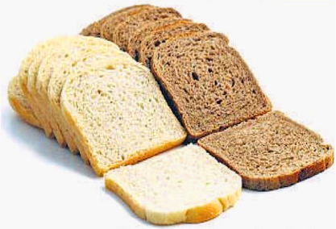  
   http://www.nutrichoice4u.com/wp-content/uploads/2016/08/brown-bread-vs-white-bread.jpg
2. Peanut Butter: One jar is sufficient for our preparation. The user can decide the brand.  
   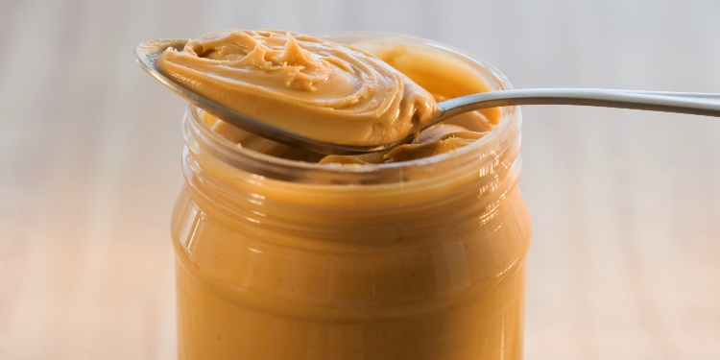

http://i.huffpost.com/gen/1398347/images/o-PEANUT-BUTTER-facebook.jpg

1. Jelly: One jar of jelly of any brand as per user’s choice.  
     
   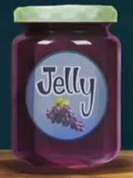  
   http://images.shoutwiki.com/fishhooks/4/41/Jelly_Jar.JPEG
2. Spreading knife: Use of one knife would suffice. However, two are preferred.  
   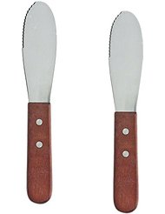  
   https://images-na.ssl-images-amazon.com/images/I/4186nbjToHL._AC_UL246_SR190,246_.jpg
3. Plates: To place slices of bread.  
     
   http://www.pngall.com/plate-png

# Recipe

## Steps to Make a PBJ

Step 1:

Place a clean plate on the table.

Step 2:  
Place two slices of bread on the plate. The bread can be white or wheat bread. The choice of the bread is left to the discretion of the user.

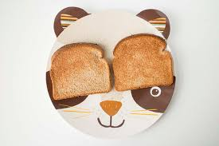  
http://farm6.staticflickr.com/5349/13960904939_5dda953034_z.jpg

Step3:

You can choose to toast the bread. This step is optional and can be skipped if not preferred.

Step 4:  
Using a spreading knife, scoop some peanut butter from the peanut butter jar and spread it over one slice of the bread. The choice of peanut butter whether crunchy of creamy is left to the user.

Step 5:  
Make sure the peanut butter is evenly spread and cover the full area of the bread slice. Repeat step 3 until step 4 is ensured.

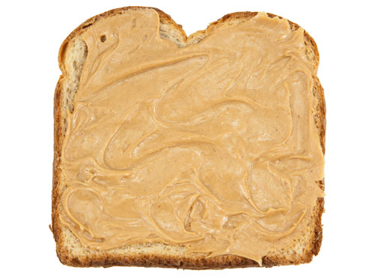  
http://www.seriouseats.com/images/20090828-peanutbutter-istock.jpg

Step 6:  
Use another spreading knife to scoop some jelly from the jar. If you have only one knife, make sure you either wash or clean the knife with a paper towel.

Step 7:

Apply jelly on another slice of bread until it is spread evenly and covered all ends of the bread surface area.

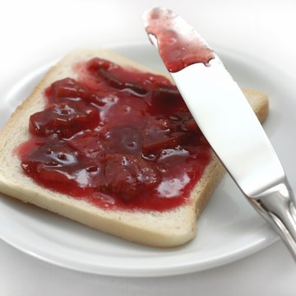  
http://www.foodchannel.com/media/uploads/galleries/recipes/images/_thumbs/iStock_000000313764Large_jpg_360x360_crop-scale_upscale_q85.jpg

Step 8:   
Place the two bread slices together. Make sure to place the peanut butter side over the jelly side of the other slice. You can choose to create multiple stacks of the same as per your appetite.

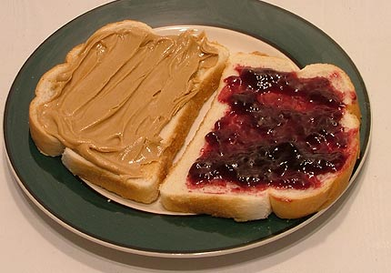  
https://theflaneursturtle.files.wordpress.com/2013/12/pbj.jpeg

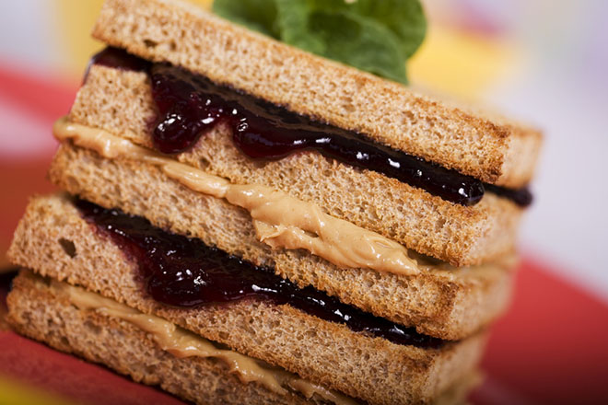

https://www.adventure-journal.com/wp-content/uploads/2012/10/pbj-sandwich-660.jpg

Step 9:   
Peanut Butter & Jelly sandwich is ready for a bite.

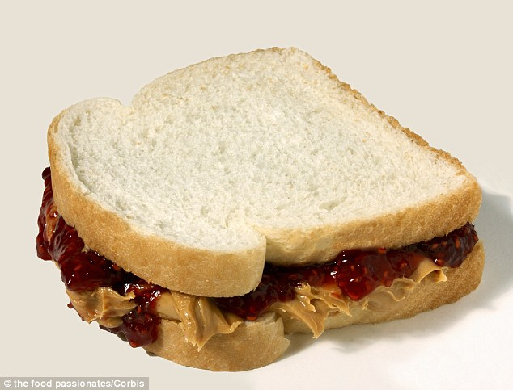  
http://i.dailymail.co.uk/i/pix/2014/04/02/article-0-1CC5329E00000578-716_634x483.jpg

Step 10:   
Repeat all steps from step 1 if you are still hungry!

## Process Flow Diagram

A diagram representation of the process flow for peanut butter and jelly sandwich is stated as follows:

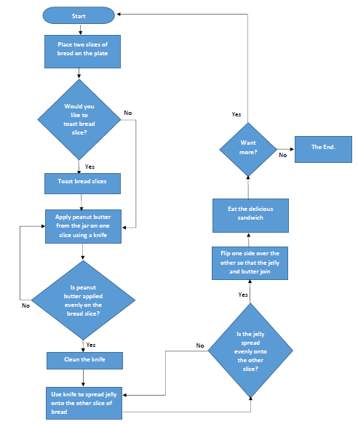

# Contingency Plan

In the case of failure, we plan to discard all the ingredients that we picked for usage for preparation of a sandwich. The process would require a restart right from Step 1. If any of the ingredients are spilled of foreseen with an expiration that has been due, they are subjected to be banned from use. A first aid kit is placed in contingency for the possible occurrence of injuries during the execution of the process.

Word Count: 573