LINEAR QUEUES
#include <stdio.h>
#include <stdlib.h>
#define MAX 5

struct queue {
int a[MAX];
int front;
int rear;
};
typedef struct queue qu;

void createEmptyQueue(qu *q) {
q->front = -1;
q->rear = -1;
}

int isfull(qu *q) {
if (q->rear == (MAX - 1))
return 1;
else
return 0;
}

int isempty(qu *q) {
if (q->front == -1 || q->front > q->rear)
return 1;
else
return 0;
}

void enqueue(int val, qu *q) {
if (isfull(q))
printf("Queue full\n");
else {
if (q->front == -1)
q->front = 0;
q->rear++;
q->a[q->rear] = val;
printf("Enqueued: %d\n", val);
}
}

int dequeue(qu *q) {
if (isempty(q)) {
printf("Queue empty\n");
return -1;
}
else {
int temp = q->a[q->front];
q->front++;
return temp;
}
}

int main() {
printf("Name: Niveditha A\nReg No: 24BCE2000\n");
qu *q = (qu *)malloc(sizeof(qu)) ;
createEmptyQueue(q);
enqueue(10, q);
printf("One element pushed into the queue \n");
printf("Front = %d, Rear = %d \n", q->front, q->rear);
enqueue(20, q);
enqueue(30, q);
printf("Front = %d, Rear = %d \n", q->front, q->rear);
printf("Dequeued: %d\n", dequeue(q));
printf("Dequeued: %d\n", dequeue(q));
printf("Front = %d, Rear = %d \n", q->front, q->rear);
enqueue(40, q);
enqueue(50, q);
printf("Front = %d, Rear = %d \n", q->front, q->rear);
enqueue(60, q);
printf("Front = %d, Rear = %d \n", q->front, q->rear);
return 0;
}
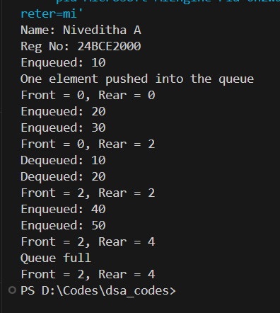

CIRCULAR QUEUES

#include <stdio.h>
#include <stdlib.h>
#define MAX 5

struct queue {
int a[MAX];
int front;
int rear;
};
typedef struct queue qu;

void createEmptyQueue(qu *q) {
q->front = -1;
q->rear = -1;
}

int isfull(qu *q) {
if ((q->rear + 1) % MAX == q->front)
return 1;
else
return 0;
}

int isempty(qu *q) {
if (q->front == -1)
return 1;
else
return 0;
}

void enqueue(int val, qu *q) {
if (isfull(q))
printf("Queue full\n");
else {
if (q->front == -1)
q->front = 0;
q->rear = (q->rear + 1) % MAX;
q->a[q->rear] = val;
printf("Enqueued: %d\n", val);
}
}

int dequeue(qu *q) {
if (isempty(q)) {
printf("Queue empty\n");
return -1;
}
int temp = q->a[q->front];
if (q->front == q->rear) {
// Queue becomes empty
q->front = -1;
q->rear = -1;
} else {
q->front = (q->front + 1) % MAX;
}
return temp;
}

int main() {
printf("Name:Niveditha A \nReg No: 24BCE2000 \n");
qu *q = malloc(sizeof(qu));
createEmptyQueue(q);
enqueue(10, q);
printf("First element added \n");
printf("Front = %d, Rear = %d \n", q->front, q->rear);
enqueue(20, q);
enqueue(30, q);
enqueue(40, q);
enqueue(50, q);
printf("Front = %d, Rear = %d \n", q->front, q->rear);
enqueue(60, q);
printf("Dequeued: %d\n", dequeue(q));
printf("Dequeued: %d\n", dequeue(q));
printf("Front = %d, Rear = %d \n", q->front, q->rear);
enqueue(70, q);
printf("Front = %d, Rear = %d \n", q->front, q->rear);
enqueue(80, q);
printf("Front = %d, Rear = %d \n", q->front, q->rear);
printf("Dequeued: %d\n", dequeue(q));
printf("Dequeued: %d\n", dequeue(q));
printf("Dequeued: %d\n", dequeue(q));
printf("Dequeued: %d\n", dequeue(q));
printf("Front = %d, Rear = %d \n", q->front, q->rear);
printf("Dequeued: %d\n", dequeue(q));
printf("Front = %d, Rear = %d \n", q->front, q->rear);
return 0;
}

