LINEAR SEARCH
#include <stdio.h>
int main(){
int n;
printf("enter no of elements in the array\n");
scanf("%d", &n);
int a[100];
for(int i = 0; i < n; i++)
scanf("%d", &a[i]);
int c = 0;
int val;
printf("enter value to be searched\n");
scanf("%d", &val);
for(int i = 0; i < n; i++)
if(a[i] == val)
{
c++;
printf("value found at index = %d", i);
}
if(c == 0)
printf("value not found");
}
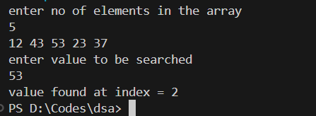
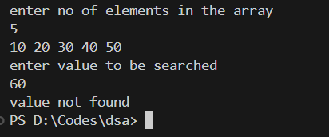

BINARY SEARCH – RECURSION

#include <stdio.h>
int binarySearch(int a[], int l, int u, int val){
// u - upper index, l - lower index, val - value to be searched
int mid = (u + l) / 2;
if(val == a[mid])
return mid;
else if(u < l)
return -1;
else if (val > a[mid] )
binarySearch(a, mid + 1, u, val);
else if(val < a[mid])
binarySearch(a, l, mid - 1, val);
}
int main() {
int n;
printf("enter no of elements in the array\n");
scanf("%d", &n);
printf("enter the elements\n");
int a[100];
for(int i = 0; i < n; i++)
scanf("%d", &a[i]);
int val;
printf("enter value to be searched\n");
scanf("%d", &val);
int ans = binarySearch(a, n-1, 0, val);
if(ans == -1)
printf("element not found");
else
printf("element found at index = %d", ans);
}

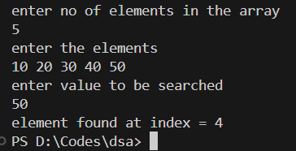
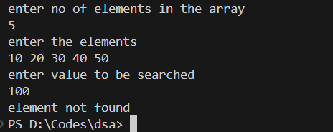
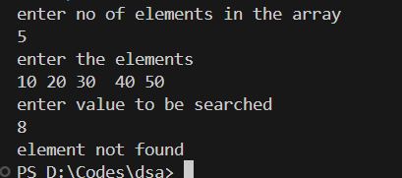

BINARY SEARCH – ITERATION
#include <stdio.h>

int binarySearch(int a[], int n, int val) {
int l = 0;
int u = n - 1;
while (l <= u) {
int mid = (u + l) / 2;
if (val == a[mid]) {
return mid;
}
else if (val > a[mid]) {
l = mid + 1;
}
else {
u = mid - 1;
}
}
return -1;
}

int main() {
int n;
printf("Name:Niveditha \nReg No:24BCE2000 \n");
printf("enter no of elements in the array\n");
scanf("%d", &n);
printf("enter the elements\n");
int a[100];
for(int i = 0; i < n; i++)
scanf("%d", &a[i]);
int val;
printf("enter value to be searched\n");
scanf("%d", &val);
int ans = binarySearch(a, n, val);
if(ans == -1)
printf("element not found");
else
printf("element found at index = %d", ans);
return 0;
}

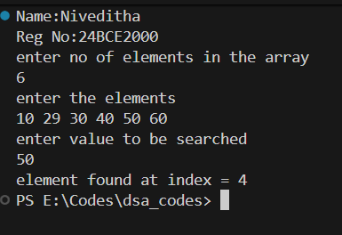
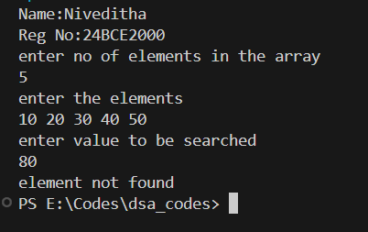

INSERTION SORT
#include <stdio.h>
void print(int arr[], int n){
for(int i = 0; i < n; i++)
printf("%d ", arr[i]);
printf("\n");
}
void insertion(int arr[], int n)
{
for(int j = 1; j < n; j++)
{
int key = arr[j];
int i = j - 1;
while(i >= 0 && key < arr[i])
{
arr[i+1] = arr[i];
printf("j = %d, i = %d, array in inner loop= ", j, i);
print(arr, n);
i --;
}
arr[i+1] = key;
printf("array after every outer loop = ");
print(arr, n);
}
printf("final sorted array = ");
print(arr, n);
}

int main(){
int a[] = {12, 34, 32, 13, 876, 987, 533, 324, 78, 19, 87, 102};
insertion(a, 12);
return 0;
}
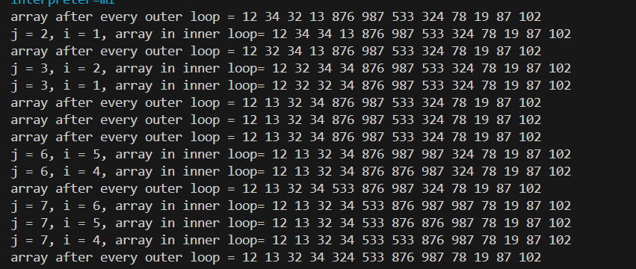
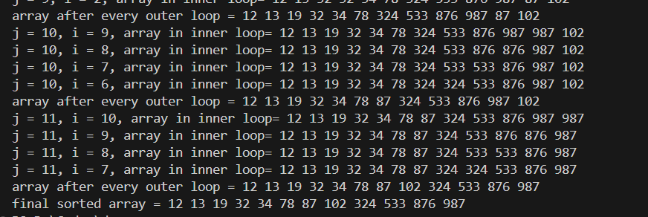

BUBBLE SORT
#include <stdio.h>

void print(int arr[], int n){
for(int i = 0; i < n; i++)
printf("%d ", arr[i]);
printf("\n");
}

void swap(int* a, int* b){
int temp = *a;
*a = *b;
*b = temp;
}

void bubble(int arr[], int n){
for(int i = 0; i < n - 1; i++) {
for(int j = 0; j < n-i-1; j++)
if(arr[j] > arr[j+1])
{
swap(&arr[j], &arr[j+1]);
printf("i = %d j = %d, array in inner loop after every swap= ", i, j);
print(arr, n);
}
}
printf("final array after sorting = ");
print(arr, n);
}

int main(){
int a[] = {12, 34, 32, 13, 876, 987, 533, 324, 78, 19, 87, 102};
bubble(a, 12);
return 0;
}
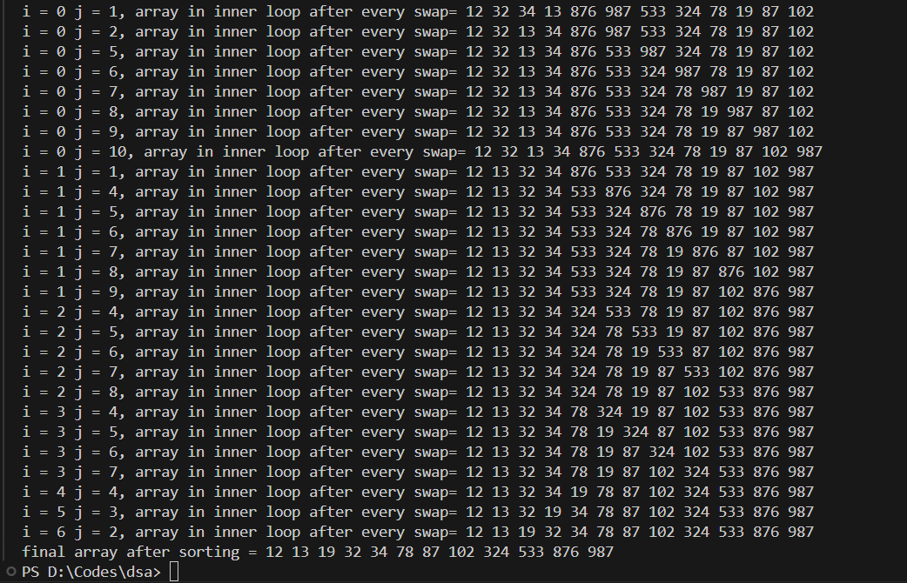

SELECTION SORT
#include <stdio.h>
void print(int arr[], int n){
for(int i = 0; i < n; i++)
printf("%d ", arr[i]);
printf("\n");
}

void swap(int* a, int* b){
int temp = *a;
*a = *b;
*b = temp;
}

void selection(int arr[], int n){
for(int i = 0; i < n; i++)
{
int min = i;
for(int j = i + 1; j < n; j++)
if(arr[j] < arr[min])
{
min = j;
printf("i = %d j = %d min = %d \n", i, j, min);
}
swap(&arr[min], &arr[i]);
printf("array after every outer loop = ");
print(arr, n);
}
printf("final array after sorting = ");
print(arr, n);
}
int main(){
int a[] = {12, 34, 32, 13, 876, 987, 533, 324, 78, 19, 87, 102};
selection(a, 12);
return 0;
}
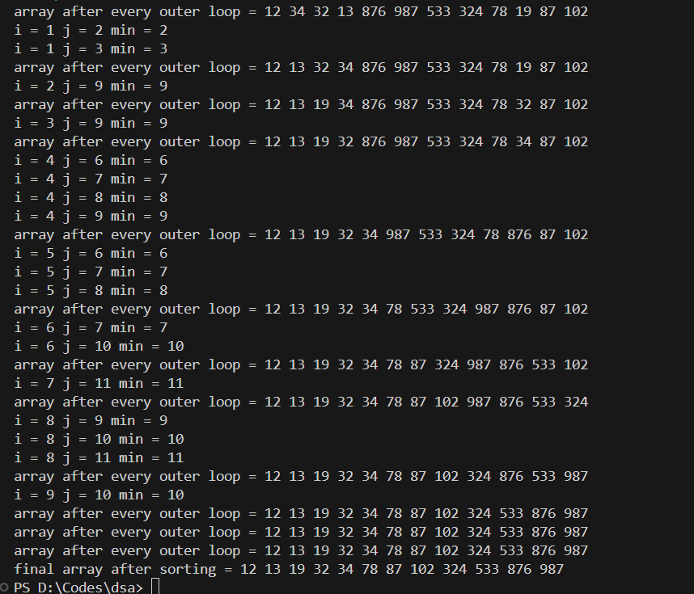

MERGE SORT

#include <stdio.h>
#include <stdlib.h>
void printArray(int A[], int l1, int r1)
{
int i;
for (i = l1; i <= r1; i++)
printf("%d ", A[i]);
printf("\n");
}

void merge(int arr[], int l, int m, int r)
{
printArray(arr, l, r);
int i, j, k;
int n1 = m - l + 1;
int n2 = r - m;
int L[n1], R[n2];
for (i = 0; i < n1; i++)
L[i] = arr[l + i];
for (j = 0; j < n2; j++)
R[j] = arr[m + 1 + j];
i = 0;
j = 0;
k = l;
while (i < n1 && j < n2) {
if (L[i] <= R[j]) {
arr[k] = L[i];
i++;
}
else {
arr[k] = R[j];
j++;
}
k++;
}
while (i < n1) {
arr[k] = L[i];
i++;
k++;
}
while (j < n2) {
arr[k] = R[j];
j++;
k++;
}
printf("After sorting = ");
printArray(arr, l, r);
}

void mergeSort(int arr[], int l, int r)
{
if (l < r) {
int m = l + (r - l) / 2;
mergeSort(arr, l, m);
mergeSort(arr, m + 1, r);
merge(arr, l, m, r);
}
}
int main()
{
printf("Name:Niveditha \nReg No:24BCE2000 \n");
int arr[] = { 12, 70, 11, 100, 90, 2, 13, 5, 6, 7 };
int arr_size = sizeof(arr) / sizeof(arr[0]);
printf("Given array is \n");
printArray(arr, 0, arr_size-1);
mergeSort(arr, 0, arr_size - 1);
printf("\nSorted array is \n");
printArray(arr, 0, arr_size-1);
return 0;
}
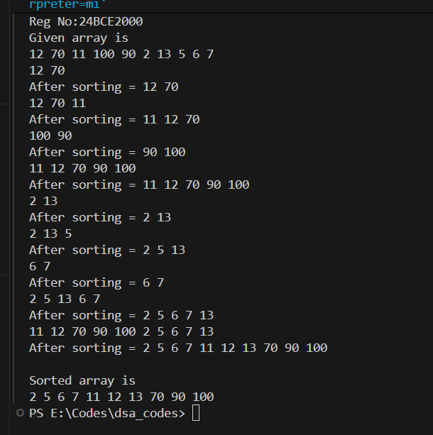
COUNTING SORT
#include <stdio.h>

void countingSort(int arr[], int n) {
int max = arr[0];
for (int i = 1; i < n; i++) {
if (arr[i] > max) {
max = arr[i];
}
}

int count[max + 1];
for (int i = 0; i <= max; i++) {
count[i] = 0;
}

for (int i = 0; i < n; i++) {
count[arr[i]]++;
}

for (int i = 1; i <= max; i++) {
count[i] += count[i - 1];
}

int output[n];
for (int i = n - 1; i >= 0; i--) {
output[count[arr[i]] - 1] = arr[i];
count[arr[i]]--;
}

for (int i = 0; i < n; i++) {
arr[i] = output[i];
}
}

int main() {
int n;
printf("Name:Niveditha \nReg No:24BCE2000 \n");
printf("Enter number of elements in the array: ");
scanf("%d", &n);
int arr[100];
printf("Enter the elements: ");
for (int i = 0; i < n; i++) {
scanf("%d", &arr[i]);
}
printf("\nOriginal array: ");
for (int i = 0; i < n; i++) {
printf("%d ", arr[i]);
}
countingSort(arr, n);
printf("\nSorted array: ");
for (int i = 0; i < n; i++) {
printf("%d ", arr[i]);
}
return 0;
}

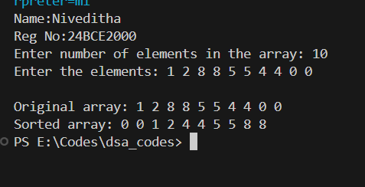
QUICK SORT
#include <stdio.h>
void swap(int *a, int *b) {
int temp = *a;
*a = *b;
*b = temp;
}
void printArray(int arr[], int start, int stop)
{
for (int i = start; i <= stop; i++)
printf("%d ", arr[i]);
printf("\n");
}

int partition(int arr[], int low, int high) {
printArray(arr, low, high);
int pivot = arr[low];
int start = low;
int end = high;
int k = high;
for (int i = high; i > low; i--) {
if (arr[i] >= pivot)
swap(&arr[i], &arr[k--]);
}
swap(&arr[low], &arr[k]);
return k;
}

void quickSort(int arr[], int low, int high) {
if (low < high) {
int idx = partition(arr, low, high);
quickSort(arr, low, idx - 1);
quickSort(arr, idx + 1, high);
}
}

int main() {
printf("Name:Niveditha \nReg No:24BCE2000 \n");
int arr[] = {4, 3, 6, 9, 2, 4, 3, 1, 2, 1, 8, 9, 3, 5, 6};
int n = sizeof(arr) / sizeof(arr[0]);
quickSort(arr, 0, n - 1);
printf("Sorted array: \n");
printArray(arr, 0, n-1);
return 0;
}

