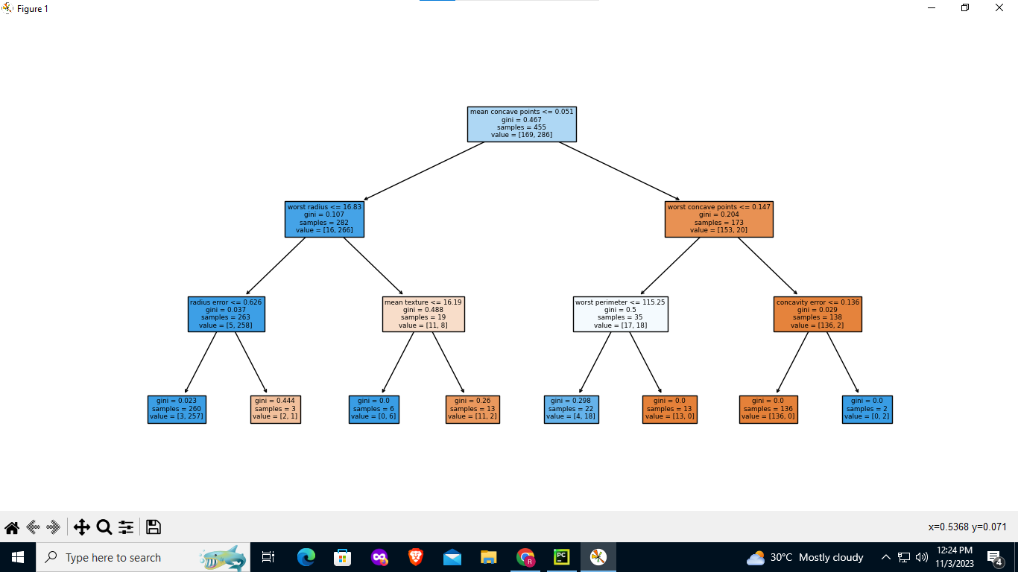

import matplotlib.pyplot as plt

from sklearn.model_selection import train_test_split

from sklearn.tree import DecisionTreeClassifier, plot_tree

from sklearn.datasets import load_breast_cancer

from sklearn.metrics import accuracy_score, classification_report

data = load_breast_cancer()

x = data.data

y = data.target *# Target Variable*

x_train, x_test, y_train, y_test = train_test_split(x, y, test_size=0.2, random_state=42) *# Training Feature, Training Target*

clf = DecisionTreeClassifier(max_depth=3)

clf.fit(x_train, y_train)

plt.figure(figsize=(15, 10))

plot_tree(clf, filled=True, feature_names=data.feature_names)

plt.show()

print(clf.predict(x_test))

V = clf.predict(x_test)

result = accuracy_score(y_test, V)

print("Accuracy:", result)

report = classification_report(y_test, V, target_names=data.target_names)

print("\nClassification Report:\n", report)