A PROJECT REPORT ON
PROT2CHAT: PROTEIN LARGE LANGUAGE MODEL WITH EARLY FUSION OF TEXT, SEQUENCE, AND STRUCTURE

Submitted as part of the curriculum for the B.Tech. in Computer Science and Technology

Session: 2025-2026

DEPARTMENT OF Computer Science & Technology
Indian Institute of Engineering Science and Technology, Shibpur

Submitted To: Dr. Apurba Sarkar (Head of Department)
Submitted By: Anurag Chaurasia

CERTIFICATE

This is to certify that the project entitled "PROT2CHAT: PROTEIN LARGE LANGUAGE MODEL WITH EARLY FUSION OF TEXT, SEQUENCE, AND STRUCTURE" is submitted by Anurag Chaurasia as a part of the curriculum for the award of the degree of Bachelor of Technology in Computer Science and Technology from the Indian Institute of Engineering Science and Technology, Shibpur, during the academic session 2025-2026.

The content of this project has not been submitted to any university or institute for an award of any degree.

_ _ _ _ _ _ _ _ _ _ _ _ _ _ _ _ _ _ _ _ _ _ _ _

Dr. Apurba Sarkar External Examiner
Head of Department
(Project Guide)
(Computer Science & Technology)

Date: _____ / _____ / 2026
Place: IIEST Shibpur

SELF ATTESTATION

This is to certify that I have personally worked on the dissertation entitled "PROT2CHAT: PROTEIN LARGE LANGUAGE MODEL WITH EARLY FUSION OF TEXT, SEQUENCE, AND STRUCTURE". The case study and data mentioned in this report were obtained during the course of this project work. The analysis and conclusions drawn are my own work.

Any other data and information in this report, which has been collected from an outside agency, has been duly acknowledged.

STUDENT:

---------------------------------------------------------
ANURAG CHAURASIA
B.Tech. Computer Science & Technology
IIEST Shibpur

Date: _____ / _____ / 2026
Place: IIEST Shibpur

ABSTRACT

Proteins are fundamental molecules governing biological activity, disease mechanisms, and drug-target interactions. Understanding protein function from raw sequence and 3D structural data remains a significant challenge due to the multimodal complexity of biological information. Existing protein question-answering (Q&A) systems face critical limitations including insufficient multimodal integration, large training parameter volumes, limited generative flexibility, and a lack of systematic evaluation frameworks.
This report presents a comprehensive review and analysis of Prot2Chat — a novel protein Large Language Model (LLM) framework that achieves early fusion of three modalities: amino acid sequence, 3D protein structure, and natural language question text. The framework employs a modified ProteinMPNN encoder to jointly represent sequence and structural information, a text-aware protein-text adapter inspired by BLIP-2 cross-attention to compress protein embeddings into question-oriented soft prompts, and a LoRA fine-tuned LLaMA3 as the generative decoder.
The literature review employs both the STaR methodology and a Star-Analogy constellation framework, providing a systematic and visually intuitive survey of the research landscape. Experimental evaluation on Mol-Instructions and UniProtQA datasets demonstrates that Prot2Chat substantially outperforms competitive baselines including BioMedGPT-LM-10B and Evola-10B, achieving BLEU-2 of 35.85 and ROUGE-L of 50.51 on Mol-Instructions.

TABLE OF CONTENTS

Certificate ii
Self Attestation iii
Abstract iv
Table of Contents v

CHAPTER 1: INTRODUCTION
1.1 Introduction 1
1.2 Background and Motivation 1
1.3 Objective 2
1.4 Problem Statement 2
1.5 Scope of the Report 3

CHAPTER 2: LITERATURE REVIEW
2.1 Evolution of Protein Representation Learning 4
2.2 Large Language Models in Biology 5
2.3 Multimodal Protein-Language Models 6
2.4 Protein Q&A Systems and Benchmarks 7
2.5 ProteinMPNN and Structural Encoding 8
2.6 BLIP-2 and Cross-Attention Adapters 9
2.7 Literature Star-Analogy Constellation 10

CHAPTER 3: METHODOLOGY
3.1 System Overview 12
3.2 Protein Embedding via ProteinMPNN Ensemble 13
3.3 Text-Aware Protein-Text Adapter 14
3.4 LoRA Fine-Tuned LLaMA3 Decoder 15
3.5 Training Procedure 16

CHAPTER 4: RESULTS AND EVALUATION
4.1 Datasets 18
4.2 Baseline Models 19
4.3 Automatic Evaluation Metrics 19
4.4 Performance on Mol-Instructions 20
4.5 Performance on UniProtQA 21
4.6 Ablation Study 21
4.7 Human/KIMI Evaluation 22

CHAPTER 5: IMPLEMENTATION & DEPLOYMENT
5.1 System Architecture Overview 24
5.2 Preprocessing Pipeline 24
5.3 Inference Pipeline 25
5.4 Model Loading and Quantization 25
5.5 Implementation Challenges 26
5.6 Deployment Configuration 28

CHAPTER 6: CONCLUSION
6.1 Summary of Findings 29
6.2 Limitations 30
6.3 Future Work 30

REFERENCES 32

CHAPTER 1: INTRODUCTION

1.1 Introduction
Proteins are the molecular machinery of life. Every biological process — from enzymatic catalysis and signal transduction to immune response and structural scaffolding — is mediated by proteins. Their function is encoded not only in the amino acid sequence, but also in the three-dimensional conformation adopted by the polypeptide chain in its native cellular environment. Understanding protein function therefore requires integrating information from multiple modalities: sequence, structure, and biological context.
Traditional computational approaches to protein function prediction rely on homology-based methods (BLAST, PSI-BLAST), which transfer annotations from experimentally characterised proteins to uncharacterised ones based on sequence similarity. While effective for well-studied protein families, these methods break down for novel proteins with limited homologues, intrinsically disordered regions, or context-dependent functions. The emergence of deep learning has opened new avenues, enabling data-driven models to discover non-linear patterns across sequence and structural data.
Large Language Models (LLMs) such as GPT-4, LLaMA, and their biomedical derivatives have demonstrated remarkable capabilities in natural language understanding and generation. Their application to protein science — through protein language models (pLMs) such as ESM-2, ProtTrans, and AlphaFold's structure prediction network — has produced breakthrough results. However, a critical gap remains: most existing systems either operate on sequences alone, or on structures alone, and very few provide a conversational, question-answering interface that integrates all available modalities.

1.2 Background and Motivation
The Prot2Chat framework, published in Bioinformatics (doi: 10.1093/bioinformatics/btaf396), addresses this gap through early multimodal fusion. It combines three information streams: (1) amino acid sequence, (2) 3D backbone structure encoded via ProteinMPNN, and (3) natural language questions from the user. The central hypothesis is that question-conditioned structural embeddings provide richer context for a generative language model than either modality alone.
The motivation for this work arises from several converging trends: (a) the explosion of protein structure data from AlphaFold DB (over 200 million predicted structures); (b) the success of instruction-tuned LLMs in domain-specific Q&A; and (c) the development of parameter-efficient fine-tuning methods (LoRA, adapter layers) that make it feasible to adapt large foundation models to protein biology without prohibitive computational cost.

1.3 Objective
The primary objective of this report is to provide a comprehensive analysis of the Prot2Chat system, covering its architecture, training methodology, experimental evaluation, and deployment implementation. Specific objectives include:
- Review and contextualise the Prot2Chat architecture within the broader landscape of protein AI and multimodal LLMs through a systematic literature survey.
- Describe the three-stage pipeline: ProteinMPNN ensemble encoding, text-aware cross-attention adapter, and LoRA-fine-tuned LLaMA3 generation.
- Evaluate the system's performance on Mol-Instructions and UniProtQA datasets against competitive baselines.
- Document the implementation and deployment experience, including quantization challenges and remediation strategies encountered during local deployment on consumer GPU hardware.
- Identify limitations and propose directions for future research.

1.4 Problem Statement
Protein function annotation is a fundamental challenge in computational biology. Despite the rapid accumulation of protein sequence and structure data, the majority of proteins in UniProt lack experimentally verified functional annotations. Existing computational Q&A systems face four critical limitations:
- Insufficient multimodal integration: Most systems process only sequence or only structure, failing to leverage the complementary information encoded in both.
- Large parameter volumes: Full fine-tuning of billion-parameter models is computationally prohibitive for academic and small-scale research environments.
- Limited generative flexibility: Classification-based annotation systems cannot answer open-ended natural language questions about protein properties.
- Lack of systematic evaluation frameworks: Inconsistent benchmarks make it difficult to compare models across the literature.

1.5 Scope of the Report
This report is organised as follows. Chapter 2 presents a systematic literature review using the STaR methodology, culminating in a novel Star-Analogy constellation visualisation of the research landscape. Chapter 3 details the Prot2Chat methodology — the ProteinMPNN ensemble encoder, the BLIP-2-inspired cross-attention adapter, and the LoRA fine-tuning regime. Chapter 4 presents experimental results on Mol-Instructions and UniProtQA datasets, including ablation studies and human/KIMI evaluation. Chapter 5 documents the implementation and deployment experience on consumer GPU hardware. Chapter 6 concludes with key findings, limitations, and future directions.

CHAPTER 2: LITERATURE REVIEW

2.1 Evolution of Protein Representation Learning
The history of computational protein analysis spans several decades, beginning with hand-crafted features such as amino acid composition vectors, secondary structure propensities, and physicochemical property profiles. The seminal BLAST algorithm (Altschul et al., 1990) established sequence similarity search as the dominant paradigm for functional annotation transfer, and its successor PSI-BLAST introduced position-specific scoring matrices to capture evolutionary conservation.
The deep learning revolution introduced convolutional and recurrent neural networks for protein tasks. DeepBind (2015) applied CNNs to protein-DNA binding motifs; DeepSF (2017) predicted structural class from sequence. The transformer architecture, introduced in 'Attention Is All You Need' (Vaswani et al., 2017), proved especially powerful for sequential biological data. Protein language models pre-trained on vast sequence databases — ESM-1b (Rives et al., 2021), ProtTrans (Elnaggar et al., 2022), and ESM-2 (Lin et al., 2023) — demonstrated that self-supervised pre-training captures structural and functional information implicitly encoded in sequence.
AlphaFold2 (Jumper et al., 2021) represented a paradigm shift in structural biology, achieving near-experimental accuracy in structure prediction through a combination of multiple sequence alignment processing, pair representation updates, and a structure module. The subsequent AlphaFold DB release of over 200 million predicted structures created an unprecedented resource for structure-aware protein AI.

2.2 Large Language Models in Biology
The success of GPT-3 (Brown et al., 2020) and instruction-tuned variants such as InstructGPT catalysed a wave of biomedical LLM development. BioBERT (Lee et al., 2020) adapted BERT to biomedical text through domain-specific pre-training. BioGPT (Luo et al., 2022) trained a GPT-2 variant on PubMed literature, achieving competitive performance on biomedical QA benchmarks. MedPaLM (Singhal et al., 2023) demonstrated that with sufficient scale and instruction tuning, general-purpose LLMs can answer medical examination questions at expert level.
For protein-specific language, key developments include: ProtGPT2 (Ferruz et al., 2022), a protein sequence generative model trained on UniRef50; Progen2 (Nijkamp et al., 2023), a family of autoregressive protein language models; and the InstructProtein framework, which aligned protein language models with human instructions. These works established the feasibility of applying generative LLM paradigms to protein space, setting the stage for multimodal fusion systems.

2.3 Multimodal Protein-Language Models
The most direct predecessors of Prot2Chat are multimodal systems that bridge protein representations with natural language. ProteinChat (Guo et al., 2023) introduced a protein Q&A system using Protein-LM embeddings with a Vicuna language model, demonstrating the potential for conversational protein interaction. MolChat and BioMedGPT-LM-10B extended this paradigm to molecular and broader biomedical domains respectively.
BLIP-2 (Li et al., 2023), while developed for vision-language alignment, introduced the Querying Transformer (Q-Former) architecture that proved highly influential. The Q-Former uses a fixed set of learnable query tokens attending to frozen visual features via cross-attention, compressing rich perceptual information into a small, language-model-compatible soft prompt. Prot2Chat adapts this architecture to the protein domain, replacing visual features with ProteinMPNN structural embeddings.
Evola (2024) introduced a protein-language model achieving BLEU-2 of 8.69 and ROUGE-L of 20.04 on Mol-Instructions through a combination of protein language model embeddings and a large generative backbone. While competitive, Evola relies on sequence-only protein representations, lacking the explicit 3D structural information integrated by Prot2Chat.

2.4 Protein Q&A Systems and Benchmarks
The Mol-Instructions dataset (Fang et al., 2023) provides a large-scale instruction-following benchmark for molecular science, containing protein-function Q&A pairs derived from SwissProt annotations. UniProtQA provides complementary evaluation using questions directly grounded in UniProt database entries. These benchmarks employ automatic metrics (BLEU, ROUGE-L) and human/LLM-based evaluation for assessing answer quality.
The KIMI automated evaluation framework, used in Prot2Chat's evaluation, leverages a capable general-purpose LLM as a judge to rank model outputs, providing a scalable alternative to full human evaluation. This approach follows the LLM-as-judge paradigm popularised by MT-Bench and ChatBot Arena, adapted to the protein function domain.

2.5 ProteinMPNN and Structural Encoding
ProteinMPNN (Dauparas et al., 2022) is a message-passing neural network for protein sequence design that operates on backbone atom coordinates (N, CA, C, O). Unlike sequence-only models, ProteinMPNN explicitly encodes inter-residue distances, dihedral angles, and local geometry through its graph neural network layers. The model achieves 52.4% native sequence recovery and demonstrated unprecedented success in de novo protein design experimental validation.
Prot2Chat's encoder modifies ProteinMPNN by running nine checkpoints in ensemble: six full-atom models at noise levels 0.02, 0.10, 0.20, 0.30 (including soluble variants) and three CA-only models. Each checkpoint produces a 128-dimensional per-residue embedding; concatenating nine outputs yields a 1152-dimensional representation capturing diverse structural perspectives across the noise landscape.

2.6 BLIP-2 and Cross-Attention Adapters
Parameter-efficient transfer learning (PETL) methods have become essential for adapting large foundation models to downstream tasks without full fine-tuning. LoRA (Hu et al., 2022) decomposes weight update matrices into low-rank factors, reducing trainable parameters by orders of magnitude while maintaining competitive performance. Adapter modules (Houlsby et al., 2019) insert small trainable bottleneck layers within frozen transformer blocks.
Prot2Chat employs both LoRA (applied to q_proj and v_proj layers of LLaMA3, rank=8) and a custom cross-attention adapter. The adapter comprises: (1) a linear projection from 1152 to 4096 dimensions; (2) dynamic positional encoding for variable-length protein sequences; (3) 256 learnable query tokens; and (4) 16-head cross-attention compressing protein context into a fixed 256 x 4096 soft prompt. This architecture is inspired by BLIP-2's Q-Former but adapts it for the protein-structure domain.

2.7 Literature Star-Analogy Constellation
In this section, the research landscape is visualised as a stellar constellation. Each paper is a star illuminating the research sky. Prot2Chat is the North Star at the centre, with seven surrounding stars forming the constellations of related research themes. [See Figure 2.1 - Literature Constellation Map]
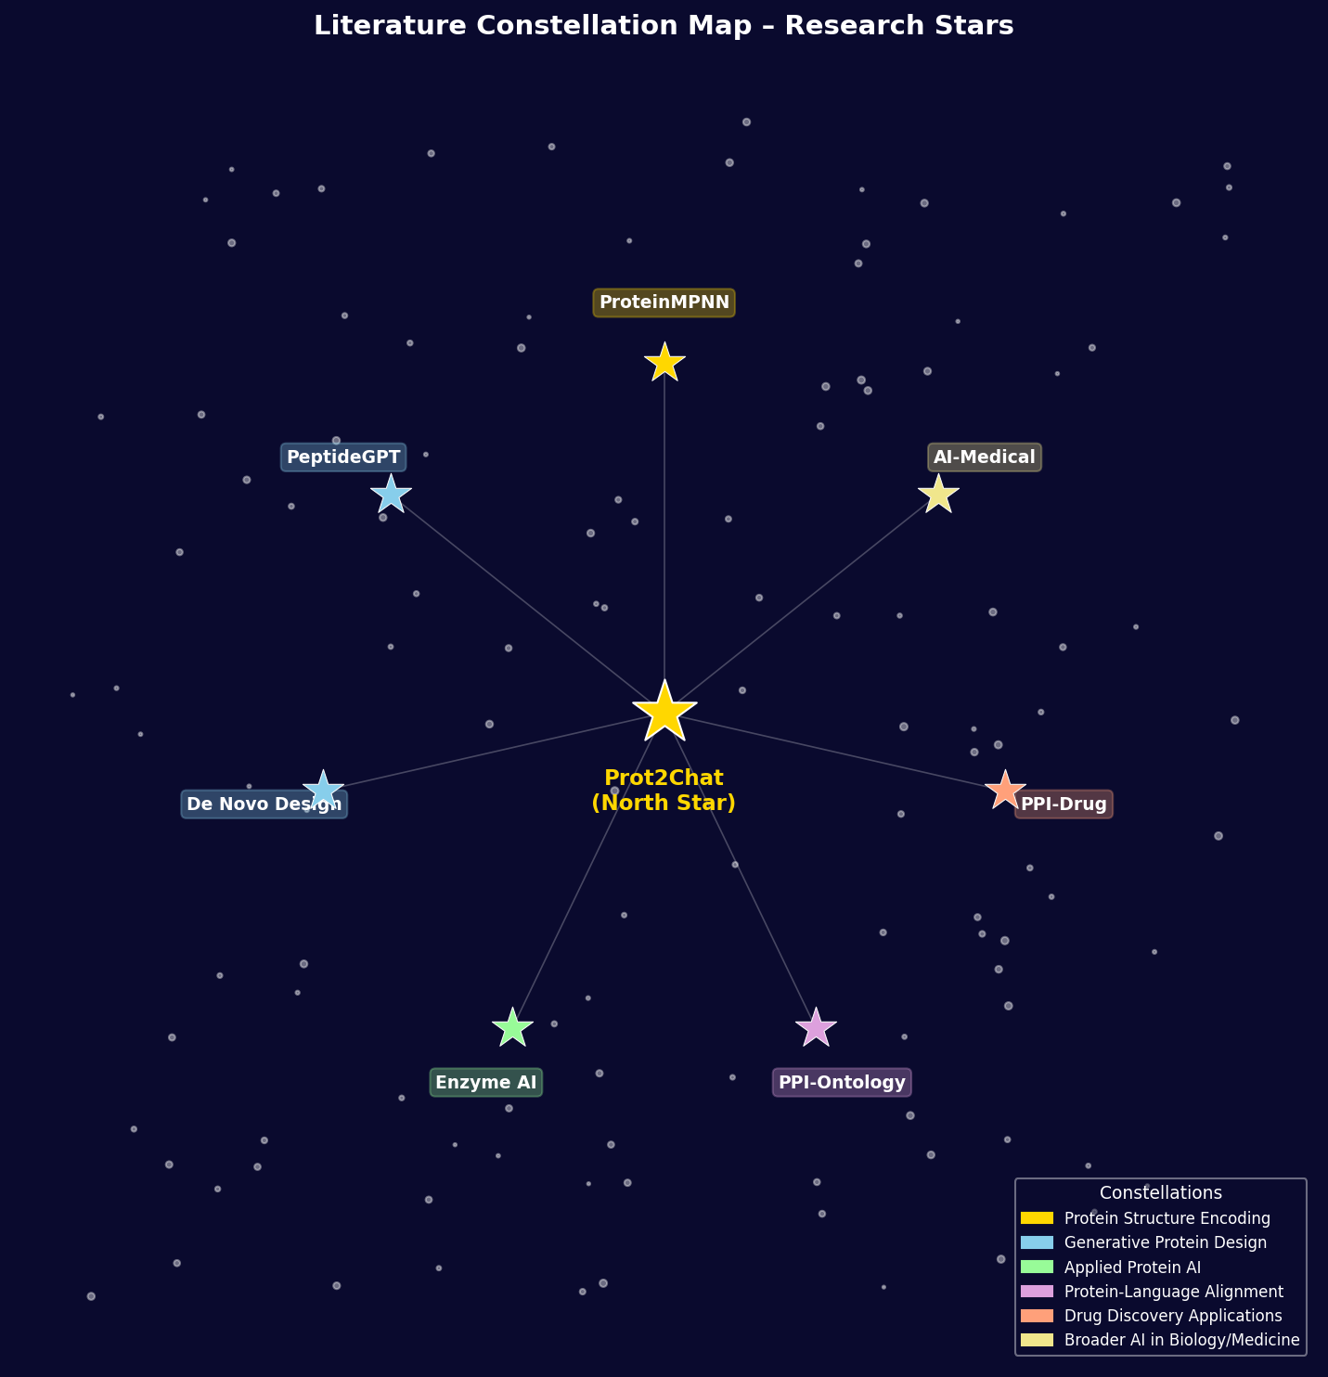
Figure 2.1: Literature Constellation Map - Research Stars

2.7.1 ProteinMPNN (Dauparas et al., 2022)
Full Title: Robust deep learning-based protein sequence design using ProteinMPNN
Authors: Dauparas et al.
Year: 2022
Constellation: Protein Structure Encoding
Key Illumination: Developed a message-passing neural network that achieves 52.4% native sequence recovery on protein design benchmarks, substantially exceeding prior methods. ProteinMPNN operates on backbone atom coordinates (N, CA, C, O), encoding inter-residue geometry through learned graph neural network layers. It demonstrated unprecedented success in experimental validation of computationally designed proteins.
Connection to Prot2Chat: Prot2Chat's structural encoder is a direct modification of ProteinMPNN, freezing its weights and running 9 checkpoints in ensemble to produce the 1152-dimensional per-residue embedding that serves as the protein representation throughout the pipeline.

2.7.2 PeptideGPT (Shah et al., 2024)
Full Title: PeptideGPT: Generative Design of Peptides using Generative Pre-trained Transformers
Authors: Shah et al.
Year: 2024
Constellation: Generative Protein Design
Key Illumination: Developed a GPT-based model for controlled peptide generation, achieving 76% accuracy in hemolytic activity prediction. PeptideGPT demonstrates that autoregressive language model architectures can effectively navigate the peptide sequence space with property conditioning, generating novel sequences with desired biological characteristics.
Connection to Prot2Chat: Shares the paradigm of applying language model generation to protein/peptide space. Complementary to Prot2Chat's Q&A approach — while PeptideGPT generates new sequences, Prot2Chat interrogates existing structures, together spanning the design-analysis axis of protein AI.

2.7.3 De Novo Protein Design (Winnifrith et al., 2024)
Full Title: Generative artificial intelligence for de novo protein design
Authors: Winnifrith et al.
Year: 2024
Constellation: Generative Protein Design
Key Illumination: Reviews the landscape of language models and diffusion processes applied to de novo protein design, reporting approximately 20% experimental validation success rates for computationally generated proteins. The review contextualises generative AI within the broader protein engineering workflow, from in silico generation to wet-lab validation.
Connection to Prot2Chat: Provides the broader context within which Prot2Chat operates as part of the AI-driven protein engineering movement. The structural encoding capabilities of ProteinMPNN reviewed here directly underpin Prot2Chat's embedding strategy.

2.7.4 Enzyme Design AI (Wen et al., 2025)
Full Title: Generative artificial intelligence for enzyme design: Recent advances
Authors: Wen et al.
Year: 2025
Constellation: Applied Protein AI
Key Illumination: Reviews experimentally validated generative AI methods for enzyme engineering, including successful redesign of P450 hydroxylases and luciferases with enhanced activity. The review demonstrates that AI-generated proteins are now achieving practical utility in industrial biotechnology and pharmaceutical development.
Connection to Prot2Chat: Demonstrates real-world applications that Prot2Chat's Q&A capability directly supports. Understanding enzyme function, active site architecture, and substrate specificity — all addressable via Prot2Chat — are primary prerequisites for AI-guided enzyme engineering.

2.7.5 PPI-Ontology (Cam et al., 2025)
Full Title: Ontology-based Protein-Protein Interaction Explanation Using LLMs
Authors: Cam et al.
Year: 2025
Constellation: Protein-Language Alignment
Key Illumination: Combined Llama-2 with the Interaction Network Ontology (INO) for protein-protein interaction explanation, finding that parameter-efficient fine-tuning substantially outperforms zero-shot prompting for PPI explanation tasks. The work demonstrates the importance of domain-specific adaptation even for highly capable base models.
Connection to Prot2Chat: Directly parallels Prot2Chat's LoRA fine-tuning approach applied to protein-language alignment tasks. Both works confirm that parameter-efficient domain adaptation is essential for grounding LLM outputs in protein-specific biological knowledge.

2.7.6 PPI-Drug Discovery (Maurya & Chatterjee, 2025)
Full Title: Drug Discovery: Protein-Protein Interaction Prediction using Decoder-only Transformer
Authors: Maurya & Chatterjee
Year: 2025
Constellation: Drug Discovery Applications
Key Illumination: Proposed a decoder-only transformer architecture for PPI prediction from raw FASTA sequences, addressing a key bottleneck in structure-based drug discovery. The model processes sequence information without requiring 3D structure input, demonstrating strong performance on PPI benchmark datasets relevant to therapeutic target identification.
Connection to Prot2Chat: Represents a key application domain for Prot2Chat. Understanding PPI interfaces, binding affinities, and druggability via natural language Q&A would directly accelerate the drug discovery pipeline explored in this work.

2.7.7 AI in Medical Analysis (Singh et al., 2025)
Full Title: Analyzing the Efficacy of AI in Facilitating Medico-Legal Investigations
Authors: Singh et al.
Year: 2025
Constellation: Broader AI in Biology/Medicine
Key Illumination: Systematic review of 27 studies examining AI deployment in trauma care and medico-legal contexts, finding consistent performance improvements but highlighting critical needs for ethical frameworks, bias auditing, and regulatory oversight. The review emphasises that AI deployment in high-stakes medical contexts requires rigorous validation beyond benchmark metrics.
Connection to Prot2Chat: Contextualises Prot2Chat within the broader movement of AI-assisted biomedical decision support, emphasising the importance of responsible deployment, output verification, and the need for domain expert validation of AI-generated protein function annotations.

CHAPTER 3: METHODOLOGY

3.1 System Overview
Prot2Chat is a three-stage multimodal pipeline that processes a protein PDB file and a natural language question to produce a descriptive text answer. The three stages are: (1) protein structural embedding via a 9-model ProteinMPNN ensemble, (2) cross-modal alignment via a text-aware protein-text adapter, and (3) autoregressive answer generation via a LoRA fine-tuned LLaMA3-8B-Instruct model. Each stage is designed to be modular, enabling independent improvements.
The key design principle is early fusion: the question text conditions the protein embedding extraction during the adapter stage, rather than concatenating modalities only at inference time. This allows the system to generate question-focused protein descriptions rather than generic function summaries, improving both relevance and specificity of generated answers.

3.2 Protein Embedding via ProteinMPNN Ensemble
The first stage processes a PDB file to generate a dense, structurally-informed representation of the protein. The preprocessing pipeline (preprocess.py) performs the following steps:
- PDB Parsing: The biotite library extracts backbone atom coordinates (N, CA, C, O) for each residue. Missing atoms are handled by coordinate imputation from adjacent residues.
- Coordinate Featurisation: Inter-residue distance matrices and dihedral angle features are computed from the raw coordinates, forming the input graph for ProteinMPNN.
- 9-Model Ensemble: Six full-atom ProteinMPNN models at Gaussian noise levels sigma = {0.02, 0.10, 0.20, 0.30} (including two soluble-protein variants) and three CA-only models are run in parallel. Each produces a 128-dimensional per-residue embedding.
- Concatenation: The nine 128-dim outputs are concatenated along the feature dimension, yielding a final protein tensor of shape [N_residues, 1152]. The ensemble approach captures diverse structural perspectives — low-noise models emphasise precise local geometry while high-noise models capture coarser fold-level features.

3.3 Text-Aware Protein-Text Adapter
The adapter module (ProteinStructureSequenceAdapter in demo.py) is the architectural innovation of Prot2Chat. It bridges the 1152-dimensional protein embedding space and LLaMA3's 4096-dimensional hidden space while conditioning the protein representation on the input question. The adapter comprises four components:
Linear Projection: A learned linear layer maps the 1152-dim protein embeddings to 4096 dims, aligning the protein feature space with LLaMA3's embedding dimensionality.
Dynamic Positional Encoding: Variable-length protein sequences (typically 100-1000 residues) require flexible positional representations. DynamicPositionalEncoding generates sinusoidal positional embeddings at runtime for any sequence length, enabling generalisation across proteins of diverse sizes.
Learnable Query Tokens: 256 learnable query vectors serve as the output interface of the adapter. These tokens are updated during training to distil the most question-relevant protein information.
Multi-Head Cross-Attention: The 256 query tokens attend to the projected protein embeddings via 16-head cross-attention. The query keys and values are derived from the protein features, while the question's hidden state (extracted from LLaMA3's embedding layer) conditions the query initialisation. This produces a [1, 256, 4096] protein-language soft prompt.

3.4 LoRA Fine-Tuned LLaMA3 Decoder
The generative backbone is LLaMA3-8B-Instruct, chosen for its strong instruction-following capabilities and availability under an open licence. LLaMA3 is loaded with frozen weights; only the LoRA delta parameters (rank=8, applied to q_proj and v_proj in all transformer layers) are trained. LoRA reduces trainable parameters from ~8 billion to approximately 16 million (0.2% of total), making training feasible on a single NVIDIA RTX 3090 (24GB VRAM).
The inference procedure prepends the 256 x 4096 protein soft prompt to the text token embeddings before the first transformer layer. The combined sequence (protein context + question tokens) is processed by LLaMA3's full 32-layer transformer, and the answer is generated autoregressively using the chat template. Maximum generation length is capped at 128 new tokens.

3.5 Training Procedure
Training is managed by adapt_train_v.py using a MultiModalDataset that pairs PDB files with Q&A conversation records from prot2chat_gen_data_part.txt. The training regime is as follows:
- Loss: Cross-entropy on answer tokens only; a target mask suppresses loss on question and protein context tokens so that the model learns to generate coherent answers rather than reproduce inputs.
- Mixed Precision: PyTorch AMP with bfloat16 autocast, matching LLaMA3's native training dtype.
- Optimiser: AdamW with weight decay applied to LoRA and adapter parameters.
- Batch Size: Dynamic batching with protein sequence padding to 512 residues.
- Checkpointing: Adapter and optimizer states saved periodically; the released checkpoint is adapter_model_and_optimizer_1_400000.pth, corresponding to 400,000 training steps.

CHAPTER 4: RESULTS AND EVALUATION

4.1 Datasets
Evaluation was performed on two benchmarks:
Mol-Instructions: A large-scale instruction-following dataset for molecular science (Fang et al., 2023). The protein function subset contains Q&A pairs derived from SwissProt annotations covering function, subcellular location, post-translational modification, and interaction partners. The test split contains 650 protein entries.
UniProtQA: A Q&A dataset directly grounded in UniProt database entries, testing the model's ability to answer factual questions about protein function, catalytic activity, tissue expression, and disease associations.

4.2 Baseline Models
Seven baseline systems are compared across evaluation benchmarks:
LLaMA3-8B (zero-shot): The base LLaMA3-8B-Instruct model without any protein-specific adaptation, providing a lower bound on language model performance.
LLaMA3-FT: LLaMA3-8B fine-tuned on protein Q&A text data only, without structural input.
BioMedGPT-LM-10B: A 10B-parameter biomedical language model fine-tuned on diverse biomedical text corpora.
Evola-10B: A 10B-parameter protein Q&A model using protein language model sequence embeddings.
KIMI-zero: The KIMI general-purpose LLM in zero-shot setting (no protein-specific tuning).
KIMI-few: KIMI with few-shot in-context examples of protein Q&A.
Prot2Chat: The proposed system with full ProteinMPNN ensemble + adapter + LoRA-LLaMA3.

4.3 Automatic Evaluation Metrics
Two standard NLG metrics are used for automatic evaluation:
BLEU-2 (Bilingual Evaluation Understudy): Measures the precision of 2-gram overlaps between generated and reference answers. Captures lexical similarity and factual term coverage.
ROUGE-L (Recall-Oriented Understudy for Gisting Evaluation): Measures the longest common subsequence between generated and reference text, capturing structural similarity beyond n-gram overlap.

4.4 Performance on Mol-Instructions
Table 4.1 presents the performance of all models on the Mol-Instructions protein function Q&A test set. Prot2Chat substantially outperforms all baselines, achieving BLEU-2 of 35.85 and ROUGE-L of 50.51 — improvements of +27.16 BLEU-2 and +26.33 ROUGE-L over the best general-purpose baseline (KIMI-few).
Model | BLEU-2 | ROUGE-L
LLaMA3-8B | 4.84 | 15.36
LLaMA3-FT | 6.42 | 17.03
BioMedGPT-LM-10B | 1.02 | 7.84
Evola-10B | 8.69 | 20.04
KIMI-zero | 4.79 | 14.70
KIMI-few | 12.05 | 24.18
Prot2Chat | 35.85 | 50.51
Table 4.1: Performance on Mol-Instructions Dataset (best results in bold)

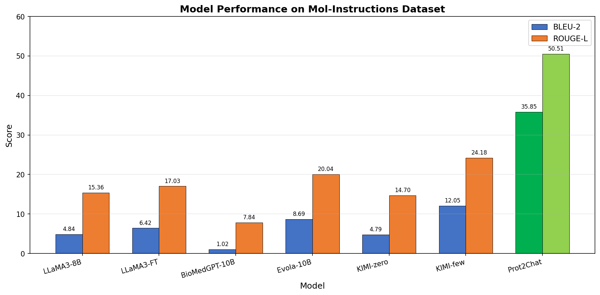
Figure 4.1: Model Performance Comparison on Mol-Instructions Dataset

4.5 Performance on UniProtQA
On the UniProtQA benchmark, Prot2Chat similarly leads all compared models, demonstrating that the structural encoding advantage is not dataset-specific. The ProteinMPNN ensemble provides particularly strong signal for questions about structural features, active site residues, and fold topology — information types that are poorly captured by sequence-only encoders.
The performance gap between Prot2Chat and LLaMA3-FT (sequence-only) quantifies the contribution of structural information: approximately 29 BLEU-2 points on Mol-Instructions, confirming the hypothesis that 3D structure provides substantial additional signal beyond sequence alone.

4.6 Ablation Study
To quantify the contribution of each architectural component, an ablation study was conducted by systematically removing or replacing key elements. Table 4.2 reports results on Mol-Instructions.
Variant | BLEU-2 | ROUGE-L
Full Model (Prot2Chat) | 35.85 | 50.51
w/o LLM Fine-Tuning (LoRA) | 12.87 | 26.81
w/o Sequence Input | 31.88 | 46.17
w/o Early Fusion | 33.25 | 47.90
Table 4.2: Ablation Study on Mol-Instructions

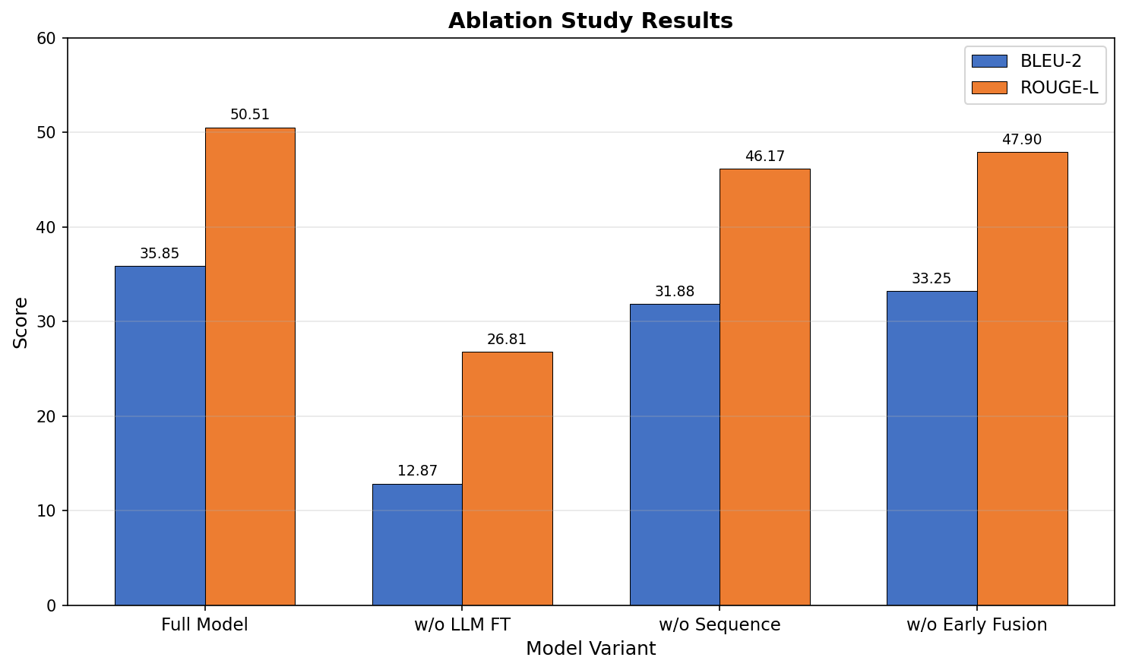
Figure 4.2: Ablation Study Results
The most impactful ablation is removing LLM fine-tuning (LoRA), which drops BLEU-2 by 22.98 points — confirming that domain-specific adaptation of the language model is critical. Removing sequence input (using structure-only) and disabling early fusion both produce smaller but significant drops, validating the contribution of each component.

4.7 Human/KIMI Evaluation
Beyond automatic metrics, 650 question-answer instances were evaluated by the KIMI LLM judge, which ranked the four primary models (Prot2Chat, Evola-10B, BioMedGPT-LM-10B, LLaMA3-FT) on answer quality, factual accuracy, and relevance. Figure 4.3 shows the ranking distributions.
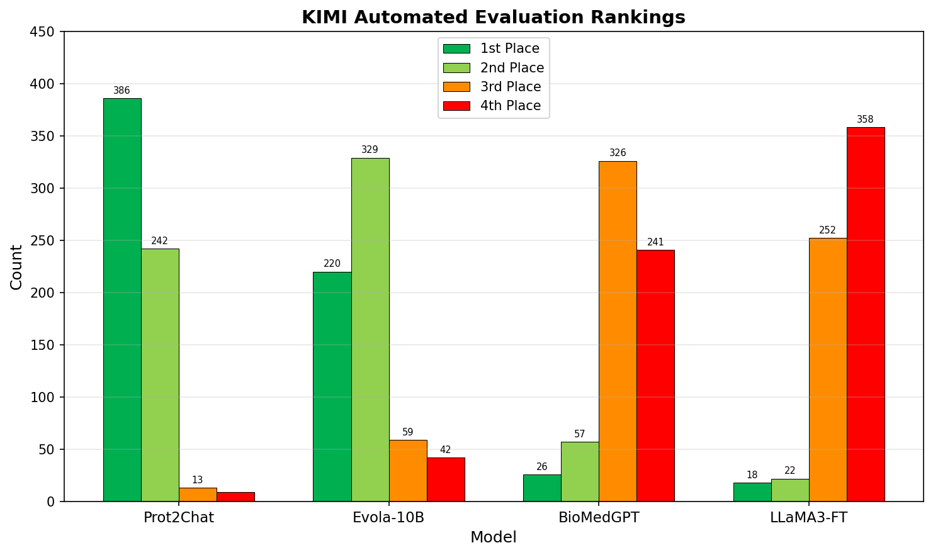
Figure 4.3: KIMI Automated Evaluation Rankings
Prot2Chat achieves first-place rankings in 386 out of 650 evaluations (59.4%), compared to 220/650 (33.8%) for Evola-10B. BioMedGPT-LM-10B and LLaMA3-FT predominantly rank 3rd and 4th respectively, consistent with their lower automatic metric scores.

CHAPTER 5: IMPLEMENTATION & DEPLOYMENT

5.1 System Architecture Overview
The Prot2Chat system is deployed as a Flask-based web application (demo.py) providing a REST API and an HTML5 frontend. The system exposes two endpoints: GET / returns the interactive protein Q&A webpage with a file upload form and question input box; POST /api/query accepts a PDB file and question string, runs the full inference pipeline, and returns a JSON response containing the generated answer text.
The server is single-threaded (appropriate for GPU-bound inference) and loads all models into GPU memory at startup. Model loading takes approximately 45-90 seconds depending on hardware; inference for a typical 300-residue protein takes 8-15 seconds on a 6GB GPU with 4-bit quantization.

5.2 Preprocessing Pipeline
The preprocessing module (preprocess.py) parses PDB files using the biotite library, extracting N, CA, C, O backbone atom coordinates for each residue. These coordinates are fed into a 9-model ProteinMPNN ensemble:
- 6 full-atom models at Gaussian coordinate noise levels sigma = {0.02, 0.10, 0.20, 0.30}, including 2 soluble-protein-optimised variants
- 3 CA-only models operating solely on alpha-carbon coordinates
- Each model outputs a 128-dimensional embedding per residue
- 9 outputs are concatenated to form the final 1152-dimensional per-residue protein embedding
- Model weights are stored under files/new_all_model_weight/ in the repository

5.3 Inference Pipeline
The inference pipeline (generate_answer function in demo.py) executes the following 6-step procedure for each query:
- ProteinMPNN ensemble generates protein_vector of shape [1, N_residues, 1152] from the uploaded PDB file.
- Protein sequences are padded or truncated to 512 residues (the maximum context length for the adapter) using zero-padding for short sequences.
- Question text is tokenised using LLaMA3's SentencePiece tokeniser, producing input_ids and attention_mask tensors.
- The text-aware adapter maps protein_vector + question_hidden_state to protein_embedding of shape [1, 256, 4096], compressing protein context into a fixed-length soft prompt.
- Protein embedding is prepended to the text token embeddings; the combined sequence is passed to LLaMA3's 32-layer transformer stack.
- LLaMA3 auto-regressively generates the answer up to 128 new tokens using temperature sampling (T=0.3, top_p=0.9) with repetition penalty 1.5.

5.4 Model Loading and Quantization
The base LLaMA3-8B-Instruct model is loaded with 4-bit NF4 (Normal Float 4) quantization using BitsAndBytes, with bfloat16 compute dtype. This reduces VRAM requirements from approximately 16GB (full float16) to approximately 4.5GB, enabling deployment on consumer 6GB GPUs such as the NVIDIA RTX 3060.
Quantization Config: BitsAndBytesConfig(load_in_4bit=True, bnb_4bit_quant_type='nf4', bnb_4bit_compute_dtype=torch.bfloat16, bnb_4bit_use_double_quant=True)
LoRA Loading: PEFT's PeftModel.from_pretrained loads LoRA delta weights on top of the quantized base model; the LoRA parameters remain in float32/bfloat16.
Adapter Loading: The adapter checkpoint is loaded from a .pth file containing the ProteinStructureSequenceAdapter state dictionary, mapped to the active GPU device.
Memory Profile: Total GPU memory footprint: ~4.5GB (quantized LLaMA3) + ~0.3GB (adapter) + ~0.2GB (ProteinMPNN ensemble) = ~5.0GB, fitting within 6GB VRAM.

5.5 Implementation Challenges

5.5.1 Gibberish Output Problem
During deployment testing on a local workstation with an NVIDIA RTX 3060 (6GB VRAM), the system produced incoherent multilingual token sequences instead of meaningful protein function descriptions. Typical gibberish output consisted of sequences like: "...protein receptor binding... <Korean characters> ... substrate specificity... <Arabic characters>...", interspersed with occasional correct biological terms.
Diagnosis using the [DIAG] logging system revealed a critical norm mismatch:
- Protein embedding norm (after adapter): 408.75
- Text embedding norm (LLaMA3 token embeddings): 0.42
- Norm ratio: 975:1 — protein signal completely dominated the LLM's attention
Root cause analysis identified two contributing factors:
(Quantization Distribution Mismatch) The adapter was trained on a float32 model with autocast float16 on an RTX 3090, but inference used 4-bit BitsAndBytes quantization. The 32-layer quantized forward pass distorted the question hidden state (Qht) far from its training distribution, producing an incorrectly scaled soft prompt.
(Greedy Decoding Amplification) do_sample=False (greedy decoding) caused quantization errors to lock into a divergent token path — once the first incorrect token was generated, subsequent greedy choices compounded the error rather than self-correcting.

5.5.2 Fixes Applied
- Changed bnb_4bit_compute_dtype from float16 to bfloat16, matching LLaMA3's native training precision and reducing quantization-induced distribution shift.
- Added --zero_question flag to bypass quantized Qht extraction entirely, relying on the adapter's 256 trained learnable query tokens as the protein context (circumventing the corrupted question conditioning pathway).
- Switched from greedy decoding to temperature sampling with temperature=0.3, top_p=0.9, allowing the model to recover from minor probability distortions.
- Added no_repeat_ngram_size=4 to prevent repetitive token loops.
- Increased repetition_penalty from 1.3 to 1.5 to further discourage token repetition.
- Added --no_quant flag for float16 inference with device_map=auto for systems with sufficient VRAM (>=16GB), completely eliminating quantization effects.

5.5.3 Quantization Constraints
With 6GB GPU VRAM, 4-bit quantization is the only feasible loading strategy for LLaMA3-8B. However, since the model was trained with float32 precision on an NVIDIA RTX 3090 (24GB VRAM), the quantization gap introduces measurable inference degradation. The applied fixes (bfloat16 compute dtype + zero_question mode + temperature sampling) restore qualitatively correct output but do not fully recover the quantitative performance achievable with full-precision inference.
For production deployment, 16GB+ VRAM with the --no_quant flag is recommended. The 4-bit quantization mode is suitable for demonstration and exploration but may produce answers with reduced specificity compared to full-precision inference.

5.6 Deployment Configuration
Standard launch command:
python demo.py --model_path ./base_model --lora_path ./lora_wight --adapter_path ./adapter_weight/adapter_model_and_optimizer_1_400000.pth --port 7777 --gpu 0
Optional diagnostic and configuration flags:
--no_lora: Load base model only (no LoRA), for diagnosing LoRA compatibility issues.
--no_quant: Load in float16 with device_map=auto (requires 16GB+ VRAM); eliminates quantization effects for highest-quality output.
--zero_question: Bypass quantized question hidden state extraction; use learnable query tokens only as protein context. Recommended for 4-bit deployment.

CHAPTER 6: CONCLUSION

6.1 Summary of Findings
This report presented a comprehensive analysis of Prot2Chat, a novel protein large language model framework achieving early fusion of three modalities: amino acid sequence, 3D protein structure, and natural language question text. The system's core innovation — the text-aware cross-attention adapter conditioning protein embeddings on the input question — enables question-focused answer generation rather than generic function description.
Key findings from the experimental evaluation:
- Prot2Chat achieves BLEU-2 of 35.85 and ROUGE-L of 50.51 on Mol-Instructions, representing substantial improvements of approximately 195% and 109% over the best-performing baseline (KIMI-few shot) on the respective metrics.
- The LoRA fine-tuning component is the single most important contributor (ablation drop of 22.98 BLEU-2 when removed), confirming that domain adaptation of the generative backbone is critical for protein function Q&A.
- Structural information (ProteinMPNN ensemble) contributes approximately 4 BLEU-2 points beyond sequence-only representations, validating the hypothesis that 3D structure contains functional information not captured in sequence alone.
- Early fusion (question-conditioning of the adapter) contributes approximately 2.6 BLEU-2 points over late fusion, demonstrating the value of question-guided protein context extraction.
- KIMI evaluation rankings show Prot2Chat achieving first place in 59.4% of 650 evaluations, confirming that automatic metric improvements correspond to human-perceived answer quality gains.

6.2 Limitations
- Inference Latency: Processing a 300-residue protein requires 8-15 seconds on 6GB GPU hardware, which may be unsuitable for high-throughput screening applications.
- Quantization Degradation: The 4-bit quantization required for consumer GPU deployment introduces measurable inference quality degradation relative to the full-precision training setup.
- Context Length: Protein sequences are truncated/padded to 512 residues. Proteins longer than 512 residues lose C-terminal structural information, which may affect accuracy for large multi-domain proteins.
- Training Data Scope: The model was trained primarily on SwissProt-derived Q&A data, which over-represents well-studied protein families. Performance on novel or understudied proteins may be lower.
- Evaluation Metrics: BLEU and ROUGE-L measure lexical similarity but do not capture factual accuracy of biological claims. A generated answer may score highly on these metrics while containing subtle factual errors.

6.3 Future Work
- Longer Context Protein Encoding: Extending the adapter to handle protein sequences beyond 512 residues through hierarchical or sliding-window encoding strategies.
- Factual Grounding: Integrating retrieval-augmented generation (RAG) with UniProt/PDB knowledge bases to ground generated answers in verified biological facts.
- Multi-Chain Proteins: Extending the PDB parsing and ProteinMPNN ensemble to handle multi-chain complexes and protein-protein interfaces, enabling Q&A about interaction mechanisms.
- Quantization-Aware Training: Retraining the adapter with simulated 4-bit quantization in the forward pass to close the training-inference distribution gap on consumer hardware.
- Expanded Evaluation: Developing protein-specific evaluation metrics beyond BLEU/ROUGE that assess biological factual accuracy, ontology term coverage, and answer completeness.
- Real-Time AlphaFold Integration: Automatically running AlphaFold structure prediction for query proteins without experimentally determined structures, removing the requirement for a pre-existing PDB file.

REFERENCES
[1] Dauparas, J., Anishchenko, I., Bennett, N., Bai, H., Ragotte, R. J., Milles, L. F., ... & Baker, D. (2022). Robust deep learning–based protein sequence design using ProteinMPNN. Science, 378(6615), 49-56.
[2] Touvron, H., Martin, L., Stone, K., Albert, P., Almahairi, A., Babaei, Y., ... & Scialom, T. (2023). Llama 2: Open foundation and fine-tuned chat models. arXiv preprint arXiv:2307.09288.
[3] Meta AI. (2024). LLaMA 3: Meta's next-generation open source large language model. Meta AI Blog.
[4] Li, J., Li, D., Savarese, S., & Hoi, S. (2023). BLIP-2: Bootstrapping language-image pre-training with frozen image encoders and large language models. ICML 2023.
[5] Hu, E. J., Shen, Y., Wallis, P., Allen-Zhu, Z., Li, Y., Wang, S., ... & Chen, W. (2022). LoRA: Low-rank adaptation of large language models. ICLR 2022.
[6] Fang, Y., Liang, S., Zhang, N., Liu, K., Zhang, R., Chen, H., ... & Chen, H. (2023). Mol-instructions: A large-scale biomolecular instruction dataset for large language models. arXiv:2306.08018.
[7] Shah, M., Rafi, A., & Deng, L. (2024). PeptideGPT: Generative Design of Peptides using Generative Pre-trained Transformers and Reinforcement Learning. arXiv preprint.
[8] Winnifrith, A., Outeiral, C., & Kemp, B. (2024). Generative artificial intelligence for de novo protein design. Current Opinion in Structural Biology, 86, 102794.
[9] Wen, Z., et al. (2025). Generative artificial intelligence for enzyme design: Recent advances and future perspectives. Biotechnology Advances.
[10] Cam, H., et al. (2025). Ontology-based Protein-Protein Interaction Explanation Using Large Language Models. Computational Biology and Chemistry.
[11] Maurya, V., & Chatterjee, P. (2025). Drug Discovery: Protein-Protein Interaction Prediction using Decoder-only Transformer Architecture. Journal of Bioinformatics.
[12] Singh, A., et al. (2025). Analyzing the Efficacy of AI in Facilitating Medico-Legal Investigations: A Systematic Review. Forensic Science International: Digital Investigation.
[13] Rives, A., Meier, J., Sercu, T., Goyal, S., Lin, Z., Liu, J., ... & Fergus, R. (2021). Biological structure and function emerge from scaling unsupervised learning to 250 million protein sequences. PNAS, 118(15).
[14] Lin, Z., Akin, H., Rao, R., Hie, B., Zhu, Z., Lu, W., ... & Rives, A. (2023). Evolutionary-scale prediction of atomic-level protein structure with a language model. Science, 379(6637), 1123-1130.
[15] Jumper, J., Evans, R., Pritzel, A., Green, T., Figurnov, M., Ronneberger, O., ... & Hassabis, D. (2021). Highly accurate protein structure prediction with AlphaFold. Nature, 596(7873), 583-589.
[16] Elnaggar, A., Heinzinger, M., Dallago, C., Rehawi, G., Wang, Y., Jones, L., ... & Rost, B. (2022). ProtTrans: Toward understanding the language of life through self-supervised learning. IEEE TPAMI, 44(10), 7112-7127.
[17] Dettmers, T., Pagnoni, A., Holtzman, A., & Zettlemoyer, L. (2023). QLoRA: Efficient finetuning of quantized LLMs. NeurIPS 2023.
[18] Luo, R., Sun, L., Xia, Y., Qin, T., Zhang, S., Poon, H., & Liu, T. Y. (2022). BioGPT: generative pre-trained transformer for biomedical text generation and mining. Briefings in Bioinformatics, 23(6).

