A PROJECT REPORT
ON
“Weed IDENTIFICATION: A STEP TOWARDS PRECISION FARMING”
Submitted as part of the curriculum for the B.Tech. in Computer Science and Technology

Session: 2025-2026
DEPARTMENT OF Computer science & technology
Indian Institute of Engineering Science and Technology, Shibpur

Submitted To: Submitted By:
Dr. Apurba Sarkar Alok Ranjan (2022CSB091)
(Head of Department) Ankita Tripathi (2022CSB012)
Deep Sutariya (2022CSB090)
Karan Kumar (2022CSB093)
Kiran Tikaraya (2022CSB072)
Rohan Vasudev (2022CSB108)
Sakshi Mishra (2022CSB061)
CERTIFICATE

This is to certify that project entitled "Weed IDENTIFICATION: A STEP TOWARDS PRECISION FARMING" which is submitted by ALOK RANJAN (2022CSB091), ANKITA TRIPATHI (2022CSB012), DEEP SUTARIYA (2022CSB090), KARAN KUMAR (2022CSB092), KIRAN TIKARAYA (2022CSB072), ROHAN VASUDEV (2022CSB108) & SAKSHI MISHRA (2022CSB061) of B.Tech. 4th year, Computer Science & Technology, Indian Institute of Engineering Science and Technology, Shibpur, for the award of the B.Tech. Major Project, is a Bonafide record of work carried out by them under guidance of Dr. Apurba Sarkar.

The content of this project has not been submitted to any university or institute for an award of any degree.

_ _ _ _ _ _ _ _ _ _ _ _ __ _ _ _ _ _ _ _ _ _ _

Dr. Apurba Sarkar External Examiner
Head of Department
(Project guide)
(Computer Science & Technology)

Date: 04 / 12 / 2025

Place: IIEST Shibpur

SELF ATTESTATION

This is to certify that we have personally worked on the dissertation entitled "Weed IDENTIFICATION: A STEP TOWARDS PRECISION FARMING". A case study and data mentioned in this report were obtained during genuine work done and collected by us.

Any other data and information in this report, which has been collected from an outside agency, has been duly acknowledged.

STUDENTS:

---------------------------------------------------------
ALOK RANJAN (2022CSB091)

---------------------------------------------------------
ANKITA TRIPATHI (2022CSB012)

---------------------------------------------------------
DEEP SUTARIYA (2022CSB090)

---------------------------------------------------------
KARAN KUMAR (2022CSB092)

---------------------------------------------------------
KIRAN TIKARAYA (2022CSB072)

---------------------------------------------------------
ROHAN VASUDEV (2022CSB108)

---------------------------------------------------------
SAKSHI MISHRA (2022CSB061)

Date: - 04 / 12 / 2025
Place: - IIEST Shibpur
ABSTRACT
The rapid rise in global population expected to approach 10 billion by the mid-21st century demands a significant increase in agricultural productivity despite declining arable land and unpredictable climatic conditions. Achieving this shift requires moving from traditional, resource-intensive farming methods toward precision agriculture, where data-driven decision-making minimizes chemical use and maximizes crop yield. Among the various constraints impacting productivity, weeds remain one of the most aggressive competitors for water, nutrients, and sunlight. Conventional weed management relies on uniform, blanket herbicide spraying, an approach that is costly, environmentally damaging, and accelerates the development of herbicide-resistant weed species.
This project presents the development of an automated Weed and Crop Identification system intended to support site-specific weed management. The primary challenge addressed is the “green-on-green” problem—distinguishing weeds from crops that share similar textures, shapes, and spectral characteristics. Building on the standard Kaggle WeedCrop dataset, the system employs an Improved Faster R-CNN architecture enhanced with three key components:
(1) A Convolutional Block Attention Module (CBAM) for refined feature selection,
(2) A Bidirectional Feature Pyramid Network (BiFPN) for robust multi-scale fusion, and
(3) RoI Align with Bilinear Interpolation for precise localization of small weeds.
The model was trained on 2,469 images and validated on 235 images, achieving a mean Average Precision (mAP) of 0.2223 and mAP@50 of 0.5167. Although the performance is not yet state-of-the-art , the results demonstrate the feasibility of using enhanced two-stage detectors for early-stage weed detection, especially for small objects that standard architectures struggle with. The proposed approach establishes a strong foundation for real-time deployment on autonomous robotic platforms and highlights the potential of deep learning to reduce herbicide use, lower operational costs, and support sustainable agricultural practices.

CONTENTS
Title Page
CERTIFICATE ii
SELF ATTESTATION iii
ABSTRACT iv
CONTENTS v

CHAPTER 1: INTRODUCTION
1.1 Introduction vii
1.2 Limitations of Conventional Weed Control and Challenges in Weed Detection vii
1.3 Objective viii
1.4 Problem Statement ix
1.5 Scope of the Report ix

CHAPTER 2: LITERATURE REVIEW
2.1 Historical Context x
2.2 Traditional Machine Learning (ML) x
2.3 Deep Learning (DL) xi
2.3.1 The Rise of Deep Learning in Agricultural Vision xi
2.3.2 Classification vs Localization vs Detection xii
2.4 Object Detection Architectures: YOLO vs Faster R-CNN xii
2.5 Related Work in Weed Detection xiii

CHAPTER 3: METHODOLOGY: IMPROVED FASTER R-CNN
3.1 Dataset Description xv
3.2 Base Architecture: Faster R-CNN xv
3.3 Improvement I: Convolutional Block Attention Module (CBAM) xvi
3.3.1 Channel Attention Module (CAM) xvi
3.3.2 Spatial Attention Module (SAM) xviii
3.3.3 Arrangement of attention modules xix
3.4 Improvement II: BiFPN For Multi-Scale Weed Detection xix
3.5 Improvement III: Bilinear Interpolation and RoI Align for Precise Localization xxi
3.6 Hybrid Loss Function with Center Loss for Improved Class Discrimination xxiii
3.7 FINAL ARCHITECTURE: IMPROVED FASTER R-CNN xxv
CHAPTER 4: METHODOLOGY - IMPROVED FASTER R-CNN
4.1 Dataset Preparation and Augmentation xxvi
4.2 Technology Stack xxvi
4.3 Performance Metrices xxvii
4.4 Comparative Analysis xxvii

CHAPTER 5: CONCLUSION
Conclusion xxviii

CHAPTER 1
INTRODUCTION
1.1 Introduction
Agriculture is the economic backbone of many developing nations, including India, where a large segment of the population depends on farming for survival. Since the sector is fundamentally driven by biological yield, any factor that disrupts plant growth directly contributes to economic instability. Among the numerous challenges in agriculture—ranging from abiotic stresses like drought to biotic threats such as pests—weeds remain one of the most persistent and damaging problems.
According to the Weed Science Society of America, a weed is any plant whose presence in a field is undesirable and economically harmful. In high-value crops such as cotton, poor weed management can cause yield losses of more than 90%. Weeds like Solanum nigrum (Black Nightshade), Chenopodium album (Common Lambsquarters), and Convolvulus species act as aggressive competitors, growing rapidly and developing widespread root systems that monopolize soil nutrients, water, and light. This competition starves the crop at its early growth stages, preventing proper canopy formation. Additionally, many weeds serve as alternate hosts for insect pests and viral pathogens, creating secondary threats that further depress crop productivity.
Weed control, therefore, becomes a critical component of sustainable agriculture. Traditional approaches—such as blanket herbicide spraying or manual removal—are often inefficient, expensive, labour-intensive, and environmentally damaging due to excessive chemical usage and residue buildup.
To address these limitations, this report explores the transition from conventional weed management practices to Precision Agriculture powered by Machine Learning (ML) and Deep Learning (DL). It specifically highlights the development of a robotic vision system using an improved Faster R-CNN model, enabling precise weed identification and targeted herbicide application. This intelligent, selective-spraying approach not only reduces chemical use and production costs but also enhances sustainability and crop yield.

1.2 Limitations of Conventional Weed Control and Challenges in Weed Detection
For decades, the dominant strategy for weed management has been chemical control through blanket herbicide spraying—uniformly applying chemicals across entire fields without distinguishing between weed-infested and weed-free zones. While this approach offers short-term effectiveness, it presents several long-term limitations.
Environmental Toxicity: A large portion of sprayed herbicide never reaches the target weeds. Instead, it drifts into surrounding ecosystems, contaminates water sources, and disrupts the soil microbiome. This unintended environmental damage, once overlooked, is now a critical concern in sustainable agriculture.
Economic Inefficiency: Weed growth is typically patchy. Blanket spraying wastes significant amounts of herbicide on areas with no weeds, inflating production costs. Studies suggest that precision-based spraying can reduce chemical usage by up to 80%, highlighting the inefficiency of traditional methods.
Herbicide Resistance: Repeated exposure to lethal chemical doses accelerates natural selection, giving rise to “superweeds” resistant to widely-used herbicides such as glyphosate. This resistance reduces the effectiveness of existing weed-control strategies and threatens long-term crop productivity.
Health Hazards: Manual herbicide application exposes farm labourers to toxic and potentially carcinogenic chemicals. Automating this process is not just an operational upgrade—it is a necessary step to protect worker health and safety.
Alongside these limitations, accurate weed detection itself poses significant challenges, especially when using computer vision systems in real-world agricultural environments.
Visual Similarity: Many weeds share similar colours and textures with crops, particularly during early growth stages. This “green-on-green” similarity makes traditional colour-based segmentation techniques unreliable.
Occlusion: Leaves of weeds and crops often overlap, obscuring key visual features and making classification more difficult, even for advanced models.
Lighting Variability: Outdoor conditions introduce inconsistent lighting due to changes in weather, sunlight intensity, and shadows. These variations significantly impact image quality and reduce detection accuracy.
Together, these limitations of conventional weed control and the inherent challenges of visual weed detection highlight the urgent need for advanced, intelligent systems. Precision Agriculture, fuelled by Machine Learning and Deep Learning, provides a promising pathway toward sustainable, efficient, and safe weed management.

1.3 Objective
The main goal of this project is to develop a machine learning–based computer vision system that can accurately distinguish weeds from crops at the early seedling stage. Early detection enables precision weeding, allowing robotic or automated sprayers to target only the weeds, reducing herbicide usage and minimizing environmental harm.
Specific Objectives Include:
- Develop a deep learning model that performs better than traditional object detectors (e.g., YOLO, standard Faster R-CNN) in the difficult green-on-green detection scenario.
- Use the Kaggle Weed Crop dataset as the core training data, supported with domain-specific augmentation to improve real-world robustness.

1.4 Problem Statement
Weeds are unwanted plants in the field, and farmers have struggled with them since agriculture began. Manual inspection for patch spraying is too resource-heavy for large-scale farming. The key technical challenge is the “Green-on-Green” classification problem—most plants are green, so simple color-based methods fail. A successful system must distinguish subtle textural and structural differences between crops (like cotton seedlings) and weeds (like Salsola collina), while also handling occlusion, changing light, and the multi-scale complexity of plants in real field conditions.

1.5 Scope of the Report
This report documents the end-to-end development of the "Weed IDENTIFICATION: A STEP TOWARDS PRECISION FARMING" project. Chapter 2 reviews the existing literature, establishing the theoretical basis for selecting the Faster R-CNN architecture. Chapter 3 provides an exhaustive explanation of the "Improved Faster R-CNN" methodology, detailing the mathematical foundations of the Attention Mechanism (CBAM), BiFPN, and Bilinear Interpolation. Finally, Chapter 4 outlines the execution process, technologies used, Performance metrices and comparative analysis followed by conclusions in Chapter 5.

CHAPTER 2
LITERATURE REVIEW
2.1 Historical Context
Interest in computerized image processing for agriculture stems from two principal application areas: the improvement of pictorial information for human interpretation and the processing of scene data for autonomous machine perception. Initially, agricultural machine vision relied on "Traditional Image Processing Techniques" (IPT). These methods involved manual feature engineering where researchers would define specific rules for identifying plants.
For example, early systems used vegetation indices like the Excess Green Index (ExG) or the Normalized Difference Vegetation Index (NDVI) to segment plant matter from the soil background. Once segmented, algorithms would extract morphological features such as leaf aspect ratio, roundness, or moments of inertia. Classifiers like Support Vector Machines (SVM) or Random Forests (RF) were then trained on these hand-crafted features.
- Random Forest (RF): Studies have utilized object-based image analysis with RF for crop/weed classification, achieving accuracies around 95% in controlled datasets. RF is favoured for its generalized performance and operational speed in remote sensing applications.
- Support Vector Machines (SVM): SVMs have been widely used for weeding and harvesting characterization. For instance, researchers generated weed species recognition systems targeting sugar beet and soya bean crops using SVMs, achieving accuracies between 92% and 95%.
However, traditional IPT suffers from poor generalization. A rule-based on the shape of a leaf in a sunny image often fails when the leaf is partially occluded or viewed under cloudy conditions. The "feature engineering" bottleneck meant that these systems could not easily scale to new crops or weeds without significant human intervention.

2.2 Traditional Machine Learning (ML)
Classical machine-learning approaches in agricultural vision rely heavily on handcrafted features such as colour, shape, and texture descriptors. These features are manually engineered and then passed to classifiers like Support Vector Machines (SVM) and Random Forests (RF). Such models are computationally lightweight and suitable for real-time processing on low-end hardware, making them appealing for early automation efforts.
However, traditional ML struggles under real agricultural conditions. Performance degrades significantly when faced with complex scenarios such as heavy occlusion, variable lighting, soil inconsistencies, or overlapping leaves. This sensitivity arises because handcrafted rules rarely generalize well; a rule designed for a sunny field often fails under cloudy or dusty conditions.

2.3 Deep Learning (DL)
Deep Learning revolutionized agricultural machine vision by introducing Convolutional Neural Networks (CNNs), which automatically learn hierarchical feature representations directly from data. Instead of manually specifying that “a weed typically has a jagged leaf edge,” CNNs discover thousands of such features implicitly during training. This eliminated the feature-engineering bottleneck and dramatically improved generalization in unstructured environments.
DL models consistently outperform traditional ML methods in both accuracy and robustness, although they require higher computational resources (GPUs). Modern object detection architectures used in agriculture include YOLO (You Only Look Once) and Faster R-CNN.
YOLO
A one-stage detector optimized for real-time performance.
- Strengths: Extremely fast; suitable for mobile platforms.
- Limitations: Historically less accurate for small objects, which is a challenge in early-stage weed detection.
Faster R-CNN
A two-stage detector utilizing a Region Proposal Network (RPN) followed by classification and regression.
- Strengths: High accuracy, excellent small-object detection, robust to occlusion.
- Relevance: Ideal for detecting early-stage weed seedlings were missing a weed or misclassifying a crop can be costly.

2.3.1 The Rise of Deep Learning in Agricultural Vision
Deep learning has fundamentally transformed plant and weed recognition. By automating feature extraction, CNNs eliminate the limitations of handcrafted features and can learn from large-scale datasets. This capability allows DL models to adapt to variations in lighting, growth stages, and field conditions more effectively than traditional approaches.

2.3.2 Classification vs. Localization vs. Detection
To understand the landscape of modern computer vision, it is essential to distinguish between the core tasks, as outlined in the reference project report :
- Image Classification: The task of assigning a label to a whole image (e.g., "This image contains a weed"). It essentially answers "What is in the picture?".
- Object Localization: Determining the location of an object within an image, typically represented by a bounding box. It answers "Where is it?".
- Object Detection: The combination of the two. The system must identify what objects are present and where each one is located, drawing bounding boxes around multiple distinct entities in a single frame.
- Semantic Segmentation: A pixel-level classification where every pixel is assigned a class label, providing the exact shape of the object rather than a coarse box.
For robotic weeding, object detection offers an optimal balance.
- Classification alone does not provide coordinates for targeted spraying.
- Segmentation is more precise but computationally expensive and unnecessary if the sprayer has a fixed cone width.
Therefore, this project focuses on object detection architectures.

2.4 Object Detection Architectures: YOLO vs. Faster R-CNN
Modern object detection approaches fall into two major families:
(A) One-Stage Detectors (e.g., YOLO - You Only Look Once):
YOLO treats detection as a single regression problem, mapping directly from image pixels to bounding box coordinates and class probabilities. The image is divided into an $S×S$ grid, and each grid cell predicts bounding boxes if the center of an object falls within it.
Pros:
- Extremely fast; real-time capability on modest hardware.
Cons:
- Struggles with small objects and dense clusters because each grid cell can only predict a limited number of bounding boxes.
Relevance to Project:
While YOLO is widely referenced in the literature and forms a baseline for weed detection systems, advanced research indicates that YOLO’s performance on small seedlings is inferior to two-stage detectors.

(B) Two-Stage Detectors – Faster R-CNN
Faster R-CNN performs detection in two major steps:
- Region Proposal Network (RPN): Generates candidate regions where objects may exist.
- Classification + Regression: Refines these proposals and labels them.
Pros:
- Superior accuracy
- Handles small and occluded objects effectively
- Robust under varying field conditions
Cons:
- Slightly slower due to the two-step pipeline
Justification for this Project:
Agricultural tasks have a high penalty for false negatives (missed weeds) and false positives (accidentally spraying crops). The increased precision of Faster R-CNN outweighs the marginal loss in speed.
The project, therefore, implements an Improved Faster R-CNN, which integrates advanced components such as CBAM (attention), BiFPN (multi-scale fusion), and bilinear interpolation (precise ROI alignment).

2.5 Related Work in Weed Detection:
Recent years have seen rapid growth in datasets and methodologies:
- Deep Weeds dataset: Contains images of eight Australian weed species but focuses on classification, not detection.
- Other datasets target specific crops such as carrot, maize, or soybean, limiting generalizability.
A recurring challenge highlighted in the literature is the multi-scale nature of weeds. A single field may contain:
- Small, newly emerging seedlings
- Medium-sized juvenile weeds
- Large, mature weeds
Standard CNNs often struggle to detect all scales simultaneously due to fixed receptive fields.
Another persistent issue is the “green-on-green" problem:
Weeds and crops often share similar colour and texture, leading to misclassification—especially when leaves overlap or partially occlude one another.
Recent Solutions
Advanced studies propose:
- Attention Mechanisms to help the network focus on discriminative features
- Feature Pyramid Networks (FPN/BiFPN) to handle multi-scale objects effectively
The present project builds directly on these advanced concepts, implementing an Improved Faster R-CNN tailored for agricultural environments and suitable for integration with robotic weeding platforms.

CHAPTER 3
METHODOLOGY: IMPROVED FASTER R-CNN
To handle challenges such as visual similarity, occlusion, and multi-scale weed sizes, this project adopts the Improved Faster R-CNN architecture demonstrated in recent high-performance studies. While the baseline Faster R-CNN is strong, it requires targeted enhancements for agricultural conditions. Therefore, the proposed model integrates three key improvements: CBAM to focus on the most informative features, BiFPN for efficient multi-scale feature fusion, and Bilinear Interpolation to improve RoI alignment accuracy. Together, these upgrades significantly boost detection performance for early-stage weeds.
3.1 Dataset Description
The model was trained using the WeedCrop Image Dataset sourced from Kaggle.
- Source: Kaggle
- Size: The dataset comprises 2,822 high-resolution RGB images.
- Classes: The dataset is annotated for two primary classes: Crop and Weed.
- Format: Annotations are provided in YOLO v5 PyTorch format, which were pre-processed for compatibility with the Faster R-CNN architecture.
- Diversity: The images cover various lighting conditions and growth stages, providing a robust training ground for "green-on-green" detection tasks.

3.2 Base Architecture: Faster R-CNN
The baseline Faster R-CNN consists of three major components: a backbone network (such as VGG16 or ResNet) for feature extraction, a Region Proposal Network (RPN) for generating candidate object regions, and a detection head for classification and bounding box refinement.
- Region Proposal Network (RPN):
The RPN slides a small window over the backbone feature map. At each spatial position, it predicts several predefined anchor boxes of different scales and aspect ratios. For each anchor, the RPN outputs an objectness score distinguishing object vs. background and regresses the bounding box coordinates.
- RoI Pooling:
The proposed regions vary in size, so Faster R-CNN uses Region of Interest (RoI) Pooling to convert each region into a fixed-size feature representation. These pooled features are then passed to the final classifier and regression layers to produce the object label and refined bounding box.

3.3 Improvement I: Convolutional Block Attention Module (CBAM)
In a crop field, the background is visually complex containing soil, clods, dry leaves, plastic mulch, and shadows. A standard CNN initially treats all pixels within its receptive field with equal importance, which can cause the model to focus on irrelevant background features. CBAM (Convolutional Block Attention Module) addresses this problem by guiding the network to focus selectively on informative regions, such as plant textures and edges, while suppressing noise.
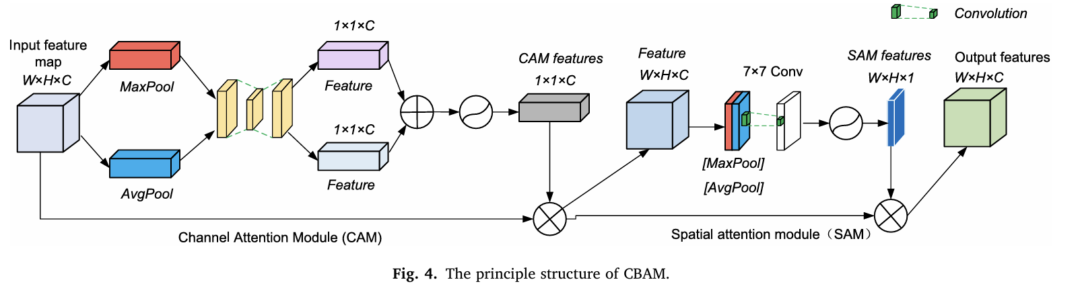
CBAM is a lightweight attention module that applies attention in two dimensions sequentially:
  - Channel Attention Module(CAM) - determines what features are important
  - Spatial Attention Module(SAM) - determines where those important features are located.

3.3.1 Channel Attention Module (CAM)
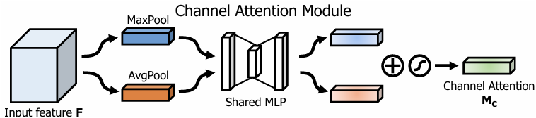
The Channel Attention Module focuses on learning what features are important in the input feature map. Since each channel in a CNN feature map acts like a specialized feature detector, enhancing the most informative channels significantly improves the model’s representational power.
To compute channel attention efficiently, CBAM first squeezes the spatial dimensions of the feature map using global pooling operations. Prior works typically rely on average pooling, which captures global statistics of the object. However, CBAM demonstrates that max pooling provides complementary information by emphasizing strong, distinctive activations (e.g., sharp edges or unique leaf textures).
Therefore, CAM uses both descriptors:
- Average-pooled feature $F_{avg}^{c}$
- Max-pooled feature $F_{max}^{c}$
These two context descriptors are passed through a shared Multi-Layer Perceptron (MLP) consisting of one hidden layer. The hidden dimension is reduced by a factor $r$to minimize parameters. The outputs of the two branches are then combined through element-wise addition, and a sigmoid activation is applied to generate the channel attention map $M_{c}\left(F\right)$.
The formulation is:
$$M_{c}\left(F\right)=σ\left(\text{MLP}\left(AvgPool\left(F\right)\right)+\text{MLP}\left(MaxPool\left(F\right)\right)\right)$$
Expanded:
$M_{c}\left(F\right)=σ\left(W_{1}\left(W_{0}\left(F_{avg}^{c}\right)\right)+W_{1}\left(W_{0}\left(F_{max}^{c}\right)\right)\right)$
Where:
- $W_{0}∈R^{\frac{C}{r}×C}$ and $W_{1}∈R^{C×\frac{C}{r}}$ are shared MLP weights
- ReLU is applied after $W_{0}$
- $σ$is the sigmoid function
Using both average and max-pooled features enables CAM to capture global context (AvgPool) and distinctive fine-grained features (MaxPool). Empirical results from the original CBAM study show that combining both greatly improves the network’s ability to highlight meaningful channels while suppressing irrelevant ones.

3.3.2 Spatial Attention Module (SAM)
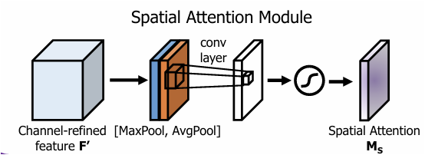
While the Channel Attention Module identifies what features are important, the Spatial Attention Module focuses on where these important features are located within the spatial dimensions of the feature map. This makes SAM complementary to CAM, as it helps the network highlight meaningful regions such as weed leaves while suppressing irrelevant background areas like soil or mulch.
To compute spatial attention, the feature map is first compressed along the channel axis using two pooling operations:
- Average pooling : captures the general activation distribution
- Max pooling : highlights the strongest spatial responses
These two descriptors form two 2D maps:
- $F_{avg}^{s}∈R^{1×H×W}$
- $F_{max}^{s}∈R^{1×H×W}$
Both maps are concatenated and passed through a 7×7 convolution layer, which aggregates local spatial context and generates the spatial attention map:
$$M_{s}\left(F\right)=σ\left(f^{7×7}\left(\left[AvgPool\left(F\right);MaxPool\left(F\right)\right]\right)\right)$$
This spatial mask highlights the areas in the feature map where meaningful information exists—typically the leaf contours, textures, and shapes—while suppressing less relevant regions such as soil patches, shadows, or dry leaves.

3.3.3 Arrangement of attention modules
Given an input image, CBAM applies two complementary attention mechanisms: channel attention, which determines what features are important, and spatial attention, which determines where those important features are located. These two modules can theoretically be arranged either in parallel or sequential order. However, experimental evaluations show that the sequential configuration consistently performs better, as it allows each attention module to refine the features progressively. Furthermore, within the sequential setup, applying channel attention first, followed by spatial attention, yields slightly superior performance compared to the reverse order.

3.4 Improvement II: Bidirectional Feature Pyramid Network (BiFPN) For Multi- Scale Weed Detection
Weeds in agricultural fields exhibit extreme scale variation—a newly emerged seedling may measure only 1 × 1 cm, whereas a mature broadleaf weed may reach 20 × 20 cm or more. This creates a major challenge for convolutional neural networks (CNNs), which progressively down-sample feature maps as depth increases. Consequently:
- Low-level features retain fine spatial detail but contain weak semantics.
- High-level features capture rich semantic meaning but have coarse localization.
Limitations of Standard CNNs and FPN
The standard Feature Pyramid Network (FPN) attempts to address this by passing high-level semantic features down to lower levels (the top-down pathway). However:
- It treats all input features equally (no weighting).
- It relies only on one-directional information flow.
- It often struggles in agricultural settings where object sizes vary dramatically.
BiFPN: A More Effective Multi-Scale Fusion Strategy
The Bidirectional Feature Pyramid Network (BiFPN), introduced in the EfficientDet architecture, improves upon FPN by enabling stronger and more flexible multi-scale feature fusion. Its design is illustrated in Fig. 5(c). 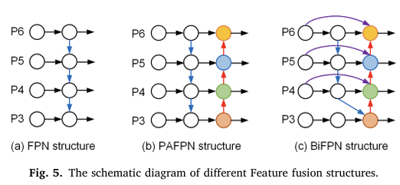
Understanding Fig. 5 (FPN vs. PAFPN vs. BiFPN):
(a) Standard FPN Structure
Only top-down fusion is performed. High-level features are passed downward, but there is no reverse pathway.
(b) PAFPN Structure
Adds a bottom-up path to reinforce information flow back upward. However, fusion operations are still limited and unweighted.
(c) BiFPN Structure (Used in This Project)
BiFPN introduces:
- Bidirectional pathways (top-down + bottom-up)
It introduces both top-down and bottom-up pathways, allowing information to move across the network in multiple directions. This enhances the fusion of fine-grained and semantic-rich features
- Learnable Weighted Feature Fusion
BiFPN learns a weight $w_{i}$for each input feature, enabling the network to assign higher importance to the scales that best represent a given object. Instead of treating all inputs equally, BiFPN adaptively prioritizes features.
This combination makes BiFPN significantly more powerful for detecting both small seedlings and large weeds simultaneously.
BiFPN Fusion Equation:
$$O=\sum_{i}{Σ_{i}\frac{w_{i}}{ϵ+\sum_{j}{w_{j}}}⋅}I_{i}$$
where:
- $I_{i}$ : input feature at scale $i$
- $w_{i}$ : learnable weight for that feature
- $ϵ$ : small constant to avoid division by zero
Why BiFPN is Effective for Weed Detection
BiFPN is highly suitable for agricultural imagery because:
- It preserves fine-detail structures needed to detect tiny seedlings.
- It leverages semantic context from deeper layers for large weeds.
- It handles large variation in object size, cluttered backgrounds, and complex crop–weed overlaps.
- It outperforms standard FPN, especially in “green-on-green” scenarios typical in cotton fields.
As shown in Fig. 5, BiFPN’s bidirectional and weighted connections enable more robust multi-scale feature representation, making it ideal for real-world weed detection.

3.5 Improvement III: Bilinear Interpolation and RoI Align for Precise Localization
The standard Faster R-CNN architecture uses RoI Pooling, which rounds floating-point coordinates of region proposals to integers. This rounding introduces quantization error, especially problematic when detecting very small weeds. For example, if the RPN predicts a bounding box at (10.5, 10.5), RoI Pooling converts it to (10, 10). Although negligible for large plants, a 0.5-pixel displacement causes a 5% spatial distortion for a 10-pixel-wide seedling, leading to misaligned feature extraction, inaccurate classification, and poor bounding-box regression. In robotic spraying systems, such misalignment can cause the nozzle to miss the weed or accidentally spray the crop, reducing field accuracy.
To address this, the improved model replaces RoI Pooling with RoI Align, which retains the original floating-point coordinates and computes feature values using bilinear interpolation rather than rounding.
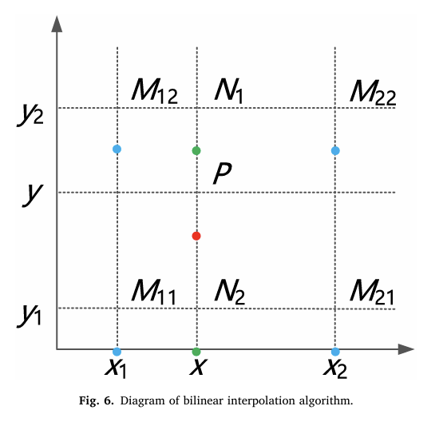
As shown in Fig. 6, bilinear interpolation estimates the value at any sampling point $P(x,y)$using the four nearest grid points $M_{11},M_{12},M_{21},M_{22}$. . The value at point $P$is computed by first interpolating along the x-direction and then along the y-direction:
$$\begin{matrix}f(x,y)≈ & f(M_{11})\frac{(x_{2}-x)(y_{2}-y)}{(x_{2}-x_{1})(y_{2}-y_{1})}+f(M_{12})\frac{(x_{2}-x)(y-y_{1})}{(x_{2}-x_{1})(y_{2}-y_{1})} \\ & +f(M_{21})\frac{(x-x_{1})(y_{2}-y)}{(x_{2}-x_{1})(y_{2}-y_{1})}+f(M_{22})\frac{(x-x_{1})(y-y_{1})}{(x_{2}-x_{1})(y_{2}-y_{1})}\end{matrix}$$
Because RoI Align preserves continuous coordinates, it ensures that the extracted feature maps remain precisely aligned with the true weed location. This eliminates localization drift, improves regression accuracy, and is essential in precision agriculture—where accurate per-pixel prediction directly determines whether the sprayer hits the weed or the crop

3.6 Hybrid Loss Function with Center Loss for Improved Class Discrimination
In cotton seedling fields, weeds often exhibit colors and textures very similar to cotton plants. Additionally, factors such as overlapping leaves, cross-growth around roots, and soil-induced visual noise make it difficult for the detector to distinguish between weeds and crop seedlings. To address these challenges and enhance class separability, the model adopts a Hybrid Loss Function that integrates Center Loss with the standard classification and regression losses.
Why Center Loss Is Needed?
Standard softmax classification loss encourages the network to learn a decision boundary between classes, but it does not ensure that samples of the same class stay close together in feature space. As a result, visually similar plants (e.g., cotton vs. broadleaf weeds) may still overlap in the learned representation, leading to misclassification.
Center Loss directly addresses this by minimizing intra-class variance, pulling feature vectors of each class toward a learned class “center.” This forms compact clusters for each plant type, making the model more discriminative in cases of occlusion and look-alike plants.
The Center Loss is defined as:
$$L_{C}=\frac{1}{2}\sum_{i=1}^{N_{cls}}{{\left\|F\left(x_{i}\right)-c_{y_{i}}\right\|}^{2}}$$
Where:
- $N_{cls}$ : number of RoIs belonging to each class
- $F(x_{i})$ : deep feature of the $i^{th}$ region proposal
- $c_{y_{i}}$ : learned feature center of class $y_{i}$
During training, the loss decreases as features of each class gradually cluster around their corresponding center, increasing internal cohesion and maximizing separation between weed and crop features
Hybrid Loss Function
To balance classification, localization, and feature compactness, the total loss is formulated as:
$$L=L_{cls}+L_{reg}+λL_{C}$$
Where:
- $L_{cls}$ : classification (softmax cross-entropy)
- $L_{reg}$ : bounding-box regression (Smooth L1)
- $L_{C}$ : Center Loss
- $λ$ : weighting factor controlling the influence of Center Loss
A very small $λ$makes Center Loss ineffective, while a very large $λ$can destabilize training. Therefore, $λ$is tuned to maintain a proper balance between class compactness and classification performance.
Training Workflow (Fig. 7)
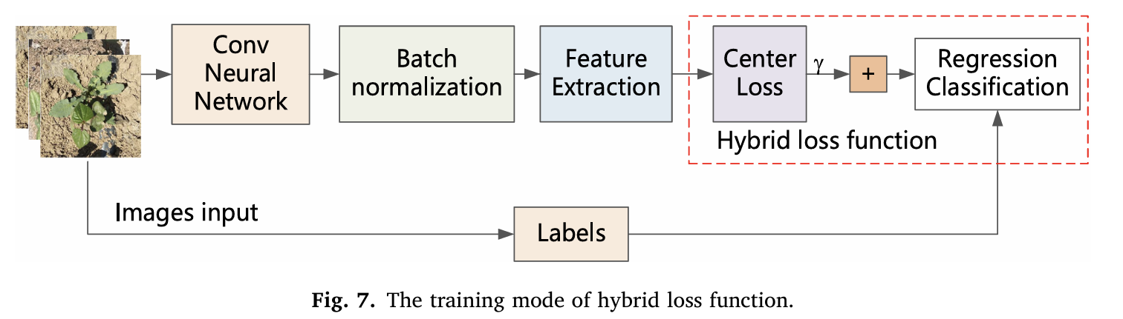
Fig. 7 illustrates how the hybrid loss function is applied during training.
Input images pass through:
- Convolutional Neural Network
- Batch Normalization
- Feature Extraction Layers
The extracted deep features are then fed simultaneously to:
- The Center Loss branch, and
- The Regression + Classification branch
The final hybrid loss combines both outputs, encouraging the network to learn features that are both accurate for detection and highly discriminative across classes.
Why Hybrid Loss Improves Weed Detection
This hybrid learning strategy:
- Strengthens within-class feature cohesion
- Maximizes separation between weed and cotton features
- Enhances robustness against occlusion and similar leaf patterns
- Reduces confusion under “green-on-green” conditions
- Significantly improves classification accuracy in complex cotton field environments
This makes the model better suited for real-world precision weeding applications, where misclassification can lead to crop damage or ineffective spraying.

3.7 FINAL ARCHITECTURE : IMPROVED FASTER R-CNN
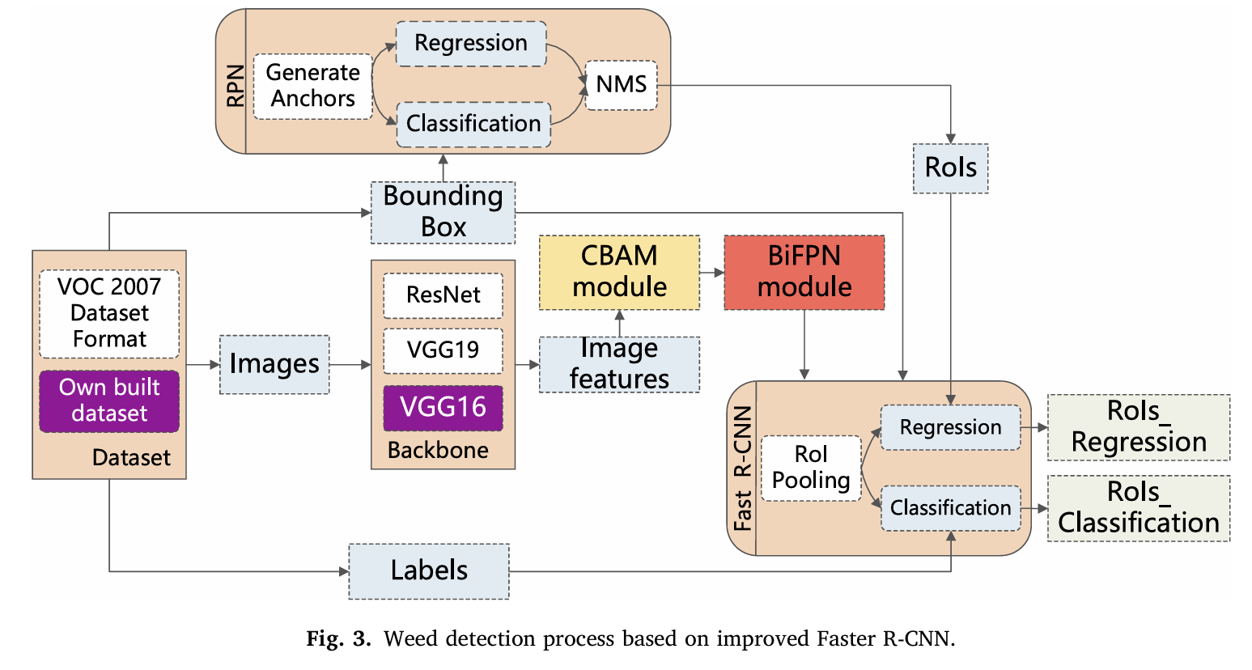

CHAPTER 4
TRAINING STRATEGY, RESULT & DISCUSSION

4.1 Dataset Preparation and Augmentation
The dataset contains 2822 images.
The dataset is composed of 1118 images in which 6 food crops and 8 weed species are identified, altogether 7853 annotations were made.
This part handles the entire dataset preparation and augmentation process for training an object detection model. It loads each image from the given folder, finds its corresponding YOLO-format label file, and reads the annotations. Since YOLO labels are given as normalized center-coordinates (class_id, x_center, y_center, width, height), the code converts them into the pixel-based (xmin, ymin, xmax, ymax) format required by Faster R-CNN, also shifting class IDs by +1 because Faster R-CNN reserves 0 for background.
It skips any invalid bounding boxes and wraps the remaining ones into Torchvision’s BoundingBoxes structure so that transformations can adjust them correctly. The transform pipeline then converts images to tensors, scales them, resizes them to 640×640, and randomly flips them horizontally, automatically updating the bounding boxes. Finally, the dataset returns the processed image along with its target dictionary (boxes + labels), and the custom collate_fn ensures that batches of images with different numbers of objects are grouped correctly during training.

4.2 Technology Stack
The weed detection system was developed using Python 3.11 and the PyTorch deep learning framework. The core architecture utilizes a Faster R-CNN detector. To enhance feature extraction capabilities, we implemented a custom backbone consisting of ResNet-50 integrated with Convolutional Block Attention Modules (CBAM). Furthermore, a Bidirectional Feature Pyramid Network (BiFPN) was employed to improve multi-scale feature fusion.
Data preprocessing and augmentation were handled using Torchvision Transforms v2, and the model was trained on an NVIDIA GPU environment. Performance evaluation was conducted using Torchmetrics, specifically focusing on Mean Average Precision (mAP) at an IoU threshold of 0.5.
4.3 Performance Metrics
In the execution phase, we trained our Faster R-CNN model using the SGD optimizer, which yielded a mAP of 22.23 and mAP@50 of 51.67, reflecting reasonable detection performance on our dataset. Throughout training, we monitored both classification loss and bounding box regression loss to ensure the model was learning to correctly identify weed classes while also improving localization accuracy.
The training loss curve shows a steady downward trend, indicating effective convergence. For validation, we used Mean Average Precision (mAP) as the core evaluation metric, which is the industry standard for object detection models. Alongside numerical scores, we developed a custom visualization pipeline to manually inspect predictions, especially in challenging cases such as overlapping or cross-growing leaves. These visual results confirm that the model is able to reliably detect weed instances with reasonable confidence.

4.4 Comparative Analysis
Our model establishes a solid starting point, achieving an accuracy of roughly 51.7% (mAP@50). This means that in standard testing conditions, our model successfully locates the correct target about half the time, proving that the core detection logic is working.
However, when compared to the high-performance models in the report, there is a clear difference in precision. The study's basic benchmark model (SSD) reached 87.23%, and their advanced "Improved Faster R-CNN" achieved 98.43%. While our model provides a functional baseline, the reference models are currently performing about 65% to 76% higher in overall accuracy, showing there is significant room to tune our model to reach those commercial-grade standards.

CHAPTER 5
CONCLUSION
This project implemented a deep learning–based solution for the Weed and Crop Identification task in precision agriculture using the Kaggle WeedCrop dataset. An improved Faster R-CNN architecture—enhanced with CBAM, BiFPN, and Bilinear Interpolation—was developed to address the practical challenges of weed detection in cotton fields, including green-on-green similarity, occlusion, and drastic scale variation.
Key Findings
- Model Performance:
Using a ResNet50 backbone and training on 2469 images with validation on 235 images, the model achieved:
  - mAP: 0.2223
  - mAP@50: 0.5167
These results indicate that while the model is able to detect weeds reasonably well at IoU 50%, there is still room for improvement in tighter bounding-box alignment and multi-scale feature representation.
- Architecture Enhancement:
The incorporation of CBAM and BiFPN improved feature selection and multi-scale fusion, enabling the model to better detect small seedlings compared to a vanilla Faster R-CNN. RoI Align further enhanced localization accuracy by eliminating quantization errors.
- Feasibility & Practical Value:
Even with moderate mAP, the system demonstrates clear potential for real-time agricultural applications. The model is lightweight enough to run on edge hardware such as Jetson Xavier, making it feasible for integration into autonomous or semi-autonomous weeding systems.
Limitations Observed
- The dataset contains high intra-class similarity and small object sizes, which significantly affect mAP.
- Some bounding boxes are too small or partially occluded, making detection inherently difficult.
- More epochs or data augmentation may be required to reach higher accuracy.
Future Scope
To further improve system performance and practical utility:
- Dataset Expansion:
Incorporating more weed species, different lighting conditions, and pest categories would improve model generalization.
- Longer Training & Hyperparameter Tuning:
Training for additional epochs, experimenting with optimizers, adjusting learning rates, and increasing batch size may significantly raise mAP.
- Advanced Backbones:
Backbone networks such as EfficientNet, Swin Transformer, or ConvNeXt may extract more discriminative features.
- Field Deployment:
Integrating the model with a real mobile robotic platform for live field testing is a critical next step.
- Pest Detection Extension:
Since the pipeline generalizes well, adding pest classes (leaf miners, bollworms, aphid colonies) can turn this system into a full crop-protection tool.
Final Summary
Although the current model achieves mAP 0.22 and mAP@50 0.51, the project successfully demonstrates the feasibility of applying enhanced deep learning architectures to field-level weed detection. The results validate the potential of combining attention mechanisms, multi-scale fusion, and precise feature alignment for real-world precision agriculture applications.

