DREAM-PCD: Deep Reconstruction and Enhancement of Millimeter-wave radar Point Clouds in ubiquitous environments

Submitted to SenSys 2023

Anonymous Author(s)∗

[Paper] [Code] [Dataset]

Abstract

Millimeter-wave radar presents low-cost, robust sensing in challenging conditions such as smoke and low-light, making it promising for applications in autonomous driving and ubiquitous sensing. However, millimeter-wave radar point clouds (PCDs) face three main challenges of high sparsity, low angular resolution, and strong interference and noise. Existing studies have failed to address them simultaneously, leading to limited PCD generation quality. In this paper, we propose DREAM-mmPCD, an innovative millimeter-wave radar PCD generation framework that tackles all three challenges with three well-designed modules: Non-Coherent Accumulation (NCA) for dense points, Synthetic Aperture Accumulation (SAA) for improved angular resolution, and Multi-frame to Multi-frame deep mapping (M2M) for noise and interference removal. Furthermore, we introduce RadarEyes, a high-quality, large-scale mmwave dataset including more than 1,000,000 frames for training and evaluating millimeter-wave radar PCD generation algorithms. It is demonstrated that the proposed DREAM-mmPCD framework outperforms existing methods in PCD generation quality and downstream perception tasks, achieving PCD generation performance comparable to cascaded 4-chip radar using only a single-chip radar. Furthermore, RadarEyes exceeds current datasets in both size and quality. We believe that the DREAM-mmPCD framework together with the RadarEyes dataset will significantly advance high-quality millimeter-wave radar perception in future real-world applications.

### Video

[Please wait]

### Real-Time PCD Generation Demo

### Loading the scene may take several seconds.

[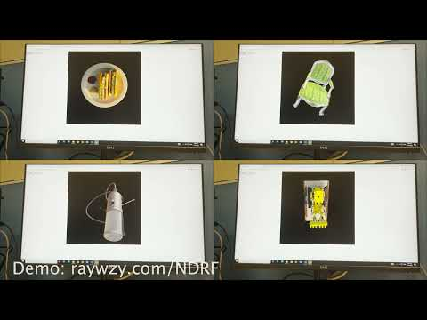](https://www.youtube.com/embed/0xtbTClz7r0?feature=oembed)

### Other Work on mmwave radar pointcloud generation

### Acknowledgements

### Citation