**CSE 212 – Programming with Data Structures**

**W01 Prove – Response Document**

|  |  |
| --- | --- |
| **Name:** | Alvaro Nunez |
| **Date:** | 14/01/2025 |
| **Teacher:** |  |

*It is a violation of BYU-Idaho Honor Code to post or share this document with others or to post it online. Storage into a personal and private repository (e.g. private GitHub repository, unshared Google Drive folder) is acceptable.*

**Question 1: For the rotate right problem, provide a description of how you solved the problem.**

First you will need a loop to go through the entire list, after that you will save the numbers to the left ‘N’ number into a list. Those save numbers you will then later add then to the end of the list.

**Question 2: For the rotate right problem, draw a picture of how you solved the problem.**

LIST: (1, 2, 3, 4, 5, 6, 7, 8, 9)

INDEX: (0, 1, 2, 3, 4, 5, 6, 7, 8)





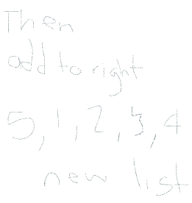

Remember: You need to commit all the changes to the prove-01-<username> repository along with this document. Then submit a link to the repository in I-Learn.