**Task 3- Answers**

**Part 1 (src/condition.cpp and ir/condition.ll):**

check():

define dso_local noundef i32 @"?check@@YAHH@Z"(i32 noundef %0) {

; Allocate space for return value

%2 = alloca i32, align 4

; Allocate space for input parameter x

%3 = alloca i32, align 4

; Store the input argument %0 into local variable %3

store i32 %0, ptr %3, align 4

; Load x from memory

%4 = load i32, ptr %3, align 4

; Compare x > 5 using signed greater-than

%5 = icmp sgt i32 %4, 5

; Conditional branch: if (x > 5) → %6 (then), else → %7

br i1 %5, label %6, label %7

6: ; if.then block

; Store return value 1 (true branch)

store i32 1, ptr %2, align 4

br label %8 ; jump to merge

7: ; if.else block

; Store return value 0 (false branch)

store i32 0, ptr %2, align 4

br label %8 ; jump to merge

8: ; merge/return block

; Load the final return value from %2

%9 = load i32, ptr %2, align 4

; Return the selected value (1 or 0)

ret i32 %9

}

* How is x>5 checked?
  + Via script – ‘ %5 = icmp sgt i32 %4, 5 ’.
  + This is the signed int comparison between x and 5.
  + sgt stands for signed greater than
* How is the if/else structure implemented?
  + Via script – ‘ br i1 %5, label %6, label %7 ’.
  + %6 is the "then" block, %7 is the "else" block.
* How does LLVM determine which return value to use?
  + By assigning 1 or 0 to memeory (%2) in %6 or %7 resp.
  + Then, at merge block %8, it loads the value from %2 and returns it as in the following script:

%9 = load i32, ptr %2

ret i32 %9

**Part 2 (src/loop.cpp and ir/loop.ll):**

sum():

define dso_local noundef i32 @"?sum@@YAHH@Z"(i32 noundef %0) {

; Allocate space for parameters and local variables

%2 = alloca i32, align 4 ; n

%3 = alloca i32, align 4 ; s (accumulator)

%4 = alloca i32, align 4 ; i (loop index)

; Store the input value (n) into %2

store i32 %0, ptr %2, align 4

; Initialize s = 0

store i32 0, ptr %3, align 4

; Initialize i = 0

store i32 0, ptr %4, align 4

; Jump to loop condition check

br label %5

; %5: Loop condition block

5: ; preds = %13 (loop), %1 (entry)

%6 = load i32, ptr %4, align 4 ; load i

%7 = load i32, ptr %2, align 4 ; load n

%8 = icmp slt i32 %6, %7 ; i < n ?

br i1 %8, label %9, label %16 ; if true → %9 (body), else → %16 (exit)

; %9: Loop body block

9: ; preds = %5

%10 = load i32, ptr %4, align 4 ; load i

%11 = load i32, ptr %3, align 4 ; load s

%12 = add nsw i32 %11, %10 ; s = s + i

store i32 %12, ptr %3, align 4 ; update s

br label %13 ; jump to increment

; %13: Increment block

13: ; preds = %9

%14 = load i32, ptr %4, align 4 ; load i

%15 = add nsw i32 %14, 1 ; i = i + 1

store i32 %15, ptr %4, align 4 ; update i

br label %5, !llvm.loop !5 ; go back to loop condition

; %16: Exit block

16: ; preds = %5

%17 = load i32, ptr %3, align 4 ; load final sum

ret i32 %17 ; return s

}

* What role does the phi node play?
  + phi merges values from multiple control paths (e.g., from entry and loop back-edge)
  + It tracks loop variables like ‘i’ and accumulators like ‘s’.
* How does LLVM remember the loop variable i across iterations?
  + Via the script :

‘ %14 = load i32, ptr %4

%15 = add nsw i32 %14, 1

store i32 %15, ptr %4

* + LLVM uses memory allocation (%4) to store and update i.
  + In each iteration, it:
    - loads i,
    - increments i,
    - and stores i again.
* How is the loop exit condition implemented?
  + Via the script:

%6 = load i32, ptr %4

%7 = load i32, ptr %2

%8 = icmp slt i32 %6, %7

br i1 %8, label %9, label %16

* + LLVM checks ‘i<n’ as follows:
    - If true, branches to loop body
    - If false, goes to return block

**Part 3 (loop_cfg.dot and loop_cfg.png)**: CFG for loop.ll

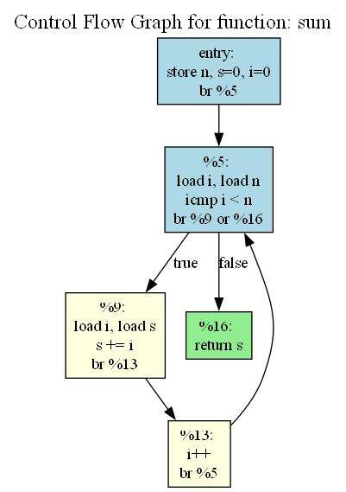

**Bonus Challenge (src/switch.cpp and ir/switch.ll)**:

* How does LLVM represent the switch statement?
  + Via the script ‘ switch i32 %4, label %7 [ i32 1, label %5, i32 2, label %6 ] ’
  + %4 is the value of x
  + If %4 == 1, control goes to block %5
  + If %4 == 2, control goes to %6
  + Otherwise, it jumps to %7 (the default case)
* This is a direct representation of the switch, not expanded into icmp and br.
* Each case block (%5, %6, %7) stores the result to %2, and unconditionally jumps to %8, where the return value is loaded and returned as follows:

‘ %9 = load i32, ptr %2

ret i32 %9 ’