Project Update 1: Streaming Data and Baselines
Predictive Multitask Learning for Streaming Code-Switching
Team 10: Artykzhan Ospan, Mahamane Bachir Sadou, Mukaila Rafiu. CS 6140, October 19, 2026.

1. Objective
We predict code-switching in real time. At every token t of an utterance, using only the tokens up to t, the model predicts two targets about the next token:
- y_sw (binary): whether token t+1 is in a different language than token t;
- y_dur (3 classes, only when y_sw = 1): the length of the new language segment starting at t+1, binned as 1-2, 3-6 or 7+ tokens.
The setting simulates predictive text for bilingual users: the future is used only to create the targets, never as input. The project goal is a predictor that works consistently across language pairs, measured by the standard deviation of switch F1 across pairs. This update covers weeks 4 to 6 of our plan: cleaning the text and mapping language IDs (week 4), building the labels (week 5), and the streaming loader with a first baseline (week 6).

2. Data and language coverage
We use SwitchLingua_text (Hugging Face, pinned version 6e048d27): 234,172 generated conversations, which we flatten into 974,994 sentences. Inspecting the data showed 15 language pairs, more than the 12 languages described in the SwitchLingua paper, and we cover all of them:
- 7 non-Latin-script pairs with English: Arabic, Cantonese, Chinese, Hindi, Japanese, Korean, Russian;
- 7 Latin-script pairs with English: French, German, Italian, Malay, Filipino, Spanish, Vietnamese;
- 1 non-English pair: German–French.
Together they span 7 writing systems (Latin, Arabic, Chinese characters, Japanese kana, Hangul, Devanagari, Cyrillic). The pairs are very unbalanced: Cantonese–English alone is 64% of the sentences, while every other pair has 20,000 to 30,000. Hindi–English is reported as two strata, Devanagari and romanized (section 3.3), which gives 16 evaluation strata.

3. Data engineering pipeline (week 4)

3.1 Parsing
The text column is a stringified Python object written by an LLM. Most rows are lists of sentences, but some are dictionaries ({'topic', 'instances'}, {'speaker', 'message'}), nested lists or plain strings. Our parser handles all formats and keeps only text fields. Five sentences (empty, or a whole conversation pasted into one string) were removed and counted per pair.

3.2 Tokenization
One tokenization is shared by every model, so all models are scored on the same targets. Words are split on whitespace and punctuation; punctuation is kept as context for the next prediction but is not a token. Each Chinese character is one token (the mBERT convention). Treating a whole run of Chinese characters as one token would leak the future: a run only ends when a non-Chinese character arrives. On our data, 22% of Cantonese runs end with the next letter attached directly, and 85% of those next letters are English, so the token boundary itself would reveal the switch. With one token per character there is a decision point after every character, which is what a user typing Chinese experiences.

3.3 Language ID per token
The dataset gives only the two languages of each row, so we assign a language to every token with three rules:
- Script rule: if the token's script belongs to only one of the two languages, that decides it. This fully covers the 7 non-Latin-script pairs.
- Frequency rule: for the Latin-script pairs, we compare the word's frequency in each language using the wordfreq library, and a clear gap decides it.
- Context rule: undecided tokens (names, numbers, words common to both languages such as "no") take the language of the nearest decided neighbor, preferring the left one.
Romanized Hindi. 56% of Hindi–English rows are written entirely in Latin script ("Logon ko acting bahut pasand aayi"), where the script rule would tag Hindi words as English. We built a romanized-Hindi word list from the corpus itself: Latin words inside Devanagari rows are English insertions, so words frequent in romanized rows but almost absent from that reference are Hindi (hai, mujhe, bahut). Labels may use the whole sentence; only model inputs must be prefix-only.

4. Labels and splits (week 5)
For each token t we set y_sw = 1 if token t+1 has a different language, and y_dur to the length bin of the segment starting at t+1 when y_sw = 1. The last token of a sentence has no target. Unit tests check the labels on hand-worked sentences. Example (Spanish–English): in "Yo no sé, but I think so", the token "sé" gets y_sw = 1 and y_dur = 3-6 tokens ("but I think so").
We split 80/10/10 by conversation, so sentences of one conversation never cross splits, stratified by the 16 strata, with a fixed seed. Conversations sharing an identical sentence (5,586 duplicates, mostly Cantonese) are kept in the same split. The split file is saved and reused by every teammate.
Stratum | Group | Sentences | Switch rate
Chinese–English | Non-Latin script | 29,561 | 5.1%
Japanese–English | Non-Latin script | 27,893 | 6.3%
Cantonese–English | Non-Latin script | 619,863 | 6.8%
Italian–English | Latin script | 24,165 | 8.4%
German–French | Non-English pair | 23,598 | 8.6%
Arabic–English | Non-Latin script | 26,791 | 9.1%
Vietnamese–English | Latin script | 26,803 | 9.1%
Russian–English | Non-Latin script | 24,625 | 9.3%
Spanish–English | Latin script | 24,517 | 9.6%
German–English | Latin script | 19,583 | 9.8%
French–English | Latin script | 23,563 | 10.3%
Korean–English | Non-Latin script | 25,388 | 10.6%
Malay–English | Latin script | 26,127 | 13.3%
Hindi–English (Devanagari) | Non-Latin script | 11,186 | 16.1%
Filipino–English | Latin script | 25,826 | 19.1%
Hindi–English (romanized) | Latin script (romanized) | 15,505 | 31.4%
Table 1. Size and switch rate per stratum (all splits). A switch rate is the share of target positions where y_sw = 1.
Switches are rare (5% to 13% of positions for most pairs), so accuracy is misleading and we report precision, recall, F1 and PR-AUC. Romanized Hindi (31%) and Filipino (19%) mix the most.
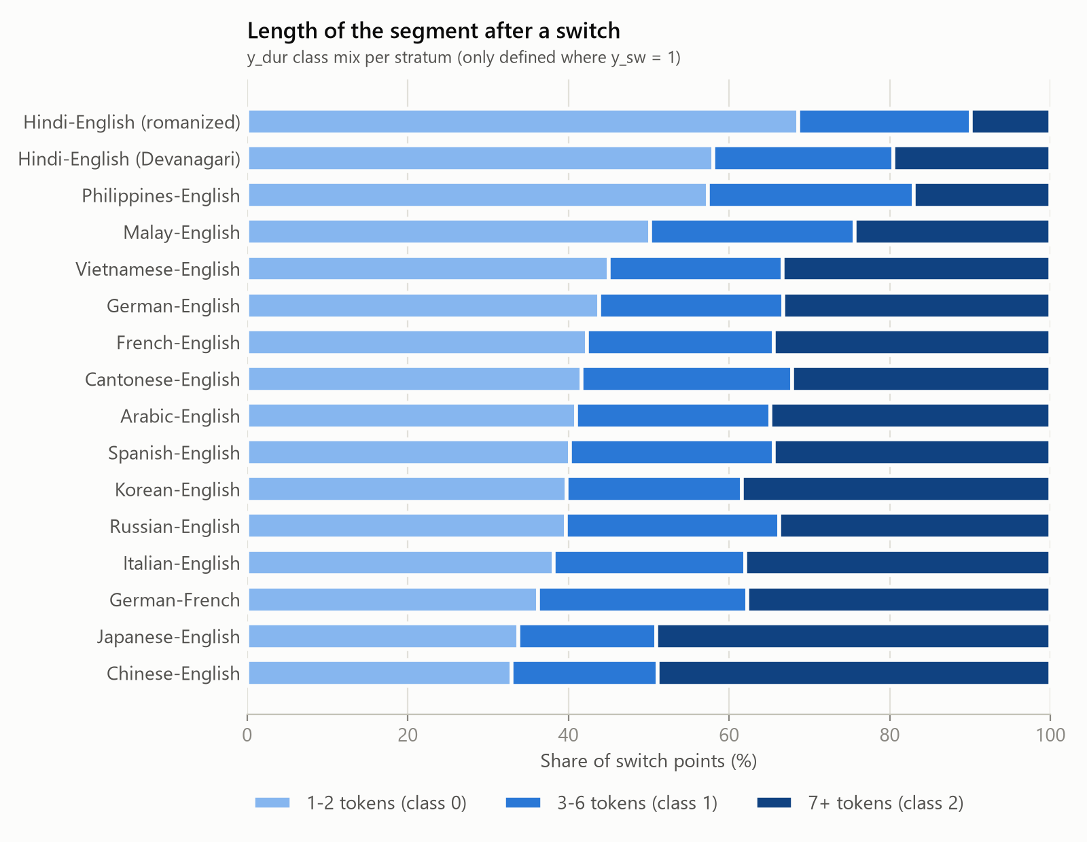
Figure 1. Duration class of the segment after a switch, per stratum (Philippines-English is the dataset's name for Filipino-English).

5. Streaming setup and baseline (week 6)

5.1 Streaming loader
At token t the model sees only the prefix and predicts the event at t+1. Example (Cantonese–English, one token per Chinese character): "... 敢 → 相 → 信 → she's → so → young". With the input ending at 信, the target is y_sw = 1 and y_dur = 1 (a 3-token English segment). The loader encodes each sentence once with the model's subword tokenizer and reads the prediction for word t at the last subword that ends before word t+1. Two checks make lookahead impossible: a subword that spans the boundary between t and t+1 is skipped, and the subwords up to the prediction point must equal the tokenization of the prefix alone. An automated test confirms that changing any later word never changes the inputs at an earlier position.
To keep Cantonese from dominating training, pairs are drawn with temperature sampling (probability proportional to size to the power 0.3, as in XLM-R and mT5), which lowers Cantonese from 64% to about 16% of training samples. Overall metrics are macro averages over the 16 strata.

5.2 Baselines
Majority class always predicts "no switch" and the most frequent duration class. Logistic regression uses prefix-only features: current language, length of the current run, number of switches so far, position, punctuation typed after the token, script, stratum, and stratum × current language. It is trained on 3,000 sentences per stratum; the decision threshold is chosen on training data. Features are rebuilt from language tags visible in the prefix, and a test checks that they never change when only later words change. Results are on the validation split (1.8 million positions); the test split is kept for the final evaluation.
Model | Switch F1 | PR-AUC | Precision | Recall | σ of F1 | Duration macro-F1
Majority class | 0.000 | 0.114 | 0.000 | 0.000 | n/a | 0.202
Logistic regression | 0.555 | 0.528 | 0.550 | 0.571 | 0.076 | 0.531
Table 2. Baselines on the validation split, macro average over 16 strata. σ is the standard deviation of switch F1 across strata (lower is more universal).

6. Pair-specific results
Stratum | Switch F1 | PR-AUC | Duration macro-F1
Korean–English | 0.717 | 0.712 | 0.663
Japanese–English | 0.633 | 0.643 | 0.519
Arabic–English | 0.609 | 0.588 | 0.571
German–English | 0.596 | 0.593 | 0.584
German–French | 0.591 | 0.593 | 0.527
Chinese–English | 0.584 | 0.517 | 0.505
Italian–English | 0.579 | 0.501 | 0.527
French–English | 0.579 | 0.551 | 0.583
Spanish–English | 0.570 | 0.520 | 0.566
Hindi–English (romanized) | 0.547 | 0.524 | 0.474
Russian–English | 0.546 | 0.552 | 0.605
Hindi–English (Devanagari) | 0.521 | 0.495 | 0.469
Vietnamese–English | 0.511 | 0.464 | 0.500
Malay–English | 0.494 | 0.476 | 0.490
Cantonese–English | 0.409 | 0.349 | 0.524
Filipino–English | 0.397 | 0.364 | 0.389
Table 3. Logistic regression baseline per stratum (validation split), best to worst.
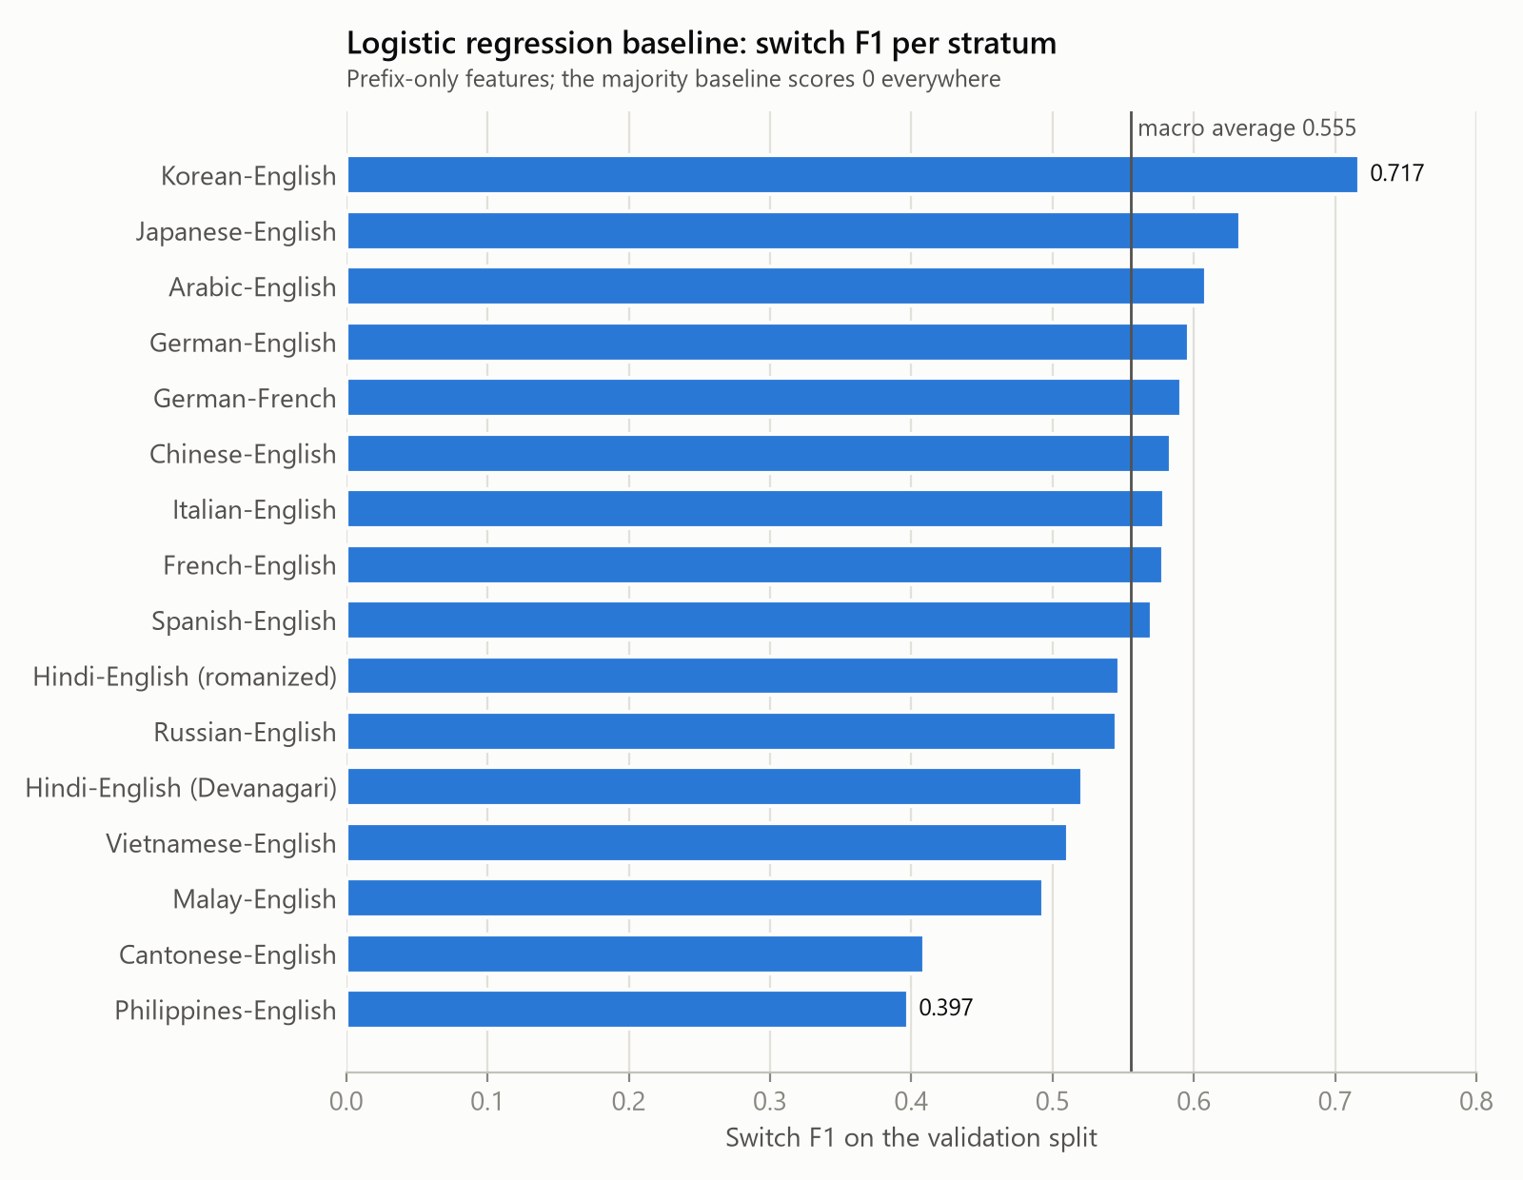
Figure 2. Switch F1 per stratum; the vertical line is the macro average (0.555). Philippines-English is Filipino-English.
Korean (0.717) and Japanese (0.633) are easiest; Filipino (0.397) and Cantonese (0.409) are hardest. Much of the signal comes from punctuation: switches between sentences tend to follow a sentence end, which a prefix model can see. For duration, the middle class (3-6 tokens) is the hardest: only 13% of true 3-6 segments are recognized. This baseline is the bar the transformer models must beat.

7. Challenges and next steps
Challenges
- Latin-script pairs rely on word frequencies, so their language IDs need hand validation; 450 sentences (30 per pair) are prepared for the team to check.
- Romanized Hindi needs its own word list, and its high switch rate (31%) should be confirmed by that validation.
- In Chinese-character text, 20% to 30% of character positions fall inside one model subword and cannot be predicted without seeing the next character; true switch points are not affected for XLM-R.
- Chinese segments are counted in characters, so they look longer (about 49% of switches into Chinese fall in the 7+ class).
Next steps (weeks 7 to 10)
- Add causal attention masking (week 7);
- Build the switch and duration prediction heads (week 7);
- Validate the language IDs by hand;
- Start multitask transformer training with XLM-R and XGLM and compare them against these baselines (weeks 8 to 10).

8. Reproducibility
All code for this update is in the team repository and in one self-contained notebook (notebooks/weeks4-6_pipeline.ipynb), which reproduces every number in this report: the splits, the statistics and both baselines. The pipeline has 57 automated tests covering parsing, language IDs, labels, splits, the no-lookahead guarantee and the metrics.

