SMML: Exercise 01

Abhijeet Parida

## Exercise 1-6

![Alt text] (picture.jpg)

## Exercise 7

x=seq(-2,2,length.out = 100)  
v_max=(1+sqrt(5))/2  
v_min=(1-sqrt(5))/2  
m=c(v_max,v_min)  
plot (x,x*exp(-((x-1)**2)/2), col='red')  
abline(v=m)

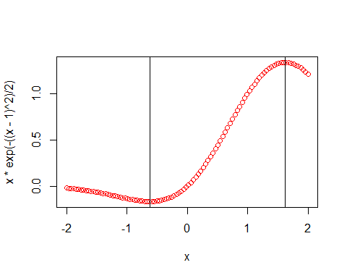

## Exercise 8

data("iris")  
summary(iris$Sepal.Length)

## Min. 1st Qu. Median Mean 3rd Qu. Max.   
## 4.300 5.100 5.800 5.843 6.400 7.900

summary(iris$Petal.Length)

## Min. 1st Qu. Median Mean 3rd Qu. Max.   
## 1.000 1.600 4.350 3.758 5.100 6.900

summary(iris$Sepal.Width)

## Min. 1st Qu. Median Mean 3rd Qu. Max.   
## 2.000 2.800 3.000 3.057 3.300 4.400

summary(iris$Petal.Width)

## Min. 1st Qu. Median Mean 3rd Qu. Max.   
## 0.100 0.300 1.300 1.199 1.800 2.500

## Exercise 9

## Histogram of Sepal Length default with break  
hist(iris$Sepal.Length)

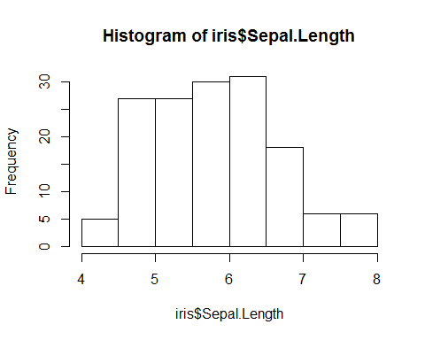

## Histogram of Sepal Length with break 20  
hist(iris$Sepal.Length, breaks = 20)

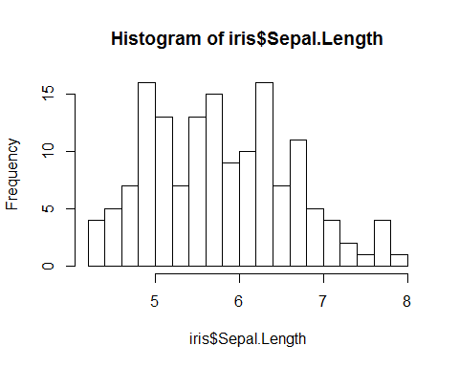

## Exercise 10

sertosa=iris$Species==levels(iris$Species)[1]  
sertosa_no=iris[sertosa,]$Sepal.Length<5.5  
sprintf("%d %s flowers have Sepal Length <5.5, rest %d do not",sum(sertosa_no),levels(iris$Species)[1],50-sum(sertosa_no))

## [1] "45 setosa flowers have Sepal Length <5.5, rest 5 do not"

virginica=iris$Species==levels(iris$Species)[3]  
virginica_no=iris[virginica,]$Sepal.Length<5.5  
sprintf("%d %s flowers have Sepal Length <5.5, rest %d do not",sum(virginica_no),levels(iris$Species)[3],50-sum(virginica_no))

## [1] "1 virginica flowers have Sepal Length <5.5, rest 49 do not"

versicolor=iris$Species==levels(iris$Species)[2]  
versicolor_no=iris[versicolor,]$Sepal.Length<5.5  
sprintf("%d %s flowers have Sepal Length <5.5, rest %d do not",sum(versicolor_no),levels(iris$Species)[2],50-sum(versicolor_no))

## [1] "6 versicolor flowers have Sepal Length <5.5, rest 44 do not"

## Exercise 11

pairs(iris, col=iris$Species)

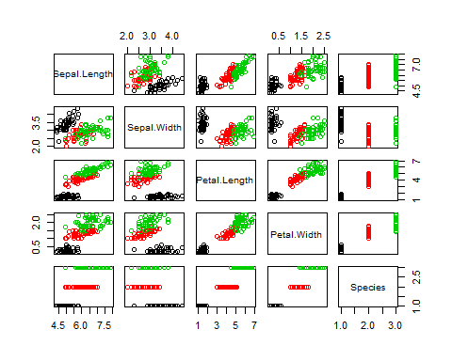

## Exercise 12

par(mfrow=c(1,3))  
plot(iris[sertosa,]$Petal.Width, iris[sertosa,]$Petal.Length, main = 'Sertosa')  
plot(iris[virginica,]$Petal.Width, iris[virginica,]$Petal.Length, main = 'Virgnica')  
plot(iris[versicolor,]$Petal.Width, iris[versicolor,]$Petal.Length, main = 'Versicolor')

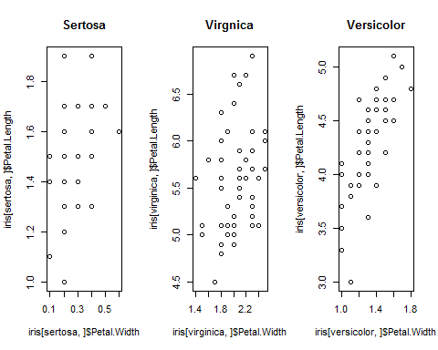

## Exercise 13

p1= c(-1,-1,0)  
p2= c(-1,1,0)  
p3= c(1,1,0)  
p4= c(1,-1,0)  
p5= c(0,0,2)  
  
v = seq(0,1,0.05)  
  
e1 = v %o% (p2-p1) + rep(1,21) %o% p1  
e2 = v %o% (p3-p2) + rep(1,21) %o% p2  
e3 = v %o% (p4-p3) + rep(1,21) %o% p3  
e4 = v %o% (p1-p4) + rep(1,21) %o% p4  
e5 = v %o% (p5-p1) + rep(1,21) %o% p1  
e6 = v %o% (p5-p2) + rep(1,21) %o% p2  
e7 = v %o% (p5-p3) + rep(1,21) %o% p3  
e8 = v %o% (p5-p4) + rep(1,21) %o% p4  
  
pyramid = rbind(e1,e2,e3,e4,e5,e6,e7,e8)  
  
projection_matrix <- t(matrix(c(1,0,0,0,1,0), nrow =2, ncol= 3,byrow= TRUE))  
pyramid_2D <- pyramid %*% projection_matrix  
plot(pyramid_2D[,1],pyramid_2D[,2], type="l")

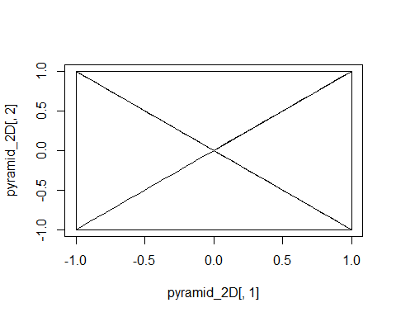 ## Exercise 14

phi=0.05*pi  
theta=0.3*pi  
  
rotate_z<-matrix(c(cos(phi),-sin(phi),0,sin(phi),cos(phi),0,0,0,1), nrow =3, ncol= 3,  
 byrow= TRUE)  
  
rotate_y<-matrix(c(cos(theta), 0, sin(theta), 0, 1, 0, -sin(theta), 0, cos(theta)),  
 nrow =3, ncol= 3, byrow= TRUE)  
  
post_rot_z = pyramid %*% rotate_z %*% projection_matrix  
post_rot_y = pyramid %*% rotate_y %*% projection_matrix  
par(mfrow=c(1,2))  
plot(post_rot_z[,1], post_rot_z[,2],type = "l")  
plot(post_rot_y[,1], post_rot_y[,2], type = "l")

