**Introduction:**

Strange Brew! The basis of the project was interest in homebrew and craft beer. As a group, everyone was interested in the music, so decided to base the project around music venues. Three initial research questions were posed:

1. What are the most popular beer styles nationwide and by state?
2. What is the number of breweries in each state?
3. What are the top cities for breweries?
4. What are the cities with the most breweries per person?
5. What style of beer has the most alcohol content by style?

Research was focused on national breweries and their selection of craft beer. Further, the team looked at the highly consumed beer styles. Brewery, beer, and census data was drawn from 2017. These data sources were collected from published csv and excel files.

**What are the most popular beer styles nationwide and by state?**

The top beer brewed in the United States is the American-Style Pale Ale. The second most brewed beer is the American-Style Lager. Finally, the third most popular beer style is the American-Style Stout. These are types of beers are generic, which may explain the amount of beers within these categories. Further, these beers share a relatively standard alcohol level, hovering in the 4.0 – 6.0% ABV (alcohol by volume) range. Additionally, these styles of beers share a lower bitterness rating, hovering in the 5-50 IBU range.

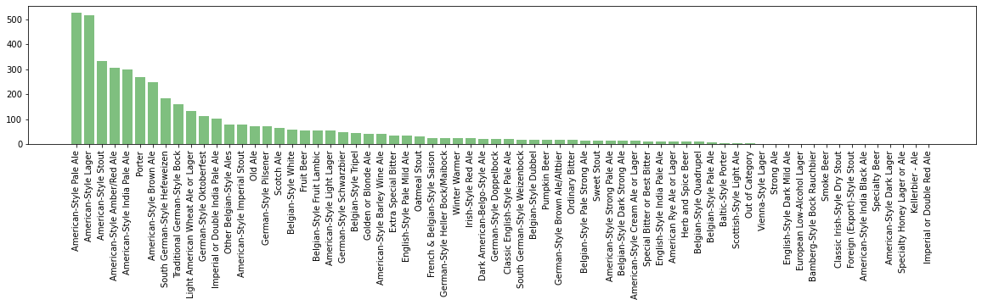

Each state had its own most popular style of beer. The states with the highest populations—California, Texas, and Florida—generally followed the same trend as on the national level. However, Florida’s most popular style of beer was the American-Style India Pale. This type of beer is less generic than the previous styles mentioned. Additionally, this style of beer has a comparatively higher ABV and IBU.

**What are the number top cities and states for breweries?**

At first, I was using 2 different data frames, Kaggle & Data World, to pull from and found that the different information listed in both data frames were conflicting so in order to get the correct analysis I had to omit the data from Data World. I cleaned up the data by pulling the columns that were necessary and dropped any columns that were not. I then had to count how many breweries were in each State and I output them into a bar chart. Colorado had the most breweries in the US but also not surprising. Seeing that there were 9 states with 2 or less breweries was interesting to me. I thought beer drinking was an American tradition?

After finding the state with the most breweries I then broke down the cities with the most breweries. I ran into an issue with Portland, seeing that there was a Portland in Oregon & in Maine. Once I was able to separate the two Portland’s I then was able to put a bar plot with the top 20 cities. Many cities listed did not have more than 2 breweries and we were only looking for the top cities. Even though Colorado had the most breweries I found that they were all spread out in the state because Portland, Oregon had the most breweries. I think I would have liked to explore a little more into chain breweries as I noticed a few. I’m curious to see if the chains only exist states or if they are planted throughout the country.

**What are the cities with the most breweries per person?**

**What style of beer has the most alcohol content by style?**

**Methods, Misgivings and Further Research:**

**Conclusion:**

The research concluded that season does have some influence on the number of reviews a venue receives. However, the average rating score stays consistent throughout the year. Research further yielded that higher priced venues have no correlation on a venues perceived quality. Additionally, the proximity of a venue’s location to a major city, such as Denver, has no impact on the number of reviews a venue may receive.