PlusQueue

Doctor User Manual

Contents
Doctor User Manual 1
How to move around 1
1. Logging In 1
2. Viewing the Queue 1
3. Starting the Queue 1
4. Pause, resume, close, and end the clinic session 1
Pause 1
Resume 1
Close the queue to new reservations 1
End the clinic session 1
5. Completing a consultation 1
6. Publishing a reservation schedule 1
Create a draft 1
Publish 1
7. Viewing Reports & Analytics 1
8. Reviewing the doctor’s report 1
9. Other doctor tools 1
Dashboard (Home) 1
Profile 1

How to move around
After you sign in, use the left menu (computer) or the bar at the bottom (phone):
Menu item | What it is
Dashboard | Today’s summary
Queue | Live line and consultation
Schedules | Create, publish, and start clinic days
Reports & Analytics | Completed-day numbers and charts (computer menu; on phone, open it from Profile)
Profile | Your account, password, and log out

On a phone, Dashboard is Home, and Reports & Analytics is not in the bottom bar — open it from Profile.
The secretary can also pause, resume, close, and end the queue. Use whichever desk is free. Completing a consultation is doctor-only.

1. Logging In
Sign in with the email (or phone) and password given to you by the administrator.
- Open the app in a browser.
- Type your email or phone number.
- Type your password.
- Click Sign In.
- You are taken to Dashboard.
Do not use Create Account on the sign-in screen. That is for parents. Staff accounts are created by the administrator.
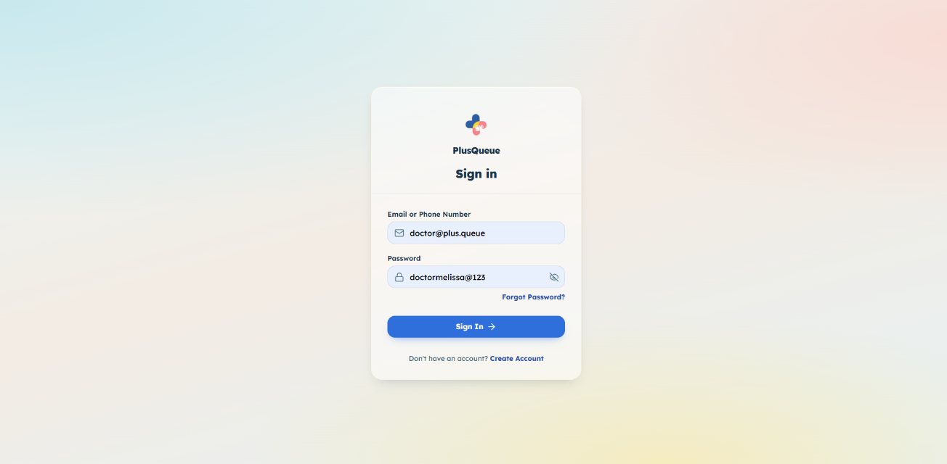

2. Viewing the Queue
This is your live view of who is with you and who is still waiting.
- Click Queue in the menu.
- If a clinic day is running, you see the branch, date, and session controls at the top. Status shows Active, Paused, or Queue Closed.
- Current Consultation shows the patient in your room (name, age, sex, and the parent’s stated concern). Walk-ins have a Walk-in tag.
- Waiting Queue lists everyone still in line, with their queue number and whether they are checked in. Checked-in time is shown on a wide screen.

The queue number is the ticket number. It does not change.
If no session is running, you will see “No Clinic Queue is Currently Active.” Start the queue from Schedules first.
Click View Details (or the consultation card) to open the same patient info in a larger popup. Waiting rows are not tappable from this screen.
The secretary is the one who sends the next checked-in patient to you. You do not send patients, penalize, or request check-in from this screen.
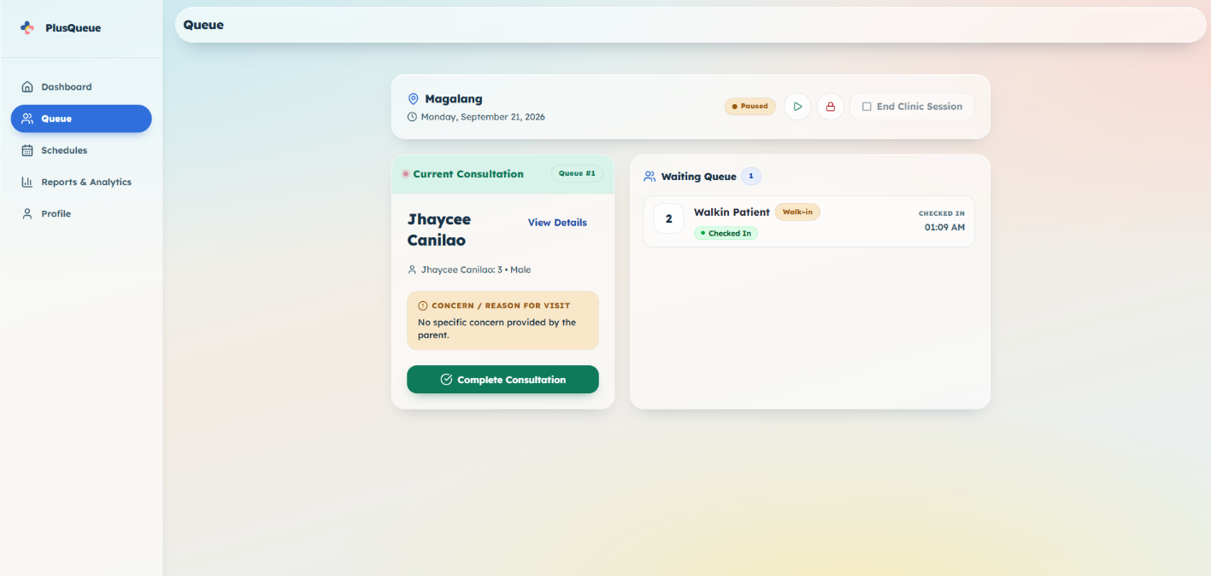

3. Starting the Queue
Start the live line when the clinic floor is ready. Parents can then check in, and consultations can begin.
- Open Schedules.
- Find the Published card for today’s clinic.
- Click Start Queue.
- Review the details.
- Click Start Queue again.
- You are taken to Queue.

You can run only one live queue at a time. End the current one before starting another. A yellow note appears on Schedules if a queue is already running.
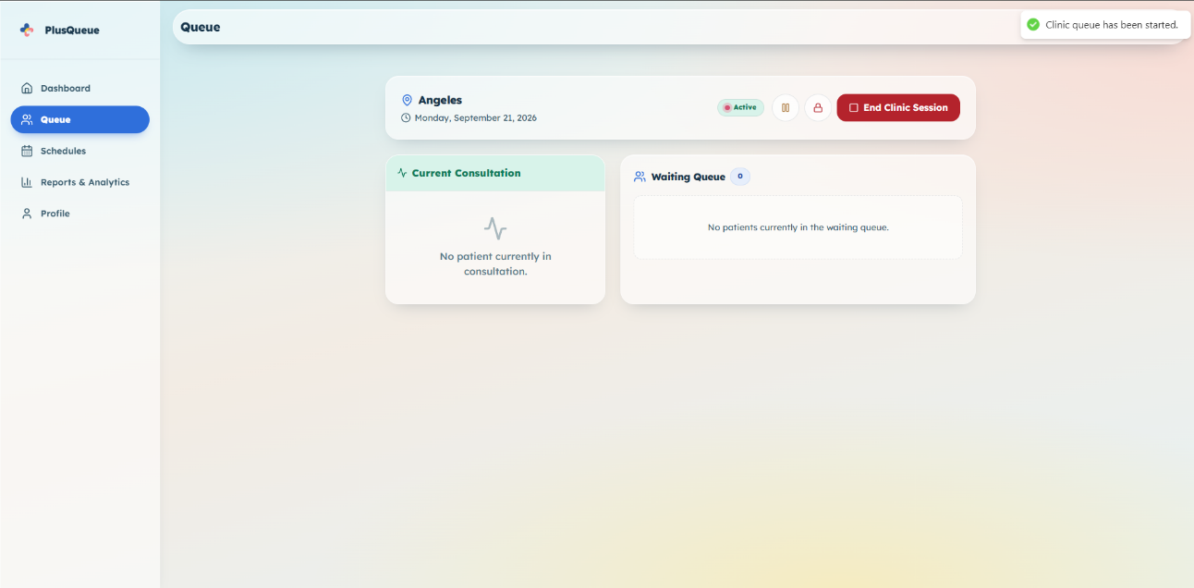
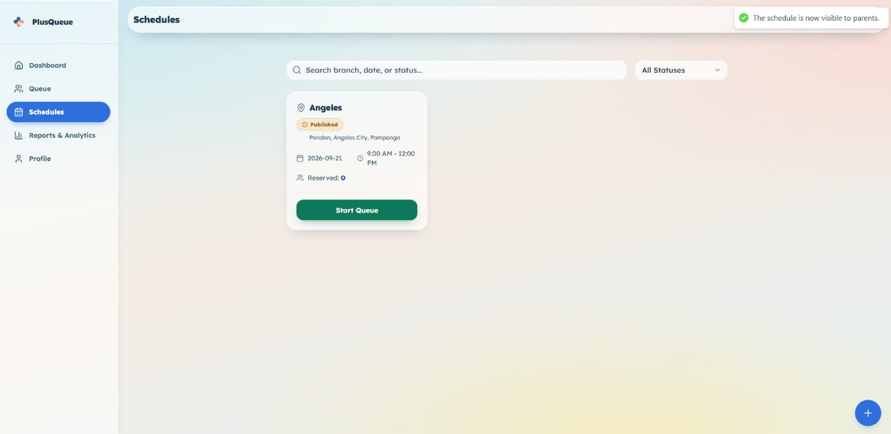

4. Pause, resume, close, and end the clinic session
These buttons sit at the top of Queue. The secretary has the same four actions on Manage Queue.
Button | What it does
Pause (pause icon) | Temporarily stop the live session. Check-in can still happen. You cannot complete a consultation while paused.
Play (play icon) | Resume after a pause.
Lock (lock icon) | Close the queue to new reservations. People already in line keep their place. Consultations continue.
End Clinic Session (square icon + label) | End the clinic day. Only works when nobody is waiting and nobody is in consultation.

Closing the queue cannot be undone. After you lock it, pause/play go away. Only End Clinic Session remains.
You can also lock the queue while it is paused.

Pause
- On Queue, click the pause button.
- Status shows Paused.

Resume
- Click the play button.
- Status shows Active again.

Close the queue to new reservations
- Click the lock button.
- Read the confirmation.
- Click Close Queue.

End the clinic session
- Finish remaining patients first.
- Click End Clinic Session.
- Confirm End Clinic Session.

This marks the schedule completed. It then appears in Reports.
If you are busy with a patient, the secretary can do any of these four actions for you.
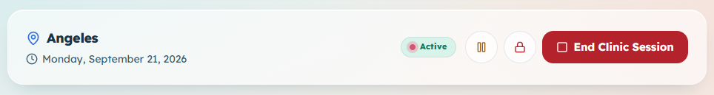

5. Completing a consultation
Mark the visit finished when you are done with the patient in your room. Only one patient can be in consultation at a time.
- On Queue, find Current Consultation.
- Click Complete Consultation.
- For a parent reservation, you may type optional Doctor's Notes (the parent can see these later).
- For a walk-in, notes are turned off. Walk-ins have no parent app account, so there is nowhere to send notes.
- Click Complete Session.

The room is then free for the next patient the secretary sends.
You cannot complete a consultation while the queue is paused. Resume first.
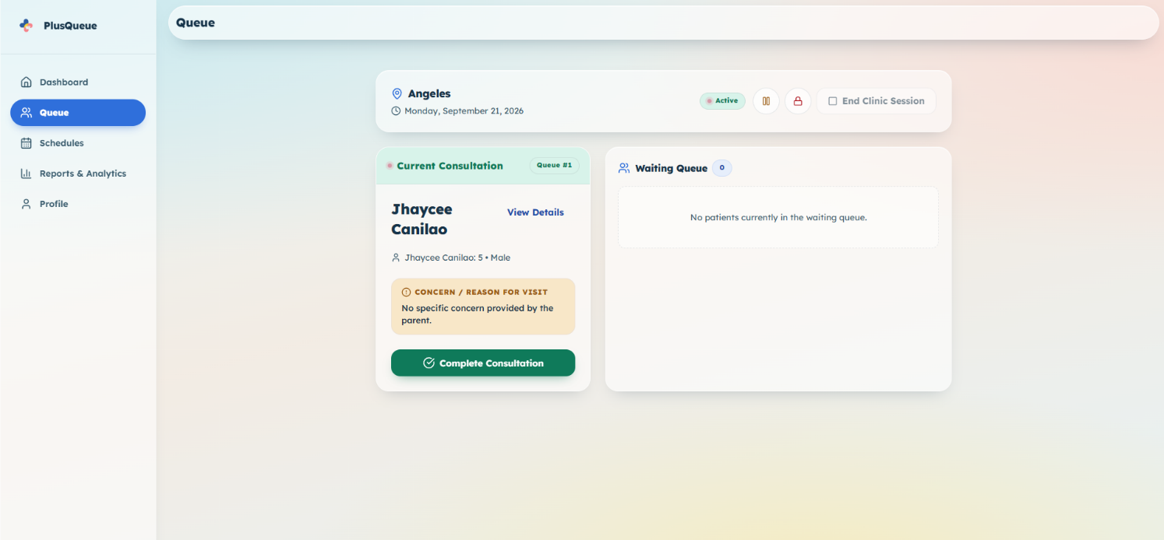

6. Publishing a reservation schedule
A schedule is a clinic day (branch, date, hours, how many slots). Parents can book only after you publish it.
You can create schedules for any branch. Clinic hours are filled in automatically from that branch’s opening and closing times. You cannot type different hours here.
You cannot create two schedules for the same branch on the same date.

Create a draft
- Open Schedules.
- Click the round + button (bottom right).
- Choose the branch and clinic date.
- Check that Clinic Hours appear.
- Type slot capacity.
- Click Create Schedule.

A draft is not visible to parents yet.
You can search schedules or filter by Draft / Published / Completed.

Publish
- On the draft card, click Publish.
- Review the details.
- Click Publish Schedule.

Parents can now reserve slots.
Drafts can also be Edited or Deleted. After the queue is running (or closed to new bookings), click Open Queue Control on the card to jump to Queue.
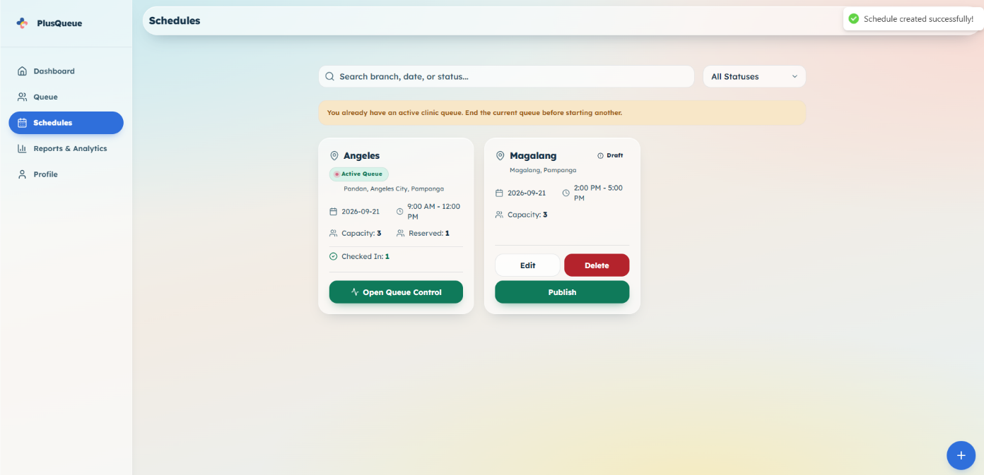
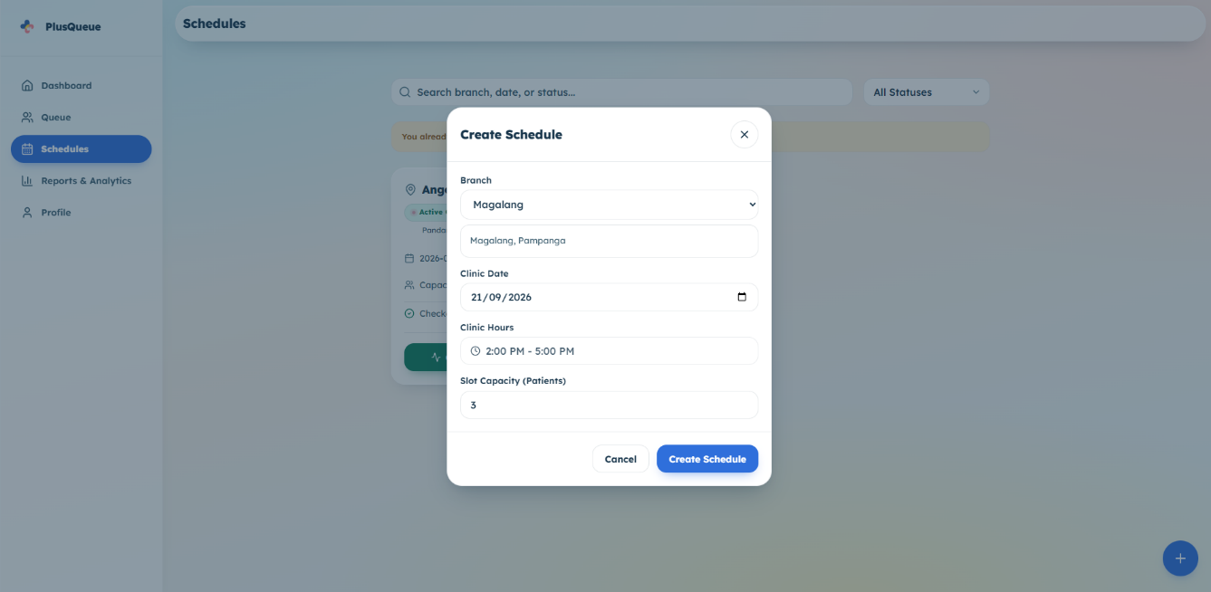

7. Viewing Reports & Analytics
This page shows numbers for finished clinic days only (after you or the secretary end the session).
- On a computer, click Reports & Analytics in the left menu.
- On a phone, open Profile, then tap Reports & Analytics.

Filters
- Branch — one clinic, or All Branches.
- Date range — Today, This Week, This Month, or This Year (This Year is the default).

Click Reset to go back to All Branches and This Year.
You will see:
- Totals: Total, Checked Up, Cancelled, Forfeited, Completion %
- Reservation Trend — bookings over time
- Outcome Distribution — checked up vs cancelled vs forfeited
- Session History — one row per completed clinic day (paginated if there are many)

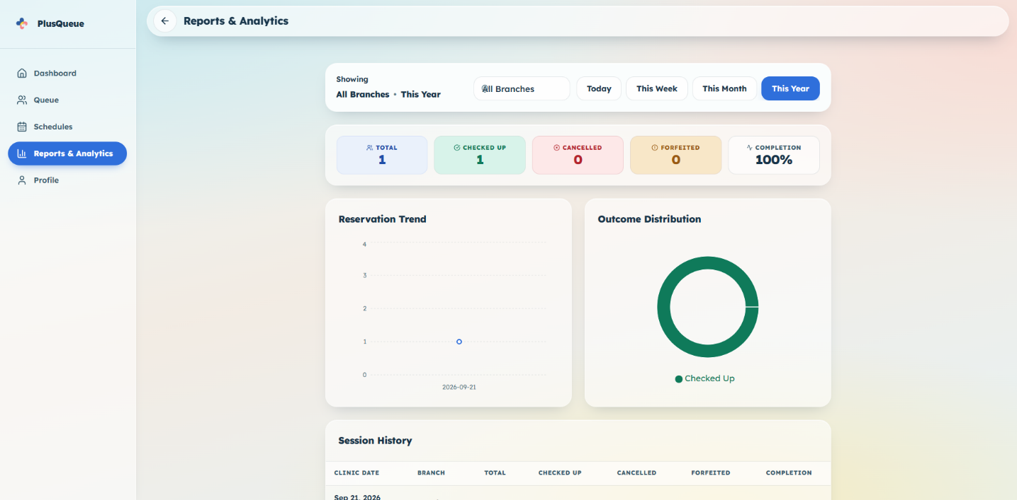

8. Reviewing the doctor’s report
The report is the Reports & Analytics page (including Session History). It is built from each completed schedule and every ticket on that day.
Number | Meaning
Total | All reservations that day — parent app bookings and walk-ins
Checked Up | Visits you finished (Complete Consultation)
Cancelled | Tickets that were cancelled (parent, or a walk-in cancelled at the desk)
Forfeited | Tickets lost because the parent did not check in in time
Completion | Checked Up ÷ Total

Walk-ins count the same as regular reservations. They are not listed in a separate report.
Nothing appears here until a clinic session is ended.
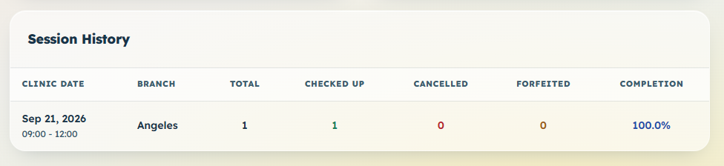

9. Other doctor tools

Dashboard (Home)
First screen after login. Pick a schedule from the dropdown to see today’s counts:
- Total Reservations
- Waiting, In Consult, Completed
- Checked In, Cancelled, Forfeited

A Schedule Overview (Draft / Published / Active / Completed counts) sits beside it.
A compact Queue view appears on a wide computer screen. On a phone, use the Queue tab, or tap Open Queue Control when a session is published.
You can hide a completed today session from this dropdown (the X on that row). It stays available under Schedules.
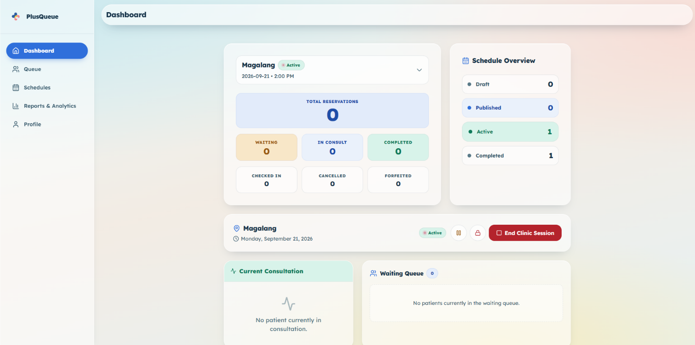

Profile
Update your name, title, contact number, and clinic name. Email cannot be changed here. Change your password under Security. Clinic branch addresses are listed here (set by the administrator).
- Open Profile.
- Edit the fields you need.
- Click Save Information.

To log out: click Log Out, then confirm.
On a phone, Profile is a menu: Account Settings, Reports & Analytics, and About System (app name and version).
