PlusQueue

Secretary User Manual
A short desk guide for the secretary role in PlusQueue (the clinic queue web app).
You only see your assigned branch. Other clinics do not appear.
Screenshots: Real captures were not taken (the app has no mock/test data mode, and screenshots would show live clinic records). Each section has a labeled placeholder. Replace it with a photo later.

Contents
Secretary User Manual 1
How to move around 2
1. Logging In 2
2. Manage Queue overview 3
3. Adding a Walk-in Patient 3
4. Validating / scanning a parent’s QR code 4
5. Penalizing a late parent 5
6. Cancelling a walk-in reservation 6
7. Pause, resume, close, and end the clinic session 6
Pause 7
Resume 7
Close the queue to new reservations 7
End the clinic session 7
8. Publishing a reservation schedule 7
Create a draft 8
Publish 8
Start the queue 8
9. System Configuration settings 9
Queue Rules 9
SMS settings 9
10. Other secretary tools 10
Dashboard (Home) 10
Request Check-In 10
Send to Doctor 10
Live Queue Monitor 11
Profile and log out 11

Open this file in Microsoft Word, then right-click the contents and choose Update Field if page numbers are blank.

How to move around
After you sign in, use the left menu (computer) or the bar at the bottom (phone):
Menu item | What it is
Dashboard | Today’s summary
Schedules | Create, publish, and start clinic days
Validate Reservation | Check in a parent with QR or a code
Manage Queue | Run the live line
Profile | Your account, walk-in patients, settings, log out

On a phone, Validate Reservation is shortened to Validate, and Manage Queue is shortened to Queue.
Live Queue Monitor is a large waiting-room screen. Open it from Manage Queue (it opens in a new tab).

1. Logging In
Sign in with the email (or phone) and password given to you by the administrator.
- Open the app in a browser.
- Type your email or phone number.
- Type your password.
- Click Sign In.
- You are taken to Dashboard.

Do not use Create Account on the sign-in screen. That is for parents. Staff accounts are created by the administrator.
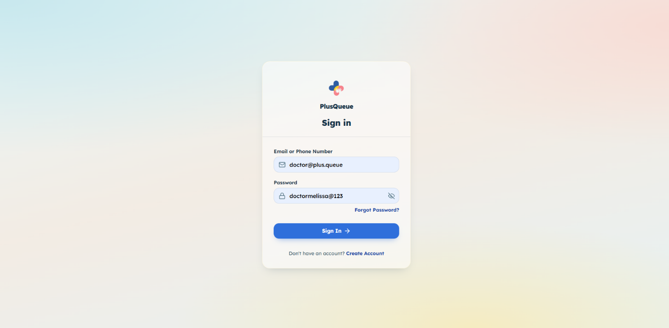

2. Manage Queue overview
This is the desk screen for the live line (who is waiting, who is with the doctor, and who is next).
It only works after you or the doctor starts the queue for today (see [Start the queue](#start-the-queue)). If no queue is running, you will see No Active Queue For your branch.
You will see:
- Session controls — pause, close, or end the clinic day
- Session Duration — how long the queue has been running
- Request Check-In — pings the next parent who is not yet at the desk
- Total Active — how many people are waiting or with the doctor
- Current Consultation — the patient with the doctor
- Waiting Queue — everyone still in line, in current turn order

Each row shows a queue number (the ticket number on the parent’s reservation). That number does not change. The order of the list can change if someone is marked late.
Tap a patient row to see parent contact details (or walk-in details, including optional parent name and phone if they were entered).
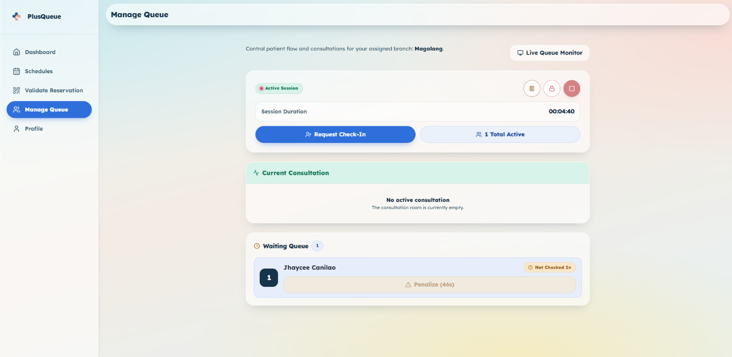

3. Adding a Walk-in Patient
Add a child who has no parent app account (they walked in, or a parent called the clinic). They are checked in right away — no QR scan.
- Open Profile.
- Click Walk-in Patient.
- Choose a schedule from the dropdown (date, hours, and how many slots are left). The list includes Upcoming published schedules and queues already Active Now or Paused. Closed or ended clinic days do not appear.
- Optional: type Parent's Name and Parent's Phone (10 digits after +63). Use this for phone-in bookings so the clinic can text them. Leave blank for in-person walk-ins.
- Type how many children (1–10). One walk-in group uses one slot.
- For each child, fill in name, age (1–25), and sex.
- Optional: type the concern (reason for visit).
- Click Check In Walk-in.

The patient appears in Manage Queue with a Walk-in tag. On an Active Now or Paused queue, they join at the back of the live line (they get the next ticket number and wait their turn). They do not skip people already waiting.
If you entered a phone:
- Upcoming schedule → they get the usual reservation-details text.
- Active Now or Paused queue → they get the “active queue” text (queue number and position).

That phone is used only for this booking text. Walk-ins do not get later texts such as queue started, near turn, penalty, or forfeiture.
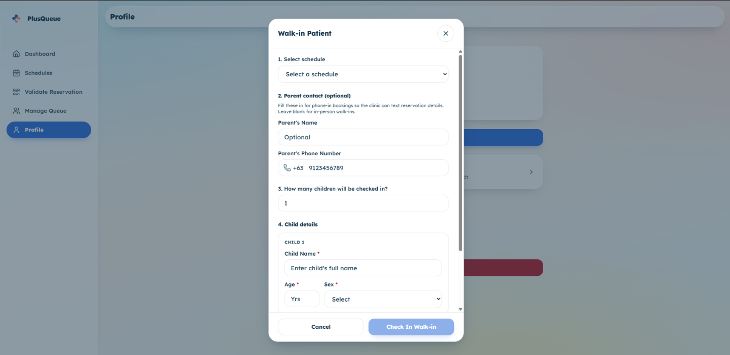

4. Validating / scanning a parent’s QR code
This checks a parent reservation at the desk so they join the live line as “Checked In.”
The clinic queue must already be started. If it is not, you will see “Clinic Queue Not Started.”
Check-in still works while the queue is paused, and after it is closed to new bookings (existing tickets stay valid).
- Open Validate Reservation.
- The camera usually starts by itself. Point it at the parent’s QR code, or type their 6-character code.
- The code checks itself when all 6 characters are entered.
- On success, you see the child’s name and queue number. Click OK.

If the camera does not start, click Start Camera. Allow camera access if the browser asks. Click Stop Camera if you need to turn it off.
If several cameras appear, pick the one facing the parent (usually the back camera on a phone).
Common results
Message | Meaning
Patient Checked In Successfully | Done
Invalid Code | Code not found, or it belongs to another branch
Already Checked In | Already scanned
Patient Currently In Consultation | They are already with the doctor
Clinic Queue Not Started | Start today’s queue from Schedules first
Queue Closed | The clinic day already ended (not the lock button)

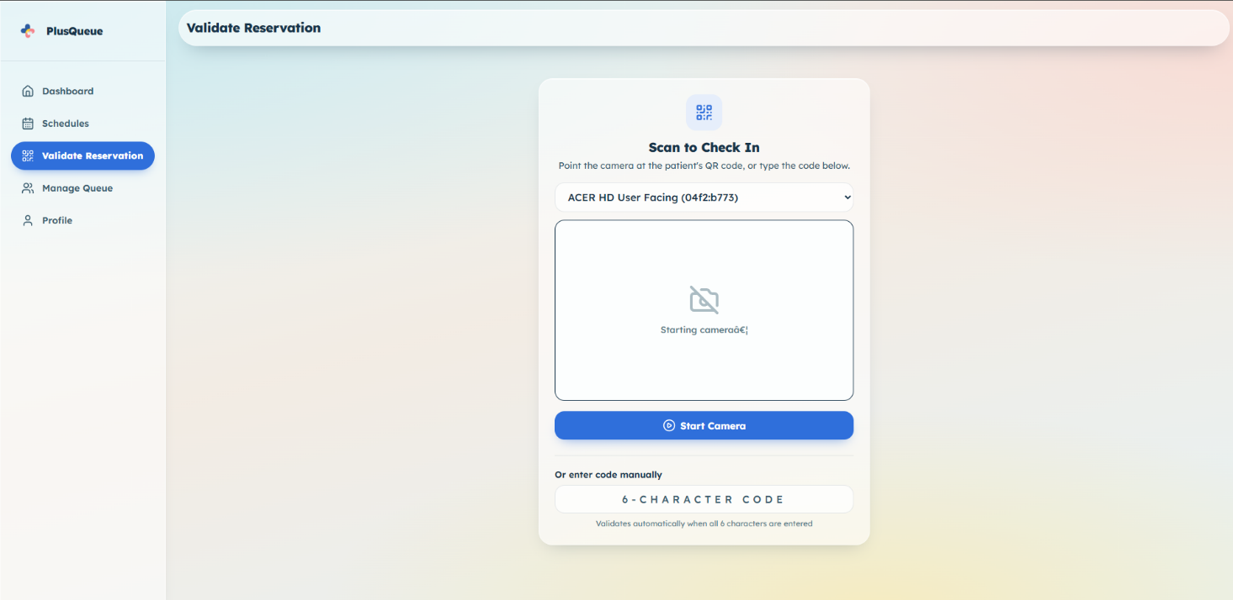

5. Penalizing a late parent
Use this when the next person in line is not at the desk when called.
Penalize = move them back in line and start a late clock. If they still do not check in before the clock runs out, they lose the slot (forfeited).
- Open Manage Queue.
- Find the waiting row with the Penalize button. It appears on:

- the first parent who is not checked in, or
- a walk-in who is first in line (even though walk-ins are already checked in).

- Wait until the button is ready. It may count down first (grace time so a parent walking in is not marked late too quickly).
- Click Penalize.

What you will see
- They drop several places down the list (how many is set in System Configuration).
- A Forfeit in … timer appears on their row.
- Parent app bookings: if they check in (QR/code) before time runs out, they stay in line at the new place and the timer stops.
- Walk-ins: they are already checked in, so they cannot scan again to stop the timer. Send them to the doctor before time runs out, or they lose the slot.
- If time runs out, they are removed from the line automatically.

You can penalize the same person more than once. Extra penalties move them back again but do not restart the first timer.
If Penalty Move-Back is set to 0, clicking Penalize removes them immediately (no move-back, no timer).
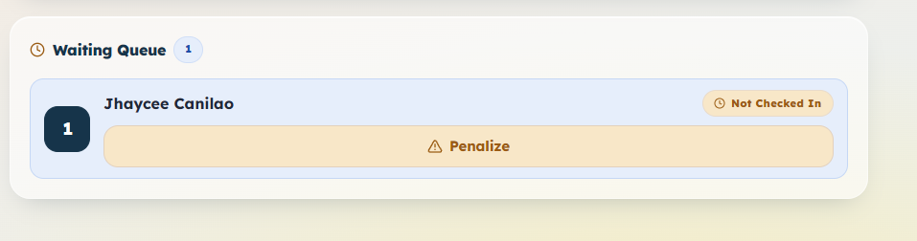

6. Cancelling a walk-in reservation
You can cancel walk-in tickets only. Parent app reservations cannot be cancelled from the secretary desk.
- Open Manage Queue.
- Click the walk-in patient’s row.
- Click Cancel Reservation.
- Click Cancel Reservation again to confirm.

The slot opens up and the line updates.
Do not cancel a walk-in who is already with the doctor. Finish that visit first.
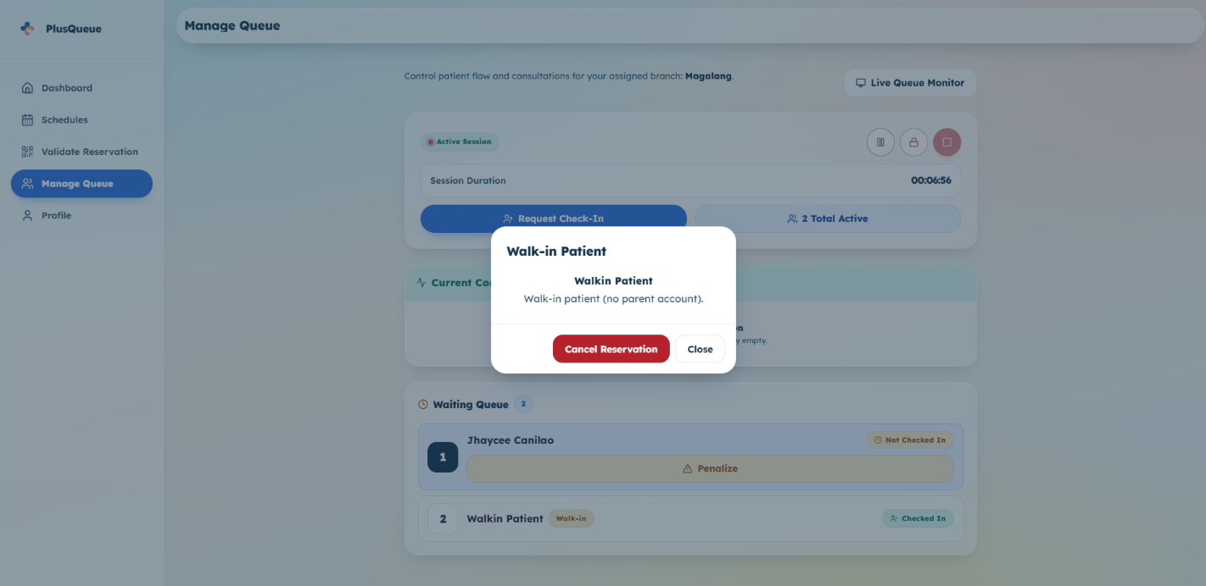

7. Pause, resume, close, and end the clinic session
These buttons sit at the top of Manage Queue. The doctor has the same four actions on Queue.
Button | What it does
Pause (pause icon) | Temporarily stop the live session. Check-in can still happen.
Play (play icon) | Resume after a pause.
Lock (lock icon) | Close the queue to new reservations. People already in line keep their place. Consultations continue. You can still check in existing tickets. You cannot add new walk-ins.
Stop (square icon) | End the clinic day. Only works when nobody is waiting and nobody is with the doctor.

Closing the queue cannot be undone. After you lock it, the pause/play buttons go away. Only End Clinic Session remains. Parents cannot book that schedule again.
You can also lock the queue while it is paused.

Pause
- On Manage Queue, click the pause button.
- Status shows Paused.

Resume
- Click the play button.
- Status shows Active Session again.

Close the queue to new reservations
- Click the lock button.
- Read the confirmation.
- Click Close Queue.

End the clinic session
- Finish remaining patients first (empty waiting list, empty consultation room).
- Click the square button.
- Click End Clinic Session.

This finishes the schedule for the day.
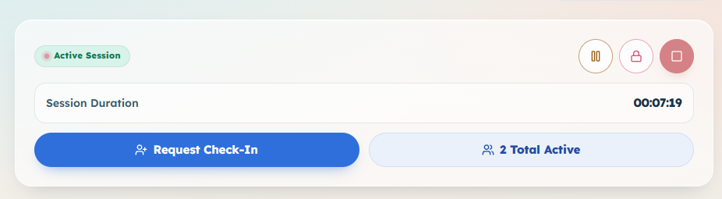

8. Publishing a reservation schedule
A schedule is a clinic day (date, hours, how many slots). Parents can book only after you publish it.
You only create schedules for your assigned branch. Clinic hours are filled in automatically from that branch’s opening and closing times. You cannot type different hours here.
You cannot create two schedules for the same branch on the same date.

Create a draft
- Open Schedules.
- Click the round + button (bottom right).
- Confirm the branch (locked to yours).
- Pick the clinic date.
- Check that Clinic Hours appear.
- Type slot capacity.
- Click Create Schedule.

A draft is not visible to parents yet.
You can search schedules or filter by Draft / Published / Completed.

Publish
- On the draft card, click Publish.
- Review the details.
- Click Publish Schedule.

Parents can now reserve slots.
Drafts can also be Edited or Deleted.

Start the queue
Start when the floor is ready (desk check-in, sending patients to the doctor).
- On the published card, click Start Queue.
- Review the details.
- Click Start Queue.
- You are taken to Manage Queue.

You can run only one live queue at a time. End the current one before starting another. A yellow note appears on Schedules if a queue is already running.
After the queue is running (or closed to new bookings), click Manage Queue on the card to jump back to the desk screen.
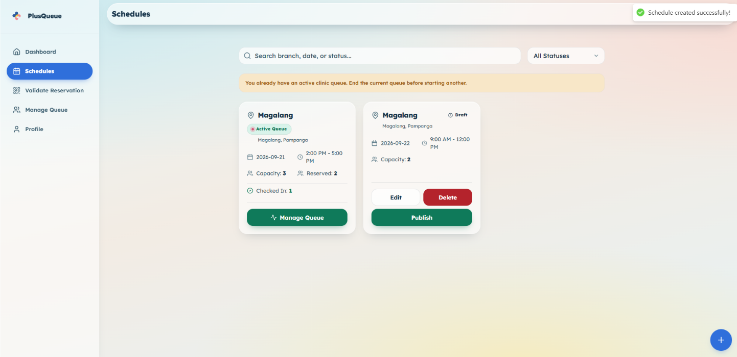

9. System Configuration settings
These rules apply only to your branch. Open them from Profile → System Configuration.
The page shows which branch you are configuring. Save Queue Rules and SMS Settings separately.

Queue Rules
Setting | What it controls
Penalty Move-Back (0–10) | How many places a late parent is moved down the line. 0 means Penalize removes them immediately.
Penalty Grace Period (0–5 min) | How long after someone becomes next in line before Penalize is available.
Penalty Timer (5–30 min) | After Penalize, how long they have to check in before they lose the slot.

Click Save Queue Rules.

SMS settings
These are the text messages parents receive. Walk-in phone numbers are not used for these later messages (only the one booking text in [Adding a Walk-in Patient](#3-adding-a-walk-in-patient)).
Setting | What it controls
Near Turn — Patients Ahead (1–10) | Send the “your turn is near” text when this many people (or fewer) are still ahead. Each reservation gets this text only once.
Near Turn Message | The text of that reminder.
Reservation Confirmed Message | Text after a parent books, before the queue has started.
Active Queue Reservation Message | Text instead, if they book after the queue has already started.
Penalty Message | Text when someone is marked late.
Forfeiture Message | Text when they lose the slot for being too late.
Queue Started Message | Text when you start the queue for the day.

Gray buttons like {queueNumber} insert that detail into the message. A character count appears under each message. Click Save SMS Settings.
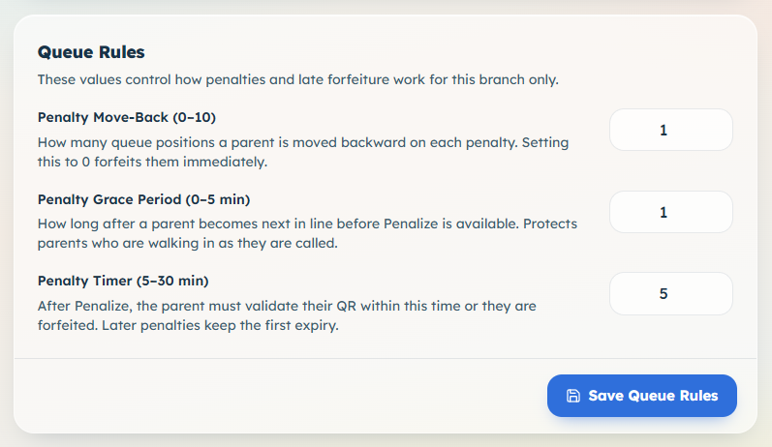

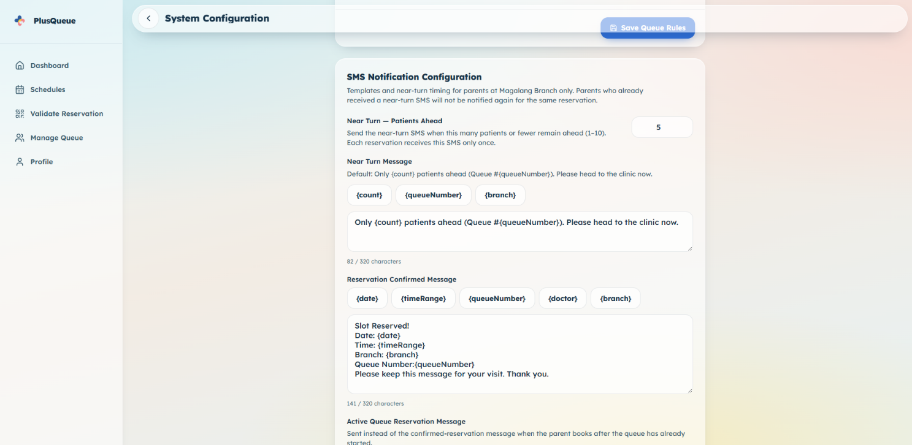

10. Other secretary tools

Dashboard (Home)
First screen after login. Shows today’s published schedule, who is with the doctor, counts (Remaining Queue / Waiting / Checked In / Completed), and recent activity.
On a wide computer screen, a compact Manage Queue also appears here. On a phone, use the Queue tab instead.
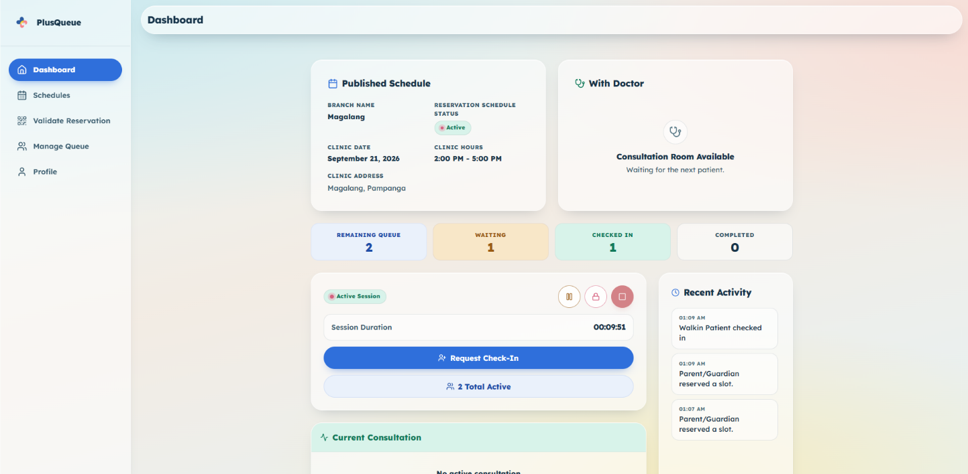

Request Check-In
On Manage Queue, click Request Check-In to remind the next parent who is not yet checked in to come to the desk. There is a short wait (about 30 seconds) before you can send another reminder.
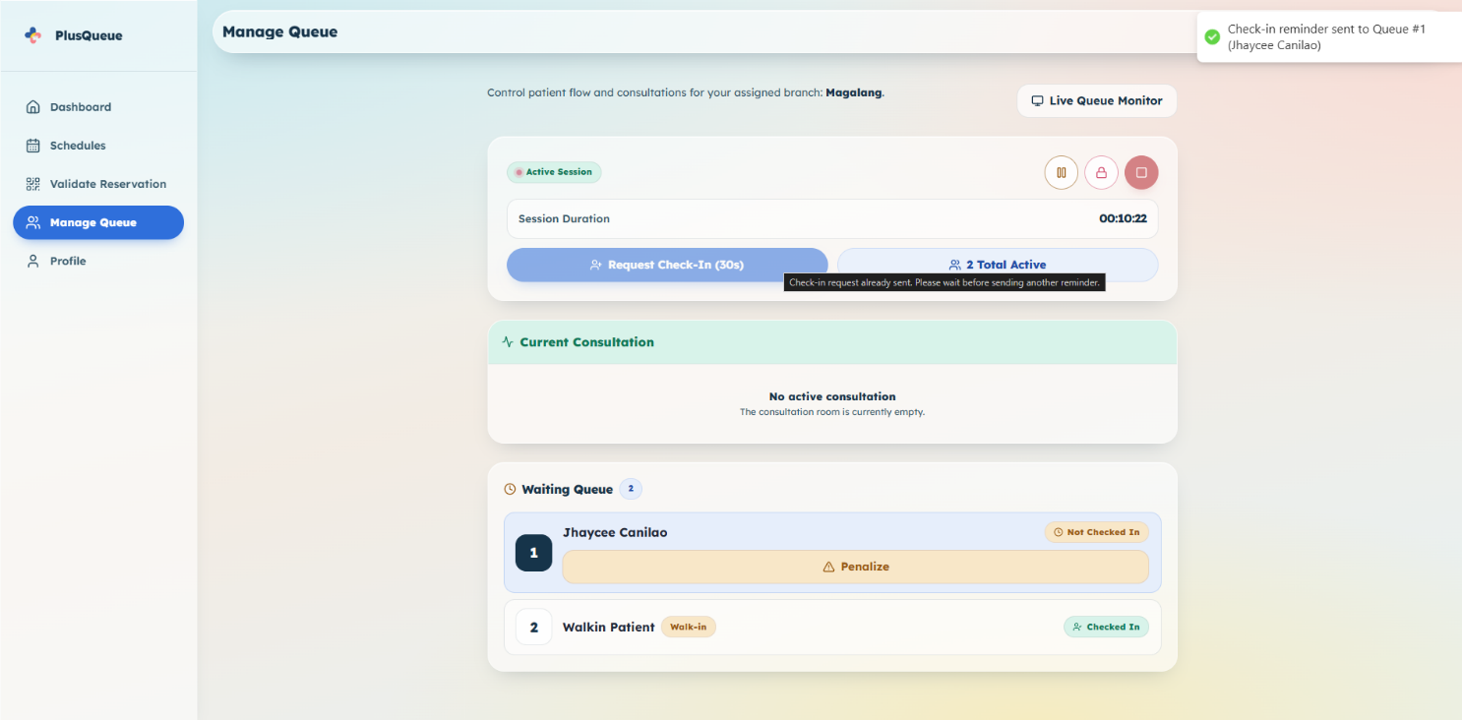

Send to Doctor
When the consultation room is empty, the first waiting patient who is Checked In gets a Send to Doctor button.
- Confirm they are ready.
- Click Send to Doctor.

Only one patient can be with the doctor at a time. The button appears again after the doctor finishes.
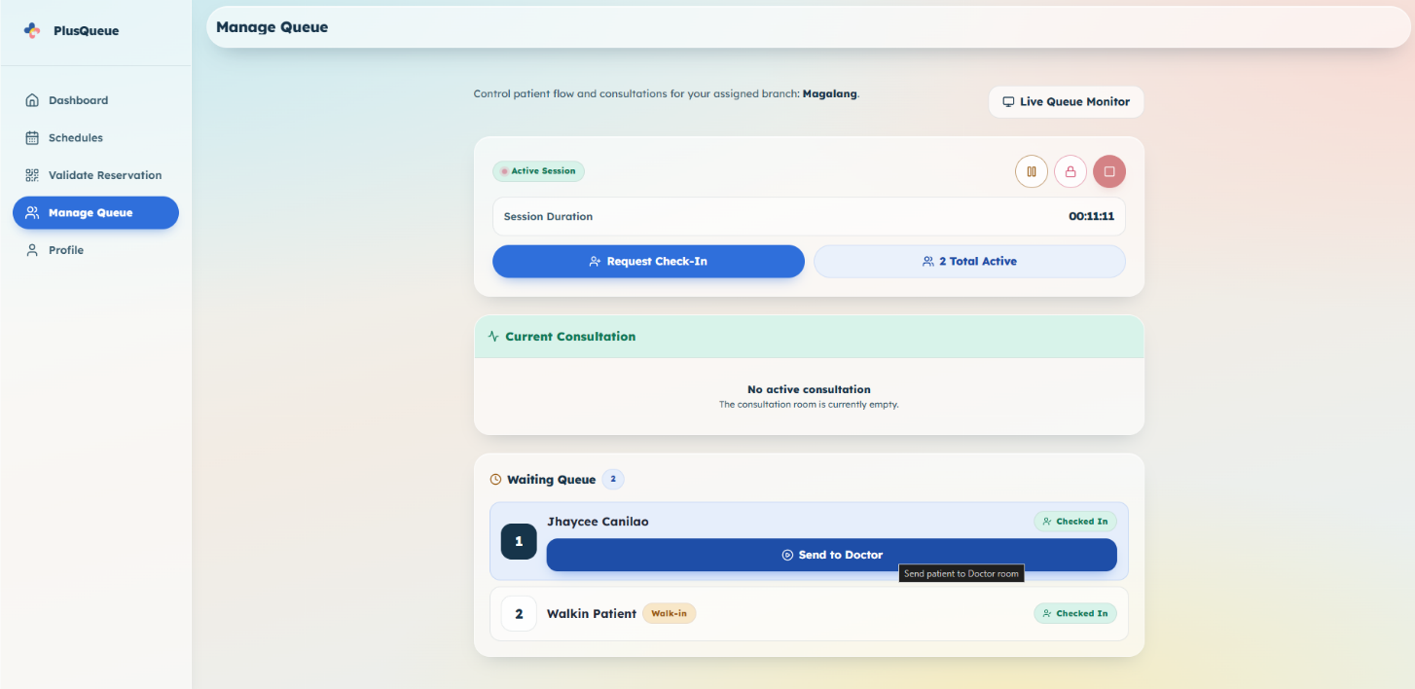

Live Queue Monitor
A large screen for the waiting room: Now Serving and Next In Queue (queue numbers only, no names). It also shows the branch name and the current time. Up to 10 waiting numbers are listed.
- On Manage Queue, click Live Queue Monitor.
- Optionally click the fullscreen button.

Paused and closed queues show a banner at the top (Queue Paused or Queue Closed).
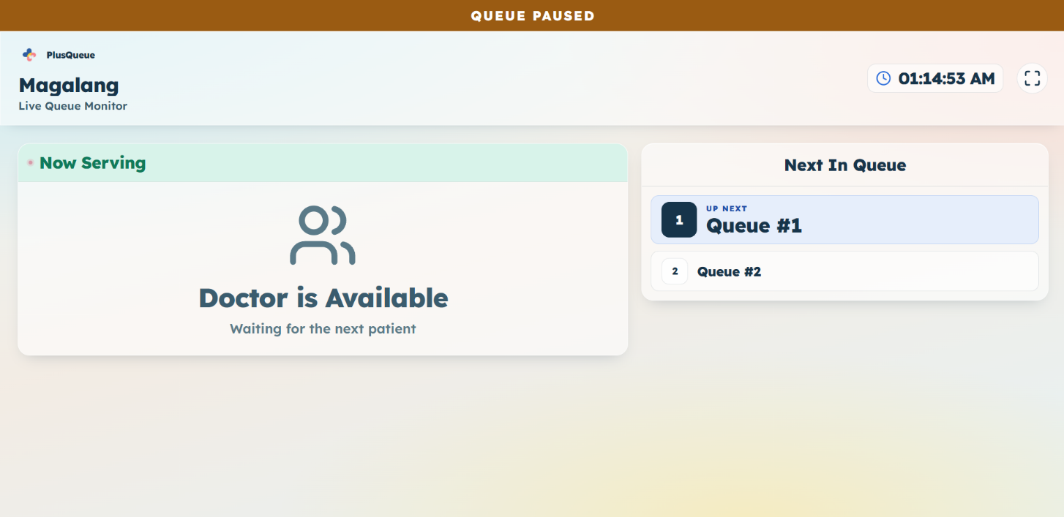

Profile and log out
Profile shows your name, email, phone, and assigned branch. You cannot edit these here. Ask the administrator if something is wrong.
- Open Profile.
- Click Log Out.
- Confirm.

