Question 1

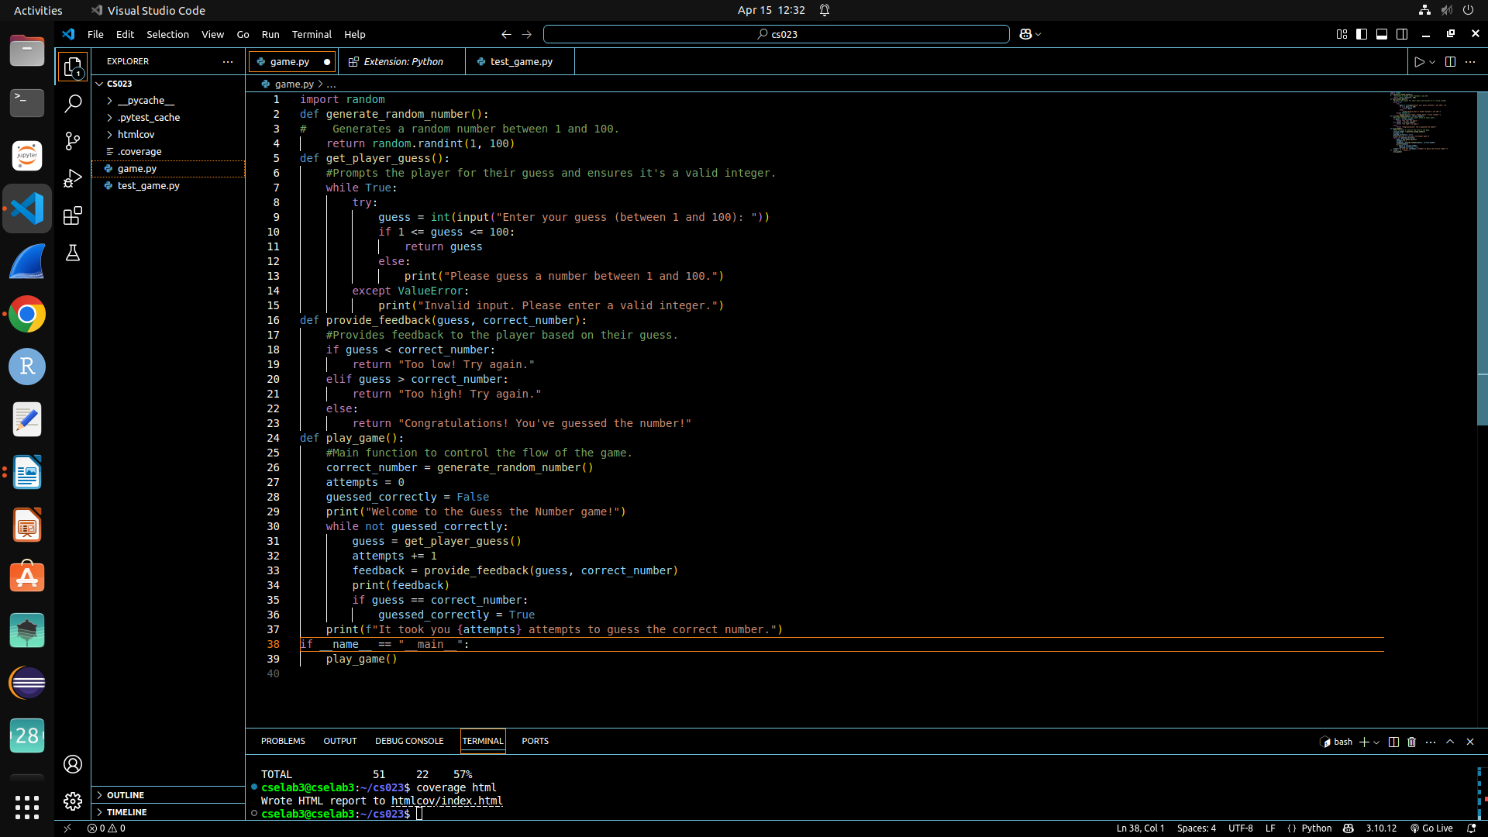
Question 2

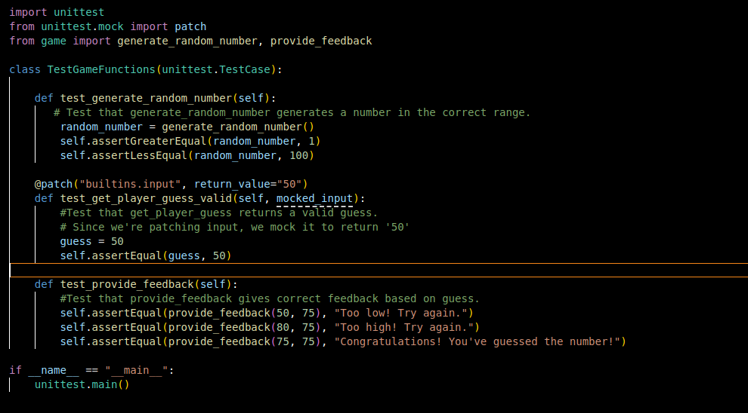
a)I chose to test the following functions:
- generate_random_number(): To ensure that the random number generator produces numbers within the correct range (1 to 100).
- provide_feedback(): To check that the feedback logic works correctly, giving accurate responses based on whether the player's guess is too high, too low, or correct.

b)Code in screenshot
Question 3
a) coverage.py
b) Step 1- install coverage using pip
Step 2- coverage run -m unittest test_guess_game.py
Step 3- coverage report -m
Step 4- coverage html
c) 57%

d)
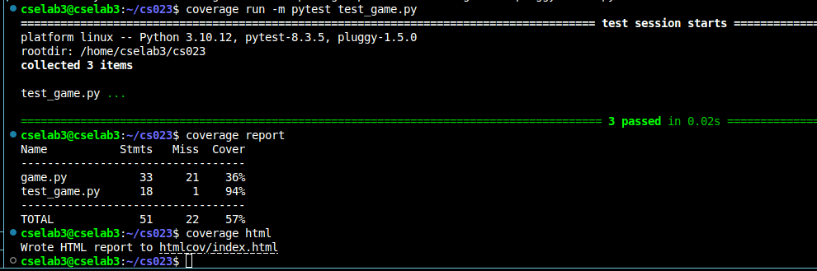
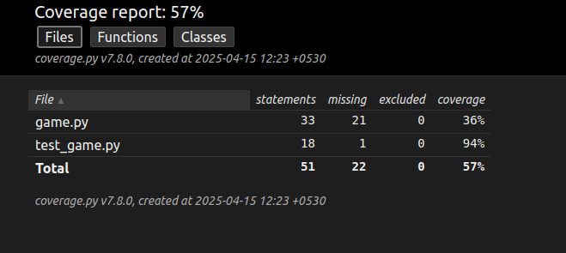

Question 4
a) get_user_guess() : Mock user input to test its behavior without requiring actual user interaction.
play_game() : Mock both user input and random number generation to simulate the entire game flow.
Test boundary values (e.g., guesses at the minimum and maximum of the range).
Test scenarios where the user guesses the correct number on the first attempt.
c) 95%
d)
