

[https://image.jimcdn.com/app/cms/image/transf/dimension=290x1024:format=jpg/path/s2a6052df1d35246c/image/i09d2afbb5fba8da7/version/1437308821/image.jpg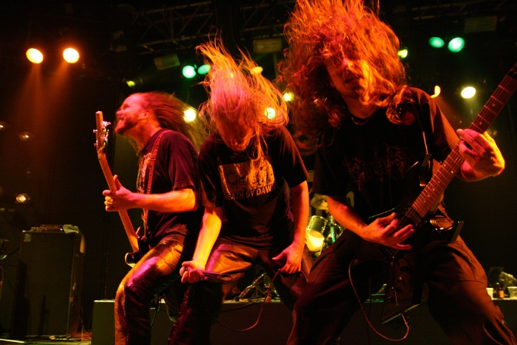](https://image.jimcdn.com/app/cms/image/transf/dimension=290x1024:format=jpg/path/s2a6052df1d35246c/image/i09d2afbb5fba8da7/version/1437308821/image.jpg#)

<https://goo.gl/images/Ei4VaG>

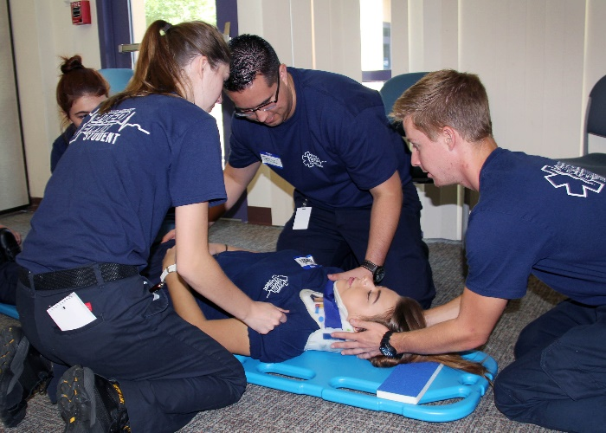

<https://www.google.com/url?sa=i&rct=j&q=&esrc=s&source=images&cd=&cad=rja&uact=8&ved=2ahUKEwjr48O_8YTfAhWH1FkKHcy0A0IQjRx6BAgBEAU&url=https%3A%2F%2Fwww.topsimages.com%2Fimages%2Femt-man-25.html&psig=AOvVaw2oKFs941FF4neBHS0XJnfJ&ust=1543968628041169>

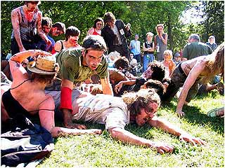

<https://goo.gl/images/jv42bV>



https://goo.gl/images/qG6rLN