Report
On
UI/UX DESIGN – ZIVIKA ACCESSORIES
INTERNSHIP PROJECT

Submitted To:
School of Computer Science and Engineering
IILM University, Greater Noida, U.P.

In partial fulfilment of the requirement of degree of
Bachelor of Technology in Computer Science and Engineering



Submitted By:
Name of Student: ARCHITA SRIVASTAVA
Roll Number: CS- 23411071
Batch: 2027

CANDIDATE’S DECLARATION
I, ARCHITA SRIVASTAVA, do hereby declare that the internship report titled “UI/UX Design – Zivika Accessories” has been prepared by me to fulfil the academic requirements of the Bachelor of Technology in Computer Science and Engineering at IILM University.
The report presents my practical learning and design work in the field of UI/UX Design during my internship with Infotact Solutions. The project documentation includes interface planning, visual design, prototyping, screen organization, and project presentation using Figma.
I further declare that this report has been prepared for academic submission and that the project material and references included in the report have been presented to the best of my knowledge.
Signature: __________________________
Student Name: ARCHITA SRIVASTAVA
Roll No.: CS -23411071

ACKNOWLEDGEMENT
I am using this opportunity to express my sincere gratitude to everyone who supported me throughout my summer internship in the field of UI/UX Design at Infotact Solutions.
I am grateful to Infotact Solutions for providing me with an opportunity to gain practical exposure to UI/UX design and understand how user-centred design principles are applied while creating digital product interfaces.
I also convey my sincere thanks to the faculty members and internship coordinators of the School of Computer Science and Engineering, IILM University, Greater Noida, for their academic guidance and support during this degree requirement.
The internship experience helped me strengthen my understanding of interface design, visual hierarchy, typography, layout, prototyping, and design documentation. I am also thankful to my parents, friends, and peers for their continuous encouragement and support.
Signature: __________________________
Student Name: ARCHITA SRIVASTAVA
Roll No.:CS-23411071

INTERNSHIP DOCUMENTATION
The following document confirms the internship opportunity offered by Infotact Solutions. The offer letter identifies the internship domain as UI/UX Design, the role as Design Associate L1, and the internship period as 25 June 2026 to 25 September 2026. It also describes the expected design responsibilities and fully remote mode.

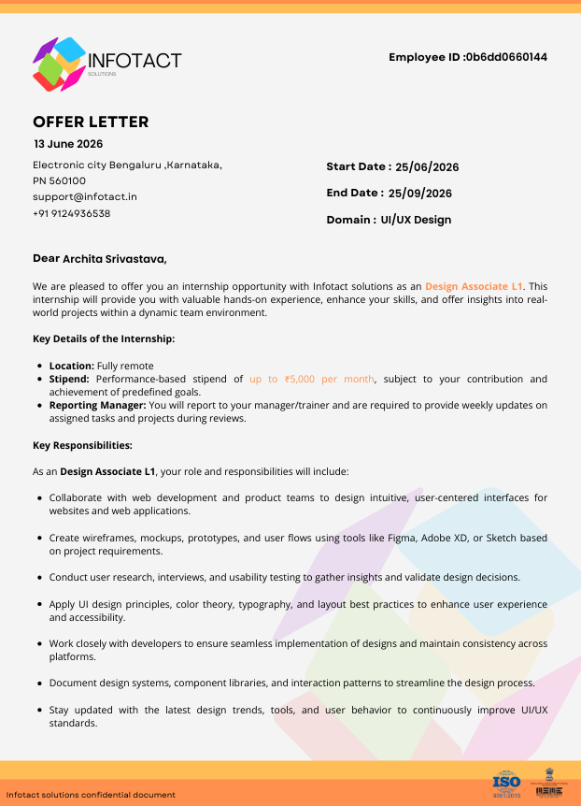
Figure 1: Internship Offer Letter – Infotact Solutions

TABLE OF CONTENTS

Chapter No. | Chapter Name | Page Nos.
— | Cover Page | 1
1. | Candidate’s Declaration | 2
2. | Acknowledgement | 3
3. | Internship Documentation | 4
4. | Project Description | 6
4.1 | Introduction | 6
4.2 | Organization Profile | 6
4.3 | Problem Statement | 7
4.4 | Project Objectives | 7
4.5 | Scope of the Project | 7
4.6 | Technologies and Tools Used | 8
4.7 | UI/UX Architecture & User Flow | 8
4.8 | Methodology & Detailed Design Process | 9
4.9 | Interface Design & Prototype | 11
4.10 | Project Outcomes & Learning | 13
5. | Bibliography / References | 15

The project description section follows the same formal chapter-based structure as the reference internship report, while the technical content has been adapted to the UI/UX Design internship and the Zivika Accessories project.

CHAPTER 4: PROJECT DESCRIPTION

4.1 Introduction
User Interface (UI) and User Experience (UX) design are important parts of developing modern digital products. UI design focuses on the visual and interactive elements through which users interact with a product, while UX design focuses on the overall experience, usability, information structure, and ease with which users complete their goals.
For e-commerce products, effective UI/UX is especially important because users must quickly understand the brand, discover categories, browse products, and move between different parts of the interface. A clear hierarchy, consistent product cards, readable typography, and intuitive navigation can make the shopping experience easier and more engaging.
The Zivika Accessories project applies these principles to a jewellery and accessories shopping interface. The project includes a branded home page, product-category screens for rings, bracelets, pendants and anklets, and a login/signup interface. The screens were designed and connected as an interactive prototype in Figma.

4.2 Organization Profile
The internship was undertaken with Infotact Solutions in the domain of UI/UX Design. According to the internship offer letter, the role was Design Associate L1 and the internship was fully remote. The internship period specified in the offer letter is 25 June 2026 to 25 September 2026.
The internship role provides exposure to user-centred interface design, wireframes, mockups, prototypes, user flows, visual design principles, design systems, interaction patterns, and collaboration with web development and product teams.

4.3 Problem Statement
Jewellery and accessories e-commerce interfaces need to balance visual appeal with usability. A product may look attractive but still create a poor experience if users cannot easily find categories, understand navigation, or move between screens. The design problem addressed by Zivika is therefore to create a structured and visually appealing interface that supports straightforward product discovery.
The project focuses on four related design requirements:
- Present jewellery products through consistent and visually clear product cards.
- Organize products into recognizable categories so users can browse efficiently.
- Create a branded home page that communicates the identity of Zivika and guides users toward products.
- Provide a simple login/signup interface and an interactive prototype demonstrating the intended navigation.

4.4 Project Objectives
- Design a modern and user-friendly jewellery e-commerce interface.
- Create a clear information hierarchy for categories and product listings.
- Apply consistent typography, spacing, imagery, and card layouts.
- Design multiple product-category screens using a common visual language.
- Create an interactive prototype using Figma.
- Document the completed UI/UX work in a professional GitHub repository.

4.5 Scope of the Project
The scope covers the visual and interaction design of the main Zivika Accessories interface. It includes the home page, product-category screens for rings, bracelets, pendants and anklets, and the login/signup screen. The current project is a UI/UX prototype rather than a production e-commerce implementation; therefore payment processing, backend services, database integration, and live inventory are outside the present scope.

4.6 Technologies and Tools Used
Tool | Category | Technical Purpose
Figma | UI/UX Design | Interface design, screen organization, components and visual layouts.
Figma Prototype | Prototyping | Connecting screens and demonstrating the intended interaction flow.
GitHub | Project Documentation | Hosting project screenshots and README documentation.
PNG Screenshots | Design Assets | Documenting the major interface screens for presentation and review.

4.7 UI/UX Architecture & User Flow
The interface is organized around a simple category-driven e-commerce flow. The home page acts as the primary entry point and introduces the Zivika brand, featured content, categories, new arrivals, and social content. Category screens then provide product browsing for rings, bracelets, pendants, and anklets. The login/signup screen provides an account-access entry point.
1. Home | Brand introduction → categories → featured/new-arrival content
2. Category | Select Rings / Bracelets / Pendants / Anklets
3. Product Browsing | View products in a consistent card-based grid
4. Account | Login / Sign up interface
5. Prototype | Navigate between connected screens in Figma

4.8 Methodology & Detailed Design Process

Stage 1: Requirement Understanding
The design process began by identifying the purpose of the interface: to present a jewellery and accessories brand through a visually engaging e-commerce experience. The major user needs considered were easy category discovery, clear product presentation, recognizable navigation, and a simple account-access experience.

Stage 2: Information Architecture
The interface was organized around the home page and category-based product browsing. Separating products into rings, bracelets, pendants and anklets creates a straightforward structure and reduces the amount of information users need to process at one time.

Stage 3: Layout Planning
The layouts were planned around navigation, headings, product cards, imagery, buttons, spacing, and content hierarchy. Repeating the product-card structure across category pages helps users understand the interface quickly and maintains consistency.

Stage 4: Visual UI Design
The visual design uses jewellery imagery, clear headings, product cards, and a consistent interface structure. Visual hierarchy was used to distinguish navigation, category labels, product information, and calls to action.

Stage 5: Prototyping
The completed screens were connected in Figma to form an interactive prototype. Prototyping makes it possible to review the interface as a connected experience rather than as separate static screens.

Stage 6: Review and Refinement
The screens were reviewed for visual consistency, spacing, hierarchy, alignment, and overall presentation. The final set of screens was organized for documentation and uploaded to the project GitHub repository.
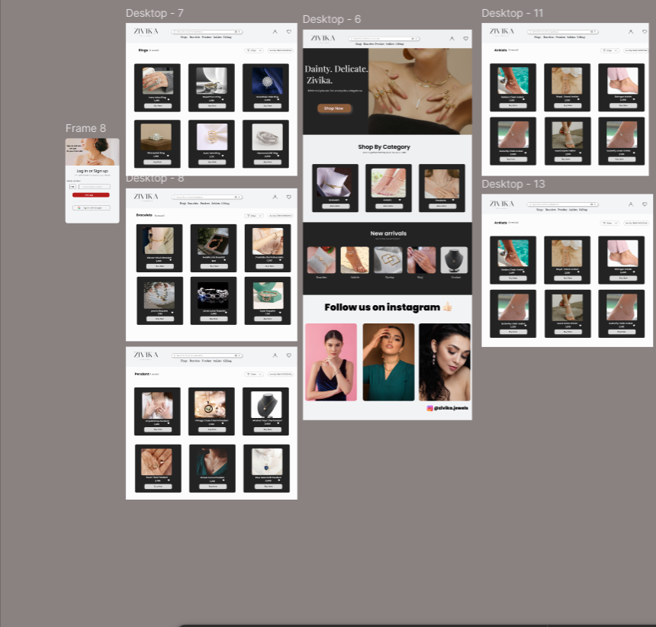
Figure 2: Zivika Accessories complete UI/UX screen board in Figma

4.9 Interface Design & Prototype
The following screens represent the main interface areas designed for Zivika Accessories. Each category page
follows a consistent product-grid structure, while the home page provides the primary brand and navigation experience.

Home Page
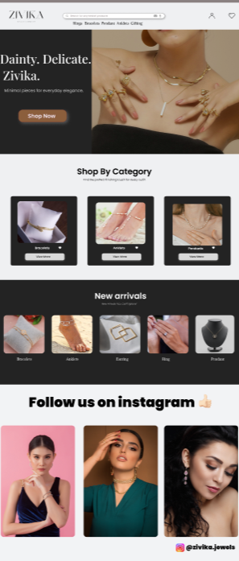
Figure 3: Zivika Accessories Home Page

Rings and Bracelets
Rings  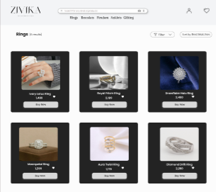 | Bracelets  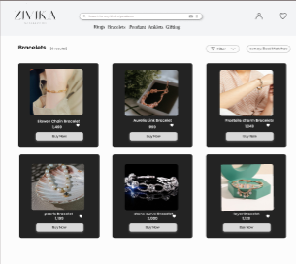
Figure 4: Zivika Rings and Bracelets category interfaces

Pendants and Anklets

Pendants  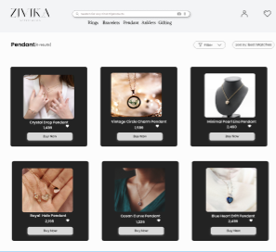 | Anklets  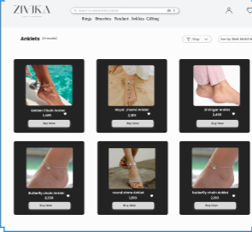
Figure 5: Zivika Pendants and Anklets category interfaces

Login / Signup
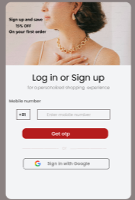
Figure 6: Zivika Login / Signup interface

Design Consistency
Across the screens, repeated card structures, navigation patterns, typography, imagery, and spacing create a consistent visual language. This consistency helps users transfer what they learn on one category page to the other category pages.

4.10 Project Outcomes & Learning

Project Outcomes
- A structured e-commerce interface for jewellery and accessories.
- Dedicated category screens for rings, bracelets, pendants and anklets.
- A branded home page that presents categories and featured content.
- A login/signup interface for account access.
- An interactive Figma prototype connecting the main screens.
- A documented GitHub repository containing screenshots and project information.

Learning Outcomes
- Improved understanding of UI and UX design principles.
- Practical experience with Figma-based interface design and prototyping.
- Better understanding of visual hierarchy, typography, spacing, and layout.
- Experience in organizing e-commerce product information into category-based screens.
- Improved ability to document and present a design project professionally.
- Understanding of how design decisions contribute to usability and user experience.

Figma Prototype
View Zivika Figma Prototype

GitHub Repository
Zivika-UI-UX GitHub Repository
The GitHub repository contains the README documentation and the six selected UI screenshots used for project presentation. The Figma prototype provides the interactive view of the designed interface.

CHAPTER 5: BIBLIOGRAPHY / REFERENCES
[1] Figma. Zivika Accessories – UI/UX Design interactive prototype.
[2] GitHub. Zivika-UI-UX project repository and project documentation.
[3] Infotact Solutions. Internship Offer Letter, dated 13 June 2026.
[4] Nielsen Norman Group. User Experience (UX) and usability design principles.
[5] Material Design. Interface design, layout, typography, and interaction guidance.

END OF REPORT

