**Introduction**

The goal of the Usability exercise is to evaluate the usability and user experience of a website. The content of the website is also reviewed. In order to perform this task, we defined three scenarios that will serve as a guideline. By performing the scenarios on the best, we evaluated the different heuristics and their relevance. The website to evaluate is [www.tim.it](http://www.tim.it). The browsing was done during the period 15th June to 30th June 2017.

**Scenarios**

**Scenario #1**

|  |  |
| --- | --- |
| **User** | Potential client, foreign student (Italian language level is A2) |
| **Situation** | 4G mobile internet for max 10 euro/month |
| **Goals** | To choose an decent mobile phone package for himself/herself. |
| **Actions** | Goes onto “OFFERTE” and chooses “MOBILE” then check all offers of the company, reads all information by auto-google-translating, and decides to stop his choice on TIM Young&Music Limited edition. |

**Scenario #2**

|  |  |
| --- | --- |
| **User** | Usual client |
| **Situation** | User got an promotion message on his phone about possibility of using phone bills to buy different tickets |
| **Goals** | The client wants to know more about parking tickets and how to use it |
| **Actions** | From the home page client clicks the SMART LIFE and chooses “Acquisti con Credito Telefonico” among listed options. Then he clicks Mobile ticketing and parking offer after that the website leads he into another page where presented various possible services which can be acquired via telephone. |

**Scenario #3**

|  |  |
| --- | --- |
| **User** | Loyal client |
| **Situation** | He is using TIM SIM card right now and he also subscribed the TIMGames service. However, he has issues to start using the service, so he opened the TIM’s website to check out. |
| **Goals** | To check out how to get to use the TIMGames service |
| **Actions** | First he clicks the ASSISTENZA and selects the TV & Entertainment option then the page jumps to the TV & Entertainment page, he clicks the first link in the TIM Games area, he reads all contents but found nothing useful, now he wants to back to previous page to check other information then he clicks TIM Games at Breadcrumbs navigation. |

**Evaluation**

The following metric is used:

**NA** = this heuristic is Not Applicable

If Applicable: severity rate

• **0** = heuristic severely violated

• **1** = heuristic partially violated

**• 2**= heuristic satisfied

**Scenario 1**

**Content heuristics**

|  |  |  |
| --- | --- | --- |
| FEATURES | Applicability rate | Comment |
| Accuracy | 2 | The content describes perfectly the topic, in this case the offers. |
| Currency | 1 | The published time and validity time scope is not shown in offers. Nevertheless, it is not that important for this topic. (Screenshot 1-1) |
| Coverage | 2 | The coverage shows exactly what it talks about in subpage. (Screenshot 1-2) |
| Content objectivity | NA | The content objectivity is hard to evaluate, given that this is the website of a telecom company and it will of course be subjective in describing its products. |
| Authority | 2 | The author is company Telecom Italia |
| Conciseness | 2 | There is no boring long list of information. It is also well-organized and readable. Short sentences are used along with pictures. |
| GENERAL COMMUNICATION QUALITY | | |
| Text errors | NA | Our level of Italian is not sufficient to evaluate this part and the website doesn’t support internationalization. |
| Multimedia consistency | 2 | Multimedia well-chosen as the page gives quickly an idea about the services offered (Phone, Internet and Streaming Softwares) |

**Navigation heuristics**

|  |  |  |
| --- | --- | --- |
| FEATURES | Applicability rate | Comment |
| Segmentation | 2 | The page is well segmented as in the right we have tabs that describe the different fragments: smartphone, how to activate … |
| Transition list | 2 | There are links to go to other topics like a link to TIM’s shops. |
| Introduction list | 2 | All offers by chosen group (in our case: mobile) are in one page |
| Group navigation | 1 | It does not allow to go to another offer you have to go back and only then you can see next offer’s description |
| Go back | 1 | There is no go back button, but you can go back by clicking breadcrumbs or via browser go back button. However this always are some problems, whenever you click bread crumbs to go back , it may leads user to another page instead of the previous page which user read before. |
| Landmarks | 2 | The landmark is always there. |
| Link consistency | 2 | The links are consistence. |
| Orientation clues | 2 | Orientation clues are clearly seen |
| Orientation clues – topic | 2 | There is a navigation at the left side of the page, it can navigate user to different content in the same page and shows the current location to user. |
| Group orientation clues | 2 |  |
| Transition orientation clues | 2 |  |

**Visual and Semiotic heuristics**

|  |  |  |
| --- | --- | --- |
| Feature | Applicability rate | Comment |
| Visual identity | 2 | Visual properties match the visual identity of TIM |
| Chromatic code consistency | 2 | All piece of information is consistent with the brand and across the site |
| Background contrast | 2 | No difficulties in readability of the information |
| Fond size | 2 | Texts are easy to read |
| Font color | 2 | Easy to read |
| Font type | 2 | Easy to read |
| Anchor identity | 2 | Well highlighted |
| Anchor states | 2 | Well highlighted |
| Icon consistency | 2 | The visual properties of icons and positions in the page are consistent across the web site. |
| Visual proximity |  | Good arrangement |
| Layout conventions | 2 | Importance of the information is clearly shown; item relevancy is good. |
| Semiotics | 2 | Clear |

**Cognitive heuristics**

|  |  |  |  |
| --- | --- | --- | --- |
| FEATURES | Applicability rate | Comment | |
| Information overload | 2 | | Each single page shows different information w.r.t topics. |
| Classification adequacy within group topics | 2 | | Information gives by group with the way that they are easy to remember |
| Website Mental map | 2 | | Web-site is created well-organized, it is easy to find information through useful information, fast tools at the bottom of the page |

**Scenario #2**

**Content heuristics**

|  |  |  |
| --- | --- | --- |
| FEATURES | Applicability rate | Comment |
| Accuracy | 2 | The content corresponds the topic. |
| Currency | 1 | There are no sources that show the currency. |
| Coverage | 2 | The coverage is cool, it keeps the similar stylish with the main page though it is an independent page and the content exactly talks the topic which leads the user to here. |
| Content objectivity | 2 | Content objectivity is clear. |
| Authority | 2 | The author is company Telecom Italia |
| Conciseness | 2 | The page is pretty concise, there are no mountained paragraphs and letters. |
| GENERAL COMMUNICATION QUALITY | | |
| Text errors | NA | Our level of Italian is not sufficient to evaluate this part and the website doesn’t support internationalization. |
| Multimedia consistency | 2 | The pictures and videos are properly used, it corresponds to content and subject of the page. |

**Navigation heuristics**

|  |  |  |
| --- | --- | --- |
| FEATURES | Applicability rate | Comment |
| Segmentation | 2 | There are 5 different dialogue acts in same page but they are placed in different sub-section which is good and it’s not complicate for users to read and browse, with simply scrolling mouse then users can browse different information and also they can easily go to different topics via clicking top menu bar(link). Check screenshot 2-2 |
| Transition list | NA | There is no need of transition list in the page. |
| Introduction list | NA | Since there are only 5 topics so there is also no need of the introduction list, however there is an introduction page before entering into the page. |
| Group navigation | NA |  |
| Go back | 0 | There is no go back button, the only way that you can go back to home page is via clicking logo but this leads user to another new window and this makes no sense so I give 0 to this point. |
| Landmarks | 1 | Since this page is totally independent of home page so there is no landmarks of main page, and I literally don’t get the idea which makes this page totally independent of the main page so give this point 1 score. |
| Link consistency | NA |  |
| Orientation clues | 1 | The underline in the menu bar indicates user where they are or which topic they are reading but it’s not very accuracy, for instance, when user apparently comes to second topics and the underline is still under the first selection of the menu bar. (Check screenshot 2-4) |
| Orientation clues – topic | 2 | Same with the above. |
| Group orientation clues | NA |  |
| Transition orientation clues | 2 | There are different titles and background colors which are used to differentiate different topics |

**Visual and Semiotic heuristics**

|  |  |  |
| --- | --- | --- |
| Feature | Applicability rate | Comment |
| Visual identity | 2 | Visual properties match the visual identity of TIM |
| Chromatic code consistency | 2 | This page keeps same stylish with main page. |
| Background contrast | 2 | The colors and background pictures used are proper and pleasurable. |
| Fond size | 2 | The font size is suitable for reading |
| Font color | 2 | The color is suitable. |
| Font type | 2 | There are few kinds of font types but all they are just right to read and distinguish for user. |
| Anchor identity | NA |  |
| Anchor states | NA |  |
| Icon consistency | 2 | The visual properties of icons and positions in the page are consistent across the web site. |
| Visual proximity |  |  |
| Layout conventions | 1 | The picture takes more space than the main content. (Check screenshot 2-2,2-3) |
| Semiotics | 2 | All of these features are clear. |

**Cognitive heuristics**

|  |  |  |
| --- | --- | --- |
| FEATURES | Applicability rate | Comment |
| Information overload | 2 | The information of each topic is well organized and distinguishable. |
| Classification adequacy within group topics | NA |  |
| Website Mental map | NA |  |

**Scenario #3**

**Content heuristics**

|  |  |  |
| --- | --- | --- |
| FEATURES | Applicability rate | Comment |
| Accuracy | 2 | For each offers they have instruction about it, basically, user can find some useful information. |
| Currency | NA |  |
| Coverage | 1 | Seems the whole page left much margin on the right side but the structure is clear. |
| Content objectivity | NA |  |
| Authority | 2 | Offered by TIM company. |
| Conciseness | 2 | The contents are clear and readable . |
| GENERAL COMMUNICATION QUALITY | | |
| Text errors | NA |  |
| Multimedia consistency | 2 | Images are consistent with the subject of the page. |

**Navigation heuristics**

|  |  |  |
| --- | --- | --- |
| FEATURES | Applicability rate | Comment |
| Segmentation | 2 | There are several borders to divide different topics , and different topics are put in different sections which can be easily recognized by users. |
| Transition list | 2 | On left side of the page there is a navigation list which classifies different topics into different sections. |
| Introduction list | NA |  |
| Group navigation | NA | There is no group navigation |
| Go back | 0 | There is no go back button, though the Breadcrumbs navigation on left top shows where you come from and where you are now and it allows you to go back to one step or even to home page, there is a problem you can easily into a 404 problem page via clicking Breadcrumbs.( <https://www.tim.it/global/pageNotFound.jsp#section1>) (check screenshot 3-404) |
| Landmarks | 2 | It exists in every page and apparently to find. |
| Link consistency | 2 | All links go to similar style of pages according to topics. |
| Orientation clues | 2 | There is a Breadcrumbs shows it. |
| Orientation clues – topic | 1 | It’s not clear for user. |
| Group orientation clues | 1 | It’s not clear for user. |
| Transition orientation clues | NA |  |

**Visual and Semiotic heuristics**

|  |  |  |
| --- | --- | --- |
| Feature | Applicability rate | Comment |
| Visual identity | 2 | Visual properties match the visual identity of TIM |
| Chromatic code consistency | 1 | It’s not very clear but not affect discriminating |
| Background contrast | 1 | A little bit flat, some proper pictures could be used except that the page looks fine. |
| Fond size | 2 | Clearly and properly and consistently |
| Font color | 2 | Clearly and properly and consistently |
| Font type | 2 | Clearly and properly and consistently |
| Anchor identity | NA |  |
| Anchor states | NA |  |
| Icon consistency | NA |  |
| Visual proximity |  |  |
| Layout conventions | 2 | Importance of the information is clearly shown, item relevancy is good. |
| Semiotics |  |  |

**Cognitive heuristics**

|  |  |  |
| --- | --- | --- |
| FEATURES | Applicability rate | Comment |
| Information overload | 2 | Each single page shows different information w.r.t topics. |
| Classification adequacy within group topics | 2 | Describes(layout) is split in different information objects according to different topics. |
| Website Mental map | 2 |  |

**Screenshots**

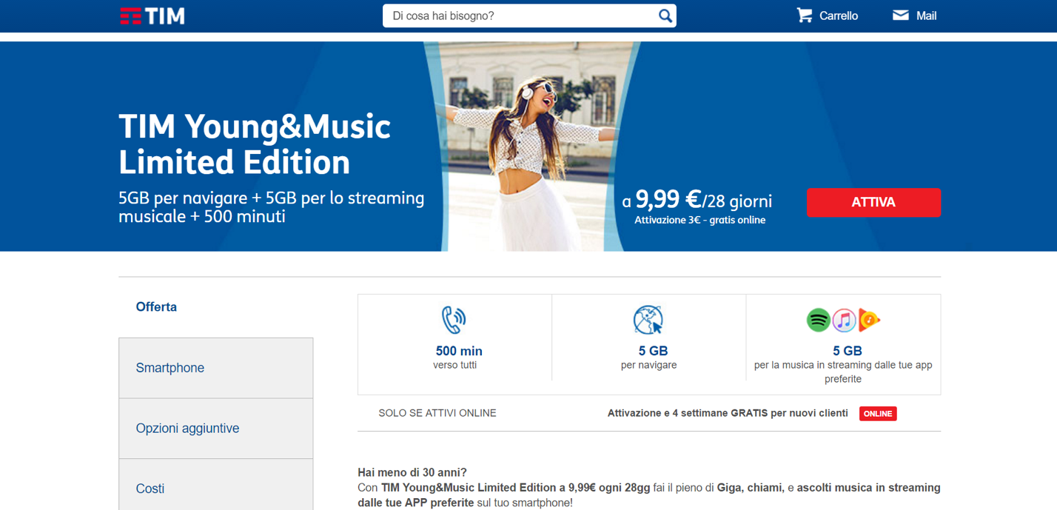

**Screenshot 1-1**

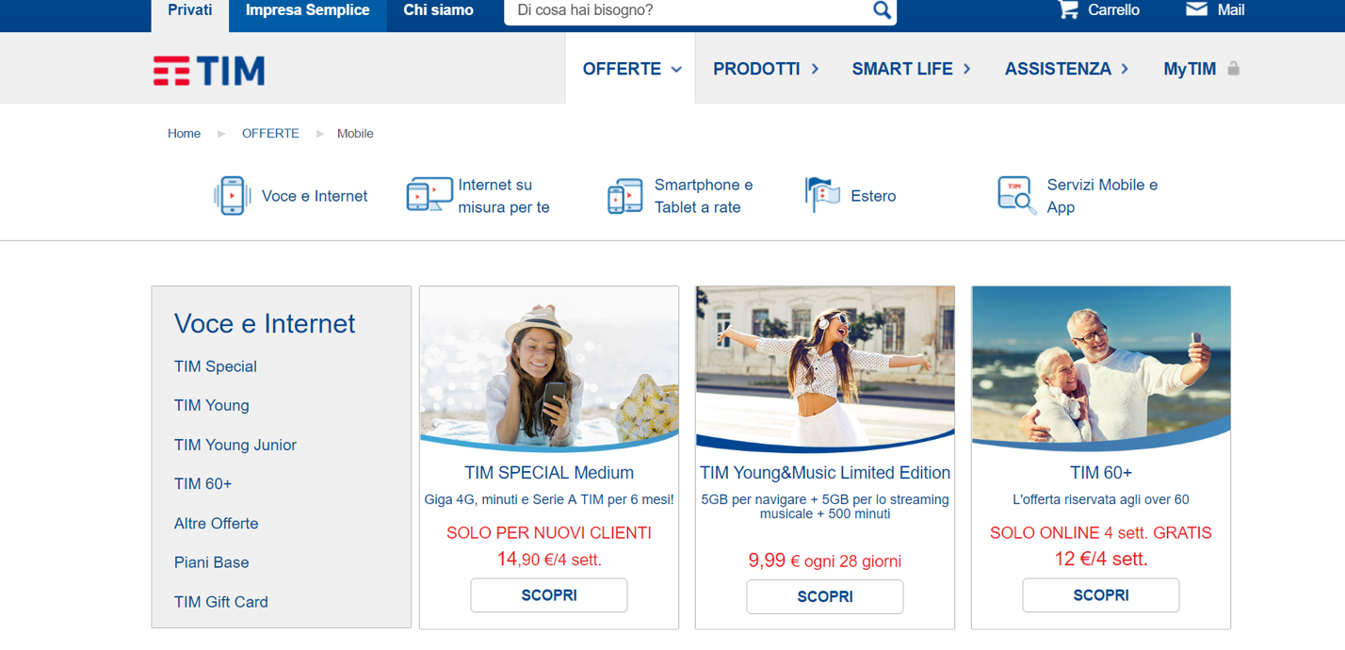

**Screenshot 1-2**

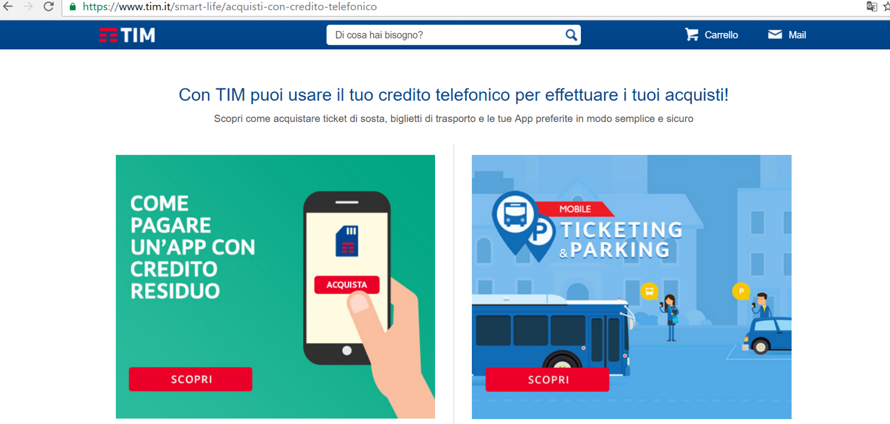

**Screenshot 2-1**

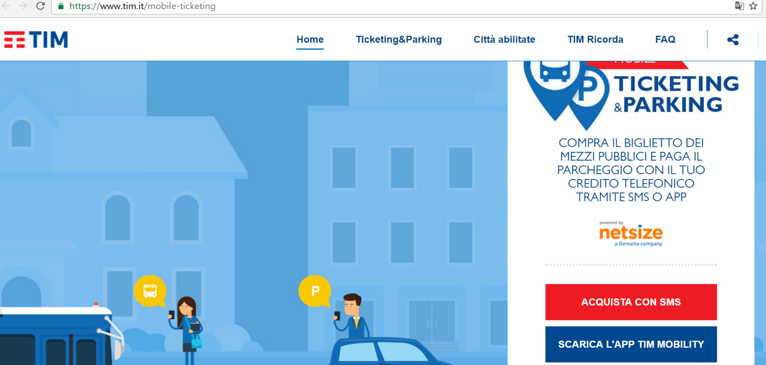

**Screenshot 2-2**

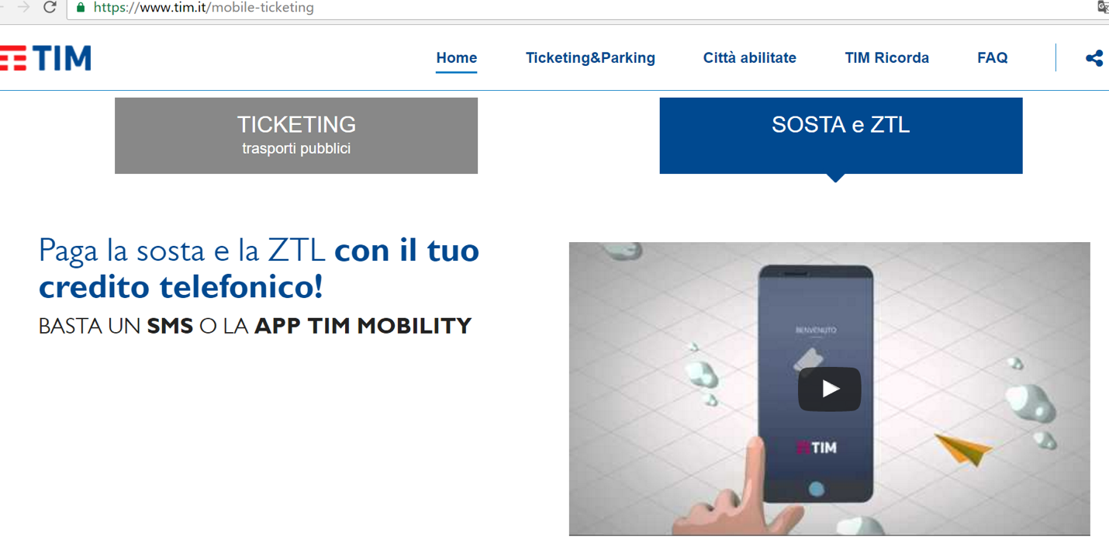

**Screenshot 2-3**

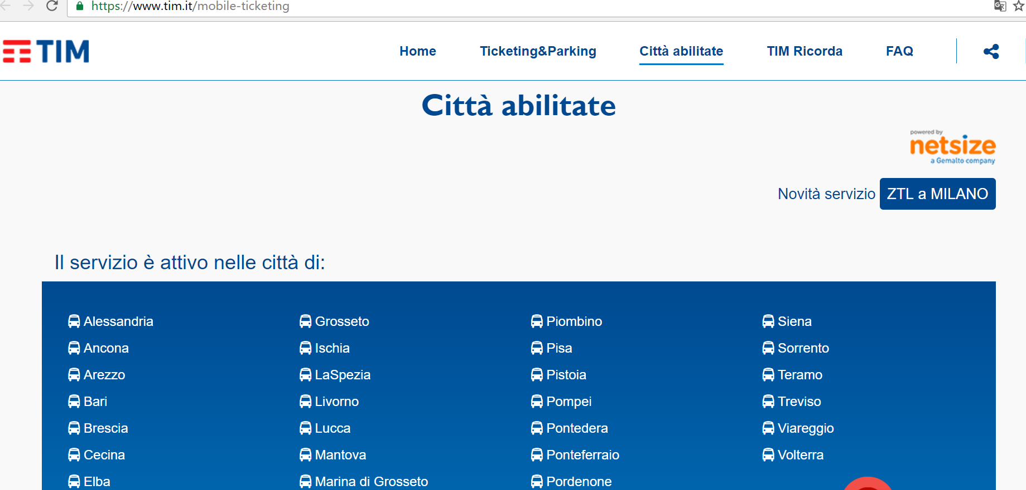

**Screenshot 2-4**

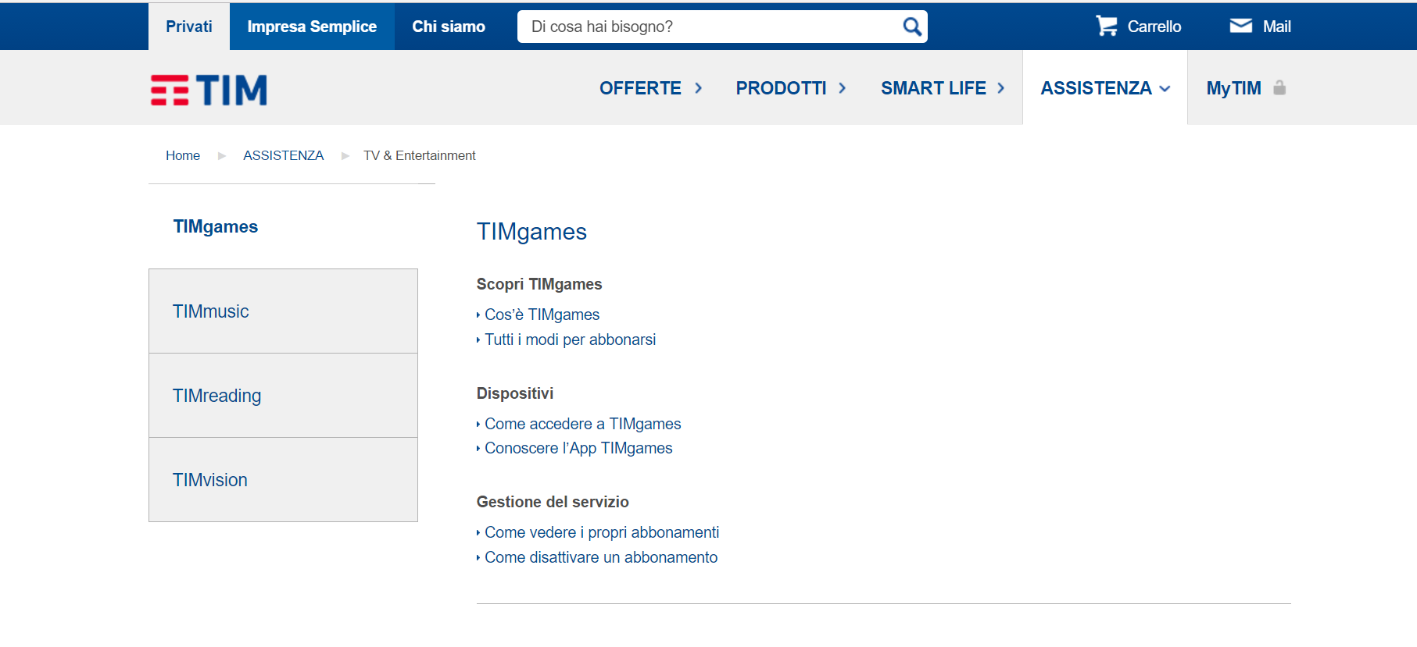

**Screenshot 3-2**

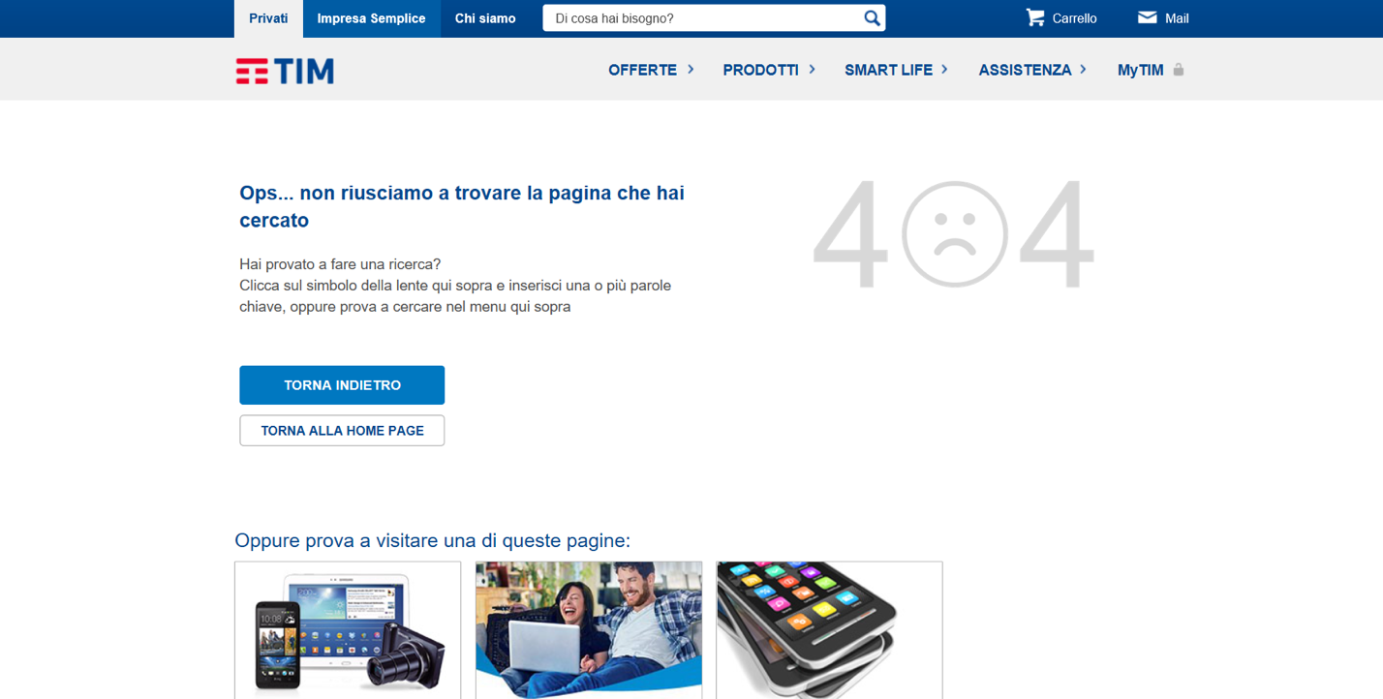

**Screenshot 3-404**