**University of Engineering and Technology, Taxila.**

**B.Sc. Computer Engineering**

**Data Structures and Algorithm**

**LAB - 1**

**Submitted By:** ABDUR REHMAN SAEED

(23-CP-82)

**Section**: Omega

**Task-1 (Positive/Negative)**

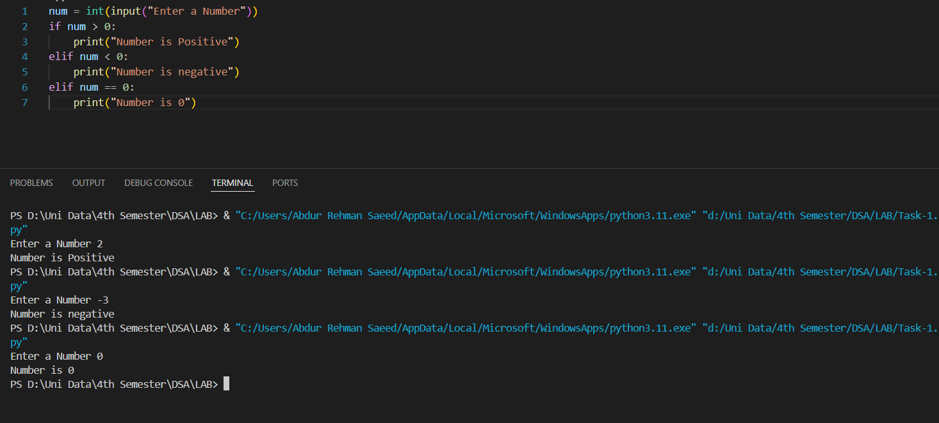

**Task-2 (Sum)**

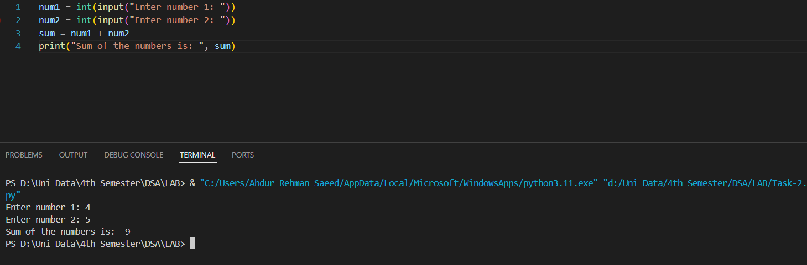

**Task-3 (Greatest One)**

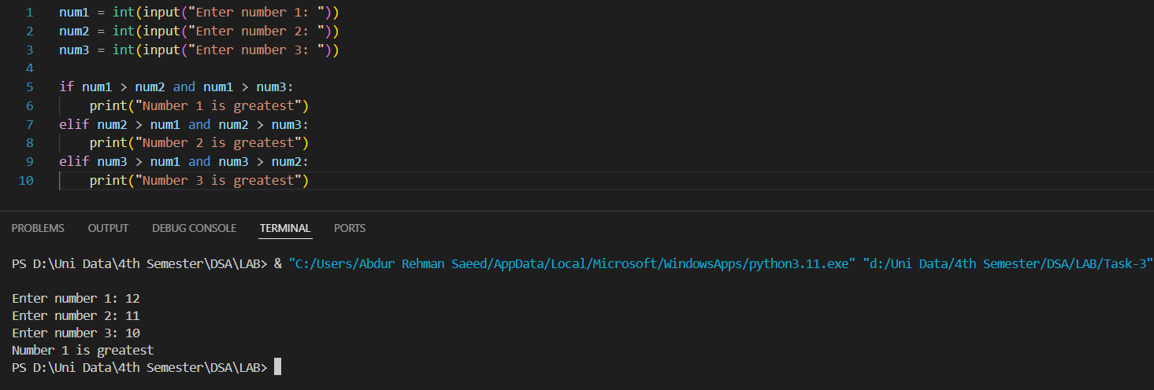

**Task-4 (Reverse String)**

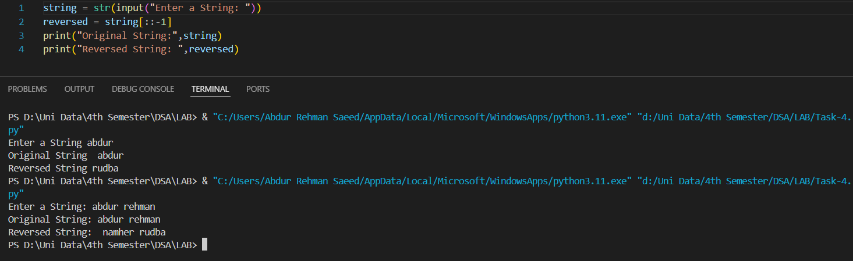

**Task-5 (Even/Odd)**

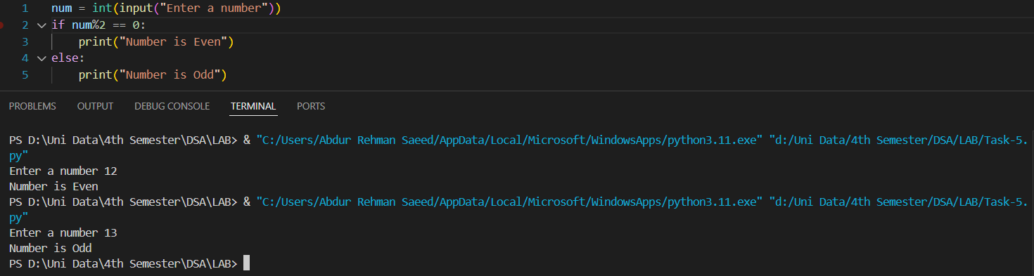

**Task-6 (Table of 10)**

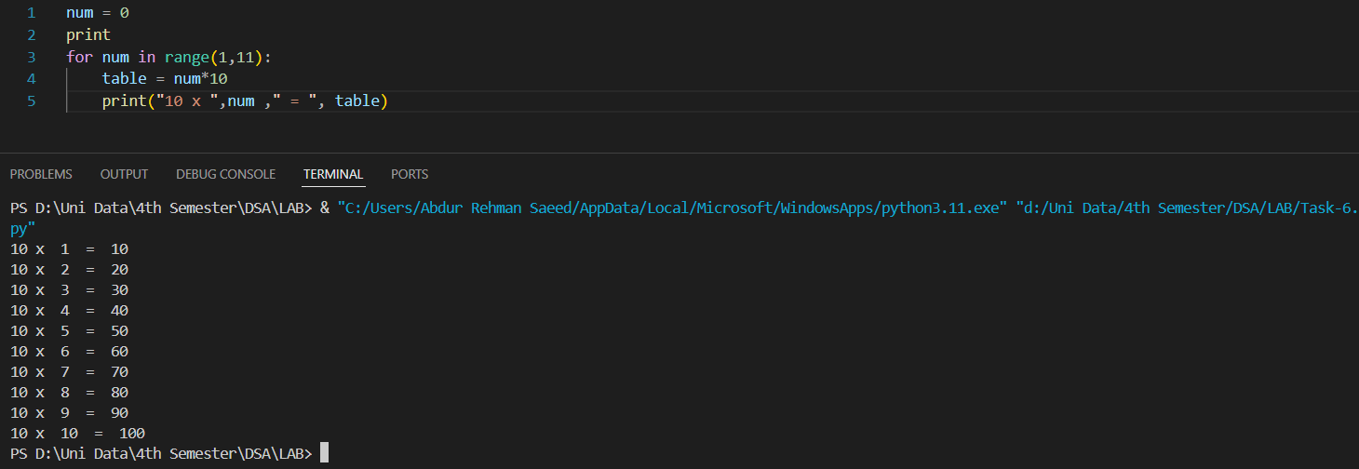

**Task-7 (Temperature)**

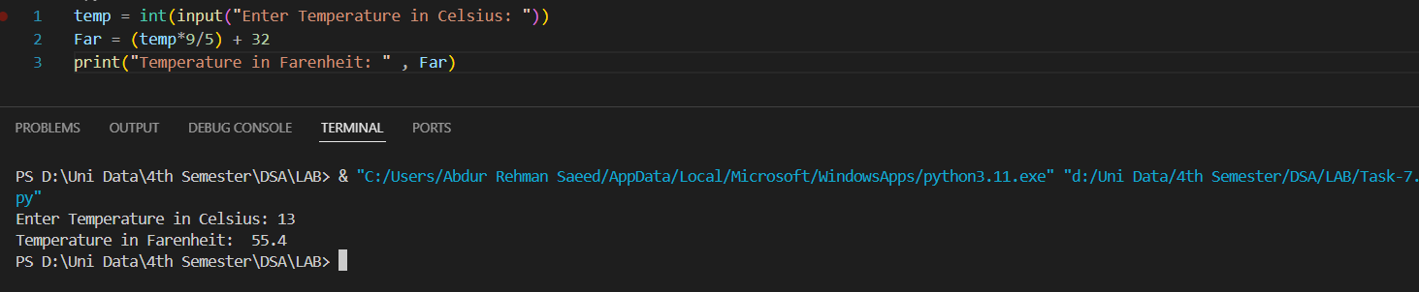

**Task-8 (Vowels)**

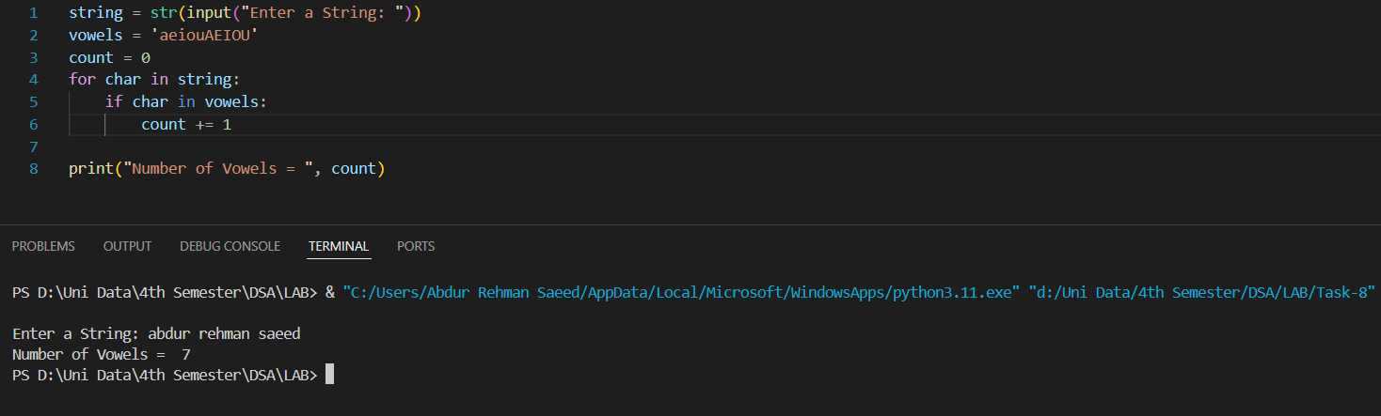

**Task-9 (Factorial)**

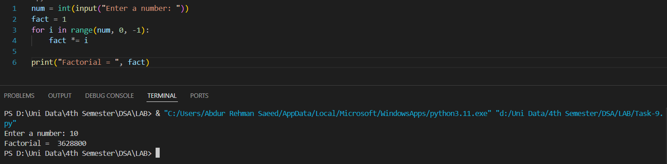

**Task-10 (Prime Numbers)**

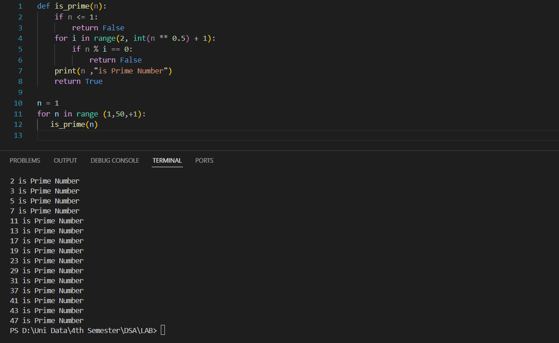

**REAL LIFE problems**

**TASK-1 (Electricity Bill)**

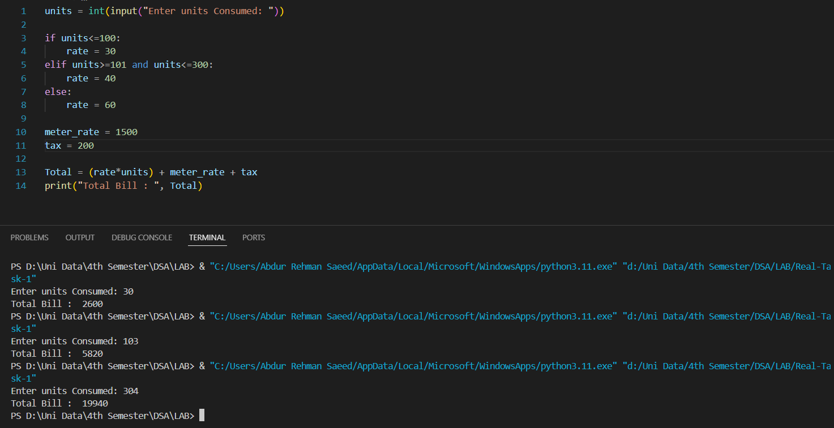

**TASK-2 (GPA Calculation)**

