**BASIC Problems**

**Task-1:** 2 Shifts in array

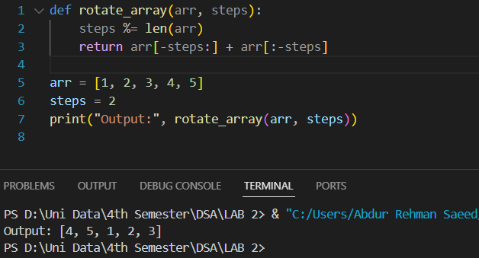

**Task-2**  Back Account Management

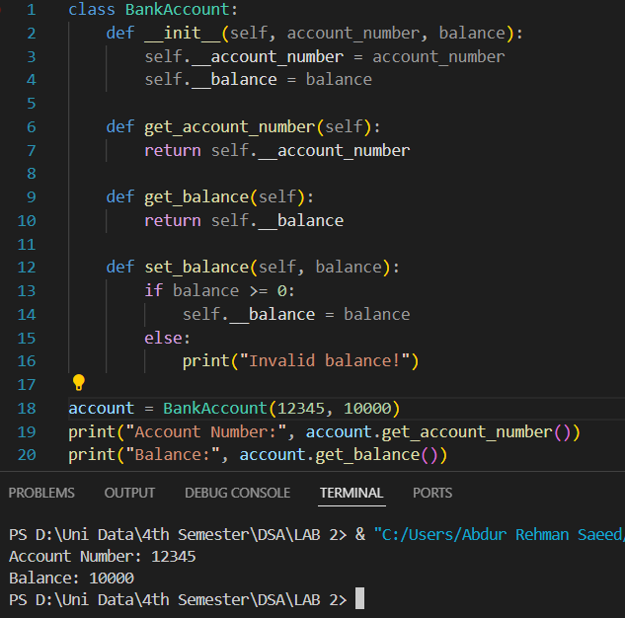

**Task-3** Difference between Dates

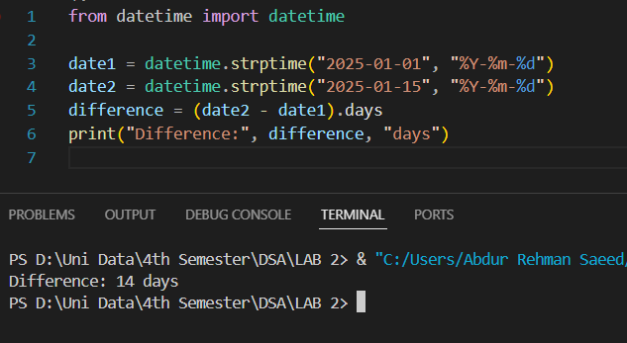

**Task-4** JSON file handling

**Task-5** GCD and LCM using build-in Math class(library)

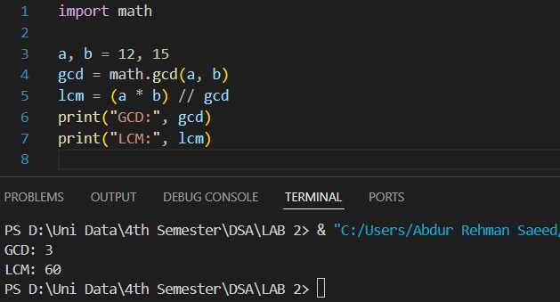

**INTERMEDIATE Problems**

**Task-1**

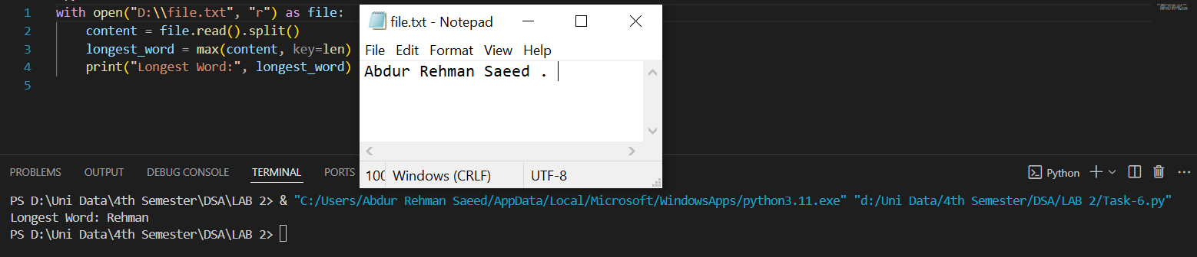

**Task-2**