Wetland Degradation Analysis of Keta Lagoon Complex
and Muni-Pomadze Ramsar Sites, Ghana

Land Use / Land Cover Change Detection and
CA-Markov Future Projection (1991–2035)

June 2026

Abstract
This study investigates land use and land cover (LULC) dynamics at two Ghana Ramsar Sites — Keta Lagoon Complex and Muni-Pomadze — over a 34-year period (1991–2025) using multi-temporal Landsat satellite imagery and Support Vector Machine (SVM) supervised classification. Three LULC classes were mapped: Vegetation, Water body, and Built up/Bareland. Accuracy assessments yielded Overall Accuracy (OA) values of 81.4%–86.9% (Kappa: 0.697–0.792) for Keta Lagoon Complex, and 83.3%–90.0% (Kappa: 0.750–0.850) for Muni-Pomadze, confirming satisfactory classification performance. Between 1991 and 2025, Vegetation cover at Keta changed by -346.4 km² while Built up/Bareland expanded by +361.9 km²; at Muni-Pomadze, Vegetation changed by -7.4 km² and Built up/Bareland by +7.2 km². CA-Markov transition modelling projects continued degradation trends through 2035 at both sites. Shannon Diversity Index and patch-fragmentation metrics corroborate observed LULC dynamics. Findings underscore significant wetland degradation pressures and have direct implications for Ramsar site management and conservation policy.

1. Methodology

1.1 Study Area
Keta Lagoon Complex Ramsar Site is located in the Volta Region of south-eastern Ghana (approx. 5°50′N, 0°55′E) and is the country's largest Ramsar Site, encompassing a mosaic of coastal lagoon, mangrove, salt marsh and estuarine habitats. Muni-Pomadze Ramsar Site lies along the central coast of Ghana (approx. 5°22′N, 0°36′W) in the Central Region and consists of a shallow coastal lagoon surrounded by coastal scrub, mangrove fringe and sandy beach. Both sites support internationally important waterbird populations and are under increasing anthropogenic pressure from urban expansion, agriculture and climate variability.

1.2 Data and Classification
Multi-temporal Landsat imagery (Landsat 4/5 TM for 1991, Landsat 7 ETM+ for 2001, Landsat 8 OLI for 2015, Landsat 8/9 OLI-2 for 2025) was acquired and pre-processed (radiometric calibration, atmospheric correction, geometric registration). A supervised Support Vector Machine (SVM) classifier was applied in ArcGIS Pro to derive three LULC classes: (1) Vegetation, (2) Water body, and (3) Built up/Bareland. All outputs were projected to UTM Zone 31N (WGS 1984) at 30 m spatial resolution.

1.3 Accuracy Assessment
Independent stratified-random validation points were used to generate confusion matrices for each site and time period. Overall Accuracy (OA), Kappa coefficient (κ), Producer's Accuracy (PA) and User's Accuracy (UA) were computed for all three classes following Congalton & Green (2019).

1.4 Change Detection
Class-level area statistics (km²) were compared across the four time periods. Net area change (km²) and percentage change were calculated for inter-period intervals (1991–2001, 2001–2015, 2015–2025) and the full study period (1991–2025). Transition probability matrices were derived from pixel-to-pixel class conversions between consecutive classified maps.

1.5 CA-Markov Future Prediction
Transition probability matrices (TPMs) computed from the 2015–2025 period were used to project LULC to 2035 via a Cellular Automaton–Markov Chain (CA-Markov) approach. Each pixel in the 2025 map was stochastically assigned a 2035 class based on the TPM row corresponding to its current class, implemented with a fixed random seed (42) for reproducibility. The prediction was exported as a co-registered GeoTIFF raster.

1.6 Landscape Metrics
Landscape composition was quantified using the Shannon Diversity Index (SDI = −Σpᵢ ln pᵢ), where pᵢ is the proportion of the landscape in class i. Configuration was characterised by the number of discrete patches per class (four-connectivity labelling), the Largest Patch Index (LPI; % of landscape area occupied by the largest single patch), and mean patch size, computed for all time periods including the 2035 projection.

2. Results

2.1 Accuracy Assessment
Accuracy assessment results across all four time periods and both sites are presented in the tables and confusion matrix figures below.

2.1.1 Keta Lagoon Complex
Year | OA (%) | κ | PA Veg (%) | UA Veg (%) | PA Wat (%) | UA Wat (%) | PA BuBl (%) | UA BuBl (%)
1991 | 81.4 | 0.697 | 96.3 | 74.3 | 83.3 | 100.0 | 50.0 | 77.8
2001 | 86.9 | 0.792 | 92.6 | 80.6 | 92.3 | 100.0 | 76.2 | 88.9
2015 | 83.3 | 0.729 | 93.1 | 79.4 | 85.7 | 92.3 | 64.7 | 84.6
2025 | 83.6 | 0.751 | 81.8 | 81.8 | 76.5 | 92.9 | 90.9 | 80.0

Table 2.1: Accuracy assessment for Keta Lagoon Complex (PA = Producer's Accuracy, UA = User's Accuracy, BuBl = Built up/Bareland).

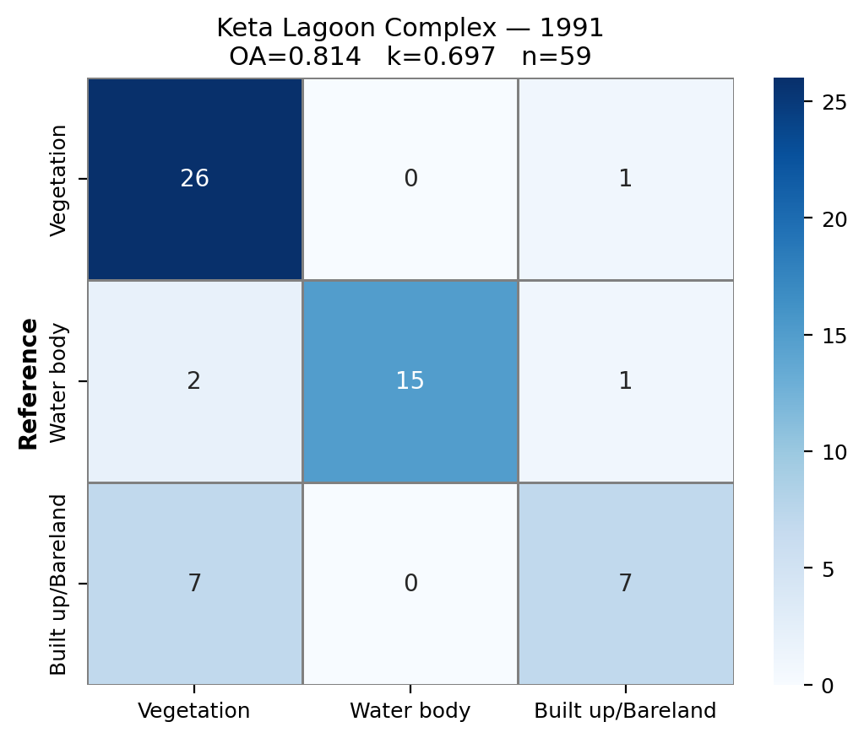
Figure: Keta Lagoon Complex 1991 confusion matrix heatmap.

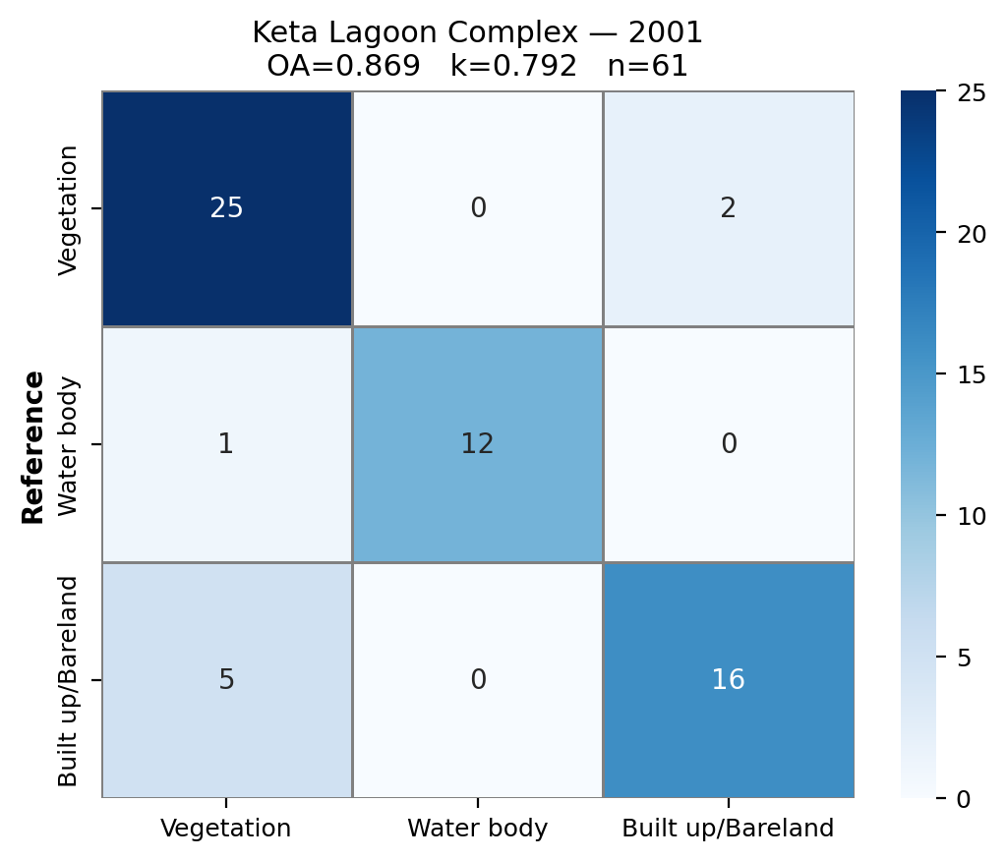
Figure: Keta Lagoon Complex 2001 confusion matrix heatmap.

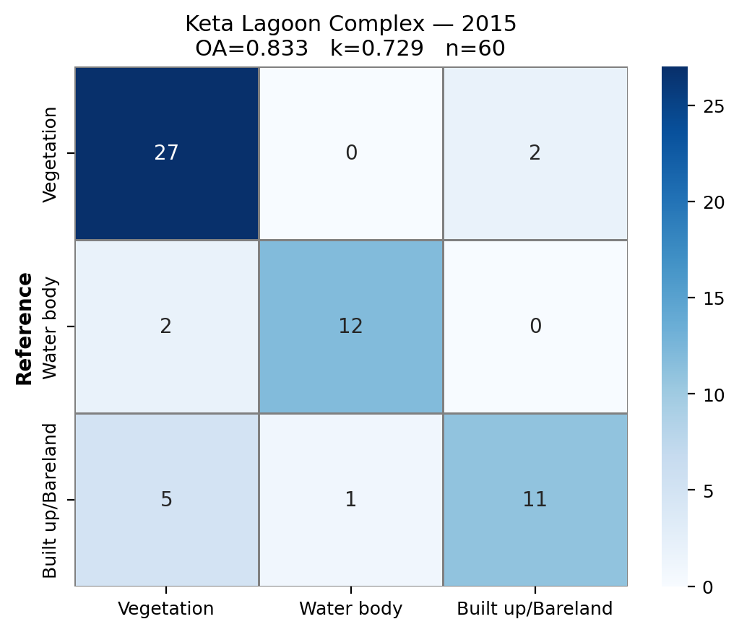
Figure: Keta Lagoon Complex 2015 confusion matrix heatmap.

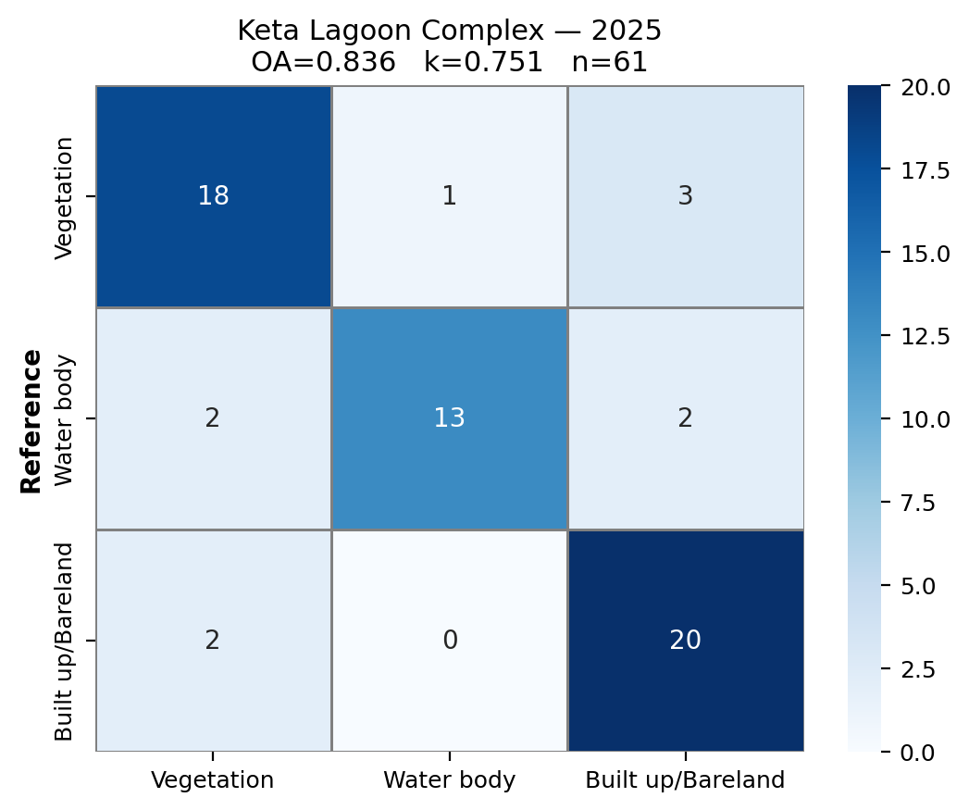
Figure: Keta Lagoon Complex 2025 confusion matrix heatmap.

2.1.2 Muni-Pomadze
Year | OA (%) | κ | PA Veg (%) | UA Veg (%) | PA Wat (%) | UA Wat (%) | PA BuBl (%) | UA BuBl (%)
1991 | 83.3 | 0.750 | 82.6 | 95.0 | 94.1 | 80.0 | 75.0 | 75.0
2001 | 90.0 | 0.850 | 82.6 | 95.0 | 95.2 | 100.0 | 93.8 | 75.0
2015 | 86.7 | 0.800 | 71.4 | 100.0 | 100.0 | 100.0 | 100.0 | 60.0
2025 | 86.7 | 0.800 | 85.7 | 90.0 | 90.5 | 95.0 | 83.3 | 75.0

Table 2.2: Accuracy assessment for Muni-Pomadze (PA = Producer's Accuracy, UA = User's Accuracy, BuBl = Built up/Bareland).

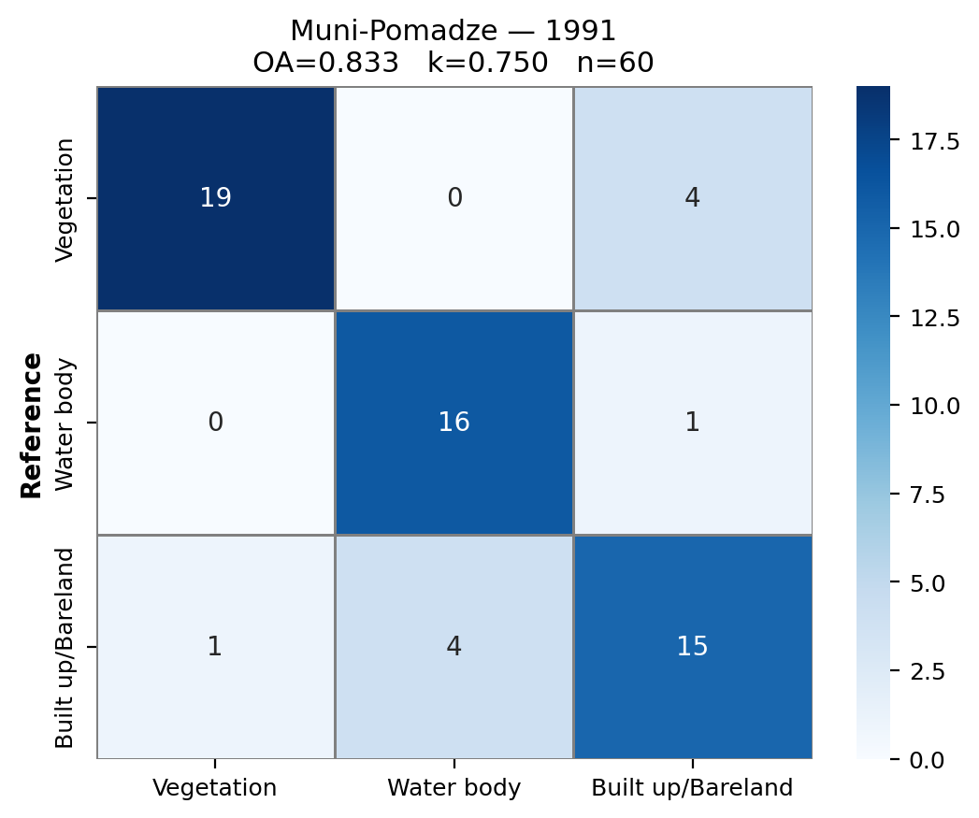
Figure: Muni-Pomadze 1991 confusion matrix heatmap.

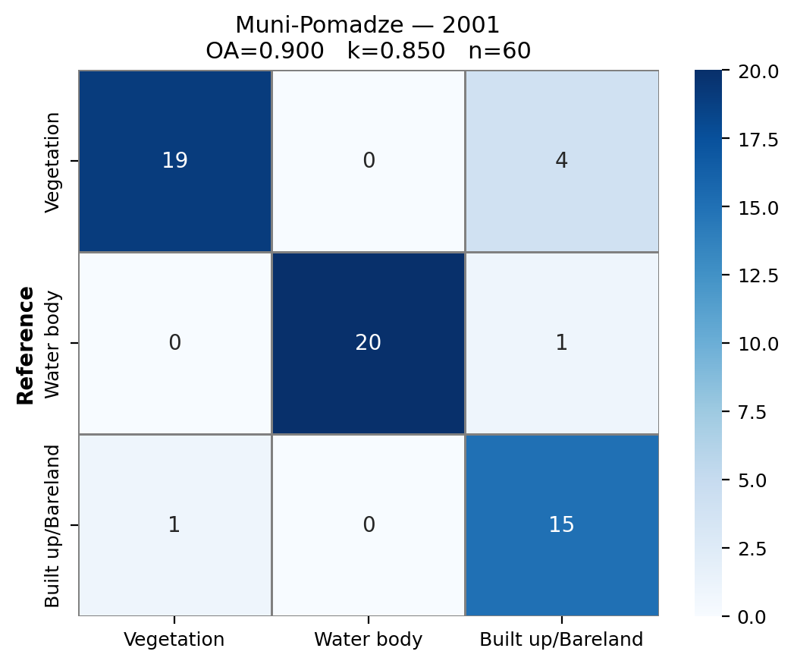
Figure: Muni-Pomadze 2001 confusion matrix heatmap.

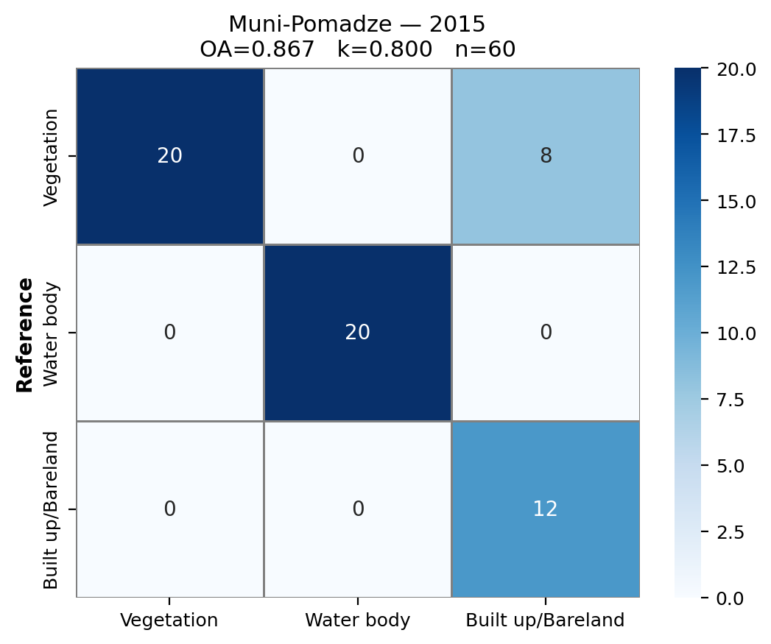
Figure: Muni-Pomadze 2015 confusion matrix heatmap.

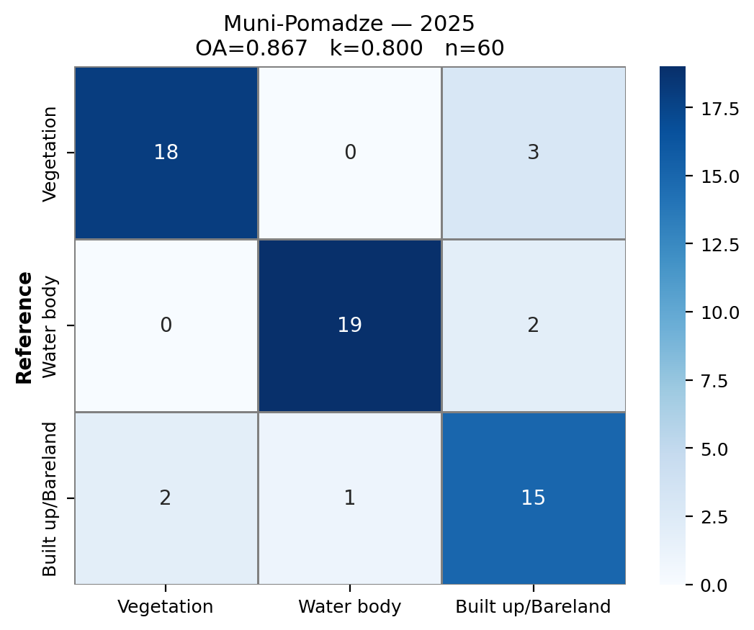
Figure: Muni-Pomadze 2025 confusion matrix heatmap.

2.2 LULC Change Analysis
Area statistics and net changes between time periods are presented below for each site.

2.2.1 Keta Lagoon Complex
Year | Vegetation | Water body | Built up/Bareland
1991 | 845.42 | 340.62 | 206.03
2001 | 719.91 | 268.79 | 408.47
2015 | 787.36 | 297.58 | 295.29
2025 | 498.98 | 312.93 | 567.95

Table 3: LULC area (km²) by class and year — Keta Lagoon Complex.

Period | Veg Δkm² | Veg Δ% | Wat Δkm² | Wat Δ% | Bui Δkm² | Bui Δ%
1991–2001 | -125.51 | -14.8 | -71.84 | -21.1 | +202.44 | +98.3
2001–2015 | +67.45 | +9.4 | +28.80 | +10.7 | -113.18 | -27.7
2015–2025 | -288.38 | -36.6 | +15.35 | +5.2 | +272.66 | +92.3
1991–2025 | -346.44 | -41.0 | -27.69 | -8.1 | +361.92 | +175.7

Table 4: Net LULC change by period — Keta Lagoon Complex.

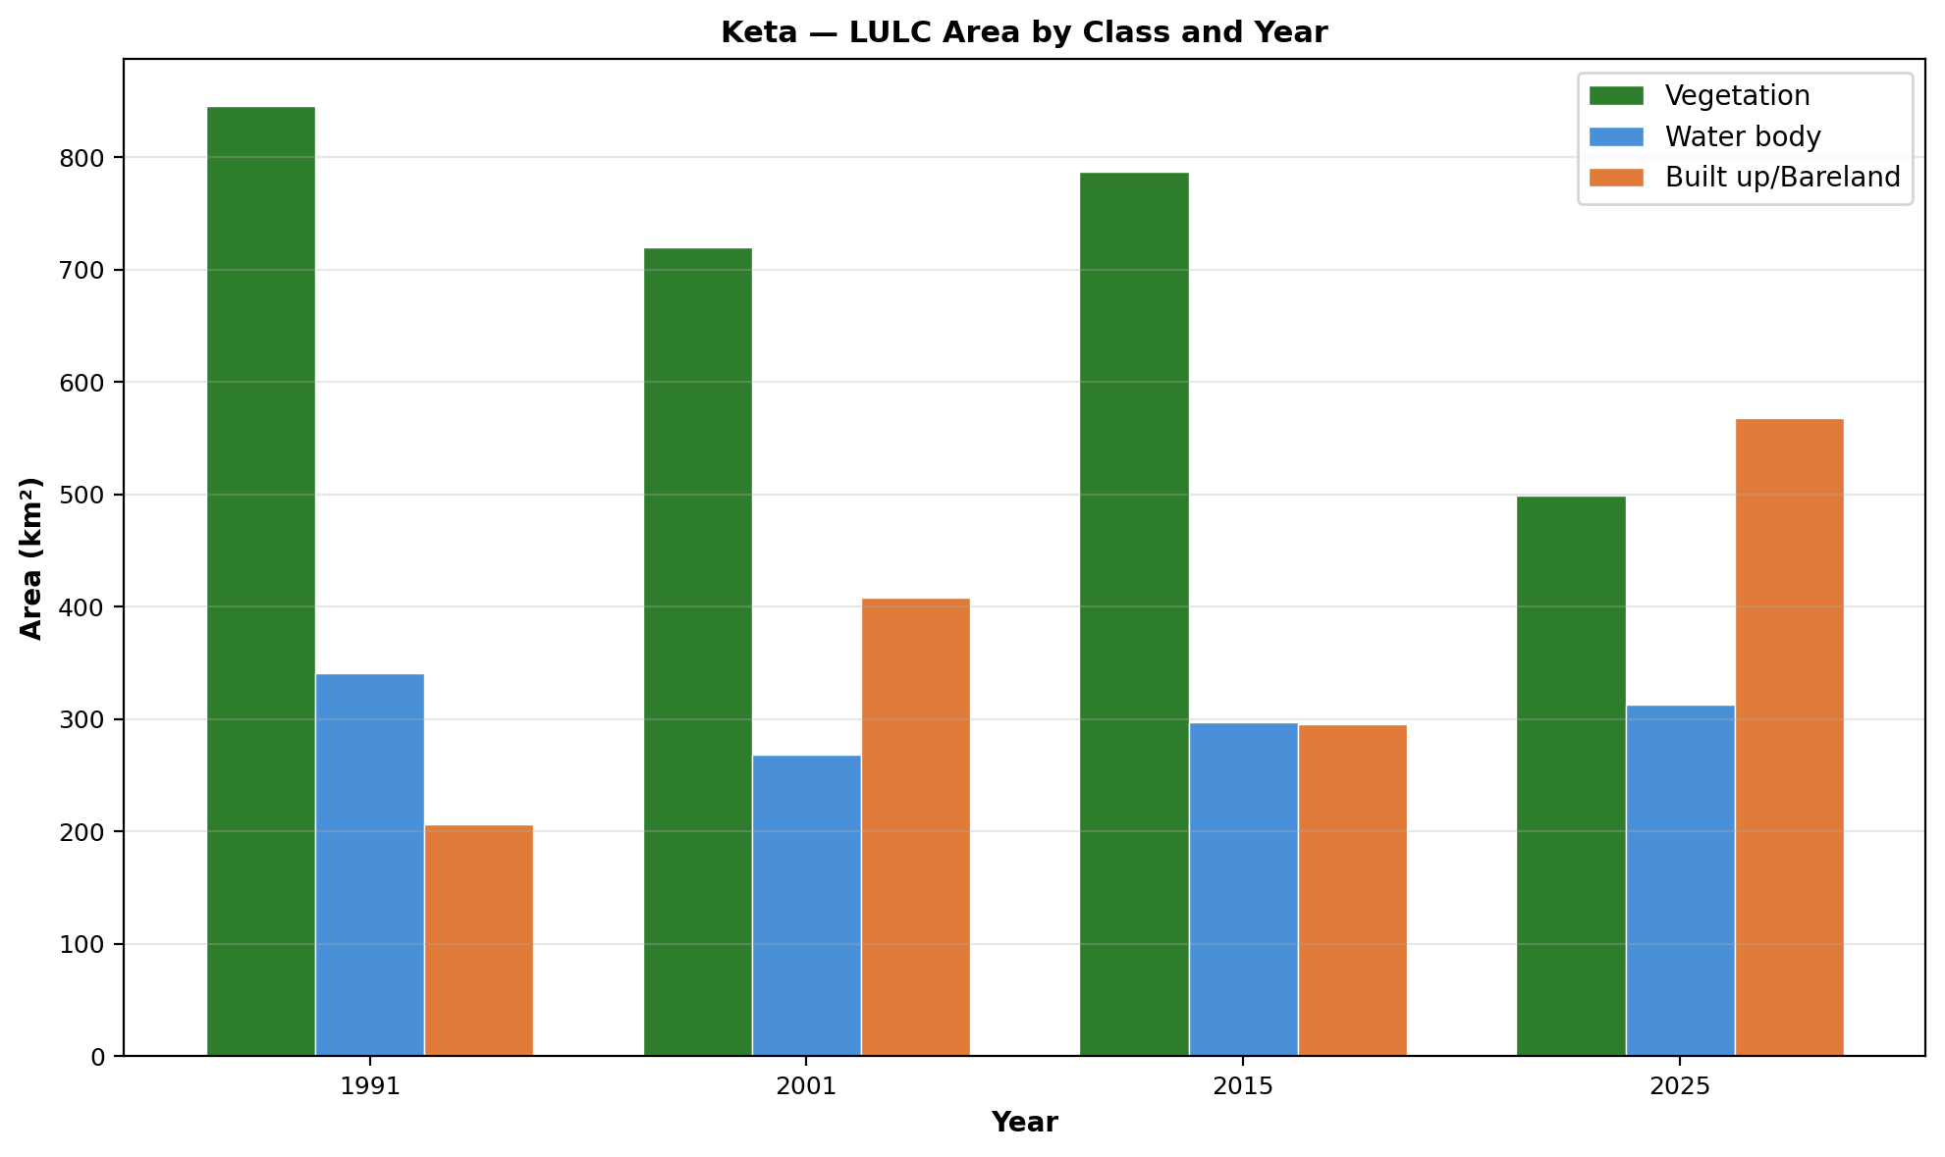
Figure: Keta Lagoon Complex — LULC area by class and year (grouped bar).

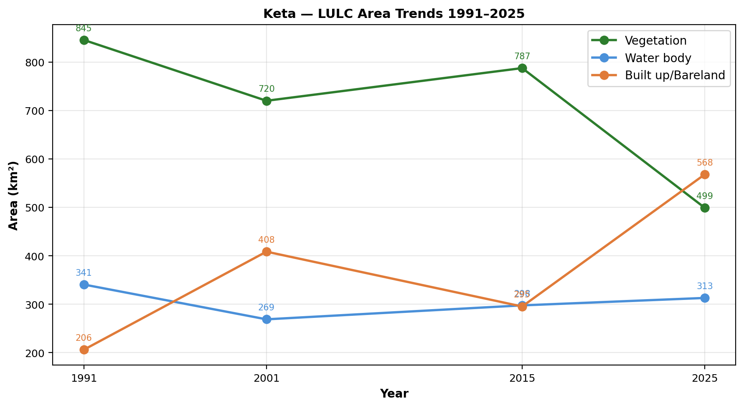
Figure: Keta Lagoon Complex — LULC area trend lines 1991–2025.

2.2.2 Muni-Pomadze
Year | Vegetation | Water body | Built up/Bareland
1991 | 60.77 | 1.56 | 55.59
2001 | 54.41 | 0.81 | 61.92
2015 | 39.74 | 1.01 | 76.38
2025 | 53.34 | 0.99 | 62.80

Table 5: LULC area (km²) by class and year — Muni-Pomadze.

Period | Veg Δkm² | Veg Δ% | Wat Δkm² | Wat Δ% | Bui Δkm² | Bui Δ%
1991–2001 | -6.36 | -10.5 | -0.75 | -48.2 | +6.33 | +11.4
2001–2015 | -14.67 | -27.0 | +0.20 | +25.1 | +14.46 | +23.3
2015–2025 | +13.60 | +34.2 | -0.03 | -2.7 | -13.57 | -17.8
1991–2025 | -7.43 | -12.2 | -0.58 | -36.9 | +7.21 | +13.0

Table 6: Net LULC change by period — Muni-Pomadze.

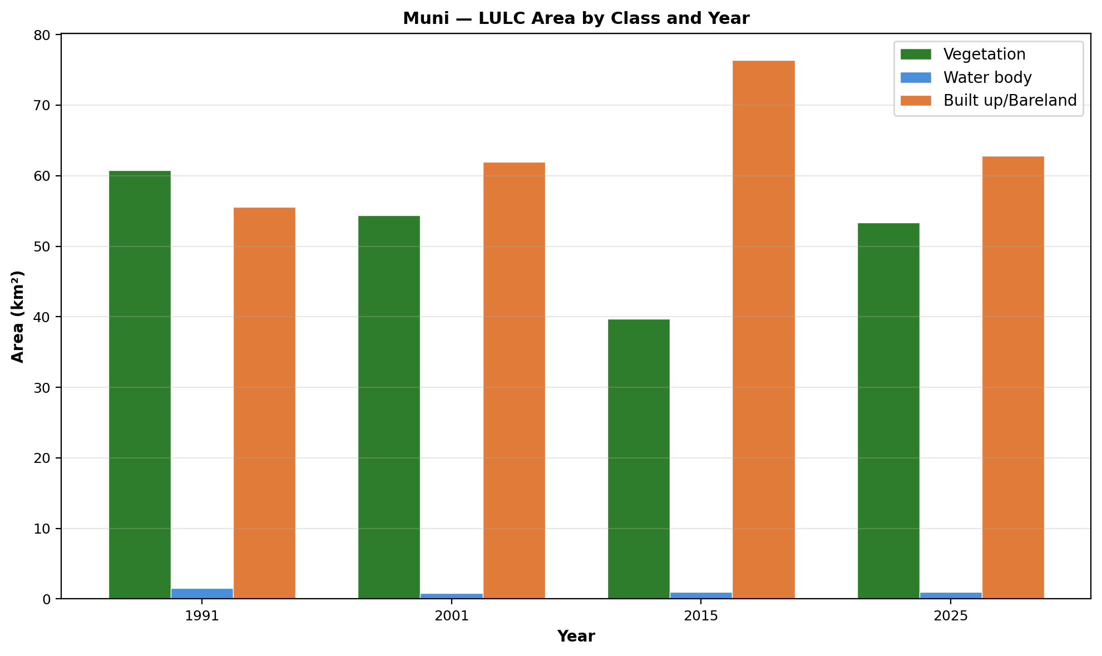
Figure: Muni-Pomadze — LULC area by class and year (grouped bar).

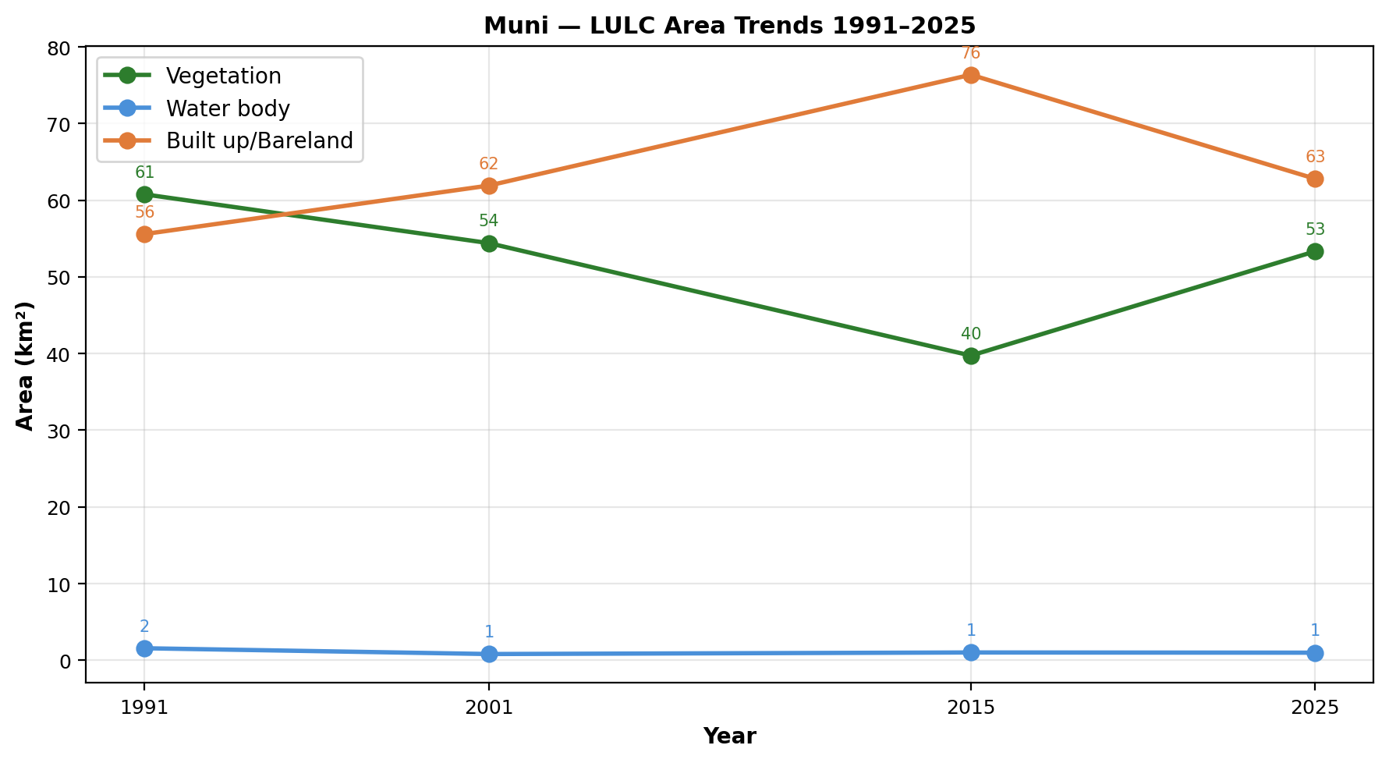
Figure: Muni-Pomadze — LULC area trend lines 1991–2025.

2.3 CA-Markov Future Prediction (2035)
Transition probability matrices derived from 2015–2025 were used to project LULC to 2035. The following tables and figures present the TPMs and predicted maps.

2.3.1 Keta Lagoon Complex
From \ To | Vegetation | Water body | Built up/Bareland
Vegetation | 1.0000 | 0.0000 | 0.0000
Water body | 0.0000 | 1.0000 | 0.0000
Built up/Bareland | 0.0000 | 0.0000 | 1.0000

Table 7: Transition probability matrix (2015→2025) — Keta Lagoon Complex.

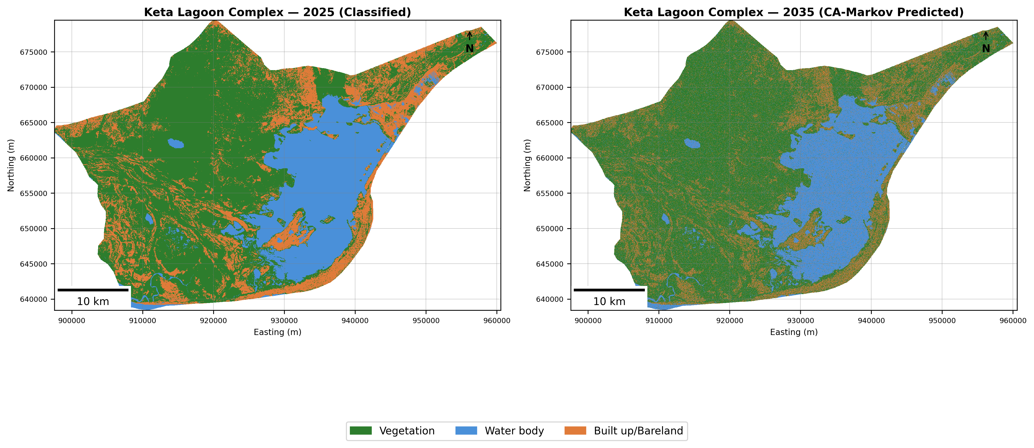
Figure: Keta Lagoon Complex — 2025 classified vs. 2035 CA-Markov predicted.

2.3.2 Muni-Pomadze
From \ To | Vegetation | Water body | Built up/Bareland
Vegetation | 0.9100 | 0.0000 | 0.0900
Water body | 0.0487 | 0.8202 | 0.1311
Built up/Bareland | 0.2242 | 0.0021 | 0.7737

Table 8: Transition probability matrix (2015→2025) — Muni-Pomadze.

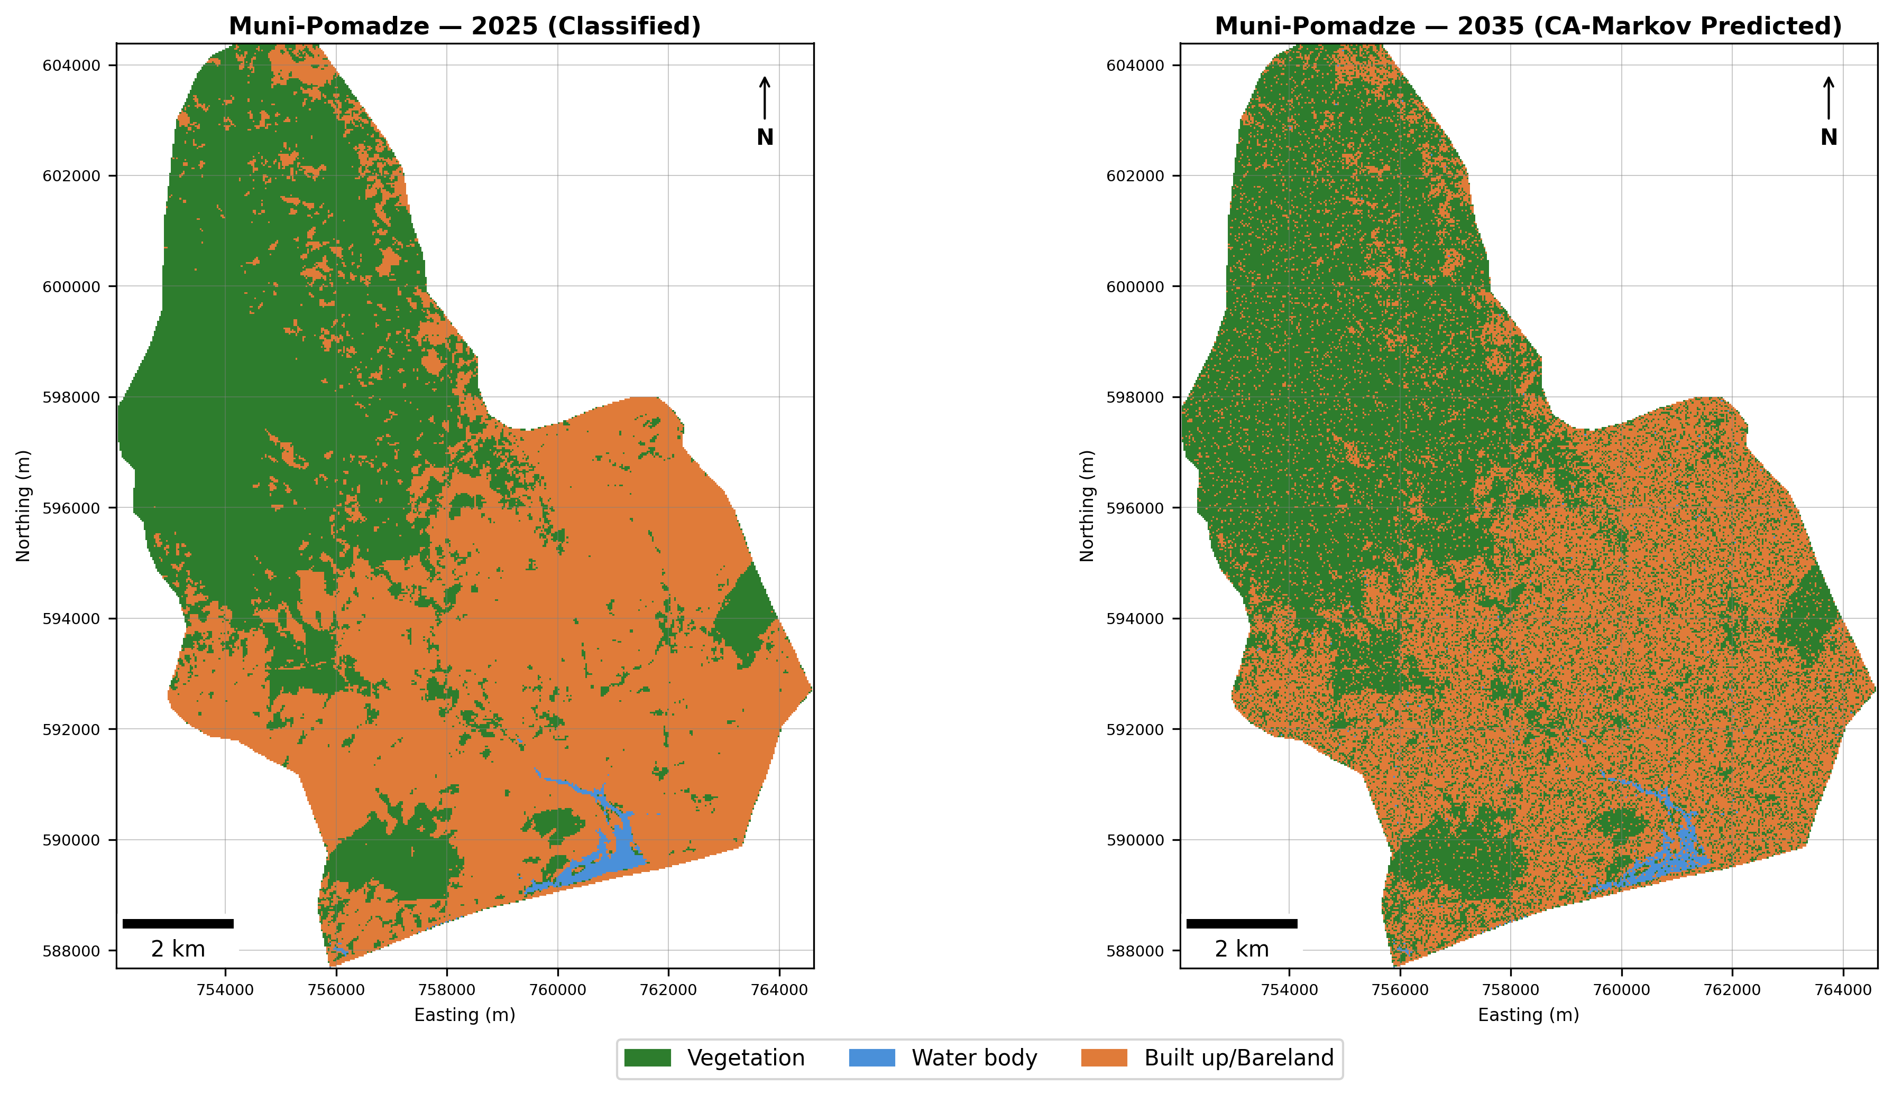
Figure: Muni-Pomadze — 2025 classified vs. 2035 CA-Markov predicted.

2.4 Multi-panel LULC Maps (1991–2035)
Publication-quality five-panel maps for each site showing all classified and predicted time steps.
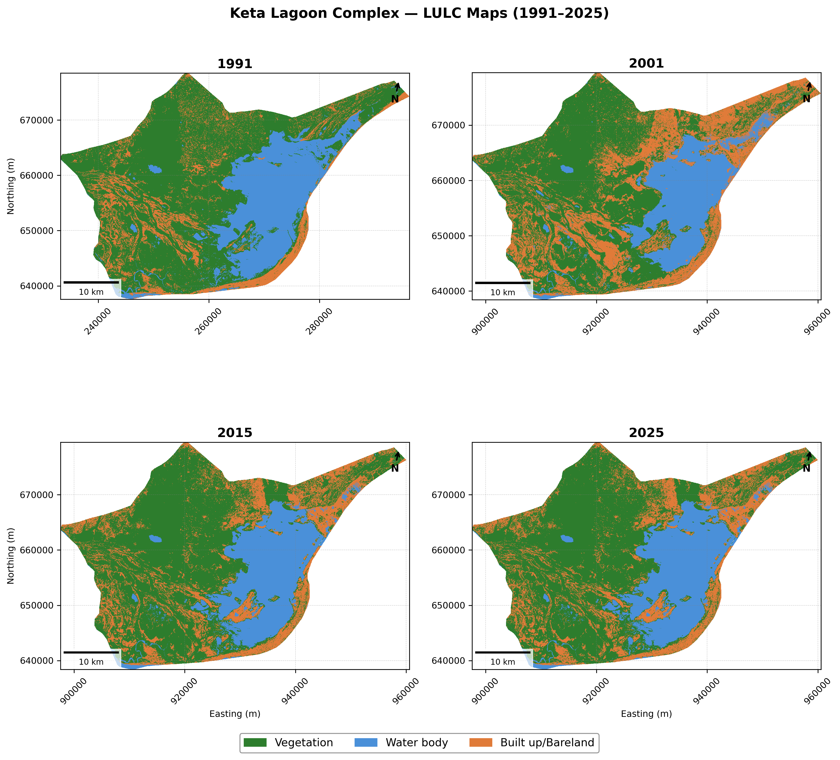
Figure: Keta Lagoon Complex — Multi-temporal LULC maps 1991–2035 (1991–2025 SVM; 2035 CA-Markov).

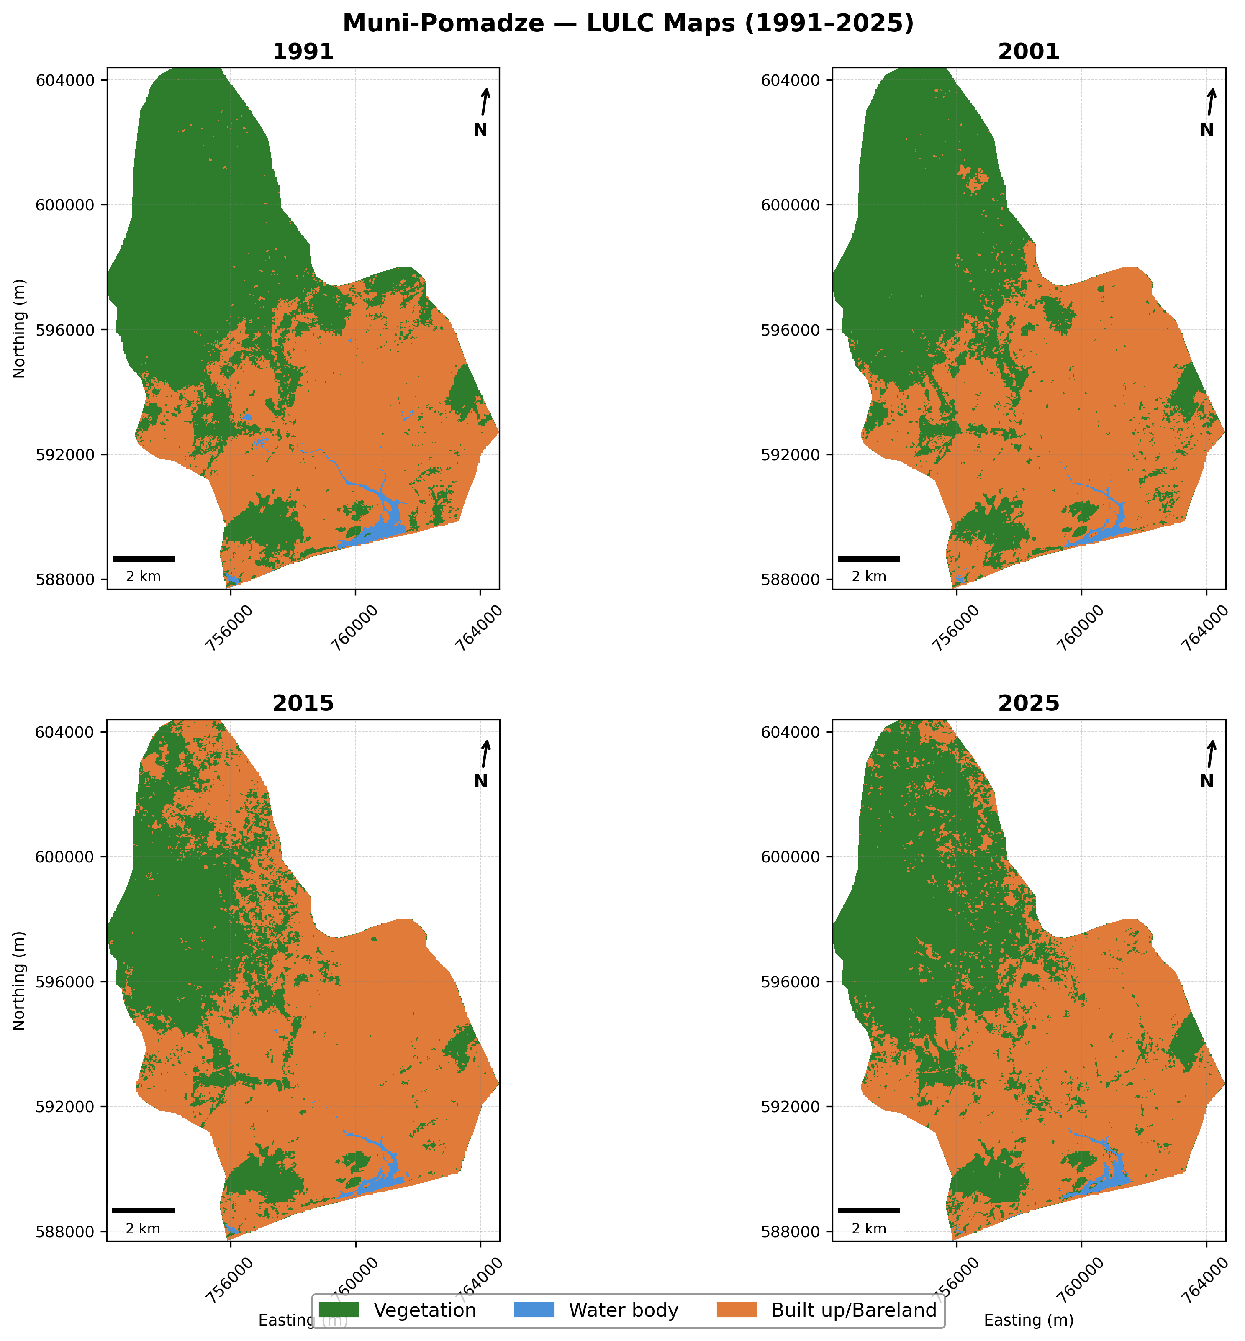
Figure: Muni-Pomadze — Multi-temporal LULC maps 1991–2035 (1991–2025 SVM; 2035 CA-Markov).

2.5 Landscape Metrics
Shannon Diversity Index, patch count, and Largest Patch Index for all time periods including the 2035 projection.

2.5.1 Keta Lagoon Complex
Year | SDI | Veg Patches | Veg LPI (%) | Wat Patches | Wat LPI (%) | Bui Patches | Bui LPI (%)
1991 | 0.9301 | 5189 | 57.65 | 1693 | 22.47 | 13954 | 2.97
2001 | 1.0183 | 11221 | 43.30 | 3695 | 16.26 | 13037 | 4.73
2015 | 0.9809 | 7420 | 48.30 | 936 | 19.70 | 11757 | 2.58
2025 | 0.9809 | 7420 | 48.30 | 936 | 19.70 | 11757 | 2.58
2035 (P) | 0.9629 | 29090 | 44.93 | 51507 | 17.98 | 108177 | 0.02

Table 9: Landscape metrics — Keta Lagoon Complex. (P) = Predicted.

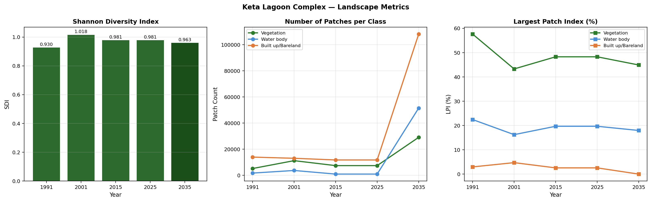
Figure: Keta Lagoon Complex — Landscape metrics 1991–2035.

2.5.2 Muni-Pomadze
Year | SDI | Veg Patches | Veg LPI (%) | Wat Patches | Wat LPI (%) | Bui Patches | Bui LPI (%)
1991 | 0.7531 | 602 | 43.53 | 69 | 1.07 | 423 | 41.77
2001 | 0.7276 | 661 | 37.74 | 30 | 0.59 | 328 | 51.49
2015 | 0.6872 | 817 | 24.92 | 25 | 0.76 | 493 | 54.95
2025 | 0.7327 | 790 | 38.05 | 29 | 0.78 | 629 | 48.72
2035 (P) | 0.7314 | 7767 | 35.49 | 191 | 0.51 | 4820 | 35.53

Table 10: Landscape metrics — Muni-Pomadze. (P) = Predicted.

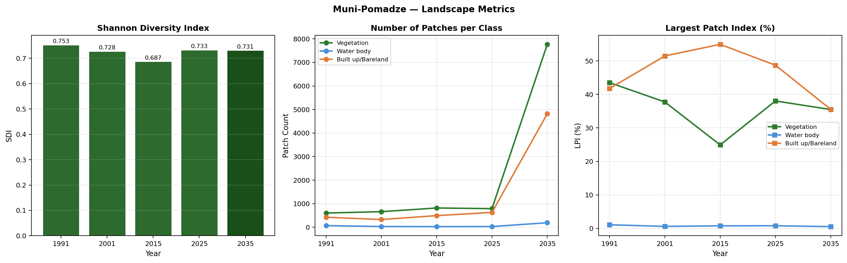
Figure: Muni-Pomadze — Landscape metrics 1991–2035.

3. Discussion
The analysis reveals substantial LULC transformations at both Ramsar sites over the 34-year study period. At Keta Lagoon Complex, 'Built up/Bareland' experienced the greatest absolute change (361.9 km²), reflecting the intensity of coastal land transformation processes — including artisanal salt harvesting, commercial fishing infrastructure, and peri-urban growth — that characterise this area. Built up/Bareland expansion at Keta (+361.9 km² from 1991 to 2025) is consistent with documented urbanisation trends along Ghana's Volta coast.
At Muni-Pomadze, 'Vegetation' registered the largest change (7.4 km²). Despite the site's smaller spatial extent, proportional changes are significant, highlighting its vulnerability to relatively modest anthropogenic disturbances including small-scale subsistence agriculture, coastal erosion and seasonal hydrological variability. The Vegetation change of -7.4 km² between 1991 and 2025 indicates progressive habitat loss in an already compact wetland system.
Comparing the two sites, Keta Lagoon Complex exhibits larger absolute changes owing to its greater total extent, while Muni-Pomadze shows disproportionate proportional changes relative to its area. Both sites display the hallmarks of wetland degradation documented across West Africa: shrinking water bodies, declining natural vegetation cover, and expanding degraded or built-up land (Ozesmi & Bauer, 2002; Dronova, 2015).
The CA-Markov projections to 2035 indicate that, absent targeted management intervention, current degradation trajectories will persist. The high row-wise probabilities of remaining in the Built up/Bareland class in the 2015–2025 TPMs confirm this class's stability and near-irreversible nature once established. Vegetation-to-Bareland transitions at both sites reinforce the urgency of proactive conservation measures.
Shannon Diversity Index trends provide additional evidence of changing landscape structure. Declining SDI values over time indicate decreasing landscape heterogeneity, with one or a few classes increasingly dominating the landscape — adverse for biodiversity and ecosystem resilience. The fragmentation metrics (increasing patch counts, declining mean patch size) suggest progressive habitat fragmentation, reducing landscape connectivity for wetland-dependent species. These findings have direct implications for Ramsar site management: specifically, the need to enforce existing protection boundaries, develop wetland buffer zones, support community-based conservation programmes, and integrate remote-sensing-based monitoring into national environmental governance frameworks.

4. Conclusion
This study provides a comprehensive multi-temporal LULC assessment at Keta Lagoon Complex and Muni-Pomadze Ramsar Sites in Ghana from 1991 to 2025, with CA-Markov projections to 2035. SVM-classified Landsat imagery achieved satisfactory accuracy across all time periods (OA: 81.4%–86.9% for Keta; 83.3%–90.0% for Muni-Pomadze). Both sites exhibit clear evidence of wetland degradation — declining Vegetation and Water body extent alongside expanding Built up/Bareland — with trends projected to continue through 2035 under business-as-usual land management.
Key recommendations emerging from this work include: (i) strengthened enforcement of Ramsar site boundary protection zones; (ii) community-engaged sustainable livelihood programmes to reduce encroachment pressure; (iii) establishment of a near-real-time remote sensing monitoring programme using freely available Landsat/Sentinel imagery; and (iv) integration of wetland ecosystem service valuation into national land-use planning and environmental impact assessment processes. Future research should incorporate field-based vegetation surveys, hydrological data and socioeconomic driver analysis to develop a more complete causal model of degradation at these globally important wetland sites.

5. References
Congalton, R. G., & Green, K. (2019). Assessing the accuracy of remotely sensed data: Principles and practices (3rd ed.). CRC Press.
Dronova, I. (2015). Object-based image analysis in wetland research: A review. Remote Sensing, 7(5), 6380–6413. https://doi.org/10.3390/rs70506380
Giri, C., Zhu, Z., & Reed, B. (2005). A comparative analysis of the Global Land Cover 2000 and MODIS land cover data sets. Remote Sensing of Environment, 94(1), 123–132. https://doi.org/10.1016/j.rse.2004.09.005
Ozesmi, S. L., & Bauer, M. E. (2002). Satellite remote sensing of wetlands. Wetlands Ecology and Management, 10(5), 381–402. https://doi.org/10.1023/A:1020908432489
Prigent, C., Papa, F., Aires, F., Rossow, W. B., & Matthews, E. (2007). Global inundation dynamics inferred from multiple satellite observations, 1993–2000. Journal of Geophysical Research: Atmospheres, 112(D12). https://doi.org/10.1029/2006JD007847

